

AMBO UNIVERSITY
SCHOOL OF GRADUATES STUDIES
COLLEGE OF NATURAL AND COMPUTATIONAL SCIENCE DEPARTEMENT OF BIOLOGY.
Isolation, Characterization And Determination of Physical Parameters For Aspergillus Amylase Activities from Chilimo forest soils Western Ethiopia
A Research Submitted To Ambo University College of Natural and Computational Science Department of Biology in Partial Fulfillment of Master of Microbiology and Microbial Biotechnology.

By: Abraham Demisse
Advisor: Asefa Keneni (PhD)

October, 2020
Ambo, Ethiopia

AMBO UNIVERSITY
SCHOOL OF GRADUATE STUDIES

APPROVAL SHEET
Isolation, Characterization and Determination of Physical Parameters For Aspergillus Amylase Activities from Chilimo forest soils Western Ethiopia
By
Abraham Demisse
Final approval and acceptance of the thesis is reliant upon the submission of the final copy of the thesis to the Council of Graduate Studies (CGS) through the Department Graduate Committee (DGC) of the candidate’s major department
Submitted by:
Abraham Demisse ___________
PG Candidate Signature Date
Approved by:
1___________________________ ____________ ______________
Advisor Signature Date
2. ___________________________ _____________ ____________
Head department Signature Date
3.___________________________ _______________ ___________
College Dean Signature Date
4.______________________________ ________________ ___________
Director, School of Graduate Studies Signature Date

AMBO UNIVERSITY
SCHOOL OF GRADUATE STUDIES

CERTIFICATION SHEET
As thesis advisor, I hereby certify that I have read and evaluated thesis entitled: - “Characterization of amylase producing Aspergillus species from soils and determination of amylase Activity
“in Ambo University of West Ethiopia prepared under my guidance by Abraham Demisse.
I recommend that it can be as fulfilling the thesis requirement and accepted for defense.

____________________ ________________ ___________
Advisor name Signature Date
As members of the examining board of the final MSc. open defense, we certify that we have read and evaluated the thesis prepared by Abraham Demisse entitled: “Characterization of amylase producing Aspergillus species from soils and determination of amylase Activity”

We are recommended that it be accepted as fulfilling the thesis requirement for the degree of Master of Science in Microbiology and Microbial Biotechnology.

___________________________ _______________ ___________
Name, Chairman Signature Date
___________________________ _______________ ___________
Name, Internal Examiner Signature Date
___________________________ ______________ __________
Name, External Examiner Signature Date

Declaration of authorship
I declare that this thesis is my work and that all sources of materials used for this thesis have been duly acknowledged. This thesis has been submitted in partial fulfillment of the requirement of M.Sc. Degree at Ambo University and is deposited at the University library to be made available to borrowers under rules of the library. I declared that this thesis is not submitted to any other institution for award of any academic degree, diploma or certificate. Brief quotation from this thesis is allowable without special permission if accurate acknowledgement of source is made. Requests for permission for extended quotation from or reproduction of this manuscript in whole or part may be granted by the major department or dean of school of graduate studies in his/her judgment the proposed use of the material is in interest of scholarship. In all other instance, however, permission must be obtained from the author.
Name: Abraham Demissie Signature____________________
Place: Ambo University
Date of submission_______________________

Dedication
I dedicate this thesis to my beloved brother Tadesse Demissie and Abdisa Hailu for harboring me fondness, love, sacrifice, sincerity and ambition and whose whole hearted support, care, guidance, and encouragement maintained me on the path of my success.

BIOGRAPHICAL SKETCH
The author, Mr. Abraham Demisse Gebisa, was born on September 01/1977 E.C in west Shoa zone, Abuna Gindeberet Woreda and Haro kebele of Oromia regional state. He joined Haro Primary school in 1984 E.C and attended his primary education up to grade 8 in 1984 .E.C up to 1992E.C. Then he went to Kachisi town and continued his secondary school education at kachisi senior secondary school from grade 9-10 in 1993E.C up to 1997 E.C. After successfully completing his senior secondary school education, he joined Adama Teacher College in 1998 E.C academic year and graduated with Dipiloma in teaching professional in 2000 E.C. After his graduation, he was employed by Oromia education Bureau and worked as a teacher at North of west shoa Zone Dawo Woreda in Beshi Kiltu kebele for 4 years and he worked at West Shoa Zone Gindeberet woreda Elementary school in Faji kebele for 1 year and he join Ambo University for up grading his academic ability in summer for five(5) years in 2002E.C up to 2007 E.C. Then he graduated from this University by Biology in Degree in 2007 E.C. After his graduates he worked in Abuna Gindeberet Haro kebele as teacher Haro Secondary school for 2 years and Abuna Preparatory school for 2 years. After these years in September 2019 E.C, he joined the school of post graduate studies of Ambo University in regular to pursue postgraduate studies in microbiology and microbial biotechnology.

ACKNOWLEDGMENTS
I would like to express my adviser, Dr. Asefa Keneni, for giving and sharing idea to me, for doing this thesis and having confidence to advise me. His assistance and suggestions were important in the construction of this thesis.
I also would like to thank head Department of biology Tilehun Tolesa and bioology lab assistant Mekdes for facilitating the material and chemical present in the biology laboratory and all Professors and all Doctors of given master course for this learning opportunity.
I would like to thank some members’ of chemistry lab assistance for helped and facilitated the chemical and materials that help me to this thesis.

Table of Contents
Contents pages
APPROVAL SHEET i
CERTIFICATION SHEET ii
DECLARATION AUTHORSHIP......................................................................................................................iii
DEDICATION...................................................................................................................................................... iv
BIOGRAPHICAL SKETCH..............................................................................................................................v
ACKNOWLEDGMENTS ..vi
LIST OF TABLES.......................................................................................................................................vi
LIST OF FIGURES ii
Abstract..................................................................................................................................................................iii
CHAPTER ONE 1
1. Introduction 1
1.2. Statement of the Problem 5
1.3. Objectives of the study 5
1.3.1. General objective 5
1.3.2. Specific objectives 5
2. Literature Review 6
2.1. Enzyme 6
2.2. The Early Discovery of Enzyme 6
2.3. Enzymes Structure 7
2.4. Classification and Function of enzymes 8
2.5. Amylases 10
2.6. The Discovery of Amylases 10
2.7. Structure Of Amylases 10
2.8. Types of Amylases 12
2.8.1. Endo-Acting or Endo-Hydrolases 12
2.8.2. Exo-Amylases or Exo-Hydrolases 12
2.9. Starch 13
2.10. Starch Structure 14
2.11. Microbial Amylases 16
2.12.Importance of Amylases in Industry 16
2.12.1. Food Industry 16
2.12.2. Textile Industry 16
2.13.3. Paper Industry 17
2.12.4. Detergent Applications 17
2.12.5. Biofuel production 17
2.12.6. Amylases in the bakery industry 18
2.12.7. Application of amylases in beer production 18
2.13. The Factors Affect Microbial Amylase 19
2.13.1. The Factors Affect fungal amylase 19
2.13.1.1.Temperature 19
2.13.1.2.P^{H} 20
2.13.1.3.Incubation time 21
3. MATERIALS AND METHDODS 22
3.1. Description of the study area 22
3.2. Study design 23
3.3. Preparation of media 23
3.4.. Preparation of soil samples 25
3.5. Inoculation and incubation 25
3.6. Sub culturing for purification 25
3.7. Screening of amylase producing organisms 26
3.8. Morphological and Biochemical Characterization of Aspergillus spp. 26
3.8.1. Morphological Identification of Aspergillus spp. 26
3.8.1.1. Microscopic observation 26
3.8.1.2. Cultural characterization. 26
3.9. Amylase assay 27
3.10. Glucose standard curve 28
3.11. Preparation of 3, 5 Dinitrosalicyclic Acids (DNSA) 29
3.12. Amylase production at different temperature 30
3.13. Amylase production at different pH 30
3.14. Effect of Incubation time on amylase activity 30
3.15. Data Analysis 30
CHAPTER FOUR 31
4.RESULTS AND DISCUSSION 31
4.1. Isolation of amylase producing Aspergillus spp. 31
4.2.Cultural characterstics of Aspergillus species isolates...........................................................32
4.3.Morphological And Microscopic Characterization Of Aspergillus Spp.......................................................34
4.4.Starch Hydrolysis Tests 36
4.5.Selection of Highest Amylase Producing Aspergillus species 38
4.6.Enzyme activity 39
4.7.Production of Amylase and Enzyme Assay 40
4.8.Optimization of Amylase production 42
4.8.1. Effect of different pH for Amylase production 42
4.8.2.Effect of different incubation Temperature on Amylase production. 44
4.8.3.Effect of Incubation Period on Amylase production 46
5. CONCLUSIONS AND RECOMMENDATIONS 48
5.1. Conclusions 48
5.2. Recommendations 49
6.Reference 50
7.Appendixes: output of data analyzed..........................................................................................56
8.Appendix- preparation of media for different purpose.............................................................63

LIST OF TABLES
Table 1: Classification And Function Of Enzymes ....................................................................................9
Table 2: Uses Of Amylase In Different Industry 19
Table 3: Composition Of Starch Agar Media To Culture Aspergillus Sp................................................24
Table 4:Total Number Of Aspergillus Spp. Isolated Chilimo Forest soil, from fieid soil, under birbirsa(podocarpus falcatus) soil, under gatira(junipers procera) soil and under ejersa (olea europaea subspecies cuspidata)soil. 30
Table 5: Morphological Characteristics Of The Aspergillus Spp. . 31
Table 6: Average Ratio Of Clear Zones Diameter Of Aspergillus 36
Table 7: Effect Of PH On Amylase Production.......................................................................................41
Table 8: Effect Of Temperature On Amylase Production.......................................................................44
Table 9: Effect Of Incubation Time On Amylase Production................................................................46

LIST OF FIGURES
figure 1: typical protein structure: two amino acid joined together peptide bond. 7
figure 2: haloenzymes attached to apoenzymes and different types of cofactor. 8
figure 3: the structure of α-amylase 11
figure 4: alpha and beta amylase 13
figure 5: structure amylose (left) and amylopectin (right). 14
Figure 6: the submerged fermentation in starch agar flasks.....................................................................27
Figure 7: Glucose Standard Curve...........................................................................................................28
figure 8: characterization of aspergillus spp. 33
figure 9 the percentage distribution of starch degrading aspergillus isolates into three categories that express as diameter of zone hydrolysis (cm). 37
figure 10: comparison among the average ratio of clear zones of the amylase producing aspergillus species on starch agar plates 38
figure 11: the highest amylase activity produced from the ten selected isolates of aspergillus spp. 39
figure 12: petri dish shows zone of amylase activity by aspergillus spp. (BSI4) 40
figure 13: effect of pH on amylase activity at different incubation periods 42
figure 14: effect of temperatures on amylase activity at different incubation periods. 44
figure 15: amylase activity of different incubation periods on aspergillus spp. isolates for amylase production 46

7. Appendixes: output of data analyzed ANOVA
Appendix 1a: 1a: The highest enzyme activities at P^{H} 5.0 BSI4............................................................................57
1b: The lowest enzyme activities at P^{H} 5.0 GSI1...................................................................................57
Appendix 2a: The maximum enzyme activities of at P^{H} 7.0 BSI4 ..............................................................57
2b: The minimum enzyme activities of at P^{H} 7.0 ESI5...........................................................................57
Appendix 3a: The maximum enzyme activities of at P^{H} 8.0 BSI4............................................................58
3b: minimum enzyme activities of at P^{H} 8.0 ESI5..................................................................................58
Appendix 4a: The maximum enzyme activities of at P^{H} 10.0 BSI4.........................................................................58
4b: The minimum enzyme activities of at P^{H} 10.0 GSI1..........................................................................58
Appendix 5a: The highest enzyme activities at 25⁰C temperature BSI4...................................................................59 5b: The lowest enzyme activities at 25⁰C temperature GSI1........................................................................59
Appendix 6a: The highest enzyme activities at 28⁰C temperature BSI4.....................................................................59
6b: The lowest enzyme activities at 28⁰C temperature GSI1......................................................................59
Appendix 7a: The highest enzyme activities at 37⁰C temperature ESI1......................................................................60
7b: The lowest enzyme activities at 37⁰C temperature ESI1......................................................................60
Appendix 8a: The highest enzyme activities at 45⁰C temperature BSI4.....................................................................60
8b: The lowest enzyme activities at 45⁰C temperature ESI5......................................................................60
Appendix 9a: The highest enzyme activities at 24hrs BSI4....................................................................................... 61 9b: The lowest enzyme activities at 24hrs ESI5............................................................................................61
Appendix 10a: The highest enzyme activities at 48hrs BSI4.....................................................................................61
10b: The lowest enzyme activities at 48hrs GSI1.....................................................................................61
Appendix 11a: The highest enzyme activities at 72hrs BSI4....................................................................................61
11b: The lowest enzyme activities at 72hrs GSI1.......................................................................................61
Appendix 12a: The highest enzyme activities at 96hrs BSI4 ....................................................................................61 12b: The lowest enzyme activities at 96hrs GSI4.........................................................................................62
Appendix 13a: The highest enzyme activities at 120hrs BSI4..................................................................................63
13b: The lowest enzyme activities at 120hrs GSI4 ...................................................................................63
8: preparation of media for different purpose and isolation, centrifuge and biochemical test during the study...................................................................................................................64

Abstract
Amylase is an industrially important enzymes which can be extracted from soil microorganisms. It is among the most important enzymes in the food industries, textile industries, production of beverage alcohols, pharmaceutical industries and leather industries; hence they are of great significance in present day biotechnology. The main aim of this study was Isolation, Characterization and determination of physical parameter for Aspergillus Amylase activity from four soil samples such as birbissa soil, gattiraa soil , ejersa soil and dirree soil of one gram for each chilimo forest soil collected by randomly mechanism. The chilimo forest soils samples were serially diluted and 0.1ml of inoculums were transferred on to starch agar media with antibiotics to avoid bacterial Ampicillin growth and incubated at 28⁰C. Then the isolated Aspergillus strains were characterized by morphological and microscopic method. The amount of amylase enzyme produced from higher clean zone former strains was determined by DNS (3, 5- Dinitrosalicyclic acid) methods. Morphologically the majority of isolates exhibited with irregular, oval, broad Condia shape form and showed different colors From 27 isolates six (22.22%) isolates showed high clear zone diameter, thirteen (48.15%) isolates were showed medium clear zone diameter and eight (29.63%) of them were not showed clear zone of diameter. From all isolates the highest clear zone diameter was 2.5cm measured from BSI4 and the smallest the clear zone diameter from ESI5 2.1cm. Isolate BSI4 was showed highest amylase activity at 28⁰C incubation temperature and at 5.0 P^{H} and 72hrs of incubation time. From this study, a number of potent amylase producing Aspergillus spp were isolated, characterized. Based on clean zone diameter and amylase activities observed, isolate BSI4 (Aspergillus sp) (612.1U/ml) was showed highest enzyme activity as compared to the rests of the isolates; as a resulted this isolate need to be further evaluated for the commercial production of fungal amylases

Key words/phrases: Amylases, Aspergillus, Characterization, microbial Enzymes,

CHAPTER ONE

1. Introduction
Soil microorganisms play an essential part in soil richness not only because of their ability to carry out biochemical change but also due to their importance as a source and basin of mineral nutrient. This is done in soil mostly because of exoenzymes that those microbe release in the environment and degrades the soil components. Soil receiving the rockery is one of the rich sources of microorganisms. Most starch degrading microorganism was isolated from soil sources (Gayatri, 2015).Microorganisms are the most important and abundant organisms which is present in their surrounding environment (Gowsalya et al., 2014). Many microorganisms that live in the soil play an essential role in maintaining life of this planet degrading or chemically modifying molecules. Significant human interest in soil organisms stems from their ability to synthesize a variety of useful chemicals (Bala et al., 2013).The main advantage of using soil microorganisms for the production of amylases is the availability and easy manipulation of microorganisms to obtain enzymes of desired features. Fungal and bacterial amylases are mostly used for industrial applications due to their cost effectiveness, consistency, less time and space requirement for production and ease of process optimization and modification. They have potential application in a various amount of industrial processes such as clinical, medicinal and analytical chemistry like in food, fermentation, textile, paper, detergent, and pharmaceutical industries (Paula and Pérola, 2010). Amylase is an enzyme that break down starch into its monomeric compounds, the smallest being glucose. The glycosidic links that grip the monomers together are broken down by amylase enzyme. This is very common and important reaction that takes place within various living organisms in order to generate or store energy. Therefore, amylase is a very predominant enzyme produced biologically by numerous types of living organisms. This includes plants, animals, humans and microorganisms. Among the different types of amylase, the microbial amylase meets the industrial strains (Islam, 2016).Amylase are used for starch hydrolysis that changes starch into low molecular weight products such as dextrin, maltose, and glucose. Conventionally, hydrolysis of starch by amylase requires three-step processes namely gelatinization, liquefaction, and Saccharification. This process is energy-intensive so, increasing the production cost of starch-based on products (Debora and Aji, 2014).
Microbial enzyme presents a wide range of characteristics that make them useful for specific applications. These includes: they are of natural origin and non-toxic, have great specificity of action and hereafter and can bring about reactions not easily carried out, they work best under moderate temperature, moderate time and near neutral pH. Thus, not requiring extreme conditions of high temperature and pH. Optimal cultural conditions is very important for optimum production of amylase enzymes from microorganism to obtain desired characteristics (Sankareswaran et al., 2015).Amylase accounts for about 30% of the world’s enzyme production. It has been derived from several fungi, yeasts and bacteria. Amylase enzyme producing organisms are Aspergillus oryzae, Aspergillus niger, Penicillium spp etc. And Bacteria producing amylase enzymes are Bacillus subtilis, Bacillus cereus, Bacillus amyloliquefaciens, Bacillus coagulans, Bacillus polymyxa, Bacillus caldolyticus, Bacillus stereothermophilus, Escherichia coli, Bacillus licheniformis, Bacillus acidocaldarius, lactobacillus spp, Micrococcus spp, pseudomonas spp, Arthrobacter spp, Proteus spp, and Serratia spp etc. Fungal and bacterial amylases are used in worldwide along with different strains (Akcan, 2011). Amylase can be produced by different species of microorganisms, but for commercial applications amylase is mainly derived from the genus Bacillus. Amylases produced from Bacillus licheniformis, Bacillus stearothermophilus and Bacillus amyloliquefaciensfind potential application in a number of industrial processes such as in food, fermentation, textiles and paper industries (Gupta et al., 2003).The study done in bakery waste, local flourmill waste, to isolates soil microbes by using pour plate method to determine their potential produce amylase. The microbes were isolated and identified from soils. The organism recognized includes: Bacillus subtilis, Bacillus licheniformis, Escherichia coli, Micrococcus spp, Staphylococcus aurous and Mucor spp. The organisms were screened for amylase production only Bacillus Licheniformis and Bacillus Subtilis showed positive result to amylase production (Bala et al., 2013).Study done on isolation of bacteria in Bangladesh, showed that from the total of 48 isolates, 17 were observed to produce amylase but only two isolates, 14 and 28 were selected based on the highest clear zone ratio. The two isolates was screened by using their enzyme activities of the Morphological characters and biochemical test such as Gram staining and spore staining shown that this isolate is gram positive, rod shaped, arranged singly and in chains and forms endospores (Islam T, 2016).The research done in India, the selected soil samples were obtained (10gm) from roorkee, hardware district, uttarakhand state, the collected soil samples were labeled as banana field, potato field and sugarcane field respectively. Soil samples were then serially diluted in normal saline and plated on sterile nutrient agar plates. All isolated colonies were screened by activity zone techniques with iodine solution. Out of 10 bacterial strains, only 5 bacterial colonies showed positive results for amylase production and out of 5, bacterial strains, bacillus spp (b3) showed widest diameter i.e. 8mm was selected for further study. Different biochemical tests were used to established the bacillus spp. Isolated bacillus spp. (b3) were chosen for amylase potential screening and it has shown maximum zone of clearance on starch agar plates (Singh and Kumari, 2016).Filamentous fungi have been used for the production of amylases for many years. Aspergillus and moulds are extracellular enzymes. They are commonly exploited for the production of different enzymes including alpha amylases. Particularly, fungi belonging to the genus Aspergillus spp. have been most commonly working for the production of amylase. In the same way, bacillus spp. are mostly used for the production of amylases. Numerous microorganisms have been used for amylase production by solid state fermentation using agro-industrial residues (Oyeleke et al., 2010).The fungal strains was carried out by starch hydrolysis method where starch agar medium was inoculated with the different Aspergillus strains and then flooded with the iodine solution. Production of amylase was showed by zone of clearance around the microbial growth. (Kumar and Duhan, 2011).Study done on fungi in Aboam cassava processing dumpsite showed that the total of twenty (20) fungal strains were isolated from soil(Johnson et al.,2014). Isolates ai020 we, ai017bn and ai009gn with largest clearing zone diameters of 59.75±0.035 mm, 57.75±1.177 mm and 56. 25±0.35 mm were isolated respectively. Submerged fermentation technique was employed for crude amylase and biomass production. Ai020we recorded the highest growth rate of 5.38±0.21mg/h followed by ai017bn and ai009gn with growth rate of 2.34±0.37 mg/h and 1.35±0.10 mg/h respectively on dry biomass weight basis (Johnson et al., 2014).The soil mycoflora was isolated by using serial dilution method and spread plate technique on potato dextrose agar medium supplemented by antibiotics such as streptomycin. Identification and characterization of the mycoflora were made with the help of authentic manuals of fungi. The most common among them are: Aspergillus flavus, Aspergillus fumigatus, Aspergillus niger, Aspergillus nidulans, Aspergillus terreus, Penicillium chrysogenum, Penicillium frequentans, Penicillium funiculosum, Trichoder maviride, Ttrichoder maharzianum, Fusarium oxysporum, Fusariumsolani, Curvulariaclavata, Curvularialunata, and Rhizopusstolanifer. The seasonal variation and percentage frequency of the mycoflora were statistically analyzed (Gaddeyyaet al., 2012).

Starch is a main plant polysaccharide it with “of” economically important crops, such as corn, potato, wheat, rice and tapioca. It is considered either as food or non-food for human applications, such as bioethanol, drug delivery systems, and paper and textile industries. Enzymes that can directly degrade raw starch below the gelatinization temperature of starch are known as raw starch degrading enzymes. Raw starch hydrolysis also described as granular starch, no-cooking, cold, sub-gelatinization temperature or non-conventional starch hydrolysis is being considered a major breakthrough in the starch processing industry (Karaki et al., 2016).

1.2. Statement of the Problem
There are so many industries that utilize amylases for their production process such as: foods, pharmaceutical, brewing and baking that utilize amylase. However, amylase enzymes are yet to be produced commercially in industry, making the cost of procurement high as a result of importation (Ominyi, 2013). The Problems associated with the production of this enzyme in developing country was the high cost of production (Oyeleke and Oduwole, 2009). The great commercial value of amylase in biotechnological applications ranging from food, fermentation, textile to paper industries, there is greater need for increase in amylase production and a search for more efficient processes (Wolfgang, 2007). A number of research activities carried out on Amylase enzyme production by Aspergillus spp. the major advantage of using microorganisms for production of amylases was in economical bulk production capacity and microbes could be manipulated to obtain enzymes of desired characteristics (Aiyer, 2005).The purpose of this thesis is then to report characteristics of amylase producing Aspergillus spp. isolated from soils and the activity of the amylase produced. Therefore, this study provided how amylase produced from Aspergillus spp. that isolated from soil amylase activity at different temperature, different pH, and different incubation time (Paula and Pérola, 2010).

1.3. Objectives of the study
1.3.1. General objective
Testing Amylase enzyme production activities of Aspergillus spp.

1.3.2. Specific objectives
- To isolate the amylase producing Aspergillus spp. from soil.
- To characterize the amylase producing Aspergillus spp. that is isolated from the soil.
- To test the activity of amylase enzymes at different temperature, different pH and different incubation time.

2. Literature Review

2.1. Enzyme
Enzymes are biological catalysts that carry out thousands of biochemical reactions, which occur in living cells. Enzymes are large protein molecules with specific three-dimensional structures. Each enzyme catalyzes a specific reaction, or specific type of reaction, that involves specific substrates. In an enzyme catalyzed reaction, the substrate binds to the active site of the enzyme. The active site has a specific three-dimensional shape that corresponds to the appropriate substrate. Enzymes are biological catalysts that speed up biochemical and biological reaction in the living cell (Mojsov, 2012).Their role is to act as chemical catalysts which accelerate the time of these reactions both internal and external to an organism’s cell. Each enzyme catalyzes a specific reaction, or specific type of reaction, that involves specific substrates. Once the substrate binds to the enzyme it is called an enzyme substrate complex. This complex goes through the biochemical reactions and the products of the reaction is released into solution. The enzyme molecule, like all catalysts, is not used up in the reaction. It is released to bind to another substrate molecule and is recycled over and over in the cell (Van der Maarel et al., 2002).

2.2. The Early Discovery of Enzyme
Enzymes has been known for well over a century. A certain of the earliest studies were performed in 1835 by the Swedish chemist Jon Jakob Berzelius who termed their chemical action catalytic. The name of ‘enzyme’ was first introduced in 1877 by Wilhelm Friedrich Kuhne who was a professor of physiology at the University of Heidelberg. He was the first person to observe the scientific terminology of the protein molecule. It was not until 1926, however, that the first enzyme was obtained in pure form, a feat accomplished by James B. Sumner of Cornell University. Sumner was able to isolate and crystallize the enzyme urease from the jack bean. His work was to earn him the 1947 Nobel Prize. John H. Northrop and Wendell M. Stanley of the Rockefeller Institute for Medical Research shared the 1947 Nobel Prize with Sumner.
2.3. Enzymes Structure
Enzymes are proteins, and their function is determined by their complex structure. The reaction takes place in a small part of the enzyme called the active site, while the rest of the protein acts as "scaffolding". Enzymes are globular folded protein arranged in a three dimensional structure. The molecular weight ranges from approximately 10,000 to up to millions (Koshland, 1963). They are made up of chains of amino acids linked with peptide bonds (Worthington Biochemical Corporation, 1972). Furthermore, enzymes are specific molecules. The specificity arises due to the selective binding site each type of enzyme possesses for its respective substrate. The substrate attaches to the binding site of the enzyme, which is known as the ‘active site’. Here, various chemical bonds are broken and formed in the substrate, converting it into a product. See Fig. 1.
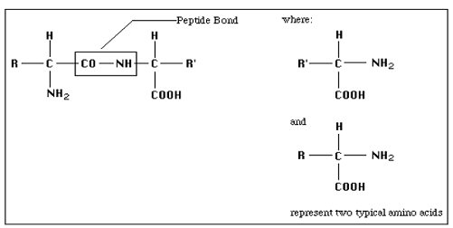
Figure 1: Typical protein structure: two amino acid joined together peptide bond.
(Worthington biochemical corporation, 1972)
Various enzymes requires additional components to function which are called co-factors. They are essential in many catalytic steps or during conformation changes of substrates. These additional components includes different metal ion, prosthetic group and chemical groups called co-enzymes (Overington et al., 2006). So enzymes is made up of a protein portion called apoenzmes attached to the co-factor called co-enzymes which makes an entire molecules called haloenzmes (Worthington Biochemical Corporation 1972).
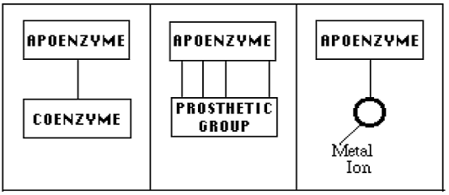
Figure 2 : Haloenzymes attached to apoenzymes and different types of cofactor.
(Worthington biochemical corporation, 1972)

2.4. Classification and Function of enzymes
Enzymes have equally a variety of functions. They are mostly responsible for the chemical inter conversion needed for an organism. About 4000 biochemical reactions are catalyzed by enzymes. The jobs of enzymes varieties from digestion of food, replacement of old tissue, buildup of new tissue to new DNA synthesis. Each enzyme has a different function on its specific substrate. Some enzymes break down polymeric compounds into its constituent monomers, whereas others do the reverse. In addition, some enzymes transform the conformational structure of a molecule into a different form (Gurung et al., 2013).

Table 1: Classification and Function of enzymes (Gurung et al., 2013).
Enzyme commission number | Classes of  Enzyme | Function | Example
EC1 | Oxidoredactases | Transfer of electron between molecule is catalyzed by these enzyme. In biological systems the transfer of hydrogen molecules takes place.The enzyme which do these are typically called dehydrogenases. | Alcohol dehydrogenases
EC2 | transferases | Different types of atoms are transferred between different molecules by these enzymes | Aminotransferases
EC3 | Hydrolases | This classes of enzymes breakdown molecules with the help of water | Amylases
EC4 | Lyases | Lyases remove to form double bonds or add group to double bonds in substrates | Pectase lyase
EC5 | Iysomerases | This enzyme causes structural transformation of the same molecule by transferring groups from one position to another. | Mutase
EC6 | Legases | Molecules joind together via covalent bonds by these enzymes.These reaction require energy input is in the form of co-factor called ATP. | DNA lygase

Among the many enzymes that are widely used α-Amylase has been in increasing demand due to its crucial role of starch hydrolysis and the applications of this hydrolytic action. (Gurung et al., 2013).

2.5. Amylases
Amylases are starch degrading enzymes. They are widely spread in microbial, plant and animal kingdoms. Amylase is a group of enzyme whose catalytic function is to hydrolyze (breakdown) starch to give varied products including dextrin and progressively smaller polymers composed of glucose units. When they have broken down the insoluble starch, the soluble end products such as glucose or maltose are absorbed into their cells. They are important enzymes employed in the starch processing industries for hydrolysis of starch into simple sugars (James and Cappuccino, 2005). They degrade starch and related polymers to yield products characteristic of individual amylolytic enzymes. Initially the term amylase was used originally to designate enzymes capable of hydrolyzing α-1, 4- glycosidic bonds of amylose, amylopectin, glycogen and their degradation products. They act by hydrolyzing bonds between adjacent glucose units, yielding products characteristic of the particular enzyme involved. Amylases are important enzymes working in the starch processing industries for the hydrolysis of polysaccharides such as starch into simple sugar constituents (Karnwal and Nigam, 2013).

2.6. The Discovery of Amylases
Amylase was discovered by Kirchhoff in 1814 for the first time. In his experiments, he observed that a paste made of malt, starch and water was converted into sweet syrup by the action gluten present in the paste. From his observation, he first discovered the presence of the enzyme amylase. After several reports being established on the enzyme, classification of amylase was suggested by the Ohlsson, observing the different a nomeric forms of sugars being produced from enzymatic reactions in malt (Gupta et al., 2003).

2.7. Structure Of Amylases
The amylase has a three-dimensional structure capable of binding to substrate and, by the action of highly specific catalytic groups, promote the breakage of the glycoside links ( Iulek et al., 2000). α-amylase is a classical calcium-containing enzyme composed of 512 amino acids in a single oligosaccharide chain with a molecular weight of 57.6 kda. The protein contains 3 domains: A, B, and C. The A domain is the largest, presenting a typical barrel shaped super structure. The B domain is inserted between the A and C domains and is attached to the A domain by disulphide bond. The C domain has a α sheet structure linked to the A domain by a simple polypeptide chain and seems to be an independent domain with unknown function. The active site of the α-amylase is situated in a long cleft located between the carboxyl end of the A and B domains. The calcium (Ca2+) is situated between the A and B domains and may act in the stabilization of the three dimensional structure and as allosteric activator. Binding of substrate analogs suggest that Asp206, Glu230 and Asp297 participate in catalysis (Muralikrishna and Nirmala, 2005).
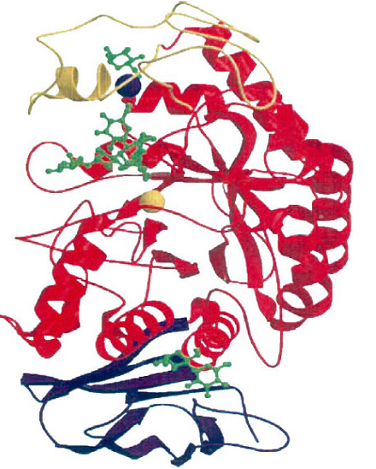
Figure 3: The structure of α-amylase
Domain A is shown in red, domain B in yellow and domain C in purple. In the catalytic center, the calcium ion is shown in the blue sphere and the chloride ion in the yellow sphere. The green structures are bound to the active site and to the surface binding sites (Payan, 2004).

2.8. Types of Amylases
Amylases are a class of enzymes, capable of assimilating glycosidic bonds. Enzymes amylase divided in to endoamylases and exoamylases. These enzymes are classified based on the attack of different types of glycosidic bond found between polysaccharide.

2.8.1. Endo-Acting or Endo-Hydrolases
This type of amylase splits the interior (inside or inner) glycosidic bonds of the amylose or amylopectin chain present in starch. The name endoamylase has been given to them. This type of amylase breaks down glycosidic bonds in a random manner. A well-known endoamylase is the α-amylase. Most α-amylase enzymes require calcium ions for their activity.
For this reason, they are called metalloenzymes. This enzyme produces oligosaccharides as end products, which have a branched structure of varying lengths. Based on the degree of hydrolysis of the substrate, α- amylases are divided into two categories, saccharifying α-amylases and liquefying α-amylases along with α- configurations and α – limit dextrin’s (Islam., 2016).

2.8.2. Exo-Amylases or Exo-Hydrolases
Enzymes belonging to the exoamylases groups are either β-amylase that break completely α, 1-4 glycosidic bonds or amyloglucosidase (glucoamylase) and α, 1-6 glycosidic bonds of α-glucosidas. Exoamylases acting on the external glucose remains of amylose or amylopectin produces only glucose (glucoamylase and α-glucosidase) or maltose and β- limit dextrin. Glucoamylase and β- amylase can convert configuration of the liberated maltose from α to β anomer. Glucoamylase and α-glucosidase differs in their substrate preference: α-glucosidase acts best on short malto oligosaccharides and liberate glucose with α- configuration while glucoamylase hydrolyzes long-chain polysaccharides best. Glucoamylases and β- amylases are found among various groups of microorganisms (Sooraj and Smitha, 2015).
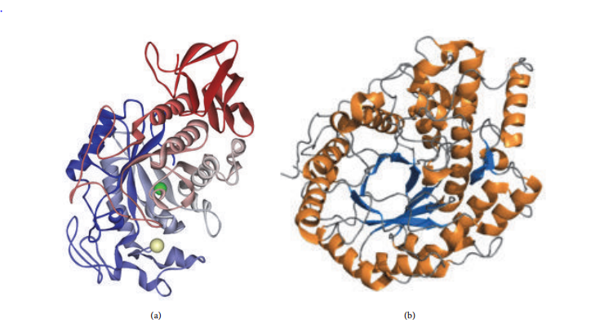
B
A
Figure 4: α-amylase β- amylases

2.9. Starch
The main substrate that amylase works on is starch. It is a complex polysaccharide containing α-1, 4-glycosidic bonds and α-1, 6-glycosidic bonds between its glucose monomers. This glycosidic bond is stable at high pH but breaks down at low pH (El-Fallal et al., 2012). Starch is a carbohydrate and is a very common and useful source of energy for plants, animals, microorganisms and humans. Starch is naturally produced mostly by higher plants as a result of photosynthesis, hence it is considered as a renewable raw material (Leszczynski, 2004).During dark periods, starch is stored in the plastids as a source of respiration. Some algae also produce starch called phytoglycogen. Starch has been widely used in industries in order to provide textural properties to many foods. It has been used as thickeners, colloidal stabilizers, gelling and bulking agents and water retention agents in food and many industrial processes (Mojsov, 2012).
Starch is an important food ingredient and a substrate for the production of many industrial products. Biological and industrial processes involve hydrolysis of raw starch, such as digestion by humans and animals, starch metabolism in plants, and industrial starch change for obtaining glucose, fructose and maltose syrup or bioethanol. Raw starch degrading α-amylases can directly degrade raw starch below the gelatinization temperature of starch. Knowledge of the structures and properties of starch and raw starch degrading α-amylases has increased significantly in recent years. Understanding the relationships between structural peculiarities and properties of raw starch degrading α-amylases is a precondition for efficient application in different aspects of human benefit from health to the industry (Natasa et al., 2017).

2.10. Starch Structure
Starch contain two different glucose polymers that makes starch molecule. These are amylose and amylopectin. Amylose is made up of around 6,000 glucose molecules arranged in a linear way by α-1, 4-glycosidic bonds. About 20 to 30% of the starch molecule consists of amylose. Amylopectin on the other hand, is a branched molecule. It consists of a linear structure made up of α-1, 4-glycosidic bonds which is similar to amylose, but the branches are formed by α-1, 6-glycosidic bonds. Amylopectin is considered as one of the largest molecules in nature since it is made up of around 2,000,000 glucose units. It is the major component of starch, making up to 75 to 80% of the molecule (El-fallal et al., 2012).
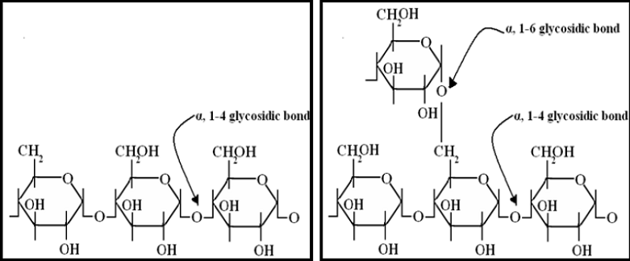
B
A
Figure 5: structure of Amylose (A), Structure of Amylopectin (B)

2.11. Microbial Amylases
Microbial amylases can be produced by bacteria and fungi (which include molds and yeast). The table below enlists some of the microbes falling under the above stated three categories (Pandeyet al., 1999; Raoet al., 2007, and Cherry et al., 2004).).

BACTERIA | FUNGI
BACTERIA | Mold | Yeast
Bacillus subtilis |  | Saccharomycopsis capsularia
  Aspergillusoryzae
Bacillus licheniformis |  | Amylomyces rouxii
  Aspergilluskawachii
Bacillus megaterium | Aspergillusniger | Amylomyces rouxii
Clostridium thermosulfurogenes | Aspergillusawamori | Amylomyces rouxii
Aeromonascaviae | Rhizopusoligosporus | Amylomyces rouxii
Pseudomonas sp(aerobic) | Rhizopus japonicas | Amylomyces rouxii

Amylase is the most important enzyme found in nature. They are known to be produced most widely by microorganisms such as bacteria and fungi as compared to plants and animals. The enzymes are produced outside the cell, in order to carry out extracellular digestion. Aspergillus spp.such as Aspergillus niger, Aspergillus oryzea, Thermomyces lanuginosus and Penicillium expansum are known to synthesize amylase (Fallal et al 2012). Bacillus spp such Bacillus subtilis, Bacillus licheniformis, Bacillus amyloliquefaciens, Bacillus stearothermophilus, Bacillus cereus, Bacillus polymyxa, Bacillus coagulans and Lactobacillus plantarum. Other bacteria such as Clostridium thermosulphurogenes, Proteus and Pseudomonas spp. are also acknowledged as amylase producers (Parmer and Pandey, 2012). Several species of actinomycetes such as Streptomyces limosus and Thermomonospora curvata have been found to be potent source of α-amylase enzyme.

2.12. Importance of Amylases in Industry
Amylases are among the most important enzymes e.g., in the food, and textile industries, hence they are of great significance in present-day biotechnology (Burhan et al., 2003). Although amylases can be produced by several microorganisms, it remains a challenging task to obtain a strain capable of producing commercially acceptable yields. Selection of a suitable strain is the most significant factor in the amylase production process (Pandey et al., 2000). Clinical, medical and analytical chemistry also used bacterial α-amylases (Gurung et al., 2013). Apart from industrial purposes, amylase was used in agricultural industry to produce digestible feed for animals as well (Vaseekaran et al., 2010). Amylase was widely used in different industries for the manufacture of various products. Approximately 25% of the enzyme market was comprised of amylase enzyme (Vaseekaran et al., 2010). The first amylase used industrially was fungal amylase in 1894 for the treatment of digestive disorders (Mojsov, 2012). Fungal and bacterial amylases were widely used in the industrial sectors (Vaseekaran et al., 2010). As it was very economical, fungal and bacterial amylase was the best choice of amylase to be used over other sources. Besides, the enzyme production rate was high and the microorganisms can be genetically engineered for the desired quality and quantity of production of amylase (Kaur et al., 2012). Amylases find potential application in a number of industrial processes such as:

2.12.1. Food Industry
Amylases are extensively employed in processed-food industry such as baking, preparation of digestive aids, production of cakes, fruit juices and starch (Couto and Sanromán, 2006). For decades, microbial α-amylases have been widely used in the banking industry (Hamer, 1995; Si, 1999).These enzymes can be added to the dough of bread to degrade the starch in the flour into smaller dextrins, which are subsequently fermented by the yeast. Besides generating fermentable compounds, α-amylases also have an anti staling effect in bread baking, and they improve the softness retention of baked goods, increasing the shelf life of these products (Gupta et al., 2003; Van der Maarel et al., 2002). The addition of α-amylase to the dough results in enhancing the rate of fermentation and the reduction of the viscosity of dough, resulting in improvements in the volume and texture of the product. The most widespread applications of α-amylases are in the starch industry, which are used for starch hydrolysis in the starch liquefaction process that converts starch into fructose and glucose syrups (Nielsen and Borchert, 2000).

2.12.2. Textile Industry
Amylases are used in textile industry for desizing process. Sizing agents like starch are applied to yarn before fabric production to ensure a fast and secure weaving process. In textile weaving, starch paste is applied for warping. This gives strength to the textile at weaving. It also prevents the loss of string by friction, cutting and generation of static electricity on the string by giving softness to the surface of string due to laid down warp. After weaving the cloth, the starch is removed and the cloth goes to scouring and dyeing. The starch on cloth is usually removed by application of α-amylase (Hendriksen et al., 1999).
Starch is a very attractive size, because it is cheap, easily available in most regions of the world, and it can be removed quite easily. Starch is later removed from the woven fabric in a wet- process in the textile finishing industry. The enzymatic desizing of cotton with α-amylases is state-of-the-art since many decades (Marcher et al., 1993).

2.13.3. Paper Industry
The use of α-amylase in pulp and paper industry is in the modification of starches for coated paper, i.e. for the production of low-viscosity, high molecular weight starch. As for textiles, sizing of paper with starch is performed to protect the paper against mechanical damage during processing (Gupta et al., 2003).The coating treatment serves improves the quality of the finished product, enhances stiffness, and elasticity of paper (Gupta et al., 2003). Because starch is added to paper at a temperature range of 45 up to 60 ᵒC, and the viscosity of the natural starch is too high for paper sizing partial degradation of this polymer is essential. α-amylase is employed for this purpose (Gupta et al., 2003).

2.12.4. Detergent Applications
The demand for α-amylase for use in laundry and automatic dishwashing is very high. The use of enzymes in detergents formulations enhances the detergents ability to remove tough stains and making the detergent environmentally safe. These enzymes are used in detergents for laundry and automatic dishwashing to degrade the residues of starchy foods such as potatoes, gravies, custard, chocolate, etc. to dextrins and other smaller oligosaccharides (Mukherjee et al., 2009; Olsen and Falholt 1998).Removal of starch from surfaces is also important in providing a whiteness benefit, since starch can bean attractant for many types of particulate soils. 90% of all liquid detergents contain these enzymes (Gupta et al., 2003).

2.12.5. Biofuel production
In beer industries, microbial amylases are used to aid cereal amylase in the production of fermentable sugar. Ethanol is the most utilized liquid biofuel. Over the past decades, there has been an increasing interest in fuel ethanol as a result of increased environmental concern and higher crude oil prices. Ethanol fuels can be derived from renewable resources such as agricultural crops and by products. For ethanol production, starch is the most used substrate due to its low price and easily available raw material in most regions of the world (Chi et al., 2010).

2.12.6. Amylases in the bakery industry
The bakery industry is a large consumer of amylases which is used to generate readily available sugars for yeast fermentation. In addition amylolytic enzymes are used to improve shelf life of backed foods preventing stalling or increasing softness, an action commonly known as anti-stalling effect and Glucoamylase delay the baked bread staling, acting on the external side chains of glucose polymer to awkward amylopectin towards retrogradation. (Gupta et al., 2008).

2.12.7. Application of amylases in beer production
Beer, which is made from the starch of cereal, is the most widely consumed alcoholic beverage in the world (Nelson, 2005). In the process of beer production the first step involves enzymatic saccharification of the starch from the cereal (usually barely) followed by fermentation of the resulting reducing sugar. The saccharifying enzymes are normally derived from the malt (Aastrup et al., 2004). But due to failure in the malting or drying process the amount of enzyme in the malt could occasionally be less than the required amount to bring about complete saccharification of the available starch. If the enzyme activity present in the malt is low, it could greatly affect the final beer quality and make the fermentation process slow. To overcome such challenges breweries normally add exogenous enzymes as supplements to the malt enzymes (Gupta et al., 2008). Because malt is very expensive in many countries up to a quarter of the malt required for beer production is replaced by starch from cereal or root crops and is known as adjuncts. Although the use of adjuncts helps to substantially lower the production of beer, because the added starch lack its own enzyme (for example root starches), the endogenous enzymes of malt may not at times be enough to bring about compete saccharification of all the available starch. Therefore, to ensure complete saccharification commercial amylolytic enzymes are often used added as supplements of the malt enzymes (Taylor, and Dewar, 2001).

Table 2: Uses of Amylase in different industry (Mojsov, 2012; Sundarram et al., 2014)
 | Uses
  Industry
Food industry | - Production of glucose syrups, crystalline glucose  - Production of high fructose corn syrups  - Production of maltose syrups  - Reduction of viscosity of sugar syrups  - Reduction of haze formation in juices  - Solubilization and saccharification of starch for alcohol fermentation in brewing industries and Retardation of staling in bread industries
Detergent industry | - Used as an additive to remove starch based dirt
Paper industry | - Reduction of viscosity of starch for appropriate coating of paper
Textile industry | - Warp sizing of textile fibers
Pharmaceutical industry | - Used as a digestive aid
Fuel Alcohol  production | - Saccharification of starch to yield fermentable sugars needed to produce ethanol

2.13. The Factors Affect Microbial Amylase
The optimum process control parameters vary depending on the microbial source, desired end product, method of fermentation employed and many other such factors.

2.13.1. The Factors Affect fungal amylase

2.13.1.1.Temperature
There are two temperatures that need to be in optimum range during production. They are temperature for the Growth of the microbial source and optimum temperature at which maximum production of enzyme takes place (Kenneth et al., 1993). Studies by B. Jensen et al., 1992 and Bunni et al., 1989, reveal that optimal production of amylase is between 50 up to55°C for the thermophilic fungal cultures such as Talaromyces emersonii, Thermomonospora fusca and Thermomyces lanuginosus. Thermococcus α-Amylases are optimally active at temperatures close to 80°C. Pyrococcus enzymes are optimally active around 100°C (Upgade et al., 2011).An optimum range of 95 up to100°C was observed to yield maximum enzyme activity in a study involving Pyrococcus furiosus (Haki & Rakshit, 2003). Penicillium fellutanum showed an optimum activity of 98±4.6 U/ml at a temperature of 30°C (Ramachandran et al., 2004). When solid state fermentation was carried out for production of the enzyme by Penicillium janthinellum in a range of 30 up to 55°C, the optimum incubation temperature was found to be 45°C (Prakasham et al., 2007). The enzyme production increases with increase in temperature till it reaches the optimum. With further increase in temperature the enzyme production decreases. This may be due to the loss of moisture in the substrate which adversely affects the metabolic activities of the Microbes leading to reduced growth and decline in enzyme production (Prakasham et al., 2007).

2.13.1.2. P^{H}
Optimum pH is a critical factor for the stability of enzyme produced. Enzymes are pH sensitive and hence care must be taken to control the pH of the production process. Pyrococcus furiosus produces α-Amylase which shows activity at an optimum pH of 6.5 up to7.5 (Haki & Rakshit, 2003). The production of extracellular amylase by the thermophilic fungus. Thermomyces lanuginosus was investigated in solid state fermentation (SSF). The maximum enzyme activity was 534 U/g when wheat bran was used as the substrate with optimum pH conditions of 6.0 (Bhargav et al., 2008). Saccharomyces cerevisiae and S. Kluyveri have shown maximum yield of enzyme at pH 5.0 (Knox et al., 2004 and Tanyildizi et al., 2005) and pH of 7.0 respectively (Syu and Chen, 1997, Ashraf et al 2005, Vieille, & Zeikus, 2001).An initial pH range 7.5 to 8 was found to be optimal for enzyme production by Rhodothermus marinus (Anto et al., 2006). Thermophilic microorganisms such as P. Woesei and Thermococcus profundus exhibited optimal production of α-Amylase at pH value of 5.0 (Swamy & Seenayya, 1996). Amylase from P. fellutanum the optimum pH was found to fall within the range of 6.0 to 7.0 Erdal & Taskin, 2010). Aspergillus spp such as A. Oryzae, A. Ficuum and A. Niger exhibit optimal production at pH 5.0up to 6.0 in smf (Carlsen et al., 1996, Djekrif-Dakhmouche et al., 2005 and Moller et al 2004).

2.13.1.3.Incubation time
The enzyme activity increases with increase in incubation time till it reaches the optimum duration. In most cases, the production of enzyme begins to decline if the incubation time is further increased. This could be due to the depletion of nutrients in the medium, or release of toxic substances (Leveque et al., 2000 and Raul et al., 2014). Different incubation time durations were compared for yield of amylase from Penicillium fellutanum isolated from mangrove rhizosphere soil. The culture when incubated at 96 hrs showed the maximum activity of 136 U/ml. This was a 2 fold increase in activity when compared to 24 h incubation 68±2.3 U/ml (Erdal and Taskin, 2010). In an attempt to produce α-Amylase from A. Oryzae using coconut oil cake as a substrate, the maximum activity was found to be 1752 U/gds which resulted after 72 hrs of incubation(Thippeswamy et al 2006).

3. MATERIALS AND METHDODS

3.1. Description of the study area
The sample were taken from chilimo forest western Ethiopia during spring season at the middle of November in Oromia regional administration, west Shoa at dendi Woreda. Chilimo forest is one of the few remnant narative dry Afro-motane forest on the central highland of Ethiopia located in the dendi district near to the smalltown of Ginchi in the Oromia Region West Shewa Zone. Chilimo forest was located 78 Km West of the capital city of Addis Ababa, on the road to Nekemte. Chilimo forest, the center of which is located at coordinates of 9° 5′ north latitude and 38° 10′ east longitude, is one of the very few remaining dry afromontane forests found in Ethiopia.The altitude of the area ranges from 2170 - 3054 m mean above sea level, characterized by cold temperate weather which was locally called ‘Bada-dare’ (mid altitude). The main species in the canopy layers are Junipers procera, Podocarpus falcatus, Prunus africana, Olea europaea subspecies cuspidata, Hagenia abyssinica,Apodytes dimidiata, Ficusspp, Erythrina brucei, and Croton macrosytachus (Deressa, 2014).
Map of Chilimo forest that found in Oromia regional state, West shoa zone of Dendi woreda.
Source: The map was developed by ArcGIS Software by using Aerial photo data taken from Ethiopian Map Agency 2002 EC.

3.2. Study design
A study was conducted from September 2019 to March 2020 by isolation and characterization of amylase producing Aspergillus species from soil in chilimo forest.

3.3. Preparation of media
Aspergillus spp. media was prepared from peptone(P), yeast extract(y), sodium chloride(N), starch(S), agar(A) and magnesium sulfate(M) ( PYNSAM) containing gm/l. Required media were freshly prepared before use. Starch agar media was used for short term preservation of fungal cultures. Starch agar media is selective Media used during the fermentation of Aspergillus spp. for amylase production in Petridis. Starch agar medium also used to screen amylase producing Aspergillus spp. The compositions of Starch agar media are found in the following table.
Table 3: Composition of starch agar media to culture Aspergillus spp.
S.N | Ingredients | g/L
1 | peptone | 10gm
2 | Yeast extract | 5gm
3 | Soluble starch | 10gm
4 | Sodium chloride | 5gm
5 | Magnesium sulphate | 0.5gm
6 | Agar 20gm | 20gm
7 | Antibiotics(Ampicillin) | 500mg
8 | Distilled water | 1000 L

Each of the components of the medium was weighed on the triple bean balance and dissolved in 1000ml (a liter) of distilled water. The medium mixture was boiled on the hot plate in order to mix. Then it was sterilized in the autoclave at 121°C, for 15 minutes. The sterilized medium was distributed in petri dishes under laminar follow hood and allowed to cool. (Alariya et al., 2013).

3.4.. Preparation of soil samples
Soil samples were randomly collected from 4 different locations in chilimo from rhizosphere of herbaceous plants. One gram rhizosphere composite soil from four(4) samples such as under the trees of grassland soil, birbisa soil, gatira soil and ejersa soil from Chilimo forest were collected 20 up to 30 cm soil depth at four randomly selected sites were collected and taken in a plastic bag and transported to microbiology laboratory, department of Biology, College of natural and computational sciences, Ambo University. For each soil samples aseptically taken by sterilized spatula and on sterilized aluminum foils by using triple bean balance. This was dissolved in 9ml of distilled sterilized water in the test tubes which constituents 10⁻¹ dilution. Then the aliquant of one ml of 10⁻¹ dilution was taken and transferred in to another test tube containing 9ml distilled sterilized water so as to form 10⁻² dilution. Next to that the aliquant of one ml of 10⁻² dilution was taken and transferred in to another test tube containing 9ml distilled sterilized water so as to form 10⁻³ dilution. This process was continued until 10⁻⁷ dilution was formed. (Clark et al. 1958).

3.5. Inoculation and incubation
The sterilized and cooled PYNSAM medium prepared as described above were inoculated with 0.1ml of each sample from 10⁻¹ to 10⁻⁷ dilution. Triplicate petri dishes were inoculated with the sample taken from the same dilution. The inoculated plates were incubated in the incubator at 28C⁰. The growths of Aspergillus spp. and contaminant were checked and after 72hrs of incubation the isolated colony of Aspergillus spp. were picked and sub cultured for purification. (Khan and Yadav, 2011).

3.6. Sub culturing for purification
The cultures were subsequently sub cultured and used regularly following the method of Ugoh and Ijigbade (2013).A single isolated colony of the Apergillus spp. were picked up by inoculating needle on the PYNSAM medium and incubated at 28C⁰ for 120hrs and the purity of culture was checked by visual inspection. The pure culture of the Aspergillus spp. isolate was grown PYNSAM plate for 5 days and kept at refrigerator for latter characterization and experiments.
3.7. Screening of amylase producing organisms
Screening of amylase producing Aspergillus spp. carries out on starch agar media. This would be sterilized at 121°c for 15 minutes in an autoclave and then allowed to cool. The glass Petri-dishes were placed in a canister and sterilized in an autoclaving at 121°c for 15 minutes, the work bench was cleaned with 75% alcohol. After cooled, the efficient Aspergillus isolated were culture onto starch agar plates for detection of their enzyme production efficacies. A clear zone of hydrolysis on starch (after addition of iodine) gives an indication of amylase producing. Any formation of clear zone around the colonies where observed and the diameters were measured using a ruler. The clear zone ratio is calculated using the following formula and for their best enzymatic starch hydrolysis(Morya et al,. 2008)
Diameter of clear zone (mm)
Clear zone ratio = ----------------------------------------------
Diameter of colony (mm)

3.8. Morphological and Biochemical Characterization of Aspergillus spp.

3.8.1. Morphological Identification of Aspergillus spp.

3.8.1.1. Microscopic observation
The microscopic morphology of the pure isolate mount was done following the method by Shamly et al. (2014) and colonial characteristics such as size, surface appearance, texture, reverse and pigmentation of the colonies were used for microscopic view of the isolate.

3.8.1.2. Cultural characterization.
The isolate Aspergillus species was observed under the microscope to obtain the colony morphology i.e. size, color, nature of hyphae and conidial shape. Pure Aspergillus species cultures were obtained and were identified by morphological structures observed by using lacto phenol cotton blue staining(Darise, 1987).

3.9. Amylase assay
Amylase activity was determined using the method described by Sindiri et al. (2013).After incubation the fermentation medium was harvest by centrifugation at 10,000 rpm (revolution per minutes) for 5 minutes. The supernatant was collected and subjected to estimate the amylase activity. To study the effect of temperature on amylase production, the submerged fermentation would be carried out at different temperatures (Room°C, 28°C, 37 and 45° C). The fermentation medium was prepared by varying the pH values for the production of
amylase, pH in the range of 5.0, 7.0, 8, 0 and 10.0 are examined for their effect on amylase production by the selected isolates grown in production media. The pH of the medium was adjusted using 1 N HCl or 1 N NaOH. The flasks were incubated at 28ºC for 120 hrs. Samples were taken at regular time intervals for amylase activity (Miller,.1959).
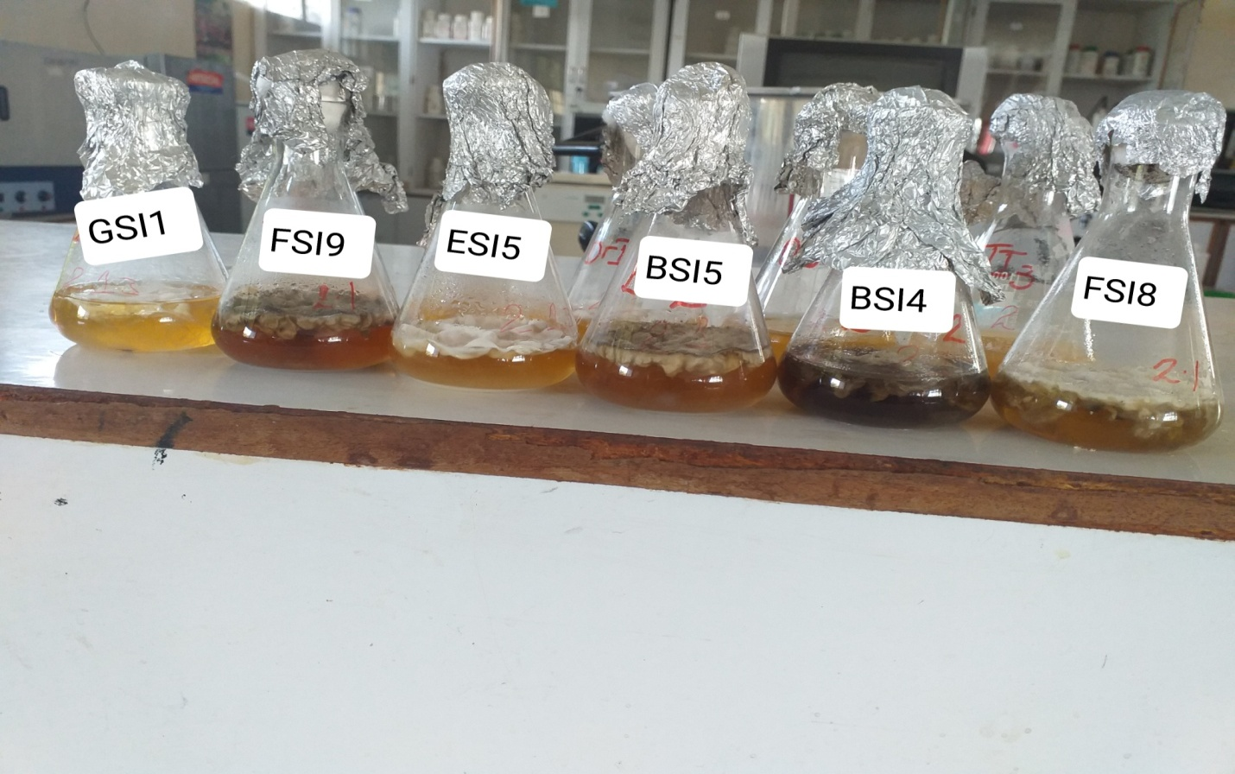
Figure 6: The submerged fermentation in starch agar Flasks
FSI: Field (grass land) isolation soil ESI: Ejersa isolation soil
BSI: Birbisa isolation soil GSI: Gattira isolation soil

3.10. Glucose standard curve
A glucose standard curve was made by the following method in order to determine the amount of reducing sugar produced by the amylase enzyme of Aspergillus species isolate. To distinguished test tubes, different concentrations of glucose solutions were added.The concentrations were formulated according to the following composition. To each concentration, 1ml of crude enzyme, 2ml of DNS solution and 6ml of distilled water was added. The test tubes were boiled at 100°C for 10 minutes in a water bath. The intensity of color of each solution was measured in optical density (OD) in a spectrophotometer at 540 nm. A graph was plotted with the acquired data where x-axis was labeled with glucose concentration (mg/ml) and y-axis was labeled absorbance (540 nm) (Muhammad,et al, 2011) and (Pokhrel B. et al, 2013).
Equation with r– value ($Y={ax+b,r}^{2}=>97)$

Figure 7: Glucose standard curve

3.11. Preparation of 3, 5 Dinitrosalicyclic Acids (DNSA)
DNS reagent recipe was from a published paper (Effects of different DNS Reagents in determination of Xylose content, Wang et al.1993), and shown as below.
3, 5 Dinitrosalicyclic acids (DNS) were prepared by dissolving in distilled water, 2gm DNS, 3.5gm of Sodium hydroxide dissolved in 40ml and 60gm of sodium potassium tartarate in a total volume of 100 ml. and add and mix two reagents to form 200ml.reagent.

3.12. Amylase production at different temperature

Peptone 10gm, yeast extracts 5gm, sodium chloride 5gm, starch10gm, magnesium sulfate 0.5gm.dissolved in 1000ml.and equally shared to four flasks.
Plates of starch agar were prepared as described above; these were inoculated with Aspergillus cultures and incubated at different temperatures namely, Room, 28°C, 37°C and 45°C. The growths of the culture were observed after 5 days for high temperatures and after 7 up to14 days for low temperatures (Puri et al., 2013).

3.13. Amylase production at different pH.
Peptone 10gm, yeast extracts 5gm, sodium chloride 5gm, starch 10gm, magnesium sulfate and 0.5gm.dissolved in 1000ml.and equally shared to four flasks. The pH of the medium was adjusted to different values (5.0, 7.0 8.0 and 10.0) using either dilute HCl or NaOH. The medium was then distributed into four sets of flasks and autoclaved at 121°C for 15 minutes. After cooling and added antibiotics the cultures were inoculated with Aspergillus isolates. At the same time, flasks of sterilized starch agar were inoculated with the same isolates as controls. The flasks were all incubated at 28°C for five days. The growth of the culture was observed periodically(Shah et al., 2014).

3.14. Effect of Incubation time on amylase activity
Peptone 10gm, yeast extracts 5gm, sodium chloride 5gm, starch10gm, magnesium sulfate and 0.5gm.dissolved in 1000ml.and equally shared to five flasks.The time of the medium was adjusted to different values (24hrs, 48hrs, 72hrs, 96hrs, and 120hrs). The medium was then distributed into five sets of flasks and autoclaved at 121°C for 15 minutes. After cooling added antibiotics the cultures were inoculated with Aspergillus isolates. At the same time, flasks of sterilized starch agar were inoculated with the same isolates as controls. The flasks were all incubated at 28°C for five days. The growth of the culture was observed periodically ( Puri et al,. 2013).

3.15. Data Analysis
The data were analyzed statistically on the basis of experiment and yielded by using Microsoft office excel spreadsheet and statistical package for social science (SPSS) window version 20. The Experimental result was analyzed and summarized by tables, graphs and the p- value of $<$ 0.05 would be considered to determined by statistical significance using 95% confidence intervals.

CHAPTER FOUR

4.RESULTS AND DISCUSSION

4.1. Isolation of amylase producing Aspergillus spp.
A total of 27 Aspergillus spp. were isolated from 4 samples such as Grassland soil, under Birbirsa(Podocarpus falcatus) soil, under Gatira(Junipers procera) soil and under Ejersa (Olea europaea subspecies cuspidata)soil. From those isolates, eleven (11) Aspergillus spp. were isolated from field soil samples, seven (7) Aspergillus spp. were isolated from Birbirsa(Podocarpus falcatus) soil samples, four (4) Aspergillus spp. were isolated from Gatira(Junipers procera) soil samples while five (5) Aspergillus spp. were isolated from Ejersa(Olea europaea subspecies cuspidata) soil samples. The Aspergillus spp. isolates with the respective samples were listed in the (Table 4).

Table 4: Total Number of Aspergillus spp. isolated from field or Grass land soil, under Birbirsa soil, under Gatira soil and under Ejersa soil of chilimo forest.
S.N | Specific place of sample collected | Scientific name | Numbers of Aspergillus spp. isolated
1 | Under Birbirsa soil | Podocarpus falcatus | 11
2 | Under Field soil | Poaceae or Gramineae | 7
3 | Under Gatira soil | Junipers procera | 5
4 | Under Ejersa soil | Olea europaea subspecies cuspidata | 4
 | Total of Aspergillus species isolaes |  | 27

4.2.Cultural characterstics of Aspergillus species isolates
The majority of isolated colonies exhibited White color with irregular shape. The shape were to be large, medium and small and all isolated Aspergillus spp. were, different color, different Condia shape,and all are septate. However, irregular and white colors were found to be more widespread (Table 5).
Table 5: Morphological characteristics of the Aspergillus spp. isolated from Field (Grass land soil) under Birbirsa(Podocarpus falcatus) soil, under Gatira(Junipers procera) soil and under Ejersa (Olea europaea subspecies cuspidata)soil of chilimo forest.
S.N | Code of A.spp.  Isolates | Colony Characteristics |  | Cell Characteristics  (Sizes) | Natures of hyphae
S.N | Code of A.spp.  Isolates | Color | Condia Shape (Form) | Cell Characteristics  (Sizes) | Natures of hyphae
1 | FSI1 | Black | Irregular | Large | septate
2 | FSI2 | Blue Green | Round Irregular | Small | Septate
3 | FSI3 | Black | Oval | Medium | Septate
4 | FSI4 | White | Broad | Large | septate
5 | FSI5 | White | Irregular | Medium | septate
6 | FSI6 | Black | Round Irregular | Medium | septate
7 | FSI7 | White | Round Irregular | Large | Septate
8 | FSI8 | Blue Green | Round Irregular | Small | septate
9 | FSI9 | Blue Green | Irregular | Small | septate
10 | FSI10 | White | Irregular | Large | Septate
11 | FSI11 | Blue Green | Oval | Medium | Septate
12 | BSI1 | Blue Green | Oval | Small | Septate
13 | BSI2 | White | Irregular | Large | septate
14 | BSI3 | White | Broad | Medium | septate
15 | BSI4 | Blue black | Irregular | Small | Septate
16 | BSI5 | White | Broad | Small | Septate
17 | BSI6 | White | Oval | Medium | Septate
18 | BSI7 | White | Oval | Medium | septate
19 | GSI1 | White | Broad | Large | septate
20 | GI2 | White | Irregular | Large | Septate
21 | GSI3 | Black | Broad | Medium | septate
22 | GSI4 | Black | Irregular | Small | septate
23 | ESI1 | Black | Broad | Large | septate
24 | ESI2 | White | Oval | Small | Septate
25 | EI3 | White | Irregular | Large | septate
26  27 | ESI4  ESI5 | White  White | Oval  Irregular | Medium  Large | Septate  septate

From the above table different proportion of colony size, large, medium and small and the majority of isolated colonies exhibited white color with irregular shape isolated Aspergillus spp. were, different color, different Condia shape.The conidiophores were conidial shape broad ,irregular, round irregular and oval smooth and about 2.1cm to 2.5 cm long; spherical vesicles were observed on the top of globose conidia (Figure 7).Ogbonna et al. (2015) isolated A.niger from soil sample which exhibited similar characteristics.

4.3. Morphological And Microscopic Characterization Of Aspergillus Spp
. 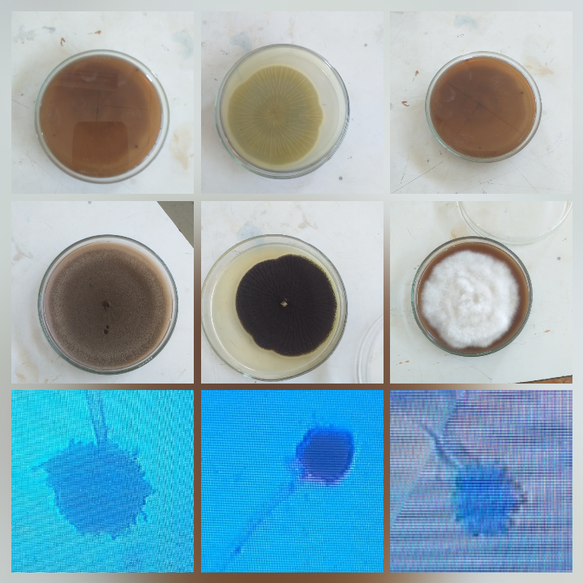
FSI9 : 2.25cm
BSI4 :2.5cm
BSI5 :2.13cm

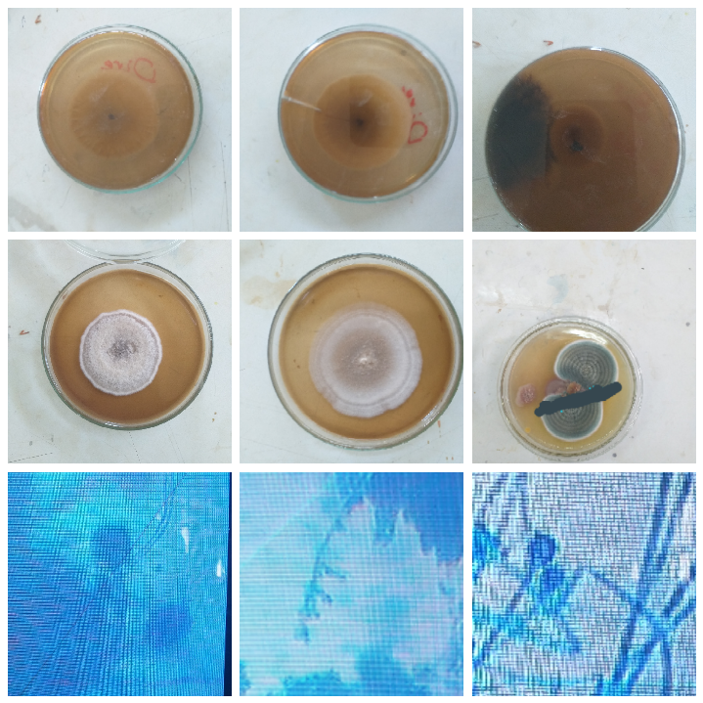
GSI1 :2.1cm
ESI5 :2.1cm
FSI8 :2.1cm
Figure 8: characterization of Aspergillus spp

From the above table different proportion of colony size the majority of isolated colonies exhibited white color such as FSI9, FSI8 and ESI5, black color such as BSI5 and blue black such as BSI4 and blue green GSI1 and with irregular shape isolated Aspergillus spp. were, different color, different Condia shape.The conidiophores were conidial shape broad ,irregular ,round irregular four and oval seven smooth and about 2 to 2.5 cm long; spherical vesicles were observed on the top of globose conidia (Figure 8).Ogbonna et al. (2015) isolated A. niger from soil sample which exhibited similar characteristics.

4.4. Starch Hydrolysis Tests
The clear zone diameters were performed with all 27 isolates, zone of diameter were measured and amylase activity was calculated for each isolates (Table 8). From 27 isolates six (22.22%) isolates showed high clear zone diameter, thirteen (48.15%) isolates were showed medium clear zone diameter and eight (29.63%) of them were not showed clear zone of diameter (Figure 9). From the all isolates of Aspergillus spp the highest clear zone of diameter was measured from isolate BSI4 (2.5cm) (Table 6). This result study was similarly related with (Azad et al., 2013) that any Aspergillus spp. isolates having clear zone ratio 2mm or more reported as potential producers of extracellular enzymes. Aspergillus spp isolates having amylase producers with clear zone ratio of 2.2mm and 2.1mm reported by (Saxena, 2015). Also, this study was in line with the reported of (Zohra and Ahmed, 2012) that isolated 92 Aspergillus species from soil. Among them 56 were found to be amylase producers as they hydrolyze starch forming clear zone around the colony.

Table 6: Average ratio of clear zones diameter of 27 Aspergillus spp. isolates on starch agar media
S.N | Code of Aspergillus spp. Isolates | Ratio of clear zone | S.N | Isolate Code of Aspergillus spp. | Ratio of clear zone
1 | FSI1 | 1.38 | 15 | BSI4 | 2.5
2 | FSI2 | 1.6 | 16 | BSI5 | 2.13
3 | FSI3 | 1.8 | 17 | BSI6 | 1.84
4 | FSI4 | 1.6 | 18 | BSI7 | 1.6
5 | FSI5 | 1.25 | 19 | GSI1 | 2.1
6 | FSI6 | 1.18 | 20 | GSI2 | 1.75
7 | FSI7 | 2.05 | 21 | GSI3 | 1.42
8 | FSI8 | 2.1 | 22 | GSI4 | 1.53
9 | FSI9 | 2.25 | 23 | ESI1 | 2.1
10 | FSI10 | 2.0 | 24 | ESI2 | 1.3
11 | FSI11 | 1.57 | 25 | ESI3 | 1.8
12 | BSI1 | 1.14 | 26 | ESI4 | 1.85
13 | BSI2 | 1.88 | 27 | ESI5 | 2.1
14 | BSI3 | 2.0
FSI: Field (grass land) isolation soil ESI: Ejersa isolation soil
BSI: Birbisa isolation soil GSI: Gattira isolation soil

The clear zone diameters were performed with all 27 isolates, zone of diameter were measured and amylase activity was calculated for each isolates (Table 6). From 27 isolates six (22.22%) isolates showed high clear zone diameter, thirteen (48.15%) isolates were showed medium clear zone diameter and eight (29.63%) of them were not showed clear zone of diameter (Figure 9).

Figure 9: The percentage distribution of starch degrading Aspergillus SPP. isolates into three categories that express as diameter of zone hydrolysis ( depending on having their higher clear zone ratio,medium clear zone ratio and lower clear zone ratio).

4.5. Selection of Highest Amylase Producing Aspergillus species
From out of twenty seven(27) the six potent amylase producing Aspergillus isolates were selected based on higherst clear zone diameter for further investigations such as BSI4, GSI1, FSI9, FSI8, BSI5 and ESI5 respectively (Figure 8).

Figure 10: Comparison among the average ratio of clear zones of the amylase producing Aspergillus species on starch agar plates

4.6. Enzyme activity
By using the DNS method and glucose standard curve (Figure 7), the six isolates with high enzyme activity were analyzed. From the six, BSI4 showed highest enzyme activity (612.11U /ml). FSI9 was the second highest amylase producer (248.85 U/ml) whereas GSI1 showed the lowest amylase activity (20.24 U/ml). Amylase activities for, BSI5,FSI8 and ESI5 were 130.7 U/ml, 57.98U/ml and 23.93U/ml respectively. Those, highly level of amylase activity were selected based on higher clear zone diameter of Aspergillus spp isolates. The result of this study was similar with the report of (Zohra and Ahmed, 2012) that the highest amylase producing strain that was identified Aspergillus spp.

Figure 11: The amylase activity of the six selected isolates of Aspergillus spp.

4.7.Production of Amylase and Enzyme Assay
Amylase activity was determined as described by Miller (1959). The absorbance was measured at 540 nm by spectrophotometer. The concentration of the enzyme produced and kinetics were evaluated against the standard amylase enzyme. One unit (U) of amylase activity was described as the amount of enzyme that released U/ml of reducing sugar per minute, under the assay conditions. On the basis of amylase activity of six Aspergillus spp. isolates showed in (Figure 11), the maximum and minimum amylase producing colonies were isolates (BSI4 and GSI1), having amylase activity (612.11U/ml ± 20.24U/ml) showed highly significant at (P<0.05)difference between isolates. They were the highest and lowest amylase producing isolates. The maximum zone of hydrolysis and amylase activity (612.11U/ml) was obtained from crude enzyme from Aspergillus spp. (BSI4) while minimum zone of clearance and amylase activity (20.24U/ml) was observed in (GSI1) and showed significant at (P<0.05) variation between isolates it was showed in (Figure 11) when it compared with each others. .In order to determine the amount of amylase produced by the selected isolates, enzyme assay was carried out. This was done using the method 1ml of crude enzyme, 2ml of DNS solution and 6ml of distilled water was added. The test tubes were boiled at 100°C for 10 minutes in a water bath. The intensity of color of each solution was measured in optical density (OD) in a spectrophotometer at 540 nm. This is one of the simplest and most widely used methods to determine the amount of reducing sugar produced and hence is an indication of the enzyme activity (El-Fallal et al., 2012)
.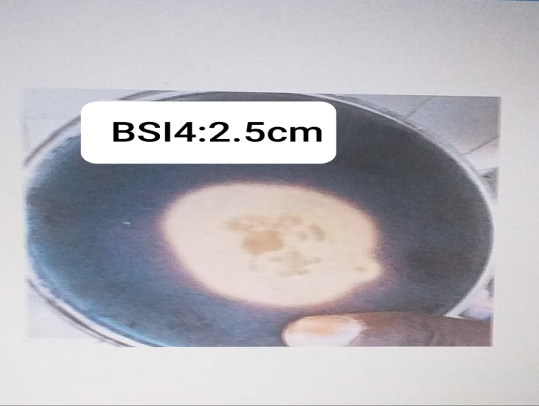
Figure 12: Petri dish show maximum zone of amylase activity by Aspergillus spp. (BSI4)

4.8. Optimization of Amylase production

4.8.1. Effect of different pH for Amylase production
The highest and lowest amylase activity at P^{H} 5 were recorded (205.19 U/ml ± 14.12 U/ml), isolates (BSI4 ) and (GSI1) , at P^{H}7 ( 147.44 U/ml ± 12.08 U/ml) (BSI4 &ESI5), at P^{H}8 (125.25U/ml±9.27 U/ml) (BSI4 and ESI5) and at P^{H}10 (50.51U/ml ± 7.51 U/ml) by Aspergillus spp. of (BSI4 and GSI1) respectively (Figure13). In this study the highest and lowest amylase activity were observed at P^{H} 5.0 and P^{H} 10.0 of isolates (BSI4 and GSI1) recorded amylase activity (205.19 U/ml ± 7.51 U/ml) showed highly significant at (P<0.05) variation between isolates(appendix 1a and 4b).The enzyme activity is markedly affected by pH. This is because substrate binding and catalysis are often dependent on ion distribution on both substrate and enzyme molecules (Shah et al., 2014). As shown in Figure 12, maximum activity (205.19 U /ml) was observed at pH of 5.0, since this was chosen as media pH for further optimization studies. With increase in pH value from 5.0 to 10.0, the activities of amylase attained the maximum followed by a gradual decrease thereafter. (Abdullah et al. 2011) has reported that further increase in the pH reduced the enzyme production, as enzymes are usually very sensitive to minor changes in pH. Similar findings were reported by Shinde et al. (2014) who found maximum enzyme activity by A. niger and Bacillus licheniformis at pH 6 and Ellaiah et al. (2002) reported that A. niger UO-01 had a preference to pH around 6.0 for amylase production but its production capacity decreased for pH levels higher and lower, probably as a consequence of a reduction in the metabolic activity of the amylase producing strain. Aspergillus spp such as A.Oryzae, A.Ficuum and A. Niger exhibit optimal production at pH 5.0 up to 6.0 in smf (Carlsen et al., 1996, Djekrif-Dakhmouche et al., 2005 & Moller et al 2004).

Figure 13. Effect of pH amylase activity at different PH incubation periods of Aspergillus spp.

4.8.2.Effect of different incubation Temperature on Amylase production by Aspergillus spp.
Temperature is one of the important physical factors influencing the enzyme production (Sankaralingam et al., 2012). Four temperatures (25C^{O}. 28C^{O}, 37C^{O} and 45C^{O}) were tested at 120hrs.(Figure 14).The maximum and minimum amylase production were showed at 25C^{O} of isolates (BSI4 and GSI1) were recorded (206.92.08U/ml ±15.43U/ml) showed highly significant (P<0.05) difference between isolates(appendix 5a and 5b). The maximum and minimum amylase production were showed at 28⁰C of isolates (BSI4 and GSI1) were recorded 612.11 U /ml ± 20.24 U/ml) of incubation periods showed highly significant (P<0.05) difference between isolates(appendix 6a and 6b).The maximum and minimum amylase production were showed at 37C^{O} of isolates (BSI4 and ESI5) were recorded (303.1 U/ml ±18.26 U/ml), of incubation periods showed highly significant (P<0.05) difference between isolates. (appendix 7a and 7b). The maximum and minimum amylase production were showed at 45⁰C of isolates (BSI4 and ESI5) were recorded (184.08U/ml ± 13.67 U/ml) of incubation periods showed highly significant (P<0.05) difference between isolates. (appendix 8a and 8b).
In this study the maximum and minimum amylase production were showed at 28⁰C and 45Cº of isolates (BSI4 and ESI5) were recorded (612.11U/ml ± 13.67U/ml) of incubation periods showed highly significant (P<0.05) difference between isolates(appendix 6a and 6b).
Lower and higher temperatures appear falling in the specific activities values, lower temperature decreases the specific activity because it is unsuitable for Aspergillus spp. growth as a result it lowers enzyme production while higher temperature lead to minimize media water content by vaporization as a result it effects cells growth, in addition to higher temperature limit oxygen concentration. and it is unnecessary the congruity between the optimal temperature for microorganism growth and the optimal temperature for enzyme activity Al-Haidery,(1989) and Bhattacharya et al (2012 ) .

Figure 14: Effect of temperature on amylase activity at different incubation temperature of Aspergillus spp.

4.8.3. Effect of Incubation Period on Amylase production

To determine the effect of incubation time on amylase production from Aspergillus spp., the enzyme activity was measured from 24 hrs to a time of 120 hrs in 24hrs intervals (Figure 15). Aspergillus spp. has produced the maximum and minimum amylase activity at different incubation periods. At 72 hrs and 96 hrs, the highest enzyme activity were recorded (226.3 U/ml and 135.98 U/ml) (BSI4 ) and at 24 hrs and 120 hrs the lowest enzyme activity were (8.42 U/ml and 7.99 U /ml) by Aspergillus spp. (GSI1 and ESI1) respectively. They were showed significant (P<0.05) variation (appendix 9a,10a,12a 13a and 9b,10b, 11b,13b) respectively, whereas at incubation periods of 48 hrs, the highest and lowest amylase activity were obtained (105.19 U/ml and 11.38 U/ml) from Aspergillus spp. (BSI4 and GSI1) showed significant(P<0.05) variation (appendix 10a and 10b). Figure 13 shows the effect of incubation time on the enzyme production potential of Aspergillus spp. of isolate BSI4 and GSI1 showed highly significant (P<0.05) differences between isolation(appendix 11a and 12b). On the initial time, the incubation time of amylase activity was gradually increase up to 72hrs and started to reduced amylase activity as incubation periods decreases. The production of amylase enzyme at 24, 48, 72 , 96 and 120 hours of the different Aspergillus spp. isolates from field soil, under Birbirsa soil, under Gatira soil and under Ejersa soil of chilimo forest found more production at 72 hrs of incubation periods. The optimum incubation periods of amylase producing Aspergillus spp were 72 hrs as these results.
At this study optimization of incubation period is an important parameter for maximum growth of the Aspergillus spp isolates and thereby greatly affects enzyme production. Maximum yield of amylase (612.11 U/ml) was observed on the 3rd day of incubation followed by 4th,5th 2nd, and 1st days. The study revealed that as shown in Figure 20 the activity of the enzymes decreased as the incubation period increased but it decreased gradually from 3rd day with the increase in incubation period. This is probably due to the availability of desired nutrient and moisture in the substrate that contribute to the growth of the isolate. The result is similar to those reported by Shah et al. (2014) for Aspergillus spp.

Figure 15: Amylase activity of different incubation period on Aspergillus spp. isolates for amylase production

CHAPTER FIVE

5. CONCLUSIONS AND RECOMMENDATIONS

5.1. Conclusions
In this study, a number of potent amylase producing Aspergillus species were isolated from soils samples taken from four sites of chilimo forest. Based on the above results, the following conclusions were made.
- From a total of 27 Aspergillus spp isolates, eleven (11) Aspergillus spp. were isolated from field soil samples, seven (7) Aspergillus spp. were isolated from Birbirsa soil samples, five (5) Aspergillus spp. were isolated from Gatira soil samples while four (4) Aspergillus spp. were isolated from Ejersa soil samples. .
- From these six Aspergillus spp formed high clear zone ratio diameter (2.5mm) than the rest of isolates.
- In starch hydrolysis test, isolate BSI4 (612.11U/ml) showed the highest amylase enzyme activity.
- In the optimization study, isolates of Aspergillus spp. (BSI4) (205.19U/ml) was produced the highest amylase activity at 5.0 P^{H} ,incubation periods of 72 hrs (226.3U/ml) and temperature of 28C^{O} (612.11U/ml) whereas the lowest amylase produced from Aspergillus spp was (GSI1) at 45C^{O} (13.67U/ml), at P^{H} 10.0 (7.51U/ml) and ( 8.42 U/ml) at 24 hrs incubation time.
- From the results obtained, it indicated that Aspergillus spp. are very important for amylase enzyme production using soil of chilimo forest products which are rich in starch and can be help full in reducing the production cost.
- The obtained results show that chilimo forest soil serve as a good substrate that enabling the growth of Aspergillus spp .and production a considerable amount of the amylases. So, the composition of the medium is a major factor in regulating the synthesis of amylase. Under respective optimum conditions, fermentation period of 3 days (72hrs), temperature of 28°C and pH 5.0.

5.2. Recommendations
Based on the above conclusions, the following recommendations were made:
- In this study, from the Birbirsa soils samples as compared to the others samples the potent amylase enzyme producing Aspergillus spp were isolated ; so in the future more focus should be given to the Birbirsa soils than the others ( Gatira, field and Ejersa soils) samples for the isolation of potent amylase producing microorganism.
- The six Aspergillus species that showed higher clean zone diameter should be further characterized to the species level.
- Isolate BSI4 (Aspergillus spp.) showed highest amylase activity at various condition such as at different temperature, different incubation time and Different P^{H} so this Aspergillus spp. isolate should be evaluated for industrial scale amylase enzyme production.

6.Reference

Abdullah R., Haq I. and Javid M. (2011). Optimization of cultural conditions for the production of alpha amylase by wild and mutant strain of Aspergillus oryzae in stirred fermenter, Pak. J. Bot., 43, 715-723

Akcan, F. U. (2011). Alpha-Amylase Production by Bacillus subtilis RSKK96 in Submerged Cultivation. S17-S22.
Al-Haidery,N.K.A. and Al-Muslih, R. M.(1989).Industrial microbiology.Higher education publisher. Baghdad university.688 page.
Alva,S.; Anupama, J.; Salva, J.; Chiu, Y. Y.;Vyshali, P.; Shruti, M.; Yogeetha, B. S.; Bahavya, D.; Purvi, J .; Ruchi, K.; Kumudini,B.S. and Varalakshmi, K. N. (2007). Production and characterization of fungal amylase enzyme isolated from Aspergillus sp. JGl 12 in solid state culture. Afr. J. biotechnol. 6(5) : 576-581
Bala, J.D., Abioye, O.P., Auta, H.S., Damisa, D., Adabara, N.U., and Tuggen T.O. (2013). Screening of soil microorganisms for amylase production. Bio technology, btaij, 7(1), 22-27. ISSN: 0974 - 7435. Correct cite
Bhargav, S., Panda, B. P., Ali, M., & Javed, S. (2008). “Solid-state fermentation. Chemical and Biochemical Engineering Quarterly, 22 (1), 49-70.
Bhattacharya, S.; Kumari, S. and Das, A. (2012). Solid state fermentation and characteri-zation of amylase from a thermophilic Aspergillus niger isolated from municipal compost soil. J. Chem. Boil. Phys. sci. 2(2): 836- 846 .
Carlsen, M., Nielsen, J., & Villadsen, J. (1996). “Growth and a-amylase production by Aspergillus oryzae during continuous cultivations”. Journal of Biotechnology, 45, 81-93.
Debora, N., and Aji, S. (2014). Isolation and characterization of raw starch degrading amylase for improving energy efficiency of starch-based industry. International journal of technical research and applications, 2, 11-15. ISSN: 2320-8163.
Darise HL (1987). Medically important Fungi. A guide to identification. Pp.14-15.

Djekrif-Dakhmouche, S., Gheribi-Aoulmi, Z., Meraihi, Z., & Bennamoun, L. (2005). “Application of a statistical design to the optimization of culture medium for a-amylase production by Aspergillus niger ATCC 16404 grown on orange waste powder”. Journal of Food Engineering, 73, 190-197.
Deressa SG (2014).The Case of Chilimo-Gaji Participatory Forest Management, West Shewa Zone, Oromia National Regional State. MSc.Thesis Department of Geography and Environmental Studies. Addis Ababa University.
El-fallal, A., Dobara, M., El-sayed, A., and Omar, N (2012). Starch and microbial α-amylases: from concepts to biotechnological applications.
Erdal, S., & Taskin, M. (2010). “Production of alpha-amylase by Penicillium expansum MT-1 in solid-state fermentation using waste Loquat kernels as substrate”. Romanian Biotechnological Letters, 15 (3), 5342-5350.
Gaddeyya, G., Shiny, P., Bharathi, P. and Ratna, K. (2012). Isolation and identification of soil mycoflora in different crop fields at salurmandal. Advances in applied science research,
Gayatri, p. (2015). Isolation and characterization of starch degrading bacteria from garden soil, Ganpat University, Gujarat, India. Indian j microbiology, 2,111-114.
Gurung, N, (2012). A Broader View: Microbial Enzymes and Their Relevance in. Biomed Research International, 1-18.
Islam, T. (2016). Isolation of amylase producing bacteria from soil and identification by 16s r RNA gene sequencing and characterization of amylase. Correct cite
Iulek, J., Franco, O.L., Silva, M., Slivinski, C.T., Bloch, C., Rigden, D., and Grossi, M. (2000). Purification biochemical characterization and partial primary structure of a new alpha-amylase inhibitor from Secale cereale. Int J Biochem Cell Biol 32, 1195-1204.
Johnson, F., Obeng, A., and Asirifi, I. (2014). Amylase production by fungi isolated from cassava processing site. J. Microbiol. Biotech. Res, 4 (4), 23-30. ISSN: 2231 –3168.
Karaki N., Aljawish A., Humeau C., Muniglia L., Jasniewski, J.( 2016). Enzymatic modification of polysaccharides: mechanisms, properties, and potential applications: a review, Enzyme Microb. Technol., 90, 1–18.
Karnwal, A., and Nigam, V. (2013). Production of amylase enzyme by isolated microorganisms and it’s application. International journal of pharmacy and biological sciences, 3, 354-360. ISSN: 2230-7605. Correct cite.
Khan J, Yadav SK (2011). Production of alpha amylases by Aspergillus niger using cheaper substrates employing solid state fermentation. Int. J. Plant Anim. Environ. Sci. 1(3):100-108.
Knox, A. M., Preez, J. C., & Kilian, S. G. (2004). “Starch fermentation characteristics of Saccharomyces cerevisiae strains transformed with amylase genes from Lipomyces kononenkoae and Saccharomycopsis fibuligera”. Enzyme and Microbial Technology, 34 (5), 453-460.
Kumar, A., and Duhan, J. (2011). Production and characterization of amylase enzyme isolated from Aspergillus Niger employing solid state fermentation. International journal of pharma and bio sciences, 2, 250 -254. ISSN 0975-295.correct site.
Lévêque, E., Janeček, S., Haye, B., & Belarbi, A. (2000). “Thermophilic archaeal amylolytic enzymes”. Enzyme and Microbial Technology, 26 (1), 3-14.
Miller GL (1959). Use of dinitrosalicylic acid reagent for determination of reducing sugar. Anal. Chem. 31(3):426-428.
Muhammad, J. A. , Muhammad, G., N. M., Nyla, J., Saqib, H., Hadri, M. I., Zahid A. and Dawood, A. (2011) . Hyper production of glucoamylase by Aspergillus niger through the process of chemical mutagenesis. International Journal of the Physical Sciences Vol. 6 (26) , pp. 6179-6190 .
Mojsov, D. (2012). Microbial α-amylases and their industrial applications: a review. International journal of management, it and engineering, 583- 609.
Moller, K., Sharif, M., & Olsson, L. (2004). “Production of fungal a-amylase by Saccharomyces kluyveri in glucose-limited cultivations”, Journal of Biotechnology, 111, 311-318.
Morya V, Yadav D (2008). Isolation and Screening of different Isolates of Aspergillus for Amylase Production. Internet J. Microbiol. 7(1):1-8.
Muralikrishna, G., and Nirmala, M. (2005). Cereal α-amylases. Carbohydrate Polymers, 60, 163-173.
Natasa, B., Nikola, L., Marinela, S., Zoran, V. (2017). Raw starch degrading α-amylases: an unsolved riddle. Review article, 1, 12–25.
OMINYI, M. (2013). Optimization of α-amylase and glucoamylase production from three fungal strains isolated from Abakaliki, Ebonyi state. European journal of experimental biology, 3(4), 26-34. ISSN: 2248 –9215.
Oyeleke, S. B., Auta, s. H. and Egwim, E. C. (2010). Production and characterization of amylase produced by bacillus megaterium isolated from a local yam peel, Dumpsite in minna, Niger state. Journal of microbiology and antimicrobials, 2(7), 88-92. ISSN 2141-2308.
Paula, M., and Pérola, D. (2010). Application of microbial amylase in industry. Brazilian journal of microbiology, 41, 850-861. ISSN 1517-8382.
Payan, F. (2004). Structural basis for the inhibition of mammalian and insect alpha-amylases by plant protein inhibitors. Biochim Biophys Acta, 1696, 171-180.
Pokhrel, B., Wanjare, P., Singh, S., Purushotham, B., & Kumara, S. M. (2013). Isolation, screening and characterization of promising Alfa-amylase producing bacteria from sewage enriched soil. International Journal of Advanced Biotechnology and Research, 4(2), 286-290.
Prakasham, R. S., Subba Rao, C., Sreenivas Rao, R., & Sarma, P. N. (2007). “Enhancement of acid amylase production by an isolated Aspergillus awamori”. Journal of applied microbiology, 102 (1), 204-211.
Puri S, Arora M, Sarao L (2013). Production and optimization of amylase and glucoamylase using Aspergillus oryzae under solid state fermentation. Int. J. Res. Pure Appl. Microbiol. 3(3):83-88.
W. (1972). Manual of Clinical Enzyme Measurements. Freehold, NJ: Worthington
Raja, M., Praveena, G., And John, W. (2017). Isolation and identification of fungi from soil in Loyola college campus, Chennai, India. International journal of current microbiology and applied sciences, 6(2), 1789-1795. ISSN: 2319-7706.
Ramachandran, S., Patel, A. K., Nampoothiri, K. M., Chandran, S., Szakacs, G., Soccol, C. R., & Pandey, A. 2004. “Alpha amylase from a fungal culture grown on oil cakes and its properties”. Brazilian Archives of Biology and Technology, 47 (2), 309-317.
Sankareswaran, M., Kaliselvi, K., Anbalagan, S., Suganya, M., and Abirami, K. (2015). Production characterization and immobilized dye decolonization of amylase enzyme produced by bacillus megaterium isolated from soil sample. International journal of advanced research, 3(8), 295-305. ISSN 2320-5407.
Shah IJ, Gami PN, Shukla RM, Acharya DK (2014). Optimization for α-amylase production by Aspergillus oryzae using submerged fermentation technology. Basic Res. J. Microbiol. 1(4):1-10.
Shamly V, Kali A, Srirangaraj S, Umadevi S (2014). Comparison of microscopic morphology of fungi using lactophenol cotton blue(LPCB), Iodine glycerol and congo red formaldehyde staining. J. Clin. Diagn. Res. 8(7):DL01-DL02.
Singh, P., and Kumari, P. (2016). Isolation and characterization of amylase producing bacillus spp. From selected soil sample. International journal of research in biosciences, 5(2), 24-29. ISSN 2319-2844. Correct cite
Sooraj, S.N., and Smitha, K.V. (2015). Determination of raw starch hydrolytic property of fungal isolates from microbiology laboratory. International research journal of biological sciences, 4(2), 41-44. ISSN 2278-3202.
Syu, M. J., & Chen, Y. H. (1997). “A study on the α-amylase fermentation performed by Bacillus amyloliquefaciens”. Chemical Engineering Journal, 65 (3), 237-247.
Upgade, A., Nandeshwar, A., and Samant, L. (2011). “Assessment of fungal protease enzyme from French bean using A. niger by Solid State Fermentation”. Journal of Microbiology and Biotechnology Research, 1, 45-51.
Ugoh SC, Ijigbade B (2013). Production and characterization of Amylase by fungi isolated from soil samples at Gwagwalada, FCT, Abuja–Nigeria. Rep. Opin. 5(7):44-53.
Veille K and Zeikus GJ. 2011. Hyperthermophilic enzymes: Sources, uses and molecular mechanisms of thermostability. Microbiology and Molecular Biology Reviews 65(1): 1- 43.
Zaferanloo, B., Bhattacharjee, S., Ghorbani, M. M., Mahon, P. J., & Palombo, E. A. (2014). “Amylase production by preussia minima, a fungus of endophytic origin: optimization of fermentation conditions and analysis of fungal secretome by LC-MS”. BMC microbiology, 14 (1), 55.

7. Appendixes: output of data analyzed

ANOVA
Appendix 1a: The highest enzyme activities at P^{H} 5.0 BSI4
ANOVA
 | Sum of Squares | df | Mean Square | F | Sig.
Between Groups | .228 | 1 | .228 | 2281.500 | .000
Within Groups | .000 | 4 | .000
Total | .229 | 5

1b: The Minima enzyme activities at P^{H} 5.0 GSI1
ANOVA
 | Sum of Squares | df | Mean Square | F | Sig.
Between Groups | .252 | 3 | .084 | 840.750 | .000
Within Groups | .001 | 8 | .000
Total | .253 | 11
Appendix 2a: The maximum enzyme activities of at P^{H} 7.0 BSI4
ANOVA
 | Sum of Squares | df | Mean Square | F |  | Sig.
Between Groups | .547 | 5 | .109 | 1094.900 |  | .001
Within Groups | .001 | 12 | .000
Total | .549 | 17

Appendix 2b: The minimum enzyme activities of at P^{H} 7.0 ESI5.
ANOVA
 | Sum of Squares | df | Mean Square | F | Sig.
Between Groups | 1.357 | 7 | .194 | 1937.946 | .002
Within Groups | .002 | 16 | .000
Total | 1.358 | 23

Appendix 3a: The maximum enzyme activities of at P^{H} 8.0 BSI4
ANOVA
 | Sum of Squares | df | Mean Square | F | Sig.
Between Groups | 1.941 | 9 | .216 | 2156.800 | .000
Within Groups | .002 | 20 | .000
Total | 1.943 | 29

Appendix 3b: The minimum enzyme activities of at P^{H} 8.0 ESI5
ANOVA
 | Sum of Squares | df | Mean Square | F | Sig.
Between Groups | .228 | 1 | .228 | 2281.500 | .002
Within Groups | .000 | 4 | .000
Total | .229 | 5

Appendix 4a: The maximum enzyme activities of at P^{H} 10.0 BSI4
ANOVA
 | Sum of Squares | df | Mean Square | F | Sig.
Between Groups | 2.628 | 13 | .202 | 2021.538 | .004
Within Groups | .003 | 28 | .000
Total | 2.631 | 41

Appendix 4b: The minimum enzyme activities of at P^{H} 10.0 GSI1
 | ANOVA
 |  | Sum of Squares | df | Mean Square | F |  | Sig.
 | Between Groups | 2.790 | 15 | .186 | 1856.506 |  | .000
 | Within Groups | .003 | 32 | .000
 | Total | 2.793 | 47
Appendix 5a: The highest enzyme activities at 25⁰C temperature BSI4
ANOVA
 |  | Sum of Squares | df | Mean Square | F |  | Sig.
 | Between Groups | 2.794 | 17 | .164 | 1640.691 |  | .024
 | Within Groups | .004 | 36 | .000
 | Total | 2.797 | 53
Appendix 5b: The lowest enzyme activities at 25⁰C temperature GSI1
 | ANOVA
 |  | Sum of Squares | df | Mean Square | F |  | Sig.
 | Between Groups | 2.818 | 19 | .148 | 1481.027 |  | .000
 | Within Groups | .004 | 40 | .000
 | Total | 2.822 | 59
Appendix 6a: The highest enzyme activities at 28⁰C temperature BSI4
 | ANOVA
 |  | Sum of Squares | df | Mean Square | F | Sig.
 | Between Groups | 9.351 | 21 | .445 | 119.468 | .000
 | Within Groups | .164 | 44 | .004
 | Total | 9.515 | 65

Appendix 6b: The lowest enzyme activities at 28⁰C temperature GSI1
 | ANOVA
 |  | Sum of Squares | df | Mean Square | F | Sig.
 | Between Groups | 12.412 | 23 | .540 | 156.421 | .000
 | Within Groups | .166 | 48 | .003
 | Total | 12.578 | 71
Appendix 7a: The highest enzyme activities at 37⁰C temperature ESI1
ANOVA

 |  | Sum of Squares | df | Mean Square | F | Sig.
 | Between Groups | 12.744 | 25 | .510 | 158.533 | .000
 | Within Groups | .167 | 52 | .003
 | Total | 12.911 | 77
Appendix 7b: The lowest enzyme activities at 37⁰C temperature ESI1
 | ANOVA
 |  | Sum of Squares | df | Mean Square | F | Sig.
 | Between Groups | 13.526 | 27 | .501 | 166.179 | .003
 | Within Groups | .169 | 56 | .003
 | Total | 13.694 | 83
Appendix 8a: The highest enzyme activities at 45⁰C temperature BSI4
 | ANOVA
 |  | Sum of Squares | df | Mean Square | F | Sig.
 | Between Groups | 13.558 | 29 | .468 | 164.602 | .001
 | Within Groups | .170 | 60 | .003
 | Total | 13.728 | 89

Appendix 8b: The lowest enzyme activities at 45⁰C temperature ESi5
 | ANOVA
 |  | Sum of Squares | df | Mean Square | F | Sig.
 | Between Groups | 13.769 | 31 | .444 | 165.255 | .000
 | Within Groups | .172 | 64 | .003
 | Total | 13.941 | 95

Appendix 9a: The highest enzyme activities at 24hrs BSI4
ANOVA
 | Sum of Squares | df | Mean Square | F | Sig.
Between Groups | 14.777 | 33 | .448 | 176.001 | .002
Within Groups | .173 | 68 | .003
Total | 14.950 | 101

Appendix 9b: The lowest enzyme activities at 24hrs ESI5

ANOVA
 | Sum of Squares | df | Mean Square | F | Sig.
Between Groups | 14.965 | 35 | .428 | 177.527 | .0001
Within Groups | .173 | 72 | .002
Total | 15.138 | 107

Appendix 10a: The highest enzyme activities at 48hrs BSI4

ANOVA
 | Sum of Squares | df | Mean Square | F | Sig.
Between Groups | 15.276 | 37 | .413 | 180.522 | .000
Within Groups | .174 | 76 | .002
Total | 15.449 | 113

Appendix 10b: The lowest enzyme activities at 48hrs GSI1

ANOVA
 | Sum of Squares | df | Mean Square | F | Sig.
Between Groups | 15.401 | 39 | .395 | 180.099 | .002
Within Groups | .175 | 80 | .002
Total | 15.576 | 119

Appendix 11a: The highest enzyme activities at 72hrs BSI4
ANOVA
 | Sum of Squares | df | Mean Square | F | Sig.
Between Groups | 16.297 | 41 | .397 | 130.627 | .000
Within Groups | .256 | 84 | .003
Total | 16.553 | 125

Appendix 11b: The lowest enzyme activities at 72hrs GSI1
ANOVA
 | Sum of Squares | df | Mean Square | F | Sig.
Between Groups | 16.896 | 43 | .393 | 135.063 | .000
Within Groups | .256 | 88 | .003
Total | 17.152 | 131

Appendix 12a: The highest enzyme activities at 96hrs BSI4

ANOVA
 | Sum of Squares | df | Mean Square | F | Sig.
Between Groups | .135 | 1 | .135 | 1350.000 | .003
Within Groups | .000 | 4 | .000
Total | .135 | 5

Appendix 12b: The lowest enzyme activities at 96hrs GSI4
ANOVA
 | Sum of Squares | df | Mean Square | F | Sig.
Between Groups | .169 | 3 | .056 | 564.000 | .010
Within Groups | .001 | 8 | .000
Total | .170 | 11

Appendix 13a: The highest enzyme activities at 120hrs BSI4
ANOVA
 | Sum of Squares | df | Mean Square | F | Sig.
Between Groups | .951 | 7 | .136 | 1358.946 | .003
Within Groups | .002 | 16 | .000
Total | .953 | 23

Appendix 13b: The lowest enzyme activities at 120hrs GSI4
ANOVA
 | Sum of Squares | df | Mean Square | F | Sig.
Between Groups | 1.017 | 9 | .113 | 1130.133 | .001
Within Groups | .002 | 20 | .000
Total | 1.019 | 29

Appendix- 8 preparation of media for different purpose

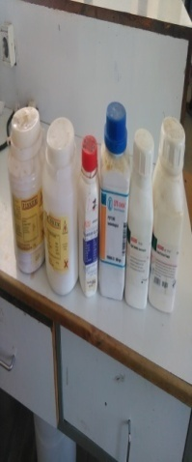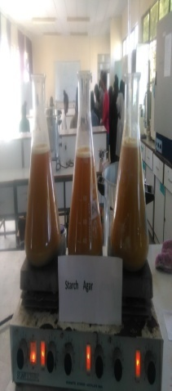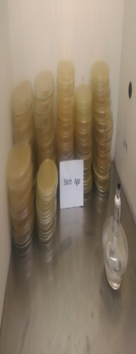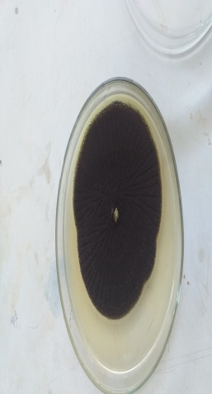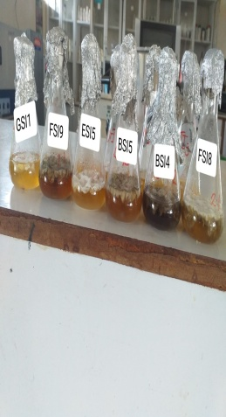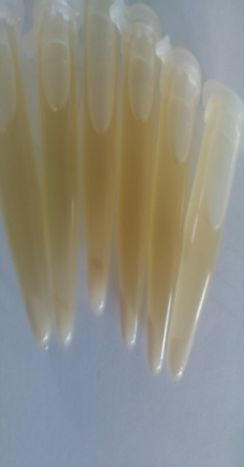
B
E
F
C
D
A

Chemicals used to preparation of starch agar media (A), heated mixed starch media on heat (B), Prepared media on
petri dish (C), Colony of Aspergillus spp. on solid media (D),Fermentation of enzyme Activity (E) and Amylase activity after centrifuge (F)

