
SCHOOL OF GRADUATE STUDIES
COLLEGE OF HEALTH SCIENCES AND REFERRAL HOSPITAL
DEPARTMENT OF PUBLIC HEALTH
INCIDENCE AND PREDICTORS OF OPPORTUNISTIC INFECTION AMONG PEOPLE LIVING WITH HUMAN IMMUNOVIRUS AFTER INITIATION OF HIGHLY ACTIVE ANTIRETROVIRAL THERAPY AT ART SITES OF PUBLIC HEALTH FACILITIES IN HORO GUDURU WOLLEGA, OROMIA,2025
BY:
SILESHI MULUGETA (BSC NURSE)

JANUARY, 2025
AMB, ETHIOPIA

AMBO UNIVERSITY
SCHOOL OF GRADUATE STUDIES
COLLEGE OF HEALTH SCIENCES AND REFERRAL HOSPITAL DEPARTMENT OF PUBLIC HEALTH

INCIDENCE AND PREDICTORS OF OPPORTUNISTIC INFECTION AMONG PEOPLE LIVING WITH HUMANIMMUNOVIRUS AFTER INITIATION OF HIGHLY ACTIVE ANTIRETROVIRAL THERAPY AT ANTIRETROVIRAL THERAPY SITES OF PUBLIC HEALTH FACILITIES IN HORO GUDURU WOLLEGA, OROMIA, 2025.
TESIS REPORT TO BE SUBMITTED TO AMBO UNIVERSITY, SCHOOL OF GRADUATE STUDIES, COLLEGE OF HEALTH SCIENCES AND REFERRAL HOSPITAL, DEPARTMENT OF PUBLIC HEALTH IN PARTIAL FULFILLMENT OF THE REQUIRMENTS FOR MASTER OF PUBLIC HEALTH IN EPIDEMIOLOGY
BY
SILESHI MULUGETA (BSC NURSE)
ADVISORS:
DR ESHETU EJETA (PHD, EPIDIMIOLOGIST)
DR GONFA MOTI (MD, ASSISTANT PROFESSOR)

JANUARY, 2025
AMBO, ETHIOPIA

AMBO UNIVERSITY
SCHOOL OF GRADUATE STUDIES

APPROVAL FORM
I. PG candidate Signature Date
Sileshi Mulugeta ____________ _________
Approved by:
II. Advisor’s Name Signature Date
1. Dr Eshetu Ejeta ____________ ___________
2. Dr Gonfa Moti _____________ ____________
III. Reviewer’s Name Signature Date
1.______________ ____________ _____________
2.______________ _____________ _____________
IV. Head, Department
Name Signature Date
Mr. Jiregna Darega (MPH,Ass’t prof ) __________ ____________
V. College Dean
Name Signature Date
___________________ ___________ __________
VI. School of Graduate Studies Coordinator
Name Signature Date
___________________ ___________ _________
VII. Director, School of Graduate Studies
Name Signature Date
___________________ ___________ _________

ABSTRACT
Background: Opportunistic infections (OIs) are illnesses that attack people with weakened immune system such as HIV positives. The majority of OIs are the leading causes of morbidity and mortality among PLHIV in low- and middle-income country.
Objective; To assess the incidence and predictors of opportunistic infections in HIV infected people after initiation of HAART in public health facilities of Horo Guduru Wollega zone, Oromia, Ethiopia, 2025.
Methods: Facility based retrospective cohort study was used. The records of 304 ART clients who initiated HAART between Jan.1, 2019 and Dec.31, 2023 were selected using simple random sampling technique. Data were collected by reviewing ART registration log book and entered to Epi data version 3.1 and imported to SPSS 26 for analysis. Kaplan–Meier curve was used to estimate the survival function and Hazard function after HAART initiation and Cox proportional hazard regression model was used to identify predictor of Opportunistic infection. An adjusted hazard ratio (AHR) with 95% CI was used to identify significant predictor of Opportunistic infections. The statistical significance was declared at p-value <0.05.
Result: The 304 study participants were followed for 60 months with a total 7818 person- months observation, 210 (61.95%) censored and 94 (30.9%) experienced Opportunistic Infections with an overall incidence rate of 12.02% (95% CI: 10.8–15.6) per1000 person-months of observation. Urban residents (AHR 1.90, 95% CI (1.24- 2.90). hemoglobin <10gm/dl (AHR 1.55, 95% CI (1.011-2.38), Bed ridden function s (AHR 2.22,95%CI. (1.24-3.97) and Ambulatory function status (AHR 2.14(1.32-3.46).Poor ART adherence (AHR 2.91(1.68-5.02) and comorbidity (AHR= 1.80; 95% CI 1.04–3.11 were potential predictors of opportunistic infection.
Conclusion and Recommendation: This study results indicate that the incidence rate of Opportunistic Infection was 12.02 per1000 person-months of observation Being bedridden, poor adherence, <10mg/dl hemoglobin level and comorbidity are significantly associated with incidence of Opportunistic infections among PLHIV. Key words: --Opportunistic Infection, HAART, HIV, Antiretroviral therapy, Event

ACKNOLEDGEMENT
First and for most, I would like to praise God for his endless help in every situation. Secondly, I would like to express my thanks and deep appreciation to Ambo University College of Health sciences and Referral Hospital Department of Public Health for giving me this golden opportunity for advancing my knowledge.
I also express my heart felt gratitude to my advisors Dr. Eshetu Ejeta and Dr. Gonfa Moti for their constructive comment and encouragement to develop research proposal and thesis on this title.
I also express my heart felt gratitude to data collectors and both health facility head for their cooperation and support during data collection process.

Table of Contents page number
ABSTRACT iv
Methods: iv
ACKNOLEDGEMENT v
LISTS OF FIGURE ix
ACRONYMS AND ABBREVIATIONS x
1 INTRODUCTION 0
1.1 Back Ground 0
1.2 Statement of The Problem 1
1.3; Significance of the Study 3
2 LITERATURE REVIEW 4
2.1 The Incidence of Opportunistic Infection Among PLHIV After Initiation Of HAART 4
2.2 Predictors of Opportunistic Infection After Initiation of HAAT Among PLHIV 6
2.2.1 Socio-Demographic Predictors 6
2.2.2 Adherence to treatment predictors 6
2.2.4 Clinical and Laboratory Characteristics 7
3 OBJECTIVE OF THE STUDY 10
3:1 General Objective 10
3:2 Specific Objective 10
4: METHODS AND MATERIALS 11
4:1 Study Area and Period 11
4:2 Study Design 11
4:3 Population 11
4:3:1 Source Population 11
4:3:2 Study Population 11
4:4 Inclusion and Exclusion Criteria 11
4:4:1 Inclusion Criteria 11
4:4:2 Exclusion Criteria 11
4:5 Sample Size Determination and Sampling Techniques 12
4:5:1 Sample Size Determination 12
4:5:2. Sampling Techniques 13
4.6 Study Variables 14
4.6.1 Dependent Variable 14
4.6.2 Independent Variables 14
4:7 Operational Definitions 14
4:8 Data Collection Tool and Procedure 15
4:9 Data Quality Control Management 15
4:10 Data Processing and Analysis 16
4:11 Ethical Consideration 16
4:12 Dissemination of The Results 17
5; RESULTS 18
5:1 Socio-Demographic Characteristics of PLHIV Started HAART 18
5:2 Base Line Clinical and Laboratory Related Characteristics 20
5:3 Medication and Treatment Related Characteristics 20
5:4 Immunological Characteristics 20
5:5 Incidence of Opportunistic Infections After HAART Initiation 23
5.6 Survival Characteristics After Initiation Of ART 24
5:7 Kaplan- Meier Survival Analysis and Log Rank Test 24
5:7:1 Predictors of OIs Among HIV-Positive Patients On ART 30
6 : DISCUSSION 32
7: Limitation and Stregth of the study 33
7.2 The strength of this study 33
REFERENCES 35
Annex I English version Information sheet form 39

LISTS OF TABLES
Table 1: Sample size determination of >15 years PLHIV on ART in Horo Guguru Wollega public health facilities 2023. 23
Table -2 Socio-demographic characteristics of PLHIV started HAART at HGW zone public health facilities January, 1.2019 to December,31. 2023 (n=304) 30
Table: 3 Clinical, Laboratory, ART and other medication related information of HIV related opportunistic infection after initiation of HAART in HGW zone public health facilities 01 January, 2019 to 31 December 2023 32
Table: 4 Lists of common HIV related opportunistic infections after initiation of HAART in HGW zone public health facilities 01 January, 2019 to 31 December, 2023 34
Table 5: Comparison of survival status of HIV patients on ART regarding to different categories by using log-rank test in public facilities of Horro Guduru Wallaga zone, Ethiopia, 2023 35
Table 6: Bi variable and multi variable cox-regression analysis of HIV patients on ART in Horo Guduru Wolega zone public health facilities (n=304)…………….40

LISTS OF FIGURE
Figure 1 conceptual framework of incidence and predictors of OIs among PLHIV/ source different literature………………………………………………………………………….. 19
Figure 2 : Schematic diagram of sampling procedure among HIV positive age 15 years and above in HGW zone …………………………………………………….23
Figure3: Kaplan-meier survival curves to compare OIs free survival time based on their base line functional status in retrospective study among HIV patient on ART in public health facility in HGW zone ……………………………………………….34
Figure 4; Kaplan-meier survival curves to compare OIs free survival time by ART adherenc in retrospective study among HIV patient on ART in public health facility in HGWzone ……………………………………………………………………..35
Figure 5: Kaplan-meier survival curves to compare OIs free survival time by place of residence status in retrospective study among HIV patient on ART in public health facility in HGW zone . 36
Figure 6 : kaplan-meier survival curves to compare OIs free survival time by base line hemoglobin status in retrospective study among HIV patient on ART in public health facility in HGW zone . 37
Figure 7: kaplan-meier survival curves to compare OIs free survival time by base line comorbidity status in retrospective study among HIV patient on ART in public health facility in HGW zone. ………………………………………………………38

ACRONYMS AND ABBREVIATIONS
AIDS---Acquired Immunodeficiency Virus
ART--- Anti retro Viral Therapy
HAART--- Highly Active Anti Retro Viral Therapy
Hgb ------Hemoglobin
HGW-----Horo Guduru Wollega
HIV – Human Immunodeficiency Virus
I P T-------Isoniazid Preventive Therapy
IRIS--------- Immune Reconstitution Inflammatory Syndrome
O Is---- Opportunistic Infection
PCP--------- Pneumocystis Pneumonia
PLHIV-----People Living with Human Immunodeficiency Virus
PMO -------Person Months observation
PYFU------- Person year follow up
PYO ---------Person per Year Observation
TB---------Tuberculosis

1 INTRODUCTION

1.1 Back Ground
Opportunistic infections are illnesses that attacks people with weakened immune system such as HIV positives , it is caused by bacteria, fungi, parasites and viruses (1). They are the first clinical manifestations that alert clinicians to the occurrence of AIDS. In the context of HIV, OIs are defined as infections that are more frequent or more severe because of HIV-mediated immunosuppression.(2) Despite the virological control opportunistic illnesses continue to occur at an unacceptable frequency and account for a large proportion of hospitalizations and deaths in HIV infected patients (3). OIs that occur after initiation of HAART are classified into three groups. The first group includes OIs that occur shortly after the start of HAART (within 12 weeks) because of worsening of previously diagnosed OIs or unmasking of sub-clinical infection. These cases represent immune reconstitution inflammatory syndrome (IRIS). The second group are OIs that occur >3 months after initiation of HAART in patients with suppressed viral load and sustained CD4 count >200cells/mm3 ,The third group includes OIs that occur in patients with virology and immunologic failure on HAART (4).
Opportunistic infections are the important causes of morbidity and mortality among PLHIV(5). Tuberculosis is the most frequently diagnosed opportunistic infection in people living with HIV/AIDS world-wide (6). TB is still one of the most frequently acquired immune-deficiency syndrome(AIDS)defining conditions worldwide(7). Oral Candidiasis, tuberculosis and herpes zoster are the most common OIs occurring in sub-Saharan Africa. However a recent publications show that even patients with good immune reconstitution are still at risk of acquiring OIs (8). In our setting studies related to this problem are limited. The aim of this study was be to assess the incidence and predictors of opportunistic infection among PLHIV after initiation of HAART in Horo Guduru wollega zone Oromia, Ethiopia.

1.2 Statement of The Problem
Opportunistic infections (OIs) remain a major cause of morbidity and mortality among age 15 years and above HIV positive people despite the widespread use of highly active antiretroviral therapy (HAART). The incidence and predictors of OIs after initiation of HAART are not well understood, and there is a need for further research to update HIV related opportunistic infection treatment guidelines and improve patient outcomes. The incidence of opportunistic infection among adult 15 years and above starting HAART has great difference from country to country.
The incidence of opportunistic infection in USA and Canada was 1.45 events/100 people per year for 2008-2010(9)and 0.27/100,000 population in Qatar (10). The incidence of opportunistic infection in China is 871/920 (94.7%) (11).The incidence of OIs in Uganda was 59.4% (12). TB was the most common OI observed in South Africa which was 243/382 (64%) (13).The incidence of OIs after initiation of HAART in Ethiopia rising rate shown by study conducted in different region of the country which reported 8.97% in Welayita sodo (14),7.5Case /100 person year in Mekele (4), and 21.4% in Arba Minich (15) and 76.22% in Gonder (16). HIV related OIs more affects productive age group, leads to low productivities and increase the economic burden on their families and countries (11). Opportunistic infections can significantly impact the quality of life of HIV positive people, causing a range of symptoms such as fever, fatigue, weight loss, and diarrhea, which can affect their ability to carry out daily activities and maintain their social and economic well-being (25). The advantage of HAART has been shown to reduce the risk of opportunistic infections, but the development of resistance to antiretroviral drugs can increase the risk of these infections (26). Understanding the predictors of opportunistic infections can help healthcare providers tailor treatment regimens to reduce the risk of resistance and improve treatment outcomes (26). Opportunistic infections can result in significant healthcare costs and resource utilization, particularly in low- and middle-income countries where access to healthcare resources may be limited. Understanding the incidence and predictors of opportunistic infections can help healthcare providers and policymakers allocate resources more effectively. OIs has health and economic impacts on individual and country level by affecting productive age group and by increasing unnecessary cost for repeated hospital visit lead to premature death.
Preventing and managing opportunistic infections is crucial intervention to improving the health outcomes of PLHIV. Several strategies have been shown to be effective in preventing opportunistic infections, including: Antibiotic prophylaxis: It is recommended for PLHIV who are at high risk of developing opportunistic infections, such as those with low CD4 cell counts or those who have previously had an opportunistic infection (27). Adherence to HAART has been shown to reduce the risk of opportunistic infections (28). Early detection and treatment of opportunistic infections can help prevent the development of severe disease and improve outcomes (29).
Taking ART medicine and OI preventive therapy is the best way to prevent getting OIs because ART drugs can keep immune system strong and healthy. There is the disagreement gap related to previous study finding. According to the study conducted in Welayita Sodo University being female is independent predicators with p-value 0.007(14) but according to the study conducted in Nigeria indicates there is no association between sex and opportunistic infection(17). There is also a knowledge gap especially on the incidence of opportunistic infection and its predictors. This study was tries to fill the gap as much as possible and the study was providing base line information on incidence and predictors of opportunistic infection among HIV positive age 15 years and above after initiation of HAAR in HGW zone public health facilities because there is no research done in this area as my understanding.

1.3; Significance of the Study
Understanding the Incidence and predictors of OIs can helps Health care workers, researchers and donors to allocate resource more effectively. It helps as base line information on the magnitude of incidence and predictors of opportunistic infection in Horo Guduru Wollega zone. It helps to develop guidelines on how to approach to prevent HIV related opportunistic infection by identifying possible preventive and treatment options for prevention and management of opportunistic infection, for quality improvement, researchers and different level stack holders, who engaged in developing guideline on treatment and prevention of opportunistic infection secondary to HIV/AIDS.

2 LITERATURE REVIEW

2.1 The Incidence of Opportunistic Infection Among PLHIV After Initiation Of HAART
The global incidence of HIV related opportunistic infection after initiation of HAART among PLHIV is not similar due to different reasons. In the study conducted in USA and Canada by the year of 2016 on HIV care during 2008-2010 the incidence rate of any first OI was highly decreased among PLHIV starting ART with CD4 T-cell less than 200cell/mm³(9).
Retrospective cohort study conducted in Qatar shows the average incidence rate of HIV infection over the seven years was 0.69per 100,000 population and the incidence rate of HIV related OIs was 0.27/100,000 population. The most predominant OIs pneumocystis pneumonia 25% of 42 cases followed by CMV renitis 7.2%TB 5.4% and toxoplasmosis 4.3% (10).
The study done in Shanghai China shows from 920 clinical records analyzed 871 (94.7%) had opportunistic infections. Among the patients who acquired OIs 845 patients received anti-infection treatment before ART initiation while AIDS-related OIs newly occurred in 75 patients who were on ART. The most common OIs were Pneumocystis pneumonia (PCP) and bacterial co-infection and the prevalence was 42.1%. This was followed by tuberculosis (31.4%) (11).
The study conducted in Kinshasa Democratic Republic of Congo shows that Malaria was the most leading OI in PLHIV starting ART with 54 cases (45.4%) followed by Tuberculosis (29.4%), skin pruritus (23.5%), urinary tract infections ( 21.8%), oral candidiasis and skin eruptions (20.2%), dermatitis (15.1%), diarrhea (14.3%), vaginal pruritus (13.4%), mycosis vagina (10.9%), intestinal parasites (10.1%), rhinitis (9.2%), non-specific sexually transmitted infections (4.2%), and shingles (3.4%) (18).
The study done in Uganda indicates that the overall incidence rate of new OIs over the 480-week period after initiation of HAART was 59.4 /1000 PYFU. The incidence rate was highest in the first year after ART start with 333.0 per 1000 PYFU, followed by 36.8/ 1000 PYFU in the second year. After the second years incidence rates stay at a lower level. The overall incidence was highest for oral candidiasis with an incidence rate of 25.4 per 1000 PYFU, followed by tuberculosis15.3, herpes zoster 12.3 and cryptococcal meningitis 3.0 (12). The study done in South Africa TB was the most common OI observed in 243/382 (64%) patients. Among those with TB, 147 (60%) had pulmonary TB and 96 (40%) had extra-pulmonary TB, including TB meningitis. Other OIs were cryptococcal meningitis (10%), chronic diarrhea (9%), bacterial pneumonia (3%), toxoplasmosis (2%), pneumocystis pneumonia (1%) and HIV-related kidney disease (1%) (13).
In Ethiopian study was conducted in limited area on incidence and predictors of OIs among PLHIV after initiation of HAART. The study done in Mekele at Ayder referral hospital shows that the incidence of OIs after initiation of HAART was 7.5case/100 person’s years. Half of the OIs developed with in the first three month after starting ART. Tuberculosis, oral candidiasis, pneumonia and toxoplasmosis were the leading OIs after HAAR (4).
Another study conducted in Welayita Sodo university indicates the incidence rate of OIs among adolescents and adults PLHIV after the initiation of ART was found to be 8.97% per 100 PYO. Community acquired pneumonia was the predominant, 68 (41.5%) OIs assessed during the follow-up period, followed by pulmonary tuberculosis, 36 (22%), and oral thrush, 16 (9.5%) , chronic diarrhea (6.1%), herpes zoster (5.5%), esophageal candidiasis (4.9%), cryptococcal meningitis (3.7%)(14) .
The study done in Gonder university comprehensive hospital shows that about 76.22% of study participants developed different opportunities infections. Out of total OIs development, the largest proportion, 90 (16.51%) was found to be Pneumocystis’ pneumonia followed by Chronic diarrhea 89 (16.33%), Bacterial pneumonia 59 (10.82%) and Pulmonary tuberculosis 57(10.46%)(19).
The study conducted in Debre Markos referral hospital shows an overall incidence density rate was 6.19 cases per 100person year. From the total incident TB cases, 49(79%) patients had Pulmonary TB while 13 (21%) had Extra pulmonary TB (EPTB) cases(20) .
The study done in Arba Minch Health Science College shows Cumulative incidence and incidence rate of tuberculosis among PLHIV patients was 21.4% (21.3, 21.44) and 5.36 per 100 persons year respectively(15). Another study conducted in Dessie comprehensive hospital indicates the incidence of OIs after starting HAART was13.5% (21). Similar study was conducted in Hawassa on incidence and predictors of tuberculosis among PLHIV after starting ART indicates the incidence rate of developing TB was 8.79/100 person per year. From this incidence rate 24.7% were pulmonary TB,4.3% were extra pulmonary TB .The majority of TB case were occurred during the first year follow up period which is 71.42% (6). The study done in Selale university on the incidence and predictors of OIs after initiation of HAART shows the incidence rate of developing any OIs was 23/100 person per month and the pattern of OIs incidence pulmonary TB was25.13% followed by oral candidiasis 12.56%and bacterial pneumonia 10.55%(22).

2.2 Predictors of Opportunistic Infection After Initiation of HAAT Among PLHIV

2.2.1 Socio-Demographic Predictors
According to the study conducted in Welayita Sodo University being female is independent predicators(14). The study done in Dessie comprehensive hospital indicates rural residence, disclosure status are considered as predictors of OIs(16). Another study conducted in Selale university shows residence especially rural residence has 2 times higher than urban considered as predictors of OIs (22) .

2.2.2 Adherence to treatment predictors
According to the study conducted in Mekele at Ayider referral hospital none adherence, poor adherence, fair adherence for HAART is predictors of OIs(4). Another study conducted in Welayita Sodo University not taking CPT, poor adherence to be independent predicators (14).The study done in Dessie comprehensive hospital indicates drug adherence, taking CPT are considered as a predictors of OIs (16). Another study conducted in Selale university ART side effect and not taking Isoniazid preventive therapy (IPT) are considered as a predictors of OIs (22). According to the study conducted in Gedeo zone poor adherence to ART drug is considered as a predictors of opportunistic infection.(23)

2.2.3 Immunological factors
Based on the study conducted in USA and Canada the predictors of OIs after the initiation of HAART was CD4 count less than 200cell/mm³and viral load greater than 500copies /ml as predictors of OIs. CD4 count greater than 500cell/mm³ and viral load less than 500copies /ml are preventive predictor (9). Retrospective cohort study conducted in Qatar shows CD4 and viral loads are a predictors of OIs(10).
According to the study conducted in Mekele at Ayider referral hospital CD4 count less than 200cell/mm³ at base line are predictors of OIs (4).
Another study conducted in Gondor University and Debremarkos Referral hospital indicates CD4 count <200cell/mm³ is predictors to develop HIV related OIs after initiation of HAART among PLHIV(18,19). Another study conducted in Arba Minch Health Science College indicates CD4 count less than 200cell/mm³ considered as predictors (15). The study done in Dessie comprehensive hospital indicates CD4 count are considered as a predictors of OIs (16). The study done in Hawassa on incidence and predictors of TB among PLHIV after starting ART level of education, substance use , functional status of enrollment ,CD4 count less than 50cell/mm³ and WHO HIV clinical stage 4 are considered as predictor of OIs (6). Another study conducted in Selale university shows CD4 count less than 200 cell/mm3 considered as predictors of OIs (22) .According to the study conducted at University of Gonder CD4 count less than 200cell/mm3 considered as predictor.(24)

2.2.4 Clinical and Laboratory Characteristics
According to the study conducted in Mekele at Ayider referral hospital bed ridden, hemoglobin level less than 7gm/dl at the initiation of HAART and WHO HIV clinical stage 3 and BMI at base line are predictors of OIs(4). Another study conducted in Welayita Sodo University mild malnutrition, WHO HIV clinical stag 3 are considered as independent predicators (14). The study conducted in Gondor University and Debremarkos Referral hospital indicates bed ridden functionality status, WHO HIV clinical stage 2 and 3 are predictors to develop HIV related OIs after initiation of HAART among PLHIV (18, 19). Another study conducted in Arba Minch Health Science College indicates WHO HIV clinical stage 3 and 4, hemoglobin <10mg/dl, are considered as predictors (15). The study done in Dessie comprehensive hospital indicates WHO HIV clinical stage and hemoglobin level are considered as a predictors of OIs (16). Another study conducted in Selale University shows , hemoglobin level less than 10mg/dl considered as predictors of OIs (22) . According to the study conducted in Gedeo zone and at University of Gonder bed ridden and ambulatory functional status was considered as predictor of OIs.(23,24)

2.3 Conceptual Frame Works of Incidence and Predictors of OIs Among HIV Positive after HAART Initiation in Public Health Facilities In HGW,2019-2023
Sociology-demographic Pattern
Sex, Residence, Disclosure status level of education, marital status, occupation

Opportunistic infection
Clinical and Laboratory Characteristic
Hgb level less than 10mg/dl
WHO HIV clinical stage I, II, III, and IV
Functional status
Adherence to treatment
Good adherence
Poor adherence
Fair adherence CPT, IPT Treatment side effect

Immunological status
Viral load suppression
CD4 count

Figure 1 conceptual framework of incidence and predictors of OIs among PLHIV/ source different literature (8, 20, 24).

3 OBJECTIVE OF THE STUDY

3:1 General Objective
To assess the incidence and predictors of opportunistic infections after initiation of HAART in Horo Guduru Wollega zone, Oromia. Ethiopia, 2024

3:2 Specific Objective
- To determine the incidence of opportunistic infection after initiation of HAART in Horo Guduru Wollega zone, 2025.
- To identify predictors of opportunistic infections after initiation of HAART in Horo Guduru Wollega zone, 2025.

4: METHODS AND MATERIALS

4:1 Study Area and Period
The study was conducted in ART site public health facilities found in Horo Guduru Wollega, Oromia, Ethiopia which is located at 350 km to the west of Addis Ababa. Horo guduru Wollega zone has one ART site hospital and fourteen ART site health centers, which give ART services for 3105 clients. From the total of 3105 clients in the zone, 1712 clients receive ART care and service from Shambu hospital, Fincha health center,Wayu health center and Kombolcha health center respectively. The study was conducted in Shambu Hospital, Fincha health center,Wayu health center and Kombolcha health center. The study was conducted from 01 Jan 2019 to 31 Dec 2023.

4:2 Study Design
Facility based retrospective follow up study was employed.

4:3 Population

4:3:1 Source Population
All records of HIV positive clients aged 15 years and above on HAART at HGW zone public health facilities.

4:3:2 Study Population
All records of HIV positive client’s age 15 years and above those on HAART in selected ART site of public health facilities in HGW zone from 2019 to 2023.

4:4 Inclusion and Exclusion Criteria

4:4:1 Inclusion Criteria
All records of HIV positive clients with age 15 years and above who starts HAART in HGW zone public health facility from 01January 2019and 31 December 2023.

4:4:2 Exclusion Criteria
Those records of with incomplete data record during the initiation of HARRT.

4:5 Sample Size Determination and Sampling Techniques

4:5:1 Sample Size Determination
The sample size for this study was determined by using double population proportion formula using Epi info version 7.2.6.0 software. Where confidence level 95% Level of precision 5% Power 80% exposed and unexposed ratio 1:1, percent of unexposed outcome , percent of exposed outcome and by adding 10 % non-response rate by taking CD4 count, functional status, WHO HIV clinical stage as independent predictor’s (18). Based on the above information the epi info software calculates our sample size for each independent variables; 110 sample for CD4 count, 304 sample for functional status and 20 sample for WHO HIV clinical stage respectively (18).
Table 1: Sample size determination of >15 years PLHIV on ART in Horo Guguru Wollega public health facilities 2023.
Variables | Assumption | Calculated Sample sizes | Total sample size after adding 10%
Base line CD4 count less than 200 | P1=92%  P2=67.67% | 100 | 110
Bed ridden Functional status | P1=85.5%  P2=70.9% | 276 | 304
Base line WHO HIV clinical stage III | P1=97.67%  P2=19.23% | 16 | 18
Base line WHO HIV clinical stage II | P1=91.66%  P2=19.23 | 18 | 20
P1: is percent of outcome in exposed group.
P2: is percent of outcome in un exposed group.
Zα/2: is taking CI95%, Zβ: 80% power.
And r: is the ratio of non-exposed to exposed 1:1.
Then the largest sample size (n=304) was selected as the final sample size for this study

4:5:2. Sampling Techniques
Sampling frame was prepared based on ART client’s medical registration numbers in selected public health facilities in HGW zone. Systematic random sampling technique was used to select the study sample from prepared sampling frame. Three hundred four sample were selected by proportional allocation with constant interval ‘‘K^{th}’’ among 1679 ART users who initiated HAART between 01 January 2019 up to 31 December 2023.
Schematic diagram of sampling procedure for incidence and predictors of OIs among HIV positive age 15 years and above in public health facilities in HGW zone, 2019-20
Horo Guduru Wollega zone health institution

Shambu hospital

Fincha health center

Wayu health center
Kombolcha health center
Total recorded ART client on ART registration book

259
211
835

527

464

773

202
258
Systematic random sampling technique will be used to select the study participants.
Total number of > 15 years old ART client

258/1698*304=46
202/1698*304=36
773/1698*304 =139

Proportional allocation

464/1698*304=83

Calculated Sample size

304

Figure 2 : Schematic diagram of sampling procedure for incidence and predictors of OIs among HIV positive age 15 years and above in public health facilities in HGW zone, 2019-2023.

4.6 Study Variables

4.6.1 Dependent Variable
- Time to the acquisition of opportunistic infections
- The time was estimated in months from the date when the patient initiated on HAART to the date OI diagnosed.

4.6.2 Independent Variables
- Socio-demographic characteristics: Age, sex, residence, marital status, educational level, occupation and disclosure status.
- Clinical and laboratory characteristic; Hemoglobin level less than 10mg/dl, WHO HIV clinical stage 1,2,3 and 4, Functional status of the patient,working, ambulatory or bedridden.
- Immunological status; CD4 count and viral load suppression.
- Medication-related predictors; past OI prophylaxis, type of baseline ART regimen, level of ART adherence, ever taking Isoniazid Preventive Therapy (IPT), ART side effect

4:7 Operational Definitions
Opportunistic Infections (OIs); are infections that are more prevalent and severe in individuals with weakened immune systems, such as Herpes zoster, Pulmonary TB, Extra pulmonary TB, Diarrhea disease, Oral candidiasis, Toxoplasmosis, Bacterial pneumonia, Skin infection, Genital ulcer and others that frequently attacks PLHIV (24).
Duration of ART is defined as the time between the start date of ART and the last date of contact with the health facility
ART adherence it was classified as good, fair and poor according to the percentage of drug dosage calculated from the total monthly dose of ART drugs.
Good ART adherence: was reported with compliance ≥95% or ≤3 missed doses per month. Fair adherence to ART reflects 85–94% compliance or between 4 and 8 missing doses per month.
Poor adherence reflects <85% compliance or ≥ 9 missed dose per month ART adherence

Event was entertained if patients infected with HIV on ART developed any form of OI during the follow-up period (5).
Time to event; A time in month between the start of ART for PLHIV and the occurrence of the outcome (5).
Censored Recorded when HIV-infected people on ART dropped or transfer out to other health institutions, died or are still on active ART follow-up, but did not develop any OIs by the end of the study (5).

4:8 Data Collection Tool and Procedure
The data collection tool was prepared based on the Federal Ministry of Health’s HIV-care/ART follow-up and intake records which are currently used in Ethiopian ART clinics. English version data collection form was used for the assessment of incidence and predictors of opportunistic infection among PLHIV age 15 and above on ART in public health facilities in Horo Guduru Wollega zone from January, 1. 2019 to December, 31.2023. The data collection form contains different variables: socio-demographic characteristics, ART medication, clinical and laboratory-related information and other drugs used by clients. This information retrieved from ART client’s registration book without mentioning the name of clients. The information was collected by BSC nurses who have basic ART training and working in ART clinic of the health facilities.

4:9 Data Quality Control Management
To ensure data quality, a well-adapted data extraction form from a standardized ART intake and follow-up form was used, and data collectors took one day training. All the filled variables were double-checked for completeness by taking some randomly selected records and the supervisor carefully monitored the entire data collection process. The predictor variables were recorded at the baseline and occurrences of OI were registered during follow up period based on the health professionals’ reporting on the patient chart. Before data entry, data were checked for completeness and consistency.

4:10 Data Processing and Analysis
Data were coded and collected by reviewing ART registration log book from selected health facilities and entered to Epi data version 3.1 and imported to SPSS 26 for analysis. Descriptive statistics presented as percentage, mean, median and visualized using tables. Kaplan–Meier method was used to estimate the OI free survival time. The incidence rate was calculated per 1000 person-months observation (PMO) with 95% confidence level for the occurrence of any OIs. The first analysis was done by using descriptive statistics to examine the proportion of participants who responded. In addition, a generalized Log rank test was used to compare the OI free survival time between different categorical predictor variables. Multi-collinearity test was used to check if there were associations among predictor variables (all values of VIF<2). The cox proportional hazard regression model assumptions were checked using the Schoenfeld residuals test global test = 0.2). Cox-Snell residual test was used to observe the goodness of fit. A bi-variable Cox-proportional hazard regression model was used to select variables that would be considered for the final model. In the bi-variable analysis, Variables having a p-value of ≤0.25 were fitted into the multivariable Cox-proportional hazard regression model. Finally, the presence of a significant association between the predictor and outcome variables was reported by adjusted hazard ratio with its corresponding 95% confidence interval.

4:11 Ethical Consideration
Ethical clearance was obtained from Ambo University College of health science and referral hospital ethical review board. An official letter was written from department of public health to HGW zone health office to get permission. Another official letter was written from HGW zone health office to selected ART site public health facility for better cooperation and to get permission. A written consent was taken from each participating health facilities head or responsible body and confidentiality was ensured throughout the research process.

4:12 Dissemination of The Results
The final report of the study was presented and discussed in Ambo University College of health science and referral hospital department of public health. Then after the finding of the study will be disseminated to HGW zonal health office and to each respective public health facility. An attempt made to present the finding in different conferences and workshops and were sent to publication on scientific journals.

5; RESULTS

5:1 Socio-Demographic Characteristics of PLHIV Started HAART
In study, a total of 304 medical record of ART client who started HAART were included in the retrospective analysis in Horo Guduru Wollega zonal public health facility. One hundred twenty-one (39.8%) were male and one hundred eighty-three (60.2%) were female. The minimum age of study participant was 15 years and the maximum age was 70years. The majority of the study participants were married 195(64.1%), divorced 37(12.2%), widowed 15(4.9), separate 7(2.3) and single was 50(16.4%). More than half of our study participant lives in rural area 158 (52%) and around 146(48%) were lives in urban. From the total participants, 83 (27.3%) were not read and write or not have formal education 143 (47%) were attended primary school, 59(19.4%) were attended secondary school and 19(6.3%) were attended colleges. The majority of the study participant 167 (54.9%) gets their ART medication from nearby health facility and 137(45.1%) of them are gets their ART drugs from outside catchment area. Almost all study participants was employed in different occupation. The majority of study participants were house wife 86 (28.3%), farmer 80(26.3%) and daily laborer 58 (19.1%) Table- 2.

Table -2 Socio-demographic characteristics of PLHIV started HAART at HGW zone public health facilities January, 1.2019 to December, 31. 2023 (n=304)
Characteristics |  |  | Frequency | Percent
Age group | 15-24 |  | 50 | 16.4
Age group | 25-34 |  | 91 | 29.9
Age group | 35-44 |  | 95 | 31.3
Age group | 45+ |  | 68 | 22.4
Sex | Male |  | 121 | 39.8
Sex | Female |  | 183 | 60.2
Marital status | Single |  | 50 | 16.4
Marital status | Married |  | 195 | 64.1
Marital status | Divorced |  | 37 | 12.2
Marital status | Widowed |  | 15 | 4.9
Marital status | Separate |  | 7 | 2.3
Educational status | Not read and write |  | 83 | 27.3
Educational status | Primary school |  | 143 | 47
Educational status | Secondary school |  | 59 | 19.4
Educational status | College and above |  | 19 | 6.3
Residence | Urban |  | 146 | 48
Residence | Rural |  | 158 | 52
Occupation | House wife |  | 86 | 28.3
Occupation | Merchants |  | 13 | 4.3
Occupation | Government employee |  | 20 | 6.6
Occupation | Daily laborers |  | 58 | 19.1
Occupation | Farmer |  | 80 | 26.3
Occupation | Un employed |  | 11 | 3
Occupation | Others | Student | 12 | 3.9
Occupation | Others | Female sex worker | 8 | 2.6
Occupation | Others | Driver | 7 | 2.3
Occupation | Others | Military | 9 | 2.9

5:2 Base Line Clinical and Laboratory Related Characteristics
From the total client’s registration reviewed, around 172 (56.6%) hemoglobin levels was greater than 10mg/dl and 132 (43.4%) study participants have less than10mg/dl hemoglobin level was documented respectively. The majority of ART client participated in these study, 191(62.8%), functional status was fit for work, 78(25.7%) ambulatory and 35 (11.5) was bed ridden at the time of ART initiation. In this study the majority of study participants are grouped to WHO HIV clinical stage II 157(51.6%), WHO HIV clinical stage III 54(17.8%), WHO HIV clinical stage IV was 37(12.2%) and WHO HIV clinical stage I was 56(18.4%) during ART starting time (Table-3).

5:3 Medication and Treatment Related Characteristics
The majority study participants, (91.1%) disclose their HIV status to the second person or to their relatives but around 25 (8.2%) study participant was not disclosing their HIV status to anyone. 1J =TDF+3TC+DTG was the leading base line ART regimen which accounts 245(80.6%). Around 272(89.5%) study participant was initiated to cotrimoxazole preventive therapy and 256 (84.2%) study participant was getting Isoniazid preventive therapy but around 32(10.5%) and48 (15.8%) study participant were not initiated CPT and IPT respectively (Table-3).

5:4 Immunological Characteristics
CD4 count was one of the criteria to initiate ART before test and treat strategy launched. In these retrospective cohort study CD4 count was performed for 304 study participants, 159 (52.3%) clients CD4 count was greater than 351cell/mm3, 94 (30.9%) CD4 was between 201up to 350 cell/mm3 and 51 (16.77%) clients CD4 was less than 200 cell/mm3.Viral load was done for 296 (97.4%) study participants. Only for 8(2.6%) study participant viral load test was not performed because of time to test viral load need six months after initiation of HAART. From total viral load test performed286 (96.6%) study participant result was less than 500copy/ml and around 10(3.4%) study participant result was greater than 1000 copy /ml (Table-3).

Table: 3 Clinical, Laboratory, ART and other medication related information of HIV related opportunistic infection after initiation of HAART in HGW zone public health facilities 01 January, 2019 to 31 December 2023
Characteristics |  | Frequency (n=304) | Percent (%)
Disclosure status | Disclosed | 277 | 91.1
Disclosure status | Not disclosed | 25 | 8.2
Disclosure status | Not recorded | 2 | 0.7
WHO clinical stage | Stage I | 56 | 18.4
WHO clinical stage | Stage II | 157 | 51.6
WHO clinical stage | Stage III | 54 | 17.8
WHO clinical stage | Stage IV | 37 | 12.2
CD4 count | 200cell/mm³< | 51 | 16.8
CD4 count | 201-350cell/mm³ | 94 | 30.9
CD4 count | 351>cell/mm³ | 159 | 52.3
Functional status | Working | 191 | 62.8
Functional status | Ambulatory | 78 | 25.7
Functional status | Bed ridden | 35 | 11.5
Base line Hemoglobin | <10gm/dl | 132 | 43.4
Base line Hemoglobin | >10gm/dl | 172 | 56.6
Base line ART regimen | AZT+3TC+NVP | 9 | 3
Base line ART regimen | AZT+3TC+EFV | 5 | 1.6
Base line ART regimen | TDF+3TC+NVP | 7 | 2.3
Base line ART regimen | TDF+3TC+EFV | 38 | 12.5
Base line ART regimen | TDF+3TC+DTG | 245 | 80.6
Adherence | Good | 176 | 57.9
Adherence | Fair | 87 | 28.6
Adherence | Poor | 41 | 13.5
CPT initiation | Yes | 272 | 89.5
CPT initiation | No | 32 | 10.5
IPT initiation | Yes | 256 | 84.2
IPT initiation | No | 48 | 15.8
ART side effect | Yes | 116 | 38.2
ART side effect | No | 188 | 61.8
Viral load status | <500 copy/ml | 285 | 93.8
Viral load status | 501-999 | 1 | 0.3
Viral load status | 1000 and above | 10 | 3.3
Viral load status | Not performed | 7 | 2.3

5:5 Incidence of Opportunistic Infections After HAART Initiation
Person times at risk for the development of OIs Participants were followed until they were censored or experienced an event after the initiation of ART was identified. The minimum follows up period was one months and the maximum follow up period was sixty months. The median duration of follow-up time was 35.00 months (IQR, 26–42 months). During 5 years (2019- 2023), 304 persons contributed 7818 person-months at risk and 94 (30.9%) exhibited at least one OI.
During the follow-up period, 210 (61.95%) censored and 94 (30.9%) of the study participants experienced OI. The majority of OIs occurred during the first 12 months follow up period (84.66/1000 PMO). The overall person-time incidence rate of OIS among study participant after the initiation of HAART was found to be 12.02% (95% CI: 10.8–15.6) per1000 person-months of observation. Bacterial pneumonia 28 (29.2%) was the most common OI among all types of OIs occurring during the follow-up time, followed by diarrheal disease 18 (5.6%) and pulmonary TB 14 (4.6%) (Table 4)
Table: 4 Lists of common HIV /AIDS related opportunistic infections after initiation of HAART in HGW zone public health facilities 01 January, 2019 to 31 December, 2023
Characteristics | Frequency | Percent (%)
Bacterial pneumonia | 28 | 29.79
Diarrhea Disease | 18 | 19.15
Pulmonary TB | 14 | 14.89
Skin infection | 11 | 11.70
Herpeszoster | 7 | 7.45
Oral candidiasis | 6 | 6.38
Toxoplasmosis | 4 | 4.26
Extra pulmonary TB | 4 | 4.26
Genital ulcer | 2 | 2.13
Total | 94 | 100

5.6 Survival Characteristics After Initiation Of ART

After the initiation of HAART, HIV patient’s registration books were followed for 60 months. In the first six month the survival rate was 0.87 with 0.02 standard error, Total cumulative survival rate at the end of the study was 0 .57 with 0.4 standard error.

5:7 Kaplan- Meier Survival Analysis and Log Rank Test
The Kaplan-Meier survival curve of urban residence, hemoglobin less than 10gm/dl, bed ridden patient, poor ART drug adherence and having co-morbidity were showed significant difference in the survival status. The result of this study showed the cumulative probability of surviving (OI-free survival time) of bedridden patients was less when compared to patients classified as working active status. Additionally, adult patients with poor ART drug adherence had less probability of surviving than patients with good ART drug adherence (Table 5).
Table 5: Comparison of survival status of HIV patients on ART regarding to different categories by using log-rank test in public facilities of Horro Guduru Wallaga zone, Ethiopia, 2023
Overall Comparisons Log Rank (Mantel-Cox)

Variable | Chi-Square | Df | Sig.
Place of residence | 5.602 | 1 | 0.018
Base line hemoglobin | 6.615 | 1 | 0.010
Base line functional status | 19.895 | 2 | 0.000
ART adherence | 26.460 | 2 | 0.000
Comorbidity | 9.658 | 1 | 0.002

Kaplan-meier survival curves to compare OIs free survival function test
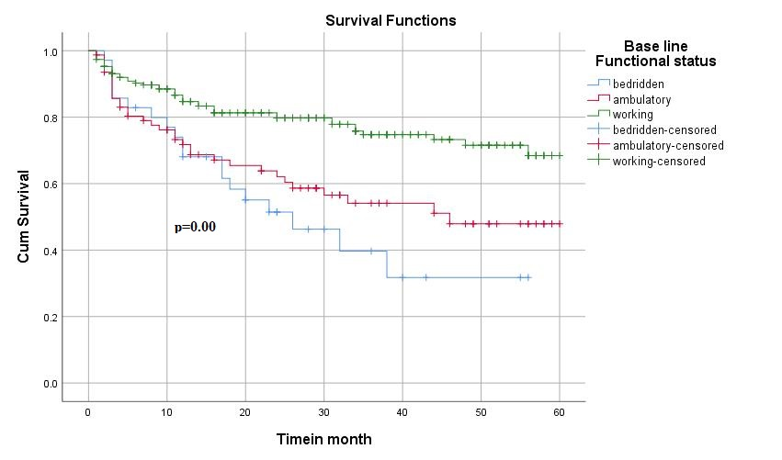
Follow up time in months

Figure3: Kaplan-meier survival curves to compare OIs free survival time HIV positive on HAART with base line functional status in retrospective study in public health facility in HGW zone from Jan 2019-Dec2023.

Kaplan-meier survival curves to compare OIs free survival function test
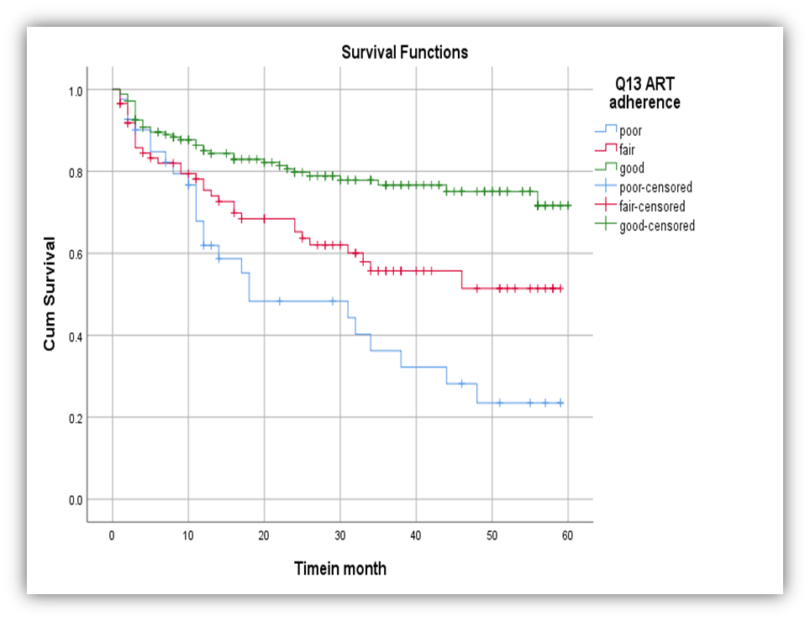
Follow up time in months

P=0.000
Figure 4; Kaplan-meier survival curves to compare OIs free survival time of HIV positive on HAART with ART adherence status in retrospective study in public health facility in HGW zone from Jan 2019-Dec2023.

Kaplan-meier survival curves to compare OIs free survival function test
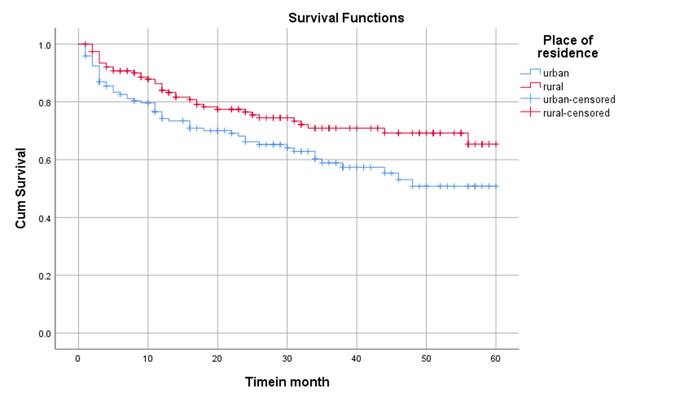
Follow up time in months
P=0.018
Figure 5: Kaplan-meier survival curves to compare OIs free survival time of HIV positive on HAART with place of residence status in retrospective study in public health facility in HGW zone from Jan 2019-Dec2023.

Kaplan-meier survival curves to compare OIs free survival function test
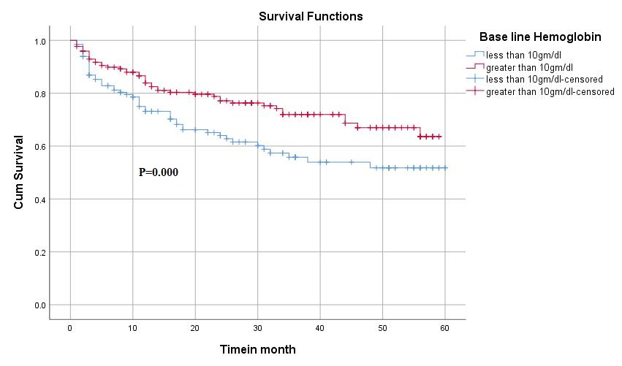
Follow up time in months
Figure 6 : Kaplan-meier survival curves to compare OIs free survival time of HIV positive on HAART with base line hemoglobin status in retrospective study in public health facility in HGW zone from Jan 2019-Dec2023.

Kaplan-meier survival curves to compare OIs free survival function test

Follow up time in months
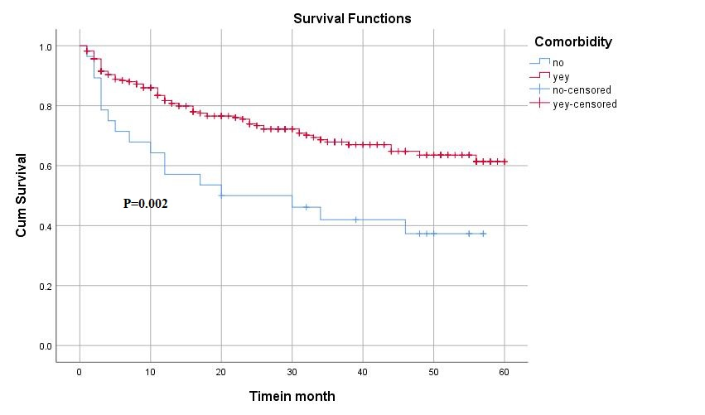
Figure7: Kaplan-meier survival curves to compare OIs free survival time of HIV positive on HAART with comorbidity status in retrospective study in public health facility in HGW zone from Jan 2019-Dec2023.

5:7:1 Predictors of OIs Among HIV-Positive Patients On ART
The multivariable cox-regression hazard analysis reveals that independent variable like place of residence, base line functional status, hemoglobin, ART drug adherence and comorbidity were found to be significant predictors of OIs at p-value less 0.05.Therefore the hazard of developing OIs among HIV-positive patients Urban residents were 1.9 times more likely to develop opportunistic infections as compared as rural residence (AHR= 1.90; 95% CI:1.242,2.907). The hazard of developing OIs among HIV-positive patients with hemoglobin <10gm/dl were 1.55 times more likely to develop OIs after ART initiation as compared as patient having hemoglobin >10gm/dl (AHR= 1.55; 95% CI:1.011,2.380), Bed ridden function status were 2.22 times more likely to develop OIs as compared as working functional status (AHR= 2.22;95%CI:1.237,3.977) and Ambulatory function status were 2.14 time more likely to develop OIs as compared as working functional status (AHR= 2.14; 95%CI:1.32,3.46).
The hazard of developing OIs among HIV-positive patients with Poor ART adherence were 2.91 times more likely to develop OIs as compared to patients with good ART adherence status (AHR 2.91;95%CI:1.69,5.02). The hazard of developing OIs among HIV-positive patients with Fair ART adherence were 2.2 times more likely to develop OIs as compared to patients with good ART adherence status (AHR 2.21;95%CI:1.13,3.14) and the hazard of developing OIs among HIV-positive patients with comorbidity was 1.80 times more likely to develop OIs as compared to HIV-positive patients without comorbidity (Table 6).

Table 6: Bi variable and multi variable cox-regression analysis of HIV patients on ART in Horo Guduru Wolega zone public health facilities (n=304).
Variables |  | HIV / AIDS related OIs
 |  | Status |  |  |  |  | Bi variable analysis |  | Multi variable analysis
 |  | OIs (%) |  | Censored (%) |  |  | CHR (95%CI) |  | AHR (95%CI) | P-Value
Place of residence
Urban |  | 55(18.8%) |  |  | 91(29.9%) |  | 1.627(1.079-2.453) |  | 1.900 (1.242-2.907) | 0.003
Rural |  | 39(12.8%) |  |  | 119(39.1%) |  | 1 |  | 1 | 1
Hemoglobin
<10gm/dl |  | 50(16.44%) |  |  | 82(27%) |  | 1.685(1.123-2.528) |  | 1.551(1.011-2.380) | 0.045
>10gm/dl |  | 44(14.47%) |  |  | 128 (42%) |  | 1 |  | 1 | 1
Base line functional status
Bed ridden |  | 19(6%) |  |  | 16(5%) |  | 2.873(1.665-4.958 |  | 2.218(1.237-3.977)* | 0.007
Ambulatory |  | 33(11%) |  |  | 46(15%) |  | 2.124(1.346-3.353) |  | 2.137(1.319-3.46)* | 0.002
Working |  | 42(14%) |  |  | 149(49%) |  | 1 |  | 1 | 1
ART adherence
Poor | 24(8%) |  | 17(5%) |  |  | 3.480( 2.089-5.826) |  | 2.909(1.686-5.017 )** |  | 0.000
Fair | 33(11%) |  | 54(18%) |  |  | 2.052(1.286-3.291) |  | 2.131( 1.329-3.416)* |  | 0.002
Good | 37(12%) |  | 139(46%) |  |  | 1 |  | 1 |  | 1
Comorbidity
Yes | 17(5.6%) |  | 11(3.6%) |  |  | 2.336(1.322-3.712) |  | 1.802(1.043-3.114)* |  | 0.035
No | 77(25.3%) |  | 199(65.5%) |  |  | 1 |  | 1 |  | 1
*p-value less than 0.05
**p-value less than 0.001 crude odd ratio (CHR) and adjusted odd ratio.(AHR)

6 : DISCUSSION
Facility based retrospective cohort study was employed to assess incidence and identify predictors of opportunistic infection among HIV patients after ART initiation in Horo Guduru Wellega zone public health facilities. During this cohort study the overall incidence rate of OIs ART initiation was 12.02/1000 months observation. In this study it was found that participants who were urban resident, base line hemoglobin less than 10mg/dl, poor and fair ART adherence, bed ridden base line functional status and having comorbidity were independent predictors of OIs after ART initiation.
The rate OIs after HAART initiation in our study was higher than that found other similar cohort study finding in Quatar (0.69 per1000population)(10), Arba Minch health science college, south Ethiopia (3.4cases per 100 PYO)(1,14). The incidence of OIs in the current study was also higher than the study finding conducted in Welayita sodo (8.97 per 100 person year observation (20), Debre Markos Referral hospital (6.19/100pyo)(22) and Hawassa (8.79/100pyo)(6).
The rate OIs after ART initiation in our study was less than similar cohort study finding found in Uganda (59.4/PYFU)(12).
The difference in the incidence rates of OIs across the studies could be due to sample, the length of follow up period. In some studies, for example the study conducted in USA and Canada was followed for 10 years but in Ayidere Referral Hospital Mekele was followed only for 36 months (8). Another reason could be due to imbalance in level of infrastructure and engagement in HIV care in low income especially African countries and western countries.
Patients with low hemoglobin level had high risk of developing HIV related OIs after HAART initiation. This finding was similar with previous research findings in Ayider Referal hospital (8), Dessie comprehensive hospital (24) and Selale University (1).In this study the hazard of developing OIs among HIV-positive patients with Poor ART adherence were 2.9 times more likely to developed OIs as compared as good adherence status. This finding was similar with previous research finding in Ayider Referal Hospital Mekele (8), Dessie comprehensive hospital (24) and Selale University (1). Poor adherence to ART reduces the effectiveness of ART drugs while also accelerating viral replication and immune suppression, creating a favorable environment for the development of OIs. Suppression of HIV replication is an important component in prolonging and improving the quality of life for the patient and minimizing the risk of transmission of HIV to others. Viral load test, applying test and treat strategies, regular follow up and adequate suppression of HIV replication requires strict adherence to prescribed regimens of antiretroviral drugs.
Study participants who were bed ridden function status at the start of HAART were at increased risk of HIV related OIs after HAART initiation. This finding was congruent with previous research finding in Ayider Referal hospital Mekele(8),Dessie comprehensive hospital(24), Hawasa(25) and Welayita Sodo(5).In this study finding the hazard of developing OIs among HIV-positive patients with Urban residents were had high risk of developing HIV related OIs ,which was not similar with the previous study finding in Dessie and Selale University(24,1).This finding difference could be due to sample, follow up period and Area of the study.

7: Limitation and Stregth of the study
7.1 Limitation
Since the nature of the data collection was retrospective, the study focus on the available information for the number and types of diseases reported during follow-up.
Therefore, some data might be missed. Some data were not properly documented, Some Routine laboratory investigations were not properly done and documented (hemoglobin, cd4 cell count and viral load test). HIV related OIs diagnoses were not performed due to diagnostic machines and limited capacity to make definitive diagnoses.

7.2 The strength of this study
The strength of this study was the involvement of data collectors and supervisors who had back ground training on ART and working at ART clinics.

8 CONCLUSSIO
The rate of OIS after the initiation of HAART in Horo Guduru Wollega zone at public health facility was high when compared to Welayita sodo, Debre Markos Referral hospital and Hawassa study findings in our country. Moreover, poor adherence to ART, base line hemoglobin less than 10mg/dl, Bed ridden and Ambulatory functional status, clients with comorbidity and urban residence were independently predicts an increases incidence and decreased survival time among PLHIV after HAART initiation.
9; RECOMMENDATION
We recommend that health workers especially ART providers, case managers, adherence supporter. Mother supporter’s and data Clark assess and provide intensified care for HIV patients to avoid the risk of developing OIs after ART initiation. Enhanced adherence counseling should be provided by the ART team based on the patient’s adherence track records.
To minimize the incidence of HIV related OIs and to keep ART client’s health ART providers and care givers must perform routine activities as per the treatment guide line and standard operational procedure. Regular viral load testing, laboratory investigation like hemoglobin test, CD4 cell count Prescription of IPT CPT for patients with ART should be instituted as indicated in the guidelines for the ART program and should be readily accessible to increase survival among patients with HIV.
The Horo guduru wellega zonal health department and all woreda health departments should strengthen public awareness to increase the health seeking behavior of community to early presentation to health facilities before advanced HIV disease occurred, which in turn curbs the frequent development of OIs that follow marked immune compromise at HIV diagnosis.
Finally prospective observational studies are required to assess the role of personal, social, or environmental factors in the occurrence of OIs.

REFERENCES
1. Thakur H, Potthoo AV, Woldegeorgis BZ. Incidence and predictors of opportunistic infections in adolescents and adults after the initiation of antiretroviral therapy: A 10-year retrospective cohort study in Ethiopia [Internet]. Available from: www.strobe-statement.org/
2. Wongkittipong P, Kiertiburanakul S. Incidence and Predicting Factors of Opportunistic Infections after Antiretroviral Therapy Initiation among Treatment-naïve Patients with HIV Infection : A Retrospective Cohort Study in A Tertiary Care Hospital. 2024;23:1–8.
3. Coelho LE, Cardoso SW, Amancio RT, Moreira RI, Ribeiro SR, Coelho AB, et al. Predictors of opportunistic illnesses incidence in post combination antiretroviral therapy era in an urban cohort from Rio de Janeiro, Brazil. BMC Infect Dis [Internet]. 2016;16(1):1–10. Available from: http://dx.doi.org/10.1186/s12879-016-1462-x
4. Arefaine ZG, Abebe S, Bekele E, Adem A, Adama Y, Brockmeyer NH, et al. Incidence and predictors of HIV related opportunistic infections after initiation of highly active antiretroviral therapy at Ayder Referral Hospital, Mekelle, Ethiopia: A retrospective single centered cohort study. PLoS One. 2020;15(4).
5. Temesgen B, Kibret GD, Alamirew NM, Melkamu MW, Hibstie YT, Petrucka P, et al. Incidence and predictors of tuberculosis among HIV-positive adults on antiretroviral therapy at Debre Markos referral hospital, Northwest Ethiopia: A retrospective record review. Vol. 19, BMC Public Health. BioMed Central Ltd.; 2019.
6. Bekele H, Kote M, Yesuf A, Girum T. Incidence and Predictors of Tuberculosis among Adult PLWHA at Public Health Facilities of Hawassa City. Int J Public Heal Sci. 2017 Sep 1;6(3):266.
7. Taarnhøj GA, Engsig FN, Ravn P, Johansen IS, Larsen CS, Røge B, et al. Incidence , risk factors and mortality of tuberculosis in Danish HIV patients 1995-2007. BMC Pulm Med [Internet]. 2011;11(1):26. Available from: http://www.biomedcentral.com/1471-2466/11/26
8. Mekonnen GB, Birhane BM, Engdaw MT, Kindie W, Ayele AD, Wondim A. Predictors of a high incidence of opportunistic infections among HIV-infected children receiving antiretroviral therapy at Amhara regional state comprehensive specialized hospitals, Ethiopia: A multicenter institution-based retrospective follow-up study. Front Pediatr. 2023;11.
9. Buchacz K, Lau B, Jing Y, Bosch R, Abraham AG, Gill MJ, et al. Incidence of AIDS-De fi ning Opportunistic Infections in a Multicohort Analysis of HIV-infected Persons in the United States and Canada , 2000 – 2010. 2016;214:2000–10.
10. Ali M, Razok A, Gassim M, Elmaki N, Goravey W, Alkhal A, et al. HIV and AIDS-defining opportunistic illnesses in the state of Qatar : A cohort population-based retrospective study covering 17 years ( 2000-2016 ). Ann Med Surg [Internet]. 2022;78(April):103842. Available from: https://doi.org/10.1016/j.amsu.2022.103842
11. Luo B, Sun J, Cai R, Shen Y, Liu L. Spectrum of Opportunistic Infections and Risk Factors for In-Hospital Mortality of Admitted AIDS Patients in Shanghai. 2016;95(21):1–8.
12. Weissberg D, Mubiru F, Kambugu A, Fehr J, Kiragga A, Von Braun A, et al. Ten years of antiretroviral therapy: Incidences, patterns and risk factors of opportunistic infections in an urban Ugandan cohort. PLoS One. 2018 Nov 1;13(11).
13. Sunpath H, Edwin C, Chelin N, Nadesan S, Maharaj R, Moosa Y, et al. HHS Public Access. 2020;16(7):917–23.
14. Woldegeorgis BZ, Zekarias Z, Adem BG, Obsa MS, Kerbo AA. Prevalence and determinants of opportunistic infections among HIV-infected adults receiving antiretroviral therapy in Ethiopia: A systematic review and meta-analysis. Vol. 10, Frontiers in Medicine. Frontiers Media S.A.; 2023.
15. Dalbo M, Tamiso A. Incidence and Predictors of Tuberculosis among HIV/AIDS Infected Patients: A Five-Year Retrospective Follow-Up Study. Adv Infect Dis. 2016;06(02):70–81.
16. Tegegne KD, Cherie N, Tadesse F, Tilahun L, Tegegne KD, Cherie N, et al. Incidence and Predictors of Opportunistic Infections Among Adult HIV Infected Patients on Anti-Retroviral Therapy at Dessie Comprehensive Specialized Hospital , Ethiopia : A Retrospective Follow-Up Study Incidence and Predictors of Opportunistic Infection. 2022;
17. Akinyemi JO, Ogunbosi BO, Fayemiwo AS, Adesina OA, Obaro M, Kuti MA, et al. Demographic and epidemiological characteristics of HIV opportunistic infections among older adults in Nigeria . 2017;17(2).
18. Ntumba TK, Bongenya BI, Losenga LO, Booto GI, Dikati NM, Dembo RD, et al. Opportunistic Infections in People Living with Human Immunodeficiency Virus Initiating Antiretroviral Therapy in Kinshasa, Democratic Republic of Congo. Austin J Infect Dis. 2022;9(3).
19. Dagnaw M, Fekadu H, Gebre Egziabher A, Yesfue T, Indracanti M, Tebeje A. Incidence of opportunistic infections and its predictors among HIV/AIDS patients on antiretroviral therapy in Gondar University Comprehensive and Specialized Hospital, Ethiopia. HIV Res Clin Pract. 2023;24(1).
20. Aemro A, Jember A, Anlay DZ. Incidence and predictors of tuberculosis occurrence among adults on antiretroviral therapy at Debre Markos referral hospital, Northwest Ethiopia: Retrospective follow-up study. BMC Infect Dis. 2020 Mar 26;20(1).
21. Tegegne KD, Cherie N, Tadesse F, Biset G, Tilahun L, Kassaw MW. Incidence and Predictors of Opportunistic Infections Among Adult HIV Infected Patients on Anti-Retroviral Therapy at Dessie Comprehensive Specialized Hospital, Ethiopia: A Retrospective Follow-Up Study. HIV/AIDS - Res Palliat Care. 2022;14(April):195–206.
22. Girma D, Dejene H, Adugna Geleta L, Tesema M, Bati F. Time to occurrence, predictors, and patterns of opportunistic infections incidence among HIV-positive patients attending Antiretroviral Therapy Clinic of Salale University Comprehensive Specialized Hospital: A retrospective cohort study. Med (United States). 2022;101(29):E29905.
23. Gebremichael G, Tadele N, Gebremedhin KB, Mengistu D. Opportunistic infections among people living with HIV/AIDS attending antiretroviral therapy clinics in Gedeo Zone, Southern Ethiopia. BMC Res Notes. 2024;17(1).
24. Agezew T. Magnitude and predictor factors of opportunistic infections among adult treatment users at universty of Gondar , 2019. 2022;1–13.

Annex I English version Information sheet form
Introduction
Good morning/Good afternoon. My name is ___________. I am working as data collector for the study being conducted by Mr. Sileshi Mulugeta who is studying his degree of master in public health at Ambo University, College of Health Sciences and Referral Hospital. He received permission from Ambo University College of Health Sciences and Referral Hospital department of public health and HGW zone health office administrators to conduct this study.
Purpose/Objective: this questioner is developed to gather information on incidence and predictors of opportunistic infection after initiation of HAART among PLHIV in public health facility.
Benefit: There would not be any payment for participating in this study. But the findings from this research may reveal important information for health office, as well as for all community. The information we collect will inform the public on major HIV related OIs problems among PLHIV. Moreover, it will help the government on evidence based planning and designing of prevention and management of opportunistic infection.
Data extraction form (cheek list )of English version table, data extraction form for the assessment of incidence and predictors of opportunistic infection among PLHIV adolescent and adults on ART in public health facility ART clinic Horo Guduru Welega Ethiopian 2013-2023.
This tool is prepared for the collection of socio-demographic clinical, laboratory, treatment outcome related information that are important for the assessment of incidence and predictors of OIs among PLHIV adolescent and adults on ART in public health facility ART clinic Horo Guduru Welega zone selected health facility . This information will be retrieved from ART clients registration book and from individual patient card without mentioning the name of clients .This information will be collected by BSC nurses who take basic ART training and working in ART clinic of the health facility
Data collection date –(DD;MM;YY)-------------------------------------
Name of health facility--------------------------------------------------
Name of data collector----------------------------------- signature--------------------------
Name of supervisor-----------------------------------------signature------------------------
Code number -------------------------------------
S NO | Question |  | Response |  |  | Skip pattern
Part I: Socio-demographic characteristic
101 | Age in year
102 | Sex |  | 1.Male  1.Female
103 | Place of residence |  | 1. Urban  2.Rural
104 | Educational status |  | 1.not read and write  2.primary education  3.secondary education  4.college and above
105 | Disclosure status |  | 1.Disclosed  2.Not disclosed  3.Not recorded
106 | Marital status |  | 1.Single  2.Married  3.Divorce  4.Widowed  5.Separate
107 | Occupation |  | 1.House wife  2.Merchant  3.Government employ  4.Daily laborer  5.Farmer  6.No work  7.Others specify
108 | Live within the catchment area |  | 1.Yes  2.No
Part II: Clinical and laboratory characteristics at base line
201 |  | Base line Hemoglobin |  | 1.Less than 10gm/dl  2.Greater than 10gm/dl
202 |  | Base line Functional status |  | 1.Working  2.Ambulatory  3.Bedridden
203 |  | WHO HIV clinical stage |  | 1.Stage I  2.Stage II  3.Stage III  4.Stage IV
Part III |  | Medication related characteristics at base line
301 |  | ART adherence |  |  | 1.Good  2.Fair  3.Poor
302 |  | Base line ART regimen |  |  | 1.AZT+3TC+NVP  2.AZT+3TC+EFV  3.TDF+3TC+EFV  4.TDF+3TC+NVP  5.TDF +3TC+DTG
303 |  | Ever initiated on CPT |  |  | 1 ,YES  2 ,NO
304 |  | Ever initiated on IPT |  |  | 1 ,YES  2 ,NO
305 |  | ART treatment side effect |  |  | 1 ,YES  2 ,NO
Part IV |  | Immunological status
401 |  | CD 4 count |  | 1, less than 200 cell/mm3  2, 201-350 cell/mm3  3,351cell/mm3 and above
402 |  | Viral load /HIV load/ |  | 1.< 500 copy/ml  2. 500-9999 copy /ml  3. 1000 and above
403 |  | Comorbidity |  | 1.Yes  2.No
404 |  | Presence of any OIs after HAART initiation |  | 1. Yes  2.No
405 |  | Type OIs occurred |  | 1.Herpes zoster  2.Pulmonary TB  3. Extra pulmonary TB  4.Diarrea disease  5.Oral candidiasis  6.Toxoplasmosis  7.Bacterial pneumonia  8.Skin infection  9. Genital ulcer  10.others specify--

Thank you for your cooperation!

