

SCHOOL OF GRADUATE STUDIES
COLLEGE OF NATURAL AND COMPUTATIONAL SCIENCES
DEPARTMENT OF BIOLGY
MSc, in Microbiology and Microbial Biotechnology

Evaluation of Antimicrobial activity of the crude extracts of Ocimum gratissimum leaves and roots against some human pathogenic bacteria and fungi.

MSc Thesis
By: Berhanu Furgasa
Advisor: Asefa Keneni (PhD.)

AMBOO, ETHIOPIA
MAY 2020

ADVISOR APPROVAL SHEET
AMBO UNIVERSITY
SCHOOL OF GRADUATE STUDIES
DEPARTMENT OF BIOLOGY
Evaluation of Antimicrobial activity of the crude extracts of Ocimum gratissimum leaves and roots against some human pathogenic bacteria and fungi

As thesis advisors, we here by certify that we have read this thesis prepared under our guidance and recommend that it be accepted as fulfilling the thesis requirement.
Approved by:
1. Asefa Keneni (PhD.) ………………….. ………………………
Name of Advisor Signature Date

EXAMINER APPROVAL SHEET
AMBO UNIVERSITY
SCHOOL OF GRADUATE STUDIES
DEPARTMENT OF BIOLOGY
As members of the Examining Board of the Final M.Sc. Open Defense, we certify that we have read and evaluated the thesis prepared by Berhanu Furgasa entitled: “Evaluation of Antimicrobial activity of the crude extracts of Ocimum gratissimum leaves and roots against some human pathogenic bacteria and fungi”; and recommend that it be accepted as fulfilling the thesis requirement for the degree of MSc, in Microbiology and Microbial Biotechnology.
1. ……………………………………… …………………. …………………
Name of internal examiner Signature Date
2. .……………………………………. ………………… ………………….
Name of external examiner Signature Date
3. ……………………………………… …………………. ………………….
Name of chairman Signature Date

DEDICATION
This work is dedicated to almighty God for His endless love, mercy, provision, protection, safety and direction, throughout this phase of my academic pursuit, in this great citadel of learning.
I dedicate this Master thesis to my entire family member who nursing me with affection and love for their dedicated partnership in the success of my life.

STATEMENT OF THE AUTHOR
First, I declare that study is my original work and all sources of materials used for writing it have been duly acknowledged. This thesis has been submitted in partial fulfillment of the requirements for the M.Sc. Degree at Ambo University and is deposited at the University’s library to be made available to borrowers under the rules of the library. I solemnly declare this thesis has not been submitted to any other institution anywhere for the award of any academic degree.
Brief quotations from this study are allowable without special permission provided that accurate acknowledgement of source is made. Requests for permission for extended quotations from or reproduction of this manuscript in whole or in part may be granted by the head of the Department of biology or the Dean of the Postgraduate Program Directorate when the proposed use of the material is in the interests of scholarship. In all other instances, however, permission must be obtained from the author.

Name: Berhanu Furgasa Signature: …………………
Place: Ambo University
Date of submission: …………………………

BIOGRAPHICAL SKETCH
The author was born in West shewa Zone Dire Incini Woreda in Western Ethiopia, on May 1982 E.C. He attended his elementary school education in Nano Jabdu Comprehensive School in 2003 G.C. He joined Dilla University in 2004 E.C. to attend his Bachelor of education degree in Biology and graduated in June 2006 G.C. He worked at Ilfata Woreda In teaching in Weastern Ethiopia. He joined Ambo University to pursue a study leading to the Degree of Master of Science in Biology (MSc, in Microbiology and Microbial Biotechnology) in 2011E.C.

ACKNOWLEDGEMENT
First of all I would like to thank the almighty and the greatest God who allowed me to live and enabled me to achieve this level. I would like to express my heart-felt thanks and appreciations to my advisor Asefa Keneni (PhD.) for their keen interest, constant supervision, valuable guidance, kindness, encouragement and constructive comment from the initial stage of proposal development to the completion of the write-up throughout the whole period of the thesis writing until the end. Without their constant support, constructive suggestions and encouragement, this would not have been possible.
I would also like to thank the department of biology and college of natural and computational sciences at Ambo University for their support and encouragement.
I sincerely appreciate chemistry department for allowing me to use laboratory facilities. My special thanks also go to Ethiopian Public Health Institute (EPHI), Addis Ababa for facilitating and isolating some human bacterial strain for my research.
At last, but not the last, my heartfelt appreciation and special thanks goes to my Mother, and my brother Firi Tarressa, Abdissa Deberssa and Gaddisa Xillaye for their patience regardless of the hard ship they faced during the course of my stays.

ABBREVIATIONS

AMR Antimicrobial resistance
CDC Centers for Disease Control
EPHI Ethiopian Public Health Institute
MHA Muller Hinton Agar
PDA Potato Dextrose Agar
WHO World Health Organization

LIST OF TABLES
Table Page

Table 1: Percentage yield of crude extracts obtained from Ocimum gratissimum leaves and roots 20
Table 2: Effect of ethanol crude extracts of Ocimum gratissimum leaf and root against gram positive bacteria. 22
Table 3: Effect of diether crude extracts of Ocimum gratissimum leaf and root against the colony growth of gram positive bacteria 25
Table 4: Effect of ethanol crude extracts of Ocimum gratissimum leaf against the colony growth of gram negative bacteria 28
Table 5: Effect of diether crude extracts of Ocimum gratissimum leaf against the colony growth of three gram negative bacteria 31
Table 6: Effect of crude extracts of Ocimum gratissimum leaf and roots against the mycelium growth of candida species 34
Table 7: Effect of crude extracts of Ocimum gratissimum leaf and roots against the mycelium growth of Asepergilus species 37
Table 8: Minimum inhibitory concentration (MIC) of the ethanol, acetone and diether crude extracts of Ocimum gratissimum leaf and root against some human pathogenic. 38

LIST OF FIGURES
Figure Page
Figure 1. Ocimum gratissimum leaf 9
Figure 2.Sample Collection and Preparation of Plant material 13
Figure 3. Filtration and removal of extracting solvents 14
Figure 4.Isolation of Bacillus species 15
Figure 5.Antimicrobial testing 17
Figure 6: Dissolve the powder in solvent 19
Fig 7. GRAM +VE Inhibition zone of ethanol extracts: 21
Fig 9. GRAM +VE Inhibition zone of diether extracts: 24
Fig 10. GRAM -VE Inhibition zone of ethanolic extracts: 27
Fig 11. GRAM -VE Inhibition zone of diether extracts 30
Fig12. Effect leaf and roots crude extract on Candia species 33
Fig 13. Effect leaf and roots crude extract on Aspergillus 36

Table of contents Page

ADVISOR APPROVAL SHEET ii
EXAMINER APPROVAL SHEET iii
DEDICATION iv
STATEMENT OF THE AUTHOR v
BIOGRAPHICAL SKETCH vi
ACKNOWLEDGEMENT vii
ABBREVIATIONS viii
LIST OF TABLES ix
LIST OF FIGURES x
ABSTRACT xiii
1. INTRODUCTION 1
1.1 Background of the Study 1
1.2. Statement of the problem 3
1.3. Objectives 4
1.3.1. General Objective 4
1.3.2. The Specific Objectives 4
1.4. Significance of the Study 4
2. LITERATURE REVIEW 5
2.1. Medicinal plants 5
2.2. Bioactive compounds from medicinal plant 6
2.3. Antimicrobial resistance 6
2.4. Taxonomic, Classification and Botanical description of Ocimum gratissimum 8
2.5. Ecology of Ocimum gratissimum 9
2.6. Morphology of Ocimum gratissimum 10
2.7. Medicinal value of Ocimum gratissimum plant 10
2.8. Bioactive compounds from Ocimum gratissimum 11
2.9. Antimicrobial activity of Ocimum gratissimum plants 11
3. MATERIALS AND METHODS 13
3.1. Description of the Study Area 13
3.2. Sample Collection and Preparation of Plant material 13
3.3. Extraction 13
3.4. Determination of percentage yields of crude extracts 14
3.5 Microbial Strain 15
3.6. Standard bactericides 15
3.7. Preparation of test solution 15
3.8. Preparation of Inoculums 16
3.9. Antimicrobial test 16
3.9. Determination of Minimum Inhibitory Concentration (MIC) 17
3.10. Statistical Analysis 18
4. RESULTS AND DISCUSSION 19
4.1. Yield of Crude Extracts 19
4.2. Anti-bacterial activity of ethanol crude extracts of Ocimum gratissimum leaf and root against gram positive bacteria. 20
4.3. Anti-bacterial activity of Diether crude extracts of Ocimum gratissimum leaf and root against gram positive bacteria 23
4.4. Antibacterial activity of ethanol crude extracts of Ocimum gratissimum leaf and root against gram negative bacteria. 26
4.5. Antibacterial activity of diether crude extracts of Ocimum gratissimum leaf and root against gram negative bacteria. 29
4.6. Antifungal activity of ethanol, acetone and diether crude extracts of Ocimum gratissimum leaf and roots against candida species. 32
4.7. Antifungal activity of ethanol, acetone and diether crude extracts of Ocimum gratissimum leaf and roots against Asepergilus species 35
4.8. Minimum inhibitory concentration 38
5. CONCLUSIONS AND RECOMMENDATIONS 41
5.1. Conclusion 41
5.2. Recommendations 41
6. REFRENCES 43
7. Appendix 51

ABSTRACT
Plants are abundant in nature which form the main source of traditional medicines used for relief in illnesses .The aim of the present study was to investigate the antibacterial and antifungal activities of Ocimum gratissimum leaf and roots crude extracts against five bacterial pathogenic species .The leaves and roots of the plant were shade dried, ground to powder to make extracted by using ethanol, acetone and diether by following maceration technique. The antimicrobial activities of Ocimum gratissimum leaf and roots crude extracts were evaluated using agar well diffusion method and compared with the standard antimicrobial Ciprofloxacin (5 μg) disc and Amoxicillin (30 μg) disc as positive control for bacterial pathogen and Copper sulphate was also used as positive controls distilled water was taken as a negative control for both. Test bacterial species Streptococcus agalactiae, Pseudomonas aeruginosa, Klebsiella pneumonia, Escherichia coli were obtained from Ethiopian Public Health Institute (EPHI) while Bacillus spp and Candida spp were isolated in the laboratory and one Asperigillus was obtained from laboratory. All the quantitative data generated were analyzed by using one way ANOVA. Highest percentage yield of the crude extract was obtained from ethanol extract of leaf (20.20 ± 1.04) and the lowest yield was from the diether extract of roots (3.73 ± 0.26). All the ethanolic crude extracts had the highest growth inhibitory effects as compared with the diether crude extracts on all bacterial and fungal pathogens tested. The crude extracts of ethanol leaves and root of Ocimum gratissimum inhibit human pathogenic growth with minimum inhibitory concentration of 5mg/ml and10mg/ml respectively. While crude extracts of diether leaves and root minimum inhibitory concentration had 10mg/ml and 20mg/ml. The crude extracts of acetone leaves and root of Ocimum gratissimum inhibit fungal pathogenic isolates at 10mg/ml and 20mg/ml of MIC respectively. The results of this revealed that Ocimum gratissimum has antagonistic impact on some human pathogens (fungal and bacteria species).Anti-microbial activity of Ocimum gratissimum against many fungi and bacteria should be studied to use it as sources and templates for synthesis of drugs to control fungal and bacterial pathogens of human in the future.
Keywords: Antibacterial activities, Antifungal activities, Human pathogenic, Minimum Inhibitory Concentration, Ocimum gratissimum.

1. INTRODUCTION

1.1 Background of the Study
Medicinal plants are used in both developing and developed countries as a source of drugs or as a source of herbal medicine for various therapeutic purposes (Vermal and Singh, 2008).Most of the medicinal plants are used in different countries as a source of many potent and powerful drugs against human pathogens (Padmaja and Yogesh, 2016). In developed countries the biological and pharmacological activities in the isolated constituents from various part of plants species use as antimicrobial, antitumor, antiviral, anti-inflammatory ,cardio tonic, contraceptive, antiplatelet, wound healing and prostaglandin inhibitory properties (Sharma et al., 2015). Nowadays, due emphasis has been given towards medicinal plants and has been trying to identify compounds which are biologically active from the extracts of renown medi20cinal plants (Steep, 2004).
In developing countries, 80% of the population relies on traditional medicinal plants for primary health care systems (WHO, 2009). Nevertheless, much work has not been done in investigating the efficacy of the medicinal plants in treating the claimed diseases. From the existing 250,000 species of higher plants described, only 5-15% has been scientifically studied for their curative value and potential as a source of drugs (Goel and Sharma, 2014). Similarly in Ethiopia traditional medicine has been used for many centuries and is integrated with the way of life in all communities. There are about 7000 species of higher plants in Ethiopia, of which 12% belong only to the country (Tewoldebirhan,1991).In folk medicine of Ethiopia the source of around 95% of traditional medicine preparations are emanate from medicinal plants (Demissew and Dagne, 2001).
The plant essential oils which are complex mixtures of mono with hundreds of constituents (Taket al., 2017) derived as secondary metabolites from various plants (Hegde et al., 2017). It has been considered as a better alternative in protecting from infections and combating antimicrobial resistant pathogens (Vadhana et al., 2015).Several plant extracts are known to possess antimicrobial properties and they are being developed to achieve control over various human pathogenic (Singh et al., 2014). Among these Damacase, clove basil, Ocimum gratissimum is an important medicinal plant which has been widely used as in folk medicine around the world (Mann, 2012).
The whole leaf and root of Ocimum gratissimum contains over 200 compounds including aloesin, anthrax quinones, acemannan, saponins, sterols, amino acids and vitamins. Most of the compounds have various biological activities with potential health benefits, such as antibacterial, antifungal, antiviral, wound healing, antioxidant, antihypertensive, anti-diabetic and gastro protective activities (Pandey and Mishra, 2010).
Successful extraction and determination of biologically active compounds from plant is largely dependent on the type of solvent used during extraction process (Koche et al., 2012). Extraction techniques used in pharmaceutical industry involves the separation of medicinally active compounds of plant tissues from inactive compounds using solvents (Koche et al., 2012).
Bacterial Pathogenic commonly occurs as a result of poor hygienic practices (Russell and Jarvis, 2011). However, infections can also occur after close contact with infected animals or consuming food or water contaminated with bacteria or the toxic substances produced by bacteria (Opara et al., 2014). Some pathogens like E. coli are commonly found in fecal matters and can cause serious food poisoning in their hosts (Kotlof et al., 2013).Klebsiella pneumonia is a well-known opportunistic pathogen and responsible for ~10% of nosocomial bacterial infections, which include sepsis, pneumonia, urinary tract infections, and hepatic abscess the bacterium can infect almost every part of the human body (Hennequin and Forestier, 2007).
Aspergillus species can involve the brain as an extension of infection from a primary lesion in the nasal and paranasal sinuses, mastoid bone, or middle ear in immune competent hosts or through hematogenous spread as a part of dissemination in an immune compromised host (Chakrabarti et al., 2007). Candida species is an emerging multidrug-resistant yeast pathogen that causes health care associated invasive infections. Oral candidiasis is a common infectious fungal disease of the oral cavity caused by an overgrowth of Candida species, with the most common being Candida albicans (Akpan and Morgan, 2002).The incidence of infection has increased dramatically over the past three decades, causing an increase in morbidity and mortality in immune compromised patients (Dolan et al., 2009).
Evaluations of different plant extracts for the controlling of human pathogenic microorganisms have gained renewed interest from scientific point of view as well as from medicinal practitioners. This is due to the fact that most pathogens microorganism are becoming multidrug resistant and then creating hazardous healthy problems. In line with this thesis reports the effect of the crude extracts of Ocimum gratissimum leaves and roots against some human pathogenic bacteria and fungi.

1.2. Statement of the problem
Infectious disease agents such as Gram positive bacteria (Bacillus cereus and Streptococcus agalactiae) the gram negative bacteria (Pseudomonas aeruginosa, E.coli and Klebsiella pneumonia) and fungi ( Aspergillus spececies and Candida species) became a serious health problem in many developing countries, (Buford et al., 2016). Because these pathogens has been led into morbidity and high mortality in humans (O’Neill, 2014). In recent years the control of those human pathogenic microorganisms is very difficult due to resistant to multiple antibiotics, or also called the multidrug resistant. As a result reported number of victims has been increasing from time to time (Meletis and Bagkeri, 2013). Due to this the need for new drugs with less toxic effects is a highly demanding public interest. Therefore intensive research activities are required to find out alternative solutions against drug resistant microorganisms. This needs evaluation of crude extracts and active constituents of traditionally used medicinal plants against human bacterial and fungal pathogens. In Ambo wereda, west shewa zone, Oromia regional state western part of Ethiopia many ruler area community has been using Damacase, clove basil, Ocimum gratissimum as traditional medicine to treat many kinds of diseases such as bacterial infection, fungal infections, mental illness, coughs, and fever.With this background information, the present study aimed at evaluation of antimicrobial (antibacterial and antifungal) activities of crude extracts of Ocimum gratissimum leaves and roots against selected pathogenic bacterial and fungal species.

1.3. Objectives

1.3.1. General Objective
- To evaluate the antimicrobial activity of the crude extracts of Ocimum gratissimum leaves and root against some human pathogenic bacteria and fungi.

1.3.2. The Specific Objectives are
- To determine the anti-microbial activity of ethanol extracts of Ocimum gratissimum leaves and root against some human pathogenic bacteria and fungi.
- To test the efficacy of acetone extract of Ocimum gratissimum leaves and root against some human pathogenic bacteria and fungi.
- To check the anti-microbial activity of diether extracts of Ocimum gratissimum leaves and root against some human pathogenic bacteria and fungi.
- To determine the minimum inhibitory concentration of ethanol, acetone and diether extracts of Ocimum gratissimum leaves and root against some human pathogenic bacteria and fungi.

1.4. Significance of the Study
The findings of this study will provide the effective and successful methods of controlling Human disease by the use of antimicrobial extracts from medicinal plants. The use of plant-based bacteria, which is quickly degradable to use in the environment and their source is renewable. The use of plant extract has more efficient, attractive approach and it provide villagers with a sustainable and environmentally, economically and ecologically sound means of controlling human pathogens. A result of this study also provides scientific information to those interested researchers to determine the antimicrobial activity of other plants for medicinal purposes. It may be used as a guide to biotechnologist and molecular biologist to study the mechanism underlying the inhibition of human pathogenic microorganisms by Ocimum gratissimum leaves and root which will be helpful in designing novel drugs as new antimicrobial.

2. LITERATURE REVIEW

2.1. Medicinal plants
Nature is blessed with a rich diversity of medicinal plants possessing bioactive phyto compounds for maintaining human health since long back. The medicinal plants have been serving as the sources of therapeutic agents and have contributed to the isolation of several modern drugs. The plant based traditional medicines continue to play a vital role in health care system with about 80% of the world’s inhabitants primary depending on the traditional medicines (Owolabi et al., 2007). Many reports have well documented the effective activity of traditional herbs against microorganisms. So plants are one of the bedrocks for the modern medicines (Evans et al., 2002).Most of the medicinal plants are used medicinally in different countries as a source of many potent and powerful drugs against human pathogens. Plants are the sources of natural bactericides that make excellent for new bio bactericides development (Padmaja and Yogesh, 2016).
A medicinal plant is any plant which contains substances useful for the therapeutic purposes in its different parts and is the precursors for the synthesis of useful drugs. They possess a variety of complex chemical compounds known as secondary metabolites, essential oils, balsam, gum exudates, resin and phenolic compounds in their different parts namely root, wood, stem, foliage, flower, seed and fruit which offer novel bioactive compounds used mainly for antimicrobial and therapeutic purpose (Westh et al., 2004).
The biological and pharmacological activities in the isolated constituents from various part of plants species showed antimicrobial, anti-tumor, antiviral, anti-inflammatory, cardio tonic, contraceptive, anti-platelet, wound healing and prostaglandin inhibitory properties (Sharma et al., 2015).
The increasing failure of chemotherapeutics and antibiotic resistance exhibited by pathogenic microorganisms had opened an avenue to screen several medicinal plants for their potential antimicrobial activity. Medicinal plants are one of the emerging and best sources for the discovery and development of novel bioactive compounds (Tomoko et al., 2002).
Medicinal plant extracts are successful as alternative control means because of their antimicrobial activity, non phyto toxicity, as well as biodegradability. Plants produce a great deal of secondary metabolites, many of them with antibacterial activity (Singh et al., 2014).

The identification of bioactive compounds in plants, their isolation, purification and characterization of active ingredients in crude extracts by various analytical methods are greatly significant. It is perhaps essential to investigate novel drugs with lesser resistance so medicinal plants should be investigated and explored to understand their properties, safety and efficacy
(Nascimento et al., 2000). Thus, in the current scenario of rapid spread of infections and emergence of multidrug resistance the search for new antimicrobials especially from plant source is the need of the hour.

2.2. Bioactive compounds from medicinal plant
Bioactive compounds in plants have been defined as “secondary plant metabolites eliciting pharmacological or toxicological effects in man and animals” (Bernhoft, 2010). These are present in comparatively higher concentrations in medicinal plants and are produced from primary metabolites through methylation, hydroxylation, and glycosylation biochemical pathways (Lacy and Kennedy, 2004). During severe and/or chronic stress, the plant may shift its metabolism more towards the secondary, making more resources available for defense, hence compromising on growth (Vetter, 2011). Typical bioactive plant compounds are produced as secondary metabolites that are not necessary for the daily functioning of the plant (such as growth), but play an important role in the competition, defense, and attraction and signaling (Aksel, 2010). Bioactive compounds have a wide range of biological activities like serving as antibiotics and counteracting oxidative stress (Aksel, 2010).It contains important phyto constituents such as alkaloids, saponins, tannins, anthrax Quinone, flavonoids, steroids and terpenoids.

2.3. Antimicrobial resistance
Antibiotics represent one of the most successful forms of therapy in medicine. But the efficiency of antibiotics is compromised by a growing number of antibiotic resistant pathogens. Antibiotic resistance, which is implicated in elevated morbidity and mortality rates as well as in the increased treatment costs, is considered to be one of the major global public health threats and the magnitude of the problem. Increase in mortality from pathogens, resistant to antibacterial substances, at the moment is one of the most important problems of modern health care (O’Neill, 2016). The rise in resistance not only impedes the ability to treat bacterial infections in humans and animals but has broader societal and economic effects that ultimately threaten achievement of the Sustainable Development Goals. This situation requires urgent, coordinated action at global, regional and national levels (WHO, 2017).
Streptococcus agalactiae is found as a commensal organism in the gut and genital tract of both female and male healthy adults. It causes severe illnesses in people of all ages, ranging from bloodstream infections (sepsis) and pneumonia to meningitis and skin infections (CDC, 2010).Streptococcus agalactiae isolated from pregnant women in different primary studies conducted in Africa showed resistance to penicillin, ampicillin, erythromycin, clindamycin, vancomycin, ciprofloxacin, chloramphenicol, and tetracycline (Assefa et al., 2018) Thus, the worldwide public health concerns with respect to the antibiotics used in food-producing animals is due to the fact that they are closely related to those used in human medicine and select for resistance. Cross-species transmission of resistant bacteria or resistance genetic elements from animals or environment to humans has been reported (Bougnom and Piddock, 2017).
The World Health Organization (WHO) global report on antimicrobial resistant(AMR)indicates that resistance of common bacteria has reached alarming levels in many parts of the world with high level resistance of Escherichia coli and Klebsiella species to third-generation cephalosporin’s and carbapenems of up to 54% (Ampaire et al., 2016)
Pseudomonas aeruginosa resists pyocyanin because of the limited redox cycling of this compound and that under conditions favoring pyocyanin production; catalase and superoxide dismutase activities are increased (Nikaido, 2009).
Antifungal treatment failure can be a consequence of bioavailability, which is poor for many antifungal agents, and to some degree, to the development by Aspergillus species. Of mechanisms that confer resistance (Pascual et al., 2012).Candida species also cause common yeast infections, which can affect the mouth, skin, and vagina, Resistant Candida are commonly detected in hospitalized patients. About 7% of blood stream infections are resistant to antifungals (CDC, 2010). The plants antibacterial agent is the notable source against bacterial infections, but in the last three decades, rapid increases in antibiotic resistant bacteria threaten human health, especially the immune suppressed patients (Nasrullah et al., 2012).

2.4. Taxonomic, Classification and Botanical description of Ocimum gratissimum
Ocimum gratissimumis a perennial herb belonging to the family Lamiaceae. Herb family of Lamiaceae consists of many genus and species. The genus Ocimum L., comprising of more than 150 species grows widely throughout temperate regions of the world (Sainsbury and Software, 2004). The plant which is believed to originate from Asia and Africa then also widely distributed in other countries. Lamiaceae family is known for the wealth of species with medicinal properties, which have been used since early times and many of these species are common in Mediterranean region. The Lamiaceae plants are generally aromatic in all parts including a number of widely used culinary herbs. Some of them are shrubs, and a very few are trees. Ocimum gratissimum is an aromatic, perennial herb, 1-3 m tall; stem erect, much branched, woody at the base, often with epidermis peeling in strips.The leaves of the plant contain essential oils (Leal et al., 2006) and it is cultivated for various purposes. In most parts of West and east Africa, it is used as a spice and condiment in dishes, because of its high pungent flavor of clove (Sainsbury and Sofowora, 2004).

Kingdom - Plantae (Plants)
Subkingdom - Tracheobionta (Vascular plants)
Super division - Spermatophyta (Seed plants)
Division – Magnoliophyta (Flowering plants)
Class - Magnoliopsida (Dicotyledons)
Subclass - Asteridae
Order - Lamiales
Family - Lamiaceae (Mint family)
Genus - Ocimum L. (basil)
Species - gratissimum L. (African basil)
Ocimum gratissimum is found in the tropical and warm temperature regions such as Ethiopia and Nigeria (Okigbo and Ogbonnanya, 2006).Ocimum gratissimum has been described to have other species in the flora of tropical region of Africa. These include: Ocimumviride L., Ocimum suave L., and Ocimum basilicum L. and Ocimum canum L, (Koche et al., 2012).

Figure 1. Ocimum gratissimum leaf (Source: Picture taken from Hulqa River locality, Ambo on 5th December 2019).

2.5. Ecology of Ocimum gratissimum
Ocimum gratissimum is found throughout the tropics and subtropics and its greatest variability occurs in tropical Africa and India. It is widely distributed throughout Central America, west and east African coast. It has been used for the treatment of various alignments including bacterial and fungal diseases ( Orwa et al., 2009).

2.6. Morphology of Ocimum gratissimum
Ocimum gratissimum is an aromatic, perennial herb, 1-3 m tall; stem erect, much branched, woody at the base, often with epidermis peeling in strips. Herb leaves petiolate, ovate to oblong in shape, and are toothed on the edges. The inflorescences arranged in a terminal, simple or branched. Its flowers are, small, irregular, whitish and grouped in spikes. The fruits are in the form of small capsules open at the apical end (Figure 1) (Sainsbury and Sofowora, 2004).

2.7. Medicinal value of Ocimum gratissimum plant
Ocimum gratissimum has been used extensively in the traditional system of medicine in many countries. In the Africa, it is used for medicinal, condiments and cooking food. The leaves of this plant are rich in essential oil, so it is used in the preparation of teas (Rabelo et al., 2003). In the Savannah areas, using of the Ocimum gratissimum leaves and roots is to treat mental illness (Akinmoladun et al., 2007). It is also used in the treatment of bacterial infections, and cold. Brazilian tropical forest inhabitants used crude of Ocimum gratissimum roots as a make them relaxed for children (Cristiana et al., 2006). People of Africa used it in the treatment of abdominal pains, sore eyes, fungal infections, coughs, fever, tooth gargle, and regulation of menstruation (Matssyoh et al., 2007). In India, the whole plant has been used for the treatment of weakness, headache and influenza. The plant is commonly used as medicine to treat different diseases such as upper respiratory tract infection, diarrheal, headache, disease of the eye, skin diseases, pneumonia, cough, and fever (Adebolu and Salau, 2005).
The whole plant and the essential oils of the plant have many applications in medicine. The crude extracts have been used in the treatment of respiratory tract infections, diarrhea, rheumatism and hemorrhoids dermatological conditions microbial infections, epilepsy, high fever and mental illness (Orafidiya et al., 2001). Photochemical screening of the leaf extract of Ocimumgratissimum had shown the plant to contain alkaloids, saponins, tannins, anthrax quinone, flavonoids, steroids and terpenoids (Sainsbury and Sofowora, 2004). Furthermore, Ocimum gratissimum had been shown to possess diverse pharmacological properties which may be attributed to its usefulness in different medicine. These properties include antioxidant, antimicrobial, chemotherapeutic, anti-mutagenic, anti-diarrheal, ant nociceptive, insecticidal hypertensive and anti-helminthic (Leal et al., 2006).
The Ocimum oil has been described to be active against several species of bacteria these include Listeria monocytogenes, Shigella, Salmonella and Proteus.For fungi Altrenaria spp.,TrichophytonrubrumTrichophytonmentagrophytes,Cryptococcusneoformans,Penicillumislandicum, and Candida albicans (Lopez et al., 2005).

2.8. Bioactive compounds from Ocimum gratissimum
Bioactive compounds in plants are compounds produced by plants having pharmacological or toxicological effects in man and animals. Although nutrient elicit pharmacological or toxicological effects when ingested at high dosages term bioactive plant compound. The typical bioactive compounds in plants are produced as secondary metabolites. Thus, a definition of bioactive compounds in plant is secondary plant metabolites eliciting pharmacological or toxicological effects in man and animals (Adebolu and Salau, 2005). It contains important phyto constituents such as alkaloids, saponins, tannins, anthrax quinone, flavonoids, steroids, terpenoids and cardiac glycosides.
Medicinal plants are considered a rich source for antimicrobial agents, with the advantage that most of the natural products used in traditional medicine are readily available in rural areas at relatively lower cost than modern medicines ( Das et al ., 2011). Plants generally produce many secondary metabolites which constitute an important source of bactericides, pesticides and pharmaceutical drugs (Koche et al., 2012).
The investigators found that extracts from O. gratissimum have antimicrobial properties for the treatment of fungus and bacteria. Additional pharmacological properties attributed to extracts from plants include antioxidant, an allergic, antigen toxic, anti-plasmodia, cardio active, anti-cough, anti-inflammatory, hypoglycemic, and anti-diabetic activities, thus, supporting its uses in traditional medicine (Mann, 2012).

2.9. Antimicrobial activity of Ocimum gratissimum plants
Plants produce a great deal of secondary metabolites, many of them with antibacterial activity. Well known examples of these compounds include flavonoids, phenols, phenol glycosides, unsaturated lactones, sulphur compounds, saponins, cyanogenic glycosides and glucosinolate (Mann, 2012). In vitro antimicrobial activity of certain essential oil obtained from plants against microbial disease of the tested oil. Ocimum gratissimum was found to be the most active, inhibiting 80% of the microbial disease strains tested and producing zones greater than 10mm in diameter. Ethanolic extract of oil from the leaves of Ocimum gratissimum was evaluated for antimicrobial activity. The antimicrobial activities of the essential oil were evaluated against (Alternaria spp.) and (E. coli,) for fungus and bacteria respectively. The minimum inhibitory concentration of oil for fungus ranged from 50 to 150 mg/ml and 107 to 250 mg/ml for bacteria. The oil had pronounced antibacterial and antifungal activities on all microbes (Matsyoh et al., 2007).
The pure, diluted essential oils of fresh leaves of Ocimum gratissimum showed the most extensive inhibition zones and very effective antimicrobial systems. Hot and cold water leaf extracts of O. gratissimum were effective in reducing the colony germination and radial growth of human pathogenic.Invitro and the growth of the pathogen in vivo (Ngassoum et al., 2003). The occurrence of bacterial isolates associated with human infection was addressed and a cheap and accessible method was sought. The uses of plant extracts that are found in the community and are known to have medicinal values were investigated. The ethanol extracts of the test plants (Ocimum gratissimum) had 100% inhibition while methanol and hexane extracts recorded over 70 and 60% inhibition, respectively (Ogbo and Oyibo, 2008).

3. MATERIALS AND METHODS

3.1. Description of the Study Area
The study was conducted at Ambo University, west shewa zone, Oromia regional state western part of Ethiopia;The area has an elevation of 2101meaters above sea level and located between latitudes 8º 59, North and longitudes37º50,East. Microbiological experiments were done in micro biology laboratory, college of natural and computational science in Ambo University.

3.2. Sample Collection and Preparation of Plant material
The fresh leaves and root of Ocimum gratissimum were collected from Ambo administrative town around Hulqa River, in December 2019. The plant was selected on the basis of traditional medicinal values (Amadi et al., 2010).The collected plant materials were washed with tap water; followed with distilled water twice; to eliminate any external contaminant. The plant was sterilized by 2% sodium hypochlorite solution for 3 minutes followed rinsing with distilled water to eliminate the hypochlorite residue. Then leaves and roots were dried separately in laboratory under table at room temperature and continuously follow up to avoid physical contamination. The dried leaves and root of Ocimum gratissimum was grounded using grinder to form powder and sieved with 0.5mm mesh to obtain fine powder. Then measured amount of powder was stored at room temperature in closed 2000 ml glass jar in the laboratory until used (Amadi et al., 2010).
Leaf Root
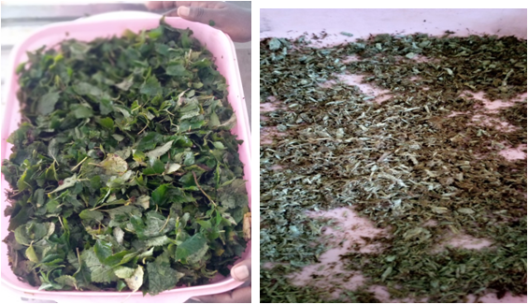
Figure 2.Sample Collection and Preparation of Plant material

3.3. Extraction
Macerate extraction method was employed to get crude extract from leaf and root of Ocimum gratissimum using three different solvent with increasing their polarity diether, acetone and ethanol according to the methods described in (Geremew et al., 2018). The sieved powder forms of Ocimum gratissimum leaves and roots of 0.35kg were with ethanol, acetone and diether in500ml beaker. Then the mixture was homogenized by using shaker at room temperature with frequent agitation. After 24hrs the plant material was filtered by using cotton followed by a double layer filter paper (Whatmann No.1) giving filtrates and residues. All filtrates were concentrated to obtain crude extracts with Rota vapour. After filtration ethanol, acetone and diether were evaporated from the extract. The extracts were dried at room temperature and it was kept in refrigerator at 4°C until use for further experiments (Geremewet al., 2018, Akinmoladun et al., 2007 and Mounyr et al., 2016).
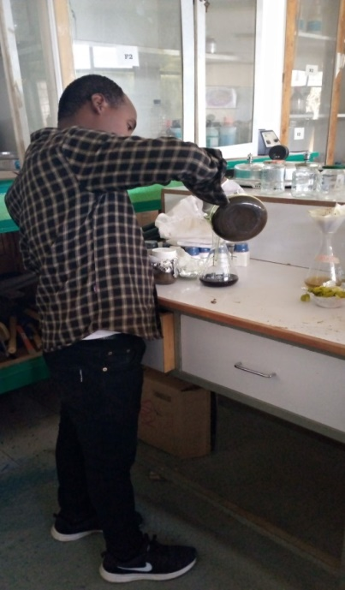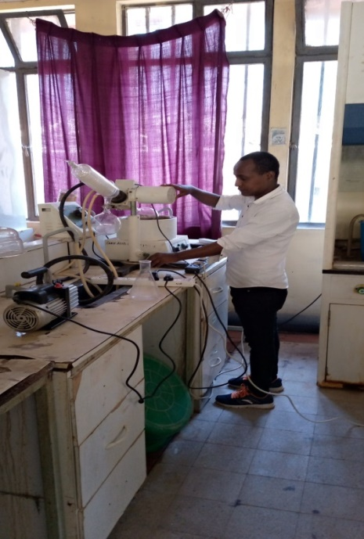

Figure 3. Filtration and removal of extracting solvents

3.4. Determination of percentage yields of crude extracts
Three hundred fifty grams of powdered plant materials were used to obtain crude extracts from plant leaf and roots. The percentage yield for each solvent extract was the amount of crude extract recovered in mass compared with the initial amount of powdered plant material used. It is presented in percentage (%) and was determined for each extraction solvent used.
*Percentage yield (%) = ($\frac{WCE}{WPM})$×100(Parekh and Chanda, 2007)
WCE = (Weight of crude extracts (gm.)
WPM = (Weight of plant material (gm.)

3.5 Microbial Strain
The pure culture of bacteria of some human pathogenic(Streptococcus agalactiae, Pseudomonas aeruginosa,,E.coli, and Klebsiella pneumonia) was obtained from Ethiopian Public Health Institute (EPHI), Addis Ababa. The Bacillus species, and candida species were cultured ,isolated and identified by using morphological methods in Ambo microbiology laboratory by using standard protocol of (Chowdhary, 2000) and (Aggarwal and Hasija, 1980) one Asperigillus species was obtained from laboratory .The cultured bacterial strains were also sub cultured using Muller Hinton Agar (MHA) (and were allowed to incubate at 37ºC for 18-24 h) while fungal cultures were sub cultured and maintained using Potato Dextrose Agar (PDA) and incubated at 27 º C for 6 days (Kesatebrhan,2013).
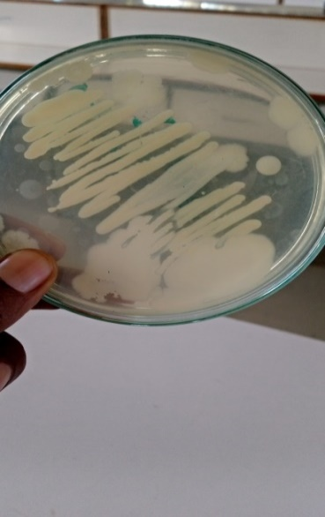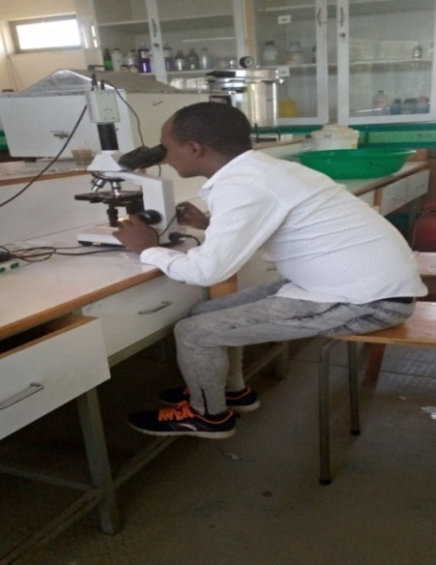

Figure 4.Isolation of Bacillus species

3.6. Standard bactericides
The following Third generation drugs Ceftriaxone (5 μg) disc for Gram-negative bacteria Amoxicillin (30 μg) disc for Gram-positive bacteria and Copper sulphate for fungi was prepared according to the method described in (Bonev et al., 2008). Both drugs and Copper sulphate was used as positive control for antimicrobial susceptibility test whereas; distilled water was served as negative control.

3.7. Preparation of test solution
The crude ethanol, acetone and diether extracts of Ocimum gratissimumn leaf and roots were further diluted to make three different working solutions i.e. 20mg/ml, 30mg/ml and 40mg/ml for the anti-microbial activity test. The first working solution was prepared by transferring 20mgof each extract to sterile test tub containing 1ml of sterile distilled water to give 20mg/ml working solution. Similarly the second and the third working solution were prepared by adding 30mg and 40mgacetone, diether and ethanol crude extract of leaves and root to the test tubes with 1ml of distilled water to prepare 30mg/ml and 40mg/ml of working solutions.

3.8. Preparation of Inoculums
Three to five well isolated bacterial colonies were selected from the plates and transferred into test tubes containing sterile nutrient broth solution. Then it was incubated in 24 hours and similarly buffer solution was used to extract spore suspensions of candida specie and Aspergillus species from PDA medium ( Bazie et al., 2014).

3.9. Antimicrobial test
The anti-bacterial activity of the plant extract was evaluated by using agar well diffusion method as described in (Mounyret al., 2016). Mueller Hinton agar weighting 38grams was put into a conical flask containing 1 liter of distilled water. This mixture was swirled vigorously for 5 minutes left for 10 minutes on the laboratory bench. The mixture was sterilized by autoclaving. The solution was allowed to cool down to ambient temperature of 32.6°C before pouring into the Petri dishes for bacteria. Potato Dextrose Agar (PDA) was prepared according to the manufacturing protocol, 1000ml of distilled water was added to 39gm PDA and boiled to mix the powder and distilled water. The media was autoclaved and subsequently poured in sterile Petri dish plates for fungi. Following this, take the following concentrations from prepared test solutions i.e. (20mg/ml, 30mg/ml, and 40mg/ml) each well was poured with 50µl test solution of the extract by using micro pipette. One well with 50µl of distilled water will been taken as negative control in both. One well with 50µl of Copper sulphate was taken as positive control for fungi and one disc of standard bactericides; Ceftriaxone (5 μg) and amoxicillin (30 μg) was taken as positive control for bacteria. Finally the plates were incubated at 28 °C for 48 hours for fungi and 37ºC for 24hours for bacteria. After given hours zone of inhibition will be recorded by measuring the diameter of each zone by millimetre (mm). Experiments were performed in triplicate and the average result was recorded as described in (Mounyr et al., 2016) with some minor modification.
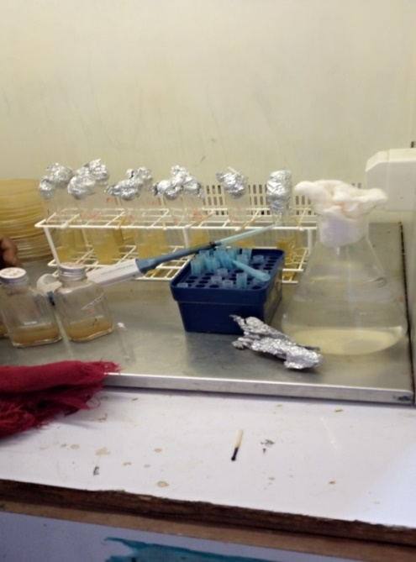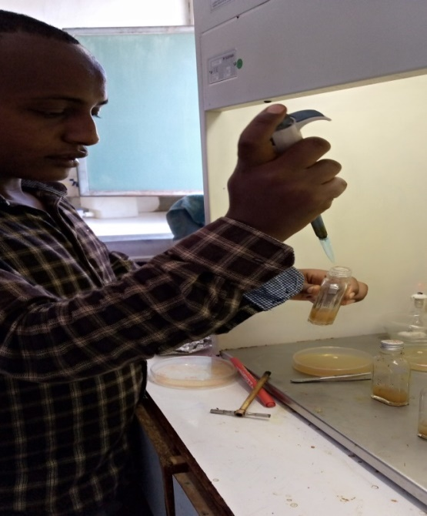

Figure 5.Antimicrobial testing

3.9. Determination of Minimum Inhibitory Concentration (MIC)
The minimum inhibitory concentration (MIC) of ethanol, acetone and diether crude extracts of the leaves and root of Ocimum gratissimum were showed effective antimicrobial activity. It was determined according to the method described in (Ogbo and Oyibo, 2008; Geremew et al, 2018). The agar well diffusion test was selected for determining MIC. 40mg of the dried ethanol, acetone and diether crude extracts were dissolved with 1ml of distilled water in test tubes to obtain 40mg/ml (w/v) stock solution and the solution was serially diluted as start from 1:1, 1:2, 1:4, 1:8, 1:16 and 1:32 to get 40mg/ml, 20mg/ml, 10mg/ml, 5mg/ml, 2.5mg/ml, and 1.25mg/ml (v/v) concentrations respectively. The same procedures applied in antibacterial and antifungal susceptibility test. The Mueller Hinton agar and PDA were first prepared according to the manufacturing protocol and sterilized by autoclaving.The sterilized media were prepared to sterilized petri plates and allowed to solidify. Wells were also prepared for each concentration of plant extracts by using cork borer. Subsequently, a loopful suspension of some human pathogenic bacteria and fungi strain was spread uniformly with the help of sterile cotton swab. Then after 50µl taken from different concentration of extract (40mg/ml, 20mg/ml, 10mg/ml, 5mg/ml,2.5mg/ml, and 1.25mg/ml) and were poured in to each well. The plates were then incubated at 28 °C for 48 hrs. Following this, the colony of some human pathogenic bacteria and fungi was observed and recorded. All procedures will be repeated three times in order to confirm results. The lowest concentration of extract that inhibit the visible growth of the human pathogenic bacteria was recorded as the MIC value (Ogbo and Oyibo, 2008; Geremew et al., 2018).

3.10. Statistical Analysis
All the experiments were done in triplicate and standard deviation from the mean was calculated.Comparisons were made between the effects of crude extracts and positive control by using one way ANOVA (Tukey), P <0.05 was considered statistically significance.

4. RESULTS AND DISCUSSION

4.1. Yield of Crude Extracts
The result of percentage yield of crude extracts is presented in table 1. The percentage yield of the crude extracts ranged from 3.7% to 6% and 2% to3% of leaf and roots respectively. Ethanol extract of the leaf resulted in maximum yield which is 6%, followed by Acetone and diether extract of leaf which produced 4% and 3.7 % respectively. The lowest yield was obtained from diether extracts of the leaf (3.7%) and ethanol extract of the roots which was 3%, followed by acetone and diether extract of roots which was 2.3% and 2 % respectively. The results clearly showed that the percentage yield of crude extracts from plant leaf and root parts varied from solvent to solvent. This could be attributed to the different polarity and potential of extracting solvents. Table 1, also showed that the percentage yield of the crude extracts using the same plant part varied from polar solvents to non-polar solvent. When different solvents are compared for the yield of crude extract the polar solvent gave the maximum yield and the non-polar extract has minimum yield.
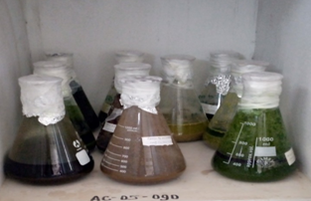

Figure 6: Dissolve the powder in solvent

Table 1: Percentage yield of crude extracts obtained from Ocimum gratissimum leaves and roots
Plant part | Solvents | Dry sample weight (g) | Extract weight (g) | Percentage yield (%)
Leaf | Ethanol | 350 | 21 | 6
Leaf | Acetone | 350 | 15 | 4
Leaf | Diether | 350 | 13 | 3.7
Roots | Ethanol | 350 | 11 | 3
Roots | Acetone | 350 | 8 | 2.3
Roots | Diether | 350 | 7 | 2

4.2. Anti-bacterial activity of ethanol crude extracts of Ocimum gratissimum leaf and root against gram positive bacteria.
Ethanol crude extracts of the Ocimum gratissimum leaf and root were tested for their antibacterial activity against Bacillus species and Streptococcus agalactiae. The zone of inhibition is directly proportional to the concentrations of the extracts in Table 2. Maximum inhibition was observed at 40mg/ml of concentration where (20.20 ± 1.04 and 16.33 ± 0.76 mm) and (19. 4 ± 0.95 and15.11 ± 0.6 mm); zones of inhibition in comparison to positive control which has ( 24.20 ± 0.50 and 24.20 ± 0.50 mm ) and (23.67 ± 0.57and 24.00 ± 0.1 mm) of inhibition was recorded in Bacillus cereus and Streptococcus agalactiae respectively. According to my result ethanol extract of Ocimum gratissimum leaf showed maximum antibacterial activity against Streptococcus agalactiae and Bacillus species. This result similar to (Agatemor, 2009) that showed the ethanol extract of Ocimum gratissimum leaf showed maximum antibacterial activity against gram positive bacteria. However, these authors did not determine the antibacterial effect of the root extract of Ocimum gratissimum.
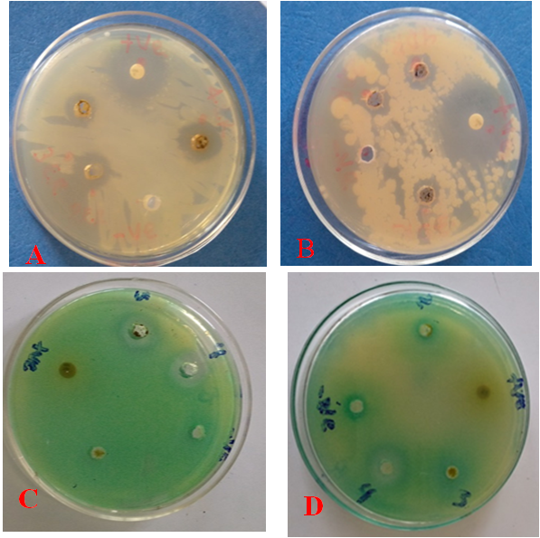
Fig 7. Inhibition zone of ethanol extracts: A) leaf extracts on Bacillus species, B, root extracts on Bacillus species C, leaf extracts on Streptococcus agalactiae D, root extracts on Streptococcus agalactiae.

Table 2: Effect of ethanol crude extracts of Ocimum gratissimum leaf and root against gram positive bacteria.
Test pathogen | Test materials | Concentration | Inhibition Zone (mm) | P= value
Bacillus species | Ethanol crude extract leaf | 20mg/ml | 8.33 ± 0.76 | 0.00
Bacillus species | Ethanol crude extract leaf | 30mg/ml | 12.00 ± 0.50 | 0.00
Bacillus species | Ethanol crude extract leaf | 40mg/ml | 20.20 ± 1.04 | 0.13
Bacillus species | PC | 100ug/ml | 24.20 ± 0.50
Bacillus species | NC | 1ml | 0.00 ± 0.00 | 0.00
Streptococcus agalactiae | Ethanol crude extract leaf | 20mg/ml | 7. 61 ± 0.81 | 0.00
Streptococcus agalactiae | Ethanol crude extract leaf | 30mg/ml | 11. 73 ± 0.95 | 0.00
Streptococcus agalactiae | Ethanol crude extract leaf | 40mg/ml | 19. 4 ± 0.95 | 0.094
Streptococcus agalactiae | PC | 100 μg/ml | 23.67 ± 0.57
Streptococcus agalactiae | NC | 1ml | 0.00 ± 0.00 | 0.00
Bacillus species | Ethanol crude extract root | 20mg/ml | 4.33 ± 0.61 | 0.00
Bacillus species | Ethanol crude extract root | 30mg/ml | 10.00 ± 0.90 | 0.01
Bacillus species | Ethanol crude extract root | 40mg/ml | 16.33 ± 0.76 | 0.067
Bacillus species | PC | 100 μg/ml | 24.20 ± 0.50
Bacillus species | NC | 1ml | 0.00 ± 0.00 | 0.00
Streptococcus agalactiae | Ethanol crude extract root | 20mg/ml | 4.1 ± 0.57 | 0.00
Streptococcus agalactiae | Ethanol crude extract root | 30mg/ml | 9.43 ± 0.5 | 0.00
Streptococcus agalactiae | Ethanol crude extract root | 40mg/ml | 15.11 ± 0.6 | 0.062
Streptococcus agalactiae | PC | 100ug/ml | 24.00 ± 0.1
Streptococcus agalactiae | NC | 1ml | 0.00 ± 0.00 | 0.00
*Values represent the mean of triplicate and ± standard deviation from mean. Where, PC; Positive control, NC; Negative control
The growth inhibitory activities of the crude extract at a concentration of 40mg/ml are insignificantly different from that of standard antibacterial drugs (P > 0.05) (Table 2). The significant difference between the crude extract of Ocimum gratissimum leaf and root at 40mg/ml with the negative control (distilled water) and the insignificant difference between the extract and the positive control (Amoxicillin disc) indicates that the extract has inhibitory effect on tested bacterial pathogen comparable to that of the standard antibacterial drugs. Although the crude extract of Ocimum gratissimum at concentration of 20mg/ml and 30mg/ml is significantly different to that of the standard drugs, the significant difference that exists between them, and they have some inhibitory effect against bacteria strain tested in this study (Table 2). Positive control (Amoxicillin) at 100µg/ml concentration inhibits the growth of Bacillus species and Streptococcus agalactiae with mean inhibition value of (24.20 ± 0.50 and 24.20 ± 0.50 mm) and (23.67 ± 0.57 and 24.00 ± 0.1mm) respectively. This indicates that positive control has highest anti-bacterial activity than crude extracts of Ocimum gratissimum leaf and root. The negative control used here, distilled water, showed no inhibition showed against tested bacterial strains.

4.3. Anti-bacterial activity of Diether crude extracts of Ocimum gratissimum leaf and root against gram positive bacteria
The effect of diether crude extracts of O. gratissimum leaf and root against the growth of two gram positive bacteria is presented in table 3. The diether crude extracts leaf and root at 40mg/ml showed highest antibacterial activity with mean inhibition value of (15.33 ± 0.76 and10.33 ± 1.30mm) and (14. 8 ± 0.8 and 9.9 ± 0.36 mm) zone of inhibition, while positive control showed ( 24.20 ± 0.50mm and 24.20 ± 0.50mm) and( 24.20 ± 0.57and 24.20 ± 0.57mm) zone of inhibition was recorded in Bacillus species and Streptococcus agalactiae respectively. According this result antibacterial activity of diether crude extract of Ocimum gratissimum leaves and root against gram positive bacteria were tested at various concentrations i.e. 20mg/ml, 30mg/ml and 40mg/ml. These three concentrations showed inhibitory activity on the colony growth of Bacillus species and Streptococcus agalactiae .In this result diether crude extract of the Ocimum gratissimum leaves and root at high concentration showed high inhibition zones and at low concentration showed low inhibition zones on colony growth of Bacillus species and Streptococcus agalactiae was observed. The result is agreed with (Okonko et al., 2012) that showed the increase of concentration of the crude extracts the greater inhibition of colony growth of bacteria was observed.

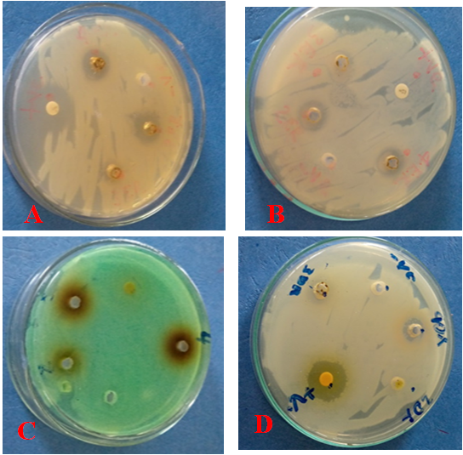
Fig 9. Inhibition zone of diether extracts: A) leaf extracts on Bacillus species B, root extracts on Bacillus species C, leaf extracts on Streptococcus agalactiae D, root extracts on Streptococcus agalactiae.

Table 3: Effect of diether crude extracts of Ocimum gratissimum leaf and root against the colony growth of gram positive bacteria
Test pathogen | Test materials | Concentration | Zone of inhibition(mm) | P= value
Bacillus species | Diether crude extract leaf | 20mg/ml | 5.00 ± 0.50 | 0.00
Bacillus species | Diether crude extract leaf | 30mg/ml | 9.10 ± 1.01 | 0.00
Bacillus species | Diether crude extract leaf | 40mg/ml | 15.33 ± 0.76 | 0. 056
Bacillus species | PC | 100ug/ml | 24.20 ± 0.50
Bacillus species | NC | 1ml | 0.00 ± 0.00 | 0.00
Streptococcus agalactiae | Diether crude extract leaf | 20mg/ml | 4.8 ± 0.26 | 0.00
Streptococcus agalactiae | Diether crude extract leaf | 30mg/ml | 8. 50 ± 0.5 | 0.00
Streptococcus agalactiae | Diether crude extract leaf | 40mg/ml | 14. 8 ± 0.8 | 0.054
Streptococcus agalactiae | PC | 100ug/ml | 24.20 ± 0.57
Streptococcus agalactiae | NC | 1ml | 0.00 ± 0.00 | 0.00
Bacillus species | Diether crude extract root | 20mg/ml | 4.50 ± 0.50 | 0.00
Bacillus species | Diether crude extract root | 30mg/ml | 6.16 ± 1.04 | 0.00
Bacillus species | Diether crude extract root | 40mg/ml | 10.10 ± 1.30 | 0.052
Bacillus species | PC | 100ug/ml | 24.20 ± 0.50
Bacillus species | NC | 1ml | 0.00 ± 0.00 | 0.00
Streptococcus agalactiae | Diether crude extract root | 20mg/ml | 4.06 ± 0.20 | 0.00
Streptococcus agalactiae | Diether crude extract root | 30mg/ml | 5. 70 ± 0.25 | 0.00
Streptococcus agalactiae | Diether crude extract root | 40mg/ml | 9.9 ± 0.36 | 0.05
Streptococcus agalactiae | PC | 100ug/ml | 24.20 ± 0.57
Streptococcus agalactiae | NC | 1ml | 0.00 ± 0.00 | 0.00
*Values are the mean of triplicate ± indicated standard deviation, Where, PC; Positive control, NC; Negative control
The growth inhibitory effect of the crude extract of Ocimum gratissimum leaf and root (20mg/ml, 30mg/ml and 40mg/ml), were significantly different from the negative control, distilled water (P = 0.00). Insignificance difference between the diether crude extract of Ocimum gratissimum leaf and root at 40mg/ml with positive control (P >0.05). This indicates that the crude extracts at the concentration 40mg/ml has protection to possess the two positive bacterial comparable with positive control (Amoxicillin disc).

4.4. Antibacterial activity of ethanol crude extracts of Ocimum gratissimum leaf and root against gram negative bacteria.
Ethanol crude extracts of the Ocimum gratissimum leaf was tested for its antibacterial activity against the growth of Pseudomonas aeruginosa, Klebsiella pneumonia and E.coli. Maximum inhibition was observed at 40mg/ml 17.36 ± 1.30, 15. 36 ± 0.70 and 7. 84 ± 0.35mm zone of inhibition respectively, while positive control resulted 25.90 ± 0.30, 27.20 ± 0.87 and 29. 90 ± 0.3 mm of inhibition for Pseudomonas aeruginosa, Klebsiella pneumonia and E.coli respectively (table 4).Also ethanol extract of Ocimum gratissimum roots produced concentration dependent manner inhibition of the colony growth of Pseudomonas aeruginosa, Klebsiella pneumonia and E.coli. 40mg/ml of roots extract has produced (13.60 ± 1.30, 11.56 ± 1 and 5.83 ± 0.4 mm) zone of inhibition. The positive control was resulted (27.50 ± 0.30, 29.16 ± 0.76 and 35.7± 0.75 mm) zone of inhibition respectively. According to this study Ethanol crude extracts of the Ocimum gratissimum leaves and root were tested for their antibacterial activity against the colony growth of Pseudomonas aeruginosa, Klebsiella pneumonia and E.coli .This study similary to (Stanley et al., 2014) who reported the strong inhibitory action of ethanolic leaf extract of Ocimum gratissimum against gram negative bacteria. However, these authors did not define the antibacterial effect of the root extract of Ocimum gratissimum.

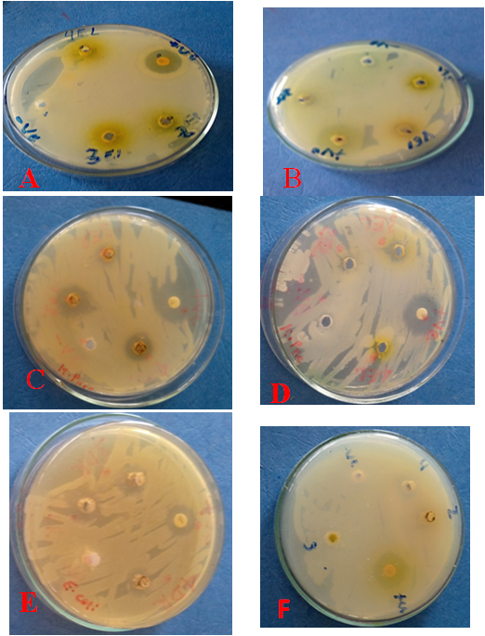
Fig 10. Inhibition zone of ethanolic extracts: A) leaf extracts on Pseudomonas aeuroginosa , B, root extracts on Psudomonas eauroginosa C, leaf extracts on Kelbsellia pnuemona D, root extracts on Kelbsellia pnuemona E,leaf extracts on, E.coli, F), root extracts on E.coli.

Table 4: Effect of ethanol crude extracts of Ocimum gratissimum leaf against the colony growth of gram negative bacteria
Test pathogen | Test materials | Plant part | Concentration | Inhibition Zone (mm) | P= value
Pseudomonas aeruginosa | ethanol crude extract | leaf | 20mg/ml | 7.30 ± 0.40 | 0.00
Pseudomonas aeruginosa | ethanol crude extract | leaf | 30mg/ml | 10.73± 0.30 | 0.00
Pseudomonas aeruginosa | ethanol crude extract | leaf | 40mg/ml | 17.36 ± 1.30 | 0.063
Pseudomonas aeruginosa | PC | Leaf | 100ug/ml | 25.90 ± 0.30
Pseudomonas aeruginosa | NC | Leaf | 1ml | 0.00 ± 0.00 | 0.00
Klebsiella pneumonia | Ethanol crude extract | Leaf | 20mg/ml | 6.70 ± 0.32 | 0.00
Klebsiella pneumonia | Ethanol crude extract | Leaf | 30mg/ml | 10.06 ± 0.3 | 0.00
Klebsiella pneumonia | Ethanol crude extract | Leaf | 40mg/ml | 15.36 ± 0.70 | 0.059
Klebsiella pneumonia | PC | Leaf | 100ug/ml | 25.20 ± 0.87
Klebsiella pneumonia | NC | Leaf | 1ml | 0.00 ± 0.00 | 0.00
E.coli | Ethanol  crude extract | Leaf | 20mg/ml | 2.50 ± 0.50 | 0.00
E.coli | Ethanol  crude extract | Leaf | 30mg/ml | 3.50 ± 0.70 | 0.00
E.coli | Ethanol  crude extract | Leaf | 40mg/ml | 7.84 ± 0.35 | 0.045
E.coli | PC | Leaf | 100ug/ml | 25.70 ± 0.36
E.coli | NC | Leaf | 1ml | 7.30 ± 0.40 | 0.00
Pseudomonas aeruginosa | ethanol crude extract | Root | 20mg/ml | 4.10 ± 0.40 | 0.00
Pseudomonas aeruginosa | ethanol crude extract | Root | 30mg/ml | 9.10± 0.30 | 0.00
Pseudomonas aeruginosa | ethanol crude extract | Root | 40mg/ml | 13.60 ± 1.30 | 0.056
Pseudomonas aeruginosa | PC | Root | 100ug/ml | 27.50 ± 0.30
Pseudomonas aeruginosa | NC | Root | 1ml | 0.00 ± 0.00 | 0.00
Klebsiella pneumonia | ethanol crude extract | Root | 20mg/ml | 3.70 ± 0.26 | 0.00
Klebsiella pneumonia | ethanol crude extract | Root | 30mg/ml | 8.03 ± 0.45 | 0.00
Klebsiella pneumonia | ethanol crude extract | Root | 40mg/ml | 11.56 ± 1 | 0.052
Klebsiella pneumonia | PC | Root | 100ug/ml | 28.16 ± 0.76
Klebsiella pneumonia | NC | Root | 1ml | 0.00 ± 0.00 | 0.00
E.coli | ethanol crude extract | Root | 20mg/ml | 2.00 ± 0.60 | 0.00
E.coli | ethanol crude extract | Root | 30mg/ml | 2.50 ± 0.80 | 0.00
E.coli | ethanol crude extract | Root | 40mg/ml | 5.83 ± 0.4 | 0.043
E.coli | PC | Root | 100ug/ml | 28.70 ± 0.75
E.coli | NC | Root | 1ml | 0.00 ± 0.00 | 0.00

*Values represent the mean of triplicate and ± standard deviation from mean. Where, PC; Positive control, NC; Negative control
The growth inhibitory effect of the crude extract of Ocimum gratissimum leaf and root (20mg/ml, 30mg/ml and 40mg/ml), were significantly different from the negative control, distilled water (P = 0.00). The ethanol crude extract of Ocimum gratissimum leaf and root at 40mg/ml with positive control not showed significance differences (P≥ 0.05) in Pseudomonas aeruginosa and Klebsiella pneumonie. This indicates that the crude extracts at the concentration 40mg/ml has possess gram negative bacterial inhibitory comparable with positive control (ceftriaxone disc).Where significance in E.coli this indicates the crude extracts of Ocimum gratissimum leaf and root at the concentration 40mg/ml has some inhibitory against E.coli.

4.5. Antibacterial activity of diether crude extracts of Ocimum gratissimum leaf and root against gram negative bacteria.
Diether crude extracts of the O. gratissimum leaves were tested for their antibacterial activity against the colony growth of Pseudomonas aeruginosa, Klebsiella pneumonia and E.coli Table 5, the zone of inhibition is directly proportional to the working concentrations. Maximum inhibition was observed at 40mg/ml 12.60 ± 0.40, 11. 16 ± 0.37 and 4. 60 ± 0.15mm respectively whereas; in comparison to positive control which has 27.50 ± 0.50, 29.60 ± 0.76 and 38. 10 ± 0.3 mm of inhibition was recorded in Pseudomonas aeruginosa ,Klebsiella pneumonia and E.coli respectively. The effect of diether crude extracts of O. gratissimum roots against the colony growth of three gram negative bacteria was studied at various concentrations i.e. 20mg/ml, 30mg/ml and 40mg/ml. The result highlighted in table 5 showed that diether root crude extracts at 40mg/ml showed highest antibacterial activity with mean inhibition value of 8.66 ± 1.50, 7. 63 ± 0.8 and 3.73 ± 0.26 mm while in comparison to positive control where 30.60 ± 0.52 ,34.50 ± 0.81and 43.00 ± 1.50mm zone of inhibition was recorded respectively. In this study the diether crude extract of leaf and root of Ocimum gratissimum was studied for their antimicrobial activities against gram negative bacteria ( Pseudomonas aeruginosa ,Klebsiella pneumonia and E. coli) using agar well diffusion method. The study revealed that diether crude extract of leaf extracts were found to have higher zones of inhibition than the root extracts.

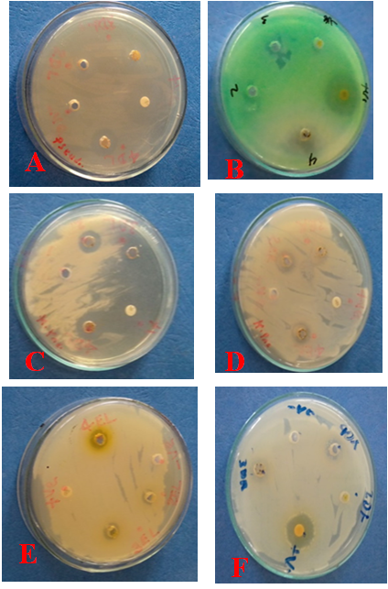
Fig 11. Inhibition zone of diether extracts: A) leaf extracts on Pseudomonas aeuroginosa , B, root extracts on Psudomonas eauroginosa C, leaf extracts on Kelbsellia pnuemonae D, root extracts on Kelbsellia pnuemonae E ,leaf extracts on, E.coli, F), root extracts on E.coli.

Table 5: Effect of diether crude extracts of Ocimum gratissimum leaf against the colony growth of three gram negative bacteria
Test pathogen | Test materials | Plant part | Concentration | Zoneof inhibition(mm) | P= value
Pseudomonas aeruginosa | Diether crude extract | leaf | 20mg/ml | 4.70 ± 0.80 | 0.00
Pseudomonas aeruginosa | Diether crude extract | leaf | 30mg/ml | 7.260± 0.60 | 0.00
Pseudomonas aeruginosa | Diether crude extract | leaf | 40mg/ml | 12.60 ± 0.40 | 0.053
Pseudomonas aeruginosa | PC | Leaf | 100ug/ml | 27.50 ± 0.50
Pseudomonas aeruginosa | NC | Leaf | 1ml | 0.00 ± 0.00 | 0.00
Klebsiella pneumonia | Diether crude extract | leaf | 20mg/ml | 3.40 ± 0.36 | 0.00
Klebsiella pneumonia | Diether crude extract | leaf | 30mg/ml | 7.13 ± 0.45 | 0.00
Klebsiella pneumonia | Diether crude extract | leaf | 40mg/ml | 11.16 ± 0.37 | 0.050
Klebsiella pneumonia | PC | Leaf | 100ug/ml | 27.60 ± 0.76
Klebsiella pneumonia | NC | Leaf | 1ml | 0.00 ± 0.00 | 0.00
E.coli | Diether  crude extract | Leaf | 20mg/ml | 1.96 ± 0.50 | 0.00
E.coli | Diether  crude extract | Leaf | 30mg/ml | 2.10 ± 0.17 | 0.00
E.coli | Diether  crude extract | Leaf | 40mg/ml | 4.6 ± 0.15 | 0.040
E.coli | PC | Leaf | 100ug/ml | 28.10 ± 1.25
E.coli | NC | Leaf | 1ml | 0.00 ± 0.00 | 0.00
Pseudomonas aeruginosa | Diether  crude extract | Root | 20mg/ml | 4.00 ± 0.450 | 0.00
Pseudomonas aeruginosa | Diether  crude extract | Root | 30mg/ml | 6.0± 0.20 | 0.00
Pseudomonas aeruginosa | Diether  crude extract | Root | 40mg/ml | 8.66± 1.50 | 0.048
Pseudomonas aeruginosa | PC | Root | 100ug/ml | 30.6± 0.52
Pseudomonas aeruginosa | NC | Root | 1ml | 0.00 ± 0.00 | 0.00
Klebsiella pneumonia | Diether  crude extract | Root | 20mg/ml | 3.40± 0.20 | 0.00
Klebsiella pneumonia | Diether  crude extract | Root | 30mg/ml | 4.96± 0.25 | 0.00
Klebsiella pneumonia | Diether  crude extract | Root | 40mg/ml | 7.63± 0.80 | 0.044
Klebsiella pneumonia | PC | Root | 100ug/ml | 34.50± 0.81
Klebsiella pneumonia | NC | Root | 1ml | 0.00 ± 0.00 | 0.00
E.coli | Diether  crude extract | Root | 20mg/ml | 1.70± 0.860 | 0.00
E.coli | Diether  crude extract | Root | 30mg/ml | 1.9± 0.60 | 0.00
E.coli | Diether  crude extract | Root | 40mg/ml | 3.73± 0.26 | 0.036
E.coli | PC | Root | 100ug/ml | 43.00 ± 1.50
E.coli | NC | Root | 1ml | 0.00 ± 0.00 | 0.00

*Values represent the mean of triplicate and ± standard deviation from mean. Where, PC; Positive control, NC; Negative control.
The significant difference between the crude extract of Ocimum gratissimum leaf at 40mg/ml with the negative control (distilled water) and the insignificant difference between the extract and the positive control (ceftriaxone disc) except in E.coli and indicates that the extract has inhibitory effect on tested bacterial pathogen comparable to that of the standard antibacterial drugs and they have some inhibitory effect against E.coli. Although the diether crude extract of Ocimum gratissimum root at concentration of 40mg/ml is significantly different to that of the standard drugs (P <0.05), the significant difference that exists between them, and they have some inhibitory effect against bacteria strain tested.

4.6. Antifungal activity of ethanol, acetone and diether crude extracts of Ocimum gratissimum leaf and roots against candida species.
Ethanol, acetone and diether crude extracts of the Ocimum gratissimum leaves and roots were tested for their antifungal activity against the mycelium growth of candida species .Antifungal activity was tested at various concentrations i.e. 20mg/ml, 30mg/ml and 40mg/ml. As seen in Table 6, the zone of inhibition is directly proportional to the concentrations of the crude extract. Maximum inhibition was observed at 40mg/ml (18.10 ± 0.260 and 15.70 ± 0.430) in ethanol, (12.28 ± 1.1 and 10.50 ± 0.730) in acetone and (9.50 ± 0.5and 7.36± 0.32) in diether zone of inhibition was noted respectively while the positive control was resulted (27.2 ± 1.3 and 27.02 ± 0.62) in ethanol, (30.6± 0.9 and 30.60 ± 0.9) mm in acetone and (36.06± 0.66 and 30.60 ± 0.66) in diether zone of inhibition was recorded. According to this study candida species the most sensitive organisms to ethanol crude extract of Ocimum gratissimum leaf with the zone of inhibition of 18.10 ± 0.260 at concentrations of 40mg/ml. The result is agreed with (Nakamura et al., 2004) who suggests that ethanol crude extract of Ocimum gratissimum leaf have inhibitory effect on candida species.

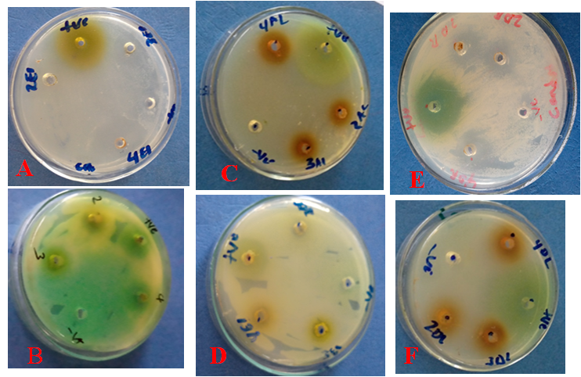
Fig12. Effect leaf and roots crude extract on Candia species A, ethanonlic extract s of leaves B, ethanol extracts of roots, C, acetone extracts of leaf, D, acetone extracts of roots , E, diether extracts of leaf, F, diether extracts of roots.

Table 6: Effect of crude extracts of Ocimum gratissimum leaf and roots against the mycelium growth of candida species
Test pathogen | Test materials | Plant part | Concentration | Zoneof inhibition(mm) | P= value
Candida species | Ethanol crude extract | Leaf | 20mg/ml | 13.10 ± 0.58 | 0.01
Candida species | Ethanol crude extract | Leaf | 30mg/ml | 17.50 ± 0.50 | 0.00
Candida species | Ethanol crude extract | Leaf | 40mg/ml | 18.10 ± 0.260 | 0.80
Candida species | PC | Leaf | 100ug/ml | 27.2 ± 1.3
Candida species | NC | Leaf | 1ml | 00.00 ± 0.00 | 0.00
Candida species | Ethanol crude extract | Roots | 20mg/ml | 11.30 ± 0.70 | 0.03
Candida species | Ethanol crude extract | Roots | 30mg/ml | 13.80 ± 0.850 | 0.00
Candida species | Ethanol crude extract | Roots | 40mg/ml | 15.70 ± 0.430 | 0.065
Candida species | PC | Roots | 100ug/ml | 28.50 ± 0.560
Candida species | NC | Roots | 1ml | 00.00 ± 0.00 | 0.00
Candida species | Acetone crude extract | Leaf | 20mg/ml | 9.46± 0.5 | 0.00
Candida species | Acetone crude extract | Leaf | 30mg/ml | 10.10 ± 0.50 | 0.02
Candida species | Acetone crude extract | Leaf | 40mg/ml | 12.28± 1.1 | 0.052
Candida species | PC | Leaf | 100ug/ml | 30.6 ± 0.9
Candida species | NC | Leaf | 1ml | 00.00 ± 0.00 | 0.00
Candida species | Acetone crude extract | Roots | 20mg/ml | 7.03 ± 0.450 | 0.00
Candida species | Acetone crude extract | Roots | 30mg/ml | 8.36 ± 0.320 | 0.00
Candida species | Acetone crude extract | Roots | 40mg/ml | 10.5 ± 0.730 | 0.05
Candida species | PC | Roots | 100ug/ml | 30.60 ± 0.90
Candida species | NC | Roots | 1ml | 00.00 ± 0.00 | 0.00
Candida species | Diether crude extract | Leaf | 20mg/ml | 5.2 ± 0.7 | 0.00
Candida species | Diether crude extract | Leaf | 30mg/ml | 6.60 ± 1.1 | 0.00
Candida species | Diether crude extract | Leaf | 40mg/ml | 9.50 ± 0.50 | 0.049
Candida species | PC | Leaf | 100ug/ml | 36.06 ± 0.66
Candida species | NC | Leaf | 1ml | 00.00 ± 0.00 | 0.00
Candida species | Diether crude | Roots | 20mg/ml | 4.26 ± 0.30 | 0.00
Candida species | Diether crude | Roots | 30mg/ml | 6.20 ± 0.520 | 0.00
Candida species | Diether crude | Roots | 40mg/ml | 7.36 ± 0.320 | 0.045
Candida species | PC | Roots | 100ug/ml | 36.06 ± 0.66
Candida species | NC | Roots | 1ml | 00.00 ± 0.00 | 0.00

*Values represent the mean of triplicate and ± standard deviation from mean. Where, PC; Positive control, NC; Negative control.
insignificance difference between the ethanol and acetone crude extract of Ocimum gratissimum leaf and roots at the concentration (40mg/ml) with positive control ( copper sulphate) in Table 6, indicates that the crude extract at 40mg/ml have inhibitory effect on candida species .Compare to positive control. where significance difference between the diether crude extract of Ocimum gratissimum leaf and roots at the concentration (40mg/ml) with positive control (copper sulphate ) in Table 6, indicates that the diether crude extract at 40mg/ml have inhibitory some effect on candida species .Compare to positive control.

4.7. Antifungal activity of ethanol, acetone and diether crude extracts of Ocimum gratissimum leaf and roots against Asepergilus species
As denoted in Table 7, ethanol, acetone and diether extract of Ocimum gratissimum leaf and roots produced concentration dependent manner inhibition of the colony growth of Asepergilus species. 40mg/ml of leaf and root extract has produced (14.08 ± 0.230 and 12.90± 0.320) in ethanol, (10.08 ± 0.40 and 6.8 ± 0.230) in acetone and (9.13 ± 0.320 and 7.03 ± 0.450) in diether mm zone of inhibition. The positive control was resulted (27.02 ± 0.620 and 28.50 ± 0.90) in ethanol and (30.9 ± 0.640 and 30.9 ± 0.66) in acetone and (37.06 ± 0.37 and 37.07± 0.250) in diether mm zone of inhibition was recorded respectively. According to this study Asepergilus species the sensitive organisms to ethanol crude extract of Ocimum gratissimum leaf with the zone of inhibition of 14.08 ± 0.23 at concentrations of 40mg/ml this study similar to (Fokou et al., 2014) who stated antimicrobial activities in ethanol extract of the leaf against Aspergillus flavus, Aspergillus fumigatus and Aspergillus niger.

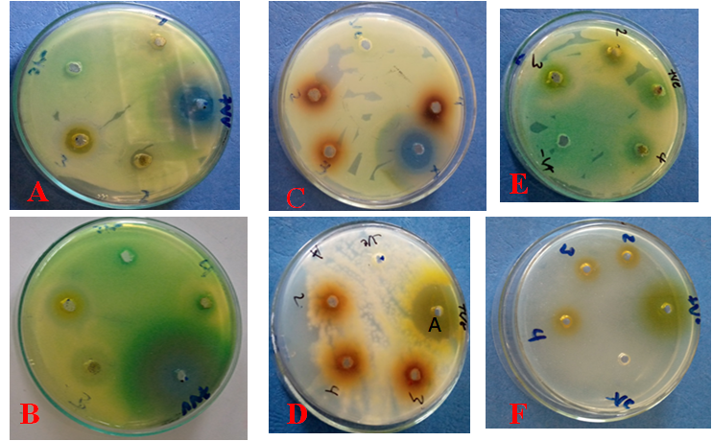
Fig 13. Effect leaf and roots crude extract on Aspergillus species A, ethanol extract s of leaves B, ethanol extracts of roots, C, acetone extracts of leaf, D, acetone extracts of roots , E, diether extracts of leaf, F, diether extracts of roots.

Table 7: Effect of crude extracts of Ocimum gratissimum leaf and roots against the mycelium growth of Asepergilus species
Test pathogen | Test materials | Plant part | Concentration | Zone of inhibition(mm) | P= value
Asepergilus species | Ethanol crude extract | Leaf | 20mg/ml | 8.14 ± 1.1 | 0.00
Asepergilus species | Ethanol crude extract | Leaf | 30mg/ml | 12.0 ± 0.50 | 0.00
Asepergilus species | Ethanol crude extract | Leaf | 40mg/ml | 14.08 ± 0.23 | 0.054
Asepergilus species | PC | Leaf | 100ug/ml | 27.02± 0.62
Asepergilus species | NC | Leaf | 1ml | 00.00 ± 0.00 | 0.00
Asepergilus species | Ethanol crude extract | Roots | 20mg/ml | 6.47 ± 0.840 | 0.00
Asepergilus species | Ethanol crude extract | Roots | 30mg/ml | 11.70 ± 0.260 | 0.02
Asepergilus species | Ethanol crude extract | Roots | 40mg/ml | 12.90 ± 0.320 | 0.051
Asepergilus species | PC | Roots | 100ug/ml | 28.50 ± 0.90
Asepergilus species | NC | Roots | 1ml | 00.00 ± 0.00 | 0.00
Asepergilus species | Acetone crude extract | Leaf | 20mg/ml | 7.36± 0.32 | 0.00
Asepergilus species | Acetone crude extract | Leaf | 30mg/ml | 9.03± 0.550 | 0.00
Asepergilus species | Acetone crude extract | Leaf | 40mg/ml | 10.08± 0.40 | 0.050
Asepergilus species | PC | Leaf | 100ug/ml | 30.9 ± 0.640
Asepergilus species | NC | Leaf | 1ml | 00.00 ± 0.00 | 0.00
Asepergilus species | Acetone crude extract | Roots | 20mg/ml | 3.9 ± 0.10 | 0.00
Asepergilus species | Acetone crude extract | Roots | 30mg/ml | 4.60 ± 0.3 | 0.00
Asepergilus species | Acetone crude extract | Roots | 40mg/ml | 6.8 ± 0.230 | 0.043
Asepergilus species | PC | Roots | 100ug/ml | 30.9 ± 0.66
Asepergilus species | NC | Roots | 1ml | 00.00 ± 0.00 | 0.00
Asepergilus species | Diether crude extract | Leaf | 20mg/ml | 4.90 ± 0.10 | 0.00
Asepergilus species | Diether crude extract | Leaf | 30mg/ml | 7.80 ± 0.9 | 0.00
Asepergilus species | Diether crude extract | Leaf | 40mg/ml | 9.13 ± 0.37 | 0.047
Asepergilus species | PC | Leaf | 100ug/ml | 37.06 ± 0.25
Asepergilus species | NC | Leaf | 1ml | 00.00 ± 0.00 | 0.00
Asepergilus species | Diether crude extract | Roots | 20mg/ml | 4.13 ± 0.41 | 0.00
Asepergilus species | Diether crude extract | Roots | 30mg/ml | 5.80 ± 0.64 | 0.00
Asepergilus species | Diether crude extract | Roots | 40mg/ml | 7.03 ± 0.450 | 0.043
Asepergilus species | PC | Roots | 100ug/ml | 37.70 ± 0.25
Asepergilus species | NC | Roots | 1ml | 00.00 ± 0.00 | 0.00
*Values represent the mean of triplicate and ± standard deviation from mean. Where, PC; Positive control, NC; Negative control.
Insignificance difference between the ethanol crude extract of Ocimum gratissimum leaf and root acetone crude extract of Ocimum gratissimum leaf at the concentration (40mg/ml) with positive control (copper sulphate) and significance in the acetone crude extract of Ocimum gratissimum roots and diether crude extract of Ocimum gratissimum leaf and root Table 7, this indicates that the crude extract leaf at 40mg/ml have inhibitory effect on Asepergilus species where some inhibitory effect at the acetone crude extract of Ocimum gratissimum roots .Compare to positive control. From the two fungal species.
Acording my study acetone based extracts Ocimum gratissimum leaf and root had antimicrobial activity only against candida species and Asepergilus species. This is disagreement with (Ramasamy and Charles, 2004) which acetone and methanol extracts of all plants showed strong antibacterial effect. The difference of the results encountered might be related to factors like the site of plant material collection, the season and time of harvest, type of soil, storage conditions, and method of preparation

4.8. Minimum inhibitory concentration
The minimum inhibitory concentration assay was employed to evaluate the effectiveness of the crude extract from Ocimum gratissimum to inhibit the growth of test pathogens. The extract of O. gratissimum leaves and roots were subjected to the concentration range from 40mg/ml of 50% to 1.25 mg/ml.

Table 8: Minimum inhibitory concentration (MIC) of the ethanol, acetone and diether crude extracts of Ocimum gratissimum leaf and root against some human pathogenic.
Test pathogen | Ocimum grtissimum Ethanol Leaf Extract in mg/ml
 | 40 | 20 |  | 10 |  | 5 |  | 2.5 |  | 1.25
Bacillus species | +++ | ++ |  | + |  | + |  | NE |  | NE
Streptococcus agalactiae | +++ | ++ |  | + |  | + |  | NE |  | NE
Pseudomonas aeruginosa | +++ | ++ |  | + |  | + |  | NE |  | NE
Klebsiella pneumonia | +++ | + |  | + |  | NE |  | NE |  | NE
E.coli | ++ | + |  | NE |  | NE |  | NE |  | NE
candida species | +++ | ++ |  | + |  | + |  | NE |  | NE
Asepergilus species | +++ | ++ |  | + |  | NE |  | NE |  | NE
Test pathogen | Ocimum grtissimum Ethanol Roots Extract in mg/ml
Bacillus species | +++ | ++ |  | + |  | NE |  | NE |  | NE
Streptococcus agalactiae | +++ | ++ |  | + |  | NE |  | NE |  | NE
Pseudomonas aeruginosa | +++ | ++ |  | + |  | NE |  | NE |  | NE
Klebsiella pneumonia | +++ | + |  | + |  | NE |  | NE |  | NE
E.coli | ++ | + |  | NE |  | NE |  | NE |  | NE
candida species | +++ | ++ |  | + |  | NE |  | NE |  | NE
Asepergilus species | +++ | + |  | + |  | NE |  | NE |  | NE
Test pathogen | Ocimum grtissimum Diether leaf Extract in mg/ml
Bacillus species | +++ | ++ |  | + |  | NE |  | NE |  | NE
Streptococcus agalactiae | +++ | ++ |  | + |  | NE |  | NE |  | NE
Pseudomonas aeruginosa | +++ | ++ |  | + |  | NE |  | NE |  | NE
Klebsiella pneumonia | ++ | + |  | + |  | NE |  | NE |  | NE
E.coli | ++ | + |  | NE |  | NE |  | NE |  | NE
candida species | +++ | ++ |  | + |  | NE |  | NE |  | NE
Asepergilus species | ++ | + |  | NE |  | NE |  | NE |  | NE
Test pathogen | Ocimum Diether Roots Extract in mg/ml
 | 40 |  | 20 |  | 10 |  | 5 |  | 2.5 |  | 1.25
Bacillus species | ++ |  | ++ |  | NE |  | NE |  | NE |  | NE
Streptococcus agalactiae | +++ |  | ++ |  | NE |  | NE |  | NE |  | NE
Klebsiella pneumonia and Pseudomonas aeruginosa | ++ |  | ++ |  | NE |  | NE |  | NE |  | NE
E.coli | ++ |  | + |  | NE |  | NE |  | NE |  | NE
candida species | ++ |  | ++ |  | NE |  | NE |  | NE |  | NE
Asepergilus species | ++ |  | + |  | NE |  | NE |  | NE |  | NE
 | Ocimum grtissimum Acetone Leaf Extract in mg/ml
candida species | +++ |  | ++ |  | + |  | NE |  | NE |  | NE
Asepergilus species | ++ |  | + |  | + |  | NE |  | NE |  | NE
 | Ocimum grtissimum Acetone Roots Extract in mg/ml
candida species | +++ |  | ++ |  | NE |  | NE |  | NE |  | NE
Asepergilus species | ++ |  | + |  | NE |  | NE |  | NE |  | NE
*NE = No effect; + = week effect; ++ = moderate effect; +++ = strong effect
The ethanol crude extract of the leaves of Ocimum gratissimum exhibited the MIC value at 5mg/ml against Bacillus species, Streptococcus agalactiae, and Pseudomonas aeruginosa and Candida species. Whereas, the MIC value was exhibited by diether crude extract of Ocimum gratissimum leaf at 10mg/ml against Bacillus species, Streptococcus agalactiae, Pseudomonas aeruginosa , Klebsiella pneumonia, Candida species and Asepergilus species. Then acetone extract of Ocimum gratissimum leaf has the MIC value at 10mg/ml against only candida species and Asepergilus species.The MIC value was exhibited by ethanol crude extract of Ocimum gratissimum roots 10mg/ml against Bacillus cereus, Streptococcus agalactiae, Pseudomonas aeruginosa, Klebsiella pneumonia, candida species and Asepergilus species .Whereas the diether crude extract of the roots of Ocimum gratissimum exhibited the MIC value at 20mg/ml against Bacillus species, Streptococcus agalactiae, Pseudomonas aeruginosa, Klebsiella pneumonia, E.coli, candida species and Asepergilus species. Then acetone extract of Ocimum gratissimum root has the MIC value at 20mg/ml against candida species and Asepergilus species. In this study relatively lowest MIC values recorded for the leaf ethanol extracts of Ocimum gratissimum against the test pathogens confirm the high activity of the extract at low concentrations. This result is agreement with (Ogbo and Oyibo, 2008) that showed the ethanol leaf extract of O. gratissimum with lower MIC scores are very effective antimicrobial agents
.All the above reports were also estimated to confirm the observed inhibitory effect of Ocimum gratissimum extracts in this study. This parameter varied according to tested microorganisms, examined plant parts and solvents (Table 2-8). The result in this experiment indicated that the ethanol extract of leaves was also more potent than other tested extracts. The difference in activity could be related to different secondary metabolites present in each extract. Otherwise, different solvents would have various degrees of solubility for different phytochemical compounds (Amadi et al., 2010). This indicates that the secondary metabolites act as an antimicrobial compounds, which either inhibit or kill the pathogens by different mechanisms.

5. CONCLUSIONS AND RECOMMENDATIONS

5.1. Conclusion
- The results of present study evidenced that Ocimum gratissimum leaf and roots solvent extracts have the ability to inhibit the growth of the selected fungal and bacateria pathogens.
- Also the present study suggested that, the three solvent such as acetone, diether and ethanol extracts of Ocimum gratissimum leaves and roots have showed different power in their extraction efficiency.
- The ethanol extract of Ocimum gratissimum showed maximum antibacterial activity against some human pathogenic (i.e. Bacillus cereus and Streptococcus agalactiae, Pseudomonas aeruginosa, Klebsiella pneumonia, Escherichia coli, Aspergillus species and Candida species) than diether extract.
- The antimicrobial effect of the crude extract of each solvent was found to be concentration dependent manner against the tested pathogens.
- The antimicrobial activity and MIC assay showed promising evidence for the antimicrobial activity of Ocimum gratissimum leaves and roots solvent extracts against selected fungal and bacterial pathogens.
- The positive findings from this study provide a scientific basis for the traditional use of Ocimum gratissimum.
- In general, the outcome of this study is that a scientific basis for the use of Ocimum gratissimum as antimicrobial agent has been established. This may also provide directives for future studies in the treatment of human pathogenic.
- Generally, the result of the present study confirmed the traditional use of Damakese plants against various microbial infections by the people in Ethiopia.

5.2. Recommendations
The following recommendations are forwarded.
- Since the present study focused only on the some antifungal and antibacterial activities of ethanol, acetone and diether crude extracts of leaf and root of Ocimum gratissimum , similar studies need to be performed another plant parts as well as on different fungal and bacterial pathogens to confirm the potential of this plant as a source of novel anti-microbial agent in the future.
- It can also be recommended that future work is needed to be screen the presence of secondary metabolites in the extracts of Ocimum gratissimum in order to test which class of compound possess better antimicrobial activity.
- More work is needed on other polar and nonpolar solvent to isolate various classes of secondary metabolites from the extracts of Ocimum gratissimum. .
- Molecular and biochemical test methods of species identification is highly recommended for antimicrobial test of the crude extract and precision of the study.

6. REFRENCES

Adebolu T.T. and Salau A.O. (2005). Antimicrobial activity of leaf extracts of Ocimum gratissimum on selected diarrheal causing bacteria. African Journal of Biotechnology, 49(7): 682 – 84.
Agatemor C. (2009). Antimcrobial activity of aqueous and ethanol extracts of nine Nigeria spices against four food borne bacterial. J. Environ. Agric. Food Chem. 8 (3): 195 – 200.
Aggarwal GP and Hasija SK. (1980). Microorganisms in the laboratory. In: Laboratory guide of mycology, Microbiology and plant pathology. Ravi. printers Jabalpur, M.P. India.; pp 58.
AkinmoladunA.C., IbukunE.O.,AforE.,ObuotorE.M. and Farombi E.O.(2007).Phytochemical constituent and antioxidant activity of extract from the leaves of Ocimumgratissimum.Journal of Science,2(5): 163 - 166.
Aksel .B (2010). A brief review on bioactive compounds in plants. In: Bioactive compounds in plants - benefits and risks for man and animals. Oslo: The Norwegian Academy of Science and Letters, 2010: 11-17.
Akpan A, Morgan R. (2002).Oral Candidiasis. Postgrad Med J 78:455-9.
Amadi J.E., Salami S.O. and Eze C.S. (2010). Antifungal properties and phytochemical screening of extracts of African Basil (Ocimum gratissimum L.). Jornal of Agriculture and Biology, 3: 51-55.
Amirkia V. (‎2015).New aspects of natural products in drug discovery. Trends in Microbiology, 67: 2141–2153
Ampaire DA, Sriruttan C, Muller EE, Golparian D, Gumede L, Fick.(2016). Phenotypic and genetic characterization of the ﬁrst two cases of extended-spectrum-cephalosporin-resistant E.coli infection in South Africa and association with ceﬁxime treatment failure. J Antimicrob Chemother, 68(6):1267-1270.
Assefa A, Desta K, Lema T.(2018). Group B streptococci vaginal colonization and drug susceptibility pattern among pregnant women attending in selected public antenatal care centers in Addis Ababa, Ethiopia. BMC Pregnancy Childbirth. 18:135.
Bazie S, Ayalew A, Woldetsadik K.(2014). Antifungal Activity of Some Plant Extracts against (Colletotrichum Musae) the Cause of Postharvest Banana Anthracnose. Journal of Plant Pathology and Microbiology; 5:226.
Bernhoft A. (2010). A brief review on bioactive compounds in plants. In: Bioactive Compounds in Plants- Benefits and Risks for Man and Animals. The Norwegian Academy of Science and Letters, Oslo, Norway. 11-17.
Bonev B, Hooper J, Parisot J. (2008) Principles of assessing bacterial susceptibility to antibiotics using the agar diffusion method. The Journal of Antimicrobial Chemotherapy. ; 61(6):1295-301.
Bougnom PB, Piddock JL. (‎2017).Wastewater for urban agriculture. A significant factor in dissemination of antibiotic resistance. Environ Sci Technol. 2017; 51:5863–4.
Buford V R, Kumar V and Kennedy B R (2016). Relationship of various infection control interventions to the prevalence of multidrug-resistant Pseudomonas aeruginosa among U.S. hospitals Am. J. Infect. Control 13–7.
CDC (Centers for Disease Control and Prevention). (2010). Prevention of perinatal Group B Streptococcal disease: revised guidelines from CDC. MMWR Recomm Rep. 2010; 59(No. RR-10):1–36.
Chakrabarti, A.; Chatterjee, S.S.; Das, A.;Shivaprakash, M.R. (2011). Invasive Aspergillosis in developing countries.Med. Mycol. , 49, S35–S47
Chowdhary P.N. (2000) Manual on identification of plant pathogenic and bio control fungi of agriculture importance.IARI, New Delhi
Cristiana M., Murbach F., Marcia O.M. and Mirtes C. (2006).Effects of seasonal variation on the central nervous system activity of Ocimum gratissimum L. Essential oil. Journal of Ethno pharmacology, 105: 161- 166.
Das S., Das. K. and Dubey V. (2011).Inhibitory activity and phytochemical assessment of ethno-medicinal plants against some human pathogenic bacteria. Journal of Medicinal Plants, 5(29): 36-43.
Demissew S, Dagne E. (2001). Basic and applied research in medicinal plants. In: Zewdu M, Demissie A, eds. Proceedings of the National Workshop on Biodiversity Conservation and Sustainable Use of Medicinal Plants in Ethiopia. Addis Ababa, Ethiopia.
Dolan K, Montgomery S, Buchheit B, Didone L, Wellington M, Krysan DJ.(2009).Antifungal activity of tamoxifen: In vitro and in vivo activities and mechanistic characterization. Antimicrob Agents Chemother; 53:3337-46.
Evans, C.E., Banso, A. and Samuel, O.A. (2002).Efficacy of some nine medicinal plants against Salmonella typhi .Anin vitro study, Journal of Ethno pharmacology, 80, 21-24.
Fokou JBH, Dongmo PMJ, Boyom FF, Menkem EZ, Bakargna-Via I, Tsague IFK, et al. Antioxidant and antifungal activities of the essential oils of Ocimum gratissimum from Yaoundé and Dschang (Cameroon). J Pharm Pharmacol 2014; 2:257-68. 65.
Geremew Tafesse, Yalemtsehay Mekonnen, Eyasu Makonnen, Runner R. T.,Gomotsang B.M. and Samuel O. Y. (2018). Antibacterial activity of crude extracts and pure compounds isolated from African Journal of Pharmacy and Pharmacology, 12(11): 136-141.
Goel A,and Sharma K.(2014). Plant extracts and phytochemicals as herbal medicines and antimicrobial. International Journal of Biological and Medical Research; 5(1):3940-3946.
Hennequin, C.; Forestier, C. (2007).Influence of capsule and extended-spectrum beta-lactamases encoding plasmidsupon Klebsiella pneumoniae adhesion. Res. Microbial, 158, 339–347.
Kesatebrhan Haile.(2013). Antimicrobial activity and phytochemical screening of crude extracts of medicinal plants grown in eastern Ethiopia. International Journal of Pharmacy and Biological Sciences, 4(4):326-333.
Koche D.K. Kokate P.S.,Suradkar S.S .and Bhadange D.G. (2012). Preliminary photochemistry and antimicrobial activity of ethanolic extract of Ocimum gratissimum L. Bioscience Discovery, 3: 20 - 24.
Kotloff KL, Nataro JP, Black welder WC .(2013). Burden and aetiology of diarrhoeal disease in infants and young children in developing countries): a prospective, case-control study. The Lancet 382 (9888):209-222.
Kpadonou KBG, Ladekan EY, Kpoviessi DS, Gbaguidi F, Yehouenou B, Quetin-Leclercq J, et al. Chemical variation of essential oil constituents of Ocimum gratissimum L. from Benin, and impact on antimicrobial properties and toxicity against Artemia salina leach. Chem Biodivers 2012; 9:139-50.
Lacy A, O‟Kennedy R. (2004).Studies on coumarins and coumarin-related compounds to determine their therapeutic role in the treatment of cancer. Curr Pharm Des. 10: 3797-3811.
Leal P.F., Chaves F.,Celio M. and Ming L.C. (2006). Global yields, chemical compositions and antioxidant activities of clove basil (Ocimum gratissimum L.) extracts obtained by supercritical fluid extraction. Journal of Food Process Engineering, 29:547-559.
Lopez P., Sanchez K.,Batlle R. and Nerin C. (2005). Solid and vapor phase anti-microbial activities of six essential oils susceptibility of selected food borne bacterial and fungal strains. Journal of Agricultural Food Chemistry, 53(17): 6939 - 6946.
Mann A. (2012). Photochemical constituents, antimicrobial and grain protecting activities of clove basil (Ocimum gratissimum L). International Journal of Plant Research, 2:51- 58.
MatasyohL.G.,Josphat C.M., Francis N.W. and Miriam G.K. (2007). Chemical composition and antimicrobial activity of the essential oil of Ocimum gratissimum L. growing in eastern Africa. African Journal of Biotechnology, 6:760- 65.
Meletis G and Bagkeri M 2013 Pseudomonas aeruginosa: Multi-Drug-Resistance Development and Treatment Options Infect. Control 33–56
Mounyr B.,Moulay S. and Saad K.I. (2016). Methods for in vitro evaluating antimicrobial activity .Journal of Pharmacology Analysis, 6(2): 71-79.
Nakamura CV, Ishida K, Faccin LC, Filho BPD, Diógenes AG, Cortez DAG, et al. In vitro activity of essential oil from Ocimum gratissimum L. against four Candida species. Res Microbial 2004; 155:579-86. 64.
Nascimento GGF, Locatelli J, Freitas PC, Silva GL ;(2000). Antibacterial activity of plant extracts and photochemical on antibiotic resist ant bacteria. Braz J Microbiol. 31(4): 247-256.
Nasrullah, Suliman, Rahman K, Ikram M, Nisar M, Khan I. (2012).Screening of Antibacterial Activity of Medicinal Plants. International Journal of Pharmaceutical Science Review and Research 14(2), 25‐29.
Ngassoum M.B.,Jessia-Ngang J.J.,Tatsadjieu L.N. and Jirovetz L. (2003 Antimicrobial study of essential oils of Ocimum gratissimum L .Journal of International Science, 74 (3): 284-87.
Nikaido H. (2009). Multidrug resistance in Bacteria. Ann. Rev. Biochem. ; 78:119–146
Ogbo E. M. and Oyibo A. E. (2008). Effects of three plants extract (Ocimum gratissimum, Acalyphawilkesiana and Acalyphamacrostachya) on postharvest pathogen of Persea Americana. Journal of Medicinal Plants Research, 2(11): 311-314.
Okigbo R.N. and Ogbonnanya O.U. (2006).Antifungal effects of two tropical plants extract Ocimum gratissimum and Afromaomummelegueta on postharvest yam Discorea .African Journal of Biotechnology,5 (9): 727- 731.
Okonko I.O., Mbakwem C. and Onianwa O. (2012).Effects of Ocimum Gratissimum Leaves on Common Dermatophytes and Causative Agent of Pityrias is Versicolor.Journal of Microbiology. 2(4): 108-113
O’Neill J. (2016). Tackling drug-resistant infections globally: Final report and recommendations the review on antimicrobial resistance.
_{O’Neill J} (₂₀₁₄). Antimicrobial Resistance: Tackling a crisis for the health and wealth of nations Rev. Anti microb. Resist. 1–16.
Opara A, Egbuobi R, Dike J, Ndudim E, Onyewuchi C, Nnodim J.(2014). Antibacterial Activity of Ocimum gratissimum (Nchu-Anwu) and Vernonia amygdalina (Bitter-Leaf). British Biotechnology Journal 4(10):1115-1122.
Orafidiya L.O., OyedeleA.O.and Shittu A.O. (2001). The formulation of an effective topical antifungal product containing Ocimumgratissimum leaf essential oil. International Journal of Pharmacology, 224(2): 177-184.
Orwa C.,Mutua A. and Kindt R. (2009). Agro forestry database. In: a tree reference and selection guide, Centre of Agro forestry Nairobi, Kenya, Pp.201-231.
Owolabi, J., Omogbai, E.K.I. and Obasuyi, O. (2007).Antifungal and antibacterial activities of the ethanol and aqueous extract of Kigeliaafricana (Bignonaniaceae) stem bark, African Journal of Biotechnology, 6, 882-85.
Padmaja M. C. and Yogesh S. A. (2016). Antifungal activity of some common medicinal plant extracts against soil borne phyto pathogenic fungi Fusarium oxysporum causing wilt of tomato. International Journal of Development, 6(3): 30-33.
Pandey R, Mishra A (2010). Antibacterial activities of crude extract of Ocimum gratissimum to clinically isolate bacterial pathogens. Appl. Biochem. Biotechnol. 160 (5): 1356-1361.
Parekh J, Chanda SV.(2007).In vitro Antimicrobial Activity and Phytochemical Analysis of Some Indian Medicinal Plants. Turkey Journal of Biology; 31:53-58.
Pascual A, Csajka C, Buclin T. (2012).Challenging recommended oral and intravenous voriconazole doses for improved efficacy and safety: population pharmacokinetics-based analysis of adult patients with invasive fungal infections. Clin Infect Dis.; 55 (3):381–90
Rabelo M., Souza E.P. and Soares P.M. (2003).Antinociceptive properties of the essential oil of Ocimum gratissimumL. Inmice.Journal of Medical Biology, 36: 521─524.
Ramasamy S., Charles Manoharan. (2004).Antibacterial effect of volatile components of selected medicinal plants against human pathogens. Asian Journal of Microbiology, Biotechnology and Environmental Science, 2004; 6:209-210.
Sainsbury M. and Sofowora E. (2004).Essential oil from the leaves and inflorescence of Ocimumgratissimum.Photochemistry,10:3309-3310.
Sharma, Pranita., Pandey, D., Rizvi, A.F. and Gupta, A.K. (2015).Antimicrobial activity of Cassiaalata from Raipur region against clinical and MTCC isolates, International Journal of current Microbiology and Applied Sciences, 4: 330-339.
Singh K., Pandey V., Singh H. and Shukla N. (2014).Effect of plant leaf extract on bacterial diseases of human pathogenic. Experimental Biology, 4(5): 138-142.
Stanley MC, Ifeanyi OE, Chinedum OK, Chinenye ND. The antibacterial activity of leaf extracts of Ocimum gratissimum and Sida acuta. Int J Microbiol Res 2014; 5:12
Steep R. (2004). The role of weeds as sources of pharmaceuticals. Journal of Ethno pharmacology; 92:163-166.
Tak Jun-Hyung, Isman MB. (2017). Penetration-enhancement underlies synergy of plant essential oil terpenoids as insecticides in the cabbage looper, Tricho plusiani. Sci Rep 2017; 7:424-32.
Tewolde birhan GE. (1991). Diversty of the Ethiopian flora. In: plant genetic resources of Ethiopian, J.M.M: Engles, J.G. Hawkes, and M. woreda, Cambridge university press, MM Cambridge; 75-81.
Tomoko, N., Takashi, A., Hiromu, T. Yuka, I., Hiroko. M., Mune kazu, I., To shiyuki, T.,Tetsuro,I., Fugio, A., Iriya, I., Tsutomu, N. and Kazuttito, W. (2002).Antibacterial activity of extracts prepared from tropical plants on methicillin resistance Staphylococcus aureus,Journal of Health Sciences, 48, 273-289
Westh, H., Zinn, C.S. and Rosdahl, V.T. (2004).An International multi cancer study of antimicrobial consumption and resistance in S. aureus isolates from 15 hospitals in 14countries, Microbe Drug Resistance, 10, 169-176.
WHO (World Health Organization). (‎ 2017) Antimicrobial resistance in the Asia Pacific region: a development agenda. Geneva: Regional Office for the Western Pacific.
WHO (World Health Organization).(2009).The use of herbal medicines in primary health care. Report of the regional meeting, Yangon, Myanmar 2009; 10-12.
Vadhana P, Singh BR, Bharadwaj M, Singh SV. (2015).the emergence of herbal antimicrobial drug resistance in clinical bacterial isolates. Pharm Anal Acta ; 6:434.
Vermal S, Singh SP.(2008). Current and future status of herbal medicines. Veterinary world 2008; 1(11):347-350.
Vetter J. (2011). Plant cyanogenic glycosides .Toxicon.; 38: 11-36.

7. Appendix
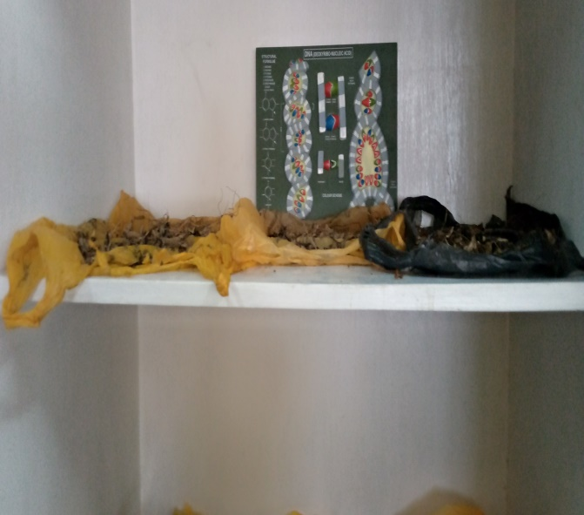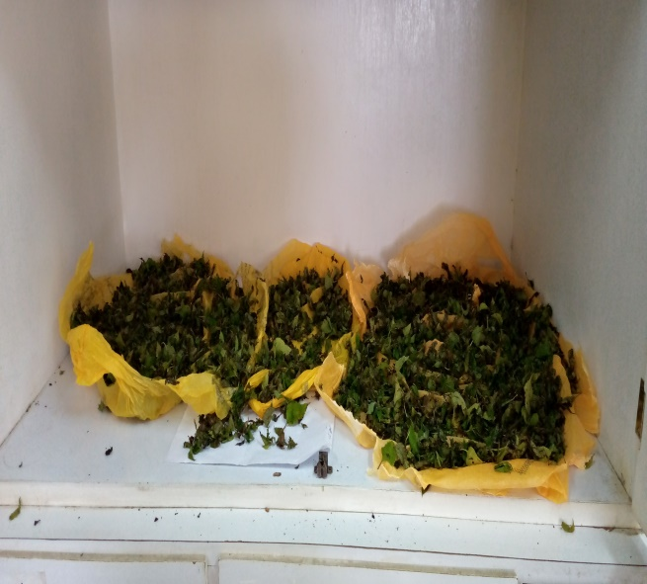
Appendix A: Drying the sample in lab
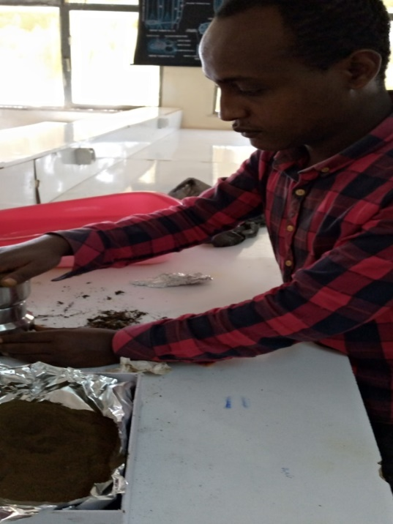
Appendix B: Grinding the sample

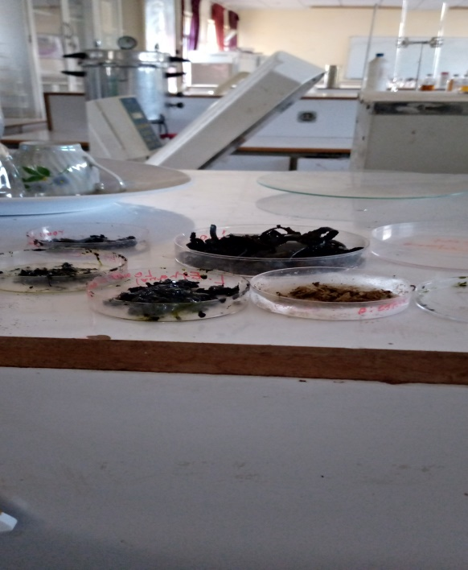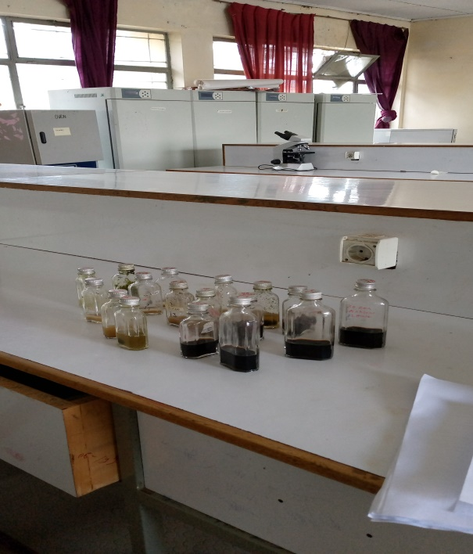
Appendix C: Bioactive compound
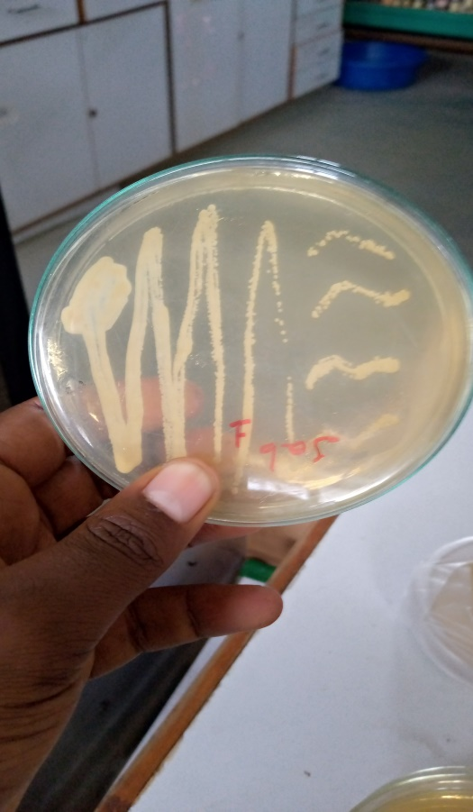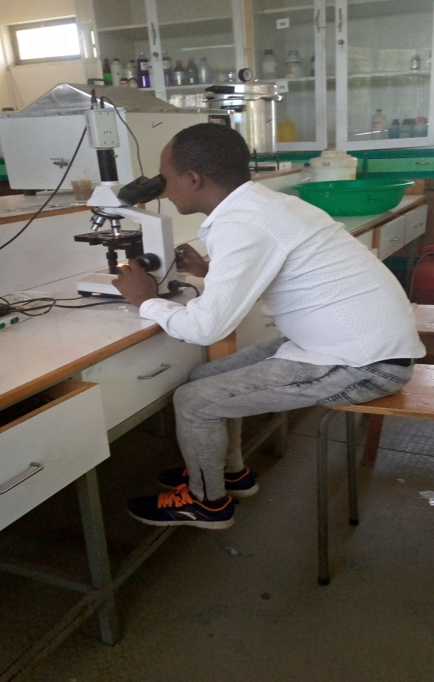
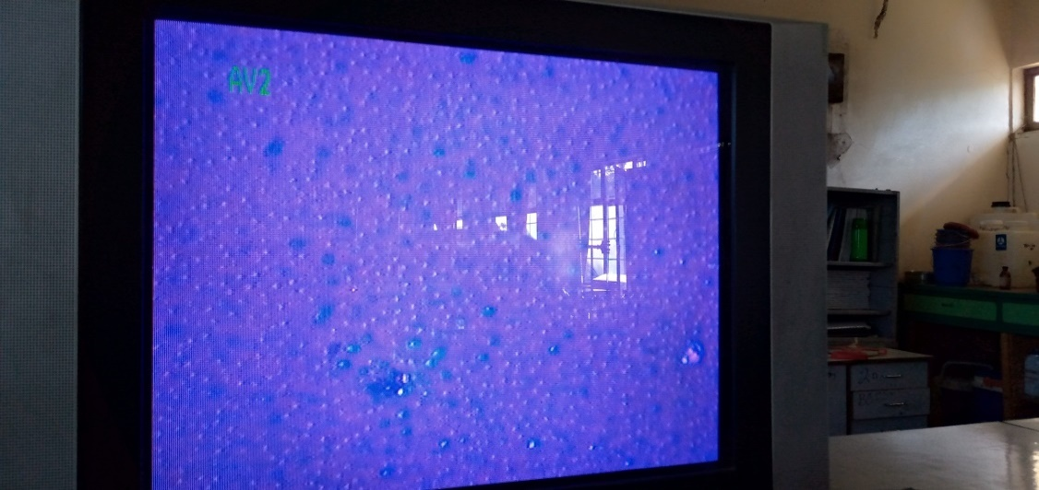

Appendix D: Isolation of candidias species

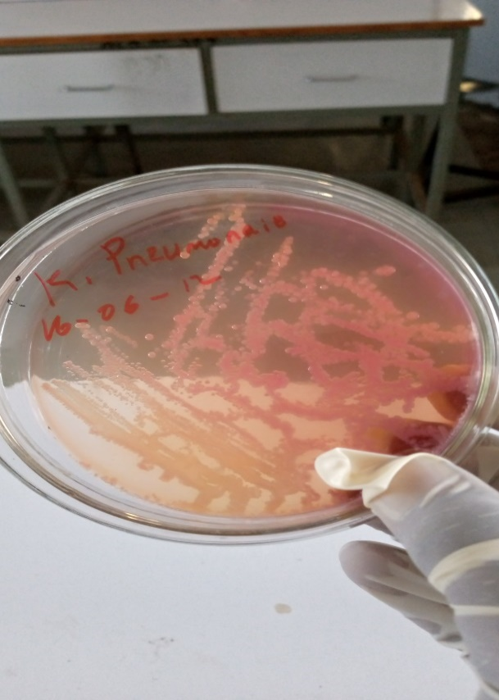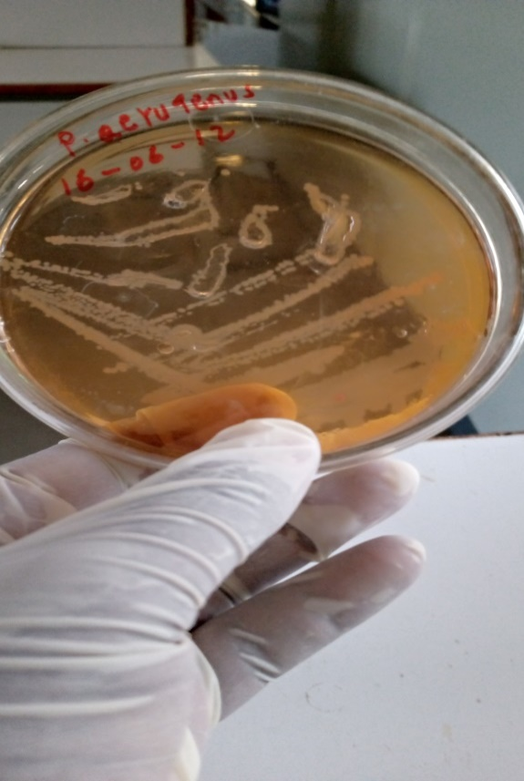
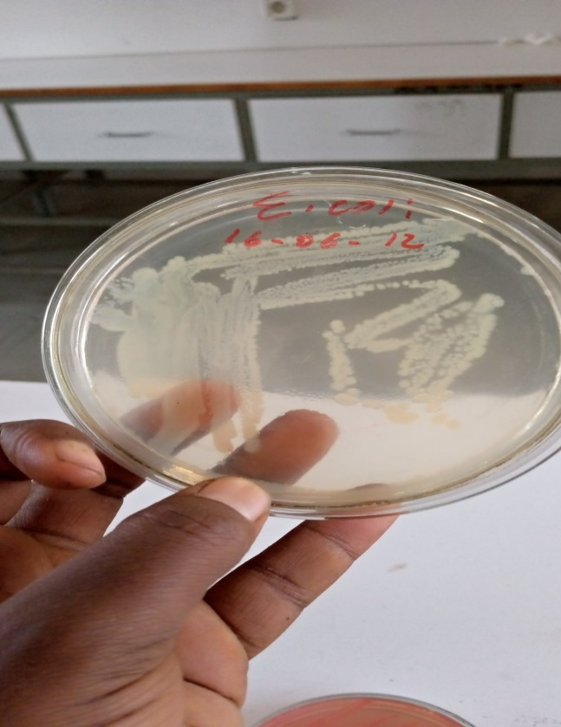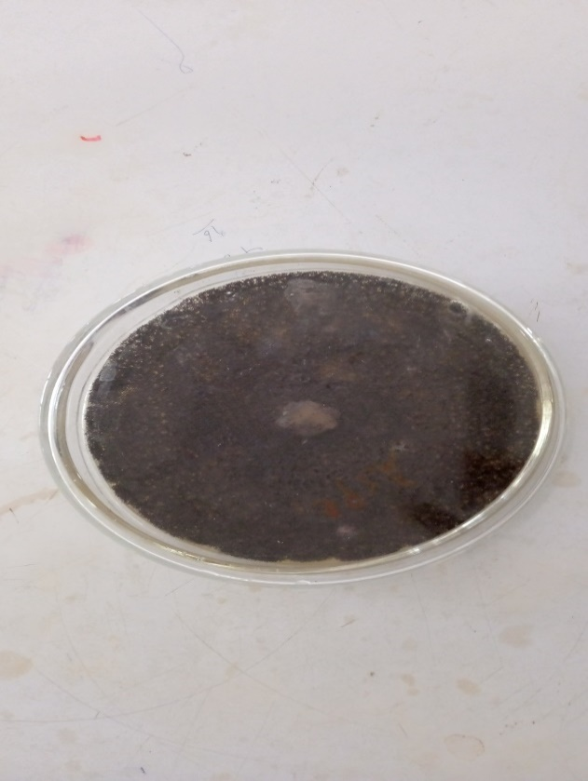
Oldculture of Asepergillus species
Appendix E: Sub culture of selected human pathogenic

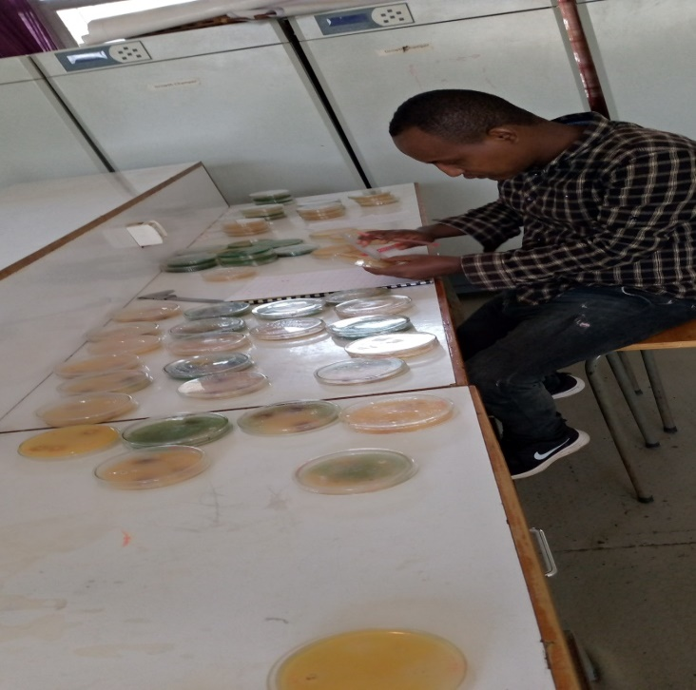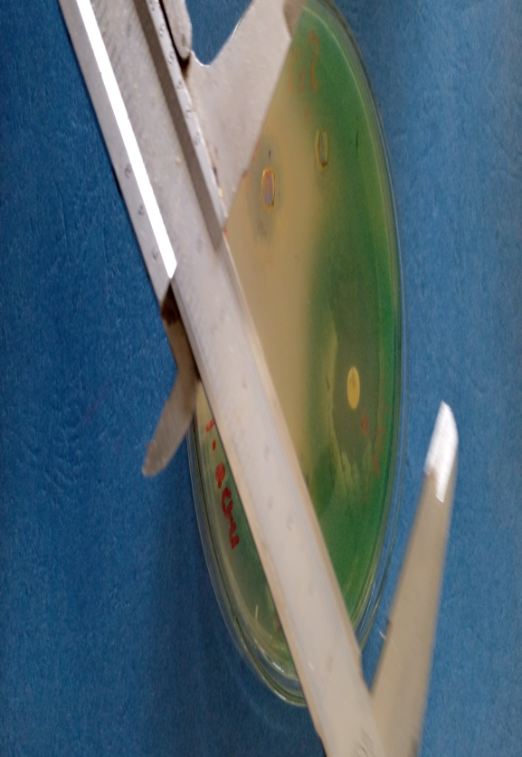
Appendix F: measuring the diameter of each zone by millimetre (mm)

