
AMBO UNIVERSITY
COLLEGE OF NATURAL AND COMPUTIONAL SCIENCE DEPARTMENT OF BIOLOGY
ASSESSMENT OF FOOD-WASTE GENERATION AND ITS’ BIOGAS PRODUCTION POTENTIAL FROM AMBO UNIVERSITY STUDENTS’ CAFETERIA, MAIN CAMPUS, AMBO
A MASTER THESIS IS SUBMITTED TO THE SCHOOL OF GRADUATE STUDIES OF AMBO UNIVERSITY IN PARTIAL FULFILLMENT OF THE REQUIREMENT FOR THE DEGREE OF MASTER OF SCIENCE, IN MICROBIOLOGY AND MICROBIA BIOTECHNOLOGY.
M.Sc. THESIS
BY ADDISU TURURA NATEI
ADVISOR: ASEFA KENENI (PhD; ASSOCIATE PROFESSOR)
AUGUST, 2020
AMBO, ETHIOPIA
AMBO UNIVERSITY
SCHOOL OF GRADUATE STUDIES, COLLEGE OF NATURAL AND COMPUTIONAL SCIENCE DEPARTMENT OF BIOLOGY, MICROBIOLOGY AND MICROBIAL BIOTECHNOLOGY PROGRAM
ASSESSMENT OF FOOD-WASTE GENERATION AND ITS’ BIOGAS PRODUCTION POTENTIAL FROM AMBO UNIVERSITY STUDENTS’ CAFETERIA, MAIN CAMPUS, AMBO
A MASTER THESIS IS SUBMITTED TO THE SCHOOL OF GRADUATE STUDIES OF AMBO UNIVERSITY IN PARTIAL FULFILLMENT OF THE REQUIREMENT FOR THE DEGREE OF MASTER OF SCIENCE, IN MICROBIOLOGY AND MICROBIAL BIOTECHNOLOGY.
M.Sc. THESIS
BY ADDISU TURURA NATEI
ADVISOR: ASEFA KENENI (PhD; ASSOCIATE PROFESSOR)

AMBO UNIVERSITY
SCHOOL OF GRADUATE STUDIES COLLEGE OF NATURAL AND COMPUTIONAL SCIENCE

APPROVAL SHEET
Submitted by:
Addisu Turura Natei _______________ ______________
PG Candidates Signature Date
Approved by
_________________________ _______________ _______________
Major Advisor Signature Date ________________________ _______________ ______________
Head of Department Signature Date _______________________ _______________ ______________ College/Institute Dean Signature Date ________________________ _______________ _____________
Director School of Graduate studies Signature Date

AMBO UNIVERSITY SCHOOLOF GRADUATE STUDIES COLLEGE OF
NATURAL AND COMPUTIONAL SCIENCE
CERTIFICATION SHEET
A Thesis Advisor, I hereby certify that I have read and evaluate this Thesis prepared under my guidance, by Addisu Turura Natei entitled assessment of food-waste generation and its’ biogas production potential from Ambo University students’ cafeteria, main campus, Ambo. I recommended that it be submitted as fulfilling the Thesis requirement.
Asefa Keneni (PhD, Associate professor) ____________ ____________
Advisor Signature Date
As member of the board of examiners of the M.Sc Thesis Open Defence Examination, We certify that we have read, evaluate the Thesis prepared by Addisu Turura Natei and examined the candidate. We recommended that the Thesis be accepted as fulfilling the Thesis requirement for the degree of Master of Science in Microbiology and Microbial Biotechnology.
____________________ ____________ ___________ Chairperson Signature Date
____________________ ____________ ___________
Internal examiner Signature Date
____________________ ____________ ___________
External examiner Signature Date

STATEMENT OF AUTHORSHIP
First, I declare that this Thesis is a result of my own genuine and original work and that all sources of materials used for writing it have been duly acknowledged. This Thesis has been submitted in partial fulfillment of the requirements for the Degree of Master of Science at Ambo University and is deposited at the library of the University to be made available to borrowers under the rules and regulations of the Library. I solemnly declare that this Thesis is not submitted to any other institution anywhere for the award of any academic degree, diploma, or certificate. Brief quotations from this Thesis are allowable without requiring special permissions provided that an accurate acknowledgement of source is made. Requests for permission for extended quotations from or reproduction of this manuscript in whole or in part may be granted by the head of the Department or the Dean of the School of Graduate Studies when in his or her judgment the proposed use of the material is for a scholarly interest. In all other instances, however, permission must be obtained from the author of the Thesis.
Name: Addisu Turura Natei
Signature: ______________
Date: ___________________

DEDICATION
This Thesis Document is dedicated to my beloved parents, my mother Yebali Injigu and my father Turura Natei. Secondly to my lovely wife Badedi Daba and my Children Abdi Addisu, Ayyantu Addisu and Bonsa Addisu as they all played a great role in praying for my success in study period. They were indeed a source of encouragement throughout this period.

BIOGRAPHICAL SKETCH
The author was born in Dire Enchini District, West Shewa Zone Oromia Regional state from his Father Turura Natei and his mother Yebal Injigu in May 4, 1977 E.C. He was attended his elementary and junior school in the same District, Yakke Elementry school grade (1-6). He attended his grade (7-8) and Secondary education (9-10) in Jibat District at Shenen Elementry and Senior Secondary school respectively. He attended his Preparatory grade (11-12) in Ambo town from 1995 to 1996 E.C. at Ambo Senior Secondary school. After completion of his Preparatory program author joined Haramaya University and graduated with B.Sc degree in Food Science and Postharvest Technology in Jul 7, 1999 E.C. After graduation he was attained into Dire Enchini District Agricultural office and services as agricultural expert in different expert area and leader position at Dire Enchini District until he joined the school of graduate studies of Ambo University to pursue his M.Sc. study in Microbiology and Microbial Biotechnology through Ambo University sponsoring.

ACKNOWLEDGMENT
A head of all things, praise and honor be to almighty God for the opportunity and capacity to give me realize my aspiration and for his unconditional love and multitude mercy and protection up on me. Next to almighty God, I would like to take this opportunity to acknowledge the following people who have enabled me to complete this thesis. I am extremely grateful for the guidance of my advisor, Asefa Keneni (PhD, Associate professor) for his constructive, skillful guidance and comment of the overall research work. His critical comments and suggestions on the structure and the contents of the thesis have considerably helped to own its present state without his guidance and continuous follow up in the entire process of the thesis work, completion of this thesis could not have be possible. Special thanks also go to Ambo University main campus administration for their giving this chance for me and supporting me up to completion of this Thesis. My heartfelt thanks, deepest gratitude and appreciation goes to the following people who have been major role players during this study: Indelcacho Cimdi, Worku Dereje, Demesa Shelema, Singitan Turura, Garomsa Daba; Mulugeta Mul’isa, Teshome Bekele, Guluma Bulo. Last, but not least my deepest thanks to my fellow MSc Microbiology and Microbial Biotechnology class mates and I wish you all the best. Finally, I am grateful to my lovely, wife Bededi Daba, which earthly words of thanks cannot express my feeling in return to the supports and encouragement she has given me. She forgone many of her interests for the success of my study and shouldered, in my absence which in one way or another had contributed to the successful completion of the study.

TABLE OF CONTENT
ContentsPage
APPROVAL SHEET ii
CERTIFICATION SHEET………………………………………………………………iii
STATEMENT OF AUTHORSHIP iv
DEDICATION v
BIOGRAPHICAL SKETCH vi
ACKNOWLEDGMENT vii
TABLE OF CONTENT viii
LIST OF TABLES ix
LIST OF FIGURES x
LIST OF APPENDICES xi
LIST OF ABBREVATION AND ACRONOMY xiv
ABSTRACT xv
CHAPTER ONE 1
1. INTRODUCTION 1
1.1. Background of the Study 1
1.2. Statement of the Problem 2
1.3. Objective of the Research 3
1.3.1. General Objective 3
1.3.2. Specific Objectives 3
1.4. Significance of the Study 4
CHAPTER TWO 5
2. LITERATURE REVIEW 5
2.1. Food Waste 5
2.1.1. Impacts of Food Waste 6
2.2. Energy from Biomass 7
2.2.1. Potential of Food Waste for Biogas Production 9
2.3. Steps Involved in AD Process during Biogas Production 11
2.3.1. Hydrolysis 12
2.3.2. Acidogenesis 13
2.3.3. Acetogenesis 14
2.3.4. Methanogenesis 14
2.4. Factors Affecting Biogas Production 16
2.4.1. Temperature 16
2.4.2. PH 16
2.4.3. Hydraulic Retention Time (HRT) 17
2.4.4. Particle Size 17
2.4.5. Nutrient 17
2.4.6. Organic Loading Rate (OLR) 18
2.5. Factors that Inhibit Anaerobic Digestion Process 18
2.5.1. Carbon to Nitrogen Ration (C:N) 18
2.5.2. Volatile Fatty Acids (VFA) 19
2.5.3. Ammonia 19
2.5.4. Inoculum used 19
CHAPTER THREE 20
3. MATERIALS AND METHODS 20
3.1. Description of the Study Area 20
3.2. Data Collection Method 20
3.2.1. Questioners 20
3.2.2. Direct Observation 21
3.2.3. Onsite Measurement of Different Food Wastes 21
3.2.4. Evaluation of biogas yield and percent of methane content 21
3.3. Assessment of Different Food Wastes from Students’ Cafeteria of Main Campus of Ambo University gains 21
3.3.1. Preprocessed Food Wastes 22
3.3.2. Leftover Foods 23
3.3.2.1. During the Breakfast Time 23
3.3.2.2. During the Lunch Time 24
3.3.2.3. During the Dinner Time 24
3.4. Inoculum Preparation 24
3.5. Determination of Some Physic-chemical Property of Food Waste 25
3.5.1. Determination of Moisture Content (%MC). 25
3.5.2. Determination of Total Solids (%TS) 26
3.5.3. Determination of Volatile Solids (%VS) 26
3.5.4. Determination of Total Ash (%TA) 26
3.5.5. Determination of Organic Carbon (%OC) 27
3.5.6. Determination of Total Nitrogen Content (%TN2) 27
3.6. Preparation of Substrate for Anaerobic Digestion 28
3.7. Experimental Design and Set-up 29
3.8. Measurement of Gas Volume 29
3.9. Determination of Percentage of Methane Contents 30
3.10. Statistical Analysis 31
CHAPTER FOUR 32
4. RESULTS AND DISCUSSION 32
4.1. Estimation of Total Biomass of Different Food Wastes Generated From Students’ Cafeteria. 32
4.1.1. Knowledge of Respondents on Generation and Management of Different Food Wastes 33
4.1.2. Direct Visual Observation on Generation and Management of Different Food Wastes. 35
4.1.3. Onsite Estimated Different Food Wastes Generated. 37
4.1.3.1. Assessment of preprocessed Food Wastes 37
4.1.3.2. Assessment of Leftover Food wastes 37
4.2. Physico-chemical characteristics of different food wastes 39
4.3. Production of Biogas 43
4.4. Composition of the Generated Biogas. 45
CHAPTER FIVE 47
5. CONCLUSIONS AND RECOMMENDATIONS 47
5.1. CONCLUSIONS 47
5.2. Recommendations 48
REFERENCES 49
APPENDIX 62

LIST OF TABLES
Table 1: Composition of food waste reported by various articles and literatures. 10
Table 2: Sosio-demogarphic characteristics of th respondents 32
Table 3: Frequency and parcentage of Respondents on generation and management of different food wastes. 33
Table 4: Total Amount of Different Food Wastes Estimated from Students Cafeteria (in Kg). 38
Table 5: Characterization of Different Food Wastes and Inoculum. 40
Table 6: ANOVA result of Biogas Yield Generated from Each Samples at 95% Confidence Interval. 45
Table 7: Percentage of Methane and Carbon Dioxide Content Each Samples. 45

LIST OF FIGURES
Figure 1: GHG Emission at different stages of Food supply chain (from Production down to waste disposal) 6
Figure 2: Process of AD during Biogas Production 12
Figure 3: Decomposition of complex organic matter into smaller units by hydrolytic enzymes. 13
Figure 4: Some Groups of microorganism involved in organic matter degradation during AD process 15
Figure 5: Onsite Collected and Measured Different Food Wastes Generated from Students’ Cafeteria of Main Campus of Ambo University. 22
Figure 6: Visual Observed Leftover Foods. 23
Figure 7: Inoculum Preparation for further experimental setup. 25
Figure 8: Experimental Design and Setup 29
Figure 9: Collected gas in gas bag and gas suction graduated cylinder used to measure biogas volume generated from each samples. 30
Figure 10: Syringe and 50ml with 7M NaOH holding equipment used to determine the biogas composition of each samples. 31
Figure 11:Visual Observed Disposal Site of Different Food Wastes…………...……….36
Figure 12: PH of the Inoculum before AD. 42
Figure 13: Biogas Volume Generated from Each Samples in every other day. 43

LIST OF APPENDICES

Appendix1: Visual Observed Preprocessed Food Waste. 62
Appendix 2: Visual Observed Leftover Foods. 63
Appendix 3: Biogas Yield generated from four samples through experimental period in Every Other Day (Frist Round from day 14/12/2019 to 23/01/2020) 64
Appendix 4: Biogas Yield generated from four samples through experimental period in Every Other Day 65
Appendix 5: Result of ANOVA Table on Biogas Yield Generated from Each Samples (ml/g VS). 66
Appendix 6: Duncan Multiple Homogeny Test of Biogas Yield Generated from Each Samples (ml/g VS). 67
Appendix 7: Result of ANOVA Table on Methane Yield from Each Sample. 68
Appendix 8: Result of ANOVA Table on Carbon Dioxide Yield from Each Sample. 68
Appendix 9: Result of ANOVA Table on Percentage of Methane from Each Sample. 69
Appendix 10: Checkup of the Flammability of the Generated Biogas from Each Samples. 70
Appendix 11: Survey Questionnaire Given to Respondents. 71

LIST OF ABBREVATION AND ACRONOMY
AD Anaerobic Digestion
C:N Carbon to Nitrogen Ratio
FBFW Firfir Breakfast Food Waste
GHG Greenhouse Gas
GT Giga-tons
HRT Hydraulic Retention Time
KBFW Kinche Breakfast Food Waste
KPFW Kinche Preprocessed Food Waste
LCFA Long Chain Fatty Acids
LLFW Lenticel Lunch Food Waste
MC Moisture Content
MLFW Meat Lunch Food Waste
OC Organic Carbon
OLR Organic Loading Rate
OP Onion Peel
PDFW Pea Dinner Food Waste
PPFW Potato Peel Food Waste
RBFW Rice Breakfast Food Waste
TN Total Nitrogen
TS Total Solid
VFA Volatile Fatty Acids
VS Volatile Solid

ABSTRACT
Bio-energy is a renewable energy and it contributes to solve the present and future energy problems. Among the alternative bio energy sources, a biogas production from different food wastes was currently applicable. The main aim of this thesis was to assess and evaluate the biogas yield of different food wastes generated from the student cafeteria of main campus of Ambo University. The amount of food wastes generated was assessed by taking samples from the students’ cafeteria for seven days. The physicochemical properties of the different food waste samples were analyzed according to the standard methods. For the evaluation of the biogas yield, these food wastes were collected and prepared for batch anaerobic digestion. The biogas yield of the different food wastes evaluated by anaerobic digestion and the total biogas produced from each substrate and percentage of methane was measured by using barrier solution and 7M NaOH respectively. From the different biomass assessed 68,230.34Kg/year found to be highest from pea dinner food waste (PDFW) while 4,440.19Kg/year was found to be the smallest in amount from kinche preprocessed food waste (KPFW). The physicochemical analysis result showed that, the highest %MC and the lowest %TS were (67.4±4.42%) and (32.6±4.42%) respectively from MLFW, while the lowest %MC and the highest %TS were (3.4±0.72%) and (96.6±0.72%) respectively from KPFW. The highest %Ash and the lowest %VS/TV were (3.66±0.17%) and (96.2±0.18%) respectively from KPFW, while the lowest %Ash and the highest %VS/TS were (0.52±0.10%) and (98.4±0.35%) respectively from MLFW. The highest %OC and the lowest %TN were (54.7±0.19%) and(1.87±0.02%) respectively from MLFW while the lowest %OC and the highest %TN were (53.4±0.10%)and(2.67±0.06%) respectively from KPFW. The result of %C:N ratio from each samples were ranges between (20.03±0.45) to (33.8±0.83) including inoculum. From 25g of the different food wastes, it was found that the amount of biogas production and quality was highest in MLFW 500±12.29ml/g VS of biogas and (81.65±2.58%) CH₄ and KPFW produced the minimum biogas production and quality (343.61±10.43)ml/g VS of biogas and (67.15±2.47%) CH₄. The results of this study indicated that, the different food wastes evaluated for the biogas yield resulted in highest total biogas yield and highest quality of bio-methane which indicates that the chance of supplementing the existing energy supply by converting biomass to biogas by anaerobic digestion which also contribute in the sustainable disposal of the increasing food wastes from student cafeteria.
Key words: Acidogenesis, Anaerobic digestion, Biogas, Food waste, Methane.

CHAPTER ONE

1. INTRODUCTION

1.1. Background of the Study
Energy is one of the most basic elements of the universe derived from both renewable and non-renewable sources. Owusu and Sarkodie (2016) reported that, the need for energy and its related services to satisfy human social and economic development, safety and health is increasing time to time; many peoples are use fossil fuels (oil, gas and coal) as primary energy source to satisfy their energy need. The current irrational use of fossil fuels and the impact of greenhouse gases (GHG) on the environment are driving research into renewable energy sources from biomass (Achinas et al., 2017). Biogas is one of the most promising alternative energy sources, which is produced from biodegradable organic wastes like food waste through anaerobic digestion (AD) processes (Caruso et al., 2019;Sugumar et al., 2017). It is serves as a high-energy renewable fuel, which could be used as a substitute for fossil fuels for various purposes such as for cooking, heating, transportation and electricity (Ahorsu et al., 2018; Yonael Mezmur and Wondwossen Bogale, 2019).
According to Joardder and Masud (2019), food is being wasted almost in every stage of food supply chain including harvesting, post-harvesting, processing, and distribution, as well as in consumer level. Agriculture Organization of the United Nations (FAO) (2012) reported that, as much as one-third of the food intentionally grown for human consumption is wasted annually throughout the world; this figure is 1300 million tons of food. According to European Union (EU) Fusions (2014), countries, cities, sectors, industries, businesses and households may develop their own standards and methods such as landfills, open dumps, incineration and AD to prevent food waste.Different studies showed that, landfills, open dumps and incineration are still the most common disposal approaches of food waste in the world (Pattnaik and Reddy, 2010; Woon and Lo, 2016).
Jain and Newman, (2018) reported that, in addition to the extravagant of resources needed to produce food that is wasted, mismanaged food waste either landfills or open dumps adversely affects our climate due to the GHG that are emitted upon its decomposition, contaminates water courses from nutrient and leachate runoff and also causes communicable diseases and a health hazard. In general, the carbon footprint of worldwide food waste has estimated 4.4 gigatons (GT) of carbon dioxide (CO₂) equivalent per year and if it were a country it would rank as the third top emitter after the United States and China (FAO, 2015). The impact of traditional way of different food wastes disposal on the environment, healthy and economic is driving research into renewable energy sources like biogas production from food waste through AD (Ahorsu et al., 2018). Mir et al. (2016), producing the renewable energy from biodegradable waste helps to overcome the energy crisis and solid waste management, which is done by AD.
Among wide range of substrates used for biogas production food waste has potential to provide high biogas yield, due to it contains highly biodegradable organic matter mainly (carbohydrate, protein and lipid), which is used by microbes as nutrients during AD process (Kuoa and Dowb, 2017; Suhartini, Lestari, and Nurika, 2019). Also Paritosh et al. (2017) reported that, AD approach is one of the most ecofriendly and promising solutions for food wastes management. Therefore, the general purpose of this study is to
assessment of food-waste generation and its’ biogas production potential from Ambo University students’ cafeteria, main campus, Ambo.

1.2. Statement of the Problem
The amount of food waste is continuously increase parallel to rapid economic and population growth (European Environment Agency (EEA), 2016; Girotto et al., 2015); due to the wastage occurs at any stages of food supply chain such as producers (on farms), processors (in processing and manufacturing facilities), retailers (during transport and distribution), and consumers (during food service outlets such as restaurants, hotels, institutional cafeteria and in households) (United Nations Environment Program (UNEP), 2019). If the massively generated food waste from different sources is not properly managed, it is imposing serious threats to our society like environmental pollution, health risk and contaminates water courses from nutrient and leachate runoff (Jain and Newman, 2018; Paritosh et al., 2017). Farther more, one of the greatest challenges facing the societies now and will be continue in the future is the reduction of GHG emitted from inappropriate ways disposed food waste and thus preventing the climate change (Horvath et al., 2016).
Nowadays, different food wastes (both pre-processed food wastes and leftover foods) are the most significant portions of solid organic wastes generated from the students’ cafeteria of main campus Ambo University and the food wastes disposal method in this campus is open dumping. This would be conducive for the multiplying of vectors and cause unhealthy environment to the students’, cafeteria workers and society nearby the University. Also it contaminates soil, ground water as well as surface water through runoff or leachate. So to minimize the effect of open disposal of food wastes from the student cafeteria of the main campus of Ambo University, conversion of these food wastes into some sort’s energy is very important. The use of AD for conversion of different food wastes to biogas production was one alternative method and it has three tier benefits; clear energy, sanitation and bio-fertilizer could be achieved. But there is no study conducted to evaluate biogas yield from different food wastes generated from students’ cafeteria of main campus of Ambo University. Therefore, the general objective of this study is to assess the abundance of food waste generation and its biogas production potential from student cafeteria of main campus of Ambo University.

1.3. Objective of the Research

1.3.1. General Objective
- The general objective of this study is to assess the abundance of food waste generation and its biogas production potential from student cafeteria.

1.3.2. Specific Objectives
- To assess the amount of the food waste generated from students’ cafeteria of main campus Ambo University.
- To determine some of the physico-chemical properties of these food wastes.
- To evaluate the biogas yield and percent methane (CH₄) contents of some of the food waste generated from students’ cafeteria of main campus Ambo University.

1.4. Significance of the Study
As different author mentioned earlier, improper ways of different food waste disposal may cause severe health, economic and environmental problems. Therefore, treatment of different food wastes through AD process has several benefits, such as climate change mitigation (reduction of GHG emissions), reduction of odor (improving air quality), and renewable energy production (biogas); due to treatment of different food wastes using AD process is one of the most attractive methods for food waste management and effective in solving environmental, health and energy challenges. After the completion of this study other researchers may get some hints to study in the area regarding food waste management to solve the environmental, health and energy challenges of the local community and the country at the whole in agreement or contradict to this study finding revealed.

CHAPTER TWO

2. LITERATURE REVIEW

2.1. Food Waste
Food waste is deﬁned in different ways by international organizations, state governments and within the specialized literature. For instance, according to FAO (2015), food waste (which is a component of food loss) is any removal of food from the food supply chain which was at some point fit for human consumption. Food waste is food that is wasted during any of the four stages of the food supply chain such as producers (agricultural processing), processors (sorting, storing, transporting), retailers (distributing, selling) and consumers (preparing, cooking, and serving) (Bellemare et al., 2017; Xu et al., 2018). EEA (2016) reported that, parallel to rapid population and economic growth the amount of food waste is continuously increase. For example, 1300 million tons of food is wasted annually throughout the world; this figure is one-third of the total food produced (FAO, 2012; Uçkun et al., 2014).
Wang et al. (2017) showed that, the composition of food waste that is generated from various sources is varies, depending on the collection source. According to Dolekoglu1and Var (2019), about 35% of wasted food occurs at the consumer level. In addition, in low income countries, more than 40% of food wastage occurs at the postharvest and processing stages due to lack of adequate infrastructure, while in middle- and high-income countries, consumers take a bigger portion of the responsibility; hence households are blame for 53% of all food waste in Europe, and 47% of food waste in Canada (Oakes, 2020). On other hang, restaurant and cafeteria food waste accounts for 50% of the total amount of food waste generated from different sources (Clercq et al., 2017).

2.1.1. Impacts of Food Waste
The World Bank (2012) reported that, CO₂, CH₄ and nitrous oxide (N₂O) are GHGs that contribute to global warming and climate change, and are emitted at all stages of the food processing from production down to final waste disposal. Also Yasin et al. (2013) reported that, food wastes contain high amounts of moisture content (MC), volatile solid (VS), and are consequently considered as the main source of GHG emissions, unpleasant odor release, attraction of vermin, and contamination of groundwater. According to Pham et al.(2015), CH₄ emissions from rotting food in landfills and open dumps is 23 times more potent GHG than CO₂ and hence causes global warming. The leachate from dumpsites and landfills pollutes the groundwater as well as surface water (FAO, 2013).
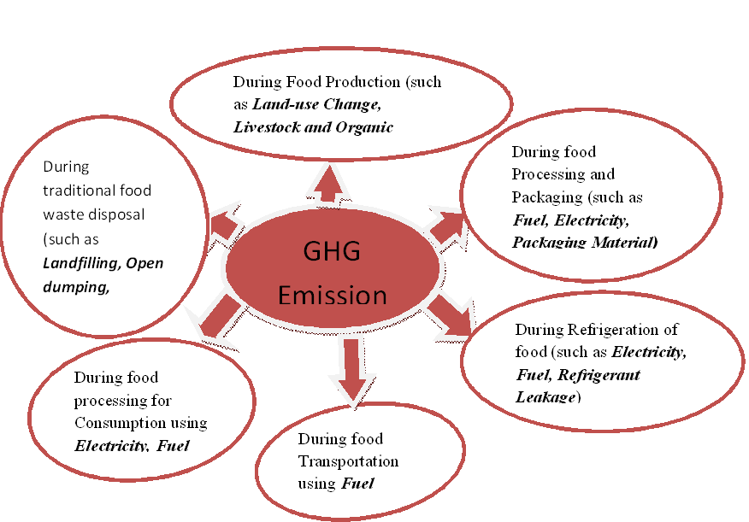
Figure 1: GHG Emission at different stages of Food supply chain (from Production down to waste disposal) (FAO,2013).
On other hand, open-dumping of different food wastes especially leftover foods attracted scavenger, birds, flies and other pests to the site and caused offensive smell and became a potential health risk for the community (Helelo, Senbeta and Anshebo, 2019). According to, Katami et al. (2004), incineration is a combustion process where highly toxic compound and environment pollutant, dioxin are produced due to high MC of food waste. Different studies reported that, if food waste is directly used as animal feed as well as Pig feed without heat treatment, it may cause a lot of risks such as environmental, economic and public health impacts; since the propagation of diseases will be higher (Salemdeeb et al., 2016; UK House of Commons, 2002).

2.2. Energy from Biomass
Energy is one of the most basic elements of the universe derived from both renewable and non-renewable sources. Different reports indicated that, the amount of GHG emissions in the atmosphere is rising, with CO₂ being the main contributor. In addition, the global energy demand is increasing rapidly, with approximately 88% of the energy produced at the present time being based on fossil fuels such as firewood, charcoal, oil, gas, coal and electricity generation from fuels (International Energy Agency (IEA), 2015; UNEP, 2014; World Wildlife Fund (WWF), 2011). Also, according to Ayhan (2016), fossil fuels still represent over 80% of total energy supplies in the world.
However, the increased use of fossil fuels for energy consumption has causes environmental problems both locally and globally (Otun et al., 2015). Farther more, Courtney and Dorman (2003) reported that, the crude oil will run out within 40 to 70 years, and natural gas will be finished within 50 years. The amount of fossil fuels is reduced if renewable energy sources were used for different purposes such as for cooking, heating, transportation and electricity (Ahorsu et al., 2018).
Therefore, renewable energy sources (RES) are biomass, hydropower, geothermal, solar and wind energies, which is energy from sources that are naturally replenishing (Panwar et al., 2011). Bioenergy is energy produced from biomass (Kuoa and Dow 2017). According to Srivastava (2018), different forms of biological waste are available in plentiful quantity and their proper and systematic disposal and treatment are required with solution for big challenges for the waste generating institution. Different resources of biomass, including animal waste, forest residues, agricultural residues, and municipal solid waste are the potential biomass resources that are being used for energy generation with fewer emissions of GHG (Iqbal et al., 2018; Owusu and Sarkodie, 2016). Also research studies mention the effectiveness of AD as alternative and efficient technology, which combines biogas production and sustainable waste management (Bharathiraja et al., 2018).In addition Kamran (2018) reported that, biomass is regarded as highly suitable for energy generation due to its important fuel product properties.
Biomass is organic material that comes from plants and animals (Ayhan, 2016); which is one of the alternative resources for renewable energy production; include food waste (Suhartiniet al. 2019). Food waste is rich in organic matters such as carbohydrate, protein, and lipid (Ong et al., 2017); which is one of the largest waste streams in the world and is being generated at an ever-increasing rate (Peng et al., 2018). So, appropriate methods of food waste management, which is cost effective as well as ecofriendly are needed (EU Fusions, 2014; Ma, et al., 2009). According to Detman et al. (2017), AD is one of the most promising processes for the energetic transformation of food waste to produce bioenergy as an alternative energy source. According to Renewable Energy (REN21) (2019), the total installed capacity of biomass energy has reached 130 gigawate (GW) worldwide.
One of the bioenergy is biogas which is the main product of AD process (Adekunle and Okolie,2015). According to Rajaeifar et al. (2017), it is produced during AD of organic materials, carried out by a complex microbial community through multiple complicated biochemical reactions. Also one study indicated that, biogas is a mixture of different gases, i.e., primarily CH₄ and CO₂ and small amounts of water vapor (H₂O), hydrogen sulfide (H₂S), hydrogen (H₂), and siloxanes (Valijanian et al., 2018). It is a green and sustainable energy consisting of CH₄ to a great extent along with other gases (Bhardwaj and Das, 2017).
Sahota et al. (2018), biogas is a clean and renewable form of energy and can be a substitute for conventional sources of energy; in other word it should be upgraded to bio-methane prior to injection into the gas grid or use as a vehicle fuel. Also Srivastava (2018) reviewed that; biogas is the mixture of both CH₄ and CO₂ and serves as a high-energy renewable fuel. In many countries biogas is used as a substitute for fossil fuels (like firewood, charcoal, coal and electricity generation from fuels) for various purposes in place of combined heat and power generation (CHP) (such as for cooking, heating and electricity generation) or it is upgraded and fed into natural gas grids, used as vehicle fuel or in fuel cells (for transportation) (Sawyerr et al., 2019; Srivastava, 2018). According to Rashed and Torii (2015), utilization of biogas serves the two-fold purpose of fulfillment of energy needs and also a reduction in the GHG emission into the atmosphere. Therefore, biogas production is a promising technique for food wastes management (Barati et al., 2017; Mirmohamadsadeghi et al., 2019).

2.2.1. Potential of Food Waste for Biogas Production
Substrate composition is one of the major factors that affect the production of biogas and yields of biogas are mainly depending on the substrates used as feedstock (Dere et al., 2017); the more digestible the feed is, the higher is the gas yield (Banks et al., 2011). Curry and Pillay (2012) reported that, food waste has potential to provide high biogas yield in comparison to other substrates (such as cow manure, whey, pig manure, corn silage, and so forth); the chemical energy stored in food waste could be released as CH₄ during the AD process (Doelle, 2015). Mirmohamadsadeghi et al. (2019), food wastes have a high bio-methane production potential because of their high organic matter contents. The composition of food wastes reported in various articles and literatures are listed in table 1.

Table 1: Composition of Food Waste Reported by Various Articles and Literatures.
MC (%) | TS (%) | VS/TS (%) | Ash (%) | References
76.55±0.09 | 23.45±0.38 | 93.05±0.11 | 1.62±0.09 | (Che et al., 2010)
43.43 to 84.12 | 15.88 to 56.57 | 68.45 to 92.05 | 1.48 to12.89 | (Alemayehu Gashaw et al., 2012)
44.18 to 76.88 | 23.12 to 55.82 | 92.78 to 96.14 | 3.96 to 6.8 | (Leta Deressa et al., 2015)
NR | 28.57 | 88 | NR | (Rathnasiri et al., 2017)
NR | 17.8±1.2 | 90 | NR | (Zamanzadeh et al., 2017)
81.85 | 18.15 | 86.1 | 13.9 | (Al-Addous et al., 2018)
NR | 24.5 | 92.5 | NR | (Lalander et al., 2018)
69.514±0.81 | 30.486±0.815 | 97.1215±0.0191 | NR | (Helelo et al., 2019)
78.10±0.01 | 21.90±0.15 | 96.76±0.01 | 3.24±0.1 | (Jansson et al., 2019)
74.31 | 25.69 | 96.65 | 0.86 | (Suhartini et al., 2019)
MC= Moisture Content, NR= Note Reported, %= percentage, TS= Total Solid, VS/TS= Volatile solid of Total solid (Dry Organic matter).
In their studies Cho et al. (1995), had obtained (480 to 280) ml/g VS of biogas yields for different food wastes under mesophilic condition. Gunaseelan, (2004), had obtained (180 to 732) ml/g VS of methane yield from different types of food waste, whereas according to Zhang et al. (2007), approximately (425 to 445) ml/g VS of methane yield had been obtained from food waste after 28 days of digestion.Chen et al. (2010), had obtained (570 to 750) ml/g VS, especially 660 ml/g VS of biogas yield from cafeteria food waste. According to Alemayehu Gashaw et al. (2012), above 2.8L biogas yield was obtained from 500g of cafeteria food waste. Zamanzadeh et al. (2017) reported that, about 480ml/g VS of methane yield was generated for the food wastes under mesophilic condition at 37⁰C.
According to Rathnasiri et al. (2017), about 500 ml/g VS biogas yield was obtained and also about 66.89%, 74.41% and 81.92%, of methane content had been reported from the generated biogas analysis. According to Al-Addous et al. (2018), about 397ml/g VS of biogas yield was generated from the organic food found in municipal solid waste. Lalander et al., (2018) reported that, more than 400NmL/g VS of biogas yield was obtained from food waste and also about 64% of methane content had been reported from the generated biogas analysis. Also, according to Jansson et al. (2019), about 402NmL/g VS methane yield was obtained from digestion of leftover foods. Suhartini et al., (2019) reported that, about 0.191 M³/Kg VS of methane yield was obtained from canteen food waste. In general, the high theoretical yield of CH₄ from food waste, which ranges from (400 to 500) ml/g VS (Li et al., 2018), has heightened interest in using AD to recover energy from food waste (Amha et al., 2017).
Therefore, biogas production from food waste through AD has been a successful treatment option for different food wastes and also it is effective in solving environmental, health and energy challenges (Ariunbaatar et al., 2016). In addition, Kuo and Dow (2017) reported that, increases in biogas production from sustainable biomass like food waste can provide many economic and environmental benefits. The World Biogas Association (WBA) (2017) indicated that, treatment of food waste through AD has multiple benefits such as renewable energy production, climate change mitigation, contributing towards a circular economy, improving air quality and contributing towards food security.

2.3. Steps Involved in AD Process during Biogas Production
Many study point out that, AD is a biochemical process that takes place naturally when various types of anaerobic microorganisms break down complex organic matter in the absence of oxygen to produce biogas from waste biomass as an alternative energy source (Detman et al., 2017; Lohani, 2017; Kader et al., 2015). Therefore, during the process of biogas production from biodegradable organic matter, decomposition of organic matter undergo a multi-stage process of series and parallel reaction and steps namely hydrolysis, acidogenesis, acetogenesis and methanogenesis (Lohani and Hayakajnen 2018; Van et al., 2019).
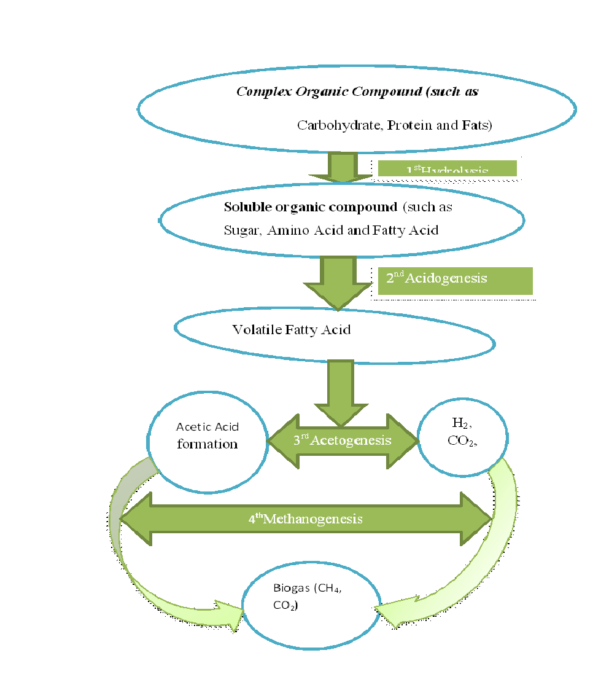
Figure 2: Process of AD during Biogas Production (California Integrated Waste Management Board, 2008).

2.3.1. Hydrolysis
Theoretically the first step of AD is hydrolysis, during which the complex organic matter (polymers) such as carbohydrates, lipids, nucleic acids and proteins are decomposed into smaller units (soluble organic molecules) such as mono-saccharides, amino acids, fatty acids, purines, pyridines and other soluble organic compounds (Al Seadi et al., 2008; Merlin et al., 2014). Hydrolytic microorganisms such as clostridia, streptococci, bacteroides, sporobacterium, lactobacillu, megasphaera, propionibacterium, bifidobacterium and sphingomonasetcas excrete hydrolytic enzymes like cellulase, amylase, cellobiase, protease, xylanase and lipase, converting biopolymers into simpler and soluble compounds (Lauwers et al., 2013; Merlin et al., 2014).
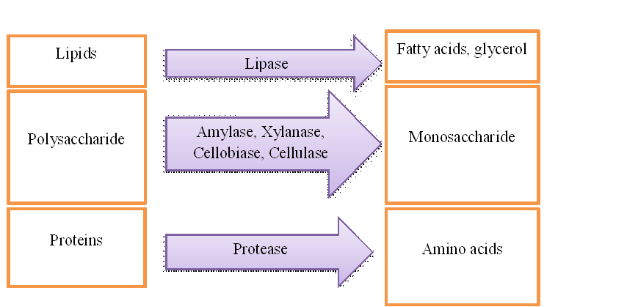

Figure 3: Decomposition of complex organic matter into smaller units by hydrolytic enzymes(Al Seadi et al., 2008).

2.3.2. Acidogenesis
During the second stages of AD, the products of hydrolysis are converted by acidogenic (fermentative) bacteria such as Ruminococcus, Paenibacillus and Clostridium into methanogenic substrates like organic acids (such as acetic acid, propionic acid, butyric acid, succinic acid, lactic acid), low alcohols, H₂, CO₂, and ammonium (NH₄) (Al Seadi et al., 2008; Zieminsk and Frac, 2012 ). According to Ali et al. (2014), the acid-phase bacteria belonging to facultative anaerobes use oxygen (O₂) accidentally introduced into the process, creating favorable conditions for the development of obligatory anaerobes bacteria such as Pseudomonas, Bacillus, Clostridium, Micrococcus, or Flavobacterium. Furthermore, in a balanced bacterial process nearly 50% of the monomers like glucose, xylose, amino acids and long chain fatty acids (LCFA) are converted into acetate (CH₃COOH), 20% is transformed to CO₂ and H₂, while the remaining 30% is broken down into short chain volatile fatty acids (Al Seadi et al., 2008; Peter, 2009).

2.3.3. Acetogenesis
Acetogenesis is the third stage of AD process. In acetogenesis, the acetate forming microorganisms such as Deculfovibrio, Aminobacterium, Acidaminococcus are convert alcohols, volatile fatty acids such as butyric acid, propionic acid and valeric acid other than acetic acid to CO₂, H₂ and acetic acid (Zamudio, 2010; Zieminsk and Frac, 2012). According to Elias (2010), acetogenic organisms are the vital link between acidogenesis and the methanogenesis during biogas production and they provide two main substrates H₂ and CH₃COOH at the last step. According to Dhamodharan and Ajay (2014), the first three steps are together called acid fermentation, in this process; no organic matter is removed from liquid phase but converted to as substrate for further process of methanogenesis.

2.3.4. Methanogenesis
In the final stage of biogas production methanogenesis, products of the third stage are converted into methane gas by two groups of microbes known as acetoclastic (Methanosarcina, and Methanosaeta) and hydrogen-utilizing (Methanobacterium, Methanothermobacter and Methanobrevibacter) methanogens (Chu et al., 2007). According to Liu et al. (2009), these micro-organisms occur in natural environment and fulfill various roles during the process of biogas production from wastes.
According to Zaher et al. (2007), the formation of CH₄, which is the ultimate product of AD, occurs by two major routes. The primary route of methane produced (two-thirds of methane gas) is the fermentation of the major product of the acid forming phase(H₂ and CO₂) reduce into CH₄ by hydrogen-utilizing and in second route acetoclastic convertacetate into CO₂ and CH₄ . In general, methanogenic bacteria use H₂ and CH₃COOH (most important substrate) and produce CH₄ and CO₂ (Balasubramaniyam et al., 2008). During this stage formic acid, acetic acid, methanol and hydrogen can be used as energy sources by the various methanogens.
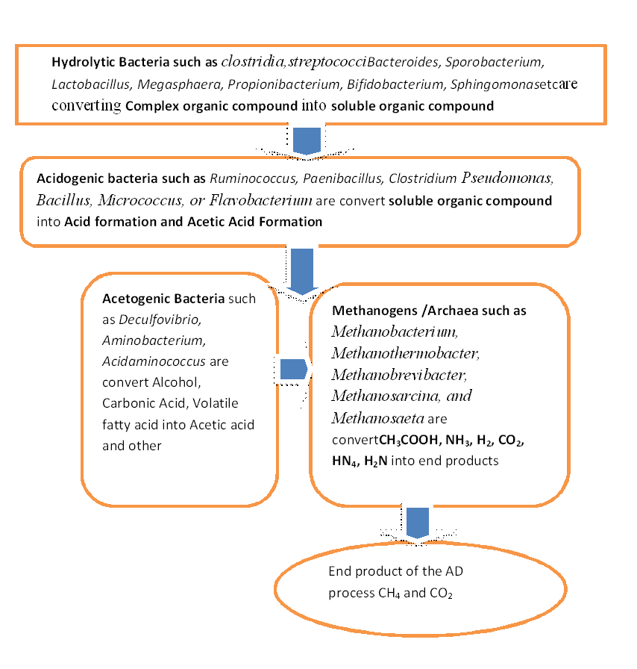
Figure 4: Some Groups of microorganism involved in organic matter degradation during AD process(Source, own creation 2020)

2.4. Factors Affecting Biogas Production
According to Lohani and Hayukajnen (2018), most of the conditions in biogas production is undertaken directly by the microorgamisms themselvels; however the operational conditions such as tempereture, PH, nutrients and toxicants can play a major role in modifying reaction rates of AD processes. Also, Van et al. (2019) reviewed that, operation of the AD systems does not only depend on the type of digestion system but also relies on the interaction among growth factors such as temperature, PH, and nutrients and operating parameters such as hydraulic retention time (HRT) and organic loading rate (OLR). So, biogas production process mainly affected by temperature, pH, HRT, particle size, nutrients concentration including MC, OLR, C:N and inoculum used.

2.4.1. Temperature
Nijaguna (2006) showed that, temperature is very important for methanogenic bacteria, due to limited temperature resistance of their enzymatic structures. According to WBA (2017) biogas production process takes place at two optimum temperature ranges, 35-40°C (mesophilic) and 55-60°C (thermophilic). Naik and Tkachenko (2013) reported that, the temperature level should be maintained between 30-60ºC to maximize rate of AD. However, different study showed that, most biogas production plants around the world operate in the mesophilic range as less heat is required to maintain that temperature and also the digestion process is more stable under these conditions (Arsova, 2010; Guo et al., 2014; Liu et al., 2009).
Nijaguna (2006) reported that, an increase in the ambient temperature generally increases the rate of reaction and high biogas production is at an optimum temperature range of 25-37°C for mesophilic bacteria. Liu et al. (2009) reported that, mesophilic bacteria show high activity within temperatures range of (28–42°C). In other study, the optimum range of temperature in biogas production is (35–40°C) for mesophilic activity (Arsova, 2010).

2.4.2. PH
Different studies showed that, pH of bioreactor affect the microbial activity in biogas production and its efficiency (Jayaraj et al., 2014; Naik and Tkachenko, 2013). Jayaraj et al. (2014) reported that, a low pH in digester inhibits the activity of microorganisms involved in the digestion process particularly methanogenic bacteria. Naik and Tkachenko (2013) point out that, the pH level should be maintained between 5.5 and 8.5 to maximize rate of AD. For example, according toMohammed et al. (2019), the highest biogas amount observed at pH range of 7 to 7.45.

2.4.3. Hydraulic Retention Time (HRT)
Nayono (2010) reported that, to achieve higher biogas amount or conversion efficiency of organic with food waste a relatively need long digestion time as compared with other bio-waste. However, if the input material is not sufficient in the reservoir and the process of digestion and fermentation is not completed the biogas is not going to be produced, so retention time is very important due to CH₄ production will increase with longer retention time (Zhao, 2011). Mohammad et al. (2013), there is no way to calculate theoretically the optimal HRT since its value depends on the ambient temperature and of the organic material loaded in the bio-digester. But, according to Chandra et al. (2012), the optimum retention time depends on temperature, OLR, and feed composition.

2.4.4. Particle Size
Different study showed that, particle size is influential on the reaction and fermentation rate of ingredients during biogas production (Huy, 2008; Rahi and Garshasbi, 2010). Huy (2008) showed that, large particle size of the feedstock will result in clogging of the digester, thereby making difficult for the microbes to carry out the digestion function. Thus, reduced particle size could increase hydrolysis rate and shorten digestion time. The smaller the particle size, the more the contact area, and so gas production increases (Rahi and Garshasbi, 2010; Agyeman and Tao, 2014). However, Zhang and Banks (2013) reported that, an excessive size reduction of food wastes can be causes severe foaming and process failure in wet and dry digesters, respectively.

2.4.5. Nutrient
Microbes use carbon to fulfill energy requirement and nitrogen for building cell structure metabolic activity. For instance, Raposo et al. (2011) reported that, microbes need small quantity of micro nutrient such as Ca, Na, K, Mg, and Cl. Also for enzyme synthesis and for maintaining enzyme activity, heavy metal ions such as Cr, Co, Cu, Zn, and Ni are required in biomethanation (Facchin et al., 2013). But according to Zayed and Winter (2000), concentration of heavy metals could have inhibitory effects on methanogenic activity and inhibition degrees depend upon many factors, such as the total metal concentration, chemical forms of the metals, pH, and redox potential.

2.4.6. Organic Loading Rate (OLR)
Organic loading rate simply refers to quantity of feed processed per unit volume of reactor per day (Dhar et al., 2016). Nagao et al. (2012) reported that, the volumetric biogas production rate increased to approximately 2.7, 4.2, 5.8, and 6.6 L/L/day as OLR increased to 3.7, 5.5, 7.4, and 9.2 kg-VS m³/day, respectively, and was maintained at the same. But, at the highest OLR (12.9 kg-VS m³/day) the volumetric gas production rate decreased below the gas production rate at OLR of (7.4 kg-VS m³/day). Also Morken et al. (2018) showed that, an increase in the OLR from 1.8 to 5.0 kg-VS/m3d led to 479% increase in the methane production per liter of digester fed with food waste. Tampio et al. (2014) reported, by comparing autoclaved and untreated food waste, highest CH₄ yield was obtained at organic loading rate of 3 kg VS/m³day for untreated food waste and 4 kg VS/m³day for autoclaved food waste. This result indicated that untreated food waste can proved high methane yield than the autoclaved one.

2.5. Factors that Inhibit Anaerobic Digestion Process

2.5.1. Carbon to Nitrogen Ration (C:N)
Different study showed that, anaerobic bacteria need appropriate C:N ratio to survive and carry out their activities and also a high or low C:N ratio of bio-wastes would have a significant impact on the reactor environment and subsequent biogas yields (Rahi and Garshasbi, 2010; Perea, 2011; Zeshan et al., 2012). For instance, Rahi and Garshasbi (2010) study showed that, feedstock with high nitrogen content (i.e., low C:N ratio) facilitates production of ammonia toxic to methane producing microbes and/or too high a carbon content (high C:N ratio) is also not suitable due to the enhancement of hydrolysis processes and drops in the pH of the system. So, the ideal C:N ratio required by bacteria is 25 -30:1 (Perea, 2011). According to Zeshan et al. (2012), AD performed well at C:N ratio of 27. Paritosh et al. (2017) reported that, C:N found in line 20:1 and 35:1 were normally mentioned as suitable range to keep the AD in a stable condition, by avoiding an excessive ammonia inhibition.

2.5.2. Volatile Fatty Acids (VFA)
In their study Bouallagui et al. (2005), volatile fatty acid (VFAs) inhibition on the activity of methanogens is caused by a pH drop, which may lead to the activity loss of acid-sensitive enzymes. According to Vijayaraghavan et al. (2012), the production and accumulation of VFAs could show inhibitory and detrimental effects on AD process which could lead to slow production of biogas.

2.5.3. Ammonia
As mentioned in Walker et al. (2011), ammonia could be beneficial for the growth of microbes or sometime have detrimental effect on them. In other study Wang et al.(2014), ammonia plays an important role in C:N ratio and could affect the performance of digestion process. In general, biodegradation of protein or other nitrogen-rich substrate produces ammonia and exists in the form of ammonium ion (HN₄⁻) and NH₃ (Yenigun and Demirel, 2013).

2.5.4. Inoculum used
According to Mirmohamadsadeghi et al. (2019), in the AD process, the quality and quantity of inoculum is a vital parameter affecting four stages of AD. Dhamodharan et al. (2015) indicated that, among different livestock inoculums, cow dung yields the highest methane production from food wastes.

CHAPTER THREE

3. MATERIALS AND METHODS

3.1. Description of the Study Area
Geographically Ambo University was located in Ambo town, in West Shoa Zone Oromia Regional State, mid highlands of Ethiopia lying between 8⁰56’30’’- 8⁰59’30’’N latitude and 37⁰47’30’’- 37⁰55’15’’E longitude in central Oromia. It ranges (Altitude between the lower 2000 meters to 2400 meters the higher) at an average altitude of 2200 meters above sea level. Ambo is characterized by warm temperate weather which is locally called ‘Bada-dare’. The temperature ranges from 15⁰C - 29ºC with average annual temperature of 22⁰C. The area gets a mean annual rainfall ranging from 800-1000mm with an average of 900mm (Girma, 2019).

3.2. Data Collection Method
During this study, both total biomass assessment and laboratory scale evaluation of biogas yield and percentage of methane contents of different food wastes were conducted. For the assessment of different food wastes, questionnaires, direct observation and onsite measurement of different food wastes were done from January 01/2020 to January 20/2020.

3.2.1. Questioners
The survey questionnaire were given to 83 respondents (the cafeteria workers) to ask about the types of food wastes, occurrence of food wastes during preprocess, occurrence of leftover foods “Bullee”, generation rate of different food wastes, the volume (amount) of the food waste generated per day, disposal time per day, the disposal method, the current use (recycling way) of the food waste, and any burden (environmental, economic and health problems related to mismanaged food) from January 01 to 03/2020. All the questionnaires were prepared in English language (appendix 11).

3.2.2. Direct Observation
During direct visual observation, different food wastes collection mechanisms; handling; transport method and disposal method (sites) were observed and photographed from January 04 to 05/2020.

3.2.3. Onsite Measurement of Different Food Wastes
For preprocessed food waste measurement kitchen and preprocessing area of the students’ cafeteria of main campus Ambo University was assessed daily for seven days from January 06 to 12/2020. For leftover foods measurement from the three students’ cafeteria in main campus of Ambo University, the manageable or smaller cafeteria was selected. The selected cafeteria was serving 680 students’. During breakfast: kinche breakfast food waste (KBFW), rice breakfast food waste (RBFW) and firfir breakfast food waste (FBFW) and at lunch “Budden” with Leantil stew food waste (LLFW) and “Budden” with meat stew food waste (MLFW) and at dinner “Budden” with pea stew food waste(PDFW) were assessed daily for seven days from January 13 to 19/2020.

3.2.4. Evaluation of biogas yield and percent of methane content
For evaluation of biogas yield and percentage of methane content, data was collected from eight different food wastes: two from pre-processed food wastes, three from breakfast and three from dinner and lunch from December14/2019 to March 11/2020 (appendix 3 and appendix 4). All samples were taken from students’ cafeteria of main campus of Ambo University except potato peels, which was taken from staff lounge found in the Ambo University main campus.

3.3. Assessment of Different Food Wastes from Students’ Cafeteria of Main Campus of Ambo University gains
Ambo University main campus has three students’ cafeteria. The total numbers of students serviced in these three cafeterias were 3480 at the time of assessment. The cafeteria is give services for the students at time of breakfast, lunch and dinner. The main constituent of the prepared food for the students’ by schedule within a week include: Kinche, rice, firfir, beef, lentil and pea with Bread or “Budden”.To estimate the total biomass of different food wastes generated in the main campus of Ambo University, preprocessed food waste biomass were assessed for a week from preprocessing area after cafeteria workers were clean (sort) different food items. Also the total biomass of leftover foods generated in the main campus of Ambo University was estimated from students’ cafeteria after the students getting the services. The synthetic sacs (“Madaberiya”) were used to collect different food wastes and a weighing balance was used to determine the amount of different food wastes generated from the students’ cafeteria figure 5.
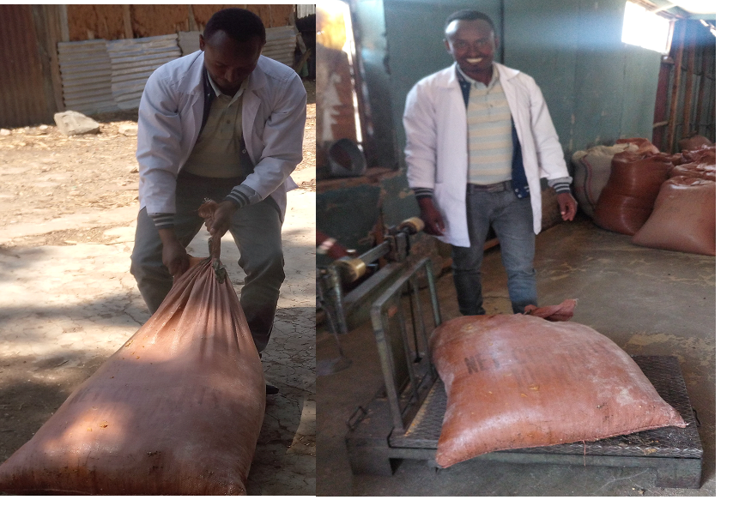

Figure 5: Onsite Collected and Measured Different Food Wastes Generated from Students’ Cafeteria of Main Campus of Ambo University.

3.3.1. Preprocessed Food Wastes
A preprocessed food wastes (onion peel and preprocessed kinche) were assessed from kitchen and preprocessing area of the cafeteria daily for a week. The total biomass of both preprocessed food wastes were collected separately on daily basis in synthetic sacs, weighed on balance and the result was presented in (Kg) per week. The total biomass of onion peels and preprocessed kinche were estimated by multiplying the amount (dry weight) generated per week with 52 weeks and the result was presented as preprocessed food wastes generated from students’ cafeteria per year in Kg from main campus of Ambo University.

3.3.2. Leftover Foods
To estimate the total biomass of leftover foods from the students’ cafeteria of main campus of Ambo University, the manageable or smaller cafeteria which has been serving about 680 students was selected from the total of three cafeterias in the main campus of Ambo University. The assessment of different leftover foods were carried out by measuring the leftover foods replaced back on the collecting table by the students themselves on individual or as a group during the breakfast, lunch and dinner time figure 6.
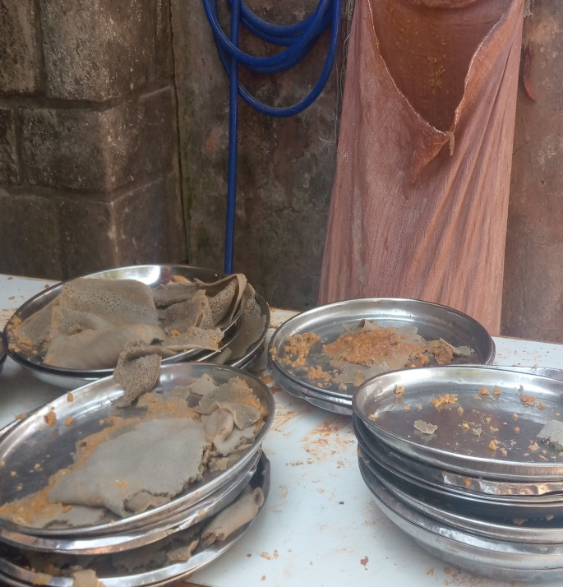

Figure 6: Visual Observed Leftover Foods.

3.3.2.1. During the Breakfast Time
Cooked kinche (FBK), cooked rice (FBR)and firfir (FBF) were the three major leftover foods replaced back by the students during breakfast time. The leftover foods were collected from tray into the synthetic sacs by hand and weighed on balance seven days in a week. The total biomass of leftover foods generated at breakfast, was calculated by multiplying the amount of leftover foods from 680 students’ with 3480 students’ and the result was presented as leftover foods generated per year in Kg from main campus of Ambo University.

3.3.2.2. During the Lunch Time
Injera with meat stew and Injera with lentil stew were the two major type’s leftover foods generated from the students’ cafeteria during lunch time. Both of the leftover foods were collected from tray into the synthetic sacs by hand and weighed on balance for seven days. The total biomass of leftover foods generated at lunch was calculated by multiplying the amount of leftover foods from 680 students with 3480 students and the result was presented as food leftover generated per year in Kg from main campus of Ambo University.

3.3.2.3. During the Dinner Time
Injera with pea stew was the major leftover foods generated from the students’ cafeteria during dinner time at the period of assessment. It was collected from tray into the synthetic sacs by hand and weighed on balance seven days throughout a week. The total biomass of leftover foods obtained during dinner was calculated by multiplying the amount of different leftover foods from 680 students’ with 3480 students’ and the result was presented as a dinner leftover foods generated per year in Kg from main campus of Ambo University.

3.4. Inoculum Preparation
The inoculum was prepared from 1:1 (v/v) ratio of fresh cow dung and tub water. The digester volume 100L was used to prepare the inoculum. Water bath (Electro thermal constant temperature water bath, model SY-1L.2H) was used to keep optimum mesophilic condition at 38 ± 1°C. The water pump (type ONDINA 50M) was used to pump and circulate the hot water from water bath to the digester holding the inoculum though the pipe connected to each other. The inoculum was fully digested for a week to degas and allow temperature adaptation of the anaerobic bacteria for further experimental setupfigure 7.
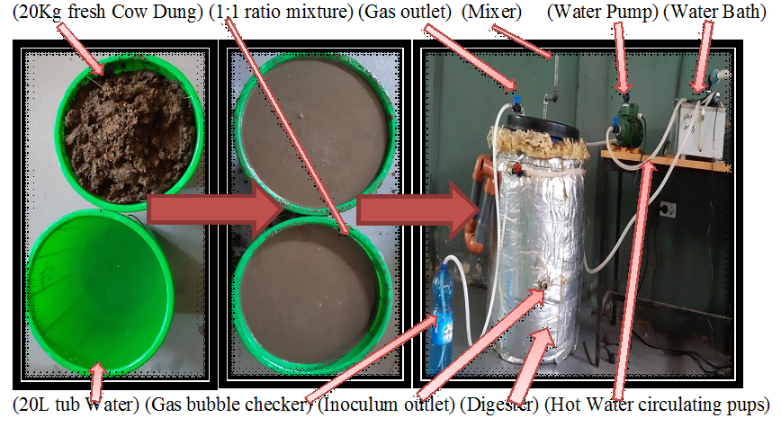

Figure 7: Inoculum Preparation for further experimental setup.

3.5. Determination of Some Physic-chemical Property of Food Waste

3.5.1. Determination of Moisture Content (%MC).
The moisture content of the samples was determined using the oven–drying method. Five to ten grams of each sample were transferred to a pre-weighed crucible and were weighed altogether and recorded. Pre–weighed samples were dried in the drying oven at105°C for 24 hours. The crucibles with dried samples were cooled in a desiccator and weighed using an electronic weighing balance. Moisture content was calculated using equation 1: (Zaman, 2010; Eze and Agbo, 2010).
$\% MC=\frac{W-D }{W}X$ 100……………………………………………………………..…………1
Where, W is the mass of the sample before drying in grams
D is the mass of the sample after drying in grams

3.5.2. Determination of Total Solids (%TS)
Samples of each food wastes were placed on the crucibles and put in a drying oven at105°C to evaporate for 24 hours. After 24 hours, the crucibles were taken out from the drying oven, cooled in desiccators and weighed using electronic balance. The percentage of TS was calculated using equation (2) (Zaman, 2010).
$\%TS=\frac{A-B}{C}×100$………………………………….…………………………………2
Where, A = weight of dried residue + crucible (g),
B = weight of crucible (g) and C= weight of wet sample + crucible (g)

3.5.3. Determination of Volatile Solids (%VS)
First samples were oven-dried in the drying oven at 105ºC for 24 hour and cooled in a desiccator, weighed and recorded. The residue of each samples were ignited to constant weight in the muffle furnace at 550°C for 6 hours. Then, the samples were removed from the muffle furnace cooled in a desiccator and weighed using electronic balance. The percentage of total volatile solids (VS) was determined using equation (3) indicated in (Eze and Agbo, 2010).
$\%VS=TS-(\frac{WA}{Ww})×100$………………………………….…………………………………3
Where, WA = weight of ash in (g); Ww = weight of wet sample (g)

3.5.4. Determination of Total Ash (%TA)
A gram of each samples were weighed then transferred into the crucibles. The crucibles were placed in the muffle furnace and heated first over a low flame till all the material was completely char followed by heating in muffle furnace for about 6 hours at 550ºC. They were then cooled in a desiccator and weighed. To ensure the completion of ashing, the crucibles were then heated in the muffle furnace for 1 hour then cooled and weighed. That were repeated till two consecutive weights was the same and the ash was changed to white or grayish color. Then, total ash of the sample of food waste was calculated using equation (4) indicated in (Raghuramulu et al., 2003).
$\%TA=\frac{WA }{WS}×100$……………………………………………….……………...……4
Where, TA= total ash of g/100g sample, WA = weight of ash (g), WS= weight of sample taken (g)

3.5.5. Determination of Organic Carbon (%OC)
The oven dried samples were analyzed for the initial carbon concentration using the ash method. According to Adams et al. (1951), for most biological materials the carbon content is between 45 to 60% of the VS fraction. Assuming 55%VS of biological materials, equation 5 were used to calculate the carbon content.
$\%C=\frac{\%VS}{1.8}…………………………………………………………………….5$.
Where %VS=100-%Ash; 1.8= an average carbon content for most of the biological materials

3.5.6. Determination of Total Nitrogen Content (%TN2)
The total nitrogen content of dried food waste samples was determined using the Kjeldahl method. Digestion, distillation and titration are three main steps involved this method. Total nitrogen tool, including the Kjeldahl digester unit (Gerhardt, kjeldatherm) was used to digest the samples. For digestion 1g of air dried that passes through 2mm sieve each sample (food waste) was weighed and quantitatively transferred into digestion tube. After adding 3g catalyst mixture the sample was allowed to stand for 5 to 15 min in the test tube rack before digestion. 5ml of concentrated H₂SO₄ was added into a test tube and mixed carefully. Then the digester was switched on and allowed to wait until its temperature reach 370⁰C. As the digester gained this temperature the rack was placed in it and the digestion continues for 3 hours until a clean solution was observed. The tube in the rack was transferred to the fume hood for cooling. About 50ml distill water was added and shacked by hand to avoid sulphate precipitation in the solution. The acid digestate was transferred quantitatively to 500mL capacity kjeldahl flask and tube was rinsed with distilled water small portion at a time and 20mL of 2% boric acid solution was measured from dispenser in to receiver Erlnmeyer flask corresponding to the number of sample .Two drops of mixed indicator were added to Erlnmeyer flask and placed under the condenser in which the tip of the condenser was dipped into boric acid solution. Slowly 75mL of 40% sodium hydroxide was added by letting it to down the neck of distilled flask. The content of the flask was shaken by swirling and heat turn on. The distillation continued for about 5 minutes to 8 minutes until a total volume become between 150 ml to 200 ml. The distillate was titrated from green to pink end point with 0.1N H₂S0₄ (Dewis and Freitans, 1970). The result was calculated by using equation (6).
% Total Nitrogen (TN₂) = $\frac{(A-B)*N*0.014*100*mcf}{S}$ ………. ………........(6)
Where: A= ml of H₂SO₄consumed to end point of titration, B= ml of H₂SO₄ required for titration of blank,N= normality of H₂SO₄ (0.1N) in milliliter, S= Sample weight on dry matter basis in grams, 0.014= molecular weight of nitrogen in grams and mcf = moisture correction factor. Finally, the C:N ratio was calculated by using equation (7) below.
$\frac{\%C}{\%N} =C:N$ ………………………………………………………………7

When %C =percentage of initial carbon content of experimental samples determined by using the ash method, %N= percentage of total nitrogen content of treatment samples determined by using the Kjeldahl method.

3.6. Preparation of Substrate for Anaerobic Digestion
In this study, kinche preprocessed food waste (KPFW) and potato peels food waste (PPFW) were the two food scraps dried out separately in air dry to remove the moisture of the substrates. A coffee grinding mill was used to reduce the size of KPFW and PPFW alone to speed up degradability of the substrates by the microorganisms. Also selected six leftover foods samples such as KBFW, RBFW, FBFW, MLFW, LLFW and PDFW were homogenized and the sizes were reduced before use by spoon on tray alone. The one-kilogram plastic containers were used to hold each sample to put in the refrigerator at 4℃ until they were used.

3.7. Experimental Design and Set-up
Laboratory-scale anaerobic batch digesters (flasks) with total volume of 500ml and working volume of 400ml were used as digester (bioreactor) in this experiment. The butyl rubber (rubber borers) for fitting super structures to each digester and the T-tube plastering materials with plastic gas bags were used to collect the biogas produced from the digester figure 8 A. The digesters were operated at mesophilic temperature at (38±1)℃ by circulating hot water from water bath to digester containing chamber for 40 days. Water bath (Electro thermal constant temperature water bath, model SY-1L.2H) was used to keep optimum mesophilic condition at 38 ± 1°C. The water pump was used to pump and circulate the hot water from water bath to the digester holding chamber through the pipe connected to each other figure 8 B. A digester was loaded with 25g each food waste based on the %VS of the substrates and inoculum. The digester was agitated by hand once in a day.
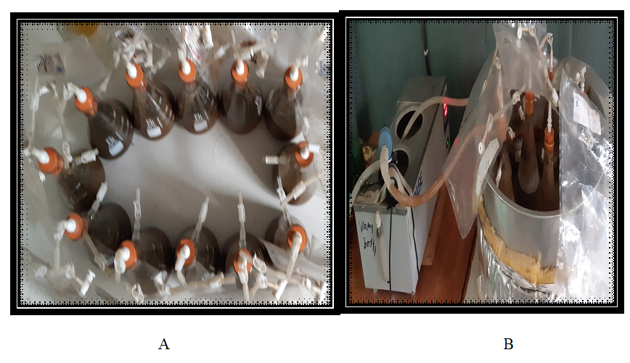

Figure 8: Experimental Design and Setup

3.8. Measurement of Gas Volume
Gases were collected in gas bags (Tedlar gas bag) with a volume of 2.5 liters positioned outside of reactor and connected with reactors by plastic pipes. Biogas was measured regularly during fermentation period in every other day. Biogas volume measurement was provided by a gas suction graduated cylinder with 1000ml volume containing barrier solutions (solution prepared from concentrated NaCl and citric Acid to prevent dissociation of gases) figure 9.
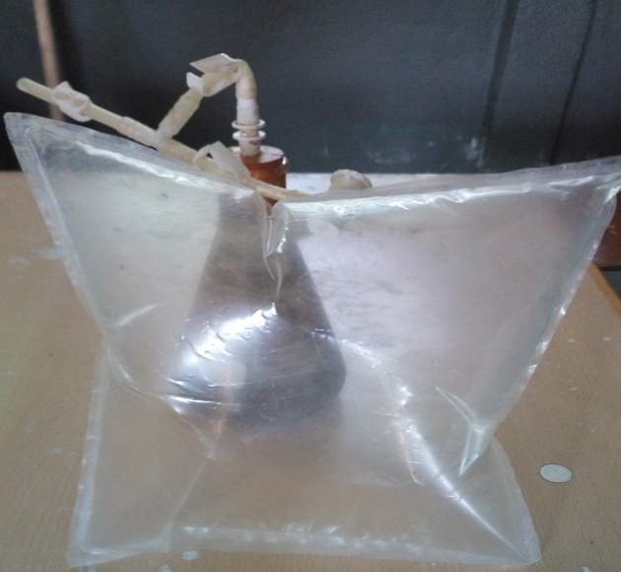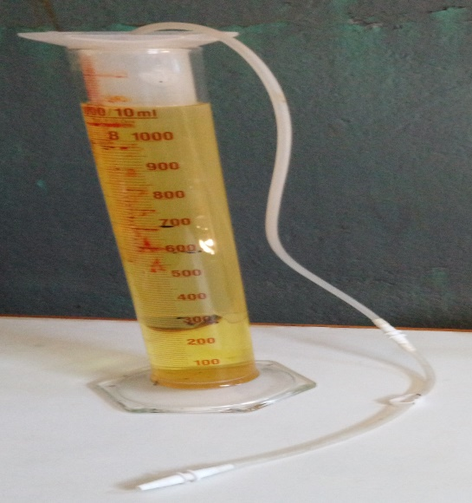

A. Collected Biogas B. Gas Suctioned Graduated Cylinder

Figure 9: Collected gas in gas bag and gas suction graduated cylinder used to measure biogas volume generated from each samples.

3.9. Determination of Percentage of Methane Contents
The percentage of methane content of each samples were measured regularly during fermentation period in every other day. A syringe with 5ml volume was used to take biogas from graduated cylinder containing barrier solutions and transfer to the 50ml of 7MNaOH to determine the biogas composition (CH₄ and CO₂) of each sample by consuming CO₂figure 10. Finally, the percentage of methane was calculated and a flammability of the methane was checked.
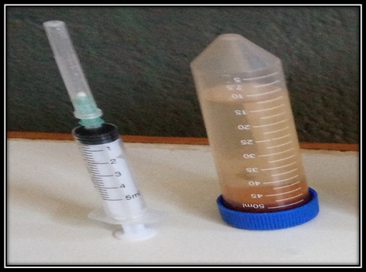

Figure 10: Syringe and 50ml with 7M NaOH holding equipment used to determine the biogas composition of each samples.

3.10. Statistical Analysis
In order to determine the effect of the different food wastes on biogas yield and %CH₄, data collected were subjected to statistical analysis using Statistical Analysis System software (SPSS v20), one-way analysis of variance (ANOVA). ANOVA was used to compare the results of the mean values of the biogas yield and percentage of methane content generated from each samples ml/g VS every other day as well as accumulated biogas, methane and carbon dioxide yield generated through 40 days at 95% confidence level. The descriptive result was help to concluded that which type of food waste enhanced biogas yield and percent of methane content under anaerobic condition at 95% confidence level.

CHAPTER FOUR

4. RESULTS AND DISCUSSION

4.1. Estimation of Total Biomass of Different Food Wastes Generated From Students’ Cafeteria.
The demographic characteristics of the respondents under this study showed that, about 23 and 60 respondents which account 27.7% and72.3% were males and females respectively. About 25 and 55 respondents which account 30.1% and 66.3% were found in the age range of 18-25 and 26-40 years respectively; whereas the remaining 3 respondents which account 3.6% were found in the age range of 41-65 years. Concerning educational states 8.4% and 31.3% respondents were attained educational level 1-4 and 5-8 respectively; while the remaining 53% and7.2% respondents completed 9-12 and college and above holders respectively. Concerning job position of respondents 1 which account 1.2% was ticker, majority of the respondents 79 which account 95.2% were students’ cafeteria workers and the remaining 3 which account 3.6% were daily employees on waste disposal table 2.

Table 2: The Demographic Characteristics of the Study Respondents.
Socio-demographic |  |  | Frequency |  | Percent
Sex |  | Male | 23 |  | 27.7
 |  | Female | 60 |  | 72.3
Age (Years) |  | 18-25 | 25 |  | 30.1
 |  | 26-40 | 55 |  | 66.3
 |  | 41-65 | 3 |  | 3.6
Education |  | 1-4 | 7 |  | 8.4
 |  | 5-8 | 26 |  | 31.3
 |  | 9-12 | 44 |  | 53
 |  | College and above | 6 |  | 7.2
Position |  | Ticker | 1 |  | 1.2
 |  | Cafeteria Workers | 79 |  | 95.2
 |  | Daily Employees | 3 |  | 3.6

4.1.1. Knowledge of Respondents on Generation and Management of Different Food Wastes

The respondent’s responses on the questions presented than were summarized in table 3 below.

Table 3: Frequency and percentage distribution of respondents on generation and management of different food wastes.
1. Do you think is there any Food Waste generated from students’ cafeteria of main campus of Ambo University? |  | Frequency | Percent | Cum. Percent
 | Yes | 83 | 100 | 100
 | No | - | - | -
 | Total | 83 | 100
2. Do you think is there Food Waste occur during preprocess? | Yes | 56 | 67.5 | 67.5
2. Do you think is there Food Waste occur during preprocess? | No | 27 | 32.5 | 100
2. Do you think is there Food Waste occur during preprocess? | Total | 83 | 100
3. Do you think is there any leftover Foods generated from students’ cafeteria of main campus of Ambo University? | Yes | 83 | 100 | 100
 | No | - | - | -
 | Total | 83 | 100
4. Which type of Food waste highly generated from students’ cafeteriaof main campus of Ambo University? | Preprocess | 9 | 10.84 | 10.84
 | Leftover | 46 | 55.42 | 66.26
 | Both | 28 | 33.74 | 100
 | Total | 83 | 100
5. Do you know the amount of food waste disposed per day? | Yes | - | - | -
5. Do you know the amount of food waste disposed per day? | No | 83 | 100 | 100
5. Do you know the amount of food waste disposed per day? | Total | 83 | 100
6. How main times the generated food waste is disposed per day? | Once | - | - | -
 | Twice | - | - | -
 | Three times | 83 | 100 | 100
 | Total | 83 | 100
7. Which type of disposal mechanism of different food wastes known in main campus of Ambo University? | Landfilling | - | - | -
 | Open Dumping | 83 | 100 | 100
 | Incineration | - | - | -
 | Other | - | - | -
 | Total | 83 | 100
8. Do you think that these food wastes recycled or reused? | Yes | - | - | -
8. Do you think that these food wastes recycled or reused? | No | 83 | 100 | 100
8. Do you think that these food wastes recycled or reused? | Total | 83 | 100
9. For the following which type of problem is related to mismanage of different food wastes? | Environmental | 18 | 21.69 | 21.69
 | Economical | 7 | 8.43 | 30.12
 | Healthy | 9 | 10.84 | 40.96
 | All | 49 | 59.04 | 100
 | Total | 83 | 100
From the frequency descriptive result of the table 3 above one could observe that, on the first survey questionnaire, all respondents were agreed on the generation of different food wastes from students’ cafeteria of main campus of Ambo University. On the second survey questionnaire, about 56 respondents which account 67.5% of them were agreed on the generation of preprocessed food wastes from students’ cafeteria whereas, 27 respondents which account 32.5% of them were not agreed on the generation of preprocessed food wastes from students’ cafeteria. This result showed that there were preprocessed food wastes generated from students’ cafeteria of main campus of Ambo University. On the third survey questionnaire, all of the respondents 83 which account 100% were agreed on the generation of leftover foods from students’ cafeteria of main campus of Ambo University. On the fourth survey questionnaire one could observe that, 9 respondents which account 10.84% were given their responses on pre-processed food wastes was the highly generated food waste from students’ cafeteria whereas, 46 respondents which account 55.42% were given their responses on leftover foods were the highly generated food waste from students’ cafeteria of main campus of Ambo University. The remaining 28 respondents which account 33.74% were given their responses on both preprocessed and leftover foods were the highly generated food wastes from students’ cafeteria of main campus Ambo University.
From table 3 above on the fifth, sixth and seventh survey questionnaire one could observe that, all of the respondents 83 which account 100% were given their responses on the amount of different food wastes disposed per day were unknown, three times per day disposal of different food wastes and open dumping disposal mechanism respectively of different food wastes generated from students’ cafeteria of main campus of Ambo University. Also on the eighth survey questionnaire, 64 respondents which account 77.1% were clearly know the effect of mismanaged of different food wastes while the left behind 19 respondents which account 22.9% were not clearly know the effect of mismanaged of different food wastes generated from students’ cafeteria. On the ninth survey questionnaire, 3 respondents which account 3.62% had environmental, 7 respondents which account 8.43 % had economical, 9 respondents which account 10.84 % had healthy and the remaining majority of respondents 64 which accounts 77.11% were given their responses on all burdens were related to mismanage of different food wastes. The finding from this study was similar with (Jain and Newman, 2018; Salemdeeb et al., 2016)studies. According to Jain and Newman, (2018)and Salemdeeb et al. (2016), mismanaged of different food wastes my causes several environmental, economic and health problems, by creating bad odors, attract vermin (pest, rats, flies, mosquitos, mice and insects), birds and other carriers of communicable diseases and further leading to causes water body and soil pollution through leachate and run-off.

4.1.2. Direct Visual Observation on Generation and Management of Different Food Wastes.
During visual observation onion peels food waste (OPFW) and Kinche preprocessed food waste(KPFW) were the two preprocessed food wastes highly generated from preprocessing area of students’ cafeteria of main campus Ambo University (appendix 1). At breakfast, lunch and dinner time the observed result shows that KBFW, RBFW and FBFW; LLFW and MLFW, and PDFW respectively were the major leftover foods replaced back by the students’ from the students’ cafeteria of main campus of Ambo University (appendix 2). Also the observed result of the handling; transport method and disposal site of different food wastes shows that, among the generated different food wastes per day from students’ cafeteria, a few amount of the leftover food (locally known as ‘’bulle’’) was eaten and taken by some children’s live in Ambo town; whereas hung amount of different food wastes were open damped once to twice a day inside the main campus of Ambo University nearby Hulluka River using pickup car and daily workers’ figure 11 below. From the figure 11 below any one could observe that open damping of different food wastes generated from students’ cafeteria of main campus Ambo University was the most common disposal method. This may cause favorable condition for the multiplying of vectors and cause unhealthy environment to the students’, cafeteria workers and society nearby the Ambo University main campus. The finding from this study was similar with study (Helelo et al., 2019; Jain and Newman, 2018).

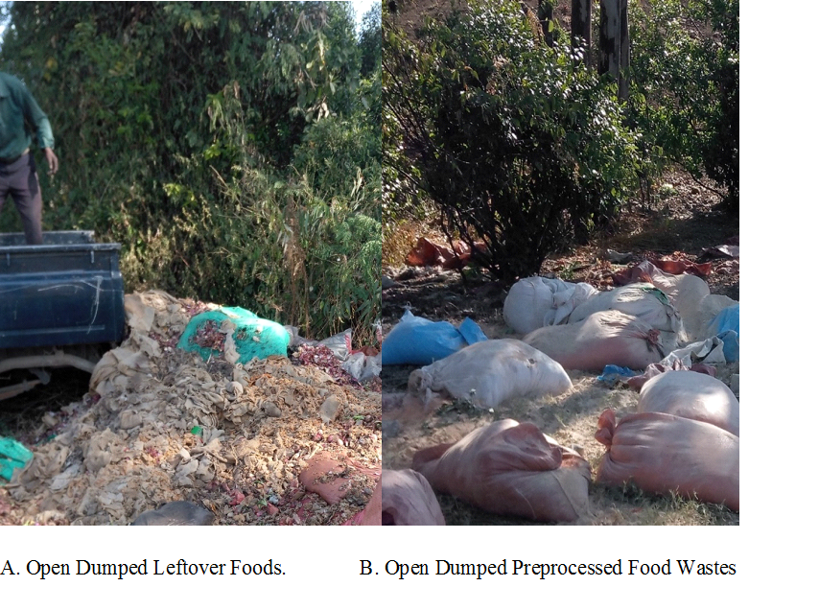Figure 11: Visual Observed Disposal Site of Different Food Wastes.
According to Helelo et al. (2019), Hawassa University main campus dumps food wastes at the back site of its compound using handcart and daily laborers; the open-dumping attracted scavenger, birds, flies and other pests to the site and caused offensive smell and became a potential health risk for the community. In addition Jain and Newman (2018) reported that, mismanaged food waste either landfills or open dumps adversely affects our climate due to the greenhouse gases (GHG) that are emitted upon its decomposition, contaminates water courses from nutrient and leachate runoff and also causes communicable diseases and a health hazard. Therefore, developing an alternative disposal method for different food wastes generated from students’ cafeteria of main campus Ambo University was very important.

4.1.3. Onsite Estimated Different Food Wastes Generated From Students’ Cafeteria.

4.1.3.1. Assessment of preprocessed Food Wastes
The result of assessment of preprocessed food wastes showed that, about 695Kg and 94.4Kg OPFW and KPFW respectively were generated from students’ cafeteria of main campus of Ambo University per week. The estimated total biomass of preprocessed food wastes generated from students’ cafeteria of main campus of Ambo University per week was 789.5Kg. The finding from this study was similar with (Helelo et al., 2019) study. According to Helelo et al., (2019), from the number of students’ using cafeteria 1,300 to 11,426in the four campuses of Hawassa University; about 331 to 3242.1kg per week of onion peels was generated, the finding of this study was found in line.

4.1.3.2. Assessment of Leftover Food wastes
The amount of leftover foods generated at breakfast showed that, 834.18Kg, 470.82Kg and 460.59Kg were estimated for KBFW, RBFW and FBFW respectively per week; 1,473.88Kg and 1,888.41Kg were estimated for LLFW and MLFW respectively per week and 3,065.74 Kg were estimated for PDFW per week. Totally, about 8,193.618Kg were the estimated leftover foods generated from students’ cafeteria of main campus of Ambo University per week. The result of this study was similar with (Helelo et al., 2019) reports. According to Helelo et al., (2019), about 1,556 to 12,390.5kg per week of leftover foods was generated from the four campuses of Hawassa University students’ cafeterias serving 1,300 to 11,426 number of student’s, the finding from this study was found in line. The total amount of different food wastes estimated per year from students’ cafeteria of main campus of Ambo University was summarized in table 4 below.

Table 4: Total Amount of Different Food Wastes Estimated from Students Cafeteria (in Kg).
Samples Code | Unit | Amount of Different Food Waste Generated per
Samples Code | Unit | Week | Year
KPFW | Kg | 94.5 | 4,440.19
OPFW | Kg | 695 | 25,194.64
KBFW | Kg | 834.18 | 17,698.93
RBFW | Kg | 470.82 | 9,982.69
FBFW | Kg | 460.59 | 8,681.23
MLFW | Kg | 1,473.88 | 40,035.12
LLFW | Kg | 1,888.41 | 31,185.58
PDFW | Kg | 3,065.74 | 68,230.40
Subtotal food wastes |  | 8,883.14 | 204,448.78
KPFW= Kinche preprocessed Food Waste, OPFW=Onion Peel Food Waste, KBFW= Kinche Breakfast Food Waste, RBFW= Rice Breakfast Food Waste, FBFW= Firfir Breakfast Food Waste, LLFW= Lenticel Lunch Food Waste, MLFW=Meat Lunch Food Waste and PDFW= Pea Dinner Food Waste.
From the above table 4, the total amount of preprocessed food wastes estimated were 29,634.83Kg per year and the total amount of leftover foods were 175,814 Kg per year, totally about 205,449.78Kg of different food wastes were generated from the students’ cafeteria of main campus of Ambo University. The result of this study indicated that, there was high potential of biomass (different food wastes) that generated from the students’ cafeteria of main campus of Ambo University. Biogas production from this biomass through AD process was an alternative and potential for supplementing the existing energy supply in the form of biogas and minimizes the solid organic wastes which mainly disposed in the open dumping. The finding from this study was similar with (Ariunbaatar et al., 2016) study. According to Ariunbaatar et al. (2016), biogas production from food waste through AD has been a successful treatment option for different food wastes and also it is effective in solving environmental, health and energy challenges.

4.2. Physico-chemical characteristics of different food wastes
The different food wastes generated from the student cafeteria of the main campus of Ambo University were characterized for the following features: Moisture content (MC), Total solid (TS), Total Ash, Volatile solid (VS), the dry organic matter content (VS/TS), organic carbon content (OC), Total Nitrogen and carbon to nitrogen ratio (C:N) content. The results of the physico-chemical parameters have been given as the average of triplicates, the mean and standard deviations in Table 6.

Table 5: Characterization of Different Food Wastes and Inoculum.
Samples | % MC | %TS | %Ash | %VS | % VS of TS | % OC | %TN | C:N ratio
KPFW | 3.4±0.72 | 96.6±0.72 | 3.66±0.17 | 92.9±0.75 | 96.2±0.18 | 53.4±0.10 | 2.67±0.06 | 20.03±0.45
PPFW | 3.8±0.34 | 96.18±0.34 | 3.1±0.17 | 93.1±0.40 | 96.8±0.18 | 53.8±0.10 | 2.56±0.06 | 20.77±0.51
KBFW | 59.3±0.56 | 40.7±0.56 | 0.77±0.01 | 39.9±0.56 | 98.1±0.04 | 54.5±0.02 | 1.96±0.01 | 27.81±0.14
RBFW | 65.5±7.73 | 34.5±7.73 | 1.28±0.20 | 33.2±7.90 | 96.1±1.39 | 53.4±0.77 | 1.97±0.01 | 27.12±0.48
FBFW | 64.5±1.67 | 35.5±1.67 | 1.22±0.15 | 34.2±1.80 | 96.5±0.57 | 53.6±0.32 | 1.98±0.01 | 27.07±0.16
LLFW | 64.4±6.99 | 35.6±6.99 | 0.86±0.10 | 34.8±7.10 | 97.5±0.77 | 54.2±0.43 | 1.89±0.01 | 28.67±0.35
MLFW | 67.4±4.42 | 32.6±4.42 | 0.52±0.10 | 32.1±4.39 | 98.4±0.35 | 54.7±0.19 | 1.87±0.02 | 29.18±0.41
PDFW | 66.4±0.46 | 33.4±0.46 | 0.93±0.26 | 32.5±0.30 | 97.2±0.75 | 53.8±0.42 | 1.98±0.02 | 27.17±0.27
INOC | 93.11±0.30 | 6.9±0.30 | 1.23±0.01 | 5.7±0.29 | 82.1±0.59 | 45.6±0.33 | 1.35±0.04 | 33.8±0.83
%MC= percent of moisture content, TS= percent of total solid, %VS= percent of volatile solid, %VS/TS = percent of the dry matter content, %OC = percent of organic carbon content, %TN= percent of total nitrogen content and C:N = carbon to nitrogen ratio, KPFW= Kinche preprocessed Food Waste, PPFW= Potato Pees Food Waste, KBFW= Kinche Breakfast Food Waste, RBFW= Rice Breakfast Food Waste, FBFW= Firfir Breakfast Food Waste, LLFW= Lenticel Lunch Food Waste, MLFW=Meat Lunch Food Waste and PDFW= Pea Dinner Food Waste.

From table 5 above, the samples taken from preprocessed food wastes KPFW and PPFW were contained lower %MC (3.4±0.72%) and (3.8±0.34%) respectively, whereas they have higher %TS (96.6±0.72%) and (96.18±0.34%) respectively. The KPFW contained %Ash (3.66±0.17%), while the PPFW contained %Ash (3.1±0.17%) of which (96.2±0.18%) and (96.8±0.18%) were %VS/TS respectively. Some characteristic of the food wastes such as %Ash(3.24±0.1%) and %VS/TS (96.76±0.01%) by (Jansson et al., 2019). The finding from this study was agrees with the values reported by this researcher. For the samples taken from the leftover foodst he highest %MC and the lowest %TS were (67.4±4.42%) and (32.6±4.42%) respectively from MLFW while the lowest %MC and the highest %TS were (59.3±0.56%) and (40.7±0.56%) respectively from KPFW, the remaining samples were found in between. The highest %Ash and the lowest %VS/TV were (1.28±0.20%) and (96.1±1.39%) respectively from RBFW while the lowest %Ash and the highest %VS/TS were (0.52±0.10%) and (98.4±0.35%) respectively from MLFW, the remaining samples taken from leftover foods found in between. Some physico-chemical characteristic of the food wastes were reported by different researchers. For instance, %MC (43.43 to 84.12%) by (Alemayehu Gashaw et al., 2012) from leftover foods;%TS (30.486±0.815%) and %VS/TS (97.125±0.091%) by (Helelo et al., 2019) for leftover foods; %Ash(0.86%) and %VS/TS (96.65%) by (Suhartini et al., 2019) for canteen food wastes. The finding from this study was agrees with the values reported by these researchers.
From table 5 above, the highest %OC was (54.7±0.19%) recorded from MLFW while the lowest %OC was (53.4±0.10%) recorded from KPFW and RBFW, the remaining samples were found in between. Also about (45.6±0.33%) %OC was recorded from inoculum, while the recommended %OC is between 45 and 60% (Adams et al., 1951), the finding from this study was found in line. The highest %TN was (2.67±0.06%) recorded from KPFW while, the lowest %TN was (1.87±0.02%) recorded from MLFW, the remaining samples were found in between. The %TN 1.26 to 10.85 was reported by (Abimbola and Olumide, 2014), the finding from this study was found in line including inoculum. The result of %C:N ratio from each samples were ranges between (20.03±0.45%) to (29.18±0.41%) and also about (33.8±0.83%) C:N ratio was recorded from inoculum. The finding from this study was similar with (Paritosh et al., 2017) study. According to Paritosh et al. (2017), C:N ratio found in line 20:1 and 35:1 were normally mentioned as suitable range to keep the AD in a stable condition, the finding from this study was found in line including inoculum. The inoculum taken was contained %MC (93.11±0.30), %TS (6.94±0.30), %Ash (1.23±0.01), %VS (5.7±0.29) and %VS/TS (82.1±0.59). Some physico-chemical characteristic of the inoculum %MC (98.74±0.01) and %VS (6.40±0.02) were reported by (Chen et al., 2010).Also the PH of inoculum was tested before filling of inoculum to the digesters (flasks) by PH-mater (HACH-model HQ40d) figure 12 below.
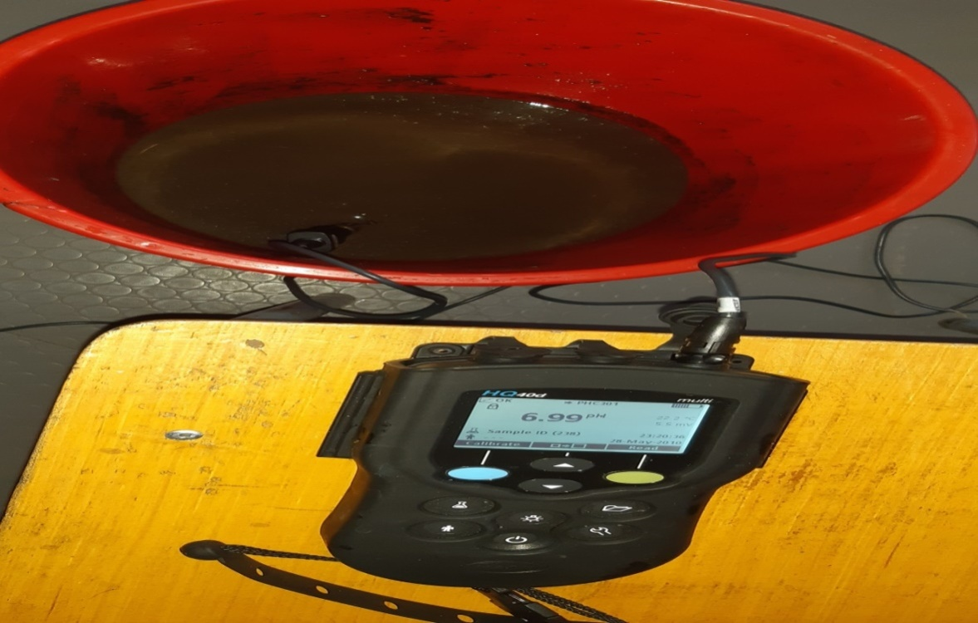

Figure 12: PH of the Inoculum before AD.
From the above figure12, one could observe that, about (6.99) PH was recorded before AD while the recommended pH is between 5.5 and 8.5 (Naik and Tkachenko, 2013). In general, from the above result of the characterization of the different food wastes and inoculum, the finding from this study showed that, all samples were suitable for biogas production including inoculum. The finding from this study was agreed with (Dowb, 2017 and Suhartini et al., 2019) studies. Because, according to Dowb, (2017);Suhartini et al. (2019), among wide range of substrates used for biogas production food waste has potential to provide high biogas yield.

4.3. Production of Biogas
The present study result showed that, the highest biogas yield was recorded from the MLFW (500±12.29) ml/g VS while the lowest biogas yield was recorded from the KPFW (343.61±10.43) ml/g VS, the remaining samples were found in between. The finding from this study was similar with (Rathnasiri et al., 2017 and Cho et al., 1995) studies. In their studies Rathnasiri et al. (2017), about 500 ml/g VS biogas yield was obtained from food waste. Also Cho et al. (1995), had obtained (480 to 280) ml/g VS of biogas yields for different food wastes under mesophilic condition, the finding of this study was found in line. Figure 14 below show the volume of biogas yield generated from each samples in every other day within the retention period 40 days. Also Appendix 3 and appendix 4 show the day at which the biogas yields taken from each sample in every other day.
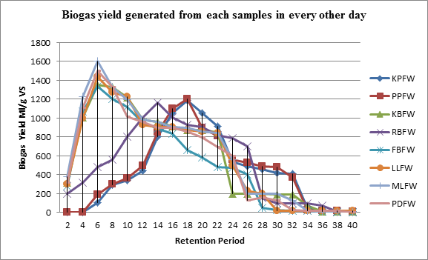

Figure 13: Biogas Volume Generated from Each Samples in every other day.
KPFW= Kinche preprocessed Food Waste, PPFW= Potato Pees Food Waste, KBFW= Kinche Breakfast Food Waste, RBFW= Rice Breakfast Food Waste, FBFW= Firfir Breakfast Food Waste, LLFW= Lenticel Lunch Food Waste, MLFW=Meat Lunch Food Waste and PDFW= Pea Dinner Food Waste.
From the descriptive result of figure 13 above one could observe that, for samples taken from preprocessed food wastes such as KPFW and PPFW, biogas was not produced for the first 4 days. In this study production of biogas from KPFW and PPFW started on day 6 of the retention period by producing average biogas of 106ml and 195ml respectively and then slowly increases to 446ml and 500ml respectively on day 12 of the retention period. Production of high biogas yield from KPFW and PPFW started on day 14 by producing average 800 ml and 850 ml of biogas yield respectively, and then continuously increases until it reached the peak on day 18 by producing average 1190ml and 1203ml of biogas yield respectively. The finding from this study was similar with (Nopharatana et al., 2007; Ukpai and Nnabuchi, 2012). According to Nopharatana et al. (2007) and Ukpai and Nnabuchi (2012), microorganisms require a longer time to degrade strong materials.
For samples taken from leftover foods such as KBFW, RBFW, FBFW, LLFW, MLFW and PDFW production of biogas started on day 2 of the retention period by producing 320ml, 202ml, 280ml, 303ml, 380ml and 313ml of average biogas yield respectively. The finding from this study was similar with (Otun, et al., 2015) study. According to Otun, et al. (2015), leftover foods were high degradability during AD process. Except RBFW, production of high biogas yield from treatment samples taken from KBFW, FBFW, LLFW, MLFW and PDFW started on day 4 of the retention period and reach the peak on day 6 by generating 1351ml, 1335ml, 1438ml, 1607ml, and 1498ml of average biogas yield respectively. From RBFW, production of high biogas yield started on day 10 of the retention period by producing 803ml of biogas yield in average, and then reaches the peak on day 14 by generating 1165ml of average biogas yield. This may be due to slow degradability of organic matter found in RBFW by microbial. In the present study, production of biogas yield begins to reduce after reach the peak of average biogas yield in all samples till the completion of the retention period of 40 days. The finding from this study was similar with (Asikong et al., 2016). According to Asikong et al. (2016), this is expected because the decline in the volume of biogas produced is as a result of the decline in the activities mainly of methanogens as well as other factors such as decrease in pH, deposition of microbial metabolites, gradual exhaustion of available nutrient from the substrates and the replacement by organisms that tend to utilize some of the products of their actions.

Table 6: Result of ANOVA Table on Biogas Yield.
 | Sum of Squares | Df | Mean Square | F | Sig.
Between Groups | 68931.74 | 7.00 | 9847.39 | 51.08 | 0.00
Within Groups | 3084.64 | 16.00 | 192.79
Total | 72016.38 | 23.00
From the result of ANOVA table 6 below, one could observe that, each samples produced different quantity of biogas yield (appendix 5). This result indicated that each samples were statistically significant (P≤0.05). However, the Duncan’s homogeneous multiple range tests (appendix 6) showed that, KPFW and PPFW samples, RBFW and FBFW samples and PDFW, LLFW and KBFW samples were within the same homogeneous group in case of biogas yield generation.

4.4. Composition of the Generated Biogas.
Table 7below shows the percentage of methane and carbon dioxide from each sample within the retention period 40 days.

Table 7: Percentage of Methane and Carbon Dioxide Content from Each Sample.
Samples Code | Percent of Methane | Percent of Carbon dioxide
KPFW | 67.15±2.47 | 32.85±2.47
PPFW | 70.6±3.21 | 29.40±3.21
KBFW | 79.01±2.58 | 20.99±2.58
RBFW | 73.53±3.33 | 26.47±3.33
FBFW | 75.15±2.62 | 24.85±2.62
LLFW | 78.41±2.59 | 21.59±2.59
MLFW | 81.65±2.58 | 18.35±2.58
PDFW | 77.25±1.59 | 22.75±1.59
KPFW= Kinche preprocessed Food Waste, PPFW= Potato Pees Food Waste, KBFW= Kinche Breakfast Food Waste, RBFW= Rice Breakfast Food Waste, FBFW= Firfir Breakfast Food Waste, LLFW= Lenticel Lunch Food Waste, MLFW=Meat Lunch Food Waste and PDFW= Pea Dinner Food Waste.
From table 7 above the highest percentage of methane was recorded from the MLFW (81.65±2.58%) while the lowest percentage of methane was recorded from the KPFW (67.15±2.47%) the remaining samples were found in between. The finding from this study was simlar with (Rathnasiri et al., 2017) study. According to Rathnasiri et al. (2017), about 66.89% to 81.96% of methane contents were obtained from the samples of different food wastes, the result of this study was found in line. From the result of ANOVA (appendix7 and appendix 8),one could observe that, each samples were statistically significant (P≤0.05) on percentage of methane content, but not statistically significant (P≤0.05) on percentage of carbon dioxide. The flammability of biogas produced from each samples were checked. The observed result showed that, all the produced biogas from each samples were shown flames. The observed flames were different in color (appendix 10). The observed blue appearance was increase with the samples that have high percentage of methane.

CHAPTER FIVE

5. CONCLUSIONS AND RECOMMENDATIONS

5.1. CONCLUSIONS

Based on the above results the following conclusions were given.
- The results of the study showed that the highest amount of food wastes generated was 68,230.34 Kg/year from PDFW while 4,440.19Kg/ year was found to be the least in amount from KPFW.
- From the physic-chemical characterization of different food wastes, the highest %MC, %VS/TS, %OC, C:N ratio and the lowest %TS,%VS, %Ash, %TN were (67.4±4.42%), (98.4±0.35%),(54.7±0.19%),(29.18±0.41%) and (32.6±4.42%), (32.1±4.39%), (0.52±0.10%),(1.87±0.02%) respectively from MLFW while the lowest %MC, %VS/TS, C:N ratio and the highest %TS, %Ash, %TN were (3.4±0.72%), (96.2±0.18%), (20.03±0.45%) and (96.6±0.72%), (3.66±0.17%), (2.67±0.06%) from KPFW. The highest %VS (93.1±0.40%) was from PPFW whereas the lowest %OC (53.4%) was recorded from KPFW and RBFW.
- The highest total biogas yield and the highest percentage of methane were recorded from the MLFW (12,500±307.16ml) and (81.65±2.58%) respectively, where as the least total biogas yield and the least percentage of methane were recorded from the KPFW (8590.33±260.77ml) and (67.15±2.47%) respectively.

5.2. Recommendations
Based on the above conclusions the following recommendations were given.
- There is a high biomass of food wastes generated from the student cafeteria of the main campus of the Ambo University, which will be used for biogas production but these food wastes are not converted to bio-energy. Therefore these food wastes should be collected properly and recycled for bio-energy production.
- The general outcome of this study suggested that, rather than open damping, AD approach was an alternative disposal method for different food wastes generated from students’ cafeteria of main campus of Ambo University.

REFERENCES
Abimbola, O., and Olumide, O. (2014).Evaluation of Biogas Production from Food Waste.International Journal of Engineering and Science, 3: 01-07.
Achinas, S., Achinas, V., and Euverink, G. (2017). A Technological Overview of Biogas Production from Bio Waste.Green Chemical Engineering a Review, 3(3), 299-307.
Adams, R. C., Maclean, R.C., Dixon, F.M., Bennett, G. I., Lough, R. C. (1951). The utilization of organic waste in Newzealand.Journal of Engineering, 396-424.
Adekunle, K., and Okolie, J. (2015).A Review of Biochemical Process of Anaerobic Digestion.Advances in Bioscience and Biotechnology, 6, 205-212.
Agyeman, F., and Tao, W. (2014). Anaerobic co-digestion of food waste and dairy manure: Effects of food waste particle size and organic loading rate. Journal of Environmental Management, 133, 268-274.
Ahorsu, R., Francesc, M., and Magda, C. (2018).Signiﬁcance and Challenges of Biomass as a Suitable Feedstock for Bioenergy and Biochemical Production: A Review.Energy Review,1-19
Al-Addous, M.,Saidan, M., Brour, M., and Alnaie, M. (2018). Evaluation of Biogas Production from the Co-digestion of Municipal Food Waste and Waste water Sludge at Refugee Camps Using an Automated Methane Potential Test System. Energy Article, 1-1.
Alemayehu Gashaw, Solomon Libsu, and Chavan, R. (2012).Evaluation of the Feasibility of Biogas Production from Leftover Foods of Bahir Dar University Students’ Cafeteria.International Journal of Science and Research, (Online): 2319-7064.
Ali, S., Mahmood, Q., Maroof S., Pervez, A., and Ahmad A. (2014).Microbial Ecology of Anaerobic Digesters.Scientific World Journal, 183752.
Al Seadi, T., Rutz, D., Prassl, H., Kottner, M., Finsterwalder, T., Volk, S., and Janssen R. (2008).Biogas Hand Book. Denmark, University of Southern Denmark Esbjerg, Niels Bohrs Vej 9-10.
Amha, Y., Sinha, P., Lagman, J., Gregori, M., and Smith, A. (2017). Elucidating microbial community adaptation to anaerobic co-digestion of fats, oils, and grease and food waste. Journal of Water Resource. 123, 277–289.
Ariunbaatar, J., Esposito, G., Yeh, D. H., and Lens, P. N. (2016).Enhanced anaerobic digestion of food waste by supplementing trace elements: role of selenium (VI) and iron (II). Frontiers in Environmental Science, 4(8).
Arsova, L. (2010). Anaerobic digestion of food waste: Current status, problems and an alternative product. Department of earth and Environmental Engineering foundation of Engineering and Applied Science Columbia University.
Asikong, B., Idire, S., and Tiku, D. (2016). Microorganisms Associated with Biogas Production Using Vegetable (Telfairia occidentalis) Wastes, Banana Peel and Pig Dung as Substrates. British Microbiology Research Journal, 16(3), 1-12.
Ayhan, D. (2016). Future Energy Systems. Energy Sources, Part A: Recovery, Utilization, and Environmental Effect, 38(12), 1721-1729.
Balasubramaniyam, U., Zisengwe, L., Meriggi, N., and Buysman, E. (2008).Biogas production in climates with long cold winters. Documentation Prepared by Wageningen University, the Netherlands for Women in Europe for a Common Future, WECF The Netherlands, 1-68.
Banks, C., Chesshire, M., Heaven, S., and Arnold, R. (2011). Anaerobic digestion of source-segregated domestic food waste: performance assessment by mass and energy balance. Bioresource Technology, 102(2), 612-620.
Barati, M., Aghbashlo, M., Ghanavati, H., Tabatabaei, M., Sharifi, M., Javadirad, G., Dadak, A., and Soufiyan, M. (2017). Comprehensive energy analysis of a gas engine equipped anaerobic digestion plant producing electricity and bio fertilizer from organic fraction of municipal solid waste. Energy Conversion and Management, 151, 753-763.
Bellemare, M., Çakir, M., Peterson, H., Novak, L., and Rudi, J. (2017).On the Measurement of Food Waste. American Journal of Agricultural Economics, 99 (5), 1148–1158.
Bhardwaj, Sh., and Das, P. (2017).A Review on Advantages and Disadvantages of Biogas.International Research Journal of Engineering and Technology, 04: 10
Bharathiraja, B., Sudharsana, T., Jayamuthunagai, J., Praveenkumar R., Chozhavendhan S., and Iyyappan, J., (2018).Biogas production – A review on composition, fuel properties, feed stock and principles of anaerobic digestion.Renewable Sustainable Energy Review, 90, 570-582
Bouallagui, H., Touhami, Y., Cheikh, R. B., and Hamdi, M. (2005).Bioreactor performance in anaerobic digestion of fruit and vegetable wastes. Process biochemistry, 40(3-4), 989-995.
California Integrated Waste Management Board (CIWMB). (2008). Current Anaerobic Digestion Technologies Used for Treatment of Municipal Organic Solid Waste.California Environmental Protection Agency.
Caruso, M., Braghieri, A., Capece, A., Napolitano, F., Romano, P., Galgano , F., Altieri, G., and Genovese, F. (2019). Recent Updates on the Use of Agro-Food Waste for Biogas Production.Applied science-Review, 1-29
Chandra, R., Takeuchi, H., and Hasegawa, T. (2012). Methane production from lignocellulosic agricultural crop wastes: A review in context to second generation of biofuel production. Renewable and Sustainable Energy Reviews, 16(3), 1462-1476
Chen, X., Rowena, T., and Zhang, R. (2010). Anaerobic digestion of food wastes for biogas production. International Journal Agricultural & Biological Engineering, 3(4): 61－72.
Cho, J., Park, S., and Chang, H. (1995). Biochemical methane potential and solid state anaerobic digestion of Korean food wastes. Bioresource Technology, 52(3), 245–253.
Chu, C., Wang, C., and Huang, C. (2007). Pilot study of the influence of stirring and PH an anaerobic converting high-solid organic wastes to hydrogen. International Journal of Hydrogen Energy, 33,1550-1558.
Clercq, D., Wen, Z., Gottfried, O., Schmidt, F., and Fei, F. (2017).A review of global strategies promoting the conversion of food waste to bioenergy via anaerobic digestion. Renew. Sustain. Energy Review, 79, 204–221
Courtney, B., and Dorman, D. (2003).World Wide Fossil Fuels.Chemistry Department of Louisiana State University.
Curry, N., and Pillay, P. (2012). Biogas prediction and design of a food waste to energy system for the urban environment. Renewable Energy, 41, 200-209.
Dere, A., Kalbande, S., and Khambalkar, V. (2017).Recent Review on Biogas Production from Different Waste.International Journal of Current Microbiology and Applied Sciences, 6(10), 3452-3457.
Detman, A., Chojnacka, A., Błaszczyk, M., Kazmierczak, W., Jan, P., and Sikora, A. (2017).Biohydrogen and biomethane (biogas) production in the consecutive stages of anaerobic digestion of molasses.Journal of Environmental study, 26(3),1023-1029.
Dewis, J., and Freitas, F. (1970).Physical and Chemical methods of soil and water analysis FAO soils bulletins 10. Rome 160
Dhamodharan, K., and Ajay, S. (2014). A Review on Pre-Treatment and Anaerobic Digestion of Food Waste for High Rate Methane Production.Journal of Environmental Chemical Engineering, 2, 1821–1830.
Dhamodharan, K., Kumar, V., and Kalamdhad, A. (2015).Effect of different livestock dungs as inoculum on food waste anaerobic digestion and its kinetics.Bioresource Technology, 180, 237-241.
Dhar, H., Kumar, P., Kumar, S., Mukherjee, S., and Vaidya, A. (2016).Effect of organic loading rate during anaerobic digestion of municipal solid waste. Bioresource Technology, 217, 56-61.
Doelle, K. (2015). Anaerobic Digestion of Food Waste to Produce Biogas: A Comparison of Bioreactors to Increase Methane Content Review. Journal of Food Processing and Technology, 06(08).
Dolekoglu, C., and Var I. (2019). Analysis of Food Waste in University Dining Halls: A Case Study from Turkey. Fresenius Environmental Bulletin, 28 (1), 156-166.
Elias J. (2010). Renewable biogas energy production from Cladodes of opuntiaficus- indica.Bioresource Technology Journal. 55, 91–101.
European Union (EU) Fusions. (2014). Report on Review of Food Waste Reporting Methodology and Practice.
European Environment Agency (EEA). (2016). What are the Sources of Food Waste in Europe.
Eze, J., and Agbo, K. (2010). Studies on the microbial spectrum in anaerobic bio-methanization of cow dung in 10m³ fixed dome digester. International Journal Physical Science, 5, 1331-1337.
Facchin, V., Cavinato, C., Fatone, F., Pavan, P., Cecchi, F., and Bolzonella, D. (2013). Effect of trace element supplementation on the mesophilic anaerobic digestion of food waste in batch trials: the influence of inoculum origin. Biochemical Engineering Journal, 70, 71-77.
Food and Agriculture Organization of the United Nations (FAO), (2012). Towards the Future we Want: End Hunger and Make the Transition to Sustainable Agricultural and Food Systems. Rome: Natural Resources Management and Environment Department.
FAO. (2013). Food Wastage Footprint: Impacts on Natural Resources Summary Report. Rome: Natural Resources Management and Environment Department.
FAO. (2015). Food Wastage Footprint and Climate Change. Rome: Natural Resources Management and Environment Department.
Girma Waktole. (2019). Evaluation and Cultivation of Oyster mushroom on coffee husk with wheat bran.Ambo University.Unpublished Research paper.
Girotto, F. (2015).A review on food waste generation and industrial uses.Waste Management, 45, 32-41.
Gunaseelan, V. (2004). Biochemical methane potential of fruits and vegetable solid waste feed stocks. Biomass and Bioenergy, 26(4), 389–399.
Guo, X., Wang, C., Sun, F., Zhu, W., and Wu, W. (2014). A comparison of microbial characteristics between the thermophilic and mesophilic anaerobic digesters exposed to elevated food waste loadings. Journal of Bioresource Technology, 152, 420-428
Helelo, A., Senbeta, A., and Anshebo, S. (2019). Assessment of Solid Waste Management (SWM) Practices in Hawassa University Campuses.Journal of Applied Science and Environmental Management, 23 (6), 1081-1086
Horvath, S., Tabatabaei M., Karimi K., and Kumar R. (2016). Recent Updates on Biogas Production: Review Paper. Journal of Biofuel Research, 10, 394-402
Huy, N. (2008). Sequential dry batch anaerobic digestion of the organic fraction of municipal solid waste. Thailand: Asian Institute of Technology.
International Energy Agency (IEA). (2015). World energy outlook special report 2015: Energy and climate change. Paris.
Iqbal, T., Dong, C., Lu, Q., Ali, Z., Khan, I., Hussain, Z., and Abbas, A. (2018).Sketching Pakistan’s energy dynamics: Prospects of biomass energy.Journal Renewable Sustainable Energy, 10 (2), 023101.
Jain, S., and Newman, D. (2018). Global Food Waste Management: An Implementation Guide for Cities. World Biogas Association.
Jansson, A., Patinvoh, R., Horvath, I., and Taherzadeh, M. (2019). Dry Anaerobic Digestion of Food and Paper Industry Wastes at Diﬀerent Solid Contents. Article Fermentation, 5(40), 1-10.
Jayaraj, S., Deepanraj, B., and Sivasubramanian, V. (2014). Study on the effect of pH on biogas production from food waste by anaerobic digestion. In 9th Annual Green Energy Conference in Tianjin China (IGEC-9).
Joardder, M. and Masud, M. (2019).Causes of Food Waste. In: Food Preservation in Developing Countries: Challenges and Solutions. Springer, Cham
Kader, F., Baky, A., Khan, M., and Chowdhury, H. (2015).Production of biogas by anaerobic digestion of food waste and process simulation. American Journal of Mechanical Engineering, 3(3), 79-83.
Kamran, M., (2018).Current status and future success of renewable energy in Pakistan.Renewable Sustainable Energy Rev. 82, 609–617.
Katami, T., Yasuhara, A., and Shibamoto, T. (2004).Formation of dioxins from incineration of foods found in domestic garbage. Environmental science and technology, 38(4), 1062-1065.
Kuoa, J. and Dowb, J. (2017).Biogas production from anaerobic digestion of food waste and relevant air quality implications.Journal of the Air and Waste Management, 67(9), 1000–1011
Lalander, C., Nordberg, A., and Vinner, B. (2018).A comparison in product-value potential in four treatment strategies for food waste and faeces assessing composting, ﬂy larvae composting and anaerobic digestion.Bioenergy, 10, 84–91.
Late Deressa, Solomon Libsu, Chavan, R., Daniel Manaye and Anbessa Dabassa. (2015). Production of Biogas from Fruit and Vegetable wastes mixed with different wastes. Environmental and Economical Research, 3(3), 65-71.
Lauwers, J., Appels, I., Thompson, J., Degreve, J., Van, I., and Dewil, R. (2013). Mathematical modeling of anaerobic digestion of biomass and waste: power and limitations. Progressing Energy and Combustion Science, 39(4), 383–402.
Li, L., Peng, X., Wang, X., and Wu, D.(2018). Anaerobic digestion of food waste: a review focusing on process stability. Journal of Bioresource Technology, 248, 20–28.
Liu, G., Zhang, R., El-Mashad, H., and Dong, R. (2009).Effect of feed to inoculum ratios on biogas yields of food and green wastes.Bioresource Technology, 100, 5103–5108.
Lohani S. (2017). Anaerobic Digestion: Factors Affecting Anaerobic Digestion Process. In Varjani, S., E. Gnansounou, B., Gurunathan, D., Pant, and Zakaria, Z. A3 Book section, chapters in research books.
Lohani, S., and Havukainen, J. (2018). Anaerobic Digestion: Factors Affecting Anaerobic Digestion Process. In Waste Bioremediation,343-359.
Ma, H., Wang, Q., Qian, D., Gong, L., and Zhang, W. (2009). The utilization of acid-tolerant bacteria on ethanol production from kitchen garbage. Renewable Energy, 34(6), 1466–1470.
Merlin C., Gopinath, L., and Divya, D. (2014).A Review on Anaerobic Decomposition and Enhancement of Biogas Production through Enzymes and Microorganisms.Renewable and Sustainable Energy Reviews, 34, 167-173.
Mir, M., Hussain, A., and Verma, C.(2016). Design Considerations and Operational Performance of Anaerobic Digester: A Review. Research Article of Civil and Environmental Engineering,3: 1181696.
Mirmohamadsadeghi, S., Karimia, K., Tabatabaei, M; and Aghbashlo, M. (2019). Biogas Production from Food Wastes: A Review on Recent Developments and Future Perspectives.Bioresource Technology Reports, 1-37.
Mohammadi, M., Ghobadian, G., Najafi and Janzadeh, R. (2013).Potential of biogas production in Iran.Renewable Sustainable Energy Review, 28, 702- 714.
Mohammed, M., Gasmelseed, G., and Abuuznien, M.(2019). Production of Biogas from Cattle Paunch Manure. European Journal of Engineering Research and Science, 4(4), 1-3.
Morken, J., Gjetmundsen, M., and Fjortoft, K. (2018).Determination of kinetic constants from the co-digestion of dairy cow slurry and municipal food waste at increasing organic loading rates. Renewable Energy, 117, 46-51
Nagao, N., Tajima, N., Kawai, M., Niwa, C., Kurosawa, N., Matsuyama, T., and Toda, T. (2012). Maximum organic loading rate for the single-stage wet anaerobic digestion of food waste. Bioresource Technology, 118, 210-218.
Naik, N., and Tkachenko, (2013).The Anaerobic Digestion of Organic Municipal Solid Waste in California.University of California, Berkeley.
Nayono S. (2010). Anaerobic digestion of organic solid waste for energy production.Doctoral Dissertation.
Nijaguna, B. T. (2006). Biogas technology.New Age International.
Nopharatana A., Pullammanappallil P., and Clarke W. (2007).Kinetic and dynamic modeling of batch anaerobic digestion of municipal solid waste in a stirred reactor.Waste management, 27: 595-603.
Oakes, K. (2020). Smart Guide to Climate Change 25 ^{th} edited February 2020.
Ong, K ., Kaur ,G., Pensupa, N., Uisan, K., and Lin, C. (2017). Trends in food waste valorization for the production of chemicals, materials and fuels: Case study South and Southeast Asia. Bioresource Technology, 248, 100-112.
Otun, T., Ojo, O., Ajibade, F., and Babatola, J. (2015). Evaluation Of Biogas Production From the Digestion And Codigestion Of Animal Waste, Food Waste And Fruit Waste. International Journal of Energy and Environmental Research , 3(3), 12-24.
Owusu and Sarkodie, A. (2016). A review of renewable energy sources, sustainability issues and climate change mitigation. Cogent Engineering 3, 1-14.
Panwar, N., Kaushik, S., and Kothari, S. (2011).A review on Role of renewable energy sources in environmental protection. Renewable and Sustainable Energy Reviews, 15, 1513– 1524.
Paritosh, K., Sandeep K., Kushwaha, M., Nidhi, P., Aakash, C., and Vivekanand, V. (2017). Food Waste to Energy: An Overview of Sustainable Approaches for Food Waste Management and Nutrient Recycling. BioMed Research International, 19.
Pattnaik, S., and Reddy, M. (2010).Assessment of municipal solid waste management in Puducherry.Resources, Conservation and Recycling, 54 (8), 512–520.
Perea KUC. (2011). Investigation of operating conditions for optimum biogas production in plug flow type reactor. KTH School of Industrial Engineering and Management: KTH Ind. Eng&Manag;
Peng, X., Zhang, S., Li, L., Zhao, X., Ma, Y., and Shi, D. (2018). Long-term high-solids anaerobic digestion of food waste: Eﬀects of ammonia on process performance and microbial community. Journal of Bioresource Technology,262,148–158
Peter, J. (2009). Biogas green energy, Plan Energy and Researcher for a Day.Faculty of Agricultural Sciences: Aarhus University,2nd edition.
Pham, T., Kaushik, R., Parshetti, G., Mahmood, R., and Balasubramanian, R. (2015). Food waste-to-energy conversion technologies: current status and future directions. Waste Management, 38, 399-408.
Raghuramulu,N., Madhavan,N., and Kalyanasundaram,S. (2003). A manual of laboratory Techniques.56-58.
Rahi, A., and Garshasbi, M. (2010). Biogas generation process and manufacture of biogas plant in order to electricity generation.1st Conf of Bioenergy.
Raja, I., and Wazir S. (2017). Biogas Production: The Fundamental Processes. Universal Journal of Engineering Science, 5(2), 29-37.
Rajaeifar, M., Ghanavati, H., Dashti, B., Heijungs, R., Aghbashlo, M., and Tabatabaei, M. (2017). Electricity generation and GHG emission reduction potentials through different municipal solid waste management technologies: A comparative review. Renewable and Sustainable Energy Reviews, 79, 414-439.
Raposo, F., Fernandez, C., De la Rubia, M., Borja, R., Beline, F., Cavinato, C., and Ganesh, R. (2011). Biochemical methane potential (BMP) of solid organic substrates: evaluation of anaerobic biodegradability using data from an international interlaboratory study. Journal of Chemical Technology and Biotechnology, 86(8), 1088-1098.
Rashed, M., and Torii, S., (2015).Removal of hydrogen sulfide (H₂S) from biogas using zero-valent iron.Journal of Clean Energy Technol., 3(6), 428-432.
Rathnasiri, P., Embuldeniya, P., Siriweera B., and Samarasiri, K. (2017).Analysis of Bio Methane production from food waste as a long term renewable energy option.Paper Proceeding of the Second Asia-Pacific Conference on Multidisciplinary Research.
Renewables REN 21, (2019). Renewables Energy Global Status Report, Paris.
Sahota, S., Shah, G., Ghosh, P., Kapoor, R., Sengupta, S., Singh, P., Vijay, V., Sahay, A., Vijay, V., Thakur, I. (2018). Review of Trends a Biogas Up-gradation Technologies and Future Perspectives. Bioresource Technology Reports, 1, 79-88.
Salemdeeb, R., Ermgassen, E., Kim, M., Balmaford, A., and Al-Tabba, A. (2016). Environmental and health impacts of using food waste as animal feed: a comparative analysis of food waste management options. Journal of Cleaner Production, 10, 05-049.
Sawyerr, N., Cristina, T., and Tilahun, W. (2019).Identification and Characterization of Potential Feedstock for Biogas Production in South Africa.Journal of Ecological Engineering. 20(6), 103–116.
Srivastava, R. (2018). Biogases from Biological Waste Resources Utilization via Chemical or Biochemical Approaches.Annals of Biological Sciences, 6(2), 43-51.
Sugumar, S., Pappupreethi, K., Muthus, S., Revathi, M., and Rizwan, A. (2017). Production of Biogas Using Food Waste from SRIT Hoster.International Journal of Energineering Research and Modern Education. 135-138
Suhartini , S., Lestari, Y., and Nurika, I. (2019). Estimation of methane and electricity potential from canteen food waste. International Conference on Green Agro-industry and Bioeconomy , 01207.
Tampio, E., Ervasti, S., Paavola, T., Heaven, S., Banks, C., and Rintala, J. (2014). Anaerobic digestion of autoclaved and untreated food waste. Waste Management, 34(2), 370-377.
Uçkun, K., Trzcinski, A., Ng, W., and Liu, Y. (2014).A review on bioconversion of food waste to energy like Fuel. 134, 389-399.
UK House of Commons report, (2002). The 2001 outbreak of Foot and Mouth disease. Repot by comptroller and Aoditor general (No HC 939), London UK.
Ukpai, P., and Nnabuchi, M. (2012).Comparative study of biogas production from cow dung, cowpea and cassava peeling using 45 liters biogas digester.Advances in Applied Science Research. 3 (3), 1864-1869.
United Nations Environment Program (UNEP). (2014). The emissions gap final report of a UNEP synthesis report. Nairobi.
United Nations Environment Program (UNEP). (2019). Reducing Food Loss and Waste in North America through Life Cycle-Based Approaches.
Valijanian, E., Tabatabaei, M., Aghbashlo, M., Sulaiman, A., and Chisti, Y. (2018).Biogas Production Systems.In: Biogas, Springer, 95-116.
Van, D., Takeshi, T., Bach, L., Pham, P, Song, T and Giang, H. (2019). A review of anaerobic digestion systems for biodegradable waste: Configurations, operating parameters, and current trends. Environmental Engineering Research, 25(1): 1-17.
Vijayaraghavan, K., Ginkel, S., Torres, C., Lee, H., Parameswaran, P., Zhou, C., and Rittmann, B. (2012). Effect of pH and Hydraulic Retention Time on Fermentation Product Distribution and Subsequent Treatment in Microbial Electrolysis Cell. TERI Information Digest on Energy and Environment, 11(3), 355-358.
Walker, M., Iyer, K., Heaven, S., and Banks, C. (2011). Ammonia removal in anaerobic digestion by biogas stripping: an evaluation of process alternatives using a first order rate model based on experimental findings. Chemical Engineering Journal, 178, 138-145.
Wang, K., Yin, J., Shen, D., and Li, N. (2014). Anaerobic digestion of food waste for volatile fatty acids (VFAs) production with different types of inoculum: effect of pH. Bioresource Technology, 161, 395-401.
Wang, Y., Wang, C., Wang, Y., Xia, Y., Chen, G., and Zhang, T. (2017).Investigation on the anaerobic co-digestion of food waste with sewage sludge.Applied Microbiol. Biotechnology, 101, 7755–7766.
Woon, K. and Lo, I. (2016).A proposed framework of food waste collection and recycling for renewable biogas fuel production in Hong Kong.Waste Management, 47, 3–10.
World Bank.(2012). A Global review of solid waste management. What a waste?
World Biogas Association (WBA), (2017). Factsheet 3 how to achieve the sustainable development goals through biogas.
World Wildlife Fund (WWF). (2011). 100% Renewable Energy by 2050.The Energy Report, January 2011.
Xu, F., Li, Y., Ge, X., Yang, L., and Li, Y. (2018).Anaerobic digestion of food waste – Challenges and opportunities.Bioresource Technology, 247, 1047-1058.
Yasin, N., Mumtaz, T., and Hassan, M. (2013). Food waste and food processing waste for biohydrogen production: a review. Journal of Environmental Management, 130, 375385.
Yenigun, O., and Demirel, B. (2013). Ammonia inhibition in anaerobic digestion: a review. Process Biochemistry, 48(5-6), 901-911.
Yonael Mezmur and Wondwossen Bogale.(2019). Simulation and Experimental Analysis of Biogas Upgrading.Research Article,7(3), 371–381.
Zaher, U., Cheong, D., Wu, B., and Chen, S. (2007). Producing Energy and Fertilizer from Organic Municipal Solid Waste.Washington State University.
Zaman, N. (2010).PhD thesis, University of Canterbury.
Zamanzadeh, M., Hagen, L., Svensson, K., Linjordet, R., and Hor S. (2017).Biogas production from food waste via co-digestion and digestion- effects on performance and microbial ecology.Scientific Report, 1-12
Zamudio, C. (2010). Technical Feasibility of Anaerobic co-digestion of Dairy Manure with chicken Litter and other Wastes.Master’s Thesis, University of Tennessee, 10-12.
Zayed, G., and Winter, J. (2000). Inhibition of methane production from whey by heavy metals protective effect of sulfide. Applied Microbiology and Biotechnology, 53(6), 726-731.
Zeshan, O., Karthikeyan, and Visvanathan, C. (2012). Effect of C:N ratio and ammonia-N accumulation in a pilot-scale thermophilic dry anaerobic digester. Bioresource Technology, 113, 294–302.
Zhang, R., Elmashad, H., Hartman, K., Wang, F., Liu, G., Choate, C. and Gamble, P. (2007).Characterization of food waste as feedstock for anaerobic digestion.Bioresource Technology, 98(4), 929-935.
Zhang, Y., and Banks, C. (2013).Impact of different particle size distributions on anaerobic digestion of the organic fraction of municipal solid waste.Waste Management, 33(2), 297-307.
Zhao, Ch. (2011). Effect of Temperature on Biogas Production in Anaerobic Treatment of Domestic Wastewater UASB System, 8-10
Zieminski K. and Frąc, M. (2012). Methane fermentation process as anaerobic digestion of biomass: transformations, stages and microorganisms. African Journal of Biotechnology. 11(18), 4127–4139.

APPENDIX

Appendix1: Visual Observed Preprocessed Food Waste.
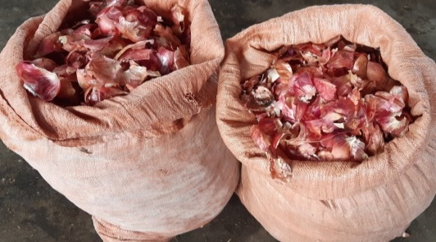
Food Preprocessed Onion Peels

Appendix2: Visual Observed Leftover Foods.
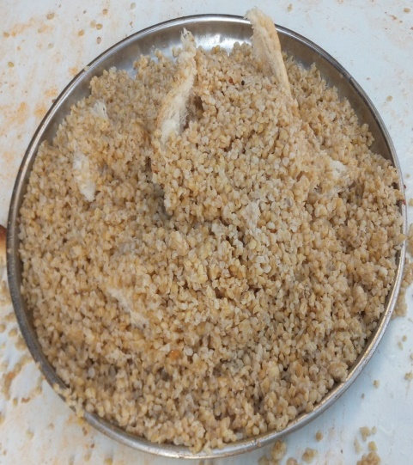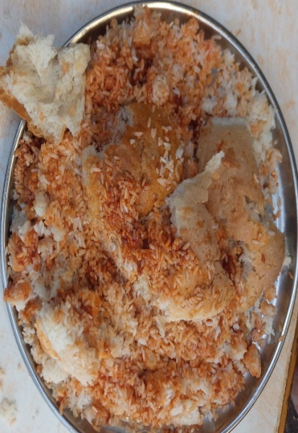
A. Cooked Kinche B. Cooked Rice
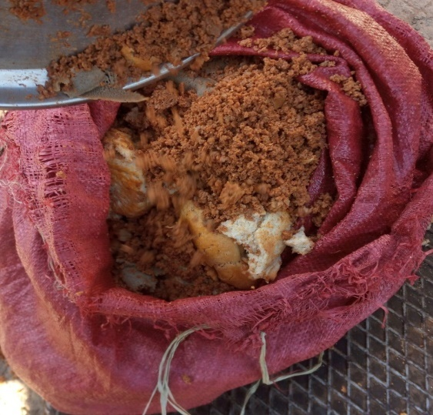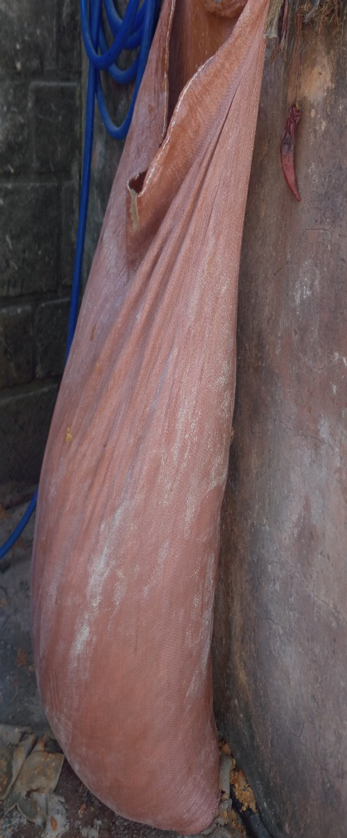
C. Mixed Injera (Firfir) D. Injera with pea stew Leftover food

Appendix 3: Biogas Yield generated from four samples through experimental period in Every Other Day(Frist Round from day 14/12/2019 to 23/01/2020)

Biogas Yield generated from four samples Every Other Day through experimental period (Frist Round from day 14/12/2019 to 23/01/2020)
S.C | 15 | 17 | 19 | 21 | 23 | 25 | 27 | 29 | 1 | 3 | 5 | 7 | 9 | 11 | 13 | 15 | 17 | 19 | 21 | 23 | Total
KPFW1 | 0 | 0 | 100 | 308 | 344 | 440 | 804 | 1060 | 1200 | 1060 | 910 | 544 | 485 | 460 | 420 | 400 | 42 | 16 | 10 | 10 | 8613
KPFW2 | 0 | 0 | 108 | 284 | 340 | 450 | 800 | 1040 | 1180 | 1050 | 918 | 533 | 490 | 453 | 422 | 414 | 40 | 24 | 10 | 10 | 8566
KPFW3 | 0 | 0 | 110 | 278 | 336 | 448 | 796 | 1053 | 1190 | 1049 | 920 | 537 | 495 | 455 | 424 | 416 | 44 | 20 | 10 | 10 | 8591
Mean | 0 | 0 | 106 | 290 | 340 | 446 | 800 | 1051 | 1190 | 1053 | 916 | 538 | 490 | 456 | 422 | 410 | 42 | 20 | 10 | 10 | 8590
PPFW1 | 0 | 0 | 185 | 310 | 360 | 450 | 900 | 1050 | 1200 | 860 | 812 | 550 | 540 | 500 | 480 | 360 | 20 | 20 | 20 | 10 | 8627
PPFW2 | 0 | 0 | 200 | 300 | 340 | 520 | 810 | 1150 | 1206 | 900 | 820 | 570 | 530 | 480 | 484 | 380 | 20 | 20 | 20 | 10 | 8760
PPFW3 | 0 | 0 | 200 | 290 | 380 | 530 | 840 | 1100 | 1203 | 940 | 804 | 560 | 526 | 490 | 488 | 370 | 32 | 20 | 20 | 10 | 8803
Mean | 0 | 0 | 195 | 300 | 360 | 500 | 850 | 1100 | 1203 | 900 | 812 | 560 | 532 | 490 | 484 | 370 | 24 | 20 | 20 | 10 | 8730
KBFW1 | 300 | 1020 | 1354 | 1320 | 1220 | 980 | 980 | 900 | 870 | 860 | 850 | 300 | 150 | 200 | 200 | 200 | 60 | 10 | 10 | 10 | 11794
KBFW2 | 320 | 1010 | 1345 | 1340 | 1210 | 960 | 940 | 920 | 860 | 890 | 850 | 150 | 200 | 200 | 180 | 180 | 60 | 10 | 10 | 10 | 11645
KBFW3 | 340 | 1000 | 1354 | 1330 | 1215 | 1000 | 960 | 910 | 880 | 860 | 862 | 150 | 250 | 200 | 190 | 190 | 90 | 10 | 10 | 10 | 11811
Mean | 320 | 1010 | 1351 | 1330 | 1215 | 980 | 960 | 910 | 870 | 870 | 854 | 200 | 200 | 200 | 190 | 190 | 70 | 10 | 10 | 10 | 11750
RBFW1 | 200 | 300 | 490 | 560 | 810 | 1000 | 1180 | 1027 | 900 | 900 | 804 | 800 | 650 | 200 | 100 | 100 | 100 | 60 | 10 | 0 | 10191
RBFW2 | 200 | 360 | 490 | 550 | 800 | 1000 | 1175 | 1000 | 960 | 924 | 802 | 790 | 700 | 100 | 100 | 100 | 100 | 80 | 14 | 0 | 10245
RBFW3 | 206 | 300 | 460 | 564 | 800 | 1030 | 1140 | 1000 | 930 | 900 | 860 | 780 | 750 | 150 | 100 | 100 | 100 | 70 | 18 | 0 | 10258
Mean | 202 | 320 | 480 | 558 | 803 | 1010 | 1165 | 1009 | 930 | 908 | 822 | 790 | 700 | 150 | 100 | 100 | 100 | 70 | 14 | 0 | 10231

Appendix 4: Biogas Yield generated from four samples through experimental period in Every Other Day(Second Round from day 03/02/2020 to 11/03/2020)
Biogas Yield generated from four samples Every Other Day through experimental period (Second Round from day 02/02/2020 to 11/03/2020)
S.C | 3 | 5 | 7 | 9 | 11 | 13 | 15 | 17 | 19 | 21 | 23 | 25 | 27 | 29 | 1 | 3 | 5 | 7 | 79 | 11 | Total
FBFW1 | 260 | 1050 | 1340 | 1200 | 1130 | 900 | 900 | 832 | 650 | 590 | 480 | 460 | 350 | 50 | 30 | 20 | 20 | 10 | 0 | 0 | 10272
FBFW2 | 280 | 1100 | 1330 | 1200 | 1120 | 1000 | 900 | 830 | 670 | 580 | 490 | 480 | 450 | 50 | 40 | 20 | 20 | 10 | 0 | 0 | 10570
FBFW3 | 300 | 1060 | 1335 | 1203 | 1110 | 950 | 870 | 840 | 660 | 570 | 470 | 470 | 400 | 50 | 20 | 20 | 20 | 10 | 0 | 0 | 10358
Mean | 280 | 1070 | 1335 | 1201 | 1120 | 950 | 890 | 834 | 660 | 580 | 480 | 470 | 400 | 50 | 30 | 20 | 20 | 10 | 0 | 0 | 10400
LLFW1 | 300 | 1000 | 1450 | 1280 | 1220 | 900 | 900 | 900 | 870 | 850 | 840 | 480 | 200 | 200 | 20 | 20 | 20 | 20 | 20 | 20 | 11510
LLFW2 | 310 | 1009 | 1414 | 1280 | 1224 | 984 | 912 | 906 | 860 | 850 | 850 | 520 | 290 | 200 | 20 | 20 | 20 | 20 | 20 | 20 | 11729
LLFW3 | 300 | 1000 | 1450 | 1268 | 1225 | 900 | 900 | 900 | 880 | 880 | 840 | 500 | 200 | 200 | 20 | 20 | 20 | 20 | 20 | 20 | 11563
Mean | 303 | 1003 | 1438 | 1276 | 1223 | 928 | 904 | 902 | 870 | 860 | 843 | 500 | 230 | 200 | 20 | 20 | 20 | 20 | 20 | 20 | 11600
MLFW1 | 350 | 1230 | 1600 | 1340 | 1200 | 970 | 970 | 900 | 900 | 855 | 830 | 550 | 200 | 200 | 200 | 100 | 20 | 10 | 0 | 0 | 12425
MLFW2 | 390 | 1220 | 1621 | 1330 | 1200 | 970 | 960 | 906 | 900 | 860 | 850 | 550 | 200 | 200 | 194 | 190 | 10 | 10 | 0 | 0 | 12561
MLF3 | 400 | 1225 | 1600 | 1320 | 1194 | 1000 | 950 | 900 | 900 | 865 | 840 | 580 | 200 | 200 | 200 | 100 | 30 | 10 | 0 | 0 | 12514
Mean | 380 | 1225 | 1607 | 1330 | 1198 | 980 | 960 | 902 | 900 | 860 | 840 | 560 | 200 | 200 | 198 | 130 | 20 | 10 | 0 | 0 | 12500
PDFW1 | 300 | 1100 | 1500 | 1330 | 1000 | 950 | 880 | 870 | 860 | 800 | 700 | 600 | 150 | 100 | 100 | 30 | 20 | 20 | 20 | 0 | 11330
PDFW2 | 300 | 1100 | 1494 | 1330 | 1036 | 960 | 920 | 915 | 855 | 800 | 670 | 600 | 150 | 110 | 100 | 30 | 20 | 20 | 20 | 0 | 11430
PDFW3 | 340 | 1127 | 1500 | 1315 | 1000 | 964 | 900 | 900 | 865 | 785 | 700 | 600 | 180 | 180 | 175 | 30 | 20 | 20 | 20 | 0 | 11621
Mean | 313 | 1109 | 1498 | 1325 | 1012 | 958 | 900 | 895 | 860 | 795 | 690 | 600 | 160 | 130 | 125 | 30 | 20 | 20 | 20 | 0 | 11460

Appendix 5: Result of ANOVA Table on Biogas Yield Generated from Each Samples (ml/g VS).
Samples Code | N | Mean | Std. Deviation | Std. Error | 95% Confidence Interval for Mean |  | Minimum | Maximum
 |  |  |  |  | Lower Bound | Upper Bound | Minimum | Maximum
KPFW | 3 | 343.61 | 10.43 | 6.02 | 317.70 | 369.52 | 334.52 | 355.00
PPFW | 3 | 349.19 | 12.39 | 7.16 | 318.40 | 379.98 | 335.68 | 360.04
KBFW | 3 | 470.01 | 21.02 | 12.14 | 417.80 | 522.23 | 447.00 | 488.20
RBFW | 3 | 409.23 | 13.30 | 7.68 | 376.19 | 442.26 | 399.60 | 424.40
FBFW | 3 | 416.00 | 12.21 | 7.05 | 385.67 | 446.33 | 402.84 | 426.96
LLFW | 3 | 464.01 | 16.40 | 9.47 | 423.26 | 504.76 | 452.52 | 482.80
MLFW | 3 | 500.00 | 12.29 | 7.09 | 469.48 | 530.52 | 486.96 | 511.36
PDFW | 3 | 458.41 | 9.60 | 5.54 | 434.58 | 482.25 | 448.20 | 467.24
Total | 24 | 426.31 | 55.96 | 11.42 | 402.68 | 449.94 | 334.52 | 511.36
KPFW= Kinche preprocessedfood waste, PP FW= Potato Peel food waste, KBFW= Kinche BreakfastFood Waste, RBFW= Rice BreakfastFood Waste, FBFW= Firfir BreakfastFood Waste, LLFW= Lenticel LunchFood, MLFW= Meat Lunch Food Waste and PDFW= PeaDinnerFood Waste

Appendix 6: Duncan Multiple Homogeny Test of Biogas Yield Generated from Each Samples (ml/g VS).
Samples Code | N | Subset for alpha = 0.05
Samples Code | N | 1 | 2 | 3 | 4
KPFW | 3 | 343.61
PPFW | 3 | 349.19
RBFW | 3 |  | 409.23
FBFW | 3 |  | 416.00
PDFW | 3 |  |  | 458.41
LLFW | 3 |  |  | 464.01
KBFW | 3 |  |  | 470.01
MLFW | 3 |  |  |  | 500.00
Sig. |  | 0.63 | 0.56 | 0.35 | 1.00
KPFW= Kinche preprocessedfood waste, PP FW= Potato Peel food waste, KBFW= Kinche BreakfastFood Waste, RBFW= Rice BreakfastFood Waste, FBFW= Firfir BreakfastFood Waste, LLFW= Lenticel LunchFood, MLFW= Meat Lunch Food Waste and PDFW= PeaDinnerFood Waste

Appendix 7:Result of ANOVA Table on Methane Yield from Each Sample.
 | Sum of Squares | Df | Mean Square | F | Sig.
Between Groups | 51033058.04 | 7.00 | 7290436.86 | 27.06 | 0.00
Within Groups | 4310134.13 | 16.00 | 269383.38
Total | 55343192.17 | 23.00

Appendix 8: Result of ANOVA Table on Carbon Dioxide Yield from Each Sample.
 | Sum of Squares | Df | Mean Square | F | Sig.
Between Groups | 532430.42 | 7.00 | 76061.49 | 1.48 | 0.25
Within Groups | 825005.72 | 16.00 | 51562.86
Total | 1357436.15 | 23.00

Appendix 9:Result of ANOVA Table on Percentage of Methane from Each Sample.
Samples Code | N | Mean | Std. Deviation | Std. Error | 95% Confidence Interval for Mean |  | Minimum | Maximum
 |  |  |  |  | Lower Bound | Upper Bound | Minimum | Maximum
KPFW | 3 | 67.15 | 2.47 | 1.42 | 61.02 | 73.27 | 64.89 | 69.78
PPFW | 3 | 70.60 | 3.21 | 1.85 | 62.64 | 78.57 | 68.23 | 74.25
KBFW | 3 | 79.01 | 2.58 | 1.49 | 72.60 | 85.43 | 76.76 | 81.83
RBFW | 3 | 73.53 | 3.33 | 1.92 | 65.26 | 81.80 | 70.43 | 77.05
FBFW | 3 | 75.15 | 2.62 | 1.51 | 68.65 | 81.65 | 72.25 | 77.33
LLFW | 3 | 78.41 | 2.59 | 1.50 | 71.96 | 84.85 | 76.60 | 81.38
MLFW | 3 | 81.65 | 2.58 | 1.49 | 75.23 | 88.07 | 79.54 | 84.53
PDFW | 3 | 77.25 | 1.59 | 0.92 | 73.29 | 81.21 | 75.93 | 79.02
Total | 24 | 75.34 | 5.07 | 1.04 | 73.20 | 77.49 | 64.89 | 84.53
KPFW= Kinche PreprocessedFood Waste, PP FW= Potato Peel Food Waste, KBFW= Kinche BreakfastFood Waste, RBFW= Rice BreakfastFood Waste, FBFW= Firfir BreakfastFood Waste, LLFW= Lenticel LunchFood, MLFW= Meat Lunch Food Waste and PDFW= PeaDinnerFood Waste.
Appendix 10:Checkup of the Flammability of the Generated Biogas from Each Samples.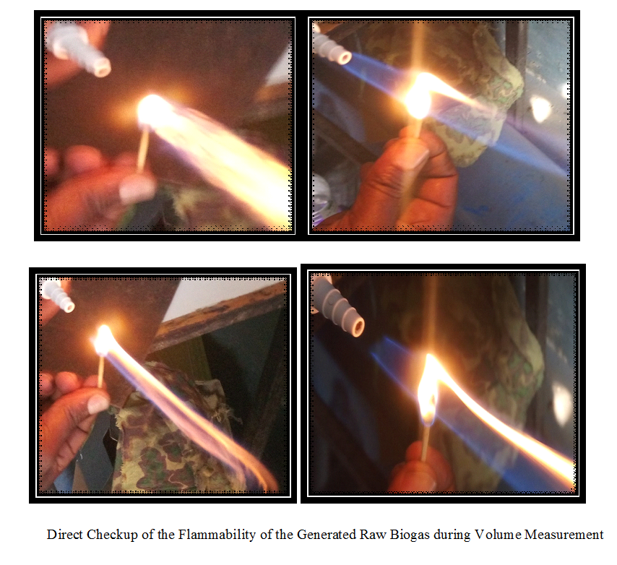



AMBO UNIVERSITY
SCHOOL OF GRADUATE STUDIES
COLLEGE OF NATURAL AND COMPUTATIONAL SCIENCE
DEPARTMENT OF BIOLOGY

Appendix 11: Survey Questionnaire Given to Respondents.
Introduction
I am doing research thesis entitled ״Assessment and Evaluation of Biogas yield from different food wastes from students’ cafeteria in main campus of Ambo University ״. This questionnaire is designed to collect data for Masters Thesis. Dear respondent, the purpose of this study isto gather information about the total biomass of different food wastes generated from students’ cafeteria of main campus of the Ambo University. Your identity and the information you provide in this questionnaire will remain confidential. No need to write your name. Indicate your response by circling the letters corresponding to each statement. Thank you for your good collaboration and timely response in advance.
Part I. Information about the respondents
- Sex: A. Male B. Female
- Age: A. 18- 25 B. 26- 40 C. 41- 65
- Educational status: A. 1-4 B. 5-8 C. 9 – 12 D. College and above
- Position of the Worker: A. Ticker B. Cafeteria workers C. Daily employee on waste disposal.

Part II. Information about different food wastes generated from students’ cafeteria.
- Do you think is there any Food Waste generated from students’ cafeteria of main campus of Ambo University?
A. Yes B. No
- Do you think is there Food Waste occurs during preprocess?
A. Yes B. No
- Do you think is there any leftover Foods generated from students’ cafeteria of main campus of Ambo University?
A. Yes B. No
- Which types of food wastes highly generated from students’ cafeteria of main campus of Ambo University?
A. Pre-process food wastes B. Leftover foods ‘’ Bullee’’ C. Both
- Do you know the amount of food waste disposed per day?
A. Yes B. No
- How main times the generated food waste is disposed per day?
A. Once B. Twice C. Three times
- Which type of disposal mechanism of different food wastes known in main campus of Ambo University?
A. Landfilling B. Open Dumping C. Incineration D. Other
- Do you think that these food wastes recycled or reused?
A. Yes B. No
- For the following which type of problem is related to mismanage of different food wastes?
A. Environmental B. Economical C. Healthy D. all

