
COLLEGE OF NATURAL AND COMPUTATIONAL SCIENCES
DEPARTMENT OF BIOLOGY

Ten Year Trend Analysis Of Malaria Prevalence And Current Assess Of Anopheles Mosquito In Aseko Special District, Central Ethiopia.
A THESIS SUBMITTED TO THE FACULTY OF NATURAL AND COMPUTATIONAL SCIENCES, AMBO UNIVERSITY, OF REQUIREMENT FOR THE DEGREE OF MASTER OF SCIENCE IN BIOLOGY
BY: Aliyi Kedir GEDA
ADVISOR: DAMTEW BEKELE (PhD)

APRIL, 2024
AMBO, ETHIOPIA

ACKNOWLEDGEMENT
First and for most, I give honor to the Almighty Allah for every protection he did to me in performing my day to day activities. I would like to express my deepest gratitude to my advisor, Dr. Demtew Bekele, for his persistent mentorship and excellent guidance, reading the manuscript and forwarding constructive comments throughout my thesis work.
My thanks also to Aseko Health Center member specially Sist.Wesane Nigusie, Mr. Mezgabu Asefa and staff members for providing me all the necessary documents and for their assistance during retrospective data collection. In addition, my thanks go to Ambo University, school of graduate studies for the financial support to carry out my research.
I am also indebted acknowledge my family for their encouragement and support from the very beginning till the end of the study and to all that contributed in one way or other for the success of this study.

ABBREVIATIONS AND ACRONYMS
ACT Artemisinin-based Combination Therapy
AHC Aseko Health center
FMOH Federal Ministry of Health
IPTP Intermittent Preventive Treatment for Pregnant
IRS Indoor-Residual Spraying
ITNs Insecticide Treated Nets
LLIN Long Lasting Insecticidal Net
RDT Rapid Diagnostic Test
SMC Seasonal Malaria Chemoprevention
SSA Sub-Saharan Africa
UNICEF United Nations Children's Fund
USAID United States Agency for International Development
USD United States Dollar
W.H.O World Health Organization

Tables of Contents
ACKNOWLEDGEMENT i
ABBREVIATIONS AND ACRONYMS ii
Tables of Contents iii
Lists of Figures v
Lists of Tables vi
Abstract vii
1. INTRODUCTION 1
1.1. Background of the study 1
1.2. Statement of the problem 2
1.3. Objectives of the study 3
1.3.1 .General objectives 3
1.3.2. Specific objectives 3
2. LITERATURE REVIEW 4
2.1. Types of Vector mosquito that bit for blood 4
2.2. Malaria parasite Species 4
2.2.1. Plasmodium falciparum 4
2.2.2. Plasmodium vivax 5
2.2.3. Plasmodium knowlesi 5
2.2.4. Plasmodium ovale and plasmodium malariae 5
2.3. Malaria situation in Ethiopia 5
2.4. Life cycle of the malaria parasite 6
2.5. The impact of Climatic factors on Vector female Anopheles 8
2.5.1. Temperature 8
2.5.2. Precipitation 9
2.5.3. Relative Humidity 9
2.6. Malaria Mosquito prevention and control 10
2.7. Vector female Anopheles Control 11
2.8. Symptoms of malaria 12
2.9. Malaria Diagnosis and Treatment 12
3. MATERIALS AND METHODS 13
3.1. Description of the Study area and period 13
3.2. Study design and collection period for retrospective data 14
3.3. Malaria mosquito study design and collection period. 14
3.4. Malaria Parasite study design for slide confirmed 15
3.5. Sample size determination for slide confirmed 15
3.6. Statistical data analysis 16
4. RESULTS 17
4.1. Annual prevalence of Malaria cases in Aseko Woreda at Aseko Health Center from 2013-2022. 17
4.2. Distribution of Malaria cases among different age group in Aseko Woreda at Aseko Health Center from 2013-2022. 18
4.3. Seasonal variation of malaria prevalence at Aseko Health center from 2013 to 2022. 19
4.4. Monthly prevalence of malaria slide confirmed cases in Aseko Health Center from 2013 to 2022 20
4.5. Prevalence of Malaria cases among sex at Aseko Health Center from 2013-2022. 21
4.6. Anopheles mosquito and meteorological variables by month, Chefa Quyo, Dere Oda and Teleta Chefa March to May, 2023. 21
4.7. The collected mosquito species at Chefa Quyo, Dere Oda and Teleta Chefa, 2023. 22
4.8. Influence of meteorological parameters on Anopheles mosquito abundance and distribution. 23
4.9. Monthly collection of different Anopheles mosquito. 24
4.10. Monthly Prevalence of malaria Slide-confirmed Patients at Aseko Health Center from February to May, 2023. 25
4.11. Prevalence of malaria Slide-confirmed cases among sex at Aseko Health Center from February to May 2023. 26
4.12. Prevalence of malaria Slide confirmed cases among Age group at Aseko Health Center from February to May 2023. 27
5. DISCUSSION 28
6. CONCLUSIONS 32
7. RECOMMENDATIONS 33
REFERENCE 34
Appendix 38

Lists of Figures
Figure 1 : Life cycle of malaria parasite 8
Figure 2: Map of study area 14
Figure 3: Annual prevalence of malaria cases in Aseko woreda at Aseko health center from 2013-2022 17
Figure 4: Seasonal variation of malaria prevalence at Aseko health center from 2013 to 2022. 19
Figure 5: Prevalence of malaria cases among sex at Aseko health center from 2013-2022. 21
Figure 6: The collected anopheles mosquito and meteorological variables by Month, Chefa quyo, Dere oda and Teleta chefa march to may, 2023. 22
Figure 7: Prevalence of malaria slide-confirmed cases among sex at AHC, from february to may, 2023. 26
Figure 8: Prevalence of malaria slide-confirmed cases among age group at ahc 27

Lists of Tables
Table 1: Distribution of malaria cases among different age group in ahc from 2013 to 2022. 18
Table 2: Monthly prevalence of malaria slide confirmed cases in Aseko health center from 2013 to 2022 20
Table 3: The collected mosquito species by aspiratory spray, Chefa quyo, Dere oda and Teleta chefa, 2023 23
Table 4: Spearman’s correlation between anopheles mosquito and metrological variables. 24
Table 5: Monthly collection of anopheles mosquito species at Chefa quyo, Dere oda and Teleta chefa March to May, 2023. 24
Table 6 : Monthly prevalence of malaria slide-confirmed cases at AHC, from february to may, 2023. 25

Abstract
Malaria is a disease caused by malaria parasite species of Plasmodium and is transmitted by females Anopheles mosquitoes. It is one of the leading causes of illness and death in the world and public health problem in Ethiopia. The aim of this study was to analysis ten year the prevalence of malaria among patients who attend Aseko Health Center from 2013 to 2022 and assess the current abundance of Anopheles mosquito in Aseko district, Central Ethiopia. Out of blood films examined for malaria in Aseko health center, 5312 (30%) microscopically confirmed malaria cases were reported in the study area. A total of 316 adults mosquitoes collected from rural areas of study sites, Out of which 232(73.42%) were Anopheles arabiensis and 84(26.58%) were Anopheles funestus. The spearman's correlation of the abundance of adult mosquitoes and the meteorological parameters showed that there was a very strong correlation and non-significant relationship between Anopheles abundance with relative humidity (-0.4) and precipitation (0.28), while its relationship with temperature was a very strong positive correlation but not statistically significant, and it was strong negative correlation with wind speed. The data also showed out of 5312 total population, 3469(65.3%) males were infected with malaria than 1843(34.7%) females with the prevalence rate 34% and 24.6% respectively, which was one of the wide ranges between the sex groups. The presence of Anopheles arabiensis and Anopheles funestus potential vectors throughout the year should warrants the top priority of breeding habitat management. In study area ten year prevalence of malaria was 30% and in relation to the type of species that infected the population, P. falciparum was the dominant parasite with prevalence of 3396(63.9%) followed by P.vivax with prevalence of 1659(31%) with least species with prevalence rate 257(4.8%). Anopheles arabiensis was the principal vector of malaria in the region, while Anopheles funestus were the second most abundant species.
Key words/Phrase: Anopheles arabiensis, Anopheles funestus, Plasmodium falciparum, Plasmodiumvivax,Prevalences

1. INTRODUCTION

1.1. Background of the study
Malaria is major public health problems worldwide with an estimated 3.3 billion people is at risk of being infected with malaria and develop the disease and 1.2 billion are at high risk. Its burden is more concerning in poorest, children and pregnant women (WHO, 2018). Globally, an estimated 198 million cases and 584,000 deaths occurred due to malaria in 2013 (Tegegne et al., 2019). In the same work it shows that malaria is one of the killer diseases worldwide. According to the World Health Organization (WHO) report in 2016, around 216 million new cases of malaria occurred globally. Besides, most of the malaria cases are in the African region (90%) followed by the Southeast Asia region (7%) and Eastern Mediterranean region (2%). Similarly, there are estimate 445000 malaria deaths worldwide. In other work, there are estimate around 214 million malaria cases and 430,000 malaria deaths worldwide in 2015 (Jackson and Black, 2019). In the same year in other study, malaria is one of the most severe public health problems in tropical regions with high morbidity and mortality rates. The number of malaria cases and deaths are estimate to be 214 million and 438,000 thousands, respectively (Tesfay et al., 2018).
According to Jackson and Black (2019), malaria is the fourth leading cause of death among children less than 5 years of age in sub-Saharan Africa. However, yet malaria remains a major public health problem in the world with significant medical, economic and social implications especially in sub- Saharan Africa countries (Shamebo and Petros ,2019). Malaria is a life-threatening caused by Plasmodium parasite infection. Malaria is the most deadly, and it predominates in Africa. Most of the cases (88%) and deaths (90%) occurred in the African Region. Most of the affects are children aged less than 5 years, who account for 78% of all deaths. In total, 18 countries account for 90% of infections in sub-Saharan Africa including Ethiopia (Tesfaye et al., 2018).

In Ethiopia because of the public health and socio-economic impact of malaria are extremely large, malaria remains among leading causes of morbidity and mortality globally. It contributes highly to the country’s poverty and underdevelopment (Alelign and Dejene, 2016).
In Ethiopia in other work it shows that most malaria cases occur at altitude less than 2000 m above sea level. Malaria is a major public health concern in Ethiopia (Shamebo and Petros, 2019). In the same work show that about 75% of the country’s landmass is malaria and 60% of the population is at risk of developing the disease. Malaria prevalence and transmission in Ethiopia relay on altitude and rainfall. The problem of malaria is very severe in Ethiopia where it has been the major cause of illness and death for many years. According to records from the Ethiopian Federal Ministry of Health, 75% of the country is malaria with about 68% of the population living in areas at risk of malaria (Getinet et al., 2012). Ethiopia has a low-to-moderate malaria transmission intensity. Despite of this, malaria prevalence decline in Ethiopia over the last ten years as a result of high coverage of key malarias control interventions (Asrat, 2017). In study area malaria remains to be the major public health problem in past ten year (2013-2022). Thus it was very essential to determine ten year trend analysis of malaria prevalence and assess current anopheles mosquito distribution and abundances in Aseko special district, central Ethiopia.

1.2. Statement of the problem
Globally malaria death rates among populations at risk fell by 60% among all age groups and by 65% among children under five. According to (Ayele et al., 2019) malaria remains a major public health burden globally particularly in sub-Saharan Africa, including Ethiopia. In other work it describes that Sub-Saharan Africa carries high share of the global malaria burden. In 2015 the region is home to 88% of malaria cases and 90% of malaria death (Meku, 2017). Malaria parasites are spread to people through the bites of infected female Anopheles mosquito and mosquito introduces the parasite from the mosquito’s saliva into a person’s blood. About 75% of the land and 60% of the population is exposed to malaria in Ethiopia. In the country due to the unstable and seasonal transmission of malaria, protective immunity of the population is generally low and all age groups are at risk (Asrat, 2017).

In Aseko Woreda particularly in malaria risks area, vector female Anopheles mosquito control measures such as the use of insecticide treated bed net (ITNs), indoor residual spraying of insecticide (IRS) have been implemented. Despite of all these efforts yet malaria is the public health problem in most of Aseko Woreda particularly three malaria areas of such as Dere Oda, Chefa Quyo and Teleta Chefa. This verifies that there may be several reasons for this situation including the deficiencies in the Health System that leads to lack of access to malaria control interventions and low effectiveness of these interventions than expected. Thus it is very essential that research is conduct to determine ten year trend of malaria prevalence and assess current anopheles mosquito distribution and abundances in Aseko special district, central Ethiopia.

1.3. Objectives of the study

1.3.1 .General objectives
To analysis ten year trend of malaria prevalence and assess current anopheles mosquito distribution and abundances in Aseko special district, central Ethiopia.

1.3.2. Specific objectives
- To determine trend of malaria prevalence from 2013 to 2022 in study area.
- To determine the prevalence of the malaria disease at different seasons in different age and sex group.
- To determine the species composition of plasmodium parasites in the study area.
- To correlate the Mosquito abundance with meteorological factors.

2. LITERATURE REVIEW

2.1. Types of Vector mosquito that bit for blood
Worldwide, there are over 3,500 species of mosquitoes grouped into 41 genera. 837 of those species are in Africa. Human malaria is transmitted only by females of the genus Anopheles. Of the approximately 430 Anopheles species, only 30-40 transmit malaria worldwide. Target Malaria works specifically on 3 major malaria vectors that are distributed widely across Sub-Saharan Africa: Anopheles gambiae, Anopheles funestus, Anopheles coustani, Anopheles Stephens, Anopheles natalensis, Anopheles coluzzii, and Anopheles arabiensis, which look identical morphologically and belong to the species complex (John, 2002).
Adult anopheles has slender bodies with three sections: head, thorax and abdomen. The head is specialized for acquiring sensory information and for feeding. The head contains the eyes and a pair of long, many-segmented antennae. The antennae are important for detecting host odors as well as odors of breeding sites where females lay eggs. The head also has an elongate, forward-projecting proboscis used for feeding, and two sensory palps (WHO, 2018).

2.2. Malaria parasite Species

2.2.1. Plasmodium falciparum
Plasmodium falciparium is widespread in tropical and sub-tropical areas of central and South America, Africa and Asia. It results in most severe infections and is responsible for nearly 90% of malaria related deaths in sub Saharan Africa. Of the four most common species of Plasmodia that infect humans, the vast majority of deaths in SSA are caused by Plasmodium falciparum (File et al.,2019) Plasmodium falciparium predominate the warmer regions close to the equator. It is the most prevalent parasite which accounts for 70%. It is lethal malaria parasite with a case fatality rate of about 10% in hospitalized adults and up to 30% in children less than 12 years old. However, another study shows that among infectious diseases malaria is a leading cause deaths of children less than five years age (Bayissa, 2016). According to Shiferaw (2018), Plasmodium falciparum and Plasmodium vivax are the two predominant plasmodium species distribute all over the country, accounting for 60% and 40% of malaria cases in Ethiopia, respectively.

2.2.2. Plasmodium vivax
Plasmodium vivax is predominates in more temperate regions. Since P. vivax can tolerate cooler temperatures, it is more geographically widespread than P. falciparium, although transmission is usually low because it is season dependent. Plasmodium vivax accounts for 30% in tropical and sub-tropical areas of central and South America, Africa and Asia (Tesfaye, 2017). In other work stated that Plasmodium vivax is responsible for most malaria cases in Asia and Latin America, but is almost absent from most of Central Africa due to absence of antigen receptor that the parasite uses to invade human erythrocytes (File et al., 2019).

2.2.3. Plasmodium knowlesi
Plasmodium knowlesi has also been recently documented to cause human infections. The disease is widely distributed in Africa, Asia and South America and found to be potentially life –threatening. They are found in more tropical and sub-tropical regions of the world and exhibit overlapping geographical distribution (Bayissa, 2016).

2.2.4. Plasmodium ovale and plasmodium malariae
Plasmodium ovale and plasmodium malariae approximately has equal case incidence rate. It has been reported that the major malaria transmission season in Ethiopia is from September to December, following the main rainy season from June to September. The shorter transmission season spans April to May following the shorter rainy season in some parts of the country (File et al., 2019).

2.3. Malaria situation in Ethiopia
In Ethiopia, the interaction of mountainous terrain with variable winds, seasonal rains, and ambient temperatures creates diverse micro-climates for malaria transmission (Birhanu et al., 2018). When a micro-climate creates local puddles, flooding conditions, and warm ambient temperatures that persist for several weeks within a malarious area with low population immunity, the resulting Anopheles mosquito proliferation may cause focal malaria transmission to accelerate, sometimes rapidly (Alelign and Dejene, 2016). In the same report it shows that, malaria is highly seasonal in many communities, but may have nearly constant transmission in some other areas in Ethiopia. Peak malaria transmission occurs between September and December in most parts of Ethiopia, after the main rainy season from June to August. In addition, some areas experience a second minor malaria transmission period from April to June, following a short rainy season from February to March. January and July typically represent low malaria transmission seasons in most communities (WHO, 2016). Since peak malaria transmission often coincides with the planting and harvesting season, and the majority of malaria burden is among older children and working adults in rural agricultural areas, there is a resultant heavy economic burden in Ethiopia (Birhanu et al., 2018). Vector species and abundance Anopheles arabiensis, a member of the An. gambiae complex, is the primary malaria vector in Ethiopia, with An. funestus, An. pharoensis, and An. nili as secondary vectors (FMoH, 2014). An. funestus, a mosquito that prefers to feed exclusively on humans, can be found along the swamps of the Baro and Awash rivers and shores of lakes in Tana in the North and the Rift Valley areas. An. pharoensis is widely distributed in Ethiopia and has shown high levels of insecticide resistance, but its role in malaria transmission is unclear. An. nili can be an important vector for malaria, particularly in Gambela Regional State (Degifie, 2017). Insecticide resistance among these vectors has become an important issue, with implications for vector control strategies. Parasite prevalence, altitude strata, and annual parasite incidence (API): Plasmodium falciparum and P. vivax are the major malaria parasites in Ethiopia, with several recent therapeutic efficacy trials documenting that ACTs and chloroquine continue to have adequate effectiveness for treating these pathogens, respectively (File et al., 2019).

2.4. Life cycle of the malaria parasite
The malaria parasite life cycle involves two hosts during a blood meal, a malaria infected Anopheles Mosquito inoculates sporozoite into the human hosts. It has a complex, multistage life cycle occurring within, the vector mosquitoes and the vertebrate hosts (figure1). When Sporozoite injected into human hosts, it rapidly invade liver Parenchymal cells, where they mature into liver stage Schizonts, which burst to release 2000 up to 40,000 Uninocleate Merozoites (James M. et al., 2006).
Malaria infection begins when an infected female Anopheles mosquito bites a person, injecting Plasmodium parasites, in the form of sporozoites, into the blood stream. The sporozoites pass quickly into the human liver. The sporozoites multiply asexually in the liver cells over the next 7 to 10 days, causing no symptoms (John W., 2016).
Mosquitoes are the definitive hosts for the malaria parasites where in the sexual phase of the parasites life cycle occurs. The sexual phase is called sporogony and results in the development innumerable infecting forms of the parasite within the mosquito that induce disease in the human host following their injection with the mosquito bite (Rosenberg W., 2008). In similar work reported that, when the female anopheles draws a blood meal from an individual infected with malaria the male and female gametocytes of the parasite find their way into the gut of the mosquito. The molecular and cellular changes in the gametocytes help the parasite to quickly adjust to the insect host from the warm-blooded human host and then to initiate the sporogonic cycle.
In an animal model, the parasites, in the form of merozoites, are released from the liver cells in vesicles, journey through the heart, and arrive in the lungs, where they settle within lung capillaries. The vesicles eventually disintegrate, freeing the merozoites to enter the blood phase of their development (Perlmann P. and Blomberg T., 2002).
In the bloodstream, the merozoites invade red blood cells (erythrocytes) and multiply again until the cells burst. Then they invade more erythrocytes. This cycle is repeated, causing fever each time parasites break free and invade blood cells. Some of the infected blood cells leave the cycle of asexual multiplication. Instead of replicating, the merozoites in these cells develop into sexual forms of the parasite, called gametocytes that circulate in the blood stream (Merck et al., 2020).
According to (Laurence et al., 2002), when a mosquito bites an infected human, it ingests the gametocytes, which develop further into mature sex cells called gametes. The fertilized female gametes develop into actively moving ookinetes that burrow through the mosquito's midgut wall and form oocysts on the exterior surface. Inside the oocyst, thousands of active sporozoites develop. The oocyst eventually bursts, releasing sporozoites into the body cavity that travel to the mosquito's salivary glands. The cycle of human infection begins again when the mosquito bites another person. The erythrocyte cycle occurs every 24 hours in case of P. knowlesi, 48hours in cases of P. falciparum, P. vivax, P. ovale and 72 hours in case of P. malariae (Rosenberg W., 2008).

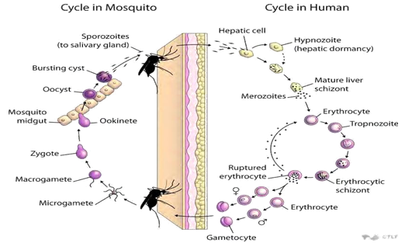
Figure 1 : Life Cycle of Malaria parasite (Source: Tesfaye M., 2017)

2.5. The impact of Climatic factors on Vector female Anopheles
Climate variability, unlike any other epidemiological factor, has the potential to precipitate simultaneously multiple disease epidemics. Climatic conditions such temperature; humidity and rainfall affect the life cycle and behavior of the vectors as well as sporogonic development of the parasites. Climatic factors also play an important part in species distribution, survival, and vectorial status epidemics (Okwa et al., 2007).

2.5.1. Temperature
Temperature affects the survival, development and life-cycle of malaria parasites in the Anopheles vectors. All species have the shortest development cycle around 27-31⁰C (James et al., 2006) from a minimum of 8 days for P. vivax to a maximum of 15 -21 days for P. malariae (Perlmann and Blomberg, 2002) the lower the temperature, the longer the duration of the cycle(John, 2016).The minimum duration roughly doubles around 20ºC, below 19⁰C for P. falciparum and 15-16⁰C for the 3 other species, the parasites are unlikely to complete their cycle and hence to further propagate the disease. In the same work states that temperature modifies the vectorial capacity of the anopheles at around 30-32ºC vectorial capacity can increase substantially owing to a reduction in the extrinsic incubation period, despite a reduction in the vectors survival rate.
If water temperature rises, the larvae take a shorter to mature and consequently there is greater capacity to produce more offspring during the transmission period. In warmer climates, adult female mosquitoes digest blood faster and feed more frequently, thus increasing transmission intensity. Similarly, malaria parasites complete extrinsic incubation within the female mosquito in a shorter time as the temperature rises, thereby increasing the proportion of infective vectors. Warming above 34ºC generally has negative impact on the survival of vectors and parasites (Rosenberg, 2008) The optimum temperatures lengthen the life span of the mosquitoes and increase the frequency of blood meals taken by the females, to up to one meal every 48 hours (Okwa et al., 2007). However, higher temperature also shortens the aquatic life cycle of mosquitoes and reduces the time between emergences and ovipositions as well as the time between successive ovipositions (Rosenberg, 2008).

2.5.2. Precipitation
Precipitation generally means new opportunistic breeding places (Laurence et al., 2002). Nonetheless, Precipitation can also destroy existing breeding places, heavy rains can change breeding pools into streams impede the development of mosquitoes eggs or larvae or simply flush eggs or larvae out to the pools, Conversely, exceptional drought conditions can turn streams to pools in which would be breed in profusion. The appearance of such opportunistic mosquitoes breeding sites sometimes proceeds epidemics (Tahereh, 2021).

2.5.3. Relative Humidity
The interaction between rainfall evaporation, runoff, and temperature modulates the ambient air humidity, which in turn affects the survival and activity of Anopheles mosquitoes. To survive, they need at least 50% relative humidity (Perlmann and Blomberg, 2002). Higher levels lengthen the life span of the mosquitoes and enable them to infect more people (John, 2016). In the Sahel, Sara (1990) observed that a constant high temperature and low relative humidity led to drastic decline in the mosquitoes’ populations between March and May i.e. the hot dry Season could affect their life-span reproductive and feeding capacities. Most of the breeding grounds dried up during these months. Insect activities are correlated with daily rhythm of temperature and humidity. Such rhythm is most evident in areas hot and relatively dry days (Merck et al., 2020). The best conditions for the development of Plasmodia in the Anopheles and the transmission of infection are when the mean temperature is within a range of 20-30c, while the mean relative is at least 60%. A high relative humidity lengthens the life of the mosquito and enables it to live long enough to transmit the infection to several persons (James et al., 2006).

2.6. Malaria Mosquito prevention and control
Methods used to prevent Vector female Anopheles are includes medications, vector mosquito eliminating and the prevention of bites. The presence of malaria in an area requires a combination of high human population density, high vector Anopheles mosquito population density and high rate of transmission from humans to mosquitoes and from mosquitoes to humans. If any of these is lowered sufficiently, the Vector female Anopheles will eventually disappear from that area globally (Asrat, 2017).
According to Feleke et al (2018) Anopheles Mosquito prevention and control activities are intensifies in Ethiopia by Ministry of Health, Non-government organizations(NGOs) working on malaria and other stakeholders. Therefore, estimating malaria incidence and time trends are very important for the expansion of intervention strategies or to design new ones to tackle the disease since this information has significant input for combating malaria.
In Ethiopia, Anopheles Mosquito control activities have been in action for long. The history of indoor residual spraying (IRS) and mosquito larval control dates back to the early 1960s. Patients of all ages are receiving malaria diagnostic test free of charge in the public sector since that time. In recent years, however, there has been heavy financial support by global donors and refreshed political commitment of governments in malaria endemic countries to curb the disease. Moreover, clear operational plans including a long-term vision for malaria control are formulate in which sustained scale-up of proven malaria control tools would progressively lead to malaria elimination in Africa, with the ultimate goal of worldwide malaria eradication by 2040-2050 (WHO, 2018)..
In other work shows that individuals can protect themselves against Anopheles Mosquito bite by wearing protective clothing and using insect repellents and bed nets. Field trials indicate that insecticide treated bed nets and curtains have the potential to reduce childhood mortality by 15 percent to 35 percent (Alelign and Dejene, 2016).
The proven malaria intervention tool which transmits by Anopheles Mosquito being extensively used in Ethiopia, like elsewhere, are insecticide-treated mosquito nets (ITNs), IRS, prompt diagnosis and treatment with artemisinin-based combination therapies (ACTs). Although Ethiopia is still in malaria control phase it has set a plan to eliminate malaria in selected low transmission settings by 2020. The aggressive malaria intervention policies and strategies of Ethiopia are supported by major external funders (Global fund, World Bank, USAID/PMI, WHO/UNICEF and others) since 2005. The funding reached peak in 2013 and then declined in 2014 as federal ministry of health (FMOH) sources demonstrate. Mosquito nets are being distributed free of charge to all age groups since 2004. In 2014, the proportion of the at-risk population estimated to have access to an ITN in their household exceeded 50% (Meku, 2017).
Currently, the most substantive Anopheles Mosquito prevention and control measures include insecticide-treated mosquito nets (ITNs), indoor residual spraying (IRS), intermittent preventive treatment for pregnant women (IPTp), seasonal malaria chemoprevention (SMC), and diagnosis by malaria microscopy or rapid diagnostic test (RDT), together with effective treatment for confirmed malaria cases with artemisinin-based combination therapies (ACTs) (Tegegne et al., 2019).

2.7. Vector female Anopheles Control
Currently the main goal of Malaria mosquito control in Ethiopia is to reduce the level of malaria transmission Public and individual measures includes; wearing long sleeves and pants during the durk period; sanitary improvements, such as filling and draining areas of impounded water; installing screens and using bed nets; particularly the use of impregnated bed nets increases the effectiveness of the bed net; larvicides and biological control, for example using larvivours fish; and nightly spraying of screened living and sleeping quarters with insecticides (Alelign and Dejene, 2016)

2.8. Symptoms of malaria
The symptoms of malaria typically begin 8-25 days following infection, but sometime symptoms may occur later in those who have taken anti-malarial medication as prevention. Initial manifestations of the disease common to all malaria species and can resemble other conditions such as ‘gastroenteritis and viral diseases’. The symptoms may include headache, fever, shivering, joint pain, vomiting, hemolytic anemia, jaundice, hemoglobin in the urine, retinal damage and convulsion are common (Asrat, 2017).

2.9. Malaria Diagnosis and Treatment
Malaria is diagnosed by seeing the parasite under the microscope. Blood taken from the patient is smeared on a slide for examination. Special stains are used to help highlight the parasite. Sometimes, it is possible to identify the species of Plasmodium by the shape of the parasite, especially if gametophytes are seen. Whenever possible, smears should be reviewed by someone with expertise in the diagnosis of malaria. If the smears are negative, they can be repeated every 12 hours. Smears that are repeatedly negative suggest another diagnosis should be considered (Meku, 2017). In the same work indicate that there are other types of tests are available for diagnosis of malaria. One rapid test is the detection of contigenic proteins of Plasmodium species. This test takes less than 30 minutes to perform. However, the reliability of rapid tests varies significantly from product to product. Thus it is recommended that rapid tests can be used in conjunction with microscopy. A second type of test is the polymerase chain reaction (PCR), which detects malaria DNA (WHO, 2018).

3. MATERIALS AND METHODS

3.1. Description of the Study area and period
The study was conducted in Aseko district (sub districts/peasant associations) and Aseko Health Center in Aseko district Arsi zone central Ethiopia located it was 242 kilometers away from Addis Ababa, capital city of Ethiopia. Aseko weroda has altitude and longitude of 08°31′N 40°02′E﻿/﻿8.517°N 40.033°E and 08°31′N 40°02′E﻿/ 8.517°N 40.033°E﻿ and an elevation of ranges from 1000-2900 meters above sea level. Three villages Chefa Quyo, Dere Oda and Teleta Chefa. Chefa Quyo located relatively 10km from Aseko woreda town toward the East with latitude and longitude of 8.53E and 40.09E. Dere Oda is relatively located 13km away from the Aseko woreda town toward the North has latitude and longitude of 8.57N and 40E, while Teleta Chefa is relatively far 15km away from the Aseko town has latitude and longitude of 8.62N and 40.1E respectively. The study site has a sub-humid, warm to hot climate, both cultivated and uncultivated land, is characterized by two rainy seasons, (June to September-the main rainy season and March to May-the short rainy season and receives annual minimum and maximum rain fall ranges from 1,300-1,800mm and has mean minimum and maximum annual temperatures of 16⁰C and 30⁰C respectively). The estimated total populations of the Chefa Quyo, Dere Oda and Teleta Chefa were 2493, 1240 and 1325 respectively (Aseko District Communication Office, 2013).
A retrospective malaria data reviewed would conducted from document cases data to determine the Ten-year (2013–2022) malaria prevalence trends from October to January, 2023 at the Aseko Health Centre. A cross-sectional vector Mosquito collection would perform between February and May in 2024 in Dire Oda, Chefa Kuyo and Delete Chefa at Aseko distinct.
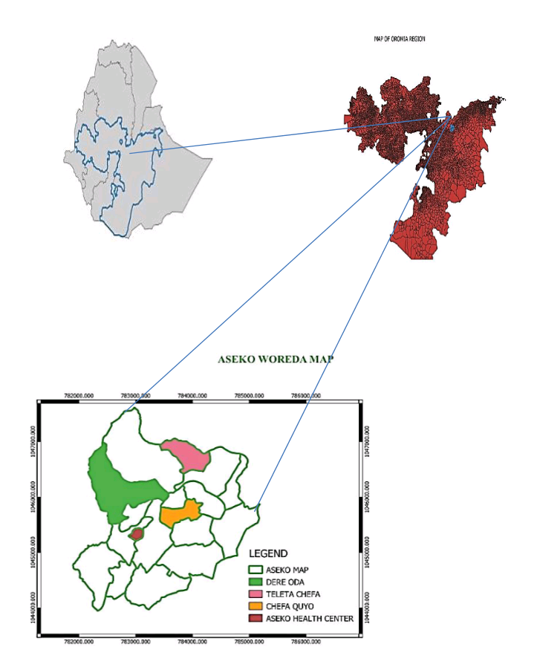
Figure 2: Map of Study area

3.2. Study design and collection period for retrospective data
A retrospective study was conducted to determine the prevalence of malaria from peripheral blood smear examinations from the Aseko Health Center. The case notes of all malaria cases reported from 2013 to 2022 were carefully reviewed between Octobers to January, 2023. Additionally, any malaria intervention activities that had been taken to control malaria were collected using a well-prepared checklist from the study area.

3.3. Malaria mosquito study design and collection period.
Three houses were randomly selected in each of the three villages selected for Aspiratory spray. Prior to spraying, the heads of households were informed about the purpose and the time of spray and given clear instructions as to what they have to do before and after their houses are sprayed. The collections were performed from 06:00 to 07:00 hrs every morning. Before mosquito collections, houses were prepared by closing all the roof space, windows and other exit points, removing all animals, all food and small furniture. White cloth sheets were spread on the floor. A commercially available insecticide spray was sprayed in the entire space of the room and then the house was closed for 15 minutes. Then all the knocked down mosquitoes on the white sheets were collected carefully would performed between February and May in 2024 and placed in prepared cups (Alemnesh, et al., 2012). All Anopheles mosquitoes collected by spray catch method were identified to anopheles species by using morphological as well as pictorial identification key (Oduwole et al., 2019)

3.4. Malaria Parasite study design for slide confirmed
A total of 227 blood films were prepared between February and May, 2024 from clinically suspected malaria cases by collecting 3 ml of blood using puncture of a vein through the skin in order to withdraw blood in full aseptic conditions. Thick and thin blood smears were prepared on same slide and stained with 10% Giemsa solution. Stained slides were considered positive if at least one malarial parasite was detected and negative when no parasite is present in 100 high power fields. Also the thin smear was used to identify the species of pre-detected parasites which was examined dependently by lab technicians. The data for the current study was extracted using laboratory registers that included all malarial cases admitted to AHC between February and May, 2023. All demographic details of subjects were also recollected from laboratory records.

3.5. Sample size determination for slide confirmed
The minimum sample size (n) require for detect the population mean abundance with target precision level and at a significance level$α$ will be determine based on mosquito spatial distribution patterns. The precision level will define as (Yamane, 1967), Where Math Processing Error is the sample mean abundance and SE is the Standard Error of the mean abundance (Southwood and Henderson, 2000).The sample size was calculated by the formula;
n = $\frac{N}{1+N\left(e\right)2 }$
Where n was sample size for malaria slide confirmed (227), N is population size (522) and e is the level of precision or sampling error which is $±$5%. Therefore the sample size was calculated as following:
n = $\frac{522}{1+522\left(0.5\right)2}$ → $\frac{522}{1+522(0.0025)}$ → $\frac{522}{2.3}$ = 226.95 ∼ 227

3.6. Statistical data analysis
Data was entered into Microsoft Office Excel and analyzed using statistical package for social sciences (SPSS) windows version 20 and used to test differences in retrospective malaria prevalence between years, sexes, ages and seasons. P-values < 0.05 was considered statistical significant and results were presented by tables and figures. The relationships of temperature, relative humidity, wind speed and precipitation with abundance of adult mosquitoes were investigated on monthly by using Spearman's correlation method. The data were analyzed in IBM SPSS Statistics 20. P < 0.05 was considered as statistically significant. Data will analyses by SPSS version 20 software package (One way ANOVA) and Microsoft Excel finally the Vector female Anopheles distribution and abundances will describes and present using tables and figures by descriptive statistics

4. RESULTS

4.1. Annual prevalence of Malaria cases in Aseko Woreda at Aseko Health Center from 2013-2022.
Annual trends of malaria prevalence in Aseko health center Within the last ten year (2013–2022) ( Figure 3) a total of 17,676, blood films were examined for malaria in Aseko health center and 5312 (30%) microscopically confirmed malaria cases were reported in the study area. There was a fluctuating trend of malaria within the last ten decade, the maximum 866(16.3%) microscopically confirmed cases of malaria being reported in 2017 and with the minimum 249(4.6%) number of microscopically confirmed malaria cases being reported in 2020. Regarding the identified plasmodium species in study area, Plasmodium falciparum, Plasmodium vivax and mixed species of plasmodium were reported in each year with Plasmodium falciparium being the predominant species in the study area and followed by Plasmodium vivax and mixed species, in which there distribution were account for 63.9%, 31.2% and 4.8% of malaria cases respectively in the study area. The prevalence of malaria among annual was statistically significant (P ≤ 0.05).

Figure 3: Annual prevalence of Malaria cases in Aseko Woreda at Aseko Health Center from 2013-2022

4.2. Distribution of Malaria cases among different age group in Aseko Woreda at Aseko Health Center from 2013-2022.
Regarding distribution of malaria prevalence among age groups at Aseko Health Center from 2013-2022 (Table 1), Out of 3905 total blood films examined in the age group of 0-4 age, 803 (20.5%) were tested positive, out of 4224 total examined in the age group of 5-14 years 1234 (29.2%) were tested positive, out of 9541 total blood films examined in the age group greater than or equal 15 years age 3275 (34.3%) were tested positive. These data showed that the highest malaria prevalence rate was observed in the age group greater than or equal to 15(≥15) age were accounted (34.3%) and followed by 5-14 and 0-4 years, were accounted 1234 (29.2%) and 803 (20.5%) respectively. But the prevalence of malaria among age groups was not statistically significant (P>0.05).
Table 1: Distribution of Malaria cases among different age group in AHC from 2013 to 2022.
Age group | Sex | No. of examined | Slide positive | Percentage (%) | Plasmodium falciparum | Percentage (%) | plasmodium vivax | Percentage (%) | Mixed species | Percentage (%) | P-Value
0 - 4 | Male | 2013 | 437 | 21.7 | 252 | 57.6 | 166 | 37.9 | 19 | 4.3 | 0.096
0 - 4 | Female | 1892 | 366 | 19.3 | 221 | 60.4 | 130 | 35.5 | 15 | 4.1 | 0.096
0 - 4 | Total | 3905 | 803 | 20.5 | 473 | 58.9 | 296 | 36.8 | 34 | 4.2 | 0.096
5 - 14 | Male | 3130 | 799 | 25.5 | 463 | 57.9 | 312 | 39 | 24 | 3 | 0.096
5 - 14 | Female | 1094 | 435 | 37.7 | 292 | 67.1 | 122 | 28 | 21 | 4.8 | 0.096
5 - 14 | Total | 4224 | 1234 | 29.2 | 755 | 61.2 | 434 | 35.2 | 45 | 3.6 | 0.096
Above15 | Male | 6135 | 2141 | 34.8 | 1547 | 72.3 | 497 | 23.2 | 97 | 4.5 | 0.096
Above15 | Female | 3406 | 1134 | 33.3 | 621 | 54.7 | 432 | 38.1 | 81 | 7.1 | 0.096
Above15 | Total | 9541 | 3275 | 34.3 | 2168 | 66.2 | 929 | 28.4 | 178 | 5.4 | 0.096
Total |  | 17670 | 5312 | 30.06 | 3396 | 63.9 | 1659 | 31.2 | 257 | 4.8 | 0.096

4.3. Seasonal variation of malaria prevalence at Aseko Health center from 2013 to 2022.
Despite the apparent fluctuation of malaria trends in the study area, malaria cases occurred in almost every month and season of the year. The highest peak of malaria prevalence cases in almost all years was observed during Spring (September, October and November) accounted 1736(32.68%) and the minimum malaria cases were observed during Winter (December, January and February) seasons with prevalence rate 681(12.8%). At species level, the maximum number of cases of P. falciparum and P.vivax were observed in spring (September, October and November) 1136(33.45%), followed by autumn (March, April and May) 1569(29.5%). During summer (June, July and August) the prevalence rate 1326(24.96%). In all plasmodium species the minimum numbers of distribution were observed during Winter (December, January, and February).The infection rate of P.falciparum, P.vivax and mixed species observed during Winter were 355(10.45%), 279(16.8%) and 47(18.3%) respectively(Figure 4).

Figure 4: Seasonal variation of malaria prevalence at Aseko Health center from 2013 to 2022.

4.4. Monthly prevalence of malaria slide confirmed cases in Aseko Health Center from 2013 to 2022
Monthly distribution of malaria and infected cases differs in each month of the year. The highest peak of malaria prevalence was observed during September to November 572(38.9%) shortly after the heavy rain season and the lowest number of malaria cases was observed during the months of January to February 185(12.5%) and 133(9.36%) respectively. Out of total examined, Slide positive Prevalences of Plasmodium falciparum, Plasmodium vivax and mixed parasites are 3396(63.93%), 1659(31.2%) and 257(4.83%) respectively. Although the highest number of Plasmodium falciparum and Plasmodium vivax was observed during November and December with percentage Prevalences 426(74.47%) and 165(45%) and the lowest was observed during February and November with prevalence rate 63(47.4%) and 121(21%) respectively.
Table 2: Monthly prevalence of malaria slide confirmed cases in Aseko Health Center from 2013 to 2022
Month | Examined | Total positive | P. falciparum | P. vivax | Mixed
September | 1532 | 541(35.3%) | 312(57.56%) | 212(39%) | 17(3%)
October | 1644 | 623(37.89%) | 398(63.8%) | 189(30.3%) | 36(5.78%)
November | 1470 | 572(38.9%) | 426(74.47%) | 121(21%) | 31(5.4%)
December | 1540 | 364(23.6%) | 180(49.45%) | 165(45%) | 19(5%)
January | 1484 | 185(12.5%) | 113(61%) | 57(30.8%) | 15(8%)
February | 1420 | 133(9.36%) | 63(47.4%) | 57(42.8%) | 13(9.7%)
March | 1475 | 411(27.86%) | 250(60.8%) | 140(34%) | 21(5%)
April | 1533 | 522(34%) | 350(67%) | 160(30.65%) | 12(2.3%)
May | 1654 | 634(38.3%) | 445(70.2%) | 157(24.7%) | 32(5%)
June | 1320 | 456(34.5%) | 299(65.57%) | 133(29%) | 24(5%)
July | 1265 | 382(30.2%) | 242(63.35%) | 124(32.46%) | 16(4%)
August | 1333 | 489(36.68%) | 327(66.8%) | 141(28.8%) | 21(4%)
Total | 17670 | 5312(30%) | 3396(63.93%) | 1659(31.2%) | 257(4.83%)

4.5. Prevalence of Malaria cases among sex at Aseko Health Center from 2013-2022.
According to this study in the last ten year (2013-2022) in the study area (Figure 4), males were more affected than females by malaria parasites but vary year to year. Out of 5312(30.5 total confirmed cases, the infections rates among males were 3469(65.3%) and out of 5312 total confirmed cases, 1843(34.7%) were female.

Figure 5: Prevalence of Malaria cases among sex at Aseko Health Center from 2013-2022.

4.6. Anopheles mosquito and meteorological variables by month, Chefa Quyo, Dere Oda and Teleta Chefa March to May, 2023.
Monthly distribution of Anopheles mosquitoes from March to May 2023 indicated different monthly peaks. Their highest density was recorded in April and the lowest was in March (Figure 6). Average of monthly temperature was increase from 26⁰C in March to 29⁰C in May which was coincided with a period of low wind speed (Figure 6). The non-significant relationship between Anopheles arabiensis abundance with relative humidity (0.909) and Precipitation (0.84), while its relationship with temperature was a positive strong correlation but not statistically significant, and it was very weak correlation with wind speed. A weak correlation and non-significant was observed between Anopheles funestus with temperature (0.830), while its relationship with relative humidity and precipitation was a very weak relationship and non-significant (Table 4). Also a moderate positive correlation was observed between Anopheles arabiensis and wind speed (0.2), but the relationship was significant. Anopheles arabiensis had negative correlation with the relative humidity (-0.4), but not significant (Table 4). Generally, our results showed that correlation of the number of total collected Anopheles arabiensis and Anopheles funestus with relative humidity (-0.4) and precipitation (-0.85) was weak negative correlation respectively but statistically not significant (Table 4).

Figure 6: The collected Anopheles mosquito and meteorological variables by month, Chefa Quyo, Dere Oda and Teleta Chefa March to May, 2023.

4.7. The collected mosquito species at Chefa Quyo, Dere Oda and Teleta Chefa, 2023.
A 316 total number of adults of mosquitoes collected from rural areas of three sites of Chefa Quyo, Dere Oda and Teleta Chefa from March to May 2023. Out of which 232 (73.42%) were Anopheles arabiensis and 84 (26.58%) were Anopheles funestus. Overall, Anopheles arabiensis (73.42%) was the predominant species followed by Anopheles funestus (26.58%). Both Anopheles species of mosquitoes were collected by Aspiratory spray, Anopheles arabiensis (73.42%) was the most abundant species in this collection method (Table 3).

Table 3: The collected mosquito species by Aspiratory spray, Chefa Quyo, Dere Oda and Teleta Chefa, 2023
Villages | An. arabiensis | An. funestus | Total
Chefa Quyo | 44 | 17 | 61
Dere Oda | 108 | 37 | 145
Teleta Chefa | 80 | 30 | 110
Total | 232 | 84 | 316

4.8. Influence of meteorological parameters on Anopheles mosquito abundance and distribution.
The spearman's correlation of the abundance of adult mosquitoes and the meteorological parameters (Table 4) showed that there was a very strong correlation and non-significant relationship between Anopheles arabiensis and temperature, very weak relationship between temperature and Anopheles funestus but statistically in-significant. The relationship between relative humidity and Anopheles arabiensis was weak negative (-0.4), statistically not significant, while very low correlation between relative humidity (0.00) and Anopheles funestus but statistically not significant. The relationship between precipitation and Anopheles arabiensis strong positive (0.7) and statistically not significant, but relationship between Anopheles funestus and precipitation was strong negative (-0.85) and insignificant. The relationship of wind speed with Anopheles arabiensis and funestus was a weak correlation but not statistically significant.

Table 4: Spearman’s correlation between Anopheles Mosquito and metrological variables.
Metrological parameters | An. arabiensis |  | An. funestus
Metrological parameters | r-value | p- value | r-value | p- value
Temperature | 1.00 | 0.197 | 0.00 | 0.830
Relative humidity | -0.4 | 0.909 | 0.00 | 0.934
Precipitation | 0.7 | 0.613 | -0.85 | 0.903
Wind speed | 0.2 | 0.007 | 0.36 | 0.0059
Hint: (r =1.0–0.9 (Very Strong Correlation), r = 0.89–0.7 (Strong Correlation), r = 0.69–0.4 (Moderate Correlation), r = 0.39–0.1 (Weak Correlation), p > 0.05 (Non-significant); P < 0.05 (significant) (Tahereh, 2021).

4.9. Monthly collection of different Anopheles mosquito.
Monthly distribution of the female Anopheles mosquito species in March, April and May (Autumn) season were 61(19.3%), 145(45.9%) and 110(34.8%) respectively. This distribution of the female Anopheles mosquito species indicated different monthly peaks. Their highest density was recorded in April 145(45.9%) and the lowest was in March 61(19.3%) (Table 4). Average of monthly temperature was decreased from 29 ⁰C in April to 26 ⁰C in May which was overlap with a period of medium wind speed (Figure 6). Generally, our results showed that correlation of the number of total collected Anopheles mosquitos’ species with relative humidity and precipitation was weak positive and there was week correlation with wind speed, and positive strong correlation with temperature.
Table 5: Monthly collection of Anopheles mosquito species at Chefa Quyo, Dere Oda and Teleta Chefa March to May, 2023.
Month | Anopheles arabiensis | Anopheles funestus | Total
March | 44 | 17 | 61
April | 108 | 37 | 145
May | 80 | 30 | 110

4.10. Monthly Prevalence of malaria Slide-confirmed Patients at Aseko Health Center from February to May, 2023.
According to the Aseko health center from February to May 2023, a total of 227 suspected people diagnosed for malaria. From out of total malaria confirmed cases about 71 (31.27%) were slide positive. Monthly Prevalence of malaria Slide-confirmed Cases were account 21(37.5%), 19(26%), 20(30.3%) and 11(34.4%) in February, March, April and May respectively. The rate of malaria prevalence were high in February (37.5%) and low in March (26%). An average around 57 malaria confirmed cases visited the Aseko health center each month. Regarding the identified plasmodium species in study area, Plasmodium falciparum, Plasmodium vivax and mixed species of plasmodium were reported in February, March and May. From identified Plasmodium species Plasmodium falciparium being the predominant species in the study area and followed by Plasmodium vivax and mixed species, in which there distribution were account 43(60.56%), 24(33.8%) and 4(5.6%) respectively. But the number of malaria suspected people who visited the health center were fluctuating in each month (Table 2). There was a significant rise in the number of confirmed malaria cases in March than the February; however, there was a significant reduction in the number of malaria confirmed cases from March to May 2023(P˂0.05).
Table 6 : Monthly Prevalence of malaria Slide-confirmed Cases at AHC, from February to May, 2023.
Months | Total Examined | Slide positive cases (%) | Plasmodium falciparum (%) | Plasmodium  Vivax (%) | Mixed species
February | 56 | 21(37.5%) | 11(52.38%) | 9(42.85%) | 1(4.76%)
March | 73 | 19(26%) | 10(52.6%) | 8(42.1%) | 1(5.26%)
April | 66 | 20(30.3%) | 15(75%) | 5(25%) | 0(0%)
May | 32 | 11(34.37%) | 7(63.63%) | 2(18.18%) | 2(18.18%)
Total | 227 | 71(31.27%) | 43(60.56%) | 24(33.8%) | 4(5.6%)
P-Value |  |  | 0.00145

4.11. Prevalence of malaria Slide-confirmed cases among sex at Aseko Health Center from February to May 2023.
According to the Aseko health center, total of 227 cases were examined for malaria. Out of total examined, about 120 (52.86%) were males and 107 (47.14%) were females. Of the total number of malaria slide confirmed, about 51 (42.5%) males and 20 (18.69%) females were slide positive (Figure 7). The data (Figure 7) shows that more number of males was examined than females, as result, there was rise in the number of malaria positive cases of males than females found to be infected. The difference was not statistically significant (P = 0.064).

Figure 7: Prevalence of malaria Slide-confirmed cases among sex at AHC, from February to May, 2023.

4.12. Prevalence of malaria Slide confirmed cases among Age group at Aseko Health Center from February to May 2023.
Prevalence of malaria is age groups at the Aseko health center shows that 14 (60.87%) were belonged to the age groups less than 5 (five), out of total slide confirmed cases 27 (26.7%) belonged to the age groups 5-14 and 30(629.13%) belonged to the age groups greater than 15. Malaria prevalence was slightly higher in the age groups less than 5 (Figure 7). Malaria prevalence was slightly lower in the age group between 5-14 ages.

Figure 8: Prevalence of malaria Slide-confirmed cases among Age group at AHC

5. DISCUSSION
In this study, a total of 5312 (30%) malaria prevalence among patients were reported in the last ten years, period from 2013 to 2022. This was higher than the study conducted in Ataye Hospital district North Ethiopia in which the overall prevalence of malaria was 2670(8.4%), (Felek et.al, 2018).This study record lower than study conducted in Kola Diba health center north Gondar district between 2002-2011 in which the overall prevalence of malaria were 23,473(39.6%) (Alemu et al, 2012). This might be due to variation in sample size, altitude and climate.
The presented study also showed that the highest number of malaria slide- positives was in 2007 866(37.4%) and then after declining trend continued with the lowest number of cases in 2010, 249(16.4%). This decreasing trend might be due to a better awareness of the people about malaria and implementation of control strategies.
From the result of the presented study the predominant plasmodium detected was P. falciparum 3396(63.9%) followed by P. vivax 1659(31%) and mixed species of plasmodium 257(4.8%) respectively. The presented study result is different from the study conducted in Dangila Health center in which P.vivax accounted 75% and Plasmodium falciparum accounted 25% (Alemu et al., 2012). However the presented study was nearly similar with study conducted in Tselemti woreda, North Ethiopia between 2013 to 2015, in which P.falciparum accounted 58.2% and P. vivax 35.5% and mixed infection 6.3% (Meresa et al., 2018). However, the presented study contradicts with the study conducted similarly, a research conducted in Arsi Negele in which the prevalence of P. falciparum and P. vivax was 19.8 and 74% respectively and mixed infection was 6.2% (Meseret et al., 2019). This finding is contradicts with malaria parasite distribution in Ethiopia which indicates that P.faliciparum and P. vivax are the two predominant parasites distributed in the country and accounting for 60% and 40% of malaria cases respectively (FMOH, 2012). This might be due to the differences in the study area, study period, study method and sample size as well as study population in which those studies focused on. These recorded data indicated that males (34%) were more infected than females (24.6%) but without any significant statistical difference. This might in line with other studies conducted in Assosa General Hospital (Tesfaye, 2017) show that In terms of sex, 7237 of the total examined patients were males and 6460 were females. Out of the malaria slide positive individuals, 54.29% were males and 45.71% were females.
Malaria slide-positives among males were 3992 (55.16%) and among females were 3351(52.03%). The reason why malaria affected more males might be due to the fact that males engaged in activities outside their residence area migration which make them more prone to infective mosquito bites as compared to female counter parts which are mostly at home and are not exposed counter parts which are mostly at home and are not exposed to malaria areas and protected from such infects bites.
Regarding the age groups at AHC, malaria infection was recorded from all age groups, but the rate of infection varies in different age group in the study area. However, the rate of infection was high in the age groups ≥15 years old (2189) followed by 5-14 age and 0-4 years ages. It was in line with the findings which were conducted in Tselemti Woreda, North Ethiopia (Meresa et al., 2018). The presented study was different from the study conducted Wolkite Health Center, South-Central Ethiopia, Which showed that a higher number of Plasmodium infection occurred between the age groups 5-14 years age compared with the others age groups. This might be due to improper usage of bed net high malaria transmission often overlaps with the planting and harvesting season that increase malaria incidence among working age group and working adults in Agricultural communities.

In the study area, seasonal distribution of malaria infected cases differs in each month and season of the year. The highest prevalence of malaria cases was observed during spring (September to November) (32.7%) and the lowest number of malaria cases was observed during winter (December to February) (12.8%). This is in agreement with other studies done in Kombolcha, South Wollo North Central Ethiopia in which malaria transmission peaks from September to November and lower from December to February, P.falciparum, P.viavx and Mixed infection were higher in spring and lower in winter (Gebretsadik et al., 2018).
Generally, this study showed that during the last ten years (2013-2022), there was trend in the decrease of malaria cases observed at Aseko Health Center. The highest peak was in 2017, 866(16.3%), after there was lowest in 2020, 249(4.6%).
Abundance and association of mosquitoes crossectional study with the meteorological parameters has been studied in some countries and meteorological parameters have been identified as an important factor involved in the transmission of vector-borne diseases (Lazarus, 2007). Temperature, relative humidity, wind speed and precipitation effects on mosquito survival, abundance and distribution.
Our findings indicate that mosquito abundance was low in precipitation above 10mm, and was consistent with the results of other researchers (Tahereh, 2021) demonstrate that precipitation significantly affect mosquito size. Researchers in northwestern Ethiopia found a negative correlation between mosquitoes with relative humidity and but observed positive correlation with Precipitation and temperature (Tilahun et al., 2020). Other work highlighted that the weather mosquito abundance relationship are complex and these effects are non-linear. In Ekiti State, Nigeria, temperature and Rainfall had a significant effect on the distribution and abundance of the mosquito vectors (Amir et al. (2015).
In this study during March to May (Season of Autumn), the mean monthly temperature below 27⁰C, in September was most suitable for adult mosquito survival and abundance, which seem to be more suitable for their host searching activity.
The precipitation affects mosquito populations. In relative low precipitation (0mm-10mm) the opportunity of mosquito to breed itself and survive is very high (File, 2021) On the other hand, high precipitation above 10mm may decrease mosquito populations. This is in agreement with our study; precipitation difference was caused by differences in the density patterns of mosquitoes, so that populations of mosquitoes were larger during the dry months.

In presented study during June to March and also May, the maximum temperature on some days was over 29 ⁰C that can be suitable for the mosquitoes. The mean monthly temperature below 30 ⁰C (29 ⁰C) in September was most suitable for adult mosquito survival and abundance, which seem to be more suitable for their host searching activity. The presented study was contrast with work done around Central Iran (Tahereh, 2021) show that, the maximum temperature over 40⁰C that can be lethal for the mosquitoes. This is in agreement with other studies done in Sudan (Lazarus, 2021), which show that abundance and association of mosquitoes with the meteorological parameters has been studied in some countries.
Meteorological parameters have been identified as an important factor involved in the transmission of vector-borne diseases Temperature, relative humidity, and wind speed and precipitation effect on mosquito survival, abundance and distribution.
The presented result is different from the study conducted in Central Kenya (Thomas, 2017). Which showed that the relationship between climatic factors and Anopheles mosquito abundance in Kenya. They reported a positive association between relative humidity with mosquito abundance, but there was no significant correlation with temperature and Precipitation.
The presented study is contradicts with work done in selected sentinel sites of Ethiopia (Alemnesh et al., 2017) which found that, the species composition of malaria vectors were six different anopheles species (An. Gambiae, An. pharoensis, An. funestus, An. cinereus, An. coustani and An. tenebrosis) collected and identified from the selected sentinel site. An. gambiae is predominant vector species in all three sites and An. pharoensis was identified in Wondo Genet and Mirab Abaya sites. An. funestus was identified only from Mirab Abaya site.
According to the Aseko health center from February to May 2023, a total of 227 malaria suspected people, a total of 71 (31.27%) were slide positive and an average 57 malaria confirmed cases attend the Aseko health center each month. There was a significant rise in the number of confirmed malaria cases in March than the February. Out of total, 120 (52.86%) of the total examined patients were males and 107 (47.14%) were females. Of the total number of malaria slide positive, 51 (42.5%) were males and 20 (18.69%) were females. According to this work shows that 14 (60.87%) were belonged to the age groups less than 5 (five), out of total slide positive 27 (26.7%) belonged to the age groups 5-14 and 30(629.13%) belonged to the age groups greater than 15.
The presented study was contradicted with work done in Wolkite Health Center (Degifie, 2017). The prevalence of malaria in age groups in study area showed that a higher number of Plasmodium infection occurred between the age groups 5-14 (10%) compared with the others age groups. In the same work indicated that malaria slide-confirmed cases shown that the Plasmodium infection is more in females than in males, and the dominant infecting parasite is Plasmodium vivax. Seasonal distribution of malaria in the study area shows that prevalence of malaria is higher in September and October and lower during the dry season of the year in December and January.

6. CONCLUSIONS
The overall prevalence of malaria in the study area was 30% and in relation to the type of species that infected the population, P. falciparum was the dominant parasite with prevalence of 3396(63.9%) followed by P.vivax with prevalence of 1659(31%) and least mixed species with prevalence rate 257(4.8%).
The prevalence of malaria was recorded in Aseko Health Center ranging from the highest infection of 37.4% in 2017 to lowest that of 16.4% in 2020.
The data also showed more males were infected with malaria than females with the prevalence rate 34% and 24.6% which was one of the wide ranges between the sexes compared other works.
There was also a different pattern of infection among the age groups in that the active age groups of ≥15 years and 5-14 years were more vulnerable to malaria infections evidenced by the prevalence of 34.45% and 29% respectively. But the prevalence of malaria among sex is not statistically significance with malaria prevalence.

This finding documented the most important malaria vectors of Ethiopia, Anopheles arabiensis and Anopheles funestus group in all surveyed months and other potential vectors. Generally, Metreological parameter has influence on the densities of mosquitoes. Therefore, the presence of Anopheles arabiensis and Anopheles funestus potential vectors throughout the year warrants the top priority of breeding habitat management.
Even though the result of trend analysis found that meteorological variables were less likely linearly correlated and predicts malaria cases occurrence in the study area, the changes in the current month meteorological factors would have effects on next month malaria case occurrence that provides an early warning which enables the health care system to be well prepared and to allocate scarce resource effectively to reduce mortality and morbidity of malaria.

7. RECOMMENDATIONS

- In order to get a clear picture of the prevalence of malaria and the distribution of the Parasite in particularly, proper diagnosis methods should be established.
- Both health professionals and people at large should consider environmental management and the community should be mobilized for practice sustainable and integrated vector control measures including drainage of breeding sites to play a crucial role on preventing the occurrence of further malaria epidemics.
- More attention to malaria control activities must be focused on the residence near to breeding sites and kebeles with high prevalence that might relate to their exposure to mosquito breeding sites.
- Laboratory diagnosis should be established in all health center found in a rural areas.

REFERENCE
Alelign A. and Dejene T. (2016). Current Status of Malaria in Ethiopia: Evaluation of the Burden, Factors for Transmission and Prevention Methods.
Alelign A.,Tekeste Z. and Petros B. (2018).Prevalence of malaria in Woreta town, Amhara region, Northwest Ethiopia over eight years. BMC Public Health: 18:990.
Alemnesh Hailemariam, Abebe Asale, Abate Waldetensai, Araya Eukubay, Getachew Eticha, Solomon Kinde, Fekadu Gemechu (2017). Assessment of malaria vector behavior in selected sentinel sites of Ethiopia.
Amir S. Siraj, Dale S. Rothman and Menno J. Boum (2015). Temperature and population of Anopheles mosquito in Jeddah, Saudi Arabia.
Asrat B. (2017). The prevalence of malaria in outpatients attending dangila health center, north central Ethiopia, Addis Ababa University. College of natural sciences. Department of zoological sciences. P. 12.
Ayele G.D., Zewotir T.T and Mwambi G.H. (2012).Prevalence and risk factors of malaria in Ethiopia. Malaria Journal; 11:195
Bianca D. Jackson and Robert E. Black (2019). A Literature Review of the Effect of Malaria on Stunting
Birhanu Z., Yihdego Y.Y. and Yewhalaw D. (2018). Quantifying malaria endemicity in Ethiopia through combined application of classical methods and enzyme linked immunosorbent assay: an initial step for countries with low transmission initiating elimination program. Malar J. 17:152
Debela B.M., Kahsay B.A. and Mokonnon M.T. (2018). Malaria outbreak and contracting factors in Afar Region, Ethiopia. Journal of Public Health and Epidemiology.p. 10-11.
Degifie Bereka (2017). Prevalence of malaria among patients attending Wolkite Health Center, South Central Ethiopia. Addis Ababa University.
European Food Safety Authority (2018). Field sampling methods for mosquitoes, sandflies, biting midges and ticks. ECDC Technical Report, Vector Net project 2014–2018. P. 6.
Federal Ministry of Health (2014). An Epidemiological Profile of Malaria in Ethiopia.

Feleke G.D., Gebretsadik D. and Gebreweld A. (2018). Analysis of the trend of malaria prevalence in Ataye, North Shoa, Ethiopia between 2013 and 2017 Malar J 17:323.
File T., Dinka H. and Golassa L. (2019). A retrospective analysis on the transmission of Plasmodium falciparum and Plasmodium vivax: The case of Adama City, East Shoa Zone, Oromia, Ethiopia. Malaria Journal. 18:193
Jemal A. and Ketema T. (2019). A declining pattern of malaria prevalence in Asendabo Health Center Jimma zone, Southwest Ethiopia. BMC Research Notes; 12:290.
James M. Crutcher and Stephen L.Hoffman (2006). The University of Texes Medical Branch at Galvester.
John Willey, (2016). Advance in Malaria research. The life cycle of plasmodium. Wiley. P. 3.
John W. Hock (2002). Guidelines for Vector Anopheles Surveillieces
Lazarus Musa Samdi (2012). Study on malaria vector (Anopheles species) in Sudano_Sahalian Savannah area. University of Jos. Sand. pp. 140-143.
Laurence Foloren, Michael P. Washborn J. Dale Raineetal (2002). Proteomic views of Plasmodium life cycle. P. 33-35.
Merck and Co., Inc., Rahway, NJ, USA, 2020. Global medical knowledge.
Mubarik Ali Aldoub (2006). Introduction to the types of mosquito that bit for blood.Kuwait.
Okwa OO, Rasheed A, Adeyemi A, Omoyeni M, Oni L, Fayemi A, and Ogunwomoju A. (2007). Anopheles species abundances, composition and vectoral competence in six areas of Lagos: Nigeria. Journal of Cell and Animal Biology Vol. 1 (2), pp. 019-023,
Perlmann. P. Troye Blomberg M (eds.). Malaria Immunology, Malaria Parasite and disease chem. Immunol. Basel, Karger, 2002, vol.88, p 1-20.
Rosenberg W., 2008. Plasmodium life cycle. Tulana University.
Shamebo T. and Petros B. (2019).Trend analysis of malaria prevalence in Halaba special district, Southern Ethiopia. BMC Research Notes. 12:190
Tadesse F., Fogarty W.A. and Deressa W. (2018). Prevalence and associated risk factors of malaria among adults in East Shewa Zone of Oromia Regional State, Ethiopia: a cross-sectional study. BMC Public Health; 18:25.
Taffese S.H. ,Schroeder H.E. , Koepfli C. , Tesfaye G., Lee C.M. , Kazura J. ,Yan G. and Zhou G. (2018). Malaria epidemiology and interventions in Ethiopia from 2001 to 2016. Infectious Diseases of Poverty; 7:103.
Tahereh Sadat Asgarian (2021). Impact of Metreological parameter on mosquito population abundance and distribution in a former malaria endemic area’ Central Iran. Tehran University of Medical science
Tegegne Y. , Asmelash D. , Ambachew S., Eshetie S., Addisu A.and Zeleke J.A. (2019). The Prevalence of Malaria among Pregnant Women in Ethiopia: A Systematic Review and Meta-Analysis.
Tilahun Adugna Daygena, Fekadu Massebo and Bernt Lindt Jorn (2017). Variation in species composition and infection rate of anopheles mosquito. Dirashe Woreda, south Ethiopia. Parasite and Vectors. Pp 4-13.
Southwood T.R.E. Henderson P.A (2000). Ecological methods. 3nd ed. Blackwell, Amsterdam, Netherland
Tesfay K., Yohannes M. and Bayisa S. (2018). Trend analysis of malaria prevalence in Raya Azebo district, Northern Ethiopia: a retrospective study. BMC Research Notes. 11:900.
Tesfaye M. (2017). Prevalence of Malaria among Patients Attending Assosa General Hospital, Western Ethiopia. Addis Ababa University. College of Natural and Computational Sciences Department of Microbial, Cellular and Molecular Biology. P. 10.
World Health Organization (2018). World Malaria Report. Netherland, Jeneva.
Woyessa A., Deressa W., Ali A. and Lindtjorn B. (2012). Prevalence of malaria infection in Butajira area, south-central Ethiopia. Malaria Journal.

Appendix
General information about collection sheet
- Field data Collection Sheet
Date of Collection | Time | Numbers of species | Species  name | Village(sites) | Temperature(ºC) | Precipitation (mm) | Humidity (%) | Wind speed(km) | House hold name
March1-3,2023 |  |  |  | Chefa Quyo
April 1-3,2023 |  |  |  | Chefa Quyo
May 1-3,2023 |  |  |  | Chefa Quyo
March 11-13,2023 |  |  |  | Dere Oda
April 11-13,2023 |  |  |  | Dere Oda
May 11-13,2023 |  |  |  | Dere Oda
March 21-23,2023 |  |  |  | Teleta Chefa
April 21-23,2023 |  |  |  | Teleta Chefa
May 21-23,2023 |  |  |  | Teleta Chefa

- Morphological identifications of anopheles mosquitoes
Identification date | No. of Anopheles  mosquito | Anopheles Species | Total number | Remark

No. |  | Field Anopheles Mosquito Collection
1 |  | 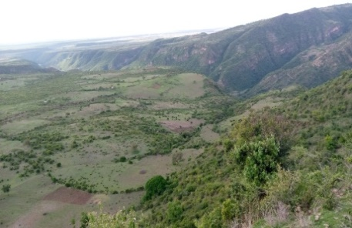 a |  | 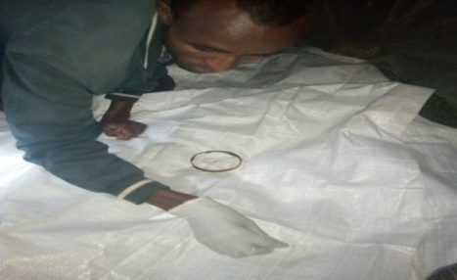 b
2 |  | 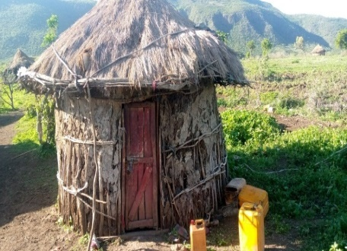c |  | 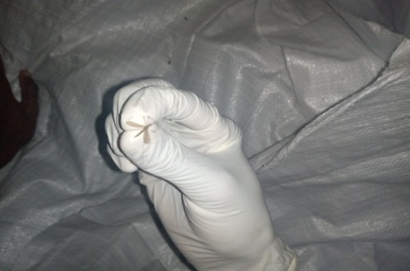d
3 |  | 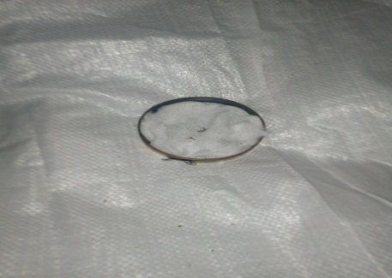e |  | 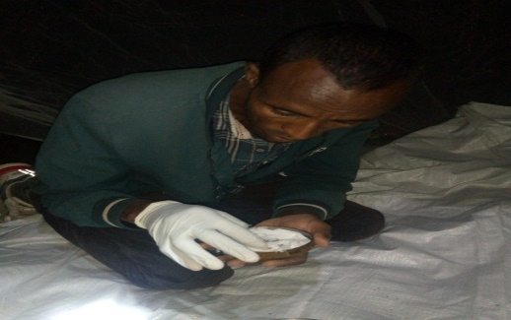f
4 |  | 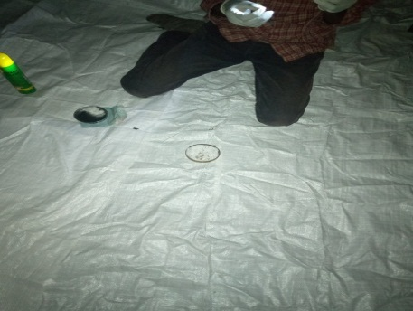g |  | 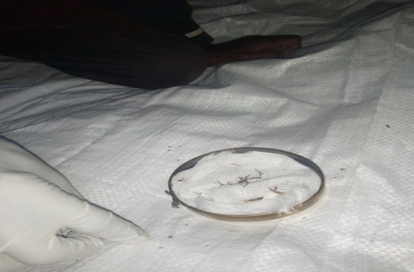h
Morphological and pictorial identification key
No. | Species name |  | Species Morphological Key |  | Figures description
1 | Anopheles arabiensis |  | Golden colors  Slender shape  Head have eyes  Have pair of antennae  Segmented antennae  Long antennae |  | 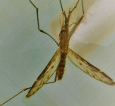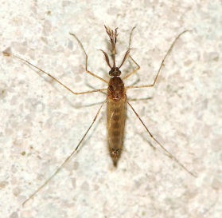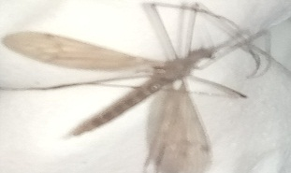
2 | Anopheles funestus |  | Have dark gray colors  Highly anthropophilic (seek human as host)  Strongly endophilic (Rest indoor)  Rest in human dwelling post feeding |  | 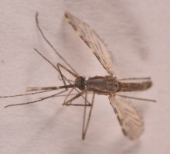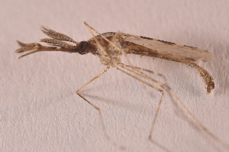

Blood Sample collection
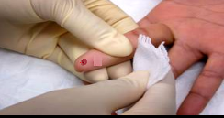a | 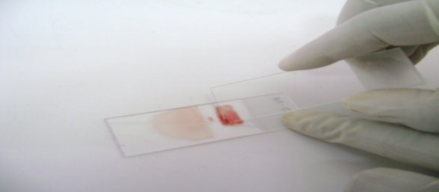b

- Collect finger blood
- Transferring blood to slide for made blood film
Smear Preparations
a | 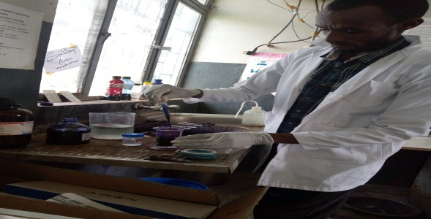b |  |  | - Main components of giemsa stain  - Giemsa(10%) solution added to bottle
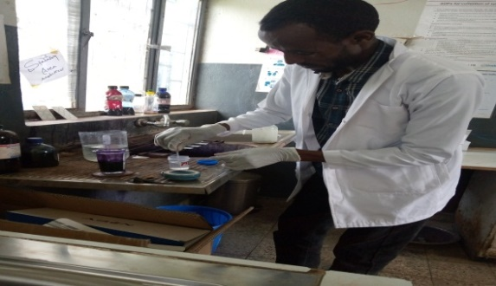c | 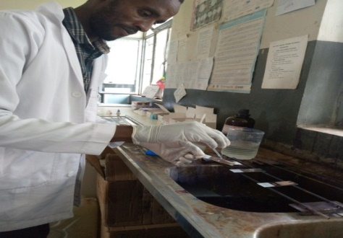d |  |  | - Absolute Methanol added to giemsa stain  - Giemsa solution and methanol were mixed
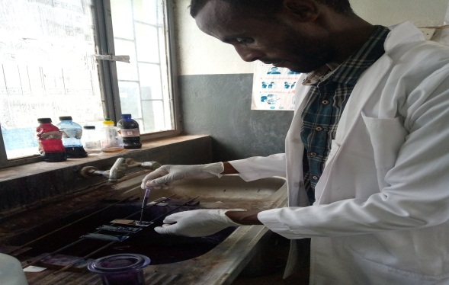e | 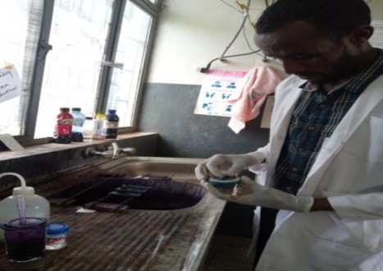f |  |  |  |  |  | - Fixation for dried  - Waiting for 30 min.
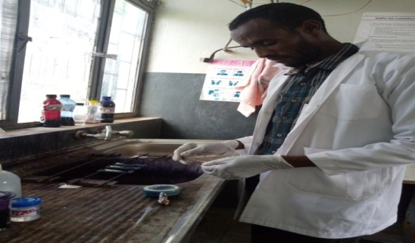g | 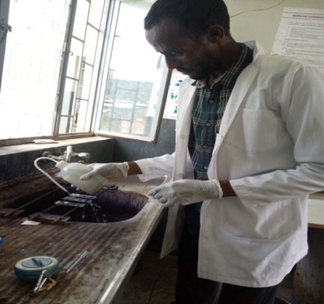h |  |  |  | - Giemsa at end of 30 min  - Wash sample with tap water giemsa stain to removed
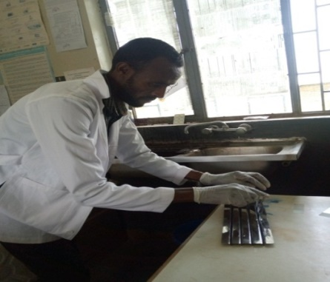 |  |  | 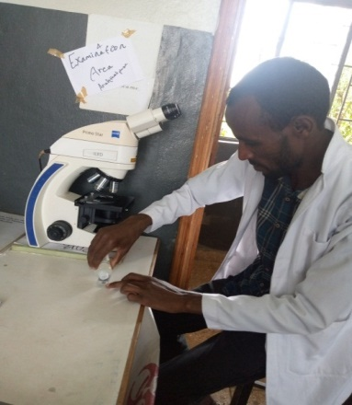j |  |  | - Keeping slides on rack for drying at room temperature  - Glycerol was added for finning parasites
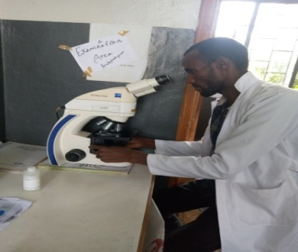k |  |  | - Identification of malaria parasites by focusing under 10 or 100 power.

Sample of confirmed Slides for identification of malaria parasite

