

AMBO UNIVERSITY
SCHOOL OF GRADUTAE STUDIES
COLLEGE OF BUSINESS AND ECONOMICS
DEPARTMENT OF ECONOMICS
THE EFFECTS OF ECOTOURISM INVESTMNET PROJECT ON THE HOUSEHOLD LIVELIHOOD: THE CASE OF WENCHI DENDI CRATER LAKE, SOUTH AND SOUTH WEST SHOA OF OROMIA REGION, ETHIOPIA

A RESEARCH THESIS SUBMITTED TO DEPARTMENT OF ECONOMICS IN PARTIAL FULFILMENT REQUIREMENTS FOR THE DEGREE OF MASTER OF SCIENCE IN DEVELOPMENT ECONOMICS

BY

TESHOME DESEA
ADVISOR: BADASSA WOLTEJI (PhD)

October, 2022

Ambo, Ethiopia

AMBO UNIVERSITY
SCHOOL OF POST GRADUATE STUDIES
Approval sheet
I hereby certify that I have read and evaluated this thesis research entitled “The effects of ecotourism investment project on the house hold livelihood”. The case of Wenchi Dendi crater lake, West and south West Shoa Zone, Oromia Region, Ethiopia” prepared under our guidance by Teshome Desea. Therefore, I recommend that it be submitted as fulfilling the thesis research requirement.
SUBMITED BY;
Teshome Desea ------------------- -----------------------
Name of student Signature Date
APPROVED BY;
Advisor; Badassa Wolteji (PHD) --------------------- ---------------
Head of Department Signature Date
----------------------------------- ---------------------- --------------------------
College/Institute/Dean Signature Date
------------------------------------ -------------------- -------------------------
Dean, School of Graduate Studies Signature Date
-------------------------------------------- ------------------ ------------------------

DEDICATION
This work is dedicated to my family for their moral support during my studies their support has had immeasurable contribution towards my success

CENTER FOR DEVELOPMENT ECONOMICS
This is to certify that the thesis prepared by Teshome Desea entitled: as “The effects of ecotourism investment project on the house hold livelihood”. The case of Wenchi Dendi Crater Lake, West and south west Shoa Zone, Oromia Region, Ethiopia submitted in partial fulfillment of the requirement for the Degree of Master of Science in Development Economics, compiles with the regulation of the university and meets the accepted standards with respect to originality and quality.
Signed by examining committee
1. _____________________ _________________ ______________
Chairman Signature Date
2. _____________________ _________________ ______________
Internal examiner Signature Date
3. _____________________ _________________ ______________
External examiner Signature Date

DECLARATION
I declare that this thesis is submitted for the partial fulfillment of the degree of Master of Science in Development Economics. It is my original work and has not been presented for any degree in other university and all sources of materials used for this thesis are dully acknowledged and references are listed at the end of the main body of the thesis.

Name Teshome Desea Fegessa
Signature _____________________________ date _________________
Place: - Ambo university

ACRNOMYS AND ABBREVIATION

ASENS Associations of South East Asian Nations
AD Ana domain
HHS House Holds
IIA Independence of Irrelevant Alternatives
NRM Natural resource management
OLS Ordinary Least Square
RGDP Real Gross Domestic Product
SEAN South East Asian Nations
SES Social ecology system
SLA Sustainable livelihood approach
SSA Sub Saharan Africa
TFP Total Factor of Productivity
UNWTO United Nations world trade organization
USD United states dollar
UNESCO United Nations Economic and Social Cooperation
UNCTAD United Nations Conference on Trade and Development
VIF Variance inflation factor
WTTC World trade and tourism council
WWF World Wild fund

Acknowledgment
Above all I would like to thank the almighty God for the Mercy and Blessings. My sincere appreciation goes to all those who helped me in the process of completion of this thesis. My heartfelt regards goes to my advisor Badassa Wolteji(PhD) and may not only patient and understanding but also guided me and offered assistance and consultant support throughout .I am greatly thank full that he took time to listen and respond to my enquire ,I would not have gone for without his support and constructive criticism . My heart thanks goes to the university of Ambo for offering masters of Art in development Economics as an evening course thus, giving me an opportunity to conveniently pursue the course .The continues discussion and consultation is greatly appreciated. And also I would like to thank my family for their support and understanding during my study .Further more I am grateful to all the acquisition for this study possible .Very special thank go to people living around Dendi Wenchi crater lake for their hospitality and openness everyone who made execution of this study possible I sincerely thank you all.

Table of Contents

Approval sheet ii
Dedication iii
Acronyms and abbbreviation vi
Acknowledgment vii
Abstract xviii
CHAPTER ONE 1
INTRODUCTION 1
1.1. Background of the study 1
1.2. Statements of the problem 3
1.3. Objective of the Study 4
1.3.1. General objective 4
1.3.2. Specific objectives of the study: 4
1.4. Research Questions 4
1.5. Significance of the study 4
1.6. Scope of the study 5
1.7. Limitation of the study 5
1.8. Organization of the thesis 5
CHAPTER TWO 6
LETERATURE REVIEU 6
2.1. Theoretical literature review 6
2.2. Evolution of Tourism and the Emergence of Ecotourism 6
2.3. Economic income of ecotourism investment in Wenchi Dendi Crater Lake 10
2.4. Stakeholders collaboration in ecotourism investment 11
2.5. Environmental education of eco-tourism investment on the household livelihood. 12
2.6. Ecotourism investment project. 13
2.7. Economic attitude 15
2.8. Socio-economic and Environmental Conditions in the area 15
2.9. Empirical literature review 16
2.9.1. Conceptual Frame work 19
CHPTER THREE 21
3. RESEARCH METHODOLOGY 21
3.1. Descriptions of the study area 21
3.4. Research Design 23
3.5. Target population 24
3.6. Sampling size and sampling procedure 24
3.7. Sample size 25
3.8. Sample size determination 26
3.9. Method of data collection 27
3.10. Methods of Data Analysis 27
3.10.1 Descriptive analysis 27
3.10.2 Econometric analysis. 28
3.10.1Model Specification 28
3.12.2. Statistical tests of multi-co linearity problem 31
CHAPTER FOUR 34
4. RESULTS AND DISCUSSION 34
4.1. Descriptive statistics 34
4.1.2. General Characteristics of the Sample Households 34
4.1.5. Actual ecotourism potentiality of the area 39
4.1.5.1. Natural resources 39
4.1.5.2. Scenery (landscape and cave) 39
4.6. Result of Econometric Model 44
4.7. The effects of ecotourism investment on the house hold livelihood 45
CHAPTER FIVE 53
CONCLUSION AND RECOMMENDATION 53
5.1. Conclusion 53
5.2. Recommendation 54
References 55

List of tables

Table 1. Households sample design 26
Table 2. Measurements variables 32
Table 3 Ages, Gender, Marital Status and Educational Background of Respondents 34
Table 4. Ecotourism investment creates employment opportunity 36
Table 5. What potential attraction areas of tourism are there for generating income? 38
Table 6. Have you benefited from tourism in your crater lake. 39
Table 7. Assistance from enables 40
Table 8. Community satisfaction 42
Table 9. Effects of environmental education on the household livelihood 42
Table .10 has ecotourism are helpful to the environment. 43
Table .11 Times of workshops to conserve the environment 43
Table 12. Methods to get education how to conserve the environment 44

list of figures

Fig .1 conceptual frame work 20
Fig 2. study area map 22

List of tables in appendices
Appendix 1. picture of ecotourism attraction areas 59
Appendix 2. Goodness of fit test 61
Appendices 3 .link tests 61
Appendices 4.collinearity 62
Appendix 5. heteroskedasticity 63
Appendix 6. Multicollearity 63
Appendix 7. Final results of Binary logistic regression on stata 64
Appendix 8.Marginal effects of ecotourism investment a case of wenchi dendi Crater Lake 65
Appendix 9 .Questioners of survey statistics 67

Abstract
Eco-tourism investment is very important to enhance the growth and development of the house hold livelihood. While there is evidence that ecotourism’s espoused benefits can be realized, there are equally as many, cases where ecotourism has fallen short of its proposed objectives, is to alleviate poverty. With the hope to provide insight on mechanisms to sustainably develop this ecotourism investment three objectives have been considered. these are , income of house hold livelihood, stake holder collaboration, and environmental education in the effects of ecotourism investment on the house hold livelihood. The study adapted descriptive research design. The target population was sought from both lakes living around Wenchi Dendi Crater Lake, Which was sampled through cluster sampling, in a sample size of 183 respondents. Both primary and secondary sources of data were utilized. The questionnaire and interview schedule guides covered items on the effects of ecotourism investment. Finally, the data was organized, tabulated and analyzed using Statistical Packages for Social Sciences (SPSS). Presentation of research findings was in the form of descriptive statistics such as percentages, frequencies and in the form of tables. The major findings of the research became about 59% of the population living around Dendi Crater Lake cannot be benefited from Crater lake. But about 60% of the respondents are satisfied by the construction of this investment project. And this investment project is crucial for the house hold livelihood. To be more profitable and economize the investment should be invested by deferent stake holders or enablers. This helps to invest more hotel lodges sport activities and deferent recreational sites, which boost the economy of the house hold livelihood. In general deferent institution government, stake holders and communities should have to participate and invest there. This investment project is very important after the completion the construction not only this but also there are deferent potential attraction areas which benefits the local people.

Key words: stake holders, environmental education, benefit, livelihood, assistance

CHAPTER ONE

INTRODUCTION

1.1. Background of the study
Tourism is a powerful vehicle for economic growth and job creation all over the world. The tourism sector is directly and indirectly responsible for 8.8 percent of the world’s jobs (258 million); 9.1 percent of the world’s GDP (US$6 trillion); 5.8 percent of the world’s exports (US$1.1 trillion); and 4.5 percent of the world’s investment US$652 billion (WTTC, 2018). Ecotourism, as a niche tourism market, is considered to be one of the fastest growing segments of tourism industry. Some have claimed that ecotourism is increasing by 25 to 30% a year UNWTO, (2017) and most tourism forecasters predict ecotourism to grow further over the coming years. The World Travel & Tourism Council (WTTC) estimates that 3.8 million jobs (including 2.4 million indirect jobs) could be created by the tourism industry in Sub Saharan Africa (SSA) over the next 10 years. The 24th general assembly in Spain Madrid from 170 tourism village Wenchi Lake is selected as the best tourism village in the world (UNWTO, 2021).
The potential for growth in tourism in SSA is significant and compelling global hotel chains are poised to spend hundreds of millions of dollars in Africa over the next few years to meet increased demand from both international tourists and the continent’s own fast growing middle class. Global international tourist arrivals have been growing steadily at 4-5 percent per year since the 1950s. Between 2009 and 2010, despite the global financial crisis, international tourist arrivals to SSA increased by 8 percent, making SSA the second fastest growing region in the world after the Asia Pacific (UNWTO,2010). In Eastern Africa, although countries like Kenya, Tanzania, Ethiopia, and, more recently, Rwanda and Uganda, have been relatively successful in attracting capital investments for their tourism sectors, the total capital investment for the region was a mere USD 3.1 billion in 2017 (WTTC, 2018). For the period 2010-2017, total capital investments amounted to USD 26.67 billion against the continent’s USD 235.17 billion for the same period.

Ethiopia’s Ministry of Culture and Tourism, (2015) listed some of the natural highlights available to gallant visitors who venture out from Addis Ababa. These include the Semien Mountains National Park, a UNESCO World Heritage site, which boasts spectacular geographic landscapes and unique wildlife; the Mago National Park on the eastern bank of the Omo River; Lake Tana, wenchi crater lake from Oromo region the source of the Blue Nile and home to the Blue Niles Falls, and Sof Omar cave system, the most extensive underground cave system in the Current Islamic Shrine with a religious history spanning thousands of years. Among lakes in Ethiopia this paper focused on Wenchi- Dendi Crater Lakes that are located in high land area of Oromia region in west and south west shoa of Ethiopia. These lakes are 150km and 86km respectively from Addis Ababa, and as a result it is near to Addis Ababa. The elevation of Dendi and wenchi are 3260masl and Dendi3500masl with temperate Climate condition. Things that make Wenchi- Dendi Crater Lake differ from other lake of Ethiopia are its creation. As oral information from elders, at very beginning there is no even source of water around this area and it was just land without water.

But mean while the form of volcano eruption has occurred and this volcano has created a very creative and beautiful lake. This mount volcano is located near the city of Addis Ababa, in Ethiopia it has an eight km wide caldera and its highest point is 3,260msl.It fully contains Lake Dendi it is the second highest volcano in Ethiopia only13.5km from wenchi and 87 km south of Addis Ababa. Dendi Lake seems number eight (8) while the wenchi lake image seems “Wechiti” one types of home furniture for the local society with ‘U’ shape. No one reached on the exact date and year in which Lake Dendi and wenchi Crater Lake have created at all, but there are evidences showing this oral information is true. For example, the existence of Orthodox Church which is known as “Chirkos” church at the center of wenchi lake which is surrounded by water and the shape of the lake itself puts evidence for this oral information. The erupted volcano has destroyed all landscapes of the area but not the church. This Orthodox Church has been the main part of the lake which attracts tourists and also induces government to invest and construct these Ecotourism investments. Its Blue-colored water is very attractive to visit. This lake, is 1,600 square meters in total area, is ecologically, recreationally, and aesthetically important as well as a popular place for tourists (Lakew and Mitiku, 2008; Malairajan, 2018)
1.2. Statements of the problems
With a growing interest to spend leisure time in nature related facilities and increasing awareness on environmentalism, ecotourism has become one of the fastest growing segments of the tourism industry in the world (UNWTO, 2018). The declaration of the year 2002 as International Year of Ecotourism by World Tourism Organization reflects the importance of ecotourism in the global industry. It provides better linkages, reduces leakages of benefits out of a country, creates local employments, creates the multiplier effect and fosters sustainable development (Khan, 1997b; Belsk, 2018).The core aim of ecotourism investment is poverty alleviation in rural communities through the creation of sustainable income-generating tourism activities, while conserving the delicate and sensitive ecological and cultural resources in the environments. Ecotourism investment project sites offer potential benefits to the individual, communities and the nation as a whole, in areas such as the creation of employment opportunity, foreign exchange earnings and improving the welfare of local people among others (Mbaiwa, 2017).

Research is scant focusing primarily on the effects of eco-tourism development on the house hold livelihood in the case of Wenchi -Dendi Crater Lake. Therefore, the study intends to assess the effects from ecotourism investment on the house hold livelihood in the case of Wench-Dendi Crater Lake. Accordingly, the development of Ecotourism investment at Wenchi- Dendi Crater Lake would be helpful, this are it fosters entrepreneurship and new business venture, creates job opportunity for all, supports vulnerable groups, preserve heritage. Tourism might be helpful to protect and finance the preservation of historic and cultural sites and even prompt the creation of new community initiative. The effects of ecotourism tourism investment from Dendi Wenchi Crater Lakes are the main research gap identified and studied.

1.3. Objective of the Study
1.3.1. General objective
The general objective of the study is to identify the effects of ecotourism investment on the household livelihood around Wenchi Dendi Crater Lake.
1.3.2. Specific objectives of the study:
- To examine effects of ecotourism investment on the households livelihood income in Wenchi Dendi Crater
- To identify the effects of environmental education in ecotourism investment in Wenchi Dendi Crater Lake?
- To determine the effects of stake holder collaboration towards the ecotourism investment in Wenchi Dendi crater lake.
1.3. Research Questions

- What are the effects of ecotourism investment on the house holds’ livelihood income in Wenchi Dendi Crater Lake?
- What are the effects of environmental education in ecotourism investment project in the case of Wenchi Dendi Crater Lake?
- What are the stake holders’ collaboration on ecotourism investment in Wenchi Dendi crater lake
1.4. Significance of the study
This study focused on the effects of ecotourism investment on the household livelihood in Wenchi-Dendi Crater Lake and estimation of assessments of the effects of investment activity on both lakes. The investment participation by individuals as well as by public body would be controlled by the federal government office. If the two lakes are invested, no one deny that, there is an increase in satisfaction for visitors and even increase in income of the local people and support the house hold livelihood . This increases the revenue for the local people. As no study has been conducted in this area yet especially on Dendi Lake, this study fills the gap and hope fully initiates other researchers to deal with Lake Dendi and Wenchi-the most beautiful area, by providing the data. This data may also use as empirical reference. And finally, the paper would be tried to provide policy makers with much needed information for further improvements of the investment on the lake and its surroundings by drawing concluding remarks. The research would be help toward possible direction that helps to provide the major effects of ecotourism on the house holds’ lively hood.
1.5. Scope of the study
The scope of the study was limited on around the two lakes of West and south West shoa Zones. Among a number of lakes and eco-tourism in Ethiopia, the paper gives emphasis to Wenchi-Dendi Crater Lake based on the real or existing situation of the lake. Shortage of time and budget is the reason for limiting the site only to those lakes. For the specification purpose, the method of the study was case study. The study was covered the period from 2018 – 2021, this period had been chosen for Dendi lake but the Wenchi lake had taken more than 2021 year, because of unavailability of data in the lake Dendi at the time before the year 2018.
1.6. Limitation of the study
As the study incorporate Dendi and Wenchi lakes which are found in Dendi and Wenchi woredas of West and south west shoa zones. The length from Woreda and from zone again limits the study the accessibility to transport as well as, available of literature review on Dendi lake limits the study.
1.7. Organization of the thesis
As to organize the paper, the rest of this thesis has had four chapters. The first chapter deals about: back ground of the study, statement of the problem, objectives of the study, research question, and significance of the study, the second chapter was dealt with the review of, Literature review and empirical literature review. Following this, the third chapter discussed the descriptive of the study area as well as it comprised issues related to the methodological part of the research, economic modeling, and econometric analysis were presented. Chapter four discussed about results and discussion, while chapter five presents the study summary, conclusion, recommendation

CHAPTER TWO

LETERATURE REVIEU

2.1. Theoretical literature review
This study utilized various approaches that seek to address the welfare of poor people in the context of their entitlements to access, utilization and management of the ecotourism available to them. The theoretical frameworks upon which opportunities for households ‘livelihoods are based conceptualize the importance of environmental resource benefits and the involvements of all stakeholders; particularly in Dendi Wenchi Crater Lake area. Consequently, the study critically examined the Sustainable Livelihood Approach (SLA) (IFAD, 2007b); the Social-Ecology System (SES) (Simon seen, 2018); Political Ecology Natural Resources Management (NRM) approach and the Social Capital Theory (Coleman, 2018; Putnam, 2020; Porte’s and Sandlot 1996; Porte’s 1998) which was adapted to form the conceptual framework upon which the study was based.
2.2. Evolution of Tourism and the Emergence of Ecotourism
Tourism is a source of foreign exchange earnings that affects the direction of a country’s balance of payment and contributes towards investment of capital projects; it attracts foreign investment hence creating an opportunity for indigenous industrial development; and aids in economic regeneration by providing support for marginal economies (Frederica, 2018). It enhances diversification and the promotion of development by encouraging new economic linkages that increase Gross Domestic Product (GDP) of an economy (Viet et al, 2018). In addition, tourism remains a significant source of employment because it retains a relatively high labor demand sector (Ikaria and Okech, 2002; Bichaka, Christian and Bedassa, 2007; Lalnunmawia, 2010). It promotes some aspects of inter-cultural communication, stimulates the expression of traditional wear, harnesses carving industries and provides opportunities for growth of local entertainment. Equally, tourism has the ability to counteract uneven development while promoting regional decentralized development (Wen and Tisdell; et al; 2015). Subsequently, sustainability of regional tourism would depend on how nature is conserved and how minority cultures would be involved. Tourism therefore helps to promote conservation of biodiversity as well as historical and cultural sites (Okungu, 2015). This is of even greater significance when it concerns ecologically and culturally sensitive areas, where conventional (mass) tourism has a heavy impact. In Ethiopia, tourism is considered an important sector accounting for 12.5 percent of the GDP and the third largest foreign exchange earner after coffee and agriculture (Office of tourism in Ethiopia). The sector accounts for 9 percent of total wage employment in the country, and is a major source of government revenue. To further demonstrate its importance, the sector is identified as one of the key drivers for achieving the goals of Ethiopians development (Office of finance and economic commission office, 2012).
However, tourism leads to a range of socio-economic and environmental challenges. It causes environmental degradation in natural areas especially if it is not properly managed reducing not only the amenity value of the tourist site but also the ecological functions and values of the environment (UNEP, 2019; Frederico,2018, Lalnunmawia,2010). Tourists‟ destinations are often contaminated with dumping of litter and disturbing of the natural habitat while wanton abuse of ecosystem, including the introduction of alien species happens quite often (UNEP, 2019, Wen and Tisdell, 2001). Consequently, to make tourism appropriate and sustainable, there emerged in the 1980s a quest for alternative forms of tourism. Among other variants was ecotourism based on the premise that environmental sustainability and welfare of the local community was a prerequisite (Fennell, 2020; Han et al; 2018). The origin of ecotourism is attributed to post-colonial, glorifications of wilderness‟ and fascination with indigenous people‟ (Mitchell, 2021). It was integrated into the consumer culture of the post-World War II boom, "making ecotourism a cultural and economic practice for those more sensitized to heightened environmental destruction and linked with exciting tourist experiences in adventurous journeys, breathtaking scenery, and trips to exotic islands" (Bandy, 1996: 542). According to the ministry of tourism and culture, tourism as one of the economic sector came into being in Ethiopia very recently. It was around 1960, that the potential of tourism drew, the attention of the imperial Government authorities. The first tourism office was established in 1962. However, a setback in international tourism demand had been seen during the military regime. From 1974 for two decades the industry was suffering from various adverse effects such as prolonged civil war, recurrent drought and restrictions on entry and free movement of tourists (World Bank, 2006). Though the sector is still at its infant stage, it has been keep growing since 2001. The total receipt from the industry in 2008 was around 204.9 million USD. As of 2008, international tourist’s arrivals were reached to 383,399. However, the sector’s share to GDP is remains very small (0.77% in 2008).

Successive Ethiopian governments have promoted tourism during their tenures. The monarchy that Mediated politics, economics, culture, environment and technology for most of the 20th century initiated the promotion, market and development of tourism as an integral part of the overall dynamics of national development. Ethiopia’s existence as an independent country for thousands of years and the diversity of its ecology and culture were images that captivated foreigners for a long time. The promotional logo of ‘Thirteen months of Sunshine” was interjected by an imaginary of a proud and cultured people professing the two major universal religions of the world-Christianity and Islam and an ethnic religion of Felecia Jewry. The magnificent material iconographies of Ethiopian culture were relayed to the visitor through the timeless architectural wonders of Axum’s stele, Lalibela’s rock hewn churches, Gondar’s Castles, Harar’s medieval walled city and archeological sites that traced the origin of homo-sapiens to the Rift valley where the skeletal remains of Dinkinesh(Lucy) and Selam were discovered. Now a day Wenchi Dendi also designed to be as tourist area.

Marketing and promoting have been, however, the weakest areas of tourism development. The negative imageries that framed the country following the famines and political strife of the 1970 -1990 period defined tourist perceptions of the country to a considerable extent. Some tour promoters have even gone further by proposing that the tourist gaze in Ethiopia was a moralistic experience. Such perspective was suggested “Lonely Planet” in the following introduction of the tourist experience in Ethiopia as “testing, inspiring and heartbreaking-a journey you will never forget. You do not explore Ethiopia for a relaxing getaway, you venture here to be moved and moved you should be” (http://www.lonelyplanet.com/Ethiopia) (Tadesse Kidane- Mariam, 2015).

In an evaluation of ecotourism, it is also important to recognize that the effects identified will be differed according to the perspective taken. From an industry perspective, tourisms’ effects are mainly assessed in economic terms, including employment rates, income levels and foreign exchange earnings; effects are evaluated in terms of contributions to the national accounts and multiplier effects. Local governments typically hold this perspective, treating tourism like any other industry in the economy. A community based perspective is also concerned with economic effects, but in contrast to an industry approach, tourism is treated as a strategy for stimulating positive change at the site level to improve the welfare of local host communities. Effects are more broadly defined, and may include a variety of socioeconomic, cultural and environmental costs and benefits. As under the industry approach, economic effects in terms of employment and income generation are important (Nallathiga and Paravastu, 2006).
However, there is also concern for the types of opportunities created (e.g. skilled vs. non-skilled), who benefits and loses (i.e. differential effects on, and opportunities for, women and men), and the distribution (leakage) of economic benefits. In addition, there is an explicit recognition that economic effects are interrelated with, and often responsible for, social, cultural and environmental effects (Mitchell et al., 2015); (Ross et al., 1999b). This study was evaluated ecotourism from a community-based perspective. Moreover, Kusler, (1991) argued that ecotourism must have a strong “people element” because failure to involve even a single group may result in destruction of the resources. Similarly, (Merg,1999) argued that ecotourism is coming with binary negative effects on the social, political and environmental set up even though it offers practical solutions to economic growth of developing countries. However, ecotourism has the potential to provide opportunities for the development of the disadvantaged, marginalized and rural areas (Manu et al., 2012). Therefore, in order to study the effects of ecotourism investment on the performance of an economy, we need to identify first the effects of the investment. As we can see that, there are different characteristics or effects of tourism investment projects on an economy in different nations or regions. Moreover, this difference is attributing to different effects involved that are specific to different countries or regions as result of specific economic policies or political ideologies. (Waktola AD. Int J Econ Manag Sci, Volume 9:5, 2020)

2.3. Economic income of ecotourism investment in Wenchi Dendi Crater Lake
In relation to economic effects, Kuvan and Akan, (2005) indicated that many rural communities have acquired tourism as a new economic development strategy to alleviate the economic difficulties. The vast majority of tourism economic effects studies focused on employment opportunities, living standards, income of a society receive from tourism activities and living costs (Kim, 2002). Additionally, a research by Norlida et al. (2012) has identified that the advancement of the tourism industry has resulted in an increase in indigenous incomes in district, which is why employment opportunities and family economic growth are increasing. Besides, Dyer et al. (2003) has acknowledged that the growth of tourism has brought different effects to the local community, which benefits from job opportunities and enhanced cultural understanding, prosperity, and well-being. This finding was supported by studies conducted by several researchers (Husbands, 1998; Madrigal, 2019; Nawijn&mitas, 2012; Woo et al. 2015).

Ecotourism investment helps to improve standard of living for example through increased disposable income of individuals. Besides these, there is an underlying concept of development of ecotourism investment which is empowerment of local people. In particular, the concept of empowerment of host communities can be divided into four different categories: Economic, psychological, social and political. In economic terms, ecotourism generates long-term benefits that are distributed equitably within the host communities and can be used for the constant improvement of the community’s infrastructure. Moreover, ecotourism can contribute to the psychological empowerment of the local people by enhancing their sense of self-esteem and by cultivating pride for their cultural and natural heritage. This happens because ecotourism reveals to the public the value of host community in terms of natural beauty or cultural uniqueness.

In addition, ecotourism may strengthen social bonds within the community by promoting cooperation among its members. Finally, ecotourism brings about political empowerment, since it creates a forum for the expression of peoples’ voices concerning issues of local development (Scheyvens et al, 2016).The concept of ecotourism investment development appears to meet the majority of the targets established in the definition of sustainable tourism, since it constitutes a tool for both social empowerment and long-term economic development of the local communities (WWF-International, 2012). This is even more crucial for small, rural and remote communities that often suffer from the lack of governmental attention and assistance. Self-development through ecotourism is particularly important for these communities, since it gives people the opportunity to utilize their own internal strengths and resources in order to become more self-sufficient (Joppe, 2012).Wearing and Neil, (2009) stated that the more obvious reason to initiate an ecotourism project is to maximize the benefits of tourism, specifically:(a) additional revenue to the local business and other services, example, Medicare, banking, car hire, cottage industries, souvenir shopping, tourism attractions; (b) increased market for local products, example, locally grown produce, artifacts, value added goods thereby sustaining traditional customs; (c) employment of local labor and expertise, example , Eco tour guides, retail sales assistance, restaurant table waiting staff; (d) source of funding for the protection of and enhancement or maintenance of natural attractions and symbols of cultural heritage; and (e) heightened community awareness of the value of local indigenous culture and natural environment. Benefits to the local business area and its communities are the major reason for undertaking ecotourism investment. It is also one of the outcomes desired by all stakeholders in community-based ecotourism.
2.4. Stakeholders collaboration in ecotourism investment
Stake holders are organizations, individuals and institutions directly or indirectly involved in development, operation and management of ecotourism investment projects. The organizations include governmental agencies such as research institutions, on-governmental institutions, local people, traditional authorities and tourists. Stakeholder’s interest in community- based ecotourism can affect the outcome of tourism development. In fact, tourism is complex and dynamic, with linkages and independencies and therefore requires binary stakeholders with diverse and divergent views and values. Stakeholders assume collective responsibilities for the ongoing directions and success of any ecotourism establishment (Ndegwa, 2015). The ecotourism industry is complex because of its nature and dynamics between its stakeholders (Buckley, 2019; Hassell et al, 2015). Each group brings to the industry its own set of interests, capabilities, strategies and traditions and if not well structured conflict may arise and at the end, the ecotourism investment may not give the desired benefits to the stakeholders involved.

2.5. Environmental education of eco-tourism investment on the household livelihood.
Another extremely important component to ecotourism environmental is environmental education. Environmental education for sustainable development is a life-wide and life –long learning which challenges individuals, institutions and societies to view tomorrow as a day that belongs to all of us, or it will not belong to anyone (UNESCO,2004:9). Whether it is through tour operators, lodges, national parks, private reserves, or different types of ecotourism related activities, education can make a difference. Education is often cited as one of the most crucial elements to ecotourism because it can change the way people (both locals and tourists) think about the environment. “Environmental education” is a cornerstone of the ecotourism philosophy. Organizers hope that ecotourists will take home what they learn about delicate ecosystems.”(Roberts and Thanos, 2019) .One of the best ways to ensuring ecotourism’s sustainability is helping to build a more discriminating and informed traveling public (Honey, 2020). The hope is that education can build environmental ethos, which can extend beyond the immediate scale of the ecotourism venture so that ecotourists become active advocates for conservation in the areas visited and their hometowns or countries (Stem et al., 2019; boluk& Carnicelli, 2019).

The most common form of environmental education comes from knowledgeable tour guides, brochures and environmental education programs. One of the most effective ways to educate ecotourists and benefit the local community is to hire local guides. The advantages of local guides as opposed to foreign guides are their knowledge about the local ecology, natural history, and local culture (Place, 1998). Since tour guides serve as the primary source for environmental education, it is important that they are knowledgeable and well trained. This has been the major ecotourism problem in Costa Rica: the lack of experienced and knowledgeable trail guides (Kieran&bezila, 2016).

Environmental education is vital to the ecotourism experience, but it is not limited to the ecotourists. Education can also be important to creating a knowledge base that benefits the local communities as well. Increased awareness and understanding of conservation issues can have a positive impact on local environments and communities and can be passed on to future generations. According to Wearing, (2001), “initiatives such as Costa Rica’s university and high-school ecotourism programmers, guided walks, young ranger and school outreach will eventually lead to greater local involvement in natural areas and, eventually, the tourism industry” According to Wearing, (2001), creating a well-educated public that understands importance of ecotourism will help benefit the general public in the long run of ecotourism will help benefit the general public in the long run.
2.6. Ecotourism investment project.
Alleviation of poverty has become a priority agenda at the global scale since the declaration of the United Nations Millennium Development Goals (MDGs) in the year 2000 (UNDP, 2000). Consequently, the World Tourism Organization (WTO), national tourism administrations and development agencies have been encouraged to seek new approaches for tourism development that focus on local economic effects and in particular on poverty alleviation (Federico, 2018). During the UN Commission on Sustainable Development in 1999, governments were called to maximize the potential of tourism in eradication of poverty by developing appropriate strategies in cooperation with major groups and indigenous and local communities (Federico, 2018; Goodwin, 2006). Kiss ,(2004) pointed out that ecotourism development is popular as a means of linking conservation and house hold livelihood and preserving biodiversity while simultaneously reducing rural poverty. Its popularity is based on the premise that biodiversity must pay for itself by generating economic benefits, particularly for local people.
Therefore, regions containing abundant special natural areas can target ecotourism in order to promote their local economy leading to a reduction in economic gap between regions (Wen and Tisdell,2001).Therefore represents a form of tourism where the government has substantial control over, and is involved in its development and management. It is an arrangement where a major proportion of the benefit remains within the community (WWF, 2001). It is a form of tourism where decisions are made by local people themselves and benefits go to the community (Babar and Khanal, 2007). Hence, the tenets of ecotourism investment are in tandem with the 2002 Quebec Declaration on ecotourism that emphasizes. Ecotourism investment therefore represents a form of tourism where the local community has substantial control over, and is involved in its development and management. It is an arrangement where a major proportion of the benefit remains within the community (WWF, 2001). It is a form of tourism where decisions are made by local people themselves and benefits go to the community (Babar and Khanal, 2007). Hence, the tenets of ecotourism investment are in tandem with the 2002 Quebec Declaration on ecotourism that emphasizes on the inclusion of local and indigenous communities in planning, development and operation while contributing to their wellbeing (UNEP and WTO, 2019).

However, a major challenge facing tourism development is that there is very little data that demonstrates the effects of tourism on poverty. The sector is managed for foreign exchange benefit rather than as a pro-poor development strategy (Goodwin H, 2017). Traditionally, tourism development has been measured and reported at macro-economic levels focusing more on the number of international arrivals, contribution to employment, balance of payment and foreign exchange earnings. There is little mention or demonstration of effects on the poor, particularly the host community. The emergence of the need to boost partnership in conservation efforts encouraged communities to participate but did not stress the need to improve their socio-economic welfare (Rutten, 2017) .It is this gap in literature, knowledge and data that this study sought to address.

This was done by focusing on the household socio-economic in ecotourism investment projects in group ranches, particularly the effects of tourism at the micro-economic level. Considering households as the primary stakeholders in the ecotourism investment projects, this study sought to determine the level and nature of local community involvement. In addition, the study sought to determine the entitlement of the households in terms of the defined and expected gains and losses in the context of experienced gains and losses. Stronza, (2019) is of the opinion that when ecotourism is participatory, it ceases being simply an economic incentive, but rather becomes a transforming experience. The emanating attention on local people and their cultures and accruing gains become factors for continuity. People relate differently (i.e. more positively) with nature and perceive their culture as an important livelihood factor.

At the United Nations Conference on Trade and Development (UNCTAD) in 2001, WTO argued that tourism can make a meaningful contribution to reduction of poverty by engaging in pro-poor and destination based development projects (Frederico, 2018). The poor in this case represent people who do achieve minimum levels of satisfaction of their most basic needs and who lack the capacity to escape from this situation by themselves (Goodwin, 2006). O’Neill, (2008) describes. Ecotourism investment as a practice in which local people, usually those who are poor or economically marginalized in rural parts of the world open up their homes and community to visitors seeking sustainably achieved cultural, educational or recreational and travel experiences. In return, the host community receives incomes as employees, managers, entrepreneurs, as food and service providers or as stakeholders.
2.7. Economic attitude
Consequently, subsistence farming system in Wenchi while fishing, honey rearing in Wenchi district bare often the majority of economic activities for indigenous people, tourism has the potential to greatly boost their household income. In addition, tourism development can provide monetary incentives for indigenous communities to pursue their traditional farming system. With hotels and other tourist accommodation providers offering a lucrative local produce market (Latip, Rasoolimanesh, Mustafa, Matura, Marzuki, and Umar, 2018). Nevertheless, the growth of tourism can have an impact on the price of essential goods and, more specifically, on increased prices or costs of houses. The increasing financial need for family support among indigenous peoples; which has changed the attitudes and lifestyles of this group from a simple lifestyle to a more complicated lifestyle in which people have to leave their jobs (Norlida et, al 2012). Tourism activities also result in higher living costs, higher property prices, overcrowding and road congestion, higher demand and competition for resources and amenities and higher prevalence of substance use and other antisocial behaviors, especially among younger generations (Deery et al., 2012); Látková and Vogt, 2012;Tosun, 2012).

2.8. Socio-economic and Environmental Conditions in the area
Wenchi Dendi district experiences a myriad of socio-economic and environmental challenges that undermine household’s livelihoods. The higher potential zone of the region is faced with the challenge of land sub-division into uneconomical units measuring an average size of between 2 acres to 5 acres with freehold titles (office of agriculture, 2021). On the other hand, there is hardship in the frost parts of the village between the two lakes is characterized by poverty and food insecurity. Over 48 percent of the population is classified as poor while 100 percent depend on agriculture and rain fed condition (office of agriculture 2021)

2.9. Empirical literature review
Wood, M. E.(2015).Ashley and Garland,(1999) cited in Fennell ,(2015) observe that community participation in resource management for tourism has the potential capacity of increasing income and employment, and of developing skills and institutions for empowering local people for more effectiveness . Ecotourism is therefore perceived as a factor for economic growth, equitable distribution of resources and a process of alleviating poverty. Frederica, (2018) observes that the greater priority of ecotourism should be on socio-economic objectives generally and to poverty reduction in particular. Okazaki ,(2008) argued that community participation therefore is an integral part of tourism in order to help increase community’s carrying capacity by reducing negative effects while enhancing positive effects.

In relation to economic effects, (Kuvan and Akan, 2005) indicated that many rural communities have acquired tourism as a new economic development strategy to alleviate the economic difficulties. The vast majority of tourism economic attitude studies focused on employment opportunities, living standards, income of a society receives from tourism activities and living costs (Kim, 2002). Additionally, a research by Norlida,et al,(2012) has identified that the advancement of the tourism industry has resulted in an increase in indigenous incomes in the district which is why employment opportunities and family economic growth are increasing. Besides, Carencro et al, (2020) has acknowledged that the growth of tourism has brought different effects to the local community, which benefits from job opportunities and enhanced cultural understanding, prosperity, and well-being. This finding was supported by studies conducted by several researchers ( Khieri and Nasihatkon,2016)

The most important reason for the inclusion of local inhabitants in ecotourism is equity, taking into consideration the conservation of the area through ecotourism development which inevitably entails restrictions in the traditional usage of local resources by the residents (Eagles et al., 1992 cited in Lindberg, 1998).In fact, numerous studies indicate the importance of incorporating the perceptions, values and interest of the local people in the very region where the ecotourism resource/destination is found (Vincent and Thomson, 2002).The involvement of local people should be encouraged from the very beginning by promoting public dialogue and by enabling them to participate in the process of decision making and profit sharing (Diamantis,2004). The main underlying concept for the development of ecotourism investment is the empowerment of local people.

This is only possible when ecotourism planning takes into consideration the views, the perceptions and preferences of the local inhabitants (WWF-International, 2001). Community participation in ecotourism investment makes the project sustainable and attains the objective in its establishment. When people do not receive sufficient benefits as a result of non- participation, they are prone to develop negative attitude towards ecotourism development. This might occur for example when indigenous people whose survival depends heavily upon the exploitation of the natural resource perceive tourism as a threat that deprives them of their livelihood by competing with others over land and resource (Ross and Wall, 1999).In such instances, ecotourism investment is very likely to either fail completely or not succeeds to the minimum possible degree thus, remaining far from the desired sustainability (McCool and Moisey, 2001).

Villages in Northern Tanzania (Christ 1998); villages in Senegal(Echtner 1999); Achuar village communities in Ecuador (Rodriquez 1999) and village communities in the Mt Everest Region.(Stevens 1993) In the case of Loboir Soit and Emboreet villages more than $40,000 in tourist fees have been paid to the two villages. These funds have been spent on maintaining a village borehole and water pump, expanding the village school and purchasing food for villages during a drought. (Christ 1998)
In contrast to these examples were others where tourism development had provided few economic benefits to the village communities. These included the: Gales Point community in Belize (Belsky 1999); a village community within the Komodo National Park in Indonesia(Walpole and Goodwin 2000); an Akha village community near Chaing Rai (Toyota 1996); village communities in the Mustang Region of Nepal (Shackley 1994); village communities in Sulawesi,Indonesia (Ross and Wall 1999) and a village community in Ngada, Flores, Indonesia (Cole 1997) In regards to the distribution of benefits thirty five out of the fifty nine studies highlighted that economic benefits of tourism development were only flowing to individuals within the villages and not the whole community. In the other twenty studies the benefits of tourism flowed to all members of the community - often in the form of a communal fund or project. Six of these communities have set up arrangements within their communities so that economic benefits flow to individuals who complete tourism related work whilst also contributing to a communal fund. These communities include: the Zabalo community in Ecuador (Borman 1999); the Capirona Community in Ecuador (Colvin 1994); Huaorani Community in Ecuador (Drumm 1998); Garifuna, Mayan and Kekchi Village communities in Belize (Edington and Edington 1997); Iban Longhouse communities in Skrang (Kedit and Sabang 1993) and the Achier village communities in Ecuador (Rodriquez 1999)

The distribution of economic benefits within the communities also provided some interesting outcomes. In particular was the fact, that in five of the studies much of the economic benefits of tourism were being cornered by local elites. Often this was as a result of their favored economic position when tourism first started within the community surprising then that studies also showed that tourism was causing division within the village communities over the distribution of income. Two further studies (Daniel 1998; Mulligan 1999) identified divisions within communities over the pace and level of tourism development. four focused on the rise of food prices (Hitchcock 1993; Stevens 1993; Robinson 1994; Shackley 1995) while the remaining two concerned the rise in prices of land within the village community. (Smith 1994; Mulligan 1999) .Other major outcomes of tourism development on the economies of village communities was the role of tourism in helping to convert the traditional economies found in some of the villages into the market and cash economies predominate in nearly all societies today. Two studies (Stevens 1993; Hatton 1999a) highlighted this fact. However in these cases it is perhaps unfair to suggest that tourism was the only reason for this change in economic relationships within the community. The final economic outcome identified by the studies was the role of tourism in providing much needed job opportunities to village members. Surprisingly only 14 studies specifically indicated this outcome. However given the broad range of studies reviewed (with varying intents) then this is understandable. Five of these studies classified the jobs created as low paid or semi only one study (Belsky 1999) contradicted this finding. In this study the management structure implemented in the community had been designed by external agents and had not built on the institutions already operating in the community. Not surprisingly the management institutions implemented failed badly.

The outcomes of tourism development for women in village communities were mixed. Seven of the studies reviewed comment on the outcomes for women. These outcomes include: Changes in traditional child rearing patterns, increased employment opportunities and social Independence, greater work load, opportunities for leadership and management positions and in three of the case studies documented by (Hatton 1999a) women have assumed defining and controlling positions in relation to tourism development within their villages. This is a reflection of the endemic cultural and historical circumstances of the village communities as well as the belief that women in these communities were more reliable and payed more attention to detail than their male counterparts. In the case of (Stevens 1993) tourism development has also been a factor in luring young people away from their village community. The interest of tourists in village culture has also reinforced the value of this culture for young

2.9.1. Conceptual Frame work
The conceptual framework is to high the key concepts to be used in this study. The aim is further understand how the effects of ecotourism investment in Wenchi-Dendi Crater Lake and the tourism projects are benefits the local people. Moreover see how the effects of eco tourism development benefits on household livelihood and to use this case study as background information for future similar projects in order to provide insights in how to develop a project. Furthermore, the related concepts discussed in this chapter was used to analyze the outcomes of this research and further explore how these concepts relate to ecotourism projects in Wenchi- Dendi Crater Lake. Wenchi-Dendi Crater Lake has a greatest potential for community based ecotourism with its diversified nature and culture. Accordingly, house hold benefit, income of ecotourism, environmental education, stake holder collaboration, which assumed to be the effects of the ecotourism. Despite valuable studies focusing on good governance and conservation of lakes (Abiot, 2010) water quality of the lake (Malairajan et al., 2008), challenges and prospects the lakes (Derara Ketama, 2015). But this Research is not scant focusing primarily on the effects of eco-tourism investment of Wenchi-Dendi Crater Lake. Therefore, the study intends to assess the effects of ecotourism investment on the house hold livelihood in the case of Wench Dendi Crater Lake.

Fig .1 conceptual frame work
Income from ecotourism
- No. of income sources planed
- Individual monthly earning and savings
- No. of people employed in ecotourism before and after construction of the project
Demo graphic variables
- Age
- Sex
- Education
- Marital status

Ecotourism investment project

Stake holders’ collaboration
- Collaboration with the private sectors
- Assistance from enablers (government, funding institution )

Environmental Education
- No. of seminars/workshops given on the environmental education
- No. of brochures or assembly developed

Fig .1 conceptual frame work developed by the author, (2022)

CHAPTER THREE

RESEARCH METHODOLOGY

3.1. Descriptions of the study area
Wenchi Crater Lake is one of the popular tourist attractions and interesting ecotourism destinations in Ethiopia. It is located at western part of Addis Ababa. The Lake is 29 Km, 38Kms, and 155Kms away from the town of the district (Chitu), and the town of the zone (Woliso) and from the capital, Addis Ababa respectively. Its altitude ranges from 2900 - 3384 meters above sea level. The average annual rainfall is 1420 millimeters. Its depth ranges from 6m-78 m with an area of 560 ha. The average land holding size for a single household is 0.5 hectares and the major crops grown in the area are “enset” or false banana, barely, wheat, and potato. As the farming land is hilly, it is difficult to use oxen plough and the common practice is hand plough. It is renowned for its beautiful Crater Lake and 15th century Monastery. However, Community Based Eco-tourism at Wenchi Crater Lake is a GTZ financed measure started in November 2002 with the cooperation of Oromia Trade Industry and Urban Development Bureau, Trade tourism and Transport Division.

Dendi Lake is 86km south west from the country’s capital city Addis Ababa and 35km from Ambo. Wenchi and Dendi is found between Woliso and ambo town .The two lakes are 13.5km far from each other Wenchi woreda is located geographically 08⁰50⁰ 34’’N38⁰ 00,40”E and the elevation of Dendi is 10⁰ 33⁰ N37⁰29 E. Wenchi woreda bordered on the North by Woliso woreda, on the South by Ambo woreda, on the West by Dire Inchene woreda, and on the East by Dawo woreda .Dendi woreda is bordered on the south by Wenchi woreda on the north by Jaldu woredas on east by Dawo woreda on west By toke kutaye woredas . The elevation of Dendi woreda ranges from 2083-3500masl. The study area covers 45% plain, 25% gentle, 19% is hilly side and 11% of mountainous slopes (office of finance and economic cooperation, ambo woreda 2021).

The result of the 2007 population and housing census showed that the total population of Dendi and Wenchi woreda was 284,122and 129,702 in the year 2007. According to the office of finance projection of population size for 2009 based on 2007 census, the total population of Dendi woreda is 285,122 while the Wenchi woreda is 130,720. Out of this total population (50.46%) are males while (49.94%) are females. In terms population size by place of residence, the vast majority of the population which accounts (97.36%) lives in rural areas residing in 54 kebeles and the remaining (3.64%) is living in urban areas namely Ginchi, Chitu and Haro towns.

Fig 2.Study area map
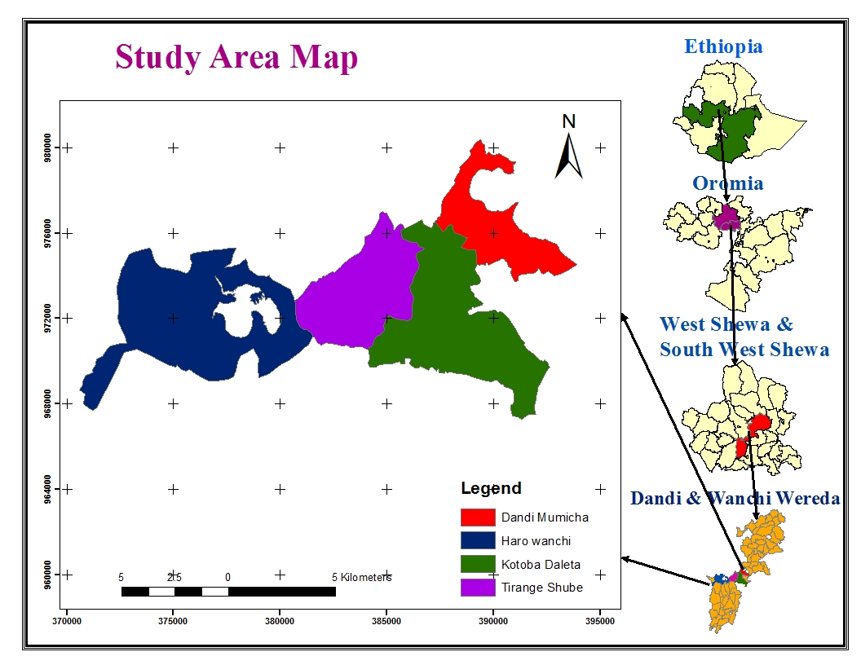
Source: own survey (2022)
3.2. Research Design
Research design is an activity plan based on the research objective and it guides the selection of source and types of information, the design of this study was the case study approach. This approach has been adopted because it was aimed at uncovering the pros and cons of a specific situation in addition to making a detailed and intensive analysis of ‘that single case’ (Bryman, 2016) defines research design as arrangement of conditions for collecting and analyzing data in a manner that it aims to combine relevance of the research purpose with economy in procedures. Jiang and Wen, (2020) adjoins that research design is not related to any particular method of collecting data or any particular type of data. Any research design can, in principle, use any type of data collection method and can use either quantitative or qualitative data.

According to Wiley, (2021) qualitative research involves studies that do not attempt to quantify their results through statistical summary or analysis, qualitative studies typically involve interviews and observations without formal measurement, qualitative research was often used as a source of hypotheses for later testing in quantitative research and qualitative research involves Studies that make use of statistical analyses to obtain their findings. Key features of quantitative research include formal and systematic measurement and the use of statistics data. This qualitative study was used in this case study to analyze the effects of ecotourism investment in the house hold livelihood in Wenchi-Dendi Crater Lake.

Relevant and necessary data was needed for this article to reach at final conclusion and to answer the effects of ecotourism investment in the house hold livelihood in the case of Wenchi and Dendi Crater Lake. Therefore it employed a qualitative approach to collect the necessary and relevant data. The study was also needed to conduct the necessary and reliable information by reviewing the available documents and needed to make a link or connection between different variables contributing to the effects tourism sector that are planned in both lakes, so that direct observation, interviews, questionnaires as well as secondary types of data assess the tourism industry in Wenchi Dendi crater lake
3.3. Target population
Target population is classified as all the members of a given group to which the investigation was related ,Whereas the accessible population was looked at in terms of those elements in the target population within the reach of the researcher. Based on the recommendation of( Gorard, 2013) in defining the unit of analysis for study ,the target population for this study was 190 respondents comprising of Government workers living around Dendi Wenchi crater lake

  - Sampling size and sampling procedure
3.4.1. Sampling Procedure
The sampling plan describes the sampling units, sampling procedure and the sample size for the study .The sampling out line depicts the lists of all population units from which the specimen were chosen (Cresswell,2017).As indicated by Wang, (2015),sampling includes selecting given number of subjects from characterized population in order to represent the whole population .
3.4.2. Sample size
Sampling frame was list of all the units of the population of interest ,it is completed of every one or everything to be studied (Cress&well,2017).For any research ,the sample size of the study must be determine during its designing stage .However before determining the size of the sample that is needed to be drawn varied the population is with respect to the characteristics of interest ,and the smallest sub group with the sample for which estimates are needed in to consideration namely .How much sampling error can be tolerated ,population size ,how varied the population is with respect to the characteristics of interest and the smallest sub group with the sample for which estimates are needed (Lewis ,2015)Using the above methods as guideline ,Krejcie and Morgan approach was used to determine the sample size of population
n= (X²NP (1-p/ (d² (N-1) +X² P (1-P))
Where; N = the total population that were studied or population size
n=the required sample size
X=Z value (1.96) for 95%confedence level yield maximum
P=Population proportion (expressed as decimals assumed to be 0.5(50%)
D= Degree of accuracy (7%), expressed as proportion (0.07).it is the margin of error
Hence the sample size of the study was
S= (1.96*12,600*0.5(1-0.5)/ (0.07²*(12,600-1) +1.962*0.5(1-0.5) =190
The selected study sites have a total of 12,600 household heads, out of which 3960, from Dendi village, and 2495 households from Kotoba Delata, 2655 from Tirange Shube and 3490 from Haro Wenchi sites. By using the above formula, the sample size becomes 190 households. Accordingly the sample size was made from 190 HHs. The distributions of sample size across the four selected areas were proportionally selected based on their size of households. Accordingly 138 and 52 were taken from Dendi and Wenchi ecotourism sites respectively. As far as sampling technique is concerned first, the study area and the study sites are selected with cluster sampling technique purposively, while the sample households were identified using probability sampling technique, using simple random sampling technique.
Table1. Households sample design
No | Village name | Total household heads | Sample of value | %
1 | Dendi village | 3960 | 60 | 31
2 | Kotoba Delata | 2495 | 38 | 20
3 | Tirange shube | 2655 | 40 | 21
4 | Haro Wenchi | 3490 | 52 | 28
Total |  | 12600 | 190 | 100

3.5. Sample size determination
Based on the given formula, the sample size was determined. Finally total of 190 household were selected from each selected kebeles to get estimation about the study to represent the total households of the study Woreda. The sample was classified to each kebeles according to its populations of the members. The proportion were calculated according to Kothari (2004) are presented in table above.
P= n*P₁/N
Dendi Village =$\frac{190*3960}{12600}$= 60
Kotoba Dalata= $\frac{190*2495}{12600}$= 38
Tirange Shube= $\frac{190*2655}{12600}$= 40
Haro Wenchi= $\frac{190*3490}{12600}$= 52
Where P1-P4 represents the total number of household that are located or living between and around the two lakes.
Piloting of the instruments
The study first constructed the research instruments which were pre-tested first to make appropriate modifications before embarking on the main study. During piloting, the study familiarized itself with the nature of respondents and their expectations during the main study. The pilot study was carried out in Wenchi Dendi in two phases, two weeks apart. After the first pilot study, the data collection instruments were checked for errors and corrections can be made. The second phase was carried out to ensure that no more errors were left, whereby any other identified error was corrected before embarking on to the main study at Dendi Wenchi ecotourism investment project. Modifications were made on sampling procedure and research objectives as applicable.
3.6. Method of data collection
The data collection instrument that was used for this study was structured questionnaire developed by the researcher and observation. Structured questionnaire were distributed to the target population .The researcher book appointment with responded organization at least two days before visiting to administer questionnaire. The questionnaires were personally administered to the respondents. So as to have an in depth understanding of how each respondents articulate issues relating to the projects .Each respondents received the same set of questionnaire in exactly the same way and was completed and collected after period of two weeks ,secondary data was collected from published and non- published materials from internet ,journals ,past research papers and books this enhanced their ethical aspects of this research
3.7. Methods of Data Analysis
Based on the objectives of the study appropriate tools and methods of data analysis were used, such as descriptive statistics, binary logistic regression was used for this study; similarly the study of Ali et al., (2019) and Takele et al., (2018); used binary logistic regression for modeling the relationship between two or more variables in the effects of ecotourism investment on the house hold livelihood variables.
3.8. Descriptive analysis
Demographic and socio-economic conditions of sample households, physical and institutional factors in the study areas of the group farmers were analyze by using descriptive statistics like mean, standard deviations, percentage, t-test, and chi-square -test. The effects of ecotourism investment on the house hold livelihood was tested for statistical difference using chi-square (χ²) tests.
The t-test was used to test the significance of the mean value difference of continuous variables in the effects of ecotourism in the house hold livelihood in the ecotourism investment. Similarly, potential discrete (dummy) explanatory variables were tested using the chi-square (χ²) distribution. The statistical package STATA version 15 had employed to compute these statistical tools. This analysis would help to have clear picture about the sample and to draw some preliminary conclusions on the effects of ecotourism in the households’ livelihood in the case of Wenchi Dendi Crater Lake.
3.9. Econometric analysis.
3.9.1. Model Specification
a) The binary logit model
The main objectives of estimating econometric (or parametric) models in ecotourism investment survey are to calculate mean of the effects of ecotourism investment on the house hold livelihood and to allow inclusion of respondents’ socio-economic factors into investment functions. Such incorporation of individuals’ socio-economic variables into the tourism investment models helps the researcher to gain information on validity and reliability of the study and increases confidences in applications of results obtained from the effects of the ecotourism in empirical analysis. Haab and McConnell, (2002.);Haneman, (1984) developed the basic model to analyze dichotomous responses based on the random utility theory. The central theme of this theory is that individual knows his/her utility certainly; it has some components which are unobservable from the view of the researcher. As a result, the researcher can only make probability statement about respondent’s “yes” or “no” responses to the proposed scenario.

So, that, first I tested the effects of ecotourism investment on the house hold livelihood in the case of Wenchi Dendi Crater Lake. The binary coefficient of determination R² was used to analyze how well the sample regression line fits the data. Then, the F-Test was conducted to measure overall significance of the estimated regression. Thirdly Durbin Watson was developed to detect correlation in Least-Squares Regressions. If the value of R² was high but the variables were insignificant, then there was an autocorrelation problem. This was followed by the Unit Root Test to determine whether the variables were stationary or not. Next, the Co-integration test was carried out to form the long-run relationship among the variables (Engle F.R and Granger, 1987)
After the data collection, the research processed the data to eliminate un wanted and unusable data which was contradictory or ambiguous ,develop a code scheme by creating codes and scales from the responses , which has been summarized and analyzed. Data was analyzed using Statistical package for social science (SPSS version 15.0).All the questionnaires received were reference, and items in the questionnaires were coded to facilitate data entry after data cleaning which entailed checking for errors in entry ,descriptive statistics ,such as frequencies ,mean score and standard deviation percentage mean score was estimated for all the quantitative variable information was presented in the form of table .the qualitative data from the open ended questionnaire was analyzed using conceptual analysis and presented in prose .Inferential analysis of data was done using binary logistic regression , analysis was done using establish the relationship between the dependent and independent variables ,the binary regression model was chosen because it is useful in establishing the relative importance of independent variable to the dependent (cress well&Cresswwll,2017).Binary regression were used because it is the procedure that uses two or more independent variable to predict dependent .Since there are three independent variable in this study the binary regression model generally assumed the following equation.
Y=β₀ + β_{i}X_{i} + $£o$… … … … … … … … … … … … … … … … … …. … … (1)
Where y is the dependent variable with a value of 1 when the effects of ecotourism achieved by house hold livelihood and 0 otherwise, Xi is a vector of explanatory variables.
Binary Logistic distribution
Binary logistic distribution is also more preferable than others in the analysis of the dichotomous outcome variable, in that it is extremely flexible and easy to use the model from a mathematical point of view and results in meaningful interpretation (Gujarati, 2004). It is a maximum probability estimator that makes it possible to estimate the probability that an event occurs or not by predicting a binary dependent outcome from a set of observable independent or predictor variables.
Yi = β₀ + β₁X₁i + β₂X₂i … … … … + β_{n}X_{ni} + εi…………………………………. (2)
Let us consider a linear regression of the form;
Yi = the outcome variable predicted from the equation
Xi = a vector of explanatory variables representing household
β’s = a vector of regression coefficients to be estimated
εi = the error terms
Binary logistic regression presupposes a meaningful coding of variables. It is difficult to analyze a binary logistic coefficient if it is not coded meaningfully. The binomial regression analysis convention is to code the dependent class of interest as 1 and the other as 0.
Maximum Likelihood Estimation
Although the binary logistic regression model looks like a simple linear regression model, the underlying distribution was binomial and Δ and β parameters cannot be estimated in the same way as for simple linear regression. The coefficients are usually estimated in the Maximum Likelihood Model (Park and Hyeoun, 2013).The probability is that, based on observed values of independent variables, the values of the dependent variable are observed. Like every other likelihood, the probability varies from 0 to 1.The probability estimation of the dependent variable as applied by Gujarati,(2004)may be shown;
Prob (Yi = 1) = F (β′X_{i})………………………………………………………… (3)
Prob (Yi = 0) = 1 − F (β′X_{i})……………………………………………….…… (4)
Where:Yi =
1 if – the investment project benefits the household livelihood
0 if – Household did not benefited from ecotourism---------------------------------------4
The probability model involves regression of the conditional expectation of Y on X as
Given by:
E (Y|X|) = 1[F (BX)] + 0[1 − F (B􀁅X)] = 1(FBX) --------------------------------------------5
The output of the binary logistic regression model explains the probability that the output Variable (Y) would be changed when the independent variables(X) change. Thus, the positive logit coefficient tells us that the change in the independent variable (X) increases the probability (Y=1). A significant factor indicates that the positive effect is statistically significant. But the logit coefficient does not tell us how much percentage the probability of (Y=1) changing when the explanatory variable (X) changes by one unit. The binary logistic coefficient indicates the direction of the change, not the magnitude of the change. The magnitude of the effects would be estimated by calculating the marginal effect. According to Gujarati, (2004)
$\frac{∂E[Yi/Xj]}{∂}=F\left(β^{'}X\right)\left[1-F\left(β^{'}X\right)\right]$ ………………………………..……………… (5)
It indicates how much percent the probability of (Y=1) changes when the X covariates change by one unit.
3.9.2. Statistical tests of multi-co linearity problem
Before executing the econometric model, all the hypothesized explanatory variables were checked for the existence of multi-co linearity problem. The problem of multi co-linearity may arise due to a linear relationship among explanatory variables. Multi-co linearity problem might cause the estimated regression coefficients to have wrong signs, smaller t-ratios for many of the variables in the regression and high R² value. Besides, it causes large variance and standard error with a wide confidence interval. Hence, it is quite difficult to estimate accurately the effect of each variable (Gujarati, 1995, 2003). Different methods are often suggested to detect the existence of multi-co linearity problem. Among them, variance inflation factor (VIF) technique had employed in the study to detect the existence of multi-co linearity in continuous explanatory variables (Gujarati, 1995) According to Gujarati (1995), VIF (Xi) can be defined as
VIF (X_{i}) =
Where:
Is the binary correlation coefficients between X_{i} and other explanatory variables; Selected continuous explanatory variables, (X_{i}) was regressed on all other continuous explanatory variables, and the coefficient of determination () were constructed for each case. The larger the value of R_{i}² results in higher value of VIF (X_{i}) which causing higher co linearity between variables. For continuous variables, as a rule of thumb, values of VIF greater than 10, are often taken as a signal for the existence of multi-co-linearity problem in the model (if the value of R_{i}² is 1, it would result in higher VIF () and cause perfect multi co linearity between the variables) (Gujarati, 1995).

Table 2.Variable definitions and working hypothesis
Variable | Definition | Measurement | Expected sign
Demographic characteristic
age | Age of household  - | male ,female equivalent years | +
sex | Sex of household | Male/Female Dummy | -
Marital status | Marital status of Hhs heads | Category,  Single/married/divorce/ separation | +
Socio economic characteristics
education | Education of households | Category  (,9-12, college above) | +
Occupation | Occupation of household heads | Category,  Un employed ,Self employed, salaried /formal employment | +
Effects of investment activity
Annual income | total annual income per annum of household heads | Category, Birr | -
Stake holder collaboration | Assistance from enablers , | Category , number of stake holders involved in ecotourism sectors ,infrastructure developed | -
Environmental  education | Availability of learning forums  Enhanced community  Initiatives | Ordinal , Improved community attitude and  awareness towards  conservation, perception of households towards | +

CHAPTER FOUR

RESULTS AND DISCUSSION

4.1. Descriptive statistics
4.1.1 Effects of Ecotourism Investment Project
The effect of ecotourism investment project is very important in changing the economy of the house hold livelihood living around the lakes of Dendi and Wenchi. This part presents results and interpretations of the study. Both descriptive statistics and econometric analysis where employed to identify the relationship between explanatory variables and dependent variables. Binary logistic regression was used to investigate the effects of ecotourism investment project in sample of household heads.
4.1.1. General Characteristics of the Sample Households
The researcher targeted 190 respondents to fill the questionnaires .However; a total of 183 respondent are able to fill and return the questionnaires .This gives a response rate of 96 %which was within (Gorared,2013) who prescribed that significant response rate for statistics analysis must be 50%or more

Table 3 Ages, Gender, Marital Status and Educational Background of Respondents
Explanatory variables
Explanatory variables |  | No | Percent
Age | Below20years | 13 | 7.10
Age | 21-40years | 82 | 44.81
Age | 41-60years | 72 | 39.34
Age | Above60yeras | 16 | 8.74
Age | Total | 183 | 100
Gender | Male | 117 | 66
Gender | Female | 66 | 34
Gender | Total | 183 | 100
Marital status | Married | 151 | 82.6
Marital status | Single | 18 | 10
Marital status | Divorced | 13 | 7.4
Marital status | Total | 183 | 100
Education back ground | Primary | 23 | 12.5
Education back ground | Secondary | 75 | 41.
Education back ground | College | 54 | 29.5
Education back ground | University | 31 | 17
Education back ground | Total | 183 | 100
Jobs characteristics | Unemployed | 35 | 19.1
Jobs characteristics | Self employed | 27 | 14.75
Jobs characteristics | Salaried | 34 | 18.57
Jobs characteristics | Farmer | 87 | 47.5
Jobs characteristics | Total | 183 | 100
Source: Own field survey, (2022)
4.1.2. Gender, Age, Marital status and Educational background of the sample households
Gender:-The overall sample population is 183; from total sample size of populations 123 of them were male head households and the rest 59 were female head households. The majority of households ‘heads (77.6%) belong to the working age category between 21 to 41 years. About 22.4 percent of the respondents were of the dependent age category; both under 20 (5.3%) and above 64 years (17.1%). So, according to the collected data, majority of the households were within the adulthood age category, which could play a great role in the decision making about the effects of ecotourism investment in the house hold livelihood in the case of Wenchi crater lake, moreover it is easy to convince the working class to do or not to do anything, because they do have the ability to understand things easily.
Marital status: - As it can be seen from the above table, the large majority of heads of households (82.6%) of the participant were married. In contrast, the percentage of sample households who have been married but either divorced or widowed is (7.4 %), while 10% of the participants are single. This implies that these local peoples are not prostituted.
Education of respondents:- From the sample of house hold about 12.5% of the respondents attends primary education, 41%attends secondary education, 29.5 attends colleges and 17 percents of the respondents were attended university this shows that this group of education category well distinguish about the advantages of ecotourism and how to benefit from tourism environments. Knowledge in general and environment related knowledge in particular, is considered as a prerequisite to environmental concern (Harris et al., 2002). As the public becomes increasingly aware of environmental protection, studies have found the crucial importance of environmental knowledge. For instance, community leader’s environmental knowledge positively correlates with their attitudes towards conservation (Harris et al., 2002); Support for wildlife and natural resources conservation is proportional to their knowledge about wildlife. Even though the respondents are not trained in the area of ecotourism environment directly or indirectly, they had the exposure to such kinds of knowledge. This investment project can be easily identified by this community. This implies that this community knows how to benefit from investment project constructed around Dendi Wenchi Crater Lake and developed on the area. But it does not mean that education and age is the only criteria to benefit the society.
Occupation of the respondents: - from 183 respondents 87 (47.5%) were farmers and 35(19.1%) became unemployment; this indicates that the farmer can be obtained deferent technology as well as adoption of technologies from investment. The unemployment rate becomes decreased by obtaining job from this tourism investment; job opportunity has been created for many people around there, so that market linkage and tourism products are the source of market product.
Table 4.Ecotourism investment creates employment opportunity
Employment opportunity | Freq. | Percent | Cum.
Strongly agree | 72 | 39.34 | 39.34
Agree | 82 | 44.81 | 84.15
Average | 29 | 15.85 | 100.00
Total | 183 | 100.00
Source: Own field survey (2022)
About 44% of the respondents agreed that Ecotourism creates Employment opportunity, 39.34% strongly agree while 15.85% of the sample population averagely agreed .Generally most of the house hold living around Wenchi Dendi Crater Lake become unemployment .so that; the investment of ecotourism creates employment opportunity for them.
4.1.3. Income from ecotourism
The interrogation on income helped to indicate the proportion of respondents benefiting from ecotourism and its significance in benefiting the house hold livelihood. Income is one of the socio-economic variables that benefit the house hold livelihood, living around Wenchi Dendi Crater Lake. The income from tourism project has been widely debated over a long period and the solution remains clear. However, a large number of outdoor recreation studies have found that low-income earners are more sensitive to price changes than high-income earners (Mamat et al. 2013). In the same way (Salleh et al. 2016) in their studies, the effects of socio-demographic characteristics and the perceived benefits of tourism on the local house hold in tourism indicated that the level of income of the respondents was important determinants in the house hold livelihood in the tourism sector. On the other hand, the presence of ecotourism will improve the average annual income of the house hold livelihood.

According to Debayan, (2008) it has been shown that there was strong evidence that ecotourism increases the local's ability to generate more income to support their families and to increase the opportunities to receive gifts or donations from tourists. It can therefore be expected that ecotourism investment have been advantageous on the house hold livelihood in Dendi Wenchi Crater Lake. Grimier and Limber, (1997) reiterated that rural people deserve access to the resources required to meet their basic needs for economic safety and, where possible for improving living standards. The use of income by respondents varied from feeding their families, paying school fees for their children, tour guides, fishing and renting horses and investing in businesses like Conservation programmers.

Therefore are only valid and sustainable when they have the dual objective of protecting and improving local livelihoods and ecological conditions. This is where eco-tourism approach is becoming increasingly popular in revenue generation and sharing amongst the people living around Wenchi Dendi in contributing to ecological preservation. Essentially, these projects use funds generated to “buy” support for conservation from local residents. Evidently, the income is being ploughed back to the local economy and has improved the standard of living in the community. There is however a feeling that the skill set of the community be improved to enable them engages in more superior ecotourism ventures like running tour firms and travel agencies.
Table 5. What potential attraction areas of tourism are there for generating income?
Potential areas for generating income | Freq. | Percent | Cum.
Religious | 45 | 24.59 | 24.59
Cultural treats | 30 | 16.39 | 40.98
Bio diversity | 50 | 27.32 | 68.31
All | 58 | 31.69 | 100.00
Total | 183 | 100.00
Source: field survey (2022)
Table 4.9 shows that, the presence of the potential areas for tourism in general and ecotourism sites in particular in the study area. The area is full of both natural and cultural resources like hot spring, the religious site of old monastery of chirkos with an impressive geographic location and full of ancient materials and other materials, and other historical as well as topographic structures that have the potential of attracting tourists are found in that locality. About 32 % of the respondents acknowledged their locality for its wide variety of ecotourism sites with religious sites, cultural traits and natural aspects (biodiversity).While 25 % of the respondents indicated religious site 30 %, while 27% bio diversity and 16 % of the respondent indicated Cultural treats.
From this the attraction areas of this ecotourism village bio diversity ,cultural treats, religious site and all of this makes this tourism site beautiful and attractive sites and make competitive

4.1.4. Actual ecotourism potentiality of the area
Wenchi Dendi ecotourism project investment has endowed with binary natural, cultural and religious resources suitable for nature and culture based ecotourism developments. The numerous potential ecotourism resources in the woredas have the opportunity to be developed into ecotourism products (DWWTO, 2021).
4.1.4.1. Natural resources
4.1.4.2. Scenery (landscape and cave)
Wenchi relief was made up of huge mountains, extensive plateaus, deep valleys and gorges, plains, fascinating cliffs and the like ((DWWTO, 2021). According to the key informants and the woreda tourism administrator the topography of the area and amazing peaks like insets, small trees and bushes that were covered can be attractive sites for tourists. These magnificent peaks also serve as a natural watching tower for tourists. Along the Wenchi river there is also a hot springs from ground as wells from rocks. The major cultural ecotourism resources of Dendi and Wenchi Woredas include lifestyle of the local community, religious sites, distinctive cultural patterns, local arts and, cultural festivals, etc. There are distinctive local cultures that are practiced by people living around Wenchi. Even though it needs further and detail investigation, the cultural activities and cultural products. Wedding ceremony, local music and dances, locally produced etc can be good tourist attraction resources (ORTOB, 2010). Local communities can, therefore, earn income by demonstrating cultural activities.
Table 6.Have you benefited from tourism in your crater lake?
Benefit from crater lake | Freq. | Percent | Cum.
Yes | 51 | 27.87 | 27.87
No | 132 | 72.13 | 100
Total | 183 | 100.00
Source: field survey (2022)
As shown from table 4.9 about 72 % of the respondents are not benefited from their crater lake this tourism sites were from the questionnaire of Dendi Crater Lake but about 51% of the respondent are benefited from wenchi Crater Lake
Improves standard of living | Freq. | Percent | Cum.
Very great extent | 68 | 37.16 | 37.16
Great extent | 91 | 49.73 | 86.89
Moderate extent | 24 | 13.11 | 100.00
Total | 183 | 100.00
Source: field survey 2022
About 49.73% respondents indicated that ecotourism investment activity on both lakes improves standard of living 37.16% of respondent agreed in great extent, 13.11% moderately knows the improvement of ecotourism against living standards of the local people.
Table7. Assistance from enables
Assistance from enables | Freq. | Percent | Cum.
Very great extent | 90 | 49.18 | 49.18
Great extent | 66 | 36.07 | 85.25
Moderate extent | 27 | 14.75 | 100.00
Moderate extent | 27 | 100.00
Total | 183 | 100.00
Source: field survey, (2022)
From table 4.7 above 49.18 respondents’ indicated that assistance from enablers are needed , 36.07 %of the respondents indicated in great extent and 14.75 in moderate extents enabler had been aids deferent local people as well as protect the environment which is very important to help investment. Deferent NGOs assist this tourism to be more effective. The government and the people lonely did not accomplish deferent projects so that enablers have to be involved in the effects of ecotourism projects in the house hold livelihood in the case of Wenchi Dendi Crater Lake
Organizations would have many stakeholders, each with distinct types and levels of involvement, and often with diverse and sometimes conflicting interests and concerns. Stakeholder official definition in business according to the International Finance Corporation Stakeholders are persons or groups who are directly or indirectly affected by a project, as well as those who may have interests in a project and/or the ability to influence its outcome, either positively or negatively. Stakeholders may include locally affected communities or individuals and their formal and informal representatives, national or local government authorities, politicians, religious leaders, civil society organizations and groups with special interests, the academic community, or other businesses, the stakeholders that each of these different individuals or groups has in a project or investment will vary. For example, there may be people directly affected by the potential environmental or social impacts of a project. Others may be resident in another country altogether, but wish to communicate their concerns or suggestions to the project company. Then there are those who might have great influence over the project, such as government regulators, political or religious leaders, and others active in the local community. There are also stakeholders who, because of their knowledge or stature, can contribute positively to the project, for example, by acting as an honest broker in mediating relationships.

Table8. Community satisfaction
Community satisfaction | Freq. | Percent | Cum.
Very great extent | 63 | 34.43 | 34.43
Great extent | 47 | 25.68 | 60.11
Moderate extent | 54 | 29.51 | 89.62
Low extent | 19 | 10.38 | 100.00
Total | 183 | 100.00
Source: field survey of (2022)
The people living around Lake Dendi and Wenchi feel very happy so that 34.43% of the respondent indicated in very great extent , 25.68% indicated great extent, 29.51% in great extent 10.38%of the respondents satisfactions were in low extent .The majority of the people became satisfied with this ecotourism investment and less percent of respondents are not satisfied
Table9. Effects of environmental education on the household livelihood
Educating environment | Freq. | Percent | Cum.
Government | 77 | 42.08 | 42.08
Non- government | 27 | 14.75 | 56.83
Others | 79 | 43.17 | 100.00
Total | 183 | 100.00
Source: field survey (2022)
This section addressed the respondents’ views on objective three on effects of ecotourism on environmental education. It looked at the various learning forums that ecotourism used to convey environmental education and consequent effects from key identified initiatives that complemented ecotourism drive in the community. Accordingly as indicated in the above table 42.08% of environmental education is given by government, 14.75 was given by Nan government and 43.17 had given by other institutions.
Table .10 has ecotourism are helpful to the environment.
Has ecotourism helpful to environment | Freq | Percent | Cum.
Yes | 141 | 77.05 | 77.05
No | 42 | 22.95 | 100.00
Total | 183 | 100.00
Source: field survey (2022)
About 77.05% of the respondents know very well about the advantage of ecotourism investment and 22.95 say no, because this tourism area yet not interested and gives any kinds of benefit for the local people for this reason the local people does not responded the advantages of tourism in Dendi crater lake area
Table .11 Times of workshops to conserve the environment
Times of work shop to conserve the environment | Freq. | Percent | Cum.
Two | 104 | 56.83 | 56.83
Three | 79 | 43.17 | 100.00
Total | 183 | 100.00
As observed from table above from 183 respondents 56.83 seminar or workshops had been given two times for the local people to conserve the environment, while 43.17respondents indicated three times of workshops had given for the local people.

Table 12. Methods to get education how to conserve the environment
Methods to get education | Freq. | Percent | Cum.
Brochure | 23 | 12.57 | 12.57
Media | 71 | 38.80 | 51.37
General assembly | 89 | 48.63 | 100.00
Total | 183 | 100.00
Source: field survey 2022
Methods to get education, 48.63 %, says the methods to get education through general assembly by government, other stake holders and non-government institution 38.80% of the respondent says the methods to get education was through media and about 12.57% of the respondents responded through brochure. Generally most of training has been giving for the people living around Wenchi and Dendi Crater Lake through Medias and general assembly by deferent stake holders. Since the area of this eco- tourism sites are hilly sides, plateau and valley it needs soil conservation and environmental protection to protect the area from land slide and other environmental damage by tourists.
4.6. Result of Econometric Model
Testing of model Assumption
Goodness-of-fit test
Goodness-of-fit is a statistical hypothesis test used to see how closely observed data mirrors expected data. Goodness-of-fit tests can help determine if a sample follows a normal distribution, if categorical variables are related, or if random samples are from the same distribution. Goodness fit table contains the χ²-test which is useful for determining whether a model exhibits a good fit to the data of the effects of ecotourism investment project on the house hold livelihood. Finally, Model goodness of fit test (Gof) was also employed to test the model robust enough to explain the dependent variable. This was evidenced by the fact that the model was tested using prob > chi2 which found to be 0.55 which lies between 0 and 1 (table4.12). The result confirms that the explanatory variables of the model could explain the dependent variable. So we can conclude that the models were correctly fitted.
Model specification (Link test)
Link test was employed to test the model specification error. The null hypothesis is that there is no specification error. If the p value of hats is not significant so we fail to reject the null hypothesis and conclude that our model is correctly specified or this model has not specification problem. Here the p value of hat sq for this model is 0.609.
Collinearity.
The pair wise correlation tests employed in order to test the existence of a correlation between independent variables. According to (Stock and Watson, 2007), the correlation coefficient range between +1 and -1 are considered as a critical point to indicate a serious co linearity. So, for this study, the largest correlation coefficient independent variables is potential areas for generating income for benefiting the house hold livelihood 0.1729 (see appendix. 5)
Heteroskedasticity : A large chi-square would indicate that heteroskedasticity was present. In this chi-square value was 9.13, indicating heteroskedasticity was probably not a problem (or at least that if it was a problem, it wasn’t a multiplicative function of the predicted values)

4.7. The effects of ecotourism investment on the house hold livelihood
The effects of ecotourism investment were examined using the binary logit model. The log likelihood estimation of -92.896581and the chi-squared value of 47.17showed that the likelihood ratio statistics are highly significant (P < 0.05) suggesting the model is good-fit and has a strong explanatory power. Results of the binary logistic analysis revealed that the effects of ecotourism investment on the house hold livelihood influenced by several variables. The variables found to have a significant influence include sex of the household heads, marital status of the household, education level of households, Household occupation, and income of house hold, environmental education, and assistance from enablers. The detail of the model result and interpretation discussed as follows.
.
Table14. Binary logistic simulation results of the effects of ecotourism
Binary Logistic regression |  |  |  |  | Number of obs =183
 |  |  |  |  | LR chi2(16) =47.17
 |  |  |  |  | Prob > chi² =0.0001
Log likelihood = -92.896581 |  |  |  |  | Pseudo R2 =0.2025
Effects of ecotourism | Coef. |  | Odds Ratio |  | Std. Err. |  | Z |  | P>z | [95% Conf.  Interval] |  | Marginal effects (dy/dx)
Age | .5093656 | 1.664235 |  | .4231213 |  | 2.00 |  | 0.045** |  | 1.011118 | 2.739223 | 5.825974
Sex | -.9440257 | .3890585 |  | .1508936 |  | -2.43 |  | 0.015** |  | .1819208 | .8320461 | 0.2057617
marital status | .1667259 | 1.18143 |  | .3716386 |  | 0.53 |  | 0.596 |  | .6377471 | 2.188607 | .2.733727
education | .4409175 | 1.554133 |  | .3366457 |  | 2.04 |  | 0.042** |  | 1.016498 | 2.376127 | 4.50666
occupation | .0362814 | 1.036948 |  | .164032 |  | 0.23 |  | 0.819 |  | .7605144 | 1.413859 | 4.288278
Employment opportunity | -.6853946 | .5038913 |  | .1380222 |  | -2.50 |  | 0.012** |  | .2945656 | .8619693 | .2088952
Income generation | -.8926414 | .4095725 |  | .1630052 |  | -2.24 |  | 0.025** |  | .1877423 | .8935097 | .3517222
Potential areas for generating income | .4057926 | 1.500491 |  | .2477384 |  | 2.46 |  | 0.014** |  | 1.085665 | 2.07382 | 4.288278
Benefit from crater lake | -1.019804 | .3606657 |  | .1597267 |  | -2.30 |  | 0.021** |  | .1514036 | .8591587 | .305535
Improve standard of living | .1642812 | 1.178546 |  | .3398412 |  | 0.57 |  | 0.569 |  | .6697258 | 2.073938 | .6507219
Assistance from enablers | -.7387815 | .4776956 |  | .1300209 |  | -2.71 |  | 0.007** |  | .2802 | .8143937 | .194424
community satisfaction | .1434011 | 1.154193 |  | .2211846 |  | 0.75 |  | 0.454 |  | .7927891 | 1.680347 | 4.390808
Educating environment | .512652 | 1.669713 |  | .3493818 |  | 2.45 |  | 0.014** |  | 1.107978 | 2.516245 | 2.949736
Has ecotourism helpful to the environment | .6142398 | 1.848251 |  | .864962 |  | 1.31 |  | 0.189 |  | .7385971 | 4.625027 | 1.770392
Times of work shop to conserve the environment | .9172091 | 2.502297 |  | .9863799 |  | 2.33 |  | 0.020** |  | 1.15559 | 5.418434 | 3.707053
Methods to get education | .2321386 | 1.261295 |  | .3420443 |  | 0.86 |  | 0.392 |  | .7412817 | 2.146099 | 1.800984
_cons | -.2678991 | .7649849 |  | 1.662751 |  | -0.12 |  | 0.902 |  | .010802 | 54.17542
Source: STATA outputs (2022
Age: - The result of the binary logistic regression model shows that, the age of respondents was significant at 5 percent level of significance and had positive relationship with the effects of ecotourism on the household’s livelihood. If all other variables kept constant, as the odds ratio result showed that the age of household’s on the effects of ecotourism were increased by 1.6 times more likely to participate effectively in ecotourism. Age from 21-40 years and above is very important in benefiting from eco-tourism investment, younger age can be benefited than older age households, See appendix 8. The result implies that the younger households are more benefited as well as participated in tourism investment. This might be due to that younger people tend to be particularly attracted to the natural, historical and cultural activities of ecotourism spots. This is why younger people are thought to participate in ecotourism activities and have a strong relationship with international visitors in the area, and as consequence, age is believed to a factor to participate since most of the activities are labor-intensive. This result harmony with the finding of Mugizi et al. (2017) revealed that the likelihood of age determine the effects of ecotourism investment influencing households’ participation in tourism activities in the age group categories of 21-40. So this study was Similarly, Mugizi et al, (2017,) Nguyen, (2018) show that age had statistically significant effects on the effects on ecotourism activities as predicted.

Sex: - The variable female was also found to be significant at a 5 percent level of a significant and male variable negative relationship in the effects of eco-tourism. The negative coefficient and the odds ratio showed that male-headed households were decreased by 0.389 times less likely to effective than female headed households. As a result of marginal effects as shown in appendix 8 that female house households were more likely to benefit in ecotourism than their male counterparts, so that participation of women is important in effectiveness of house hold livelihood. This is because of that, the social norms, the majority of women in the study area spend a large part of their time in housekeeping tasks and on various responsibilities such as childcare, fetching water, and cooking food. The study is consistent with Safari et al. (2015)on their study entitled "Involvement in Tourism Activities and Perceived Benefits in Communities around Udzungwa Mountain National Park in Tanzania," more men than women were being engaged in tourism-related activities.

Likewise, Ishmael, (2015) also said that the variable sex and community participation to be benefited in ecotourism have a significant relationship. The author Hosmer and Lemeshow Test goodness of fit=2.43(p=0.015) noted that males tended to be more involved in tourism development than their female counterparts. The effect of access to training was positively associated with the likelihood of participation in the outcome and benefit from ecotourism in the study area as expected. The positive Marginal effects and odd ratio indicate that eco- tourism investment improved the house hold livelihood of the local people. This means that the higher participation for the household who had access to training compared to the house hold livelihood does not have access to training. This is because of less information dissemination in regarding to ecotourism benefits. Each type of training fills the gap of the decision-making ability of households basically for participating and had obtained benefits in the tourism sector. This finding is also similar to the result of Ndzifon et al. (2019) on entitled Households Assets Dynamics and Ecotourism Choices in the Western Highlands of Cameroon”: proved that a large proportion of respondents who participated in training know the advantage and incomes from ecotourism investment preferred to participate in ecotourism to diversify their assets. Similarly Israr etal ,(2009) found that access to be relevant to the staff needs, improve the performance, and create a difference in the ecotourism work and to solve the organization problem on their study entitled of “Role of Host Community in Promotion of Eco-Tourism in the Northern Areas of Pakistan found that”.

Education is statistically significant at 5 percent and positively associated with in ecotourism ,as the model of marginal effects showed in appendix 8 secondary education and colleges skilled man power is quickly accept and participate in ecotourism investment, so this skill and un skilled man power determine the effectives of eco-tourism investment on the house hold livelihood. So unskilled person can only involve by labor work and also did not accept technologies as compared to educating person the level of education is the one that determine the effects of ecotourism investment project on the house hold livelihood. In the literature, the term environmental education (EE) began to be used in the 1960s as an effort “to produce citizens who are knowledgeable about the biophysical environment and its problems, aware of strategies that can be used to deal with those problems, and actively engaged in working toward their solution” (Stapp et al., 1969; cited in Fishman, 2005, p.39). A few years later, The United Nations Education Scientific and Cultural Organization (UNESCO) and United Nations Environment Program (UNEP) announced three major declarations that structured the objectives of environmental education courses.

Employment opportunity: - The variable employment opportunity was also found to be significant at a 5 percent level of a significant with 0.022 and less likely agreed with few respondents as indicated in appendix 8,with the effects of eco tourism investment on the house hold livelihood was averagely agreed. The employed person or government workers had less likely relates with the effects of ecotourism on the household’s livelihood. If all other variables kept constant, as the odds ratio result showed that the hired population did not participate from investment income from tourism ,because jobless people or unemployment person can only seeks job from tourism investment as observed from table 4.14 above and appendix 8 .The results of employment opportunity of odds ratio was decreased by 0.503 ,if the people have had their own job they cannot be benefited directly from tourism, in other word job opportunity was needed for effective utilization from ecotourism as cited by (Kerr et al. 2016); (OECD 2016c); (World Bank Group and International Monetary Fund ,2016). Money and enough income was a source of start-up for small businesses in the study area, such as selling tourism products renting horses, boat, lodges, and honey rearing; to do so when households had enough money to be more involved in the ecotourism destination. This outcome is supported by the result of Nguyen, (2018). The result also confirms the finding from China by Wei et al. (2012) on their study of Drivers and Socioeconomic Impacts of Tourism Participation in Protected areas.

Generating income is another important variable and the model revealed that this variable was statistically significant at 5 percent level of a significant with 0.024 p value. The negative sign of coefficient and odd ratio shows that as the household annual income generating increased by 0.409.This ecotourism less likely benefit the local people. Wydick , (2018) develops a model indicating when cash transfers are likely to significantly and sustainably increase the income of recipients. In the previous year wenchi Crater Lake benefits the house hold livelihood, by renting deferent horses, boats and other tourism products, but Dendi crater lake did not benefits throughout.

Potential areas for generating income: - was positively significant at 5% level of significant, with 0.022of biodiversity, religious site, cultural treats and all of this are the effects in eco-tourism as pointed in marginal effects on the house hold livelihood from the center of Wenchi Crater Lake or “Chirkos monastery”, bio diversity and landscape, cultural treats and deferent areas were the main sources of tourism development which benefits the house hold livelihood. The availability of eco tourism potential is very important for the effectiveness of tourism areas.

Benefit from Crater Lake: The variable benefit from Crater Lake was also found to be significant at a 5 percent level of a significant and negatively relate with the effects of ecotourism investment on the house hold livelihood in Wenchi Dendi Crater Lake. The negative coefficient and the odds ratio showed that Dendi Crater Lake was decreased by 0.360 times less likely to benefit the environment than Wenchi crater. This implies that both lakes cannot benefits the house hold livelihood. (See appendix 8 )
Assistance from enablers: - The result of the binary logistic regression model shows that, assistance from enablers was significant at 5 percent level of significance with 0.033and 0.016 p value and had positive relationship with the effects of ecotourism investment on the household’s livelihood as indicated from 183 respondents more of respondent indicated within great and moderate extent. If all other variables kept constant, as the odds ratio results showed that assistance from enablers of household’s on the effects of ecotourism was increased by 0.477. The ecotourism investment project needs enablers to be more profitable, like NGOs government funding, deferent institutions. Enablers who investing deferent lodges, sport activity, hotels and other deferent infrastructures for the development. As mentioned before there is no any benefits obtained from Dendi Crater lake because assistance from enablers become nil for a long period of time. But in wenchi there are deferent enablers e.g., ZTE Ethiopia aids for years and deferent lodges, infrastructure and hotel are there and tourism activities are good there. Wiederspan et al, (2015) argue that a negative income tax can help fill the gaps in current federal means-tested assistance programs.

Educating the environment: - The result of the binary logistic regression model shows that, educating the environment was significant at 5 percent level of significance and had positive relationship with the effects of ecotourism on the household’s livelihood. If all other variables kept constant, as the odds ratio and marginal effects 1.66 result showed, educating how to conserve the environment was more likely increased by 1.6 times more likely to benefit ecotourism on the household .The other variable of the effects of ecotourism investment was educating the environment this variable was statistically significant at 5% because the p value of the variable 0.014 and 0.022 from marginal effects is<0.05 This is also very important point in that during ecotourism investment activity. Tourism arrived can be deteriorate the environment by deferent mechanisms, managing the local forest, planting trees protecting land degradation occurred duet to ecotourism development project. Keeping the bio diversity of the indigenous ecology of fauna and flora has been surviving for the next generation. Korhonen & Lappalainen, (2004) and air pollution in studies in Israel (Negev et al. 2008) and in Malaysia (Said, Yahaya, Ahmadun, 2007 similarly, when examining Chinese students’ awareness of global problems and local problems, Duan and Fortner (2005 p.30) say “It is reasonable that people would be determined that an issue is real if they can see or smell it.

Times of workshops given to conserve the environment:-were positively and statistically significant at 5 percent level of significance and had positive relationship with the effects of ecotourism on the household’s livelihood. If all other variables kept constant, as the odds ratio and marginal effects showed that times of workshops given to house hold on the effects of ecotourism was 2.33 more likely to obtain education how to conserve the environment effectively. The result implies that training the local people to conserve the environment is very important point. This indicates that to be effectively benefiting the house hold livelihood conservation of natural resource through educating local people and tourists are the best

CHAPTER FIVE

CONCLUSION AND RECOMMENDATION

5.1. Conclusion
In this thesis, deferent data were obtained from households, governmental organization. Through, interviews, questionnaires and focus group discussion. According to these, the following main findings were found in the effects of ecotourism investment in the house hold livelihood in the case of Wenchi Dendi Crater Lake. There for the following conclusion has been made. The area is found to be rich in bio diversity , cultural as well as historical heritage and lakes that attracts different tourists ,but due to various factors the indigenous house hold is not benefited from crater lake .The study area was found to be gifted with various tourist sites that could be developed in to viable community and government base tourism products. This tourism would range from cultural activities to natural attraction to other recreational sites which creates deferent opportunities. The peoples are not aware how to conserve natural resources and protect the environment.

In synthesizing ,the findings of the study shows that the presence of abundant ,both natural and manmade tourist attracting sites ,but the people living these area are not benefited from there for a long period of time. There are no ecotourism activities under taking in Dendi Wenchi Crater Lakes. Similarly the results of this study identified and discussed the fact that this ecotourism investment projects is very important and have huge effect on the house hold livelihood for the future. As shown from the study about 49% of respondents indicated assistance from enablers is needed to invest the area. The people can also satisfied with the ecotourism investment activity, about 34% of the respondents satisfied in a very great extent within the investment activity. There are also huge potential attraction areas of ecotourism sites which benefit the local people these are, landscape, falls, hot springs, religious sites and village living inside the lakes.
5.2. Recommendation
Based on the major finding of the study and conclusion drawn with the effects of ecotourism investment on the house hold livelihood in the case of Wenchi Dendi craterlike, the following recommendations are suggested.
- As the majority of the people supported the idea of effectiveness of investment activity(table 4.6) it will be un complicated to introduce and develop the issue. So this ecotourism will have broad based and will be fruitful easily. Hence stake holders like NGOs, Private sectors and other institutions should have formal work and relationships with government.
- The study sought to exposure effects of ecotourism initiatives on improving the livelihoods of the local community around Wenchi Dendi Crater Lake. The potential attraction sites has immense potential in up lifting the lives of the house hold livelihood in the area .so that tourism potential attraction areas should be conserved as well as developed to insure the effects of eco-tourism. The community are increasingly support this investment projects that benefit their house hold livelihood.
- The findings of this study revealed that the average age group of the house hold livelihood of this study revealed that the average age group of residents of ecotourism in Wenchi Dendi crater lake is 21-41 years old ,Which reflects youth full community which can be trained on matters of the industry for employment and entrepreneurships These groups are very young and energetic and can engage in ecotourism initiatives if only community members can be fully involved in ecotourism investment .
- Since there was no awareness creation was given for the local community for participation for the development of ecotourism project, the government should create awareness and should put decision how to benefit the local people and change the house hold livelihood.

References
Akan and Kuvan,(2005).Indicated that many rural communities have acquired tourism as a new economic development strategy to alleviate the economic difficulties.

Among other variants was ecotourism based on the premise that environmental sustainability and welfare of the local community was a prerequisite (Fennell, 2020; Han et al; 2018).

Coghlan, A., (2012).Linking natural resource management to tourist satisfaction: a study of Australia Great Barrier Reef. - Journal of Sustainable Tourism 20: 41-58.

Cress well, (2017). As indicated by Wang, (2015), sampling includes selecting given number of subjects from characterized population in order to represent the whole population.

Carencro et al, (2020).Has acknowledged that the growth of tourism has brought different effects to the local community, which benefits from job opportunities and enhanced cultural understanding, prosperity, and well-being effects are more broadly defined, and may include a variety of socioeconomic, cultural and environmental costs and benefits. As under the industry approach, economic effects in terms of employment and income generation are important (Nallathiga and Paravastu, 2006).

Frederica, (2018).Wander S. Ecotourism and economic incentives: Ecol Econ. 2000; 32(3):465-79.Stronza A. Because it is ours: ecotourism investment in the Peruvian Amazon. Gainesville: University of Florida. 2000.

Haab and McConnell, (2002.Haneman, (1984) developed the basic model to analyze dichotomous responses based on the random utility theory

Han, H, Hsu, L.T. J., Lee, J.-S., Sheu, C. (2011) and (Fennell, 2020; Han et al; 2018).Are Lodging Customers Ready to Go Green? An Examination of Attitudes, Demographics, and Eco-friendly Intentions- International Journal of Hospitality Management 30(2): 345-355

Its Blue-colored water is very attractive to visit. This lake, is 1,600 square meters in total area, is ecologically, recreationally, and aesthetically important as well as a popular place for tourists (Lakew and Mitiku, 2008

Job opportunity was needed for effective utilization from ecotourism as cited by (Kerr et al. 2016); (OECD 2016c); (World Bank Group and International Monetary Fund, 2016).

Kuvan and Akan,(2005).Indicated that many rural communities have acquired tourism as a new economic development strategy to alleviate the economic difficulties.

Keeping the bio diversity of the indigenous ecology of fauna and flora has been surviving for the next generation. Korhonen & Lappalainen, (2004) and air pollution in studies in Israel (Negev et al. 2008) and in Malaysia (Said, Yahaya, Ahmadun, 2007

Malairajan S., Lakew W. and Mitiku T. (PhD), (2008).Water quality of Wenchi Crater Lake In Ethiopia, Maejo International; Journal of Science and Technology.

Khan, 1997b, Belsk,(2018). Report to the Attorney General of the State of Alaska University of California, San Diego. Choe, K, D Whittington and D.T. Laura, (1996), “The economic benefit of surface water quality improvements in developing Countries”: a case study of Davao, Philippines Land Economics 72(3):519-527.

Merg,(1999). argued that ecotourism is coming with binary negative effects on the social, political and environmental set up even though it offers practical solutions to economic growth of developing countries

Ndzifon et al. (2019).On entitled Households Assets Dynamics and Ecotourism Choices in the Western Highlands of Cameroon”:
Norlida et al.(2012). Has identified that the advancement of the tourism industry has resulted in an increase in indigenous incomes

Stapp et al., 1969; (cited in Fishman, 2005, p.39). A few years later, The United Nations Education Scientific and Cultural Organization (UNESCO) and United Nations Environment Program (UNEP) announced three major declarations that structured the objectives of environmental education courses.

Sewnet, (2017).“Valuing the benefits of improved lake quality: Application of Choice experiment, the case of Awassa Lake, Ethiopia;Msc ,thesis Addis Ababa University.

Safari et al. (2015).On their study entitled "Involvement in Tourism Activities and Perceived Benefits in Communities around Udzungwa Mountain National Park in Tanzania," more men than women were being engaged in tourism-related activities.

Sustainable Livelihood Approach (SLA) (IFAD, 2007b); the Social-Ecology System (SES) (Simon seen, 2018); Political Ecology Natural Resources Management (NRM) approach and the Social Capital Theory (Coleman, 2018; Putnam, 2020; Porte’s and Sandlot 1996; Porte’s 1998)

Salleh et al. (2016) in their studies, the effects of socio-demographic characteristics and the perceived benefits of tourism on the local house hold in tourism indicated that the level of income of the respondents was important determinants

The 24th general assembly in Spain Madrid from 170 tourism village selected Wenchi Lake is selected as the best tourism village in the world (UNWTO, 2021).

The ecotourism industry is complex because of its nature and dynamics between its stakeholders (Buckley, 2019; hassell et al, 2015).

WTTC,(2018).Capital returns from soil-conservation practices, Journal of Farm Economics, 29, 1181-1196; Culture and tourism office, 2011, South- West Shoa ZoneWoliso.

Wydick,(2018). Develops a model indicating when cash transfers are likely to significantly and sustainably increase the income of recipients.

Wiederspan et al,(2015). Argue that a negative income tax can help fill the gaps in current federal means-tested assistance programs.

Wood, M. E.(2015).Ashley and Garland,(1999) cited in Fennell ,(2015) observe that community participation in resource management for tourism has the potential capacity of increasing income and employment, and of developing skills and institutions for empowering local people for more effectiveness .

Appendix 1 picture of ecotourism attraction areas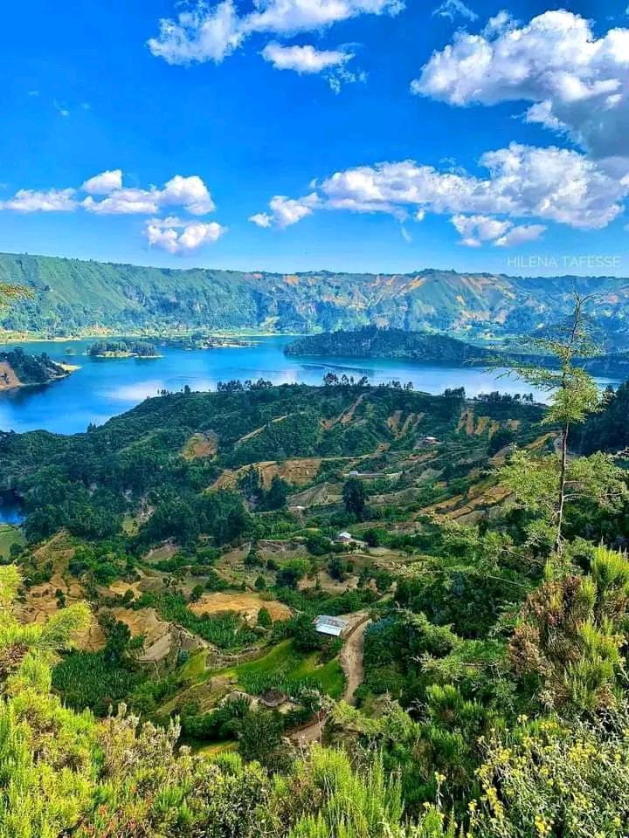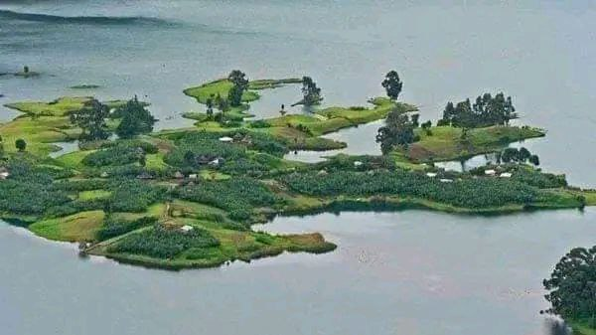

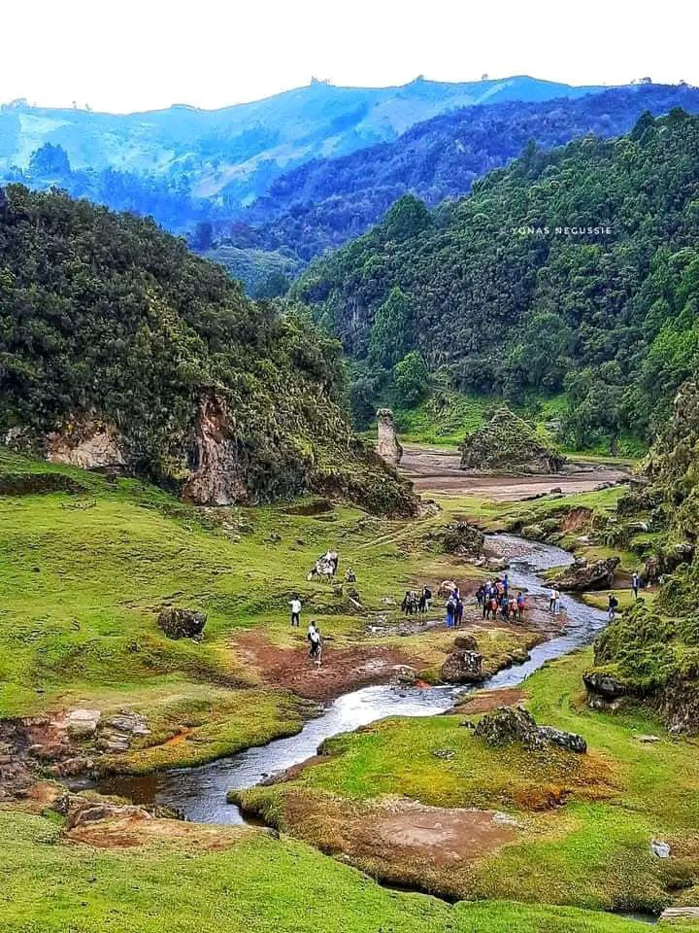
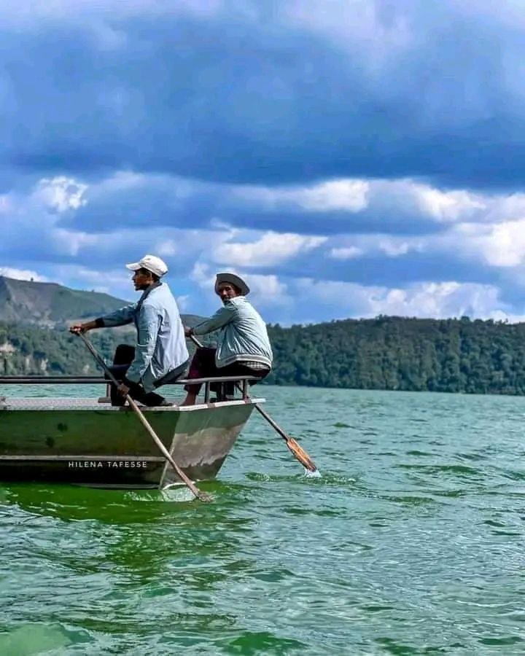

Appendix 2 Goodness of fit test

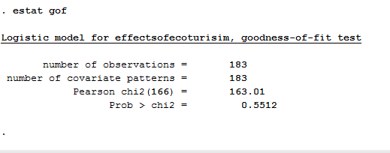
Appendices 3 link tests
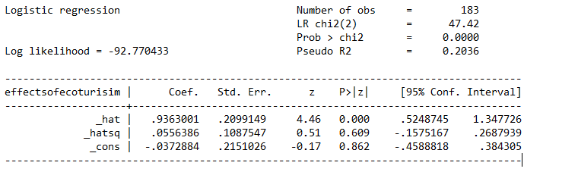

Appendices 4.collinearity
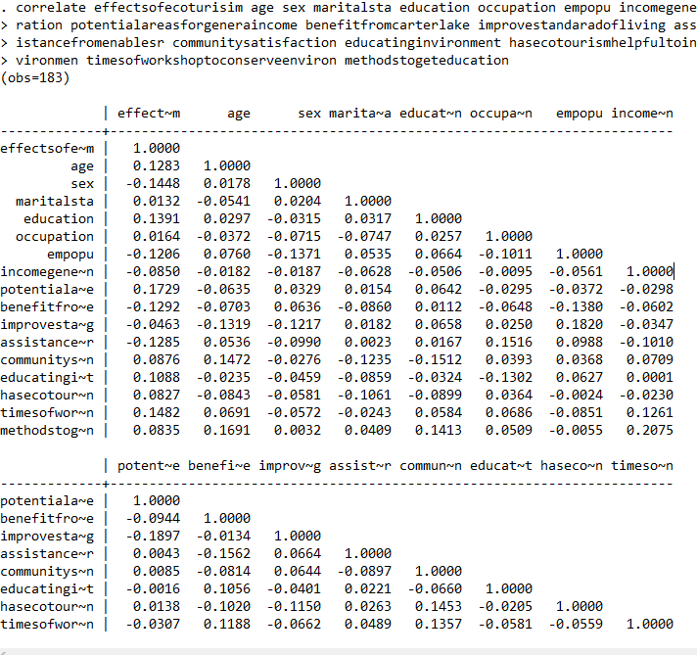

Appendix 5, heteroskedasticity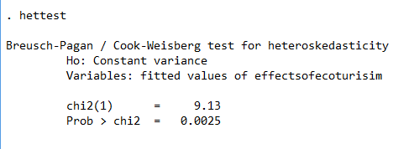

Appendix 6, Multicollearity
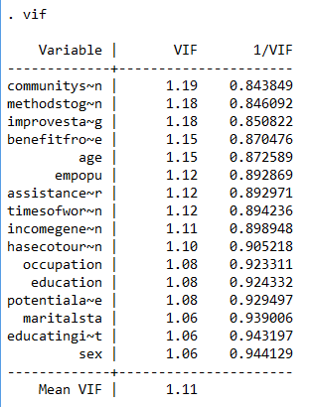

Appendix 7: Final results of Binary logistic regression on stata
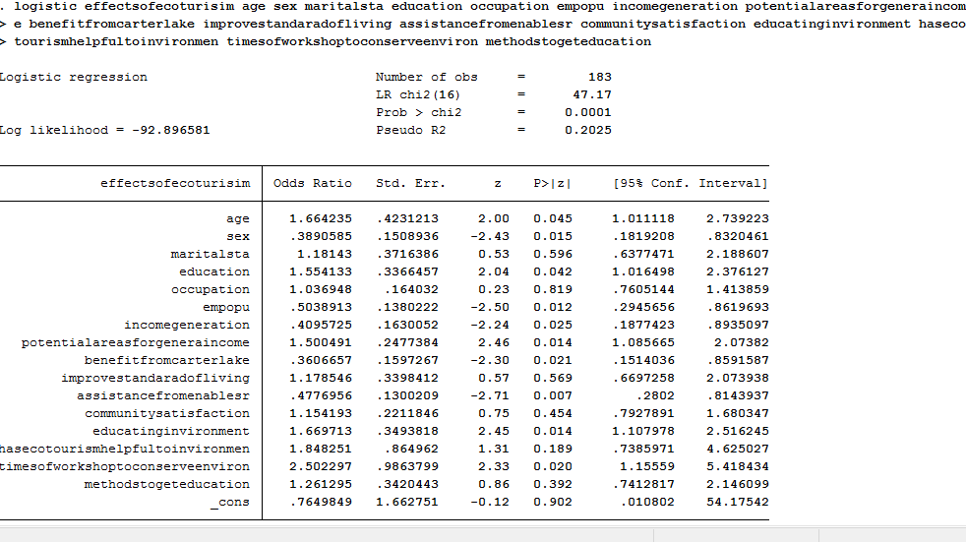

Appendix 8.Marginal effects of ecotourism investment a case of wenchi dendi Crater Lake

Appendix 9 Questioners of survey statistics
School of graduate studies department of economics.
The purpose of this questionnaire is to gather the necessary and fundamental information for my thesis research concerning the title; the effects of ecotourism investment: the case of Wenchi Dendi crater area in Oromia Regional State. I confirm you that all data will be treated confidentially and only aggregate and average information will be utilized. Therefore, I kindly request your cooperation to fill out the questionnaire accurately considering the importance of the study.
I can assure you that there is no any hidden agenda other than the research for academic purpose. Therefore, your genuine and correct response has a great value and role in my research and to the study area. I appreciate your honest and correct response to the questions listed below. So I ask you to fill the questionnaire carefully and appropriately.
Thank you in advance for your cooperation
Questionnaire Number_______________ Interview Date ____________________
Residence: Village _________ Woreda________ County_________

Part A: General Information
1. Age (Tick one):
(01) Below 20 years (02) 21-40 years
(03) 41-60 years (04) above 60 years
2. Sex (Tick one):
(01) Male (02) Female
3. Marital Status (Tick one): (01) Married (02) Single (03) Divorced/ Separated
4. Educational Level (Tick one)
(01) None (02) Primary (03) Secondary (04) College (05) University
5. Occupation (Tick one)
(01) Unemployed (02) Self- employed (03) Salaried/formal employment (04) Farmer
Part B Income from ecotourism
6 Tourism Provide many worthwhile employment opportunity
1 Strongly agree 2 Agree 3 Average 4Disagree 5 strongly disagree
7 Tourism generates income 1 strongly agree 2 Agree 3 Average 4 Disagree 5 strongly disagree
8 What potential attraction areas of tourism are there for generating income?
1 Religious sites 2 Cultural traits 3 Nature of bio diversity 4 all
9 Have you benefited from tourism in your crater lake?
1 yes 2 No
If yes how?
1 Job opportunity at hotel at hotel /tourist establishment or as guide
- selling’s tourist products 3 renting horses 4 others
10 What are the monthly incomes you get from tourism?
1)500 2) 1000 3) 1000-2000 4) above 2000 5) less than 500 6 none
11. How many people are employed in ecotourism after the project is completed?
1) 15,000 2)20,000 3)30,000-40,000 4) over 50,000
Part C Stake holder’s collaboration
12 To What extent do you think stake holder collaboration affects income of the house hold livelihood?
1 Very great extent 2 great extent 3 Moderate extent 4 Low extent 5 Very low extent
13 In your opinion how do the aspects of stake holders collaboration affects the income of eco- tourism investment in the case of Wenchi Dendi Crater lake ?
1 Very great extent 2 great extent 3 Moderate extent 4 Low extent 5 Very low
14 To What extent do the following aspects of stake holders collaborations affects the investment projects in the case of Wenchi Dendi crater lake
 | Very great extent | Great extent | Moderate extent | Low extent | Very low extent
Collaboration with the private sector | 1 | 2 | 3 | 4 | 5
Networking with tourism expertise | 1 | 2 | 3 | 4 | 5
Facilitating links to market | 1 | 2 | 3 | 4 | 5
Assistance from enablers (governments, Funding, institution ) | 1 | 2 | 3 | 4 | 5

15 What is the trend of the following aspects of the effects of ecotourism investment in Wenchi Dendi Crater Lake by five years?
 | Very great extent | Great extent | Moderate extent | Low extent | Very low extent
Objectives Meet | 1 | 2 | 3 | 4 | 5
Improving standard of living /Improving livelihood / | 1 | 2 | 3 | 4 | 5
Level of income | 1 | 2 | 3 | 4 | 5
Community satisfaction | 1 | 2 | 3 | 4 | 5
Social benefit and equity | 1 | 2 | 3 | 4 | 5

16 Has ecotourism affected on the number of stakeholders in tourism investment project? 1) Yes (2) No
. If yes, who are they and how have they affected ecotourism?

Part D: Environmental Education
17. What activities are currently being undertaken and by whom which are educating about
environment.
1 Government 2.Stake holders 3 Non government 4 others
18. Has ecotourism investment helpful to your environment? 1) Yes 2) No
If yes how?
.........................................................................................................................................
.........................................................................................................................................
19. How many times did you get workshops to conserve the environment?
1) 2 times 2) 3times 3) 4 times 4) 5 times
20 By what methods did you get education or skills how to protect your environments while constructing the tourism project and others? 1 Brochures 2 Medias 3 General assembly 4 all

Part F: Interview Questions on Ecotourism investment on the house hold livelihood in Wenchi Dendi Crater Lake.
1. What are the deferent effects of ecotourism investment project on the house hold livelihood?
…………………………………………………………………………………………
…………………………………………………………………………………………
…………………………………………………………………………………………
………………………………………………………
2. List ways in which ecotourism can be developed to meet your aspirations.
-------------------------------------------------------------------------------------------------------
-------------------------------------------------------------------------------------------------------
-------------------------------------------------------------------------------------------------------
--------------------------------------------------------------------------
3. How best do you think you can participate in ecotourism investment? -------------------------------------------------------------------------------------------------------
-------------------------------------------------------------------------------------------------------
-------------------------------------------------------------------------------------------------------
-------------------------------------------------------------------------------------------------------
4. What is your opinion on the effects of ecotourism on the following?
Environmental education------------------------------------------------------------------------------------------------------------------------------------------
- Generation of sustainable income----------------------------------------------------------------------------------------------------------------------------------------------------------------------------------------------------------------------
- Building partnership among stakeholders-------------------------------------------------------------------------------------------------------------------------------------------------------------------------------------------------------------------------------------------
- In your own opinion, is ecotourism an incentive enough to change attitudes and actions for economic benefits? 1yes 2 No if yes how briefly explain

5. How do you support investment of ecotourism in the area? --------------------------------------------------------------------------------------------------------------------------------------------------------------------------------------------------------------------------------------------------------------------------------------------------------
- How has ecotourism investment in this area benefits on your life? --------------------------------------------------------------------------------------------------------------------------------------------------------------------------------------------------------------------------------------------------------------------------------------------------------------------------------------------------------------------------
- Has ecotourism investment in this area improved or impoverished your household living conditions------------------------------------------------------------------------------------------------------------------------------------------------------------------------------------------------------------------------------------------------------------------------------------------------------------------
- Can you briefly comment on the effects of ecotourism on your house hold livelihood over the years? ----------------------------------------------------------------------------------------------------------------------------------------------------------------------------------------------------------------------------------------
- Opinion on ecotourism investment project in this area
1Do you support ecotourism investment project in this area?
----------------------------------------------------------------------------------------------------------------------------------------------------------------------------------------------------------------------------------------------------------------------------------------------------------------------------------------------------------------------------------------------------------------------------------------------------
- Are you involved in ecotourism investment projects area? 1) yes 2) No
If no why if yes how
-----------------------------------------------------------------------------------------------------------------------------------------------------------------------------------------------

