

AMBO UNIVERSITY
SCHOOL OF GRADUATE STUDIES
COLLEGE OF NATURAL AND COMPUTATIONAL SCIENCE
DEPARTMENT OF BIOLOGY, ENVIRONMENTAL SCIENCE PROGRAM
ASSESSMENT OF LAND USE AND LAND COVER (LULC) CHANGE AND ITS DRIVERS; IN THE CASE OF JIMMA RARE DISTRICT, HORO GUDURU WOLLEGA ZONE, WESTERN OROMIA, ETHIOPIA
BY: GAMACHU WAYESA
A THESIS SUBMITTED TO THE COLLEGE OF NATURAL AND
COMPUTATIONAL SCIENCE, DEPARTMENT OF BIOLOGY, FOR PARTIAL FULFILLMENT OF THE REQUIREMENTS FOR THE DEGREE OF MASTER OF SCIENCE IN ENVIROMENTAL SCIENCE

ADVISOR: SIRAJ MAMMO (PhD)
AMBO, ETHIOPIA
JUNE, 2020

ASSESSMENT OF LAND USE AND LAND COVER (LULC) CHANGE AND ITS
DRIVERS; IN THE CASE OF JIMMA RARE DISTRICT, HORO GUDURU WOLLEGA ZONE, WESTERN OROMIA, ETHIOPIA

A THESIS SUBMITTED TO THE SCHOOL OF GRADUATE STUDIES,
AMBO UNIVERSITY, IN PARTIAL FULFILMENT OF THE REQUIREMENTS FOR THE DEGREE OF MASTER OF ENVIRONMENTAL SCIENCE
BY: GAMACHU WAYESA
ADVISOR: SIRAJ MAMMO (PHD)

AMBO, ETHIOPIA
JUNE, 2020

APPROVAL SHEET
TITLE
ASSESSMENT OF LAND USE AND LAND COVER (LULC) CHANGE AND ITS DRIVERS; IN THE CASE OF JIMMA RARE DISTRICT, HORO GUDURU WOLLEGA ZONE, WESTERN OROMIA, ETHIOPIA

Submitted By:
_____________________ ____________________ ______________
PG Candidate Signature Date

Approved By:
_____________________ ____________________ ______________
Major Advisor Signature Date
_____________________ ____________________ ______________
Department Head Signature Date
_____________________ ____________________ ______________
College/Institute Dean Signature Date
_____________________ ____________________ ______________
Director/School of Graduate Signature Date

CERTIFICATION SHEET
As Thesis research advisor, I hereby certify that I have read and evaluated this Thesis prepared under my guidance by Gamachu Wayesa entitled: “ASSESSMENT OF LAND USE AND LAND COVER (LULC) CHANGE AND ITS DRIVERS; IN THE CASE OF JIMMA RARE DISTRICT, HORO GUDURU WOLLEGA ZONE, WESTERN OROMIA, ETHIOPIA”
We recommend that it can be submitted as fulfilling the Thesis requirement.

____________________ ______________ __________
Name of Advisor Signature Date

As mentioned of the Board of Examiners of the M.Sc. Thesis Open Defense Examination, we certify that we have read and evaluated the thesis prepared by Gamachu Wayesa and examined the candidate. We recommended that the Thesis be accepted as fulfilling the thesis requirement for the Degree of Master of Science in Environmental Science.
____________________ ___________ ________
Name of Chairperson Signature Date
____________________ ___________ ________
Name of Internal Examiner Signature Date
____________________ ___________ ________
Name of External Examiner Signature Date
____________________ ___________ ________
Name of PG Coordinator Signature Date

DECLARATION
I declare that this thesis entitled “ASSESSMENT OF LAND USE AND LAND COVER (LULC) CHANGE AND ITS DRIVERS; IN THE CASE OF JIMMA RARE DISTRICT, HORO GUDURU WOLLEGA ZONE, WESTERN OROMIA, ETHIOPIA’’ is my work and that all sources of materials used for this thesis have been appropriately acknowledged. This thesis is submitted in partial fulfillment of the requirements for M.Sc. degree in environmental science at Ambo University. I seriously declare that this thesis is not submitted to any other institution anywhere for the award of any degree or diploma. The thesis is deposited at the University Library to make available to borrowers under rules of the Ambo University Library.
Brief quotations from this thesis are allowed without requiring special consent provided that an accurate acknowledgement of the source is made. Requests for extended quotations from or reproduction of this manuscript in whole or part may be granted by college of Natural and Computational Science and/or the Department of Biology or by the Dean of the School of Graduate Studies of the University when in his or her judgment, the proposed use of the material is for a scholarly interest. In all other instances, however, permission must be obtained from the author.
Name: Gamachu Wayesa
Signature: __________
Date of Submission____________
Place: Ambo University, Ambo

ACKNOWLEDGEMENT
Above all, I thank the Almighty GOD for giving me the potency to start and go through with my studies. I would like to appreciation and gratitude to my advisor Dr. Siraj Mammo for his follow‐up, dedication of his valued time, important suggestions, helpful comments, and efficient guidance to progress the content of this paper from beginning to the end. He also deserves my greatest thankfulness for his support, on time responses.
I would like to forward my admiration to Jimma Rare District Agricultural and Rural Development Office, Environment and Forest Protection office and Land Administration Office  for their devotion during collection of data. Also I extend my appreciation for all interviewed and FGD farmers for their giving me time and permission to observe their plots. I deeply thankful to my wife Sena Wakjira Imiru and my brother Geleta Wayesa Garba for helping me struggle towards realization of my potentials, initiation, encouragement, moral and income support. Finally, I would like to express my gratitude to all my friends Damalash Lamessa, Bayana Kejela and Begna Garadew who were directly or indirectly involved to add their efforts, encouragement and moral support for the accomplishment of this study.

TABLE OF CONTENTS
CONTENTS PAGES
APPROVAL SHEET ii
CERTIFICATION SHEET iii
DECLARATION iv
ACKNOWLEDGEMENT v
TABLE OF CONTENTS vi
LIST OF TABLES ix
LIST OF FIGURES x
ACRONYMS xi
ABSTRACT xii
1 INTRODUCTION 1
1.1 Background 1
1.2 Statement of the problem 3
1.3 Objectives 3
1.3.1 General objective 3
1.3.2 Specific Objectives 4
1.4 Research Questions 4
1.5 Significance of the study 4
1.6 Scope of the study 4
1.7 Limitations of the Study 5
1.8 Organization of the Study 5
2 REVIEW OF LITERATURE 6
2.1 Concepts of Land Use Land Cover Change (LULC) 6
2.2 LULC change at Global view 8
2.3 LULC changes in Ethiopia 9
2.4 Causes of LULC change 11
2.4.1 Direct Causes of LULC change 11
2.4.2 Indirect Causes of LULC change 12
3 RESEARCH METHODOLOGY 16
3.1 Description of Study Area 16
3.1.1 Location and size of study area 16
3.1.2 Agro-Ecology 17
3.1.3 Vegetation 18
3.1.4 Soil Texture types 18
3.1.5 Demographic and Socio-Economic characteristics 18
3.1.6 Livestock production 19
3.2 Data Sources and Acquisition Method 21
3.3 Image pre-processing 22
3.4 Remote Sensing Data Analysis 22
3.5 LULC Classes of the Study Area 24
3.6 Accuracy Assessment 25
4 RESULT AND DISCUSSION 27
4.1 Result of Accuracy Assessment 27
4.2 Analysis of LULC change from 1974–2019 28
4.2.1 Trends of change in land use and land cover 34
4.2.2 LULC change Matrix 35
4.3 Socio-economic and demographic characteristics of HH 38
4.3.1 Sex status of Respondents 38
4.3.2 Age of Respondents 38
4.3.3 Marital Status and Family Size of Respondents 39
4.3.4 Educational Status and Main Source Income of Respondents 40
4.3.5 Land holding Size of Respondents 41
4.4 Long term trend of LULC Dynamics 41
4.4.1 Perception of respondents about LULC dynamics 41
4.4.2 Mechanism of obtaining agricultural land 42
4.4.3 Main source of fuel for cooking and heating 43
4.4.4 Perception of HHs on population growth 44
4.4.5 Number and Trend of Livestock 45
4.4.6 Land Availability 46
4.4.7 Reason of Land Scarcity 46
4.5 Drivers of LULC change 48
4.5.1 Direct Drivers of LULC change 48
4.5.2 Indirect Drivers of LULC change 52
5 CONCLUSION AND RECOMMENDATION 55
5.1 Conclusion 55
5.2 Recommendation 56
REFERENCES 57
APPENDEXS 67
Appendix: A Questionnaires prepared for Hose Hold Leaders (HHLs) 67
Appendix: B Checklists for Focus Group Discussion (FGD) 72
Appendix: C Ground Truth Of LU Types (X, Y) Of J/Rare 74
Appendix: D LULC change of Jimma Rare District (1974-2019) 75
Appendix: F LULC change Matrixes 77
Appendix: G Agro-Ecology and Location Maps 78
Appendix: H Direct & Indirect causes of LULC change 80

LIST OF TABLES
Table1: LULC classes and their description (Land Use office, 2020)............................... 24
Table 2 : The accuracy level & Conditional kappa coefficient of each LULC category...27
Table 3 : Rate of change ha/year in the study area...........................................................28
Table4: LULC change classes in the Study Area from 1974-2019................................... 31
Table 5: LULCC change in Percentage 1974-2019............................................................33
Table 6: LULC classes changed to another LULC classes in 1974- 2019……................35
Table 7: Sex status of Respondents (Field survey, 2020)................................................ 37
Table 8: Age category of Respondents (Field survey, 2020)........................................... 37
Table 9: Marital Status and Family Size of Respondents (Field survey, 2020)…….......38
Table10: Educational Status &Main source income (Field survey, 2020).......................39
Table 11: Land Holding Size in hectare (Field survey, 2020)..........................................40
Table 12: How the respondents perceive the LULC change in the study area? ...............41
Table 13: How Respondents Posses their own land.........................................................42
Table 14: Main Source of Fuel used for cooking and heating purpose ………………....43
Table 15: Perception of respondents on population growth………………………….....44
Table 16: The Number and trend of change of Livestock (Field Survey, 2020) ………..45
Table 17: Availability of Land (Field Survey, 2020).........................................................45
Table 18: Reason of Land Scarcity (Field Survey, 2020)....................................................... 46
Table 19: Mechanism of solving the problem of land scarcity (Field Survey, 2020)........46
Table 20: Proximate drivers of LULC dynamics (Field survey, 2020)…………………51
Table21: Underlying Causes of LULC dynamics (J Field survey, 2020)……………….53

LIST OF FIGURES
Figure 1: Proximate and Underlying Causes of Land Use Cover dynamics…………....15
Figure 2.Boundary Map of Horo Guduru Wollega Zone and Jimma Rare Woreda…..…16
Figure3; Topographic features of Jimma Rare Woreda(CMA, 2020)………………….17
Figure 4: Ehiopia, Oromia National Regional State, Horro Guduru Wollega Zone, Jimma Rare District and Selected Kebeles Map……………………………………………...…20
Figure 5: Flow chart that shows the general methodology of this thesis...........................26
Figure 6: Map of Land use and cover changes in Jimma Rare district 1974–2019……...31
Figure7: Deforestation and ploughing steep slope used for expansion of agriculture…...50 Figure 8: Charcoal production and Fuel wood extraction in study area…………………51
Figure 9: Degraded land (Jimma Rare Field Observation, 2020)………………...…….52
Figure 10: a) Degraded communal grazing land over time b) grazing land converted to settlement area (Jimma Rare Field Observation, 2020)....................................................52
Figure 11: Illegal logging of tree for timber (Jimma Rare Field Observation, 2020)...…53

ACRONYMS
CMA - Central Metrological Agency
CSA- Central Statics agency
DAs-development agents
EFAP-Ethiopian Forestry Action Program
EHRS – Ethiopian highland reclamation study
EPA- Environmental protection authority
FDRE –Federal democratic republic of Ethiopia
FGD – Focused group discussion
GHG – Green house gas
GIS – Geographic Information system
GPS – Global positioning system
HGWZMO-Horo Guduru Wollega Zone
IGBP-International Geo sphere-Biosphere Project
JRANRO – Jimma Rare Agricultural and natural resource office
JREPA –Jimma Rare environmental protection Authority
JRPEDR – Jimma Rare Planning Economical Developmental Offices
JRDRLEPO-Jimma Rare Rural land and environmental protection office
KIIs- Key Informant Interview
LULC – Land use land cover
MoARD - Ministry of Agriculture and Rural Development
NTFPs -Non Timber Forest Products
UNFCCC -United Nations Framework Convention on Climate Change
USGS-United States Geological Survey
WGS –world geodetic system &WRI-World Resource Institute

ABSTRACT
Land use and cover (LULC) is one of the very important environmental phenomena that affect many parts of the earths’ systems including climate, hydrology, biodiversity and fundamental sustainability of land resources on the earth. Anthropogenic factors are responsible for major LULC. For the above mentioned reason, this study was conducted to assess LULC change and its drivers in Jimma Rare district. Land sat satellite images of1974, 1991, 2005 and 2019 were downloaded and used to analyze the spatial and temporal changes. To assess the drivers of LULC change, Respondent interviews, focus group discussions (FGD) and field observations were made. The results of the study showed that Grass land decreased from 4518.87ha (13.09%) in1974 to 902.42ha (2.61%) in 2019.Forest lands declined from 3287.79ha (9.52%) in 1974 to 2506.63ha (7.26%) in 2019. The total forest lands cleared between 1974 and 2019 amounts to 781.16ha (2.26%) similarly, Wetland declined from 1182.08ha (3.42%) in 1974 to 562.37ha (1.63%) in 2019.While, Cultivated lands and Settlement areas were increased from 24999.6ha (72.42%) in 1974 to 29313.9ha (84.92%) in 2019 and 530.19ha (1.54%) in 1974 to 1233.21ha (3.57%) in 2019 respectively. The greatest expansion of cultivated land and settlement area occurred between1974-1991. This kind of conversion occurred at the expense of Grass land, Forest land, and Wetland. Agricultural expansion, Deforestation for fuel wood and charcoal consumption, constructions of infrastructures, overgrazing and expansion of rural and urban settlement were among the major proximate causes. Likewise, major underlying drivers of LULC dynamics include population pressure, policy and institutions, poverty, lack of awareness and biophysical factors that are identified by respondents and focus group discussants of this study. Hence, the precise policy packages are required to control the expansion of cultivation at the expense of wetland and forest resources in the study area.

Key words: Jimma Rare; Land cover land use change; Remote sensing and GIS, Proximate causes; Underlying causes.

INTRODUCTION

Background
Land is the resources most human activities are performed on it and the source of many of materials required for such activities. Land is the most important natural resource for countries like as Ethiopia, where their economy depends upon Agricultural sector. Developments in difficult methods and differing abilities to use land resources often give rise to changes in land use and land cover (LULC). At times such changes have beneficial while at other times they have had negative and adverse impacts on the environment and people’s livelihoods Briassoulis, (2000).Throughout the course of human history, the land has been strongly attached to economic, social, infrastructure and other human activities (Lambin et al., 2004).
Land use and land cover change (LULC) are different terminologies but, until now closely connected characteristics of the Earth’s surface. Land use refers to the purposes for which humans make use of or immediate actions to modifying or converting the land and its resources/covers (Turner et al., 1993; Sherbinin, 2002). In additional (Meyer,1995) described as the use which could be grazing, agriculture, urban development, logging and mining among many others and set land cover as it could be cropland, forest, wetland, pasture, roads, and urban areas among others. (Turner et al, 1993) discussed land cover as the bio-physical sate of the earth's land surface and immediate sub-surface including biota, soil, topography, surface and ground water, and human structures. According to (James et al., 1976) LULC terms are closely related and in many cases they have been used interchangeably. The purposes for which lands are being used commonly have associated to the types of covers, whether they are forest, agricultural, residential, or industrial. The understanding of land use land cover relationship is connected with causes and consequences of LULC change (Turner et al., 1995) because the change in land cover leads to the change in land use (Turner et al, 1993)

Land use and land cover (LULC) change are linked with large negative impacts on ecosystems observed at global scales, regional and local. High rates of water, soil and air- pollution are the consequences of observed LULC change. Biodiversity is reduced when land is changed from a comparatively undisturbed state to more exhaustive uses like farming, livestock grazing, selective tree harvesting, etc. ( Ellis, 2011 ). LULC change due to deforestation in the tropics was the major contributor to CO2 emissions in the 1990s, which averaged between 0.5 and 2.7 gigatone of carbon (GtC) per year (UNFCCC, 2007).These changes modify ecosystem services and affect the ability of biological systems to support human needs, also decide the susceptibility of places and people to climatic, economic and socio-political perturbations (Lambin & Geist , 2006).
Research on the Ethiopian highlands showed that, between 1860 and 1980, land under cultivation had increased significantly at the expense of shrub land, woodlands and forestlands, especially on steep slopes and in marginal areas (Girma & Hassan, 2014).
As Muluneh and Arnalds , 2011 ‘Hence, vegetation removal results an increase in surface runoff’. LULC change is a rising threat to the resilience of socio-ecological systems, since it is often connected with land degradation Lambin and Meyfroidt , (2010). In the context of this study, land cover refers to the biophysical (e.g. soil, and water) of land surface while land use is associated to any human management activity affecting land. We define therefore land use change as either a shift into another land use or the intensification of the current land use (Turner and Meyer, 1994).
Interpreting and conceptualizing the land cover/use changes contribute to complex dynamics of land cover and is important for policy and planning actions Tahir et al., (2013), Reddy and Gebreselassie , (2011). Land use changes are caused both natural and socioeconomic factors (Campbell et al., 2005). LULC is maybe the most famous form of global environmental change fact occurring at spatial and temporal scales. Land cover is the physical and biological cover of the surface of land, whereas land use is the syndromes of human activities such as agriculture, forestry and building construction that alter land surface processes (Foley et al., 2005).
The conversion of natural land to cropland, pasture, urban area, reservoirs, and other anthropogenic landscapes represents the form of human impact on the environment Sewnet Amare, (2015). Roughly 40% of earth’s land surface is under agriculture, and 85% has some level of anthropogenic influence Sanderson et al, (2002). For that reason, large-scale land cover change is largely a rural phenomenon, but many of its drivers can be traced to the consumption demands of the growth urban population Carr, (2004). Deforestation, wetland drainage, and grassland degradation have all amounted to a globally major adjustment of the land cover changes. Large scale environmental phenomena like land degradation and desertification, biodiversity loss, habitat destruction and species transfer are consequences of land use by converting natural land covers (Meyer and Turner, 1996).

Statement of the problem
To understand how LULC change affects and interact with earth system such as; hydrosphere, biosphere and atmosphere, exact information is needed on what type of change occur where and when it occurs and the speed at which change occurs (Lambin, 1997). Hence, information on LULC and possibilities for their most profitable use is necessary for the selection, scheduling and operation of land use system to meet up the increasing demands for basic human needs and wellbeing. This information also assists in monitoring the dynamics of LULC consequential out of changing demands of increasing population. Despite several studies were conducted in Ethiopia, somewhere else up to date and area specific information is needed. There have been no studies of LULC dynamic in Jimma Rare district, which is an important consideration for environmental interpretation and in the development of integrated natural resource management practices.

Objectives

General objective
- The major objective of the study is to investigate and evaluate the extent and direction of changes in LULC dynamics and its drivers from 1974 to 2019 and its drivers in Jimma Rare district.

Specific Objectives
- To assess LULC problems in the Jimma Rare district;
- To identify the long term trend of LULC dynamics of the study area;
- To identify drivers of land use and land cover change in the study area.

Research Questions
The following research questions will be addressed:
- What is the magnitude of LUCC in the Jimma Rare?
- ‘Which LULC types added or lost most as a result of the detected LULC dynamics?
- What are the main drivers LULC dynamics of the study area?

Significance of the study
The study findings help different stakeholders including the district agricultural development official1s, experts, civil societies and DAs to design correct policies and strategies for monitoring Natural resource degradation and encourage sustainable management of Natural resources strategies, investment programs and projects that would bring positive synergies to restore land productivity, improve food security and prevent the vicious poverty cycle and natural resource degradation in indicating key priority areas for conservation measures. Furthermore, the analysis contributes to the general knowledge on the trend and drivers of LULC dynamics. It may also help to be proposed and recommend mitigation measures to combat the negative impacts of LULC change dynamics.

Scope of the study
The scope of the study was limited to one district Jimma Rare district, Horro Guduru Wollega Zone, due to time and financial limitation and the study was limited to assess LULC dynamic and its drivers. The scope of this study was also delimited to the problem related to LULC dynamic. Although treating the overall problem of the environment would enable the inhabitants to aware the causes of environmental degradation on the agricultural productivity, the study bounded on LULC dynamic and its drivers.

Limitations of the Study
The data collected for drivers of LULC change was limited to three Kebeles of Jimma Rare District because of the researchers financial and time limitation as well as due to lack of transportation. The study focuses on the social aspects in particular which strengthen by normal secondary data. As in all studies it cannot entertain all spheres and dimensions associated with the broad subjects of LULC dynamic and its drivers due to the lack of organized documents in the area and lack of facilities for data collection and due to the unavailability of necessary material.

Organization of the Study
This study was organized into five parts. The first part deals with introduction part in which background of the study, statement of the problem, objectives of the study, research questions, significance of the study, scope of the study and limitation of the study are included. The second part deals the review of related literatures to the topics of the current study is described. The third part deals with the methodology in which the descriptions of the study area are given priority to the description of the materials used and the methods to be employed. Then primary and secondary data sources were used as materials are described in detail. In the methodology section; the research design, sampling size and sampling techniques, sources of data, instruments of data collection, method of data analysis and presentation are described briefly. The fourth parts deals with result and discussions in which the findings are presented, analyzed, and discussed. Finally the fifth chapter includes conclusion of the major findings and recommendations based on the findings of the study

REVIEW OF LITERATURE

Concepts of Land Use Land Cover Change (LULC)
Changes in land cover represent significant threats to ecosystem sustainability, particularly when naturally vegetated forms give way to human use. Such conversions often reduce the availability of energy, water, and nutrients to ecosystems, facilitate the invasion of exotic species, and generally speed-up natural change processes (Ojima et al., 1994). Besides inducing on-site impacts, the expansion of urban and agricultural areas into the natural landscape also leads to externality effects beyond the development fringe. The purposeful conversion of natural vegetative cover is driven by the demand for land. In the agrarian setting of the tropical frontier, land is a key production factor, and the demand for land is a derived demand affected by both product and factor prices (Douglas, 1994).
Local changes in land use and land cover (LULC) affect life support functions and human livelihoods Lambin et al. 2001. It has diverse environmental impacts by negatively affecting water supply, reservoir storage capacity, agricultural productivity and ecology of a region Sharma et al., 2015. In most developing countries, the demands for meeting local food production caused agricultural lands expansion at the expense of natural forests and grasslands Lambin et al., 2003. Local level studies undertaken in highlands of Ethiopia suggest that a presence of significant LULC changes were caused by a combination of varying factors depending on each locality condition Girmay et al.,(2017).
Zubair,( 2006) and Chrysoulakis et al., (2004) mentioned land use is the intended employment of land management strategy placed on the land cover by human agents, or land managers to exploit the land cover and reflects human such as industrial zones, residential zones, agricultural fields, grazing, logging, and mining among many others. On the other hand, land use change refers to a conversion of land use due to the interference of human being for different purposes such as for settlement, infrastructural development, agriculture and recreational uses (Meyer and Turner, 1992; Turner et al., 1995).
Land use change is defined to be any physical, biological or chemical change attributable to management, which may include conversion of wetland and forestland to cropping, change in fertilizer use, drainage improvements, and use of irrigation, plantations, building farm dams, pollution and land degradation, vegetation elimination, changed fire regime, broaden of weeds and exotic species, and change to non-agriculture use (Quentin et al., 2006).
Land cover is defined by the attributes of the bio-physical sate of the earth‘s land surface and immediate subsurface, including biota, soil, topography, surface and ground water and human structures as in the case for agricultural expansion or deforestation (Lambin et al., 2003; Turner et al., 1995). IGBP (1997) stated that land cover is defined as the physical characteristic of earth‘s surface, captured in the distribution of vegetation, water, ^{desert}, ice and other physical features of the land, including hose created solely by human activities such as mine exposures and settlement. Meyer and Turner (1992) and Lambin & Geist (2003) also explain that a change in land cover refers to conversion of one land cover type to a new Cover type or alteration within one land cove.
The relationship between LULC can be described as: change in land use can affect and be affected by land cover; however the change in either of them is not necessarily the product of the other. Single land use system may correspond to a single land cover or it may involve several different covers (Briassoulis, 2011).
LULC dynamics refers to the human modification and conversion of the earth terrestrial surface (Lambin et al., 2003; Ibrahim Hamza & Iyela, 2012). Modification represents a change within one land use or land cover category due to changes in its physical or functional attributes. On the other hand conversion of LULC dynamics occurs when one LULC dynamics type completely replace by another (Turner et al., 1995; Lambin et al., 2003; Biniam Alemu et al., 2015).These changes in LULC -systems have important environmental consequences through their impacts on soil and water, biodiversity and microclimate (Lambin et al., 2003).
Much of the world‘s natural land cover has been transformed by human activities (Mottet et al., 2006), resulting in ecosystem degradation and biodiversity loss worldwide (Green et al., 2005). According to Lambin et al. (2003), since 1850 about 4.7 million km² of- grassland areas and 6 million km² of forest/woodland have been converted to cropland and the main purpose for land use change is to obtain food and other essentials (Alfred, 2010). Land use change in Ethiopia is largely driven by the decision of the people and population growth, declining household farm size and income (Efrem Garedew et al., 2009).
Land-use and land-cover changes (LUCC) increasingly have been regarded as a primary source of global environmental change such as emission of greenhouse gases, global climate change, loss of biodiversity, and loss of soil resources. However, the causes of LUCC are complex and change over time and from region to region (Wang & Lei, 2016). In recent times, land use/ cover (LULC) has generally been considered a local environmental issue, but it is becoming a force of global importance. Worldwide changes to forests and farmlands are being driven by a number of factors (Foley et al., 2005).

LULC change at Global view
LULC dynamics is as old as the age of human kinds (Hagos Gebreslassie, 2014). LULC dynamics occurs at local, regional and global scales and changes at local scales can have cumulative impacts at broader scales (Ashanafi Burka, 2008). The spread of human land use activities were mainly at the expanse of forest lands, resulting reduction of global forest cover from 50% to less than 30% (Lambin et al., 2003). Between 1700 and 1980 for instance, at the global scale total cultivated land was estimated to have increased by 46% (Turner et al., 1992). Furthermore, between the years 1700 and 1990, the area under cultivation and pasture has increased from an estimated 300-400 million ha to 1500-1800 million ha, and 500 million ha to 3100 million ha respectively. This resulted in reduction of forests from around 5000-6200 million ha in 1700 to 4300-5300 million ha in 1990 and natural grasslands, steppes and savannas from around 3200 million ha in 1700 to 1800- 2700 million ha in 1990 (Lambin et al., 2003).
However LULC dynamics is not homogeneous across all parts of the world (WIREs Climate Change, 2014). There are regions still with relatively undisturbed land cover such as parts of tropics and Polar Regions. Some other regions experienced massive LULC dynamics mainly expansion of agricultural lands at the expanse of vegetated lands. This is true in regions with a shorter history of human development such as Africa, south and Southeast Asia and Latin America countries. Since 1850, these regions have experienced dramatic increases in cropland, especially during the second half of the twentieth century (Lambin et al., 2003). In contrast enlargement of agricultural lands reduced in European countries (WIREs Climate Change, 2014).

LULC changes in Ethiopia
The total area of Ethiopia covers above 1.12 million km² (MoME, 2003). About 55% of this area is below 1500m m.s.l. which is lowland, where as the remaining 45% of the area, with an altitude of greater than 1500 m is highland (Mesay Mulgeta et al., 2017). In Ethiopia the land is dominantly used for mixed farming system, by smallholders who farm for subsistence (Asmamaw Adamu, 2013; Mesay Mulgeta et al 2017).The country also known by several environmental, climatic, and socio-economic problems such (Mesay Mulgeta et al., 2017).
The above mentioned problems are directly or indirectly linked with Climate change and LULC dynamics. LULC dynamics including forest cover change is one of the major environmental problems in Ethiopia (Biniam Alemu et al., 2015). It could be possible to make projections for the upcoming LULC dynamics by conduct research to understanding the past.
Different studies, made using remotely sensed data of different years, for some parts of Ethiopia, at catchment, zone, watershed, village and district levels. For instance Gete Zeleke and Hurni (2001) in Dembecha area of Gojjam; Bewket Woldeamlak (2002) in Chemago watershed, Gojjam; Efrem Garedew (2010) in the Semi Arid Areas of Central Rift Valley of Ethiopia; Solomon Gebrehiwot et al. (2010) in Koga watershed at the headwaters of the Blue Nile Basin; Diress Tsegaye et al. (2010) in North eastern Afar range lands; Abule Ebro et al. (2011) in Adami Tulu and Fantale Districts, in the rift valley of Ethiopia; Mesay Mulgeta (2011) in Nonno District, Central Ethiopia; Fentahun Tesfahun & Gashaw Temesgen (2014) in Bantneka Watershed, Ethiopia; Siraj Mamo et al. (2018) in Chilimo forest Dendi district Central Highlands of Ethiopia; Iyayu Molla (2014) in Arsi Negele District, Central Rift Valley Region of Ethiopia; Worku Gebrekidan et al. (2014) in Ameleke Watershed, South Ethiopia; Temesgen Gashaw & Tigabu Dinkayoh, (2015) in Hulet Wogedamea Kebele, Northern Ethiopia.
Most of these researches reported the decline of natural vegetation including forests, shrub lands and woodlands due to conversion to cultivation land, grazing lands, open areas and settlements areas. This idea is in line with Munchen, (2012) who stated that almost all LULC change studies conducted in Ethiopia have common characteristics, such as expansion of cultivation land and the loss of natural vegetation, combined with a loss of biodiversity.
In Ethiopia expansion of cultivation land and loss of natural vegetation are associated with population growth, poor economic condition, unclear land tenure right and several other biophysical and socio-political factors Lemenih, (2004). According to Sege and Turner & Meyer (1994), in most developing countries including Africa, Asia and L/America countries population growth and LULC dynamics have a strong statistical correlation. In agreement to these different studies under taken in different parts of Ethiopia also reported population growth as a major cause for LULC dynamics. Population growth was the major cause for the expansion of cultivation and reduction of vegetation covers in Ethiopian (Alemayehu Muluneh, 2010), Borena District South Wello Highland (Abate Shiferaw, 2011); Nono District, Central Ethiopia (Mesay Mulugeta et al., 2011), West Guna Mountain South Gondar Bewuketu et al., (2018) and Northwest lowland of Ethiopia (Biniam Alemu et al., 2015). The total population of Ethiopia during the first population and housing census (1984) was 39,868,572. However, during the census of 1994 and 2007 it increased to 53,477,265 and 73,918,505 respectively (Sewunet Amare, 2016). This implies that between 1984 and 2007 the total population of the country increased by more than 34 million persons. Agricultural land and settlement areas expansion by clearing forest, grassland and woodlands caused by population growth (Sewunet Amare, 2015).

Causes of LULC change
The question of what factors drive LULC change remains largely unanswered Turner and Meyer, (1994).In recent times, human activities and social factors were accepted to have a vital meaning for understanding of LULC change (Geist and Lambin, 2002). Driving forces are in general subdivided into two broad categories: proximate causes and underlying causes. LULC is never static, it continuously changes in response to the dynamic relations between underlying drivers and proximate causes (Lambin et al.,2003). The conceptual understanding of proximate causes and underlying forces has a vital importance to identifying the causes of LULC changes (Turner and Meyer, 1994).

Direct Causes of LULC change
Proximate causes are the activities and actions which directly affect land use, e.g. wood extraction or clearing land for agriculture. According to Geist and Lambin (2002), proximate (direct) causes are instant actions of local people in order to fulfill their needs from the use of the land. These causes include agricultural expansion, wood extraction, infrastructure expansion and others that change the physical state of land cover (Turner and Meyer, 1994). At the proximate level, LULC change may be explained by multiple factors rather than a single variable (Geist and Lambin, 2002).
Proximate causes of LULCC are direct actions of local communities and directly exerted on land resources due to different underlying causes such as economic, social, political, etc (Geist & Lambin, 2002; Abate Shiferaw, & Singh 2011). They operate at the local level (individual farms, households or communities) and explain how and why local land covers and ecosystem processes are modified and converted directly by humans (Lambin et al., 2003; Lambin & Geist, 2007). According to Geist & Lambin (2002) agricultural- expansion, wood extraction and infrastructure expansion are major proximate causes of LULC dynamics.

Agricultural Land expansion:
Sherbinin (2002) mentioned that agricultural expansion is the leading proximate cause for LULC dynamics. Agricultural expansion comprises permanent cultivation (large scale, smallholder subsistence and commercial), shifting cultivation and cattle rering (large-scale and smallholder) (Geist & Lambin, 2002). Houghton (1994) discussed that over 50% of the global agricultural lands increased in the past 100 years. In the developing world, half of the land cover change occurred in precisely the past 50 years. In Ethiopia large areas, which were once under vegetation cover are now changed to cultivated land and depiction to soil erosion resulting into environmental degradation and severe threat to the land (Amare Bantider et al., 2007).

Deforestation:
To fulfill the demand of fuel and pole woods is one of the major drivers for clearing widespread area of vegetation cover and trees in general. Cutting of trees for fire wood, charcoal and constructional materials without replacement is a critical problem contributing to the loss of various forms of vegetation in general and indigenous tree species in particular. In this regard, the investigation conducted by Lambin et al., (2001) indicated that harvesting of fuel and pole woods for home consumption and commercial purposes were the primary causes of deforestation in Africa, Latin America and Asia.

Infrastructure expansion:
The development of infrastructure is interrelated with urban growth also leads LULC conversion, especially in Latin America, Asia and Africa (Geist & Lambin, 2002; Kissinger et al., 2012).while, better access to markets is connected with land use conversion by infrastructure can activate market development, cash crop adoption and economic growth. Infrastructure extension can be a component of rural development and settlement policies that drive market integration (Kissinger et al., 2012)

Indirect Causes of LULC change
Underlying driving forces are crucial socio-economic and political processes that push proximate causes into immediate action on LULC(Geist & Lambin, 2002).They function at the regional(districts, provinces, or country) or even global levels by changing one or more proximate causes (Lambin et al.,2003; Lambin & Geist, 2007). According to Sherbinin (2002) and Geist & Lambin (2001, 2002) underlying causes of LULC dynamics originate from a complex interaction of social, policy and institutional, economic, demographic, technological, cultural and biophysical factors.

Population Growth:
The demographic characteristics mostly population growth and density are indirect factors for LULC conversion through the growing needs for additional lands for farming and grazing as well as demands for tree products (fuel and construction wood). Population growth and density are extensively discussed as an important driver for land use change (Kissinger et al., 2012; Alexander et al., 2016).
The growth of urban population places pressure on rural landscapes for commercial cultivation (Houghton et al., 2012).Mutoko et al. (2014) argued that population growth increase the demand for food, and leads to agricultural intensification in developing countries. In this regard, land cover conversions due to demographic pressure are more serious largely in tropical regions such as Latin America, Africa and Southeast Asia (Lambine et al., 2003, Geist & Lambin 2004, Geist et al., 2006).
The land cover conditions of the Ethiopian have also been widely transformed by the rapidly increasing population pressure and growing livestock population. Human population in the highlands has grown fast on the limited land area and almost every piece of land is converted into cultivated land to produce food (Bewket Woldeamlak, (2002); Dejene Alemneh, (2003); Hurni et al., (2010)).

Poverty:
Poverty is one of the major underlying causes of LULC dynamics particular for tropical deforestation. Economic variables such as low domestic costs (for land, labor, fuel or timber), increase in product price (mostly for cash crops) influence land use decision making, thereby impacting the land cover (Geist & Lambin, 2002).Besides these, change in prices, taxes, and subsidies on land use inputs and products, change is the costs of production and transportation and access to credit, market, and technology also plays crucial role in LULC dynamics (Lambin & Geist, 2007).

Property Right of Land:
Land tenure arrangement affects the utilization of land resources and land management investment decisions. In this regard Lakew Desta,(2000), Tefera Bezuayehu & Sterk, (2008), MoARD & WB (2007) and MoARD & SLM Secretariat (2008) argued that easily transferable and secure property rights have long been identified as key elements to bring about natural resources conservation, sustained use of resources and investments on land resources management. Under the current land tenure policy of Ethiopia, land is public property and land users have only use rights. Short-term leasing or share cropping is allowed, however, land cannot be sold, exchanged, or mortgaged (MoARD & WB, 2007). Since the utilization of land resources and application of land resource management practices involve long-term investments, land tenure security is an important consideration for sustained use of land resources

Biophysical Nature:
Usually refers to catastrophic factors that lead to sudden shifts in the human-environment condition (Geist & Lambin, 2001). It comprises the natural processes of the environment such as climatic variations, topography, drainage, soil type and geomorphic processes. Verburg &Veldkamp (2004) noted that biophysical factors mostly do not drive land use change directly, they can cause LULCC (through climate change) and they influence land use allocation decisions (soil quality).

Socio-cultural:
Cultural factors often affect economic and policy drivers, public attitudes, values and beliefs toward the environment are important that how land is used in terms of socio-culture aspect. Understanding values and beliefs of communities are essential in particular towards people and the future generations that can contribute to land use planning and management (Geist & Lambin, 2002)..

Technological:
Technological progress also fosters growth in individual city size because of knowledge accumulation leads to enhance urban scale economy or improving the ability to manage cities through transport technologies that have increased access to land and greater access to markets that have an impact to land use and finally, the conversion (Gruber & Peckham, 2009)

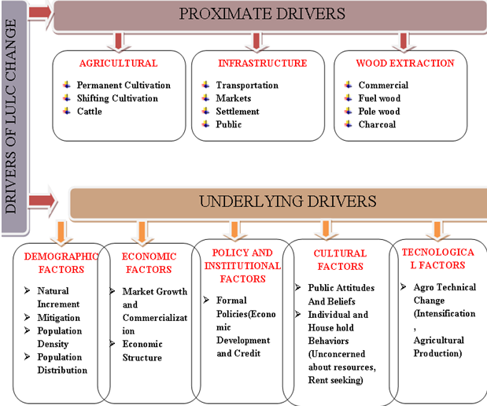
Figure 1: Proximate and Underlying Causes of Land Use Cover dynamics (Source: Geist & Lambin, 2002).

RESEARCH METHODOLOGY

Description of Study Area

Location and size of study area
Jimma Rare District is located in Oromia Region, Horo Guduru Wollega Zone. Horo Guduru Wollega Zone shared boundary with West Shewa Zone in South Eastern, with East Wollega Zone in South West and By Amhara Region in Northern. Jimma Rare district bounded by Choman Guduru district in the north, Jimma Geneti district in the western, Bakko-Tibe district(West Shewa Zone) in South West, Chelia district(West Shewa Zone) in South and Mida kegni district (West Shewa Zone) in the Eastern.
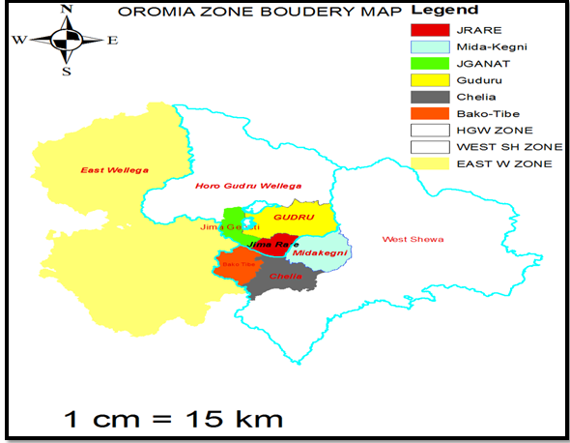
Figure 2.Geographycal boundary map of Horo Guduru Wollega Zone &
Jimma Rare Woreda
The district possesses total areas in 34,518.53hectares. The district has 20 administrative units of which 18 Rural and 2 Town kebeles. Wayu is the administrative centre of the district. It is geographically located at N 09⁰13’48.5” and E 037⁰21’32.3’’, far 96 Km from Shambu (Administrative Centre of Horo Guduru Wollega Zone) and 245km from Adis Abeba (JRDRLEPO, 2017).

Agro-Ecology
According to Ethiopian Agro-ecological zone, the district is classified as Woina-Dega (subtropical) which covers 72% and the remaining 28% is Dega (High land) (JRANRO, 2019). Since, it is found in the high land and subtropical parts of Ethiopia, the district is comfortable for crop growing. Therefore, almost all agro-ecological practiced similar economic activities that are cultivation together with rearing of animal (JRANRO, 2019).The altitude of the district range from 1547 to 2846m.a.s.l (Central Metrological Agency, 2020).
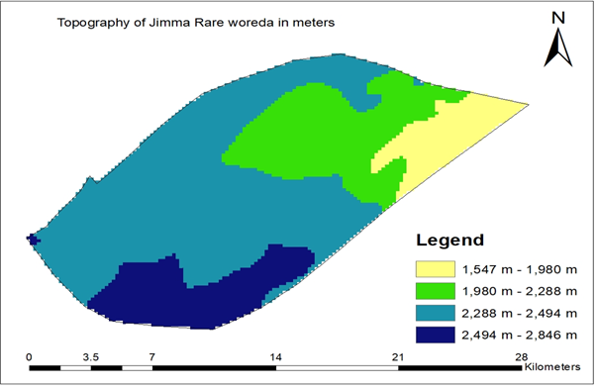
Figure3; Topographic features of Jimma Rare District
The mean annual temperature varies between 18 °C and 25 °C. Rain is occurs during April to August and September is a transitional period between rainy and dry season and the annual rain fall of the district is ranges between 1400-2000 mm (CMA 2020). Cultivation is the principal economic activity in the study area, though some people derive additional income from vegetables and livestock production (rearing). Agricultural production is destined mainly for home consumption a garden system and a field -cropping system. The principal agricultural activity is crop cultivation, which is entirely rain-fed with livestock rearing as a secondary activity.

Vegetation
The district has various types of vegetation in responses to the variation of soil, climate and human activities. At present time, matured and naturally grown tree are observed in the church compounds and in homestead. In the remaining area, natural vegetation is very much degraded. Some of the major indigenous tree (shrub species) which still survives in the area includes Wadesa(Cordea africana), Harbuu (Ficus sur), Birbisa (Podocarpus falcatus), Homi (Prunus africana (Hook.f.)Kalkm), Hexo (Hagenia abyssinica (Bruce) J.F. Gmel) and Bakanisa (Croton macrostachyus). In addition, important exotic tree such as Bargamoadi (Eucalyptus globules), Bargamo dima (Eucalyptus camaldulesis), and Gatira faranji (Cupressus lustanica) and Giraaviliyaa (Grevillea robusta (Zerihun, (2012) are commonly observed in the area.

Soil Texture types
The dominant soil type of the study district includes sandy loam soil 55% and clay silt loam 45% (JRANRO, 2018). Generally the soil type of this district is characterized as silt loam dark red in color and with high water holding capacity. It is a fertile soil that different crops, fruits and vegetable were produced.

Demographic and Socio-Economic characteristics
The population density in the study district is relatively high, and small units of land are extensively cultivated by subsistence farmers. According to the 2007 population and housing census data, the projected population of the district for the year 2019 is estimated to be 80,437 out of which 40,836 (50.8%) are men and 39,601 (49.2%) are female. The rural population size constitutes 68,922 of which 35743 (51.9%) are male and 33179 (48.1%) are female (JRPEDO, 2019). Of these total populations, 85.7% of them are live in rural area, and 14.3% lives in urban and their income depended on Agriculture (JRPEDO, 2019).Jimma Rare is one of the densely populated area with 233 persons per sq. km. This created the problem of deforestation and intensive-cultivation including sloppy lands that aggravated the problem of LULC dynamics.

Livestock production
Livestock play important role in the economy of small holder farmers. Animals are kept as a source of milk, meat, and cash. Cattle dung is also an important source of manure. In the study area the livestock production is also an important subsector under taken in line with crop production. The types of livestock found in study area includes: oxen, cow, sheep, goat, poultry, horse, mule and donkey. The main source of feed for livestock in the study area includes Straw, and grazing land (JRANRO, 2019).

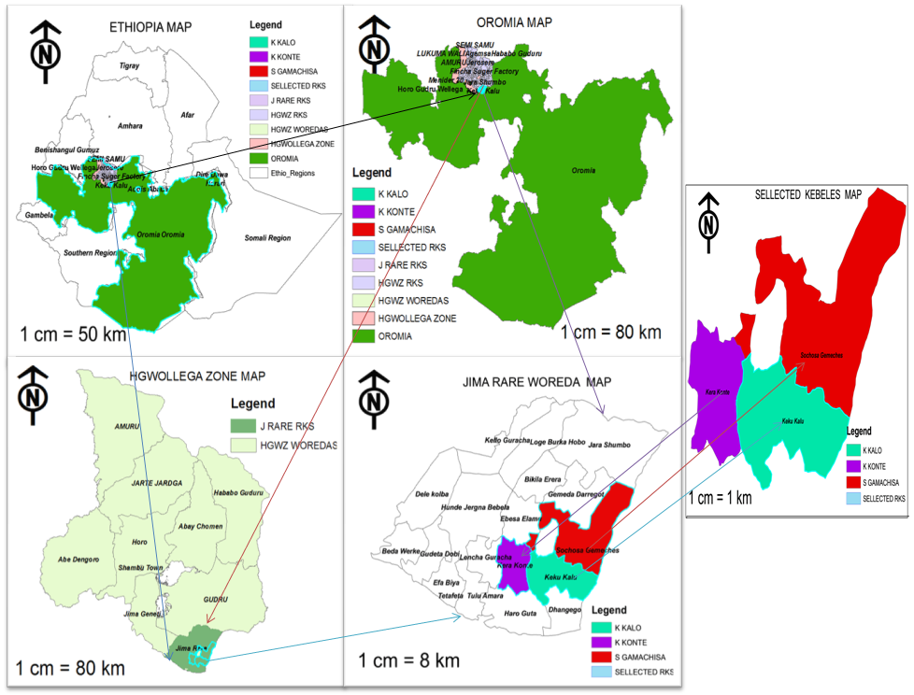
Figure4: Ethiopia, Oromia National Regional State, Horro Guduru Wollega Zone, Jimma Rare District and Selected Kebeles Map

Data Sources and Acquisition Method
To investigate trends of LULC changes total of four (4) land sat satellite images for the past 45 years were downloaded from USGS satellite https://earthexplorer.usgs.gov/ where freely accessible. The images were downloaded during the dry season, because they were more likely to be cloud free and their spectral properties were less affected by the availability of moisture. Ground truth exercise were carried out in Jimma Rare district in which the different LULC types existing with the aid of global positioning system (GPS). In order to accomplish the specified objectives of this research study both primary and secondary data were used. The primary data was obtained systematically from selected natural resource management experts, DAs, farmers and other responsible bodies by using structured interviews and field observation. The data for the drivers of LULC change were collected from 178 household heads through interviews. The secondary data was gathered from related published and unpublished materials. The investigator purposively selected three (3) kebeles from the 18 kebeles of the Jimma Rare District namely Keku-Kalo, Sochosa-Gamachisa and Kara-Konte. The criteria for the selection of these three (3) kebeles were based on the degree of LULC change. The total number of HHs in the three (3) kebeles was 1417 and the needed sample size was178 which were 12.6 % of the total HHs.
- The sample size for the study
Sample size was determined based on sample size determination of Yamane (1967) at confidence level 93% and expected error 0.07. Once the sample size was determined the sample respondents from each kebeles, selected by simple random sampling techniques from the list of HHs found at each kebeles, therefore, the sample size calculated as follows.
That is: - $n=N/(1 + N \left(e\right)2 )$ Where, $n=sample size$
$N=total household heads = 1417$
$e=margin error (0.07)$
Thus, $n=1417/(1 +1417\left(0.07\right)2 )$
$$n=178$$
- Key Informant Interview (KIIs)
The investigator used semi-structured interviews. The interviews conducted by the investigator targeting the KIIs such as Development Agents (DA’s) 3 (three), local elders 3 (three), and Kebele managers 3 (three), totally 9 (nine) interviewees purposively selected. The DAs selected because they were working with farmers, the local elders has been living in the area for a long time thus, they witnessed the change on the land and Kebele managers were selected as they are representatives of the local government.
- Focus Group Discussions (FGDs)
Focus Group Discussions (FGDs) with 1 (one) group from each target Kebele containing 6 (Six) members totally eighteen (18) to be held with selected knowledgeable experienced farmers, Development Agents, and local elders to know the awareness of the community about LULCC and how the people of the study area manage the land.

Image pre-processing
Image pre-processing involves management and interpretation of digital images which may be affected by systematic and random errors and was not be directly utilized for features identification and any applications and it needed some correction(Habtamu Ayele, 2011) and needed to remove errors. Therefore standard image processing techniques of extraction, layer stacking, radiometric correction, and geometric correction/geo referencing and change detection were performed on the 4 Land sat images downloaded and obtained on different years of dry season in the study area.

Remote Sensing Data Analysis
In image analysis, ground reference data play important role to determine information
classes, interpret decisions, and assess accuracies of the results (Thapa & Murayama, 2009). The data obtained from the fieldwork was used for validating LULC change interpretation from satellite image, for image classification and for qualitative description of the characteristics of each LULC change types. The software ERDAS visualize 14.1 and Arc GIS 10.4 employed for satellite image processing and LULC change analysis.
Image categorization defined as the extraction of differentiated classes or theme categories from raw remotely sensed digital data (Ismail & Jusoff, 2008) and created thematic maps from satellite images (Golmehr, 2009), in which all pixels in an image automatically categorized into LULC change types. In order to clearly identify the type and size of LULC change in the study area from the multi spectral and temporal satellite images, a reconnaissance survey was carried out in March 2020 to acquire general understanding of the land pattern.
The investigation survey assisted by information’s collected from the FGD past, present knowledge joined with interpretation of remotely sensed satellite image. Each satellite images were classified into different LULC change types used supervised image classification joined with the maximum likelihood classification algorithm. Ground truth data collection was carried out for collecting the fixed location of different LULC used them as guidance sites during classification and for accuracy assessment of the classified LULC change map of 2019 classification year. A total of GCP’s were collected randomly from the study area taking into consideration area proportion for different LULC change types. LULC change statistics computed in three following different ways:
- LULC Change in hectare calculated by;
$Total LULC change =Area Final Year - Area Initial Year$.................... (1)
Where, Area is extent of each LULC type. Positive values suggest an increase where as negative values imply a decrease in extent.
- Percentage LULC changes calculated using the following equation:
$Percentage of LULC change$=$\frac{ Area Final Year - Area Initial Year * 100}{Area Initial}$………….... (2)
Where, Area is extent of each LULC type. Positive values suggest an increase where as negative values imply a decrease in extent.
3) Rate of LULC: computed using the following simple formula.
$$r = \frac{Q1_Q2}{t}………………………………………………………………………………... (3)$$
Where, r, Q2, Q1 and t indicates rate of change, recent year LULC in ha, initial year LULC in ha and interval year between initial and recent year correspondingly.
ERDAS visualize software algorisms were used to perform classification and post classification comparison of change detection which involves the application of multi-temporal data sets analyzed the changes between consecutive classification years. It was the process of sorting pixels into a finite number of individual classes, or categories of data, based on their data file values (singh et al.,2011). Matrix analysis produces a thematic layer that contains a separate class for every coincidence of classes in two Layers and the output to be described with a matrix diagram (ERDAS Field Guide, 1999). The classes of the two input layers represent the rows and columns of the matrix. The output classes were assigned according to the coincidence of any two input classes.

LULC Classes of the Study Area
Major LULC types were identified by using the field data and satellite images and confirmed the existence of major LULC types in Jimma Rare district. To understand the changes occurred within a period of time an approach of temporal analysis for change detection was carried out. The LULC change maps of Jimma Rare district for four reference years and statistical summaries of the different LULC dynamics types were presented. LULC dynamics results was obtained by using combined methods of remote sensing and GIS techniques from Land sat images that the Jimma Rare district was considerable Land use Land cover (LULC) changes discussed. LULC changes were discussed in subsequent sections.

Table: 1 LULC classes and their description
LULC class | LULCC Description
Cultivation land(CL) | Areas of land ploughed/prepared for growing rain fed or  irrigated including fallow plots and degraded  grazing land with very few scattered vegetation
Grassland(GL) | The land around the wet land where cattle feed on it whether summer or winter seasons / throughout the year.
Forest Land(FL) | Land covered with dense trees which include ever green  Forest land, mixed forest and plantation forests.
Settlement area(SA) | Areas occupied by urban and rural residential houses and  Other buildings
Wet Land(WL) | Areas that are waterlogged and swampy during the wet season and relatively dry during the dry season

Accuracy Assessment
The accuracy assessment measures what number ground truth pixels were classified properly. Accurate information on LULC changes and the forces and processes behind is essential for designing sound environmental policies and management (Sewunet Amare, 2016). Accuracy assessment was very important for understanding the classification results and employing these results for decision-making (Lu et al., 2009).
In these studies, the classification accuracy for recent LULC change map was carried out used ground control points (GCP’s) from field observations as the major sources of reference data and set of reference points. These GCP’s were collected in same dry season for remove any sort of incongruity in vegetation reflectance behavior. According to Jensen et al., (2003), producer accuracy gives how well a certain area can be classified. The result of an accuracy assessment delivers us with an overall accuracy of the map based on an average of the accuracies for each class in the map (Habtamu Ayele, 2011).
$Overall Accuracy =\frac{Total number of correctly classified pixels (diagonal) }{Total number of reference pixel }*100$
$User Accuracy =\frac{Number of correctly classified pixels in each category }{Total number of classified pixel in that category (raw total)}*100$
$$Producer Accuracy =\frac{Number of correctly classified pixels in each category }{Total number of classified pixels in that category (column total)}*100$$
$$Kappa coefficient (T) =\frac{(Total sample×Total corrected sample)˗∑ (Column total × Row total)}{Total sample2 - ∑ (Column total × Row total)}*100$$
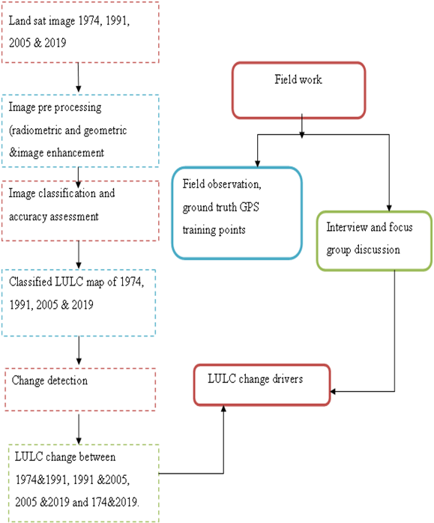
Figure 5: Flow chart that shows the general methodology of this thesis

RESULT AND DISCUSSION

Result of Accuracy Assessment
The accuracy assessment measures what number ground truth pixels were classified properly. Accuracy assessment was very important for understanding the classification results and employing these results for decision-making. Accurate information on LULC changes and the forces and processes behind is essential for designing sound environmental policies and management (Sewunet Amare, 2016).
- Producer’s accuracy:-Producers accuracy assessment was made and it result 96.77% for Cultivation land and 100% for Forest land (Table 2).
- Users’ accuracy: - Users’ accuracy was the percentage of correctly classified from total classified showed 94.49% for Cultivation land and 80% for Settlement area LULC types and the overall classification accuracy was 91.33% (Table 2).
- Conditional kappa coefficient: - the overall kappa statistics was 0.7041 there is 70.41 % better agreement than by chance alone. Scientifically accepted result for kappa statistics defined as poor when kappa coefficient is less than 0.4; good when it was between 0.4 and 0.7 and it will be taken as admirable when kappa coefficient is greater than 0.75 as (Moges & Bhat, 2018).This finding shows that strong agreement was there between classification map and ground truth indicating kappa coefficient ranges of all the LULC change classes were very good and accuracy level of each land cover category was given in (Table 2).

Table 2: The accuracy level and Conditional kappa coefficient of each LULC category
No | LULC Name | Area (ha) | GCP | Reference Totals | Classified Totals | Number Correct | Producers Accuracy | Users Accuracy | Kappa
1 | CL | 29313.9 | 127 | 124 | 127 | 120 | 96.77% | 94.49% | 0.682
2 | GL | 902.42 | 4 | 6 | 4 | 3 | 50.00% | 75.00% | 0.7119
3 | FL | 2506.63 | 11 | 8 | 11 | 8 | 100.00% | 72.73% | 0.7396
4 | SA | 1233.21 | 5 | 7 | 5 | 4 | 57.14% | 80.00% | 0.7902
5 | WL | 562.37 | 3 | 5 | 3 | 2 | 40.00% | 66.67% | 0.6552
 |  | 34518.53 | 150 | 150 | 150 | 137
 | Overall Classification Accuracy = 91.33% |  |  | Overall Kappa  Statistics = 0.7041

CL-Cultivated land, GL-Grass land, FL-Forest land, SA-Settlement area, WL-Wet land

Analysis of LULC change from 1974–2019
During study periods 1974-2019 two land use types namely, cultivation land (84.92 %) and settlement area (3.57 %) increased. During these period forest land lost 3287.79 ha (9.52%), grass land 4518.78ha (13.09%) &wetland 1182.08ha (3.42%) of its original area (Figure, 6). The highest amount of wet land 325.19ha, Grass land 2147.09ha and Forest land 776.21ha lost during1974-1991 period (Table 3). Especially the changed in government in 1991 has exposed the grass land, forest land and wet land areas for expansion of cultivation land.
Concerning LULC rate of change, Table 3 indicate that agricultural land has been extremely increased annually by 2799.6ha, 513.47ha and 1001.23ha during the period, 1974-1991; 1991-2005 and 2005-2019 respectively. Also, the other land use type Settlement area has increased for the period of the study (1974-2019). Differing, the annual rate of forest land, grass land and wetland area depletion significantly increased throughout the periods.
Generally, during the study period 1974-2019, the grassland, forestland and wetland area has converted into other land use type area annually by1205.48ha, 206.57ha and 260.38ha in average respectively (Table 3). But throughout the study period 1974-2019 the settlement area and cultivation land increased by 234.34ha and 1438.1ha in average respectively from its original cover while grassland, forest land and wetland have decreased.
Table 3: Rate of change ha/year in the study area
Class Name | Rate of change in ha/year
Class Name | 1974-1991 | 1991-2005 | 2005-2019 | 1974-2019
CL | 2799.6 | 513.47 | 1001.23 | 4314.30
GL | -2147.09 | -847.09 | -622.27 | -3616.45
FL | -776.21 | -177.52 | -172.57 | -781.16
SA | 448.89 | 164.82 | 89.31 | 703.02
WL | -325.19 | 346.32 | -640.84 | -619.71
CL-Cultivated land, GL-Grass land, FL-Forest land, SA-Settlement area, WL-Wet land

Figure 6: Map of Land use and cover changes in Jimma Rare district 1974–2019
Table4: LULC change classes in the Study Area from 1974-2019
Class Name | 1974 |  | 1991 |  | 2005 |  | 2019
Class Name | Ha | % | Ha | % | Ha | % | Ha | %
CL | 24999.6 | 72.42 | 27799.2 | 80.53 | 28312.67 | 82.02 | 29313.9 | 84.92
GL | 4518.87 | 13.09 | 2371.78 | 6.87 | 1524.69 | 4.42 | 902.42 | 2.61
FL | 3287.79 | 9.52 | 2511.58 | 7.28 | 2334.06 | 6.76 | 2506.63 | 7.26
SA | 530.19 | 1.54 | 979.08 | 2.84 | 1143.9 | 3.31 | 1233.21 | 3.57
WL | 1182.08 | 3.42 | 856.89 | 2.48 | 1203.21 | 3.49 | 562.37 | 1.63
Total | 34518.53 | 100 | 34518.53 | 100 | 34518.53 | 100 | 34518.53 | 100

CL-Cultivated land, GL-Grass land, FL-Forest land, SA-Settlement area, WL-Wet land
Cultivation Land (CL): Evaluation made on current land use in the Jimma Rare district. As in different places of Ethiopia, the greater part of rural HHs of the district get their livelihoods from agriculture, mostly crop cultivation is majority of the land use. Table 4 and Figure 6, showed the land that has been brought under cultivation was significantly high. The land covered by cultivation category included areas of land ploughed for growing rain fed or irrigated, it covered 72.42% of the total area of the study area in 1974 also, extent and its proportional share in the years 1991, 2005, 2019 were, 80.53 %, 82.02 % and 84.92 % respectively. CL has shown increasing trends from 1974 to 2019(Table 4 and Figure 6).
In subsistence agriculture, where the developed technological agricultural input is slight or none existent, yield increases are achieved by bringing more land under agricultural land. Subsistence agriculture is naturally unsuccessful therefore; huge areas of land are needed to meet the needs of rural households Desalegn et al., (2014). As earlier studies indicated, much of the agricultural land expansion targets marginal and ecologically fragile environments such as forests, wetlands, grassland and steep slopes (Terefe Tolessa et al., 2017 Verburg et al., 2015)
Grass Land (GL): Grass lands have been transformed into other land use types. Their proportion decreased from 4518.87ha (13.09%) in 1974, 2371.78ha (6.87%) in 1991, 1524.69ha (4.42%) in 2005 and 902.42ha (2.61%) in 2019. About, 3616.45 ha of this land are converted to cultivation land and settlement area.
Forest Land (FL): was the large LULCC class, with the share of 3287.79 ha (9.52 %) of the total area of the study area in 1974 (Table 9). Forest cover has shown a rapid decrease during the entire study period. The land cover share of the forest has declined to 2511.58ha (7.28%), 2334.06ha (6.76%) and 2506.63ha (7.26%) in 1991, 2005 and 2019 respectively. As elsewhere in Ethiopia, the forest cover of the study area showed a gradual decrease during the study periods (1974-2019). This has revealed that the majority of available forests have changed into other land use units.
Settlements Area (SA): settlements also expanded between the study periods. The proportion of land under settlements constitute 530.19ha (1.54%), 979.08ha (2.84%), 1143.9ha (3.31%) and 1233.21ha (3.57%) in 1974, 1991, 2005 and 2019 respectively. A total of 703.02ha of land have been converted to settlements between 1974 and 2019 (Table4 and Figure 6).
Wet Land (WL): Wet land also changed into other land use types. Their proportion decreased from 1182.08ha (3.42%) in 1974, 856.89ha (2.48%) in 1991, 1203.21ha (3.49%) in 2005 and 562.37ha (1.63%) in 2019. About, 619.71 ha of this land are converted to cultivation land in study district, the findings similar with the study reported by Hussien et al., (2018).

Trends of change in land use and land cover
As reflection of overall study period, cultivated and settlement land has revealed a remarkable areal expand by 12.5% and 2.03% respectively. Contrary to this, Forest land, Grass land and Wetland have diminished by 2.26%, 10.48% and 1.79% respectively in this period (Table 5 and Fig. 6).
In general, the result has indicated a series of LULC change for the last 45 years (1974–2019). In this view, the trend has shown a trend towards more land being brought under cultivated land and settlement area. To the converse, more and more land covered from forest land, grass land and wetlands had transformed to cultivated and settlement areas and declined severely. This related with result of Kindu et al., (2015) and Abate Shifera (2011) who reported a significant increase of agricultural land at the expense of vegetation cover. Speedy declining of area under forest cover and increase in area under agricultural land is also documented in studies conducted in dry and semi-dry land parts of Ethiopia such as Terefe Tolessa et al., 2017, Kibret et al., 2016, Ariti et al., (2015) Mesay Mulgeta (2011) & Efrem Garedew (2010).
Table 5: LULCC change in Percentage 1974-2019
Class  Name | LULCC in Percentage change (1974-2019)
Class  Name | 1974-1991 | 1991-2005 | 2005-2019 | 1974-2019
CL | 8.11 | 1.49 | 2.90 | 12.5
GL | -6.22 | -2.45 | -1.81 | -10.48
FL | -2.24 | -0.52 | 0.5 | -2.26
SA | 1.3 | 0.47 | 0.26 | 2.03
WL | -0.94 | 1.01 | -1.86 | -1.79
CL-Cultivated land, GL-Grass land, FL-Forest land, SA-Settlement area, WL-Wet land

LULC change Matrix
A significant aspect of change finding is to decide what is really changing to what type of LULC type or LULC type is changing to the other type of land use type (Zewdie &Csaplovies, 2015).
LULC matrix involves a pixel to pixel difference of the study year images through overlay analysis; also it depicts the direction of change and land use type that remains originally (Table 6).Therefore, from 1974 to 2019, 2886.96ha (63.89%) of grassland converted to cultivation land, similarly 94.05ha (2.08%) also converted to settlement area. On the other hand, from 1974 to 2019, 263.16ha (22.26%) and 6.57ha (0.56%) of wetland was converted to cultivated land and settlement area respectively likewise, from 1974 to 2019, 353.5ha (29.91%) of wet land converted to other land use category. This implies the speedy expansion of cultivation land at the cost of wetland. These conversions could also be as a result of each natural and artificial factor.
Even though some area gained cultivation land and settlement areas of LULC types, decline was also observed in forest covers, grassland and wetland over the whole study period. The leading contributors for the decline of forest cover was largely due to conversions of original cover into cultivation land 2126.99ha (64.69%), wetland 1.77ha (0.05%) and settlement area 40.5ha (1.23%) as shown in (Table 6).These possibly recognized to over exploitation of forests, the agricultural expansion, deforestation and illegal logging of forest product. These were intensified basically due to population pressure for the last decade as it is stated under the drivers LULC change, at the same time as some portions of the original extent of farming land was simultaneously lost into other LULC classes such as settlement area563.12ha (2.25%), it has been expanded mainly due to area gained from wet land 263.16ha (22.26%), forest land 2126.99ha (64.69%) and grass land 2886.96ha (63.89%) as shown in (Table 6).This is largely associated with encroachment of cultivation land into wetland and original natural forest cover as a result of population pressure.
Population pressures through crop growing in the form of exact cutting of trees for firewood and construction of houses have changed land cover and loss of biodiversity. During the study period between 1974 and 2019 about 26,666.33 ha (77.25%) of the study area land remained unchanged. This imply around 22.75% of the total land of the study area was converted from one LULC type to the other (Table 6). The net perseverance for cultivation land and settlement area was large, while it is closer to zero for the remaining LULC types (Table 6). The net perseverance closer to zero indicates the higher tendency of LULC types to continue rather than decline or increase.
Table 6: LULC classes changed to another LULC classes in 1974- 2019
LULC class | Changed to | 1974-2019 |  | LULC class | Changed to |  | 1974-2019
LULC class | Changed to | Ha | % | LULC class |  |  | Ha |  | %
Cultivation Land | Cultivation Land | 24036.21 | 96.15 | Grass Land | Cultivation Land |  | 2886.96 |  | 63.89
 | Grass Land | 276.21 | 1. 10 |  | Grass land |  | 443.79 |  | 9.82
 | Forest Land | 123.61 | 0.49 |  | Forest Land |  | 1092.77 |  | 24.18
 | Settlement Area | 563.12 | 2.25 |  | Settlement Area |  | 94.05 |  | 2.08
 | Wet Land | 0.45 | 0.002 |  | Wet Land |  | 1.3 |  | 0.03
Total |  | 24999.6 | 100 | Total |  |  | 4518.87 |  | 100
Forest Land | Cultivation Land | 2126.99 | 64.69 | Settlement Area |  | Cultivation Land |  | 0.58 |  | 0.11
 | Grass Land | 20.02 | 0.61 |  |  | Grass land |  | 0 |  | 0
 | Forest Land | 1098.51 | 33.41 |  |  | Forest Land |  | 0.64 |  | 0.12
 | Settlement Area | 40.5 | 1.23 |  |  | Settlement Area |  | 528.97 |  | 99.77
 | Wet Land | 1.77 | 0.05 |  |  | Wet Land |  | 0 |  | 0
Total |  | 3287.79 | 100 |  |  |  |  | 530.19 |  | 100
Wet Land | Cultivation Land | 263.16 | 22.26
 | Grass Land | 162.4 | 13.74
 | Forest Land | 191.1 | 16.17
 | Settlement Area | 6.57 | 0.56
 | Wet Land | 558.85 | 47.28
Total |  | 1182.08 | 100

Socio-economic and demographic characteristics of HH

Sex status of Respondents
The investigation data indicated that 82.6% of the total HHs in the study area was male-headed and the rest 17.4% were female headed HHs during the survey time. 100% of the respondents were born at that place (Table 7).
Table 7: Sex status of Respondents
Sex of Respondents. | Frequency | Percent
Female | 31 | 17.4
Male | 147 | 82.6
Total | 178 | 100.0

Age of Respondents
It is supposed that the different age groups respond differently to the existence of land cover resource. The elder people more open- mind and often, express the need to have conserved resource, dissimilar the youth whose major interest is create economic benefit out of natural resource. This has influenced people’s participation in different natural resource management practices. As indicated in (Table8) about 67.4% of respondent were aged between 31-64 years old; 17.4% of respondent were aged below or equal to 30 years old, 15.2% greater or equal to 65 years. This indicates that, as it is true for Ethiopia and some other developing countries especially in Sub-Sahara Africa, the population is predominantly young. This, in turn, indicates the existence of high fertility rate.
Table: 8 Age category of Respondents
Age group of Respondents. | Frequency | Percent
15-30 | 31 | 17.4
31-64 | 120 | 67.4
> 64 | 27 | 15.2
Total | 178 | 100.0

Marital Status and Family Size of Respondents
Marital status is an important variable affecting fertility behavior since most of the births take place within marital union. So the change in the distribution of marital status has an important bearing on the size and structure of families and households. The investigation at three kebeles: S/Gamachisa, K/kalo and K/Konte has revealed that 76.4% of the sampled respondents were married, 3.4% single and the remaining 14% and 6.2% were divorced and widowed respectively. Table 9 below indicates that, the majority of the respondents (61.8%) have family size ranging from 6-10 children and about 21.3% of respondents have family size 3-5, the rest 8.4% ,5.1% and 3.4% have >10 ,<3 and 0 family size respectively. The average family size of the individual households in the study area as a whole is 6.9. However, it ranges widely from 2 to 12(Table9). According to the report of MOA (2003) population pressure has negatively impact on the vegetation due to additional search for agricultural land expansion.
Table 9: Marital Status and Family Size of Respondents
Marital Status | Frequency | Percent |  | Family size | Frequency | Percent
Single | 6 | 3.4 |  | <3 | 9 | 5.1
Married | 136 | 76.4 |  | 3-5 | 38 | 21.3
Divorced | 25 | 14 |  | 6-10 | 110 | 61.8
Widowed | 11 | 6.2 |  | >10 | 15 | 8.4
 |  |  |  | Have not(0) | 6 | 3.4
Total | 178 | 100.0 |  | Total | 178 | 100.0

Educational Status and Main Source Income of Respondents
Among the respondents, 38.2% of the respondents cannot read and write those who have received primary education, secondary; diploma and degree contain 42.7%, 16.9%, 1.7% and .6% respectively (Table 10). As indicated in Table 9, the majority of the surveyed three kebeles: S/Gamachisa, K/kalo and K/Konte households were engaged in farming activities (98.9%).The farm income includes the sale of rain fed crops, irrigated crops and sales of livestock and its products and some of them, 1.1% were engaged in some form of off-farm activities like trading, selling charcoal and wood and income earned from households’ labor supplied outside their own farm plot etc
Table10: Educational Status &Main source income
Education level of Respondents | Frequency | Percent | Main Source of Respondents Income | Frequency | Percent
Illiterate | 68 | 38.2 | Agriculture | 176 |  | 98.9
Primary (1-8) | 76 | 42.7 | Both Agriculture and non agriculture | 2 |  | 1.1
Secondary (9-12) | 30 | 16.9
Diploma | 3 | 1.7
Degree | 1 | .6
Total | 178 | 100.0 | Total | 178 |  | 100.0

Land holding Size of Respondents
Table 11 show that, about 18%, 38.2%, 25.8%, 5.1%and 12.9% of respondents have <0.5ha, 0.5-2ha, 2.1-3.5ha, 3.6-5ha and >5ha respectively. The farm size of households for the study area is small. Based on the survey, land holdings of households in the study area varied from 0.25 ha to 5.75 ha with an average holding size of 2.1ha per household.
Table 11: Land Holding Size of Respondents in hectare
Land Holding Size |  | Frequency | Percent
 | <0.5 | 32 | 18.0
 | 0.5-2 | 68 | 38.2
 | 2.1-3.5 | 46 | 25.8
 | 3.6-5 | 9 | 5.1
 | >5 | 23 | 12.9
 | Total | 178 | 100.0

Long term trend of LULC Dynamics

Perception of respondents about LULC dynamics
Table 12, reflect farmer’s views on the proportion of cultivated land and settlement areas were good during 1974 and reached its climax in 2019s. More than 72.5% of the respondents confirmed that the proportion of cultivated land and settlement areas at present is significantly high (Table 12). Converse to the cultivation land and settlement areas, forest land, wetland and grassland were once abundant was significantly decreased and as indicated in Table 12, 72.5% respondents confirmed that Forest land, wetland and Bare land deteriorated seriously in the study district and FGD reveal that wet land is become decreasing in the study area. Rural population used wetland for the purpose of irrigation practices, for thatching of houses granaries or outbuildings. In the study district settlement expansion follows a similar trend like population increase and agricultural expansion. For that reason, cultivated land and settlements areas were small during the 1974 and it tended to increase in 2019, as shown (figure6). This is confirmed by 72.5% of respondents and FGD.
The land under forest land, wetland and bare land decreased continuously as shown from satellite image of 1974-2019. About 72.5% of respondents and FGD also confirmed that the decreasing trend of forestland. However the largest part of lands that were covered by vegetation and forest before 40 years now replaced by agriculture and settlement. In agreement to the finding of this research, studies conducted in dry and semi-dry land parts of Ethiopia such as Efrem Garedew (2010), Meze-Hausken (2004) and erhane et al., (1999) documented reduction of area under vegetation and forestland and increase in area under agricultural land. Rapid reduction in woodland and forest and increase in agriculture and settlement were also reported by Mengiste Kindu et al., (2013) in Munessa Shashemene landscape of the Ethiopian highlands.
Table 12: How the respondents perceive the LULC change in the last 1974-2019 in the study area?
LULC classes | Respondent’s perception the change in LULC classes? | Frequency | Percent
Cultivated Land and  Settlement area | Increased | 129 | 72.5
Cultivated Land and  Settlement area | Decreased | 46 | 25.8
Cultivated Land and  Settlement area | No change | 3 | 1.7
Cultivated Land and  Settlement area | Total | 178 | 100.0
Forestland, Wetland and Grass land | Increased | 46 | 25.8
Forestland, Wetland and Grass land | Decreased | 129 | 72.5
Forestland, Wetland and Grass land | No change | 3 | 1.7
Forestland, Wetland and Grass land | Total | 178 | 100.0

Mechanism of obtaining agricultural land
About 27%, 5.6%,13.5%,6.7%,14%, 15.7% and 17.4%of the respondents obtained agricultural land by Inheritance, Clearing Vegetation, Contract, Crop sharing, Government, Inheritance and Government & Inheritance, Clearing Vegetation and Government respectively(Table 13). A related problem is that those poor farmers who do not own the land they farm on, so they do not care much about land cover change and promote conservation practice rather they expand their farm to the forest boundary.
Table 13: How Respondents Posses their own land?

Mechanism of obtaining agricultural land |  | Frequency | Percent
 | By Inheritance | 48 | 27.0
 | By Clearing Vegetation | 10 | 5.6
 | Contract | 24 | 13.5
 | Crop sharing | 12 | 6.7
 | By Government | 25 | 14.0
 | Inheritance and Government | 28 | 15.7
 | Inheritance, Clearing Vegetation and Government | 31 | 17.4
 | Total | 178 | 100.0

Main source of fuel for cooking and heating
As any other developing countries, farming communities in Jimma Rare district have used fire wood and charcoal for heating or cooking .As respondent revealed that cause for decline of forest resource in the study area is the frequent collection and production of fuel wood and charcoal as being sources of energy. Table 14 show that, About 77.5% , 1.7% & 20.2%of the respondents rely on collecting fire wood, charcoal and both firewood and charcoal from the nearby forests and this has become so series especially during dry seasons when the price of charcoal and fuel wood rise up. Very less (0.6%) respondents uses agriculture residue. Majority of the farming communities uses trees as sources of product presently, people around the forest have use the whole stem 41% natural forest for household energy consumption and home material. Survey results of this study show that 30.9% of the respondent uses natural forest (common wood lands) as energy sources and any other product like house constructions and material (Table 14).

Table 14: Main Source of Fuel used for cooking and heating purpose
Main source of fuel for cooking and heating | Frequency | Percent
Fire wood | 138 | 77.5
Charcoal | 3 | 1.7
Agricultural residues | 1 | .6
Both Fire wood and Charcoal | 36 | 20.2
Total | 178 | 100.0
Main sources of forest product | Frequency | Percent
Own farm | 82 | 46.1
Other farms | 33 | 18.5
Common wood land | 55 | 30.9
Market | 7 | 3.9
Own farm and other farms | 1 | .6
Total | 178 | 100.0
Part of tree used for different purposes | Frequency | Percent
Deadwood | 19 | 10.7
Living branches | 37 | 20.8
Tree stumps | 49 | 27.5
The whole stem | 73 | 41.0
Total | 178 | 100.0

Perception of HHs on population growth
Melese, (2016) discussed as, over 80 % of the world’s population as well as98 % of the world population growth is currently occurring in developing countries. Also Africa, and particularly Sub-Saharan Africa, has shown growth rates in excess of 2.5 % and total fertility rates that exceed 5% (Population Reference Bureau, 2012). In three investigated kebeles HHs were asked to explore their perception on population increases 38.8 % of respondents’ revealed that very high, 54.5% high and 6.7%low population growth was occurred, in study area (Table 15). As FDG reports, the rapid increase of the population could be partially explained by having of more than one wives and practiced in the study area.
Table 15: Perception of respondents on population growth
Perception of respondents | Frequency | Percent
Very High | 69 | 38.8
High | 97 | 54.5
Low | 12 | 6.7
Total | 178 | 100.0

Number and Trend of Livestock
It is a well-known practice in Ethiopia to mix crop production and rearing of animals. The latter is conducted for various purposes including prestige, source of income, draught power, and sources of manure. In the study area rearing of animals is as important as other agricultural activities. Table16 showed that, the number of farm households involved in livestock rearing were large. In this study farmers owned a wide range of livestock types that including cattle, sheep, goats, horse, and mule, donkey and chicken. 27% of respondents have <5 live stocks, 30.9%, 25.8% and 16.3% have 5-10, 10-20 and >20 respectively.
FGD and survey result indicates that trend of change in the number of livestock is declining from time to time in the study area. In view of this, 70.8% of farm households confirmed that the number of livestock is decreasing. FGD have also clearly indicated that there is shortage of grazing land. One of the reasons mentioned by farmer households is that more and more land was brought under cultivation due to trigger the need for additional agricultural land to fulfill their daily livelihood.

Table 16: The Number and trend of change of Livestock
Number of  Live stocks | Frequency | Percent | Trend of change | Frequency | Percent
<5 | 48 | 27.0 | Increasing | 37 | 20.8
5-10 | 55 | 30.9 | Decreasing | 126 | 70.8
10-20 | 46 | 25.8 | No change | 12 | 6.7
>20 | 29 | 16.3 | Not Known | 3 | 1.7
Total | 178 | 100.0 | Total | 178 | 100.0

Land Availability
The population of the study area is mostly depending on agriculture (JRNRAO, 2019). Thus, land is an important asset to practice different agricultural activities. Farmer households were asked to respond whether or not land in the study area is a scare resource. To this end, the majority of respondents responded that land is a scarce resource, confirmed by 91.0% of surveyed respondents. Small proportion (9.0%) of respondents, feels that land is no changed resource (Table17).
Table 17: Availability of Land
Land is become scarce in your Keble? | Frequency | Percent
Yes, it is becoming scarce | 162 | 91.0
No Change | 16 | 9.0
Total | 178 | 100.0

Reason of Land Scarcity
Respondents were also asked to give their views on the possible reason(s) for land scarcity and 83.7% respondents state that populations increase is the most important cause (Table 18). This has resulted in the use of large tracts of land for cultivation and widespread clearing of forest for fuel, house construction, and charcoal as alternative source of income. On the other hand, respondents who assume that because of the proportion of fertile land is diminishing constitute 83.7%. The equivalent share for Land has been converted to non-Agricultural use was supported by 5.6%.
Table 18: Reason of Land Scarcity
Reason of land Scarcity |  | Frequency | Percent
Land has fallen in fewer hands |  | 18 | 10.1
Population increase and proportion of fertile land is diminish |  | 149 | 83.7
land has been converted to non-agricultural use |  | 11 | 6.2
Total |  | 178 | 100.0
Farmers have native knowledge to solve problems related to agriculture including land scarcity. In view of this reality, Table 18 indicates that, household respondents were asked to give their practice of how to overcome land scarcity. To this effect, 46.1% farm households favor engaging on off farm activities where as opting for farming steep slope was claimed by 17.4%. Furthermore, clearing more woodland as a strategy of alleviating land scarcity is supported by 25.3% of the respondents both clear vegetation and farming steep slope about 11.2%. During focus group discussions it was stated that some farmers who have no land are engaged in off farm activities like daily laborer in the nearby towns.
Table 19: Mechanism of solving the problem of land scarcity
How did you solve land Scarcity? |  | Frequency | Percent
Clear more wood land |  | 45 | 25.3
Plough steep land |  | 31 | 17.4
Look for Off-farm employment |  | 82 | 46.1
Clear vegetation and Plough steep land |  | 20 | 11.2
Total |  | 178 | 100.0

Drivers of LULC change

Direct Drivers of LULC change
Among all 8 drivers were supposed by the HHs three of them as being significant direct drivers of LULC dynamics in the study area. More of the respondents, 95.5% supposed farm land expansion as the main drivers of LULC dynamics. As reported from discussion and interview with FGD expansion of agriculture including crop farming and other cash crops are the major drivers of LULC dynamics in study area (Figure 5).
This finding was agreed with Sahle &Yeshitela, (2018), Melese, (2016) and Wubie et al., (2016). They reported that expansion of agricultural land is major driver of LULC dynamics. The land sat image analysis of the study area more revealed that of the total 13,225.43 ha of land that undergo conversion, farmland constituted 68.5% indicating that agricultural expansion is important proximate cause for LULC change in the study area.
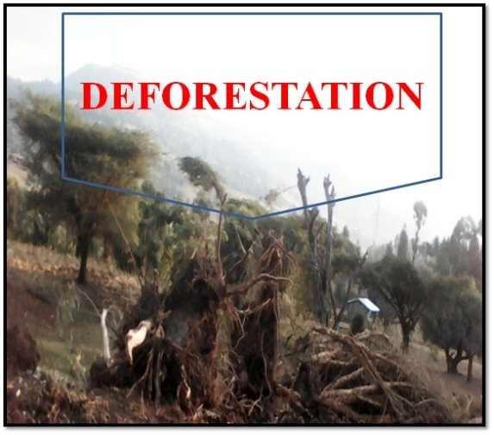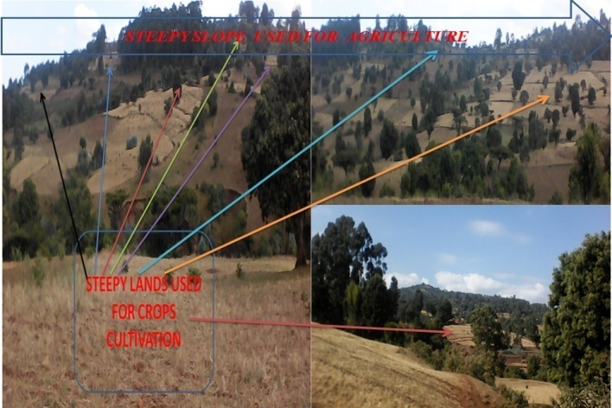
Figure8: Deforestation and ploughing steep slope used for expansion of agriculture (Jimma Rare Field Observation, 2020)
According to the investigation result and field observation a multiple drivers contributed to land cover modification within the study area. Comparable to the remote sensing data results, investigation results were shown that forest cover and wet land, were decreased. The majority of the respondents reported that fuel wood collection, house construction (settlement), land degradation, over grazing and charcoal making, i.e. 93.3%, 90%, 88.8%, 88.8%, and 87.3% respectively, as also important direct causes for the observed LULC dynamics in the study area. It was also understood from the explanation of the elder people during the FGDs and figures 6 indicate fuel wood extraction in the form of charcoal and fire wood is also a major driver for the diversion of forest in study area. The result of this study is agreed with Alemu et al., (2015). He reported that cause for decline of forest resource is the frequent collection and production of fuel wood and charcoal as being sources of energy. Kindu et al., (2015) found similar results at south central high lands of Ethiopia forest priority area, Ethiopia who stated that firewood and charcoal productions are major causes of forest cover change. Fuel wood collection and charcoal production were the main degradation drivers in Ethiopia (Sahle &Yeshitela , 2018).
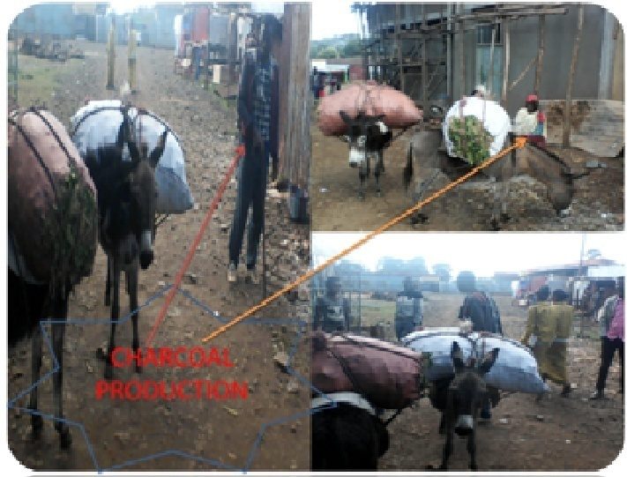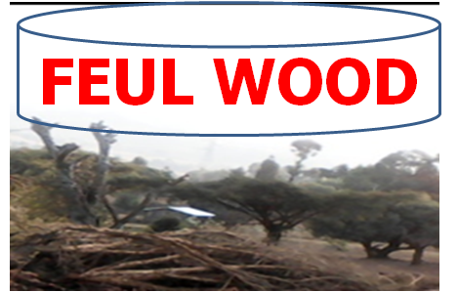
Figure 9: Charcoal production and Fuel wood extraction in study area (Jimma Rare Field Observation, 2020)
As indicate in Figure10, land degradation is the driver of LULC dynamics. About 88.3% of the respondents and FGD confirm that land degradation is the driver of LULC dynamics. Because of small land holding size and shortage of land in the study area farming of steep slopes is contributing to land degradation this result is similar with (Wubie et al., 2016).

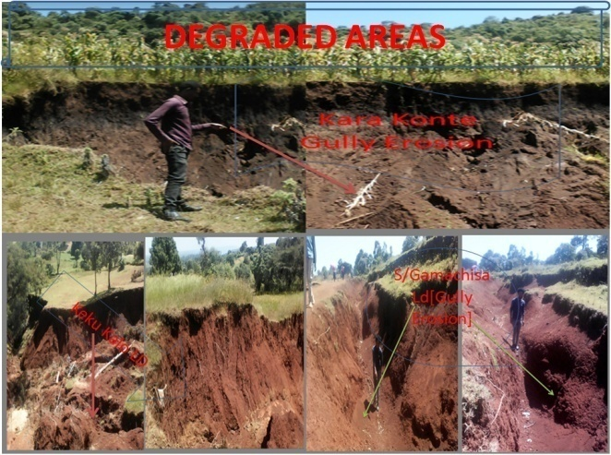
Figure 10: Degraded land (Jimma Rare Field Observation, 2020)
Over grazing was also viewed by respondents as one of the important drivers for changes in the study area. Cattle are allowed to graze on the remaining crop stalks on the cultivation land after harvest and on communal grazing lands. However, with detailed discussion among the FGD members, the currently existing grazing land is under the carrying capacity of their livestock, which is associated to declining area of grazing land over time .They pointed out that cultivation land and settlement expansion are responsible for the conversion(Figure 11). As a result, they confirmed that there are farmers who are sending their cattle to the remaining forests, which they also did not view as a sustainable system.
a) 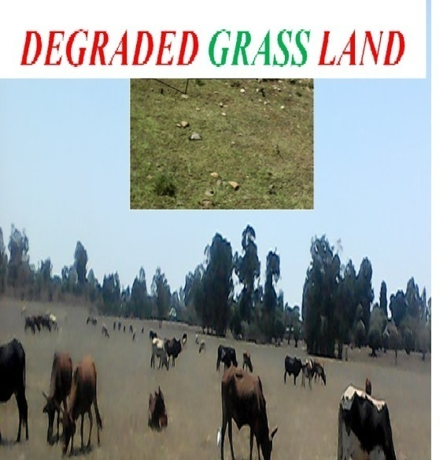b)
Figure 11: a) Degraded communal grazing land over time b) grazing land converted to settlement area (Jimma Rare Field Observation, 2020)
About 58.2% of respondents and figure 12 show that timber trade is another prominent problem threatening the forest cover of the study area where inhabitants cut off huge amount of trees. Rapid increase of human population demanding huge amount of timbers for construction purpose in the town have also triggered series illegal logging forest. This has been triggered by the general increase in price of the timber in the town. Although the government has put strong rules and regulation on preventing illegal logging people have been still involved in cutting trees in the study area.
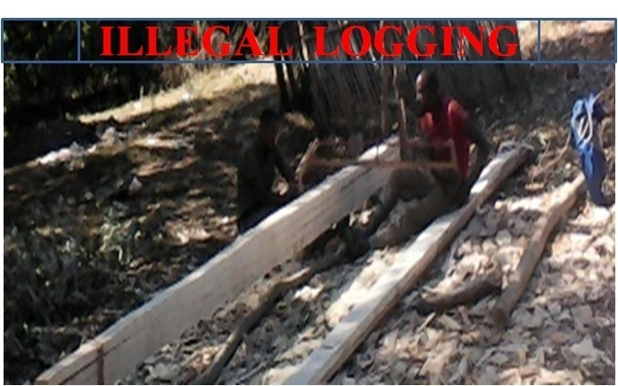
Figure 12: Illegal logging of tree for timber (Jimma Rare Field Observation, 2020)
Construction of infrastructures like school and roads also contributed for the conversion of grazing land. Some 29.2%, 19.1%, 15.7%, of the respondents argued that the Agricultural land expansion, Deforestation and expansion of rural and urban settlement areas were the causes of LULC dynamics in the Jimma Rare (Table, 20). Previous studies also highlighted that better market and road infrastructure availability were driving forces of LULC changes (Belay et al., 2014 and Gessesse & Bewket 2014).

Table 20: Proximate drivers of LULC dynamics (Jimma Rare, Field survey, 2020)
What are Proximate Causes of LULCC? | Frequency | Percent
Agricultural land expansion | 52 | 29.2
Deforestation | 34 | 19.1
Settlement | 28 | 15.7
Infrastructure development | 12 | 6.7
Charcoal production | 17 | 9.6
Over grazing | 15 | 8.4
Land degradation | 10 | 5.6
Timber Production | 8 | 4.5
All | 2 | 1.1
Total | 178 | 100.0

Indirect Drivers of LULC change
This investigation revealed about 42.13% respondents confirmed that of population growth is the primary of all underlying drivers of LULC change recognized in the Jimma Rare District. This investigation similar with the research result of Siraj Mamo (2018),Sahle &Yeshitela, (2018) and Tsehaye Gebrelibanos&Mohammed Assen (2015). They discussed as population pressure is one of the major underlying drivers of LULC change in different parts of Ethiopia. FGD participant supposed that population of Jimma Rare has been increasing from time to time. The insight of respondents is agreement with CSA reports that show an increase in total population of the study area. In 1994 the total population in the study area was 39,924 (CSA, 1994). In 2019 it increased to 80,437 with population density of 233 person/ km² (CSA, 2017). This implies that between these two years the number of population in study area increased by about 40,513 with yearly rate of about 1,621 persons / year. The land cover conditions of the Ethiopia have also been modified or significantly transformed by the rapidly increasing population pressure and growing livestock population (Melese, 2016). The rapid population growth increases the demand for land for agricultural activities and biomass as the source of fuel and construction materials. This in turn resulted in forest and wetland encroachment for settlement, new agricultural land and fuel wood extraction.
Policy and institutional factors also found to be underlying drivers of LULC change accounted about 29.78% respondents. Information obtained from FGD policy during the Derge regime was people were clustered in small towns which known as “Sefera” and the resettlement policy contributed to expansion of settlements and agriculture. National and regional policies on land use and economic development such as infrastructural expansion (e.g. roads, schools, markets etc.), attained food self-sufficiency through investment on agriculture are the other factors contributing to LULC change. Not have of proper land use plans is another policy related driver of forest and vegetation cover change. It is characterized by encroachment of vegetated lands especially forest, wetland and cultivation of steep slope. Weak law enforcement is also crucial driver of LULC change. Information obtained from FGD indicate that manifestations of weak law enforcements in the study area were corruption, and delay in decision making by the courts. Participants of the FGD informed that change in land tenure system was another policy related driver of forest and vegetation cover change. In 1973 and subsequent years, in Ethiopia, there was a change in the feudal regime to a military regime (Terefe Tolessa et al., 2017). The military regime proclaimed the nationalization of all rural land by abolishing private and common property of the land, thereby giving a usufruct rights for all. This policy made land and land related resources absolutely owned by the state, which in turn was unable to monitor and enforce laws. As a result, forest land was converted to settlements, agricultural land and highly degraded because of low level of land management practices. The current government, Ethiopian People Revolutionary Democratic Front (EPRDF), also maintains the same status, where land is the property of the nations, nationalities and people of Ethiopia according to Article 40(3) of the constitution endorsed in 1994 (FDRE, 1994). This makes land related resources to be easily changeable to agricultural land, however in the study area participants of the FGD agreed that farmers are still lacking confidence and feel as they have no right over their land. This joined with a very low land holding per household motivated local farmers to invade in to vegetated lands for cropping, grazing and settlement.
Poverty, unemployment due to lack of off-farm jobs (especially for landless and educated youth) and change in rural economic activities are the economic causes of LULC changes in study area. About 14.61% respondents and focus group discussants stated that these were the major underlying economic factors behind the expansion of agriculture illegal logging and fuel wood extraction in the form of charcoal and fire wood. Owing to lack of off-farm employment opportunities adults in study area remain in their area as unemployed. This resulted in land fragmentation due to sharing of lands from their families and encroachment of forest in search of new cultivation land and fuel wood. Hence in the study area those economically poor and landless households were engaged in fuel wood extraction in the form of charcoal and firewood to fulfill the livelihood requirement of their family. To show the role of poverty on environmental change the World Commission on Environment and Development pointed out that people who are poor and hungry always destroy their immediate environment in order to survive (Belay et al., 2014).
Socio-cultural factors, an important underlying driving force of LULC change, represented by 11.24% of respondents. Lack of awareness about the negative impacts of forest conversion, distribution of land and other resource are the socio-cultural causes for the expansion of agricultural lands at the expense of other LULC types mainly wetland, grassland and forest.
Biophysical factor careful was flood, another underlying driving force of LULC change, identified by 2.25% of respondents and FGD particularly in highland of the district like K/Kalo. In summer session, when more rain is overcome this biophysical factor is appeared. Because of this factor the soil fertility and land covered by crops is eroded. As FGD indicates that, at this time more people extract fire wood and charcoal to fulfill their livelihood necessity of their family. This calls attention to the threats of forest land.
Table21: Underlying Causes of LULC dynamics (Jimma Rare, Field survey, 2020)
What are Underlying causes of LULCC? |  | Frequency | Percent
 | Population Growth | 75 | 42.13
 | Policy and Institution | 53 | 29.78
 | Income | 26 | 14.61
 | Socio - Cultural | 20 | 11.24
 | Bio-Physical | 4 | 2.25
 | Total | 178 | 100.0

CONCLUSION AND RECOMMENDATION

Conclusion
Land use and land cover changes specifically deforestation has been a global concern, with an difficult implications for human livelihood systems. Long -term land use and land cover (LULC) changes information is essential to understand the trends and make necessary land management interventions, such as in the highlands of Ethiopia. The changes in land use-cover worsen land degradation. The land use-cover change observed in Ethiopia has a negative impact on the environment settings. Decline of forest, shrub and grass lands accelerates soil erosion and subsequently results in decline of agricultural productivity as cultivated land expansion at the cost of natural vegetation bring out soil erosion. Cultivated land expansion at the cost of grass land adversely affects animal rearing practice and in turn additional income from animal and animal products sale.
LULC change in study area was also driven by a combination of proximate and underlying causes. Agricultural land expansion, deforestation for fuel wood and charcoal consumption, constructions of infrastructures, overgrazing and expansion of rural and urban settlement were among the major proximate causes. Similarly, major underlying drivers include population pressure, policy and institutions, income, socio-cultural and biophysical factors that drivers of LULC changes were identified by HHs interview and FGD of this study.
Remote sensing and GIS are beneficial tools for monitoring and evaluating temporal and spatial LULC changes. Analyses of LULC changes over four decades using these tools revealed that there were significant LULC changes in the area during the 1974-2019 reference years. The most important changes were forest land; wet lands and grass land are continuously declining. On the converse, cultivated land and settlement area were main land use types over the study period kept on expanding dramatically.

Recommendation
The following issues are recommended based on findings of study,:
- Agricultural land expansion by small holder farmers is the major proximate causes of LULC dynamics in study area causing loss of several hectares of forest, grassland and wetland. Therefore, controlling the expansion of agriculture at the expense of forest, grass land and wetland requires the right policy packages by national and regional governments for livelihood diversification and improving production and productivity of existing farm lands through improved technologies.
- Change major source of domestic energy for cooking and heating in the study area which comes from cutting trees for fuel wood majorly causes LULC changes in the study area. Alternative energy saving technologies be supposed to provided by concerned bodies for HHs.
- Control an alarming population growth and its related impacts on the natural resources, because of population growth is the major cause for LULC change in the study area. Illegal practices such as early marriages, polygamy (practice having more than one wife) and misunderstanding about family planning services are the reasons for population growth. So it requires the right policy packages by national and regional governments such as awareness creation and increasing productivity.
- Develop projects like REDD+, PFM, SLM and apply SWC practices and sustainable managements of the remaining resource.
- Make sure management system assurance to return to the communities that management the coverage and sustainable use of the resource in the study area.
- Decision makers should give due attention to the problems and make suitable interventions. Maximizing agricultural productivity by intensification with technology, creating off/non-farm job opportunities in the rural villages and encouraging community participation in the protection of the destruction of forest, shrub and grass lands as well as rehabilitating of bare lands need to be considered.

REFERENCES
Alemu, B., Garedew, E., Eshetu, Z., & Kassa, H. (2015). Land use and land cover changes and associated driving forces in north western lowlands of Ethiopia. International research journal of agricultural science and soil science, 5(1), 28-44.
Anderson, J. R. (1976). A land use and land cover classification system for use with remote sensor data (Vol. 964). US Government Printing Office.
Ariti, A. T., van Vliet, J., &Verburg, P. H. (2015). Land-use and land-cover changes in the Central Rift Valley of Ethiopia: Assessment of perception and adaptation of stakeholders. Applied Geography, 65, 28-37.
Ayele, H. (2011). Land use/land cover change and impact of Jatropha on soil fertility: the case of Mieso and Bati Districts, Ethiopia (Doctoral dissertation, Haramaya University).
Belay, S., Amsalu, A., &Abebe, E. (2014). Land use and land cover changes in Awash National Park, Ethiopia: impact of decentralization on the use and management of resources. Open Journal of Ecology, 4(15), 950.
Bewket, W. (2002). Land cover dynamics since the 1950s in Chemoga watershed,
Blue Nile basin, Ethiopia. Mountain Research and Development, 22(3), 263-270.
Briassoulis, H. (2000, 2011). Analysis of land use change: theoretical and modeling approaches.
Burka, A. (2008). Land Use/Land Cover Dynamics in Prosopis juliflora invaded area of Metehara and the Surrounding Districts Using Remote Sensing and GIS Techniques. Faculty of science, RS & GIS, Department of Earth Science, AAU.
Campbell, D. J., Lusch, D. P., Smucker, T. A., & Wangui, E. E. (2005). Multiple methods in the study of driving forces of land use and land cover change: a case study of SE Kajiado District, Kenya. Human Ecology, 33(6), 763-794.
Carr, D. L. (2004). Proximate population factors and deforestation in tropical agricultural frontiers. Population and environment, 25(6), 585-612.

Chrysoulakis, N., Abrams, M., Feidas, H., & Velianitis, D. (2004). Analysis of ASTER multispectral stereo imagery to produce DEM and land cover databases for Greek islands: the REALDEMS project. Proceedings of e-Environment: Progress and Challege, 411-424.
Colomer, J. F., Henrard, L., Van Tendeloo, G., Lucas, A., & Lambin, P. (2004). Study of the packing of double-walled carbon nanotubes into bundles by transmission electron microscopy and electron diffraction. Journal of Materials Chemistry, 14(4), 603-606.
Davies, R. G., Barbosa, O., Fuller, R. A., Tratalos, J., Burke, N., Lewis, D., ... & Gaston, K. J. (2008). City-wide relationships between green spaces, urban land use and topography. Urban Ecosystems, 11(3), 269.
Dejene, A. (2003). Integrated natural resources management to enhance food security. The case for community-based approaches in Ethiopia. Environment and natural resources working paper, 16.
Desalegn, T., Cruz, F., Kindu, M., Turrión, M. B., & Gonzalo, J. (2014).Land-use/land- cover (LULC) change and socioeconomic conditions of local community in the central highlands of Ethiopia. International Journal of Sustainable Development & World Ecology, 21(5), 406-413.
De Sherbinin, A. (2002). A guide to land-use and land-cover change (LUCC). A collaborative effort of SEDAC and the IGBP/IHDP LUCC Project, USA.
Desta, L. (2000). Land degradation and strategies for sustainable development in the Ethiopian highlands: Amhara Region (Vol. 32). ILRI (aka ILCA and ILRAD).
De Sy, V., Herold, M., Achard, F., Beuchle, R., Clevers, J. G. P. W., Lindquist,E., & Verchot, L. (2015). Land use patterns and related carbon losses following deforestation in South America. Environmental Research Letters, 10(12), 124004.
Douglas, I. (1994). Human settlements. Changes in land use and land cover: a
global perspective, 149-169.
Ebro, A., Shenkute, B., Haile, G., Sauerborn, J., & Treydte, A. (2011). Land use land cover dynamics in the rift valley of Ethiopia: Implications on food security. FSC brief, 12.

Ellis, J. T., Spruce, J. P., Swann, R. A., Smoot, J. C., & Hilbert, K. W. (2011). An assessment of coastal land-use and land-cover change from 1974–2008 in the vicinity of Mobile Bay, Alabama. Journal of Coastal Conservation, 15(1), 139- 149.
erhane, Y., Mekonnen, E., Zerihun, L., &Asefa, G. (1999). Perception of fertility regulation in a remote community, South Ethiopia. The Ethiopian Journal of Health Development (EJHD), 13(3).
Foley, J. A., DeFries, R., Asner, G. P., Barford, C., Bonan, G., Carpenter, S. R., ... & Helkowski, J. H. (2005). Global consequences of land use. science, 309(5734), 570-574.
Garedew, E., Sandewall, M., Söderberg, U., & Campbell, B. M. (2009). Land-use and land-cover dynamics in the central rift valley of Ethiopia. Environmental management, 44(4), 683-694.
Garedew, E. (2010). Land-use and land-cover dynamics and rural livelihood perspectives, in the semi-arid areas of Central Rift Valley of Ethiopia (Vol. 2010, No. 7).
Gashaw, T., & Fentahun, T. (2014). Evaluation of land use/land cover changes in East of Lake Tana, Ethiopia. Environ. Earth Sci, 4(11).
Gashaw, T., & Dinkayoh, T. (2015). Land use/land cover dynamics in Hulet Wogedamea Kebele, northern Ethiopia. Current Research in Agricultural Sciences, 2(1), 36-41.
Gebrehiwot, S. G., Taye, A., & Bishop, K. (2010). Forest cover and stream flow in a headwater of the Blue Nile: complementing observational data analysis with community perception. Ambio, 39(4), 284-294.
Gebreslassie, H. (2014). Land use-land cover dynamics of Huluka watershed,Central Rift Valley, Ethiopia. International Soil and Water Conservation Research, 2(4), 25- 33.
Geist, H. J., & Lambin, E. F. (2002). Proximate Causes and Underlying Driving
Forces of Tropical DeforestationTropical forests are disappearing as the result of many pressures, both local and regional, acting in various combinations in different geographical locations. BioScience, 52(2), 143-150.
Geist, H., McConnell, W., Lambin, E. F., Moran, E., Alves, D., & Rudel, T. (2006). Causes and trajectories of land-use/cover change. In Land-use and land-cover change (pp. 41-70). Springer, Berlin, Heidelberg.
Geremew, A. A. (2013). Assessing the impacts of land use and land cover change on hydrology of watershed: a case study on Gigel-Abbay Watershed, Lake Tana Basin, Ethiopia (Doctoral dissertation).
Gessese, B. H. (2018). Drivers of land use/land cover change in the Guraferda district of Bench- Maji Zone, southwestern Ethiopia. Journal of Ecology and Environmental Sciences, 6(1), 52-62.
Gessesse, B., &Bewket, W. (2014). Drivers and implications of land use and land cover change in the central highlands of Ethiopia: Evidence from remote sensing and socio-demographic data integration. Ethiopian Journal of the Social Sciences and Humanities, 10(2), 1-23.
Girma, H. M., & Hassan, R. M. (2014). Drivers of land-use change in the Southern Nations, Nationalities and People’s Region of Ethiopia. African Journal of Agricultural and Resource Economics, 9(311-2016-5578), 148-164.
Girmay, W., Tesfaye, B., Seifu, W., & Elias(2017), E. Effect of Land Use/Cover Changes on Ecological Landscapes of the Four Lakes of Central Rift Valley Ethiopia.
Gruber, S., & Peckham, S. (2009). Land-surface parameters and objects in hydrology. Developments in Soil Science, 33, 171-194.
Guide, E. F. (1999). Earth resources data analysis system. ERDAS Inc. Atlanta, Georgia, 628.
Hamza, I. A., & Iyela, A. (2012). Land use pattern, climate change, and its implication for food security in Ethiopia: a review. Ethiopian Journal of Environmental Studies and Management, 5(1), 26-31.
Hartemink, A. E. (2010). Land use change in the tropics and its effect on soil fertility. In Proceedings 19th World Congress of Soil Science, Brisbane, Australia, 01-06 August, 2010 (pp. 55-58).

Hodgson, M. E., Jensen, J. R., Tullis, J. A., Riordan, K. D., & Archer, C. M. (2003). Synergistic use of lidar and color aerial photography for mapping urban parcel imperviousness. Photogrammetric Engineering & Remote Sensing, 69(9), 973- 980.
Hurni, H., Abate, S., Bantider, A., Debele, B., Ludi, E., Portner, B., ... & Zeleke, G. (2010). Land degradation and sustainable land management in the highlands of Ethiopia.
Hussien, K., Demissie, B., &Meaza, H. (2018).Spatiotemporal wetland changes and their threats in North Central Ethiopian Highlands. Singapore Journal of Tropical Geography, 39(3), 332-350.
Houghton, R. A. (1994). The worldwide extent of land-use change. BioScience, 44(5), 305-313.
Houghton, R. A., House, J. I., Pongratz, J., Van Der Werf, G. R., DeFries, R. S., Hansen, M. C., ... & Ramankutty, N. (2012). Carbon emissions from land use and land- cover change. Biogeosciences, 9(12), 5125-5142.
Kibret, K. S., Marohn, C., &Cadisch, G. (2016). Assessment of land use and land cover change in South Central Ethiopia during four decades based on integrated analysis of multi-temporal images and geospatial vector data. Remote Sensing Applications: Society and Environment, 3, 1-19.
Kindu, M., Schneider, T., Teketay, D., &Knoke, T. (2015). Drivers of land use/land cover changes in Munessa-Shashemene landscape of the south-central highlands of Ethiopia. Environmental monitoring and assessment, 187(7), 452.
Lambin, E. F., Turner, B. L., Geist, H. J., Agbola, S. B., Angelsen, A., Bruce, J. W., ... & George, P. (2001). The causes of land-use and land-cover change: moving beyond the myths. Global environmental change, 11(4), 261-269.
Lambin, E. F., & Meyfroidt, P. (2010). Land use transitions: Socio-ecological feedback versus socio-economic change. Land use policy, 27(2), 108-118.
Lai, L., Huang, X., Yang, H., Chuai, X., Zhang, M., Zhong, T., ... & Thompson, J. R. (2016). Carbon emissions from land-use change and management in China between 1990 and 2010. Science advances, 2(11), e1601063.

Lambin, E. F., Turner, B. L., Geist, H. J., Agbola, S. B., Angelsen, A., Bruce, J. W., ... & George, P. (2001). The causes of land-use and land-cover change: moving beyond the myths. Global environmental change, 11(4), 261-269.
Lambin, E. F. (1997). Modelling and monitoring land-cover change processes in tropical regions. Progress in physical geography, 21(3), 375-393.
Lambin, E. F., Geist, H. J., & Lepers, E. (2003). Dynamics of land-use and land-cover change in tropical regions. Annual review of environment and resources, 28(1), 205-241.
Lemenih, M. (2004). Effects of land use changes on soil quality and native flora degradation and restoration in the highlands of Ethiopia (Vol. 306).
Lepers, E., Lambin, E. F., Janetos, A. C., DeFries, R., Achard, F., Ramankutty, N., & Scholes, R. J. (2005). A synthesis of information on rapid land-cover change for the period 1981–2000. BioScience, 55(2), 115-124.
Lu, Z. J., Gloor, J. W., & Mathews, D. H. (2009). Improved RNA secondary structure prediction by maximizing expected pair accuracy. Rna, 15(10), 1805-1813.
Melese, S. M. (2016).Effect of land use land cover changes on the forest resources of Ethiopia. International Journal of Natural Resource Ecology and Management, 1(2), 51.
Meyer, W. B., & Turner, B. L. (1996). Land-use/land-cover change: challenges for geographers. GeoJournal, 39(3), 237-240.
Meyer, W. B., & Turner, B. L. (1992). Human population growth and global land- use/cover change. Annual review of ecology and systematics, 23(1), 39-61.
Meze-Hausken, E. (2004). Contrasting climate variability and meteorological drought with perceived drought and climate change in northern Ethiopia. Climate research, 27(1), 19-31.
Moges, D. M., & Bhat, H. G. (2018). An insight into land use and land cover changes and their impacts in Rib watershed, northwestern highland Ethiopia. Land degradation & development, 29(10), 3317-3330.
Mottet, A., Ladet, S., Coqué, N., & Gibon, A. (2006). Agricultural land-use change and its drivers in mountain landscapes: A case study in the Pyrenees. Agriculture, Ecosystems & Environment, 114(2-4), 296-310.
Muke, M., & Haile, B. (2018). Land-use/cover change analysis using remote sensing techniques in the landscape of Majang Zone of Gambella Region, Ethiopia. African Journal of Environmental Science and Technology, 12(4), 141- 149.
Muluneh, A., & Arnalds, O. (2010). Synthesis of research on land use and land cover dynamics in the Ethiopian highlands. UNU-Land Restoration Training Programme, Keldnaholt, 112, 39.
Muluneh, A., & Arnalds, O. (2011). Synthesis of research on land use and land cover dynamics in the Ethiopian highlands. In Geophysical Research Abstracts (Vol. 13, p. 1).
Mulugeta, M., Engelsen, C. J., Wibetoe, G., & Lund, W. (2011). Charge-based fractionation of oxyanion-forming metals and metalloids leached from recycled concrete aggregates of different degrees of carbonation: a comparison of laboratory and field leaching tests. Waste management, 31(2), 253-258.
Mulugeta, M., Tesfaye, B., & Ayano, A. (2017). Data on spatiotemporal land use land cover changes in peri-urban Addis Ababa, Ethiopia: Empirical evidences from Koye-Feche and Qilinto peri-urban areas. Data in brief, 12, 380.
Mutoko, M. C., Hein, L., & Bartholomeus, H. (2014). Integrated analysis of land use changes and their impacts on agrarian livelihoods in the western highlands of Kenya. Agricultural Systems, 128, 1-12.
Ojima, D. S., Galvin, K. A., & Turner, B. L. (1994). The global impact of land-use change. BioScience, 44(5), 300-304.
Ogato, G. S., Abebe, K., Bantider, A., & Geneletti, D. (2017). Towards mainstreaming climate change adaptation into urban land use planning and management: the case of Ambo Town, Ethiopia. In Climate Change Adaptation in Africa (pp. 61-85). Springer, Cham.
Prestele, R., Alexander, P., Rounsevell, M. D., Arneth, A., Calvin, K., Doelman, J., ... & Havlik, P. (2016). Hotspots of uncertainty in land‐use and land‐cover change projections: a global‐scale model comparison. Global change biology, 22(12), 3967-3983.
Reddy, T. B., & Gebreselassie, M. A. (2011). Analyses of land cover changes and major driving forces assessment in middle highland Tigray, Ethiopia: the case of areas around Laelay-Koraro. Journal of Biodiversity and Environmental Sciences, 1(6), 22-29.
Sahle, M., &Yeshitela, K. (2018). Dynamics of land use land cover and their drivers study for management of ecosystems in the socio-ecological landscape of Gurage Mountains, Ethiopia. Remote Sensing Applications: Society and Environment, 12, 48-56.
Sanderson, E. W., Jaiteh, M., Levy, M. A., Redford, K. H., Wannebo, A. V., & Woolmer, G. (2002). The human footprint and the last of the wild: the human footprint is a global map of human influence on the land surface, which suggests that human beings are stewards of nature, whether we like it or not. BioScience, 52(10), 891- 904.
Sewnet, A. (2016). Land use/cover change at Infraz watershed by using GIS and remote sensing techniques, northwestern Ethiopia. International journal of river basin management, 14(2), 133-142.
Shiferaw, A., & Singh, K. L. (2011). Evaluating The Land Use And Land Cover Dynamics In Borena Woreda South Wollo Highlands, Ethiopia. Ethiopian Journal of Business and Economics (The), 2(1).
Sinha, S., Sharma, L. K., & Nathawat, M. S. (2015). Improved Land-use/Land-cover classification of semi-arid deciduous forest landscape using thermal remote sensing. The Egyptian Journal of Remote Sensing and Space Science, 18(2),217- 233.
Singh, P., Thakur, J. K., Kumar, S., & Singh, U. C. (2011). Assessment of land use/land cover using geospatial techniques in a semi-arid region of Madhya Pradesh, India. In Geospatial Techniques for Managing Environmental Resources (pp. 152-163). Springer, Dordrecht.
Siraj, M., Zhang, K., Xiao, W., Bilal, A., Gemechu, S., Geda, K., ... & Xiaodan, L. (2018). Does participatory forest management save the remnant forest in Ethiopia?. Proceedings of the National Academy of Sciences, India Section B: Biological Sciences, 88(1), 1-14.
Tahir, M., Imam, E., & Hussain, T. (2013). Evaluation of land use/land cover changes in Mekelle City, Ethiopia using Remote Sensing and GIS. Computational Ecology and Software, 3(1), 9.
Tefera, B., & Sterk, G. (2008). Hydropower-induced land use change in Fincha'a watershed, western Ethiopia: Analysis and impacts. Mountain Research and Development, 28(1), 72-81.
Turner, B. L., & Meyer, W. B. (1994). Global land-use and land-cover change: an overview. Changes in land use and land cover: a global perspective, 4(3).
Turner, B. L. I. I., Skole, D. L., Sanderson, S., Fischer, G., Fresco, L., & Leemans, R. (1995). Land-use and land-cover change.
Tolessa, T., Senbeta, F., &Abebe, T. (2017). Land use/land cover analysis and ecosystem services valuation in the central highlands of Ethiopia. Forests, Trees and Livelihoods, 26(2), 111-123.
Tsegaye, D., Moe, S. R., Vedeld, P., & Aynekulu, E. (2010). Land-use/cover dynamics in Northern Afar rangelands, Ethiopia. Agriculture, ecosystems & environment, 139(1-2), 174-180.
UNFCCC, F. (2007). Climate change: impacts, vulnerabilities and adaptation in developing countries. Bonn, Germany: United Nations Framework Convention on Climate Change.
Veldkamp, A., & Verburg, P. H. (2004). Modelling land use change and environmental impact.
Worku, G., Bantider, A., & Temesgen, H. (2014). Effects of land use/land cover change on some soil physical and chemical properties in ameleke micro-watershed, Gedeo and Borena zones, south Ethiopia. Journal of Environment and Earth Science, 4(11), 13-24.
Wubie, M. A., Assen, M., &Nicolau, M. D. (2016). Patterns, causes and consequences of land use/cover dynamics in the Gumara watershed of lakeTana basin, Northwestern Ethiopia. Environmental Systems Research, 5(1), 8.
Zeleke, G., & Hurni, H. (2001). Implications of land use and land cover dynamics for mountain resource degradation in the Northwestern Ethiopian highlands. Mountain research and development, 21(2), 184-192.
Zenebe, A., & Addisu, A. (2019). Dynamics of Land Use and Land Cover in the Kafta- Sheraro National Park, NW Ethiopia: Patterns, Causes and Management Implications. Momona Ethiopian Journal of Science, 11(2), 239- 257.
Zerihun, J. (2012). Sesame (Sesame indicum l.) crop production in ethiopia: Trends, challenges and future prospects. Science, Technology and Arts Research Journal, 1(3), 01-07.
Zewdie, W., &Csaplovies, E. (2015). Remote sensing based multi-temporal land cover classification and change detection in northwestern Ethiopia. European Journal of Remote Sensing, 48(1), 121-139.
Zubair, A. O. (2006). Change detection in land use and Land cover using remote sensing data and GIS (A case study of Ilorin and its environs in Kwara State). Department of Geography, University of Ibadan, 176.

APPENDEXS

Appendix: A Questionnaires prepared for Hose Hold Leaders (HHLs)
HOUSE HOLD QUESTIONAIRE
This questionnaire is prepared to collect data about LULCC dynamics and it’s drivers in the case of Sellected kebeles (Sochosa-Gamachisa,Keku-Kalo and Kara-konte) Jimma Rare District, Horro Guduru Wollega Zone, Western Oromia National Regional State, Ethiopia.
It is expected to generate and provide help full information for Farmers and Development participators about magnitude and trends of LULCC dynamics and it’s drivers .Therefore, your inputs as stake holder to fulfill this questionnaire is highly appreciated and information provided will stay confidential and your right to involve or not is also respected. The respondents should clearly know that this is interview has nothing to do with development assistance and any other expectations.
- House hold characteristics (Demography)
- House hold code number(Name is optional)_________________________________
- Sex of House hold head: A) Female B) Male
- Age of House hold head __________________
- Marital Status : A) Single B) Married C) Divorced D) Widowed
- Religion of House hold heads: A) Orthodox B) Protestant C) Muslim D) Catholic
E) Wakefata F) Others
- Educational status of House hold head: A) Illiterate B) Primary(1-8) C) Secondary(9-12) D) Diploma E) Degree
- Total family size by age group and gender (by number )_____________

- Age category of respondents
Age group | Male | Female | Total
0-14
15-30
31-64
≥65

- What is your family’s main source of house hold subsistence income and cash?
- Farm B) Non-farm
- Long term trend of Land use land cover changes(LULCC)
- How do you perceive the change in land use land cover in the following land use land cover change (LULCC) in the last 1973-2020?
- Increased B) Decreased C) No change D) Don’t know
- Land Use land cover types
Land use land cover types | Increased | Decreased | No change | Don’t know
Cultivated land
Wet land
Settlement
Forest land
Water body
Bare land
- If you perceive an increase in land use land cover change in the last 20 years, what factor/factors do you think might have caused it ?( you can choose more than one )
A) Population growth/increase C) Infrastructure
B) Agricultural land expansion D) Deforestation E) Other (specify)
- How many hectare of land do you have? _______hac.
A) For cultivation ___________ hectare. C) For irrigation land _________ hectare.
B) For grazing land __________ hectare.

- How do you gain land posses?
- By inheritance B) By clearing vegetation cover C) By contract D) By crop sharing E) Government F) other (specify)
- How do you perceive population growth in your area between 1973- 2020?
- Very high B) High C) Low D) No change E) Don’t know
- Do you think that land is becoming scarce in your kebele?
A) Yes, it is becoming scarce C) No change
B) No, it is abundant
- If your answer for question is yes , why is land become scarce (give more than one answer)
Ns | Reason of land scarcity | Yes | No
1 | Because of population increase
2 | Because of the proportion of fertile land is diminishing
3 | Land has been converted to non agricultural use
4 | Other (specify)
- If the answer “no” how did you solve the problem (Or how do you solve land shortage)?
A) Clear more wood land B) Plough steep land
C) Look for off-farm employment D) other (specify)
- What measures do you take when the productivity of your land (farm) declines?
A) Look for additional land B) Fallow C) Improve fertility D) Other (specify)
- The following problems are the crop production problems order them according to their importance ;
- Shortage of cultivated land
- Deterioration of soil fertility
- Lack of quality seed
- Lack of Credit

- How many the live stocks you have in numbers _________
NS | Types of live stocks | No. of live stocks | NS | Types of live stocks | No. of live stocks
1 | Cows |  | 6 | Donkeys
2 | Oxen |  | 7 | Horses
3 | Sheep |  | 8 | Muels
4 | Goats |  | 9 | chicken
5 | Calf |  | 10

- What is the trend of change in the number of livestock?
  - Increasing D) Not Known
  - Decreasing E) Others (specify)
  - Not changing
- If there is a decreasing trend in the number and types of live stock, why?
Ns | Reasons | Yes | No
1 | More income from cropping
2 | Lack of fodder /grass
3 | Disease prevalence
4 | Shortage of water
5 | Less land for grazing

- Drivers of Land use land cover(LULC) change
- What are your main sources of fuel for cooking and heating?
  - Fire wood B) Charcoal C) Agricultural residues D) Petroleum gas
- What are your main sources of forest products?
- Own farm land B) Other farms C) Common wood land D) Market

- What are the direct / proximate drivers of LULC change over the last 20 years?
Ns | Drivers of LULCC dynamics | Yes | No
1 | Agricultural land expansion
2 | Fuel wood extraction
3 | Settlement
4 | Charcoal production
5 | Over grazing
6 | Land degradation
7 | Infrastructure development
8 | Timber production
- Which land cover type is highly affected by each of the proximate (direct) drivers of LULC change? _____________________________

- What are the underlying / indirect causes of LULC change?
Ns | Underlying causes | Yes | No
1 | Population growth
2 | Policy and Institution
3 | Income
4 | Socio-cultural
5 | Bio-physical

Appendix: B Checklists for Focus Group Discussion (FGD)
Administrative units: Region; -----------------, Zone----------------District; -------------Kebele---------------------
Number of participants’ ------------------------, Date---------------------------
- What are currently existing LULC types in your local area? ----------------------------------------------------------------------------------------------------------------------------------------------------------------------------
- What does the LULC type of your area looks like before 40 years? -------------------------------------------------------------------------------------------------------------------------------------------------------------------
- Which LULC type is increasing and which is decreasing starting from 1973(1965E.C) to this time, why?----------------------------------------------------------------------------------------------------------------------------------------------------------------------------------------------------------------------------------------------
- On which the period of time you observed rapid LULC change why? -----------------------------------------------------------------------------------------------------------------------------------------------------------------
- What are the proximate /direct drivers of LULC change dynamics over the last 40 years between 1973 and 2020? (options provided; Infrastructure development and Urban expansion, Forest encroachment for illegal and legal settlement, Overgrazing ,Agricultural land expansion and un sustainable harvest of forest products(like fire wood , charcoal and logging )
- What are the understanding causes along each proximate/direct driver? --------------------------------------------------------------------------------------------------------------------------------------------------------------------
- Which land cover type is highly affected by each proximate/direct driver of LULC change dynamics? ---------------------------------------------------------------------------------------------------------------------------------

- How Local Communities, Government and NGOs participating in Natural Resources conservation and management measures? ------------------------------------------------------------------------------------------------------------------------------------------------------------------------------------------------------------------------------
- What are the main sources of fuel for cooking and heating in your area? ---------------------------------------------------------------------------------------------------------------------------------------------------------------------
- Is the trend of change in the number of livestock is decrease or increase? Why--------------------------------------------------------------------------------------------------------------------------------------------------------------
- How do you perceive population growth of your area? ------------------------------------------------------------
- What do you think about the causes of population growth in your local area? --------------------------------------------------------------------------------------------------------------------------------------------------------------
- What is the main source of income in your local area?-------------------------------------------------------------------------------------------------------------------------------------------------------------------------------------------

Appendix: C Ground Truth Of LU Types (X, Y) Of J/Rare
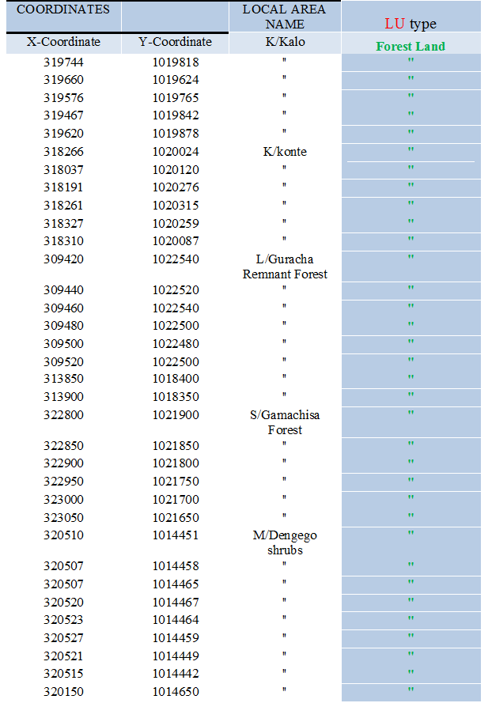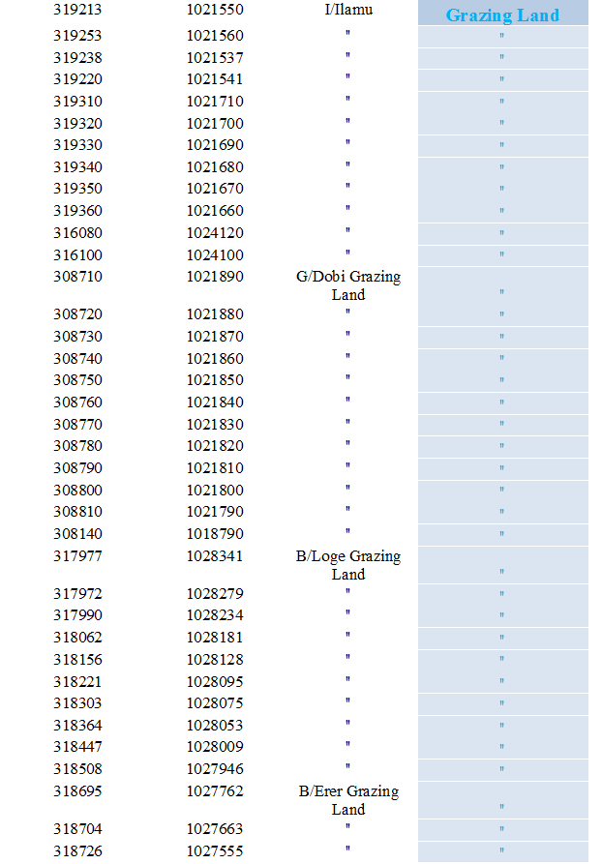

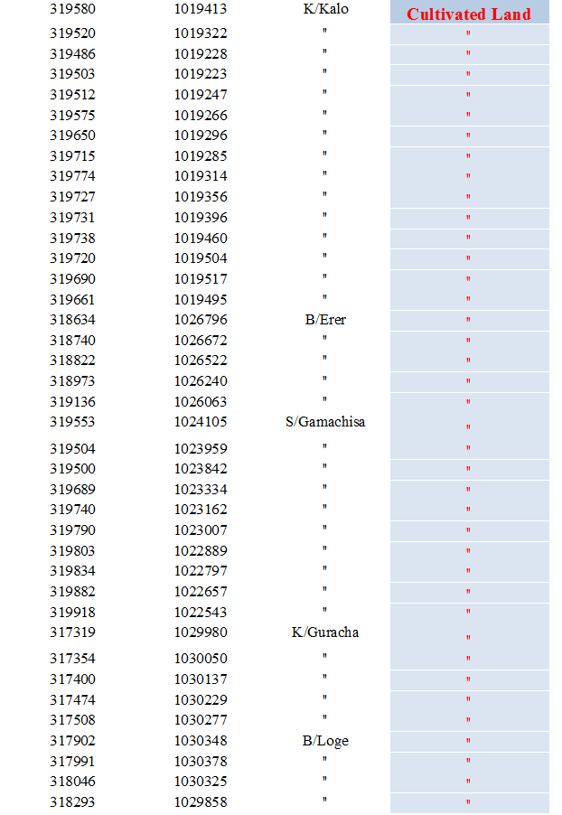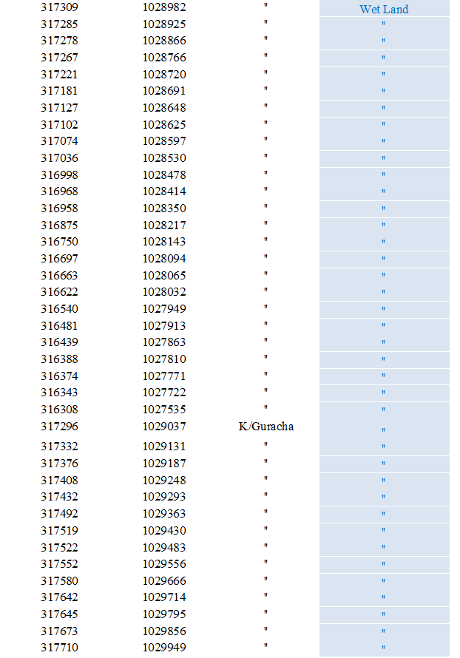

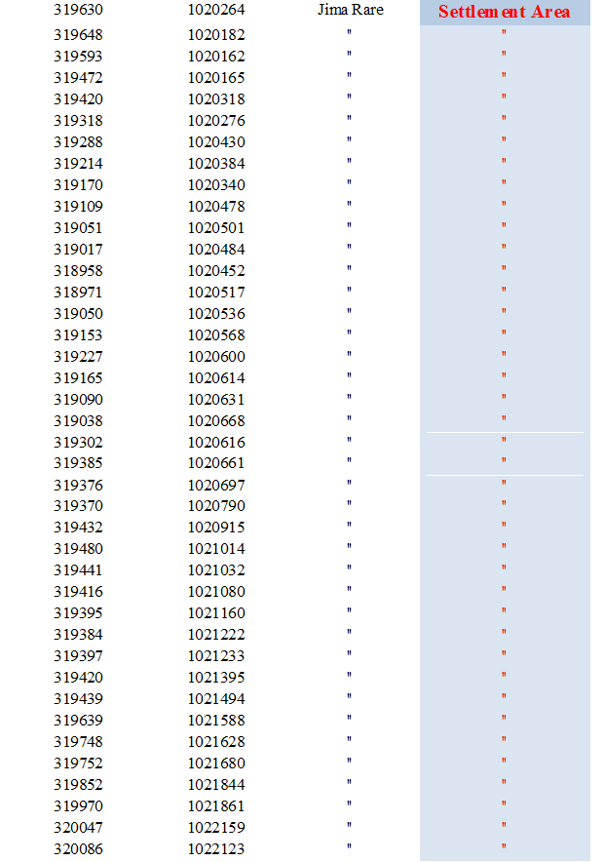

Appendix: D LULC change of Jimma Rare District (1974-2019)

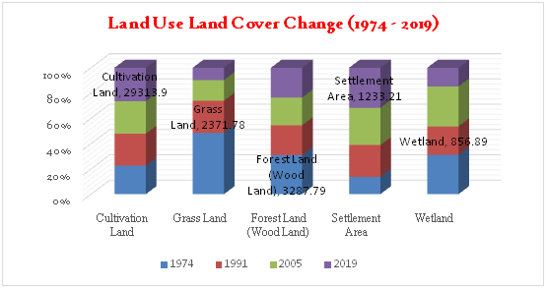
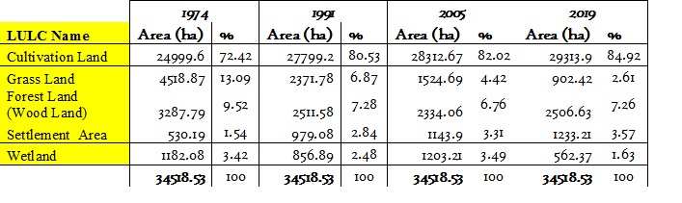
Appendix: E Accuracy Assessment
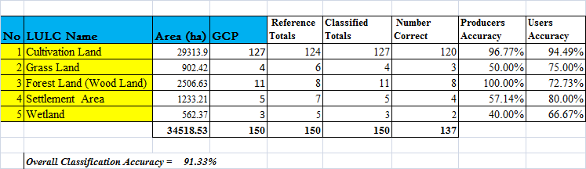

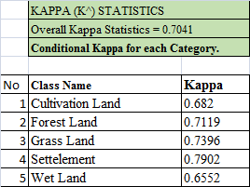

Appendix: F LULC change Matrixes

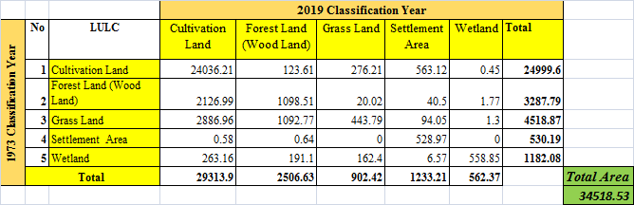

Appendix: G Agro-Ecology and Location Maps

Appendix: H Direct & Indirect causes of LULC change
