
AMBO UNIVERSITY
COLLEGE OF BUSINESS AND ECONOMICS
Department Of Economics
Choices Of Sustainable Land Management (Slm) Practice And Its Determinants Among Smallholder Farmers. The Case Of Dendi District, West Shewa Zone, Oromia Region, Ethiopia
A Research Thesis Submitted to Department of Economics in Partial Fulfillment of the Requirements for the Degree of Master of Science in Development Economics
BY: Sorsa Abdisa Chalchisa
ADVISOR: -DERESE GETACHEW (Assistant professor)

MAY.2022
AMBO, ETHIOPIA

AMBO UNIVERSITY
SCHOOL OF POST GRADUATE STUDIES

Approval sheet
I hereby certify that I have read and evaluated this thesis research entitled “Choices of Sustainable Land Management (SLM) Practice and its Determinants among Smallholder Farmers’. The case of Dendi District, West Shewa Zone, Oromia Region, Ethiopia” prepared under our guidance by Sorsa Abdisa. Therefore, I recommend that it be submitted as fulfilling the thesis proposal requirement.
Submitted by:
- _____________________________ _________________ _________
PG Candidate Signature Date
Approved by:
- Derese Getachew (Assistant professor) ___________________ ______________
Major advisor Signature Date
_________________________________ _________________ __________________
3. Head, Department Signature Date
_________________________________ _________________ __________________
4. College/Institute Dean Signature Date
_________________________________ _________________ _____________
5. Director School of Graduate Studies Signature Date

CENTER FOR DEVELOPMENT ECONOMICS

This is to certify that the thesis prepared by Sorsa Abdisa entitled: as “Choices of Sustainable Land Management (SLM) Practice and its Determinants among Smallholder Farmers’. The case of Dendi District, West Shewa Zone, Oromia Region, Ethiopia” submitted in partial fulfillment of the requirement for the Degree of Master of Science in (Development Economics) compiles with the regulation of the university and meets the accepted standards with respect to originality and quality.
Signed by examining committee
- _____________________ _________________ ______________
Chairman Signature Date
- _____________________ _________________ ______________
Internal examiner Signature Date
- _____________________ _________________ ______________
External examiner Signature Date

DECLARATION
I declare that this thesis is submitted for the partial fulfillment of the degree of Master of Science in Development Economics. It is my original work and has not been presented for a degree in any other university and all sources of materials used for this thesis is dully acknowledged and references are listed at the end of the main body of the thesis and cited using APA system.

Name Sorsa Abdisa Chalchisa
Signature _____________________________ date _________________
Place: - Ambo university

ACKNOWLEDGMENT
First and foremost I would like to thank the almighty God! “Everything is not accomplished without the will of him”. I am deeply grateful thanks to my advisor Derese Getachew (Assistant professor) for his support, guidance, encouragement, suggestion, comment and overall assistance. Special thanks also give for Dr. Tedele Melaku for his invaluable comment he provided during proposal defense. My special thanks also goes to Dendi woreda Finance and Economy office for offering me the necessary logistical and financial support during my research work. I also give thanks for Dendi woreda agriculture &natural resource office and SLM coordinator Mr.Tolosa Ejeta for their willingness to give relevant information’s, approaches and over all supports. My grateful thank goes to the study area administrators and the community for sharing their invaluable knowledge and information. Also, I gratefully tank my friends Mr. Diriba Defa and Mr. Qoricho for their helpful support on the completion of this study. Finally, I want to acknowledge my families especially my heart beat mother Galane Regesa, my father Abdisa Chalchisa and my best younger/late brother Arersa Abdisa for your endless support and help. And also I want to give thank for my friends who have directly or indirectly supported me during data collection time and all over the time when I was involved in this study.

TABLE OF CONTENTS
Contents pages
acknowledgment iv
Table Of Contents v
List Of Tables vii
List Of Figures viii
Acronyms And Abbreviations x
Abstract xi
CHAPTER ONE 1
INTRODUCTION 1
1.1. Background of the study 1
1.2. Statement of the Problem 5
1.3. Research Questions 6
1.4. Objective of the study 7
1.4.1. General Objective 7
1.4.2. Specific Objectives 7
1.5. Significance of the Study 7
1.6. Scope and Limitation of the Study 7
CHAPTER TWO 8
LITERATURE REVIEW 8
2.1. Concept and Definition of Sustainable Land Management (SLM) 8
2.2. Components of SLM 9
2.3. SLM Practices and Its Implementation 10
2.4. Land Degradation and Sustainable Land Management 13
2.5. Challenges of SLM Practices 13
2.6. SLM and Land Policy of Ethiopia 14
2.7. Empirical Literature 15
2.8. Conceptual Framework of the Study 16
CHAPTER THREE 17
RESEARCH METHODOLOGY 17
3.1. Description of the Study Area 17
3.2. Sources and Methods of Data Collection 18
3.3. Sampling Techniques and Sample Size 19
3.4. Methods of data analysis 20
3.4.1. Descriptive Statistics 20
3.4.2. Econometric model 21
3.4.2.1. Multinomial Logistic Regression 21
3.4.2.2. Econometric model specification 23
3.5. Definition of variables and working hypothesis 24
3.5.1. Physical Factors 24
3.5.1.1. Agro-Ecological Factors 25
3.5.1.2. Topography 25
3.5.1.3. Climatic Characteristics 25
3.5.2. Socio-Economic Factors 26
3.5.3. Institutional Factors 27
CHAPTER FOUR 30
RESULTS AND DISCUSSION 30
4.1. Descriptive Statistics 30
4.1.1. Sustainable Land Management Practices 30
4.1.2. Demographic Characteristics of respondents 33
4.1.3. Socio-Economic characteristics of respondents 35
4.1.4. Institutions and farming characteristics of respondents 39
4.2. Econometric Model Result: Determinants of choose of SLM Practices 41
4.2.1. Testing of Model Assumption 41
4.2.2. Determinants of choose of SLM Practices 43
CHAPTER 5 50
CONCLUSION AND RECOMMENDATIONS 50
5.1. Conclusion 50
5.2. Recommendations 51
REFERENCES 52

LIST OF TABLES
Table3. 1. Sample size of the kebele’s 20
Table 3. 2. Explanatory variables, measurement, descriptive statistics and their hypothesis 29
Table 4.1:- Farm households choose of SLM practice 31
Table 4.1: Demographic characteristics of respondents on continuous variables 33
Table 4.2: Demographic characteristics of respondents on dummy/categorical variables 34
Table 4.3: Socio-Economic characteristics of the households on continuous variables 35
Table 4.4: Socio-Economic characteristics of the Households on dummy/categorical variables 37
Table 4.6: institutions and farming characteristics of the Households on dummy/categorical variables 39
Table 4.7:- Goodness-of-fit test for a multinomial logistic regression model 42
Table 4.8 model of specification 42
Table 4.8: MNL simulation results of the choose of SLM practices. 43

LIST OF FIGURES
Figure 2.1: Conceptual framework of the study 16
Figure 3.1: Map of the Study Area 18
Figure 4.1:- terracing 31
Figure 4.2:- soil and stone bund 32
Figure 4.3:- tree planting 32
Figure 4.4:- gabion check dam 33

Appendix
Appendix1.Finally results of MNL regression Model on STATA 54
Appendix.2:- Goodness-of-fit test 57
Appendix.3:- Results of marginal effect (dx/dy) 58
Appendix.4:- Results of MNL regression on SPSS out put 61
Appendix.5:-Model Fitting Information 62
Appendix.6:- Summary SPSS 62
Appendix.7:- Results for R-Square 63
Appendix.8:- Collinearity 63
Appendix.9:- pictures of FGC and some of SLM practices 64
Appendix.10:- Questionnaires of survey data collection 67

ACRONYMS AND ABBREVIATIONS
SLM Sustainable Land Management
AGP Agricultural Growth production Program
MOA Ministry of Agriculture
ETHIOCAT Ethiopian Overview of Conservation Approaches and Technologies
EFD Environment for Development.
ESI-FSLM Ethiopian Strategic Investment Framework forSLM
SW Soil and Water Conservation
WFP World Food Program
NGO Non-Governmental Organization
FAO Food and Agricultural Organization
UNCCD United Nations Convention to Combat Desertification
ECO Ecological or Environmental
FGD Focus Group Discussion
MNL Multinomial Logit Model
HHs Households
m.a.s.l Meter above sea level
TLU Tropical livestock unit

Abstract
Land degradation is an environmental problem that reduces the productivity of all natural ecosystems and agriculture, which threatens the livelihoods of society. Low land productivity due to land degradation in form of soil erosion is one of the leading challenges to improving the performance of the smallholder farming sector in Ethiopia. In this context, Sustainable Land Management (SLM) is quite crucial to increase agricultural productivity, ensure food security and improve the livelihoods of smallholder farmers. Therefore, this study aims to examinechoice of SLM practice and its determinants among smallholder farmers in Dendi district in West Shewa zone, Oromia regional state.To achieve the objectives of the study primary data were collected through scheduled questionnaires from 168 sampled smallholder farmers while secondary data were collected from relevant local authority reports and records. In addition focus group discussions, and key informants interviews were used to support the result of the survey.Descriptive statistics and Multinomial logistic (MNL) econometric model were used to analyze the data. The descriptive analysis result revealed that from SLM practices trees planting (26.2%), soil and stone bund (25%), terracing (24.4%),and gabion check dam (24.4%) practices were the dominant land management practices chosen in the study area. The results of multinomial logistic (MNL) regression model result show that sex of household head, family size, education level household head, household experience, and slope of farm plot have positively associated and significant effect at least on one SLM practice while farmers’ perception on SLM, household occupation, marital status, farmer status, soil erosion hazard and frequency of extension contact, were negatively associated with choice of SLM practice. Based on the finding of the study recommended that planners and policy makers consider the choices of farmers when scale up choice of SLM practice. Furthermore, need to give attention for slope of land, extent of soil erosion, experience and perception of farmers on SLM for successful scaling up of SLM practice in the district and other areas.
Keywords: Smallholder farmers, Choose, Sustainable Land Management (SLM), Multinomial logistic (MNL)

CHAPTER ONE

INTRODUCTION

Background of the study
Land degradation is an environmental problem that reduces the productivity of all natural ecosystems and the agricultural sectors, which threatens the livelihoods of the small holder farmers. (Gessesse et al., 2015), land degradation is defined as a negative trend in land condition, caused by direct or indirect human-induced processes including anthropogenic climate change, expressed as long-term reduction or loss of at least one of the following: biological productivity, ecological integrity or value to humans. This definition applies to forest and non-forest land: forest degradation is land degradation that occurs in forest land. Soil degradation refers to a subset of land degradation processes that directly affect soil (Prosdocimi et al., 2016).
The SRCCL definitions derived from the IPCC AR5 definition of desertification, which is in turn taken from the United Nations Convention to Combat Desertification (UNCCD): ’Land degradation in arid, semi-arid, and dry sub-humid areas resulting from various factors, including climatic variations and human activities. Land degradation in arid, semi-arid, and dry sub-humid areas is a reduction or loss of the biological or economic productivity and integrity of rain fed cropland, irrigated cropland, or range, pasture, forest, and woodlands resulting from land uses or from a process or combination of processes, including processes arising from human activities and habitation patterns, such as (i) soil erosion caused by wind and/ or water; (ii) deterioration of the physical, chemical, biological, or economic properties of soil; and (iii) long-term loss of natural vegetation’ (UNCCD 2014).
On average, one out of every three people on earth is in some way or other affected by land degradation, latest estimates indicate that nearly 2 billion hectares of land worldwide are already seriously degraded, some irreversibly (Emmanuel, 2017). The Ethiopian economy has its foundation in the agriculture sector and this sector continues to be a fundamental instrument for poverty alleviation, food security and fueling economic growth. However, this sector continues to be affected by land degradation in the form of depletion of soil organic matter, soil erosion and lack of adequate plant nutrient supply (EFD, 2009).
In Ethiopia land degradation has been the major responsible factors for the declining and low agricultural productivity, persistent food insecurity and rural poverty. The major cause of land degradation in Ethiopia is heavy reliance of the countries rapidly growing population on wood and other biomass for the purpose of household energy together with rapid expansion of agriculture in to forested areas (MoA, 2014).Over the last three decades, the governments of Ethiopia and a consortium of donors have invested substantial resource to develop and promote sustainable land management practice as part of efforts to ensure sustainable and increased agricultural production and reduce poverty. However, due to the low rate of adoption; most of the proposed practices have been only partially successful. In some case, Dis-adoption and reduced use of technologies have been reported (EFD, 2019).
Land degradation and soil erosion is a global phenomenon throughout the world that endangers the agricultural land and leads to the decreasing in the agricultural production and it also endangers the livelihoods of rural farmers at a large scale as well as countries ability to produce. It is one of the major challenges for agricultural production in Ethiopia. Because of this reason, different land management technologies are introduced to combat the problem but the effectiveness of this practice is below expectation.
The ministry of agriculture and rural development in collaboration with the relevant stakeholders and partners initiated the establishment of the Ethiopian overview of conservation approaches and technologies (EthiOCAT) network under the natural resource sector with responsibilities of documenting the various approaches and technologies applied for the land management in various localities of Ethiopia, in addition to this the MoA has recently developed the Ethiopian strategic investment framework for SLM (ESIF-SLM) which provides guidance on harmonization and alignment of efforts, resource and expertise needed for scaling up SLM practices in a systematic manner and the ESIF-SLM also offers strategies, directions and investment opportunities for SLM in Ethiopia for the coming 15 years (Daniel, 2018).
Land management in Ethiopia has involved into various farming systems with a different level of intensification (Wegayehu, 2016). Gete et al., (2006), classified the land management practices, which have been applied in Ethiopia into two broad categories, whichisindigenous, introduced, with different degrees of acceptability, areal coverage, and based on their benefits. The acceptance and implementation of these management practices are depends on farmer’s willingness, which in turn request continuous and effective activities from agricultural experts and researchers. In fact, it is not easy to put common criteria to categorize land management practices in to indigenous and introduced. As a result, this categorization is done based on the direct purposes of the management techniques why farmers apply on their farmlands (Tadesse, 2017).
SLM practices minimize the risk of land degradation and maintain soil health. Furthermore, they can reverse the impacts of land degradation, potentially restoring the productivity of degraded land (Bell, 2002; Liniger et al., 2011; Read et al., 2012; Winterbottomet al., 2013). The development of effective SLM practices, that maintain soil health and combat land degradation, requires an understanding both of land degradation processes and of the interacting influence of the biophysical variables (soil, climate, land form, water resources and agro ecosystem features) that determine land potential.
Without SLM, decline in soil health resulting from degradation processes can lead to loss of productivity, which in turn further exacerbates degradation: as plant growth is restricted, organic inputs decline and the risk of erosion increases, causing a downward trend in land condition that can lead to a tipping point, beyond which recovery is very difficult. An example of such a threshold is seen in the semi-arid rangelands: when high grazing pressure and drought coincide, ground cover declines, which reduces capacity to intercept rainfall, so infiltration decreases, leading to a transition to a lower productivity state (Fernandez et al, 2002). In the eastern Australian rangelands, 50% ground cover has been identified as a critical threshold for water erosion (Eldridge, 2001; Tighe et al., 2012).
The extent to which the productivity of degraded lands can be restored is debatable, and the long term impacts of some land degradation processes on the productive potential of soils are unknown (Wiebe, 2002). The effects of degradation processes such as loss of topsoil, soil acidification, salinization and accumulation of toxicities in certain soil types can have longer-term impacts, but nutrient decline may be reversible in relatively short periods. In practice, the loss of nutrients may not be easy to correct under conditions where agriculture is dominated by low-input practices (Ngoze et al., 2008, Liniger et al., 2011; Winterbottomet al., 2013; Harris and Orr, 2014). Further, the supply of global environmental public goods such as climate regulation, biodiversity and avoided degradation of land is traditionally not valued in economic terms (Niemeijer and Moran, 2016). In areas with well-functioning markets and well-defined property rights, landholders have an incentive to protect the long-term productive potential of their soil and land (Wiebe, 2014).
A challenge for effective implementation of SLM programs understands the barriers to choose of good practice. These barriers may arise from biophysical, social, economic or cultural constraints to changing land management. Biophysical constraints have a range of sources, including climatic and soil limitations and the challenge of defining good practice with the flexibility that allows for the variable interaction of land use and management with natural resource factors. Socioeconomic constraints at household level may include financial circumstances, skills, security of land tenure and marketing arrangements. The capacity to introduce incentives to promote choose may be limited by institutional factors and political structures, while social instability and conflict also affect the potential for effective action. These factors may interact to influence the extent of choose of SLM practices, and so influence the duration and severity of ongoing land degradation and the effectiveness of responses (Weith et al., 2013).
Despite uncertainty in quantifying land degradation and its impacts, statistics from UNCCD (2016) the large challenge for SLM programs designed to combat land degradation. Food and fibred production are the focus for SLM investment, but environmental concerns extend beyond agriculture and forestry. Natural landscapes and waterways, which also provide ecosystem services on which human populations depend, are also vulnerable to the negative consequences of unsustainable management (UNCCD, 2016). Thus, SLM also seeks to minimize negative off-site impacts.
Sustainable land management combines technologies, policies, and activities aimed at integrating socioeconomic principles with environmental concerns, so as to simultaneously: maintain and enhance production (productivity),reduce the level of production risk, and enhance soil capacity to buffer against degradation processes (stability/resilience),protect the potential of natural resources and prevent degradation of soil and water quality (protection),be economically viable (viability),be socially acceptable, and assure access to the benefits from improved land management (acceptability/equity).
SLM includes a range of approaches and technologies that ensure humans use soils, water, animals and plants with ecosystem health and future livelihoods in Dendi district west shoa zone. These range from broader approaches such as participatory management, to physical technologies such as building small dams or terraces, trees planting, construct soil-stone bunds, restoring gullies, or improving livestock grazing practices.

Statement of the Problem
According to Melese (2014), land degradation has become a serious problem affecting all spheres of social, economic and political life of the population. It is one of the major challenges to agricultural development and food security of people in Ethiopia. In Ethiopia, the rate of the countries land degradation is very high. A large portion of agricultural land, which is mainly located in the highland part of the country, is affected by severing to moderate land degradation (Kruger et al., 2017). To solve the problem of land degradation in the country many efforts have been made since the 1970s a large number of soil and water conservation activities were implemented in different parts of Ethiopian highlands in the 1970s and 1980s with a huge resource obtained from the international community, particularly world food program (WFP).
Although different activities have been performed to bring about the desired change it didn’t bring sustainable change. This is because of the limited capacity of farmer‟ to invest in SLM practices, farmers, incentive from their investment in SLM practice is limited and also because of other enabling conditions for motivating farmers‟ to invest on SLM practices or technologies (Melese, 2014).
A number of local and international NGOs have involved in implementing land management practices, and more importantly local communities have been practicing a range of traditional land management practices with the purpose of improving land productivity, increasing availability of soil moistures and reducing soil nutrient losses (Daniel, 2010).
Despite all these efforts, the area coverage and sustainability of land management practice have been limited and localized in projects and program areas and only with the communities practicing those (MoA, 2014).
Different studies were conducted related to SLM such as Motuma (2017); Micheal (2002); Haymanot (2018) and Mamuye (2015). These researchers generally focus on assessing what land management practices look like, what are the causes of land degradation and assessing the traditional land management practices and its role on their study area. On the other hand, the methodology they used to conduct their research was simple descriptive statistics like percentage and frequency and cross tabulation which different from this study.
Furthermore, unlike many past studies that only considered land management practices as binary MVP, variable (Pender et al. 2004; Benin 2006; Tiwari et al. 2008; Belay and Bewket 2013; Guteta and Abegaz 2015),Miheretu (2017) and Yimer (2017) for adoption SLMdecisions. The present study considers the choice of sustainable land management(SLM) practicedetermine as multi-variablesor when the dependent variable is categorical, rather than binary/dichotomous because using multinomial models considers the effect of useful interdependent demographic, economic, institutional, or biophysical variable and simultaneous choose determines.
This study conducted in view of gap, it intends to add to the stock of knowledge on the factors that determine farmers’ determine to choose certain sustainable land management practices. Hence this study assesses the choice sustainable land management practice among smallholder farmers in Dendi District West Shewa of Oromia, Ethiopia.The reason behind selecting the study area is because the area is found in the highlands and it is very prone to land degradation.

Research Questions
- What are SLM practice chooses by the farmers in Dendi District, West Shewa Zone, Oromia Region, Ethiopia?
- What are the determinants of farmer’sdetermine to choose among SLM practices in Dendi District, West Shewa Zone, Oromia Region, Ethiopia?

Objective of the study

General Objective
- The general objective of the study is to examine choice of Sustainable Land Management (SLM) Practice and its determinants among Smallholder Farmers’ in the study area

Specific Objectives
- To assess the smallholder farmers choice of sustainable land management practice in the study area
- To identify determinants of sustainable land management (SLM) practices choose among smallholder farmers in the study area

Significance of the Study
The main purpose of study to Determinants of land degradationand choice sustainable land management practice among smallholder farmers will assistance Government,NGO and policymakers, others stakeholders and private sectors that are intervening to provide SLM practice. The research also tried to identify the farmers‟ choice to determine SLM practices. This research wills may use as a source of information regarding the Sustainable Land Management (SLM) Practice Choices and its Determinants among Smallholder Farmers’.

Scope and Limitation of the Study
This study focused on identify the determinants of sustainable land management practice and assessing the existing SLM practices choice based on farmers view mainly, and adding up literature and experts view. The study is limited to in the Dendi woreda highlands. Hence, inter-spatial variations were not taken care of in this study.
  - Organization the study
This thesis has five chapters. The first chapter is about background information of the study. The next chapter reviews the related literature about sustainable land management practices and it also contains the main concept of the study. The methods and tools used for the study are found in chapter three. Fourth chapter presents and discusses the major finding and results of the analysis. Conclusion and recommendation part is found in the last chapter which is in chapter five.

CHAPTER TWO

LITERATURE REVIEW

Concept and Definition of Sustainable Land Management (SLM)
The concept of SLM refers to divers and long-running dispute over the direction of societal actions. For all the ambiguity and diversity involved in defining the term precisely, the definition contained in the Brunt land report is often mentioned as a general starting point, it contains the formulation, “sustainable development is the development that meets the needs of the present generation without compromising the ability of future to meet their own needs” (Weith et al., 2013).
Sustainable land management is the combination of technologies, policies and activities aimed at integrating socio-economic principles with environmental concerns so as to simultaneously maintain or enhance production, reduce the level of production risk, protect the potential of natural resources and prevent soil and water degradation be economically viable and be socially acceptable(Dirk et al., 2004).
SLM also defined as a system of technology and/ or planning that aims to integrate ecological with socio-economic and political principles in the management of land for agriculture and other purposes to achieve intra and intergenerational equity (Hurni et al., 1996). SLM is thus so composed of the three development components „technology‟, „policy‟ and in particular „land use planning‟ (Bouna, 1997).
According toFAO (2008), SLM is simply about people looking after the land for the present and for the future. The main objective of SLM is thus to integrate people’s coexistence with nature over the long- term, so that the provisioning, regulating, cultural and supporting services of the ecosystem are ensured. SLM is the antidote, helping to increase average productivity, reducing seasonal fluctuations in yields, and under pinning diversified production and improved incomes.
SLM has been defined by Terrafrica partnership (2006), as the adoption of land use system that through appropriate management practices enables land users to maximize the economic and social benefits from the land while maintaining or enhancing the ecological support functions of the land resources. SLM includes management of soil, water, vegetation and animal resources. SLM focuses on increasing productivity of agro-ecosystems while adapting to the socioeconomic context, improving resilience to environmental variability, including climate change and at the same time preventing degradation of natural resources (FAO, 2011).
SLM is crucial to minimize land degradation, rehabilitating degraded areas, and ensuring the optimal use of land resources for the benefit of present and future generation. Thus it is based on four major common principles;1) land user-driven and participatory, approach 2) integrated use of natural resources at ecosystem and farming system levels, 3) multi-level and multi-stakeholder involvement, and 4) targeted policy and incentive mechanisms for SLM adoption and income generation at the local level( Liniger et al., 2011).
According to the perspective of the World Bank, knowledge as a resource is equally important to be able to integrate different management areas. “Sustainable land management is a knowledge based procedure that helps to integrate land, water, biodiversity and environmental management including input and output externalities to meet rising food and fiber demands while sustaining ecosystem service and livelihoods (Weith et al., 2013).
World Bank (2008) cited by Weith et al., (2013), states that SLM is necessary to meet the requirements of a growing population and improper land management which can lead to degradation of land in a significant reduction in the production and service functions.

Components of SLM
According to Peter et al., (2013), The common components for SLM understand the ecology of land use management, maintain or enhance productivity, maintenance of soil quality, increased diversity for higher stability and resilience, provision of economic and ecosystem service benefits for communities and social acceptability. SLM requires a better understanding of the direct and indirect effect of land management and ecosystem functions.
The foundation for the success of SLM system often depends on the adaptability and the social acceptability of that system by the affected communities. Sustainability among different communities may have a different level of social perceptions, various factors like knowledge and education, geographic variability, time and social affiliation may affect social acceptability.
The components for sustainable land use management include: achieve biological balance in the country; needs for nature protection and rational utilization of natural resources; in particular, the protection of the land, water, forests, and gene pool, important for the protection of cultural and historical resources; needs for the regeneration of human resources and the protection of human health; demands on the humanization and aesthetic appeal of the landscape. These incorporate the fundamental principles of sustainable societal development. Sustainable development accentuates caring for the Earth by putting sustainable living principles into practice and integrating conservation and development: the conservation to maintain human actions within the Earth’s capacity and the development to enable people everywhere to enjoy long, healthy, and fulfilling lives (Ruzicka and Miklos, 1990).

SLM Practices and Its Implementation
SLM practices are agricultural practices that preserve and enhance production capacities of land for crops, livestock’s, water shade and forest, and actions to minimize and reverse land degradation and also they are necessary to meet the food needs of the growing population, rehabilitate degraded lands, adapt to changing climate and mitigate climate change ( Recha et al., 2014).
The most frequently SLM practices and/or measures based on its importance are Bund (stone face soil bund, trench), fanyaju, waterway, cut off drain, and terrace construction. However, these technologies are applied not only for the purpose of immediate reduction of soil erosion but also the increased percolation of water (MoA, 2014).
The practices including diversified cropping systems (strip cropping and mixed intercropping), integrated agronomic practice (multiple cropping, mulching, and strip cropping), structural soil erosion practices (terraces both soil and stone bund ), soil management practices ( compost, green manure and fertilizer usage) and cultivation practices like minimum tillage and conventional tillage are the most sustainable land management practices and are a key mechanism for effective change in the sustainable use and management of land resources (Webb, 2004).Overall the SLM practices will be determined by the local context and particular situation of local stakeholders, it can be different from region to region and based on topographic condition.
Unsustainable land management practice can threaten biodiversity and increase the release of carbon especially through the destruction of the forest as well as impacting adversely on water resource management. On the other hand, they present the opportunities‟ for enhancing the livelihoods of the poor or fostering inclusive growth as well as for achieving environmental goals (UNCCD and FAO, 2009).
As modified from FAO (2011), adopting SLM practice contributes for the mitigation of climate change by sequestering atmospheric carbon in the soil and in the perennial vegetation through the help of technology include a forestation, agro forestry, reduce tillage, improved grazing land management, greenhouse emission can also be reduced by limiting deforestation, reducing the use of fire, better livestock management, and better agro-economic practices. Practices to be truly sustainable must be environmentally friendly, reduce current land degradation, improve biodiversity and increase resilience to climate variation and change.
SLM interventions are vital to prevent, mitigate and rehabilitate land degradation. The choice of SLM practice will be determined by the local context and particular situation for local stakeholders (FAO, 2011).
    - SLM Practices and its Implementation in Ethiopia
SLM practices are structural, agronomic, and vegetative management measures used to control soil erosion, reduce nutrient depletion, improve soil conservation and enhance productivity (Shiferaw et al., 2009; Adimassu et al., 2016). Some examples of SLM practices include: terraces, stone/soil bunds, minimum tillage, intercropping, composting, manuring, and agro forestry. This study focuses on stone bunds, which, in Ethiopia, can play a crucial role in addressing soil erosion on farmlands (Vancampenhout et al., 2006). Stone bunds are an embankment of stones constructed along the contour line to reduce or stop the velocity of water flowing down-slope, consequently reducing soil erosion (Gebremichael et al., 2005; Vancampenhout et al., 2006).
SLM approaches encompass the ways and means to support and enable farmers to implement, adopt and adapt SLM on the farmland (Hurni, 2000; WOCAT, 2007; Liniger et al., 2011). In Ethiopia, the regular government extension program, the food-for-work program and mass mobilization are important approaches for spreading SLM practices (Danano, 2010; Nedessa et al., 2015). Next to project – or program – based SLM approaches, World Overview of Conservation Approaches and Technologies, WOCAT (2007) identifies the “spontaneous” approach, in which farmer-to-farmer learning takes place, often supported by an adequate enabling environment for spreading of SLM practices. Spontaneous spreading can be measured in terms of the distance that a practice has spread, for instance, from the original farmers involved in a project to non-project farmers through existing social networks (German et al., 2006).
The uses of SLM practices are the key factors to preserve, enhance, and sustain the productive capacity of land in agriculture (Singh et al., 2018). SLM practices mitigate soil fertility loss, soil erosion, and wastage of water via controlling water run-off, evaporation and infiltration of water (Liniger et al., 2011). In order to reduce the ongoing land degradation across watersheds thereby improving the ecosystem and livelihoods of farmers, the government of Ethiopia implemented the SLM program in six regions of the country since 2012 (Schmidt and Tadesse, 2018).
SLM practices enabled smallholder farmers to be resilient for climate change, use wisely and conserve resources (soil and water), and thereby enhance their food security situations. Among the six regions where SLMP was implemented Oromia region is one and central Oromia is among it (Wondimu Legesa, 2020). Because of this, farmers in the study areas were assessed to what extent they adopted SLM practices implemented by the government, the challenges they are facing at plot and household levels, their WTP for sustaining this intervention and its welfare impact in the study area. In this study, the various SLM practices chooses in the study area are soil erosion control methods which include the use of terrace, soil and stone-bunds, gabion check-dam, trees planting practices.
In this research, the term ‘spontaneous spreading’ refers to the choose and implementation of SLM practices based on a farmer’s intrinsic motivation using his/her own resources, and using knowledge obtained elsewhere: from project interventions, from neighboring farmers or through participation in mass mobilization campaigns.

Land Degradation and Sustainable Land Management
Within the sphere of agriculture, land management includes maintenance of soil productivity. This contains the combination of soil treatment including the application of mineral and organic fertilizer like animal dung with soil and water conservation measures implementation of agronomic, soil management and physical measures such as contour ridging, terracing or providing ground cover through mulching, use of plants and living crop residue (Wood fine, 2009). Also like any limited resource, it is important to manage agricultural land because it is most suitable for farming and also essential.
SLM is a necessary building block for sustainable agriculture development and it is a key element in AGENDA 21‟s goals of sustainable development (chapter 10). Sustainable agriculture development, conservation of natural resource and promoting sustainable land management are key objectives of the new World Bank rural investment programs, from vision to action ( world bank,1997), and increasingly these objectives are being include in all agriculture development and natural resource management projects.
According to Pieri et al., (1995), more ecological balanced land management can achieve both economic and environmental benefits, and this must be the foundation for further rural intervention (investment). Without good land management, other investments in the rural sector are likely to be disappointing. At the same time, a requiring for the future maintenance of agriculture without reference to environmental sustainability is increasingly difficult.

Challenges of SLM Practices
Three major factors for the limited investment in SLM by smallholder farmers in Ethiopia Includes: 1) farmers capacity to invest in SLM is very limited, 2) farmers incentive from their investment in SLM practice is limited, and 3) there are insufficient enabling conditions for motivating farmers to invest in SLM practice or technologies (Liniger et al., 2011).
According to Weith et al., (2013), economic globalization, climate change, global food security, biodiversity, water supply, migration, demographic change process and the world growing energy needs are the key to lead changes in land use in almost all major regions.

SLM and Land Policy of Ethiopia
As a core concept, responsible land administration provides four core functions: land policy framework, institutional arrangements, land information and sustainable development. Cited in (Zevenbergen,2009), the United Nation Economic Commission for Europe's (UNECE,1996,p.6), defined Land administration as ‘ a process of recording and disseminating information about the ownership, value, and use of land and its associated resource’. Due to land use changes, driving forces and actors will result in a significant paradigm shift to responsible land administration. In particular, responsible land administration is flourishing in a world where global challenges such as rapid and massive urbanization and migration, as well as land, food security, water, infrastructure, and other resources conflicts are wide spread existent (Zevenbergen &Vries, 2018). Fit for purpose land administration promotes alternative approaches to help the process of land tenure security or to improve it. Overlapping or secondary land rights have been lost in many contexts through formal land registration systems (Lengoiboni, 2017). Therefore, strong and well organized Land administration institutions in a given country are so vital to implement and practice the pillars of sustainable development through creating workable and robust land management systems.
The present constitution of Ethiopia, which was put in to force January 1995, vests land ownership exclusively in the state and in the peoples of Ethiopia. The relevant section continues to, the land is a property of the nations, nationalities and peoples of Ethiopia and shall not be subject to sale or to other means of exchange (Art, 40 of the constitution). Despite these differences to land reform, Ethiopia still faces issues of sustainable food self – sufficiency.
The Ethiopian constitution asserts state ownership of land; these are no private property rights in land. Even if there are national debates on the existence of different ownership and tenure regimes for land in Ethiopia, the government of Ethiopia is not prepared at this time to realize private property right in the land. While the government of Ethiopia is the decentralized administration of land to the regional governments, the formulation of broad land policy still rests with the federal government (Adopted from Ethiopian land policy and administration assessment final report, 2004).

Empirical Literature
A study titled as “assessment of land management practices in Girar Jarso woreda, central Ethiopia by Motuma (2017) uses survey questions, FGDs, and key informant interview in order to assess the land management practices in the study area. The study analyzes the qualitative data in a narrative way and the quantitative data was analyzed using frequency and percentage the result of quantitative data was analyzed in the form of a table. The finding of this study shows that in the study area traditional land management practices such as fallowing; manure application, counter farming and drainage ditch were more applicable and practiced than the modern land management practices. This study also found that the lack of arable land, topography, population pressure and vegetation cover affects farmers determine on choice and use of introducedsustainable land management practices.
Tadesse (2011) cited by Kefle (2016), argues that government policies and programs, socioeconomic and institutional factors, farmer’s local knowledge and practices, household “endowments of physical and human capital as well as topography, soil type and climate are the most important factors that could influence land management practices.
A study conducted by Kefle (2016), in Bale- ECO- regions of South Eastern Ethiopia Identified that education level of household head, age of household head, family size, agroecology, income, market access, extension service, access to credit, farming experience, livestock ownership, land holding size, sex of household, perception on soil fertility and training access to have an influence in the adoption of land management’s. On the other hand, a study conducted in Werra Garso wereda, Oromiya, Ethiopia by Tola (2015), Identifies population growth, income level, urbanization, and infrastructural development, policies at national and international level and land tenure and property rights are the major factors affecting sustainable land use management.
Additionally, SLMP focus on alleviating the detrimental impact of climate change on productivity, concurrently preventing the degradation of natural resources with issues relating to ecological, economic and socio-cultural dimension (Olsson et al., 2019). Intrinsically, the primary aim of SLMP is to incorporate people’s coexistence with nature in the long term so that provisioning, regulating, cultural and supporting services of ecosystems are ensured (The Intergovernmental Panel on Climate Change, IPCC, 2013). It is a key measure in adapting to the eﬀects of climate change. The essence of adopting SLMP is to develop a synergism between environmental issues and food security. In South Africa, the World Overview of Conservation Approaches and Technologies (WOCAT) has instigated for years with numerous approaches and technologies been documented on SLMP. However, several practical problems arise in espousing and fully adopting SLMP owing largely to information gaps on SLMP as well as indiﬀerence among farmers toward transitioning from traditional to modern farming practices (Olawuyi and Mushunje, 2020).

Conceptual Framework of the Study
The conceptual framework of the choose of SLM practices in this study was based on the principal of absolute and comparative advantage to farmers in combination with some influence of the personal, demographic, socio-economical, institutional, and biophysical factors.

Farming factors
- Farming(Hhs)experience
- Soil erosion hazard
- Farmer perception on SLM
- Slope of farm plot
- Farmer status

Demographic factor
- Sex
- Age
- Marital status

Choice of SLM Practice
- Terracing
- Trees planting
- Stone and soil bund
- Gabion check dam

Socio-Economic Factor
- Off farm activity
- Livestock holding
- Annual income
- Households occupation
- Farm size
- Livestock size
- Education

Institutional Factors
- Access to credit
- Access to extension service
- Access to information

Physical Factor
- Agro Ecological Factors
- Climatic
- Topography
- Land holding size
- Land resource

Figure 2.1: Conceptual framework of the study

CHAPTER THREE

RESEARCH METHODOLOGY

Description of the Study Area
The study was conducted at Dendi district, West Shewa zone, Central Ethiopia, which is delineated by, Ejersa Lafo Woreda in East, Ambo woreda in West, Jeldu and Elfeta Woreda in North and south west Shewa zone (Dawo, wenchi and Waliso Woreda) in South. Dendi is one of the 22 Woreda in West Shoa zone of Oromia region and consists of 40 kebeles. It is about 78 km west of Addis Ababa along the Addis Ababa-Ambo road. Of the 40 Dendi woreda kebeles Galesa Kota Geshar, Galesa Koftu, Ketketa Weran Bulchi and Keba Bareda kebeles are located 2320–2620 m a.s.l. in the warm to cool highlands. Ginchi town, the capital of Dendi Woreda is 12 Km farand found Southwest of those (four) kebeles.
The area has a bi-modal rainfall pattern with two distinct rainy and cropping seasons. The main rainy season (meher), which is also the main cropping season, extends from June to September. The short rainy season, known as “belg rain”, usually covers the period from February to April. The mean annual rainfall of the area ranges from750-1170mm.The maximum and minimum temperature of the area ranges from 16 to 19ºC. The farming system of the area is mainly rain-fed.
The soil type is characteristic of clay and clay-loam type, but the riverbed has a loam and sandy-loam type of soil (Dendi Woreda Atlas data by Sorsa .A, 2012).Eucalyptus globules are the main tree planted in the area. It has an area of 7993,929 hectares. The district is characterized as a mixed crop livestock production system. Land preparation mainly done by ox-drawn plough. The main crops grown in the study areas include wheat (Triticumaestivum), teff (Eragrostistef), broad bean (Viciafaba), barley (Hordeumvulgare) and potato (Solanumtuberosum).Soil erosion in the area is mainly attributed to the steep slopes, population pressure, deforestation, poor farming methods and vulnerable soils.
However, the major factor fueling soil erosion on the steep slopes is that farmers are increasingly destroying contour bunds on terraces to pave way for more farmland. As a result, soil erosion has been accelerated which in periods of heavy rainfall results in silting and flooding of the valley-bottom fields and landslides are becoming very common.
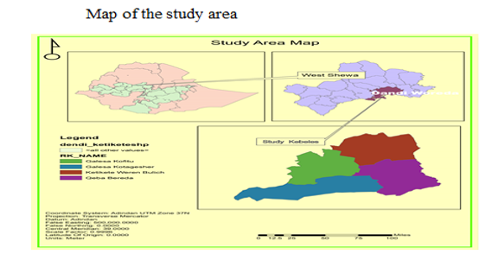

Figure 3.1: Map of the Study Area

Sources and Methods of Data Collection
Data for the study was collected from both primary and secondary sources.
Primary data collected by employing household questionnaire survey, focus group discussion, field observation, and key informant interview to bring the study to realization. Information about personal characteristics of the household head, the knowledge of SLM practices/ technologies, the resource endowment of farmers, farm management practices, cropping patterns, crop yield, role of different institutions to improve farming, and adoption of improved and indigenous soil conservation technologies, such as the construction of check dams, terrace improvement, terrace bunds, hedge management, retention walls, waterways, and mulching, were collected through individual interviews by using a semi- structured questionnaire.
A secondary data source includes books, journals and other unpublished literatures that related to the subject matter of the study topic, Agriculture & Natural Resource office (Coordinator of SLM project), and Finance& Economic Development Cooperation office of Dendi district, research reports and other publications, including internet sources of information.
The Tools of Data Collection will be based on both qualitative and quantitative methods. In qualitative research methods, the study will be done by used interview method. Structured questionnaire employed in order to generate the relevant information from study participants by the preparing of interview guideline. With quantitative research methods, the research also employed survey method.

Sampling Techniques and Sample Size
In this study, a multi-stage sampling procedure employed. First, Dendi district was purposively selected because; the district is one of severely affected areas by land degradations. The district is highly vulnerable to land degradation in particular soil compaction, deforestation and environmental degradation. Second, four kebele (Galesa Kota Geshar, Galesa Koftu, Ketketa Weran Bulchi and Keba Bareda) were purposively selected from the existing 40 kebeles. In the third stage, the total lists of households in the four selected SLM project program kebele’s were purposive into upstream and downstream land users.
Finally, the reason behind selecting the study area is because the area is found in the highlands, land degradation and selected place of Dendi woreda SLM project program.
The purposive selection of households participants based on the list of household heads found in each kebele’s and proportional to the size population.
The study applied Yamane (1967) statistical formula to determine the representative sample size with 95% confidence interval and 0.07 level of precision.
Accordingly, 175 sample households from the selected kebele’s drew using purposive sampling technique for the household questionnaire survey. For populations that homogenous, Yamane (1967) developed the Equation 1 to known population sample for purposive.
$n=\frac{N}{1+\left(N\right)℮^{2}}$ (1)
Which is valid where n is the sample size, N is size of population, Z² is the abscissa of the normal curve that cuts off an area α at the tails (1 - α equals the desired confidence level, e.g., 95%), e is the desired level of precision (sample error). The value for Z is found in statistical tables which contain the area under the normal curve.
Given
N=1211
Let, e=0.07 (b/c of the greater sample error will be thelower sample size.)
Therefore,$n=\frac{1211}{{1+1211(0.07}^{2})}=175$
According to Yamane (1967) the sample size of in each Kebele’s (stratum) households calculated as follows.
Implies that $n_{i}=(\frac{N_{i}}{N})n$ (3)

Table 3.1. Sample size of the kebele’s
Name of villages | HH SLM participants in the Keeble |  |  | Sampled households
Name of villages | M | F | T | M | F | T
Galesa Kota Geshar | 165 | 45 | 210 | 24 | 6 | 30
Galesa koftu | 181 | 56 | 237 | 27 | 8 | 35
Ketketa Waren Bulchi | 174 | 59 | 233 | 26 | 7 | 33
Qeba Bareda | 426 | 105 | 531 | 62 | 15 | 77
Total | 946 | 265 | 1211 | 139 | 36 | 175

Methods of data analysis
The analysis of household survey data was done by using descriptive statistics and econometric model (multinomial logit model using STATA 15 and SPSS 25).

Descriptive Statistics
Descriptive statistical techniques such as measure central tendency, measures dispersion and chi-square testes are used while, multinomial logistic regression model applied and detail justification and specification are provided Different empirical studies argued that farmers usually consider a set of possible technologies and select the one that they assume will have the best results and the highest utility; hence, the choice and determine is inherently multinomial logistic regression.
However, most previous studies of conservation technology choosedetermine assume a single technology without considering the possible correlation/interdependence between different technologies, there by masking the reality that determine makers are often faced by a set of choices. In general, when technologies are correlated, univariate modeling excludes useful information contained in the interdependence and choice determine analysis.
A single technology approach may, therefore underestimate overestimate the determinants of factors on the farmers choice determine. In general, univariate models ignore the potential correlation among unobserved disturbances in the choose equations as well as the relationships between choose of different rainwater management technologies, because farmers may consider some combination of conservation as complementary and/or competing. Failure to capture such interdependence will lead to biased and inaccurate estimates.

Econometric model
A model is a simplified representation of a real-world process. It should be representative in the sense that it should contain the salient features of the phenomena under study. In general, Econometrics is the quantitative application of statistical and mathematical models using data to develop theories or test existing hypotheses in economics and to forecast future trends from historical data. It subjects real-world data to statistical trials and then compares and contrasts the results against the theory or theories being tested.This is the main difference between economic modeling and econometric modeling. This is also the main difference between mathematical modeling and statistical modeling.

Multinomial Logistic Regression
Multinomial logistic regression is used to predict categorical placement in or the probability of category membership on a dependent variable based on multiple independent variables. The independent variables can be either dichotomous (i.e., binary) or continuous (i.e., interval or ratio in scale). Multinomial logistic regression is a simple extension of binary logistic regression that allows for more than two categories of the dependent or outcome variable. Like binary logistic regression, multinomial logistic regression uses maximum likelihood estimation to evaluate the probability of categorical membership.
Multinomial logistic regression does necessitate careful consideration of the sample size and examination for outlying cases. Like other data analysis procedures, initial data analysis should be thorough and include careful univariate, bivariate, and multivariate assessment. Specifically, multicollinearity should be evaluated with simple correlations among the independent variables. Also, multivariate diagnostics (i.e. standard multiple regression) can be used to assess for multivariate outliers and for the exclusion of outliers or influential cases. Sample size guidelines for multinomial logistic regression indicate a minimum of 10 cases per independent variable (Schwab, 2002).
Multinomial logistic regression is often considered an attractive analysis because; it does not assume normality, linearity, or homoscedasticity. A more powerful alternative to multinomial logistic regression is discriminate function analysis which requires these assumptions are met.
Indeed, multinomial logistic regression is used more frequently than discriminates function analysis because the analysis does not have such assumptions. Multinomial logistic regression does have assumptions, such as the assumption of independence among the dependent variable choices. This assumption states that the choice of or membership in one category is not related to the choice or membership of another category (i.e., the dependent variable). The assumption of independence can be tested with the Hausman-McFadden test. Furthermore, multinomial logistic regression also assumes non-perfect separation. If the groups of the outcome variable are perfectly separated by the predictor(s), then unrealistic coefficients will be estimated and effect sizes will be greatly exaggerated. There are different parameter estimation techniques based on the inferential goals of multinomial logistic regression analysis. One might think of these as ways of applying multinomial logistic regression when strata or clusters are apparent in the data.
In the mixed crop-livestock production systems of the Ethiopian highlands, smallholder farmers produce several crops that may compete for scarce household resources such as land and/or complement each other through such effects as nitrogen fixation and breaking disease and pest cycles across seasons. Analysis of smallholder farmers technology choice of SLMP practice determine behavior, therefore, needs the use of a multivariate (instead of univariate) modeling framework to take into account the multiple commodities, and the possible simultaneity of the determine making process. Consequently, a multinomial logistic regression (MNL) is used in this paper for assessing the choices of SLM practice determineamong smallholder farmers.
In the MNL model estimated here, the choice of improved varieties related to each of the crop enterprises corresponds to a binary choice (yes/no) equation and the choices are modeled jointly while accounting for the correlation among disturbances. Model estimates from the multivariate specification improve over those from univariate specifications when the error correlations are significantly different from zero. Otherwise, the two modeling frameworks would lead to comparable results. Hence, if a household grows M different crops, M equations each describing a latent dependent variable that corresponds to the observed binary outcome for each crop would be needed to be estimated simultaneously.

Econometric model specification
In this study, farmers are likely to have several land management practices from which they can choose. Bekele and Drake (2003) stated that it is more appropriate to treat adoption of soil and water conservation measures as a multiple choice determine, since attempting bivariate modeling excludes useful economic information contained in the interdependent and simultaneous adoption determines (Dorf man 1996). It is important to treat choose of land management practices as multiple-choice determines made simultaneously. Therefore, the multinomial logit model was used to determine factors that influence the determine to choice sustainable land management practices. The household’s determine of choiceland management practices was considered under the general framework of utility or profit maximization. We choose a linear random utility model as specified by Greene (2000). This linear random utility model is commonly used as a framework in determining of farmers’ choice for land management practices (Greene 2000) and specified as:
Y_{ij =}β_{j}X_{ij} + ε_{ij (1)}
Where Y_{ij} is the utility of household i derived from land management practice choice j, X_{ij} is a vector of factors that affect the determine to use a particular land management practice choice j, and β'j is a set of parameters that reflect the impact of changes in X_{ij} on Y_{ij}. The disturbance terms ε_{ij} are assumed to be independently and identically distributed. If farmers choose land management practice j, then Y_{ij} is the maximum among all possible utilities.
This means that:-Y_{ij}>Y_{ik ,}k≠j (2)
where Y_{ik} is the utility to the i^{th} farmer from land management practice k. Eq. (2) means that when each land management practice is thought of as a possible adoption determine, farmers will be expected to choose the land management that maximizes their utility given available alternatives (Dorfman 1996). The choice of j depends on X_{ij}, which includes aspects specific to the household and plot, among other factors.
Definition of variables in this study, choice is defined as the use of land management practices on farmers’ plots. Therefore, the dependent variable (Yi) in this study was the choice or use of the sustainable land management practices by farmers on their plots of land. The dependent variable for multinomial Logit model was described as follow: Yi =0 if a farmer has no land management practices (LMP) (j =0); Yi =1 if a farmer choice stone bund (j=1); Yi =2 if a farmer choices chemical fertilizer (j=2). The chemical fertilizer referred to the application of dominium phosphate (DAP) and/or Urea; which are commonly applied to farmland in the study area. Previous studies indicated that determinants for choice and practice determine of farm household related to demographic, socioeconomic, institutional, and plot characteristics (Shiferaw and Holden 1998; Alemu 1999; Gebremedhin and Swinton 2003; Bekele and Drake 2003; Yirga 2007). A range of independent variables that determines the choice determines of land management practices (SLMP) by a farmer was identified based on review of related literature. Accordingly, the descriptions of independent variables were indicated in Table 3.2.

Definition of variables and working hypothesis
The dependent variable in the empirical estimation for this study is choice of SLM practices of the study area.
Those practices Choose of SLM practice and soil erosion control methods (terrace, stone soil-bund, gabion check dam and tree-planting) techniques.
The covariates include demographic, socio-economic, farming, farm specific, institutional, market and infrastructure characteristics.

Physical Factors
These are a factor which is related to characteristics of landforms, topographic conditions, farm size and land tenure or owner of lands. Physical factors are Classify in to three Agro-ecological factors (includes climate, topography), Socioeconomic factors and Institutional factors (includes like credit, extension service.

Agro-Ecological Factors
Agro-ecological factors that influence the extent of topography, climate, soil properties, and soil water. It is the combination of these four factors that allow specific crops to be grown in certain areas.

Topography
The topography of farmland may also determine the use of SLMP. The existence of farmland with the degradation and vulnerability to degradation has its own role to implement SLMP, which means that farmers who cultivate on sloppy and undulating lands are expected to be more conscious of information on SLMP (Babalola et al., 2013).Farmers having Step slop land have the probability of practicing sustainable land management practices when the farmland of the farmer is very stepper, they are very inclined to practice land management practices in order to protect the soil from erosion and to improve their production output (Motuma, 2017). This implies that the steepness of landform is good to choose SLM practices.

Climatic Characteristics
Climate plays a major role in the type of land management practices a farmer can adopt. Rainfall pattern is the major determinant for land management practice adoption according to (Chomba, 2004).Change on the rain fall pattern affects the farmers‟ determine to practice land management practices. In addition, change in rainfall patterns has shortened the time available for land preparation as the fields dry out very quickly.
This limited time to prepare fields for growing crops has led to the use of inappropriate tillage practices this is because when the rain fall comes very late this poses a limited time to prepare the land management practices and also poor rain fall at the beginning of the season tend to cause manure to scorch the crops because of the already high soil temperature (Paulus, 2015).

Socio-Economic Factors
This is factors which are related to household’s socio-economic condition includes age and sex of the household heads, education level of the household heads, livestock holding size and farm size or land holding size of the household heads.

Age and Sex of Farmers
The age of farm household are relatively and significantly influence the choice of SLM, this implies that younger farmers have a potential of practicing SLM practices than old farmers. Young farmers might have longer planning horizon and more flexible in deciding to practice new ideas and technologies, while the old farmers have shorter planning horizon and they are physically weak, more resistance to change and hence less interested in practicing SLM practices and soil conservation practices ( Mihertu and Yimer, 2017).According to Motuma (2007), Being male or female has its own implication to identify factors affecting implementation of SLM practices, which indicates that Meal headed households has the potential to practice land management practices than Female-headed households.

Education Level of Farmers
The study conducted by Tola (2015), Argues that education levels of household’s are the major factors affecting sustainable land management practices. Education level affects household “determine which determines the welfare of the society such as income, health, and their attitudes towards using of land management. It may also enable the households to have broad vision about land management practices or overall the surrounding environments.

Livestock Resources
Livestock is the major component of the agricultural system in Ethiopia. Wealthy farmers or farmers having livestock had accesses to more manure and implement more soil fertility management practices than other farmers that do not have livestock (Michael, 2007).

Farm Size
Farmer’s having Large farm sizes are expected to practice better land management practice, this is due to farmers perception to large farm size is very high because farmers having large farm size are practiced better land management practice by planning different land management technologies (Motuma,2017). In this context farmers‟ having small land farm size is relatively practices good land management practices.

Institutional Factors
These factors are related to institutional facilities which tackling the implementation of land management practices.

Access to Credit
According to Samuel (2014), Access to credit is one of the major drivers of farmers‟ investment on SLM technologies and it improves the problem of liquidity and enhances the use of agricultural input in production as it is often claimed in development theory.
As described by Pender and Kerr (1998) and Holden et al., (2004), credit helps to reduce the extent to which household strange about the future and this would enable them to make more investment in land conservation practices.

Access to Extension Services
Informal education through extension workers will enhance SLM practices among peasant farmers. This is due to the role of that extension services play in providing informal education to farmers who might be illiterate on different aspects of farming activities (Samuel, 2014).

Access to Persistence Information
A study conducted by Zeneb and Aad (2003), shows that accesses to persistence information as major factors which positively influence farmers‟ investment in land management practices. This implies that lack of access to adequate and persistence information affects farmers‟ determine in implementing SLM practices.
Following Cappellari and Stephen (2003), the multinomial logistics econometric approach for this study is characterized by a set of m multiple dependent variables y_{im} such that:
$Y_{IM}^{*}=β_{m}^{'}X_{im}+ε_{im},$m=1,…,4(choice of SLM practice) (1)

Y_{im}=1if $Y_{im}^{*}>0$ and 0 other wise (2)
Where ε_{im}, m=1 ... 4 are error terms distributed as multivariate normal, each with a mean of zero, and unitary variance. The estimation is based on the observed binary discrete variables Y_{im} that indicate whether or not h^{th} farm household has chosen and adopted a particular SLM practices technology choices. The status of adoption is assumed to be influenced by various observed characteristics (X_{im}). The unobserved characteristics are captured by the error term denoted by ε_{im} while β_{m}is a parameter to be estimated. In line with this, it can be assumed that SLM practices considered in this study are interdependent, implying that the choice of one SLM is likely to influence (positively or negatively) the choice of another conservations, hence the error terms (ε_{im}, m = 1... 4) in Equation 1 are distributed as multivariate with zero mean and variance 1. The off-diagonal elements in the covariance matrix represent the unobserved correlation between the stochastic components of the m^{th} type of SLM practices.
This assumption means that Equation 2gives a MNL model that jointly represents determines to choice and determinants of a particular SLM practices. This specification with non-zero off-diagonal elements allows for correlation across the error terms of several latent equations, which represent unobserved characteristics that affect choice of alternative SLM practices. The explanatory variables, measurement, descriptive statistics and their hypothesis used in the study are summarized in Table 3.2.below.

Table 3.2 Description of variables, measurements and working hypothesis
Variables |  | Definition | Measurement | Expect sign
Demographic characteristics
- Age | Age of household head |  | Continuous, Men equivalent | +
- Sex | Sex of household head |  | Dummy, Male/Female | +
- family size | Number of family member |  | Continuous, Adult equivalent | +
- Marital status | Marital status of Hhs.heads |  | Category, Single/married/divorce | -
Socio-economic characteristics
- Farmer status | Farmer status of HHs.heads |  | Dummy(modern/ordinary) | -
- Education | Education of households |  | Category  (Illiterate,1-12, 12 above) | +
- Farmer/Households Occupation | Occupation of HHs.heads |  | Category,  [Farm/non-farm/off-farm] | -
- Land size | Land sizes of Hhs.heads |  | Continuous, Hectare | +
- land tenure | farm land size owned by a HHs. |  | Dummy(Yes/No | -
- Livestock size | Livestock herd size of HHs.heads |  | Continuous, TLU | -
- Annual income | total annual income per annum of HHs.heads |  | Category, Birr | +
Farming and farm specific characteristics
- Soil erosion hazard | Farmland have soil erosion |  | Dummy, Yes/No | -
- Perception of HHs heads on SLM | Perception of HHs heads on SLM in reducing land degradation |  | Category, Very important/important/not important | -
- Slope of farm plot | slope of a farmland |  | Category, Flat/Rugged/steep | +
Institutional, market and infrastructure characteristics
- Frequency extension contact | Number of extension to contact farmers in each kebeles |  | Category, (once a week, every 15 days, once a month, every 3 month) | -
- Use of credit | Household received credit |  | Dummy, Yes/No | +
Source: Researcher’s expectation and literature reviewed, (2020)

CHAPTER FOUR

RESULTS AND DISCUSSION
This part presents results and interpretations of the study. Both descriptive statistics and econometric analysis where employed to identify the relationship between explanatory variables and dependent variables. Multinomial logistic regression was used to investigate determinants of choose of SLM practices in sample of household heads.

Descriptive Statistics

Sustainable Land Management Practices
The management of land degradation is vital to reduce poverty and maintain ecosystem health. Besides, land management improves the productivity of agriculture and income of farming communities (Legassa 2010). As confirmed during group discussion and key informant interview, the farmers were well aware of the problem of land degradation loss which was largely influenced (determinant) by their sustainable land management (SLM) practices.
The results on farmers‟ choice of SLM practices are presented in Table 4.1.In order to achieve the first objectives of this study. The result of the study revealed that among various SLM practices use of terrace, soil and stone-bunds, gabion check-dam and trees planting practices are choose by the farm households as a means of SLM in the study area. In view of this, the result presented in Table 4.1 shows sampled farmers have choose the SLM practice methods; stone and soil-bund (25%),terraces (24.40%), gabion check dam (24.40%) and tree planting (26.2%)the improvement of livelihoods of people. In this regard, farmers in the study areas were assessed regarding their explicabilities of these practices for enhancing the productive capacity of their farmland.

Table 4.1:- Farm households choose of SLM practice
SLM practices | Freq. | Percent
Terracing(1) | 41 | 24.40
Stone and Soil-bund(2) | 42 | 25.00
Tree planting(3) | 44 | 26.20
Gabion check dam(4) | 41 | 24.40
Total | 168 | 100.00
Source: Own survey data (2022)
Terracing: is one of the SLM practices used in the study kebeles. According to the survey result, 41(24.4%) household respondents were used terracing for soil conservation and they were applying this practices on their farmland. Also (zuazo et al., 2005) states that terracing is an agricultural technique for collecting surface runoff water this increases infiltration and controlling water erosion in many hilly and mountainous regions of the world. Key informant interview and FGD revealed that, most of the time this practice was applied on mountainous and valley landforms because these landforms are very susceptible to erosion.
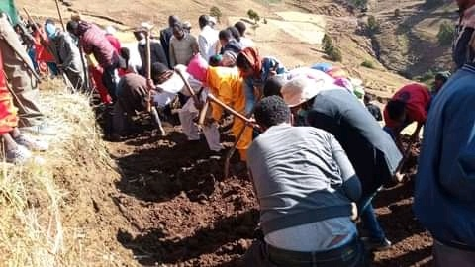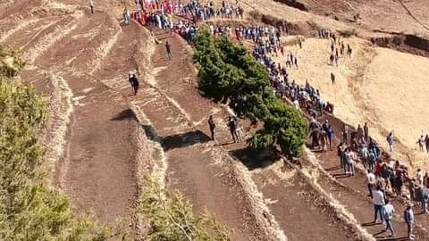

Figure 4.1:- terracing
Soil and Stone bund:
According to survey data indicated in Table 4.6, 42(25.0%) household respondent were practicing soil and stone bund practices. A soil & stone bund is an embankment along the contour, made of soil and/or stones, with a basin at its upper side. The bund reduces or stops the velocity of overland flow and consequently soil erosion. Soil which is eroded between two bunds is deposited in the basin behind the lower bund. Soil bunds reduced soil losses and runoff by 35% and 15% respectively (Amare et al., 2014). The FDG and key informant interview also confirm to the choice of SLM practices that soil erosion is highly reduced and the protect land degradation. On the conserved land the soil and stone bund practices used is able to maintained and permanently settled because of the conservation.
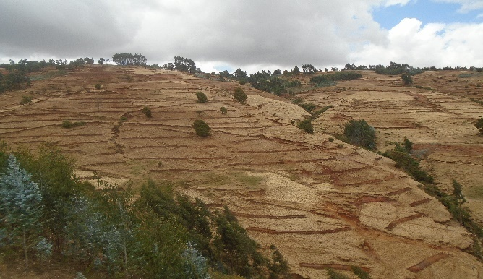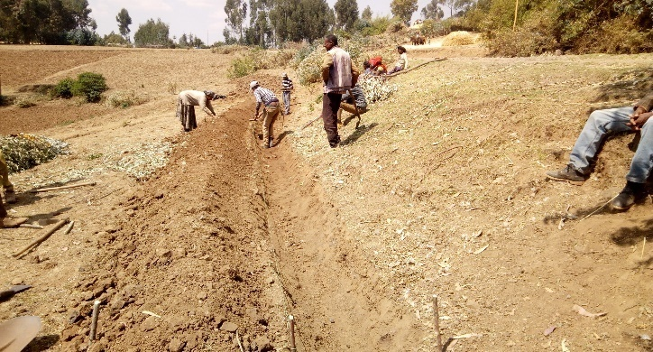Figure 4.2:- soil & stone bund
Tree planting:-As shown from above table 4.6 to survey data indicated 44(26.19%) household (more of HHs) respondent were practicing tree planting practices. With regard to the choice of SLM practices the FDG and key informant interview also confirm that soil erosion is highly reduced and the protect land degradation. On the conserved land the tree planting used is able to maintained and permanently settled because of the conservation.
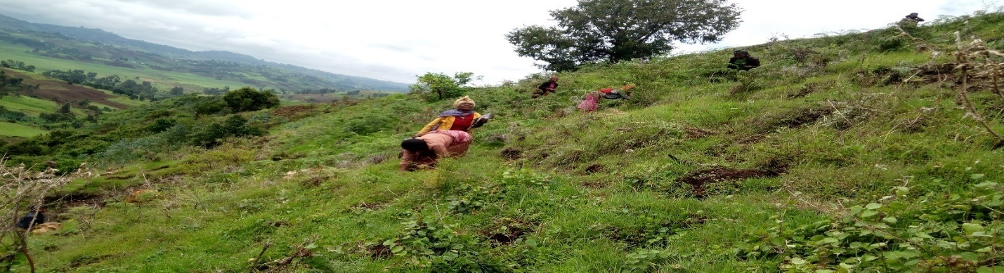

Figure 4.3:- tree planting

Gabion check dam
A Gabion check dam is an obstruction wall across the bottom of a gully or a small river to reduce the velocity of the runoff and prevent deepening or widening of the gully and help to fill it up with sediment (Fig 4.4). The potential energy is absorbed below the vertical drops of the over-fall. Sediments are deposited behind the check dams so that the slope gradient of the gully is also reduced.
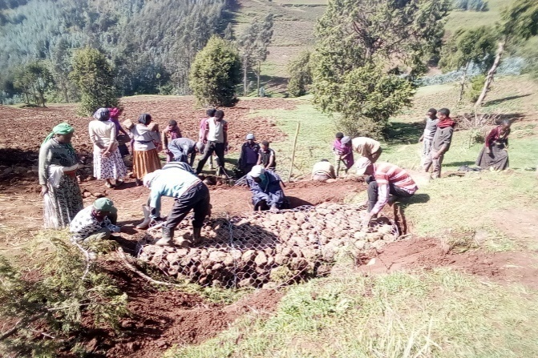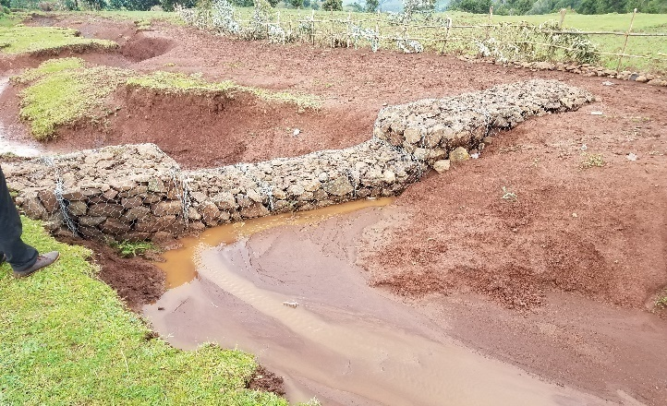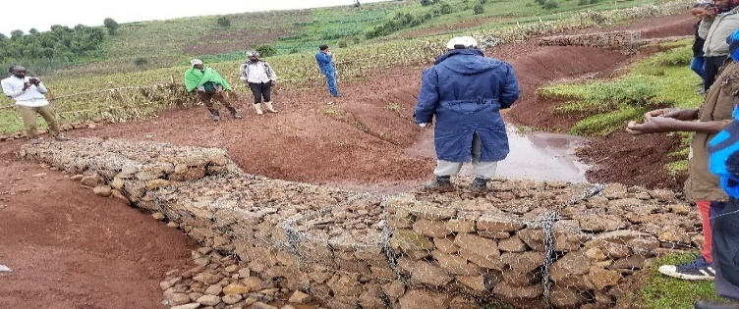Figure.4.4:- Gabion check dam

Demographic Characteristics of respondents
The demographic characteristic of household head includes age, sex, family size and marital status.

Table 4.1: Demographic characteristics of respondents on continuous variables
Explanatory | mean | Sd. | t-value
Age of HHs | 38.881 | 14.6 | 0.000
Family size(men equivalent) | 3.091 | 1.5 | 0.0001
Source: Own survey data (2022)
As shown from Table 4.1, the standard deviation and mean age of respondent were 14.6 &38.881 respectively. The mean age of the household heads implementing choice of sustainable land management practice were 38.881. The t-test indicates that, there are statistically associations mean difference on age between household heads who implement choice SLM practices at (t-value=0.000).
In addition, the standard deviation and mean family size of the household head respondents were 1.5 & 3.09 by use of conversion factor of household labor into ME (man equivalent conversion) respectively. According to the CSA, (2008) the average family size of rural household head is 4.9 which is approximately 5, based on the data indicated in Table 4.1 Shows that, the study area family size exceeds the average national rural family size. The mean family size value of farmers’ ‟ who choose practice SLM practices were 3.091. According to Table 4.1 the t-test for family size indicates that there are statistically associations mean deference on family size of farmers‟ who implement choice of SLM practices.

Table 4.2: Demographic characteristics of respondents on dummy/categorical variables
Explanatory variables | Category |  | Frequency | Percentage |  | Chi-square (χ²)
Sex of HHs | Female |  | 24 | 14.3% |  | 32.658**
 | Male |  | 144 | 85.7% |  | 32.658**
Marital status of HHs | Married  Single |  | 78  54 | 46.43%  32.14% |  | 27.010**
Marital status of HHs | Divorced |  | 20 | 11.9% |  | 27.010**
 |  | Widowed | 16 |  | 9.52% | 27.010**
Source: Own survey data (2022) ** indicates significant level at 5%
As it can be seen from Table 4.2, from a total of observation 168 male and female household heads 144 males and 24 females respondents were implement choice of SLM practices. The p-value indicates that there is statistically a significant between sex of the household heads and determine to choice of sustainable land management practices and also the chi square test indicates that there is statistical association between sex of HHs and determine to choose SLM practices. Thus, from the above Table information, the majority of household heads are Male households.
On the other wing, from168 households who choice of SLM practices 78 are married, 54 unmarried (single), 20 divorced and 16 widowed respondents. According to the above table the chi square test indicates that there is statistical association between marital status and determine to choice SLM practices and the p value for marital statuses indicates that there is statistically a significant between marital statuses of the household head and determine to choice of SLM practices.

Socio-Economic characteristics of respondents
The socio-economic characteristic of the household head includes Education, land resource, land farming size and livestock holding. The response of sample household heads has been categorized as continuous/discrete and dummy/categorical variable and summarized in Table 4.3 and 4.4 respectively.

Table 4.3: Socio-Economic characteristics of the households on continuous variables
Explanatory variables | mean | Sd. | t-value
Land farm size | 0.83 | 0.74 | 0.000***
Distance of farm land to home | 0 .75 | 0 .74 | 0.000***
Livestock | 2.01 | 0.67 | 0.000***
Source: Own survey data (2022) NB: *** indicates the level of significance at 1%

Livestock in TLU: Livestock is an important component of the farming system in the study area. The main purpose Livestock products such as milk and meat have secondary importance to the farmers. A vast majority of the sample households included in this survey owned animals of different kind. Cattle, donkeys, horse sheep, goats and chicken are common domestic animals. Small ruminants and chickens were sold and serve the purpose of immediate cash needs at times of cash shortage. The size of livestock owned indicated the wealth status of the household. According to the above table the standard deviation livestock of household head respondent was 0.67 and the mean value for households who determinedchoice SLM practices were 2.01 respectively, also the t-test indicates that there is statistical association between livestock and determine to choice SLM practices. According to Motuma (2016), farmers‟ livestock holding size could be considered as one indicator for better availability of resources or resource endowment.
As indicated from the above Table, the land farm size is one of the socio-economic characteristics of the household heads. The standard deviation land holding size of household head respondent was 0.74 and the mean value for households who determined choice SLM practices were 0.83 respectively, also the above table reveals that there is the t-test indicates that there is statistical association land farming size between households and implementing choose of SLM practices.
Based on Table 4.4, the standard deviation of distance for farmland of household head respondents were 0.74 and the mean value for households who choice of SLM practices was 0.75 of households implementing choice of SLM practices. According to the above table there is the t-test indicates that there is statistical association distance of farm land to home between households and implementing choice of SLM practices, also p value for distance of farm land to home indicates that there is a not significant mean difference between households who determine choice SLM practices.

Table 4.4: Socio-Economic characteristics of the Households on dummy/categorical variables
Explanatory variables | Category | Frequency | Percentage | Chi-square (χ²)
Education | Illiterate  1-12  above 12 | 59  82  27 | 35.12  48.81  16.07 | 3.265**
Household occupation | Farming  Non farming  Off farming | 47  37  87 | 27.98  22.02  50 | 20.988**
Farmer Status | Model  Ordinary | 59  109 | 35.12  64.88 | 14.944**
Annual income (ETB.) | <50,000  50,000-75,000  >75,000 | 39  93  36 | 23.21  55.36  21.43 | 23.854**
Farmers perceptions on SLM | Decreasing  Increasing  No change | 14  111  43 | 8.33  66.07  25.6 | 18.795**
Source: Own survey data (2022) NB** indicates that significant level at 5%
As it can be seen from Table 4.5 the farmer status from a total of 168 households who determines choice of SLM practices 109 respondents were ordinary farmers and 59 were model farmers respectively. According to the above Table the chi square test indicates that there is statistical association between farmer status and determine to choose SLM practices and also the farmer status are statistically significant on the choices of SLM practice.

As shown from above the Table, from a total of 168 households who choice of SLM practices 59 is illiterate, 82 from grade 1 up to 12 which means elementary, high school & preparatory are there and 27 above grade 12 which means college and university. The chi square test indicates that there is statistical association between education level and determine to choice SLM practices. Thus from this, we can conclude that the majority of respondents were 1-12 gradeeducations levels are more choice SLM practice in study area. According to Todaro and Smith (2009), education is the key factors that affect development and growth.
On the other hand, from a total of 168 households who determines choice of SLM practices 47 and 37 respondents were engaged in farming and off farm activity and 87 were engaged in non-farm activity respectively. According to the above table the chi square test indicates that there is statistical association between farmer occupations and determine to choice SLM practices and thep- value for House hold occupation indicates that there is statistically a significant household who choose SLM practices.
As from above table a total of 168 households of annual income who choice of SLM practices 39 and 93 respondents were the income of HHs are <50,000 and b/n 50,000-75,000 and 36 were more than 75,000 ETB get annual income respectively. According to the above Table the chi square test indicates that there is statistical association between annual income and determine to choose SLM practices and the p- value for House hold annual income indicates that there is not statistically a significant household who determine choice SLM practices.
The knowledge and perception of farmers regarding land degradation is important when we consider choicesustainable land management practices. Farmer’s perception about the existence of land degradation problem on their farm plots, causes of the problems as well as its consequences might make farmers to choice SLM practice. The majority of the sample household heads (66.07%) have increasing, 8.33% decreasing and 25.6% no difference are perceived the choice SLM practices. This can imply that perceiving the problem of land degradation problem is cannot always be guarantee for choice of SLM practices/ technologies. According to the above Table the chi square test indicates that there is statistical association between farmer perceptions and determine to choice SLM practices and the difference between the three groups with respect to perceiving the existence of choices SLMP was statistically significant.

Institutions and farming characteristics of respondents
The institutions and farming characteristic of the household head includes farming (household) experience, slop of farm plot, use of credit,and frequency of extension contact and soil erosion hazard. The response of sample household heads has been categorized as continuous/discrete and dummy/categorical variable and summarized in Table 4.5.

Table 4.5: Institutions and farming characteristics of the households on dummy/categorical variables
Explanatory variables | Category | Frequency | percentage | Chi-square (χ²)
Household experience | <5 years  b/n 5-10 years  >10years | 44  72  52 | 26.19  42.86  30.95 | 19.440**
Slope of farm plot |  | 42  43  83 | 25  25.6  49.4 | 17.387**
  Flat
  Rugged
  steep slope
Use of credit | No  Yes | 56  112 | 33.33  66.67 | 1.259*
Frequency of extension contact |  | 68  56  19  25 | 40.48  33.33  11.31  14.88 | 31.734**
  0nce a week
  every 15 days
  once a month
  every 3 month
Soil erosion hazard |  | 25  143 | 14.88  85.12 | 14.684**
  No
  Yes
Source: Own survey data (2022) NB: - * and ** indicates that significant level at 10%, 5%

Household Experience
As shown from above the Table 4.5, from a total of 168 households who choice SLM practices 44 is < 5 years’ experience on farming land, 72 found between 5-10 years’ experience on farming land and 52 above 1o years’ experience on farming land respectively. The chi square test indicates that there is statistical association between householdsexperience and determines to choice SLM practices statistically significant.
Soil erosion hazard
In addition above the table 4.5, from a total of 168 households who choice SLM practices 25 were say no soil erosion and 143 were say yes soil erosion. The chi square test showed that there is statistical association between soil erosion of the land and determined tochoice SLM practices statistically significant. Thus, from the above Table information, the majority of household heads are said that our farm lands have soil erosion.
Slope of farm plot
Overwhelming majority of farmers disclosed that their land productivity is declining with each passing year due to soil erosion. Farmer’s perception about the existence of land degradation problem on their farm plots, causes of the problems as well as its consequences might make farmers to choose SLM measures. The majority of the sample household heads have perceived the problem of soil erosion on their farm plots. From this, 49 of household’schoice SLM practices/ technologies rugged plots, 43 of household’schoice SLM practices/ technologies flat plots and 73 of households choice SLM practices/ technologies flat steep plots. The difference between the SLMP with respect to perceiving the existence of soil erosion on farm plots was statistically significant.
Frequency of extension contact
In the study area, the most important sources of information cited were through communication with relatives and neighbors, community leaders, and the government’s mainstream agricultural extension program. Farmers’ pointed out the governments’ extension service as the most important one. In addition, they further revealed that information about input supply and use, land management practices; improved cultural practices and soil conservation practices are among the aspects covered by the extension services. Access to extension service is very important element of institutional support needed by farmers to enhance the use of agricultural technologies in general and soil conservation technologies in particular. Three Development Agents (DA’s) were assigned in each sample kebeles. It was expected that sample farmers in the study area have an access to extension services through the DAs, attending field days and training. Development agents had visited about 68 households every 15 days, 56 households once a month, 19 every 3 months and 25 of sample households from once times per a week. Focus group discussions revealed that extension workers focused mostly on the promotion of SLM practice and method of control land degradation. The frequency of extension services/contact/ was found to be statistically significant.

Econometric Model Result: Determinants of choice of SLM Practices

Testing of Model Assumption
Goodness-of-fit test
Goodness-of-fit is a statistical hypothesis test used to see how closely observed data mirrors expected data. Goodness-of-fit tests can help determine if a sample follows a normal distribution, if categorical variables are related, or if random samples are from the same distribution. Goodness fit table contains the χ²-test which is useful for determining whether a model exhibits a good fit to the data of choice of SLM practice and its determinants. Finally, Model goodness of fit test (Gof) was also employed to test is the model robust enough to explain the dependent variable. This is evidenced by the fact that the model of was tested using prob> chi2 which found to be 0.995 which lies between 0 and 1 (table4.7). The result confirms that the explanatory variables of the model could explain the dependent variable. So we can conclude that the models were correctly fitted.

Goodness-of-fit test foramultinomiallogisticregressionmodel
Dependent variable: choose of SLM practice
number of observations | 168
number of outcome values | 4
base outcome value | 3
number of groups | 10
chi-squared statistic | 9.853
degrees of freedom | 24
Prob> chi-squared | 0.995

Table 4.7:- Goodness-of-fit test for a multinomial logistic regression model
Model specification (Link test)
Link test was employed to test the model specification error. The null hypothesis is that there is no specification error. If the p value of hatsq is not significant so we fail to reject the null hypothesis and conclude that our model is correctly specified or this model has not specification problem. Here the p value of hatsq for this model is 0.227 (table 4.8).
Slm | Coef. | Std. Err. | t | P>t | [95% Conf. | Interval]
_hat | 2.465399 | 1.216675 | 2.03 | 0.044 | .0631417 | 4.867657
_hatsq | -.2886832 | .2378438 | -1.21 | 0.227 | -.7582929 | .1809264
_cons | -1.785149 | 1.520269 | -1.17 | 0.242 | -4.786839 | 1.21654

Table 4.8 model of specification
Collinearity
The pair wise correlation tests employed in order to test the existence of a correlation between independent variables. According to (Stock and Watson, 2007), the correlation coefficient range between +1 and -1 are considered as a critical point to indicate a serious collinearity. So, for this study, thelargest correlation coefficient in dependent variablesis frequencies of extension contact of farmer which is recorded as strong linear association in all variables found to be 0.2318 (see appendix. 8).

Determinants of choice of SLM Practices
The Determinants choice of SLM Practices were examined using the multinomial logit (MNL) model. The estimated MNL model coefficients, standard error, marginal effects (dy/dx), confidence interval and their significance levels were presented in Table 4.8. The log likelihood estimation of -184.71 and the chi-squared value of 96.23 showed that the likelihood ratio statistics are highly significant (P < 0.05) suggesting the model is good-fit and has a strong explanatory power.
Results of the MNL analysis revealed that choice of SLM practices: - terracing, soil-stone bund, trees planting and gabion check dam was influenced by several variables. The variables found to have a significant influence include sex of the household heads, marital status of the household, education level of households, farming(house hold) experience, Household occupation, Farmer status, frequency of extension contact, slop of farm plot, soil erosion hazard and farmer perception. The detail of the model result and interpretation discussed as follows.

Table 4.8: MNL simulation results of the choice of SLM practices.
Multinomial logistic regression |  |  |  |  | Number of observation =168
 |  |  |  |  | LR chi2(48) =96.23
 |  |  |  |  | Prob> chi2 =0.0000
Log likelihood = -184.70999 |  |  |  |  | Pseudo R2 =0.2067
Choose of SLM practice | Coef. |  | Std. Err. |  |  | z |  | P>z |  |  |  | Marginal effect(dy/dx)
Terracing (1)
Sex | 6.731824 |  |  | 1.611473 |  | 4.18 |  | 0.000** |  |  |  | .299967
Age | -.0054848 |  |  | .0189378 |  | -0.29 |  | 0.772 |  |  |  | -.0001139
Family size | .3483707 |  |  | .1953114 |  | 1.78 |  | 0.074* |  |  |  | .0290701
Marital status | -.5866283 |  |  | .2697936 |  | -2.17 |  | 0.030** |  |  |  | -.0208793
Education level | 1.005797 |  |  | .4117522 |  | -2.44 |  | 0.015** |  |  |  | -.1173575
HH.occupation | -1.620465 |  |  | .6283303 |  | -2.58 |  | 0.010** |  |  |  | -.0401573
Farmer status | -1.369539 |  |  | .627954 |  | -2.18 |  | 0.029** |  |  |  | -.1788087
Income HHs | .0020677 |  |  | 1.042684 |  | 0.00 |  | 0.998 |  |  |  | -.0637431
Land size | .0552045 |  |  | .3748171 |  | 0.15 |  | 0.883 |  |  |  | .030263
Land tenure | -.0708178 |  |  | .5849995 |  | -0.12 |  | 0.904 |  |  |  | .045915
Slop farm plot | .7880617 |  |  | .604162 |  | 1.30 |  | 0.192 |  |  |  | -.0720607
HH.experience | 1.526892 |  |  | .5472139 |  | 2.79 |  | 0.005** |  |  |  | .155275
Freq.ext.contact | -1.159039 |  |  | .2945913 |  | -3.93 |  | 0.000** |  |  |  | -.1227717
Soil hazard | -4.83244 |  |  | 1.526118 |  | -3.17 |  | 0.002** |  |  |  | -.2364944
Farmer perception | -1.179963 |  |  | .5052458 |  | -2.34 |  | 0.020** |  |  |  | -.1542008
Livestock | -1.037583 |  |  | .9287057 |  | -1.12 |  | 0.264 |  |  |  | -.0916564
_cons | 7.399703 |  |  | 2.568489 |  | 2.88 |  | 0.004
Stone and soil-bund(2)
Sex | 5.080391 | 1.380058 |  |  |  | 3.68 | 0.000** |  |  |  |  | .2738854
Age | -.0181815 | .0191391 |  |  |  | -0.95 | 0.342 |  |  |  |  | -.0037614
Family size | .3488947 | .1912411 |  |  |  | 1.82 | 0.068* |  |  |  |  | .0355973
Marital status | -.7723129 | .2672547 |  |  |  | -2.89 | 0.004** |  |  |  |  | -.0784385
Education level | -.528382 | .3937082 |  |  |  | -1.34 | 0.180 |  |  |  |  | -.0068908
HH.occupation | -2.141639 | .6215725 |  |  |  | -3.45 | 0.001** |  |  |  |  | -.1976661
Farmer status | -1.266303 | .6076305 |  |  |  | -2.08 | 0.037** |  |  |  |  | -.1885826
Income HHs | .1891566 | 1.091801 |  |  |  | 0.17 | 0.862 |  |  |  |  | -.0243484
Land size | -.1673495 | .3676624 |  |  |  | -0.46 | 0.649 |  |  |  |  | -.0265955
Land tenure | -.6221235 | .5586571 |  |  |  | -1.11 | 0.265 |  |  |  |  | -.1017925
Slop farm plot | 1.811353 | .593924 |  |  |  | 3.05 | 0.002** |  |  |  |  | .20409
HH.experience | 1.140932 | .5494404 |  |  |  | 2.08 | 0.038** |  |  |  |  | .0792206
Freq.ext.contact | -.9801986 | .280075 |  |  |  | -3.50 | 0.000** |  |  |  |  | -.0986806
Soil hazard | -3.7992 | 1.423634 |  |  |  | -2.67 | 0.008** |  |  |  |  | .0494972
Farmer perception | -.7971075 | .468468 |  |  |  | -1.70 | 0.089* |  |  |  |  | -.0787966
Livestock | -.391801 | .9189466 |  |  |  | -0.43 | 0.670 |  |  |  |  | .0724862
Cons. | 5.618013 | 2.427499 |  |  |  | 2.31 | 0.021**
Tree planting(3) (base outcome)
Gabion check dam (4)
Sex | 5.346056 | 1.580273 |  |  |  | 3.38 | 0.001** |  |  | .2945885
Age | .0050636 | .0167142 |  |  |  | 0.30 | 0.762 |  |  | .0029264
Family size | .1480924 | .1737036 |  |  |  | 0.85 | 0.394 |  |  | -.0221153
Marital status | -.4805986 | .2418826 |  |  |  | -1.99 | 0.047** |  |  | .0048848
Education level | -.4061813 | .3585797 |  |  |  | -1.13 | 0.257 |  |  | .0285174
HH.occupation | -1.576901 | .6116421 |  |  |  | -2.58 | 0.010** |  |  | -.0372466
Farmer status | .2626881 | .5978611 |  |  |  | 0.44 | 0.660 |  |  | .2524643
Income HHs | .7565538 | 1.008305 |  |  |  | 0.75 | 0.453 |  |  | .1402059
Land size | -.1351372 | .3516511 |  |  |  | -0.38 | 0.701 |  |  | -.0177424
Land tenure | -.2509428 | .5357361 |  |  |  | -0.47 | 0.639 |  |  | .0054416
Slop farm plot | 1.357546 | .5875958 |  |  |  | 2.31 | 0.021** |  |  | .0760593
HH.experience | .6205371 | .5326257 |  |  |  | 1.17 | 0.244 |  |  | -.0705988
Freq.ext.contact | -.2870013 | .2387466 |  |  |  | -1.20 | 0.229 |  |  | .1010208
Soil hazard | -4.392777 | 1.565283 |  |  |  | -2.81 | 0.005** |  |  | -.1150076
Farmer perception | -.059884 | .4414275 |  |  |  | -0.14 | 0.892 |  |  | .1340954
Livestock | -1.00154 | .8392222 |  |  |  | -1.19 | 0.233 |  |  | -.1034495
_cons | .762374 | 2.269408 |  |  |  | 0.34 | 0.737
Source:-stata15 output (2022). **, * Significant at less than 1%, & 5% probability level, respectively

Sex of HHs: -As it was hypothesized sex of households is positively and significantly determines choice of SLM practice at less than 5% significance level. Most of the land management practices require more labor force. Hence, male headed households are expected to better undertake different land management practices, as better endowed with labor. Women are often faced with more labor constraints than male farmers and male-headed households. Women are also sometimes inhibited from making determines about land management practices while their husbands are away (Benin, 2006). In addition, women are commonly busy in household activities and their prime responsibility is usually child rearing. The marginal effect value revealed that being male household head increases by one probability of SLM Practice choices of soil stone bond by 0.274, terracing by 0.3, gabion check dam by 0.295and related to base outcome.
Family size:-Family size had a positive effect on the choiceofSLM practices terracing, soil&stone bund, of SLM practice at a 1% signiﬁcant level (Table4). This result is in line with the ﬁndings of Gebremedhin, Swinton, Miheretu and Yimer (2017), who stated that the presence of more household members’ favors choice labor-demanding SLM practices. The same view was also stressed by FGDs and key informant interview participants in the study area. However, Amsalu and de Graaff and Sileshi et al. (2017) found contradictory results and explained that larger families might be less likely to choose SLM practices because there is a competition for labor between food generating off-farm activities and SLM work. Likewise, Shiferaw (2001) and Holden (2011) speciﬁed that structural SLM measures occupied a wide area and occupied the scarce productive land resource. The marginal effect resultfor family size of household by one increases the probability of SLM Practice choices by soil stone bond (0.029), terracing (0.035) and related to base outcome respectively. Therefore, farmers with large family sizes may be inclined to choose the constructed SLM practices from their farm ﬁelds.
Marital status of HH ፦marital status of household was negatively and statistically significant at 5% and1% in affecting farm household to choice of SLM practices terracing,gabion check dam and soil-stone bund SLM practicesrespectively. The result is in line with the finding done by Aboaba et al. (2020), if the head of a household is married, they are mature and take the responsibility for providing for their families. The Marginal effect with value of terracing(0.021),stone soil-bund (0.078), gabion check dam (0.005) and related to base outcome implies that keeping other factors constant, as the married household head is being engaged in marital status of Hhs, the chance of choice sustainable land management practices are decreased by one probability of 0.021, 0.078, 0.005and related to base outcome.
Educational level of household: - The level of education of household was positively and significantly affected the likelihood of choice of SLM practices terracing at 5% level of significances. This implies that the likelihood of choice of SLM practices are increases with the level of education of the household head. This is probably because educated household head better understand the benefit of chosenland degradation control methods of SLM practices. The study by Senbetie et al. (2017), Tesfaye and Brouwer (2016), Wondimu Legesa (2020) and Yitayal (2004) also obtained a similar result in their respective studies on the relationship between the level of education and the determine to choiceSLM practices technology in Ethiopia. The marginal effect value for education levels shows that keeping all factors constant an increase in education by one year the probability of choice of SLM Practices by terracing (0.117) andrelated to base outcome.

Occupations of House hold: -As it was hypothesized occupations of the household heads and choice of sustainable land management practices become negative and statistically significant at 5%. The Marginal effect with value of terracing(0.04),stone soil-bund(0.198) , gabion check dam(0.037) and related to base outcome implies that keeping other factors constant, as the household head is being engaged in occupations of HHs, the chance of choose sustainable land management practices are decreased by 0.04, 0.198, 0.037and related to base outcomerespectively. The finding of this study is similar with the previous work of Paulus (2015), which indicates that commitment in off farm activities (occupations of HHs) can negatively determines farmers to carry out SLM practices.
Farmer status:-Farmer status of household was negatively and statistically significant at 5% and1% in affecting farm household choice of SLM practices terracing and soil & stone bund respectively. Based terracing and stone soil bund SLM practice among farmers with status have much higher chance of applying negative and significant effect on choice ofSLM practices terracing and soil & stone bund at five percent levels of significance (p=0.05).The marginal effect value revealed that being farmer statusdecreases the probability of SLM Practice choices by soil stone bond (0.189), terracing (0.179) and related to base outcome.
HH experience: -As it was hypothesized households experience of the HHs were positively and statistically significant in explaining the variation in the choice of terracing and stone soil bund of SLMP. Farmers who have many years of farming have the propensity to increase their choiceSLM practices. This reason is not farfetched from the fact that farming activities are presumed to be a vocation and farmers gain knowledge and improve their skills as the number of years in that vocation increases. The marginal effect value for farming experience of farmer increases by probability of year SLM Practice choices by soil stone bond (0.079),terracing (0.155) and related to base outcome respectively.

Slope of the farm plots (SLOP): This variable positively influenced the choice of SLM practices at less than p-value (0.05) level of significance. The significant positive terms in choose of SLM practices indicate that farmers are inclined to invest in SLM practices where their farm plots are located on higher slopes. This goes with the perception that those plots can only be productive if protected by SLM practice structures. On the other hand, Berhanu, Tesfaye Samuel Saguye (2017) and Swinton (2003) have stated that an increase in the slope of the plots may create a disincentive to invest in protects land degradationSLM practices as the slope of the plot increase the distance between two consecutive terraces will decrease because the structures of SLM measures occupy more area of land and will create inconvenience for farm operation. The marginal effect value for slop of the farm plot decreased by the probability of SLM Practice choices by soil stone bond (0.204), gabion check dam (0.076) andrelated to base outcome implies that keeping other factors constant, as the land farm of household head is being engaged in slop of the farm plot, the chance of choice sustainable land management practices are decreased by 0.204, 0.076and related to base outcome.
Frequency of Extension contact: As hypothesized, frequency of extension contact is found to have a significant and negatively effect on choice of SLM Practices (terracing, soil-stone bonds and related to base outcome) at 5% probability level. This may be explained by the fact that the message/contents that farmer gain from extension agents help them to initiate to use the newly introduced land management practices on their farm to protect their land from erosion and improve its fertility. Therefore, contact between a farmer and development agent and information gained accelerate the attitude of farmers towards SLM practices positively, and the determine of farmers to invest on SLM Practice on his/her land (Tesfaye 2006). The marginal effect value for extension contact by one increases the probability of SLM Practice choicesby terracing (0.123) and soil stone bond (0. 099)and related to base outcomerespectively. Many other case studies too revealed that low adoption of rainwater harvesting technology were due to lack of extension services (Nasr, 1999; Kihara, 2002; Mitiku and Sorsa, 2002; Ngigi, 2003).

Soil erosion hazard: -As hypothesized, soil erosion hazard is found to have statistical significant and negatively effect on choice of SLM Practices (terracing, soil-stone bonds, gabion check dam and related to base outcome) at 5% probability level. This implies that farmers who perceive soil erosion problem and its adverse effects on the productive capacity of farming land are more likely to choice the SLM practices. Consistent with this, Paulos and Belay (2017) found perception of erosion hazard has a positive effect on choice SLM technologies. The marginal effect value for soil erosion hazard on SLMpractice decreasedby the probability of SLM Practice choicesterracing (0. 24), soil stone bond (0. 05) and gabion check dam (0.115) and related to base outcome.
Farmers’ perception on choose SLM practices: the perception of farmer on SLM has a negative and significant effect on choice ofSLM practices terracing and soil-stone bundat 5% & 1% levels of significance. This implies that farmers who perceive on SLM and its adverse effects on the productive capacity of farming land are more likely to choose the terracing and related to base outcome of SLM practices than others. Consistent with this, Paulo’s and Belay (2017) found perception of erosion hazard has a positive effect on choice SLM technologies. The marginal effect value indicate that as farmers perceiveSLM practices is very important in reducing land degradationSLM Practice choicesof terracing and soil-stone bunddecreased by the probability of 0.154 and 0.0787 related to base outcome.

CHAPTER 5

CONCLUSION AND RECOMMENDATIONS

Conclusion
Understanding the determinants of a household’s determine to choice various sustainable land management practices is critical to prevent land degradation and improve rural livelihoods. This study was conducted to access choices of sustainable land management (SLM) practice and its determinants among smallholder farmers’ in land degradation areas of the Dendi District. The primary data was collected from 168 sample households using structured questioners. Descriptive statistics and econometric models were applied to analyze the quantitative data, while the content analysis method was applied to quantitative data.
The finding shows that 95% of respondents reported choosing at least one type of SLM practice on one plot of land. The most widely used SLM practices measures were trees planting(26.19%), soil &stone bunds (25%),terracing (24.4%), and gabion check dam (24.4%) basedon the information of the key informants and focus group discussants other land management practices practiced on the study kebeles to protect the agricultural land from degradation and soil erosion.
The results of multinomial logistic (MNL) regression modelrevealed that sex of household head, family size, education level household head, household experience, and slop of farm plot positively and significantly affect at least one SLM practice while farmers’ perception on SLM, Household occupation, marital status, farmer status, soil erosion hazard and frequency of extension contact, were negatively and significantly associated with choice SLM practices.
The marginal effect of choice of SLM practices was observed to be higher with increase the level of education, increase in family size andfrequency to extension contact. A male farmer choosesSLM practices more than female farmers. Theprobabilities of a household choose multiple SLM measures were higher for larger family size, sex of Hhs head, Household experience, and farmer status. Farmers’ perceptions on SLM, marital status and soil erosion hazard were associated with decreased probabilities of marginal effect to choice SLM practices.

Recommendations
Based on the findings of the study the following recommendations are given:
- First, Planners and policy makers should formulate appropriate policies and programs considering the farmers’ interest, capacity, and limitation in promoting improved land degradation bySLM practice for greater acceptance and choice of SLM practice by the farmers of study area. In order to achieve the social benefits of natural resource conservation, there is a need for aggressive programs to tackle the problem of low level of education, poor perception on SLM practice in community organizations and government initiated soil conservation programs.
- Second, for sustainable land management, despite the fact that sustainable land management is multifaceted and seems to require formal knowledge and guidance from extension providers to farmers of study area. For this reason, government and policy makers should focus on improving skill of extension staff in-line with increasing their number and their availability for well-organized and useful dissemination of SLM practice.
- Third, more educational institutions with continuing education programs might be opened besides adult education centers at study areas. This eventually enhances the educational qualification of the farmers in the study area enabling them to becomechoicer of SLM practices.
- Fourth, positive awareness creation and changing any negative perception of the farmers on the choose of SLM practices through FTCs, periodical workshops and seminars and lecturing on the positive of SLM practices during farmers’ day celebration would achieve the desired goals with regard to choiceSLM practices on study are.
- Any future land management efforts should give a due attention to genuinely involve farmers in entire process of SLM practice based on thechoiceand its determinants at the study area. The government and Non-governmental organization that support farmers such like SLM and AGP program should extend their activities to cover land management practice issues and also integrates their activities in land management with the help of the government.
- Finally, the study recommended the local and regional government should design specific programs of solving constrain and thereby scale up and foster chooses of SLM practices and determine-making about land management and land degradation should encompasses factors that may be biophysical (slop of farm land plot, soil erosion hazard), economic (occupation Households, Households experience), social (marital status, sex, education level, frequency of extension contact, farmer status and farmer perception) on the study area.

REFERENCES
Babalola, D.A., and Olayemi,J.K. (2013). Determinants of farmers preference for sustainable land management practices for maize and cassava production in Ogun state, Nigeria. pp 1-19.
Belay, T. (2000a). “Integrating Indigenous and Modern Agricultural Technologies in the Drought-prone Areas of Ethiopia”. Zenebework Tadesse (ed.) Issues in Rural Development: Proceedings of the Inaugural Workshop of the Forum for Social Science Studies, 18 Sep. 1998, Addis Ababa, Forum for Social Science Studies.
Bouna, J. (1997). The land use system approach to planning sustainable land management at several scale, ITC journal 3/4, Enschded, the Netherlands, pp. 237-242.
Chomba GN (2004). Factors affecting smallholder farmers adoption of soil and water conservation practices in Zambia. M.Sc. Thesis, Michigan State University, Michigan
Case Study; National Conservation Strategy Secretariat, Ministry of Planning and Economic Development, Transitional Government of Ethiopia, Addis Ababa, Ethiopia.
Daniel, D. (2010). Sustainable land management technologies and approaches in Ethiopia. Natural resource management sector, MoARD, Addis Ababa, Ethiopia.Pp.1-321.
Desta Damena Heyi. (2012).Determinants of Farmers’ Land Management Practices: The Case of Tole District, South West Shewa Zone, Oromia National Regional State, Ethiopia. Journal of Sustainable Development in Africa (Volume 14, No.1, 2012). Bindura University of Science Education, Zimbabwe.
Ethiopian land policy and administration assessment, 2004. Www. Ardinc.com site visited on Nov 20/2017 at 4:27pm.
FAO (2008).Terr Africa – a vision paper for sustainable land management in sub-Saharan Africa.FAO, Rome, Italy.
Gujarati, D.(2004). Basic Econometrics, Fourth Edition. Topics in Econometrics 15.Qualitative Response Regression Models. The McGraw−Hill Companies.
GWPD, (2009).Sustainability of natural resource management, panel discussion, Debre Markos, Ethiopia.
Habtamu, E. (2006). Adoption of Physical Soil and Water Conservation Structures in Anna Watershed, Hadiya Zone, Ethiopia. (Master’sThesisAddis Ababa University, 2006).
Haymanot Eshetia. (2018). Factors Influencing Farmers‟ Determine in implementing Sustainable Land Management Practices in Erosion- prone Areas of East Gojjam Zone, Ethiopia, thesis, Addis Ababa University.
Hurni, H. (1996). (With the assistance of an international group of contributors). Precious earth: from soil and water conservation to sustainable land management. International soil conservation organization (ISCO) and center for environment and development (CED), Berne, 89 pp.
Kruger, H., Berhanu, F., Yohannes, G., M and Kefeni, K.(1997). Inventory of Indigenous Soil and Water Conservation Measures on Selected Sites in the Ethiopian highlands, University of Bern, Center Development and Environment, Switzerland.
Kurukulasuriya, P & Rosenthal, S, (2003).Climate change and agriculture: A review of impacts and adaptations. Paper No. 91 in Climate Change Series, Agriculture and Rural Development Department and Environment Department, World Bank, Washington, DC.
Liniger, H.P., R. Mekdaschi Studer, C. Hauertand M. Gurtner. 2011. Sustainable Land Management in Practice – Guidelines and Best Practices for Sub-Saharan Africa. TerrAfrica, World Overview of Conservation Approaches and Technologies (WOCAT) and Food and Agriculture Organization of the United Nations (FAO)
Mamuye, T. (2014). Factors affecting sustainable land use management: the case of Warra Jarso Woreda, Oromiya, Ethiopia, and thesis Addis Ababa University.
Mihertu,B.A., and Yimer, A.(2017). Determinates of farmers adoption of land management practice in Gelana sub-watershed of northern highlands of Ethiopia.doi 10.1186/513717017-0085-5.
Ministry of agriculture and rural development. (2010).Sustainable land Management Technologies and Approaches in Ethiopia. Report paper by SLMP and natural resource management sector, Addis Ababa, Ethiopia.
Ministry of agriculture. (2014). Sustainable land management (1). (Project completion report). Addis Ababa, Ethiopia: pp.1-122.
Motuma,D.(2017). Assessment of the current status of land management practice in Girar Jarso woreda, central Ethiopia Oromia Region. Thesis, University of South Africa.

Negessa Gadisa. (2021).Soil and Water Conservation Measures in Ethiopia: Importance and Adoption Challenges Review (Ethiopian Institute of Agricultural Research, Holeta Agricultural Research Center). January 31st 2021
Paulus, N. (2015). Factors influencing sustainable subsistence farmers‟ adoption of sustainable land management practices in Oshikoto region, Namibia. United Nations University Land Restoration Training Program [final project] http:// www.unulrt.is/static/fel lows/document/Paulus2015.pdf
Tegegn,S. (2014). An assessment of the current land management practices of Nono woreda, Oromia region, Ethiopia, thesis, Addis Ababa University.
Tesfaye Samuel .S. (2017).Determinants of Adoption of Sustainable Land Management (SLM) Practices among Smallholder Farmers’ in Jeldu District, West Shewa Zone, Oromia Region, Ethiopia. Journal of Natural Sciences Research Vol.7, No.8, 2017, Ambo University.
Todaro, M., & Smith, S. (2009). Economic development (10th Ed.). Boston: Addison Wesley. United Nations.(2011).Millennium goals. Retrieved August 15th, 2011, fromhttp://www.un.org/ millennium goals/bkgd.shtml.
UNCCD and FAO. (2009).policy and financing for sustainable land management in sub-Saharan Africa. (Www. Ittr.arizona.edu) site visited on 20/11/2017 at 10:41am
Wondimu Lagasse. (2020).Determinants of adoption of sustainable land management practice choices among smallholder farmers in Abay Basin of Oromia, Ethiopia. Journal of Development and Agricultural Economics, Vol. 13(1), pp. 1-9, January-March 2021, Haramaya University.
Zuazo, V.H.D.; Ruiz, J.A.; Raya, A.M. & Tarifa, D.F. (2005).Impact of erosion in taluses of subtropical orchard terraces. Agriculture, Ecosystems ad Environment 107, pp. 199-210.

Appendix1.Finally results of MNL regression Model on STATA
Multinomial logistic regression |  |  |  |  |  | Number of obs =168
 |  |  |  |  |  | LR chi2(48) =96.23
 |  |  |  |  |  | Prob> chi2 =0.0000
Log likelihood = -184.70999 |  |  |  |  |  | Pseudo R2 =0.2067
Slm practice |  |  | Coef. |  | Std. Err. |  |  | Z | P>z [95% Conf.Interval] |  |  |  | Marginal effect(dy/dx)
1
Sx |  | 6.731824 |  | 1.611473 |  |  | 4.18 |  | 0.000** | 3.573395 |  | 9.890253 | .299967
Agcnt |  | -.0054848 |  | .0189378 |  |  | -0.29 |  | 0.772 | -.0426023 |  | .0316327 | -.0001139
Fmlycnt |  | .3483707 |  | .1953114 |  |  | 1.78 |  | 0.074 | -.0344327 |  | .731174 | .0290701
Mstat |  | -.5866283 |  | .2697936 |  |  | -2.17 |  | 0.030** | -1.115414 |  | -.0578426 | -.0208793
Edu |  | -1.005797 |  | .4117522 |  |  | -2.44 |  | 0.015** | -1.812817 |  | -.198778 | -.1173575
Hhocc |  | -1.620465 |  | .6283303 |  |  | -2.58 |  | 0.010** | -2.851969 |  | -.3889598 | -.0401573
Fstat |  | -1.369539 |  | .627954 |  |  | -2.18 |  | 0.029** | -2.600306 |  | -.1387716 | -.1788087
incomehh |  | .0020677 |  | 1.042684 |  |  | 0.00 |  | 0.998 | -2.041555 |  | 2.04569 | -.0637431
Landsize |  | .0552045 |  | .3748171 |  |  | 0.15 |  | 0.883 | -.6794235 |  | .7898325 | .030263
Landt |  | -.0708178 |  | .5849995 |  |  | -0.12 |  | 0.904 | -1.217396 |  | 1.07576 | .045915
Slop |  | .7880617 |  | .604162 |  |  | 1.30 |  | 0.192 | -.3960741 |  | 1.972197 | -.0720607
Hhexp |  | 1.526892 |  | .5472139 |  |  | 2.79 |  | 0.005** | .4543723 |  | 2.599411 | .155275
Freqext |  | -1.159039 |  | .2945913 |  |  | -3.93 |  | 0.000** | -1.736428 |  | -.5816508 | -.1227717
Soilhzrd |  | -4.83244 |  | 1.526118 |  |  | -3.17 |  | 0.002** | -7.823577 |  | -1.841304 | -.2364944
Fpercp |  | -1.179963 |  | .5052458 |  |  | -2.34 |  | 0.020** | -2.170227 |  | -.1896996 | -.1542008
Lvstkcnt |  | -1.037583 |  | .9287057 |  |  | -1.12 |  | 0.264 | -2.857813 |  | .7826466 | -.0916564
_cons |  | 7.399703 |  | 2.568489 |  |  | 2.88 |  | 0.004 | 2.365558 |  | 12.43385
2
Sx | 5.080391 |  |  | 1.380058 |  |  | 3.68 |  | 0.000** |  | 2.375527 | 7.785255 | .2738854
Agcnt | -.0181815 |  |  | .0191391 |  |  | -0.95 |  | 0.342 |  | -.0556934 | .0193305 | -.0037614
Fmlycnt | .3488947 |  |  | .1912411 |  |  | 1.82 |  | 0.068 |  | -.0259309 | .7237203 | .0355973
Mstat | -.7723129 |  |  | .2672547 |  |  | -2.89 |  | 0.004** |  | -1.296122 | -.2485033 | -.0784385
Edu | -.528382 |  |  | .3937082 |  |  | -1.34 |  | 0.180 |  | -1.300036 | .243272 | -.0068908
Hhocc | -2.141639 |  |  | .6215725 |  |  | -3.45 |  | 0.001** |  | -3.359899 | -.9233794 | -.1976661
Fstat | -1.266303 |  |  | .6076305 |  |  | -2.08 |  | 0.037** |  | -2.457237 | -.0753691 | -.1885826
incomehh | .1891566 |  |  | 1.091801 |  |  | 0.17 |  | 0.862 |  | -1.950735 | 2.329048 | -.0243484
Landsize | -.1673495 |  |  | .3676624 |  |  | -0.46 |  | 0.649 |  | -.8879546 | .5532555 | -.0265955
Landt | -.6221235 |  |  | .5586571 |  |  | -1.11 |  | 0.265 |  | -1.717071 | .4728243 | -.1017925
Slop | 1.811353 |  |  | .593924 |  |  | 3.05 |  | 0.002** |  | .6472836 | 2.975423 | .20409
Hhexp | 1.140932 |  |  | .5494404 |  |  | 2.08 |  | 0.038** |  | .0640483 | 2.217815 | .0792206
Freqext | -.9801986 |  |  | .280075 |  |  | -3.50 |  | 0.000** |  | -1.529136 | -.4312617 | -.0986806
Soilhzrd | -3.7992 |  |  | 1.423634 |  |  | -2.67 |  | 0.008** |  | -6.589471 | -1.008929 | .0494972
Fpercp | -.7971075 |  |  | .468468 |  |  | -1.70 |  | 0.089 |  | -1.715288 | .121073 | -.0787966
Lvstkcnt | -.391801 |  |  | .9189466 |  |  | -0.43 |  | 0.670 |  | -2.192903 | 1.409301 | .0724862
_cons | 5.618013 |  |  | 2.427499 |  |  | 2.31 |  | 0.021 |  | .8602022 | 10.37582
3 (base outcome)
4
Sx | 5.346056 |  |  | 1.580273 |  |  | 3.38 |  | 0.001** |  | 2.248779 | 8.443334 |  | .2945885
Agcnt | .0050636 |  |  | .0167142 |  |  | 0.30 |  | 0.762 |  | -.0276956 | .0378228 |  | .0029264
Fmlycnt | .1480924 |  |  | .1737036 |  |  | 0.85 |  | 0.394 |  | -.1923604 | .4885452 |  | -.0221153
Mstat | -.4805986 |  |  | .2418826 |  |  | -1.99 |  | 0.047** |  | -.9546799 | -.0065174 |  | .0048848
Edu | -.4061813 |  |  | .3585797 |  |  | -1.13 |  | 0.257 |  | -1.108985 | .2966219 |  | .0285174
Hhocc | -1.576901 |  |  | .6116421 |  |  | -2.58 |  | 0.010** |  | -2.775697 | -.3781042 |  | -.0372466
Fstat | .2626881 |  |  | .5978611 |  |  | 0.44 |  | 0.660 |  | -.9090981 | 1.434474 |  | .2524643
incomehh | .7565538 |  |  | 1.008305 |  |  | 0.75 |  | 0.453 |  | -1.219689 | 2.732796 |  | .1402059
Landsize | -.1351372 |  |  | .3516511 |  |  | -0.38 |  | 0.701 |  | -.8243607 | .5540863 |  | -.0177424
Landt | -.2509428 |  |  | .5357361 |  |  | -0.47 |  | 0.639 |  | -1.300966 | .7990806 |  | .0054416
Slop | 1.357546 |  |  | .5875958 |  |  | 2.31 |  | 0.021** |  | .2058793 | 2.509213 |  | .0760593
Hhexp | .6205371 |  |  | .5326257 |  |  | 1.17 |  | 0.244 |  | -.4233901 | 1.664464 |  | -.0705988
Freqext | -.2870013 |  |  | .2387466 |  |  | -1.20 |  | 0.229 |  | -.754936 | .1809334 |  | .1010208
Soilhzrd | -4.392777 |  |  | 1.565283 |  |  | -2.81 |  | 0.005** |  | -7.460675 | -1.324879 |  | -.1150076
Fpercp | -.059884 |  |  | .4414275 |  |  | -0.14 |  | 0.892 |  | -.925066 | .805298 |  | .1340954
Lvstkcnt | -1.00154 |  |  | .8392222 |  |  | -1.19 |  | 0.233 |  | -2.646385 | .6433055 |  | -.1034495
_cons | .762374 |  |  | 2.269408 |  |  | 0.34 |  | 0.737 |  | -3.685584 | 5.210332

Appendix.2:- Goodness-of-fit test
Mlogitgof
Goodness-of-fit test for a multinomial logistic regression model
Dependent variable: choose of SLM practice
number of observations |  | 168
number of outcome values |  | 4
base outcome value |  | 3
number of groups |  | 10
chi-squared statistic |  | 9.853
degrees of freedom |  | 24
Prob> chi-squared |  | 0.995

Appendix.3:- Results of marginal effect (dx/dy)
mfx,predict(pr outcome(1))
Marginal effects after mlogit
y = Pr(slm==1) (predict, pr outcome(1))
= .23398157
Variable |  |  | dy/dx |  | Std. Err. |  | Z |  |  | P>z [ 95% C.I. ] |  |  |  |  |  | X
sx* |  |  | .299967 |  | .0524 |  | 5.72 |  |  | 0.000 |  | .197272 |  |  | .402662 | .857143
Agcnt |  |  | -.0001139 |  | .00266 |  | -0.04 |  |  | 0.966 |  | -.005327 |  |  | .0051 | 38.881
Fmlycnt |  |  | .0290701 |  | .02629 |  | 1.11 |  |  | 0.269 |  | -.022461 |  |  | .080602 | 3.09226
Mstat |  |  | -.0208793 |  | .03722 |  | -0.56 |  |  | 0.575 |  | -.093833 |  |  | .052074 | 1.96429
Edu |  |  | -.1173575 |  | .05621 |  | -2.09 |  |  | 0.037 |  | -.22752 |  |  | -.007195 | 1.80952
Hhocc |  |  | -.0401573 |  | .06829 |  | -0.59 |  |  | 0.557 |  | -.174009 |  |  | .093695 | 2.22024
Fstat |  |  | -.1788087 |  | .08204 |  | -2.18 |  |  | 0.029 |  | -.339599 |  |  | -.018018 | 1.64881
Incomehh |  |  | -.0637431 |  | .1482 |  | -0.43 |  |  | 0.667 |  | -.354202 |  |  | .226716 | 1.98214
Landsize |  |  | .030263 |  | .05042 |  | 0.60 |  |  | 0.548 |  | -.068554 |  |  | .12908 | .833333
landt* |  |  | .045915 |  | .07704 |  | 0.60 |  |  | 0.551 |  | -.105083 |  |  | .196913 | .541667
Slop |  |  | -.0720607 |  | .06982 |  | -1.03 |  |  | 0.302 |  | -.208897 |  |  | .064776 | 2.24405
Hhexp |  |  | .155275 |  | .06776 |  | 2.29 |  |  | 0.022 |  | .022459 |  |  | .28809 | 2.04762
Freqext |  |  | -.1227717 |  | .03953 |  | -3.11 |  |  | 0.002 |  | -.200246 |  |  | -.045297 | 2.00595
soilhzrd* |  |  | -.2364944 |  | .17071 |  | -1.39 |  |  | 0.166 |  | -.571071 |  |  | .098082 | .85119
Fpercp |  |  | -.1542008 |  | .07183 |  | -2.15 |  |  | 0.032 |  | -.29498 |  |  | -.013422 | 1.17262
Lvstkcnt |  |  | -.0916564 |  | .13785 |  | -0.66 |  |  | 0.506 |  | -.36184 |  |  | .178527 | 2.00595
(*) dy/dx is for discrete change of dummy variable |  |  |  |  |  |  |  |  |  |  |  | from 0 to 1
. mfx,predict(pr outcome(2))
Marginal effects after mlogit
y = Pr(slm==2) (predict, pr outcome(2))
= .28531455
Variable |  | dy/dx |  | Std. Err. |  | z |  |  | P>z |  |  | [ 95% C.I. ] |  |  |  | X
sx* |  | .2738854 |  | .05545 |  | 4.94 |  | 0.000 |  |  |  | .165211 | .38256 |  |  | .857143
Agcnt |  | -.0037614 |  | .00306 |  | -1.23 |  | 0.219 |  |  |  | -.009763 | .002241 |  |  | 38.881
Fmlycnt |  | .0355973 |  | .02908 |  | 1.22 |  | 0.221 |  |  |  | -.021407 | .092601 |  |  | 3.09226
Mstat |  | -.0784385 |  | .04152 |  | -1.89 |  | 0.059 |  |  |  | -.159809 | .002932 |  |  | 1.96429
Edu |  | -.0068908 |  | .06101 |  | -0.11 |  | 0.910 |  |  |  | -.126464 | .112682 |  |  | 1.80952
Hhocc |  | -.1976661 |  | .07097 |  | -2.79 |  | 0.005 |  |  |  | -.336758 | -.058574 |  |  | 2.22024
Fstat |  | -.1885826 |  | .09042 |  | -2.09 |  | 0.037 |  |  |  | -.365803 | -.011363 |  |  | 1.64881
incomehh |  | -.0243484 |  | .18042 |  | -0.13 |  | 0.893 |  |  |  | -.377965 | .329268 |  |  | 1.98214
Landsize |  | -.0265955 |  | .05665 |  | -0.47 |  | 0.639 |  |  |  | -.137625 | .084434 |  |  | .833333
landt* |  | -.1017925 |  | .08536 |  | -1.19 |  | 0.233 |  |  |  | -.269101 | .065516 |  |  | .541667
Slop |  | .20409 |  | .07371 |  | 2.77 |  | 0.006 |  |  |  | .059621 | .348559 |  |  | 2.24405
Hhexp |  | .0792206 |  | .07924 |  | 1.00 |  | 0.317 |  |  |  | -.076084 | .234525 |  |  | 2.04762
Freqext |  | -.0986806 |  | .04332 |  | -2.28 |  | 0.023 |  |  |  | -.18359 | -.013772 |  |  | 2.00595
soilhzrd* |  | .0494972 |  | .13492 |  | 0.37 |  | 0.714 |  |  |  | -.214948 | .313943 |  |  | .85119
Fpercp |  | -.0787966 |  | .07564 |  | -1.04 |  | 0.298 |  |  |  | -.22705 | .069457 |  |  | 1.17262
Lvstkcnt |  | .0724862 |  | .15951 |  | 0.45 |  | 0.650 |  |  |  | -.240148 | .385121 |  |  | 2.00595
(*) dy/dx is for discrete change of dummy variable |  |  |  |  |  |  |  |  |  |  |  | from 0 to 1
. mfx,predict(pr outcome(4))
Marginal effects after mlogit
y = Pr(slm==4) (predict, pr outcome(4))
= .2908484
Variable | dy/dx |  |  | Std. Err. |  |  | z |  |  | P>z |  | [ 95% C.I. ] |  |  |  | X
sx* | .2945885 |  |  | .05925 |  |  | 4.97 |  |  | 0.000 |  | .178453 |  | .410725 |  | .857143
Agcnt | .0029264 |  |  | .00282 |  |  | 1.04 |  |  | 0.300 |  | -.002605 |  | .008458 |  | 38.881
Fmlycnt | -.0221153 |  |  | .02844 |  |  | -0.78 |  |  | 0.437 |  | -.077861 |  | .033631 |  | 3.09226
Mstat | .0048848 |  |  | .0416 |  |  | 0.12 |  |  | 0.907 |  | -.076643 |  | .086412 |  | 1.96429
Edu | .0285174 |  |  | .05951 |  |  | 0.48 |  |  | 0.632 |  | -.088129 |  | .145164 |  | 1.80952
Hhocc | -.0372466 |  |  | .07767 |  |  | -0.48 |  |  | 0.632 |  | -.18948 |  | .114986 |  | 2.22024
Fstat | .2524643 |  |  | .10031 |  |  | 2.52 |  |  | 0.012 |  | .055857 |  | .449071 |  | 1.64881
Incomehh | .1402059 |  |  | .16621 |  |  | 0.84 |  |  | 0.399 |  | -.185562 |  | .465974 |  | 1.98214
Landsize | -.0177424 |  |  | .05722 |  |  | -0.31 |  |  | 0.757 |  | -.1299 | .094415 |  |  | .833333
landt* | .0054416 |  |  | .08713 |  |  | 0.06 |  |  | 0.950 |  | -.165339 | .176222 |  |  | .541667
Slop | .0760593 |  |  | .07969 |  |  | 0.95 |  |  | 0.340 |  | -.080137 | .232256 |  |  | 2.24405
Hhexp | -.0705988 |  |  | .08344 |  |  | -0.85 |  |  | 0.397 |  | -.234129 | .092931 |  |  | 2.04762
Freqext | .1010208 |  |  | .04086 |  |  | 2.47 |  |  | 0.013 |  | .020942 | .1811 |  |  | 2.00595
soilhzrd* | -.1150076 |  |  | .18863 |  |  | -0.61 |  |  | 0.542 |  | -.484718 | .254702 |  |  | .85119
Fpercp | .1340954 |  |  | .07599 |  |  | 1.76 |  |  | 0.078 |  | -.014836 | .283027 |  |  | 1.17262
Lvstkcnt | -.1034495 |  |  | .14382 |  |  | -0.72 |  |  | 0.472 |  | -.385326 | .178427 |  |  | 2.00595
(*) dy/dx is for discrete change of dummy variable |  |  |  |  |  |  |  |  |  |  |  | from 0 to 1

Appendix.4:- Results of MNL regression on SPSS out put
Variables |  | Coefficients (Equations)
 | Terracing  (1) | Soil and stone bund  (2) | Tree planting  (3) | Gabion check dam  (4)
age.cont |  | χ2 |  | β | p-value |  | β | p-value |  |  | β | p-value |  | β | p-value
 |  | 5.093 |  | .031 | 0.114 |  | -.036 | .066 |  |  | -0.001 | .957 |  | 5.346056 | 0.001**
familysize.cont |  | 7.392 |  | .213 | 0.320 |  | .387 | .088 |  |  | -.230 | .279 |  | .0050636 | 0.762
livestock.cont |  | 1.055 |  | -.949 | 0.380 |  | -.347 | .744 |  |  | .164 | .901 |  | .1480924 | 0.394
Sex |  | 32.658 |  | -1.053 | 0.490 |  | .740 | .641 |  |  | 5.948 | .001 |  | -.4805986 | 0.047**
m.status |  | 27.010 |  | 3.879 | 0.003 |  | 2.039 | .038 |  |  | -1.046 | .228 |  | -.4061813 | 0.257
edu.level |  | 3.265 |  | .871 | 0.382 |  | 1.167 | .286 |  |  | -.605 | .522 |  | -1.576901 | 0.010**
HHoccupation |  | 20.988 |  | -20.192 | 0.000 |  | 35.044 | 0.000 |  |  | -19.372 | .000 |  | .2626881 | 0.660
F.status |  | 14.944 |  | 1.320 | 0.045 |  | 2.175 | .002 |  |  | -.238 | .737 |  | .7565538 | 0.453
incomehhsAnual |  | 23.854 |  | -1.532 | 0.319 |  | -20.939 | .994 |  |  | .708 | .680 |  | -.1351372 | 0.701
Landtenure |  | 1.406 |  | -.147 | 0.818 |  | .468 | .465 |  |  | -.185 | .773 |  | -.2509428 | 0.639
Farmlandsize |  | 6.126 |  | -1.596 | 0.077 |  | -1.115 | .217 |  |  | -.711 | .453 |  | 1.357546 | 0.021**
Sloplandfarmplot |  | 17.387 |  | 20.950 | 0.000 |  | -35.075 | 0.000 |  |  | 19.125 | 0.000 |  | .6205371 | 0.244
distance.offarmland |  | 8.685 |  | -2.060 | 0.044 |  | -2.098 | .040 |  |  | -.307 | .740 |  | -.2870013 | 0.229
HH.experience |  | 19.440 |  | -2.157 | 0.069 |  | 19.179 | .995 |  |  | .522 | .592 |  | -4.392777 | 0.005**
Useorgetcredit |  | 1.259 |  | .213 | 0.750 |  | .205 | .773 |  |  | .710 | .277 |  | -.059884 | 0.892
FreqofE.adviceprogram |  | 31.734 |  | 3.329 | 0.003 |  | 2.639 | .008 |  |  | -2.107 | .063 |  | -1.00154 | 0.233
F.perceptionSLM |  | 18.795 |  | 2.339 | 0.002 |  | 2.137 | .006 |  |  | 1.105 | .133 |  | .762374 | 0.737
havesoilerosiononfarmland |  | 14.684 |  | .330 | 0.769 |  | -1.597 | .254 |  |  | 4.452 | .010
Intercept/constant |  | 0.00 |  | -2.868 | 0.000 |  | -2.432 | .523 |  |  | -.108 | .980
 | Appendix.5:-Model Fitting Information
 | Model |  | Model Fitting Criteria |  |  | Likelihood Ratio Tests
 |  |  | -2 Log Likelihood |  |  | Chi-Square |  |  | df | Sig.
 | Intercept Only |  | 465.232
 | Final |  | 304.608 |  |  | 160.624 |  |  | 87 | .000

Appendix.6:- Summary SPSS
Likelihood Ratio Tests
Effect | Model Fitting Criteria | Likelihood Ratio Tests
Effect | -2 Log Likelihood of Reduced Model | Chi-Square | df | Sig.
Intercept | 304.608 | .000 | 0 | .
age.cont | 309.702 | 5.093 | 3 | .165
familysize.cont | 312.000 | 7.392 | 3 | .060
livestock.cont | 305.663 | 1.055 | 3 | .788
Sex | 337.266 | 32.658 | 3 | .000**
m.status | 331.618 | 27.010 | 9 | .001**
edu.level | 307.873 | 3.265 | 6 | .775
HHoccupation | 325.596 | 20.988 | 3 | .000**
F.status | 319.552 | 14.944 | 3 | .002**
incomehhsAnual | 328.462 | 23.854 | 6 | .001**
Landtenure | 306.014 | 1.406 | 3 | .704
Farmlandsize | 310.734 | 6.126 | 6 | .409
Sloplandfarmplot | 321.996 | 17.387 | 3 | .001**
distance.offarmland | 313.293 | 8.685 | 6 | .192
HH.experience | 324.048 | 19.440 | 6 | .003**
Useorgetcredit | 305.867 | 1.259 | 3 | .739
freqofE.adviceprogram | 336.342 | 31.734 | 9 | .000**
F.perceptionSLM | 323.403 | 18.795 | 6 | .005**
Havesoilerosiononfarmland | 319.292 | 14.684 | 3 | .002**

Appendix.7:- Results for R-Square
Pseudo R-Square
Cox and Snell | .616
Nagelkerke | .657
McFadden | .345

===========================//================================

Appendix.8:- Collinearity
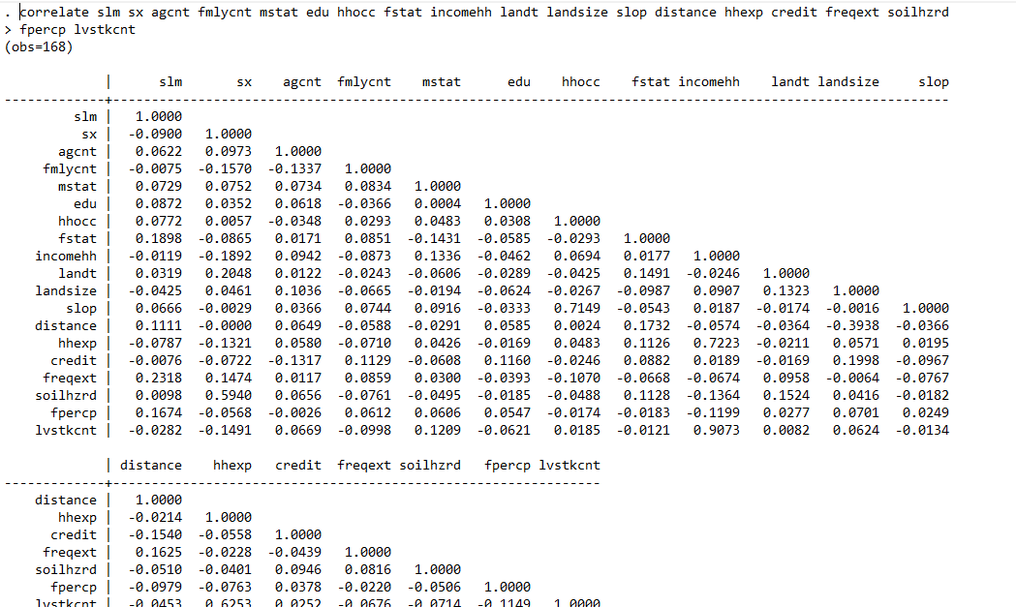

Appendix.9:- pictures of FGC and some of SLM practices
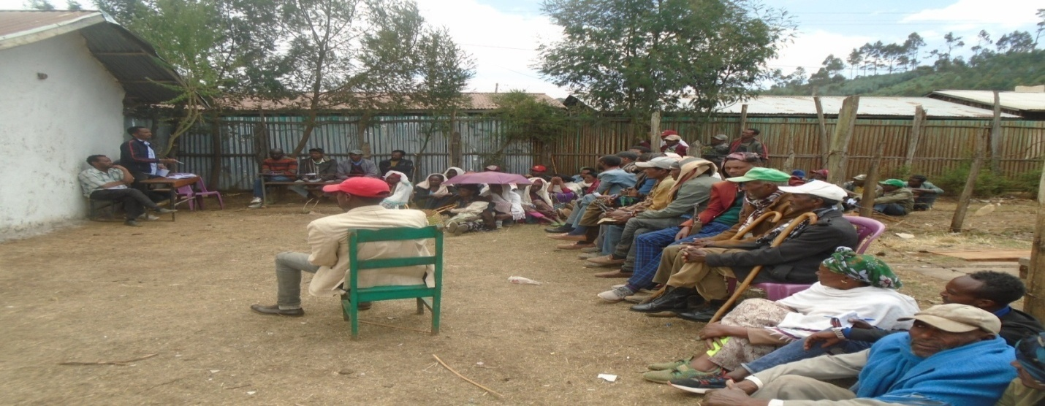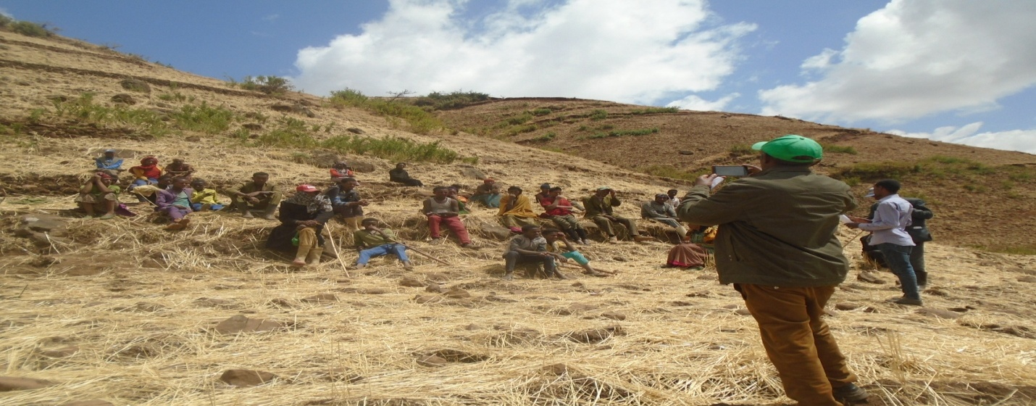Pic. Focus group discuss
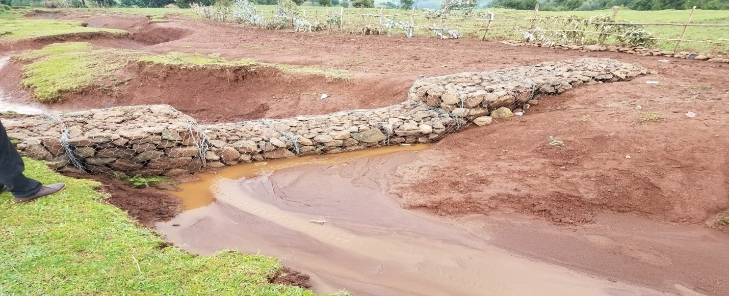
Pic. Gabion check dam
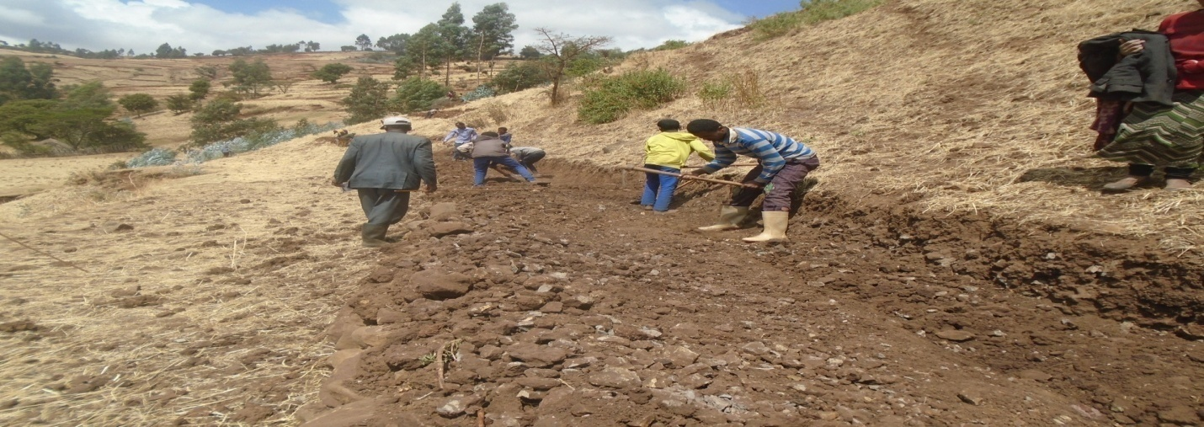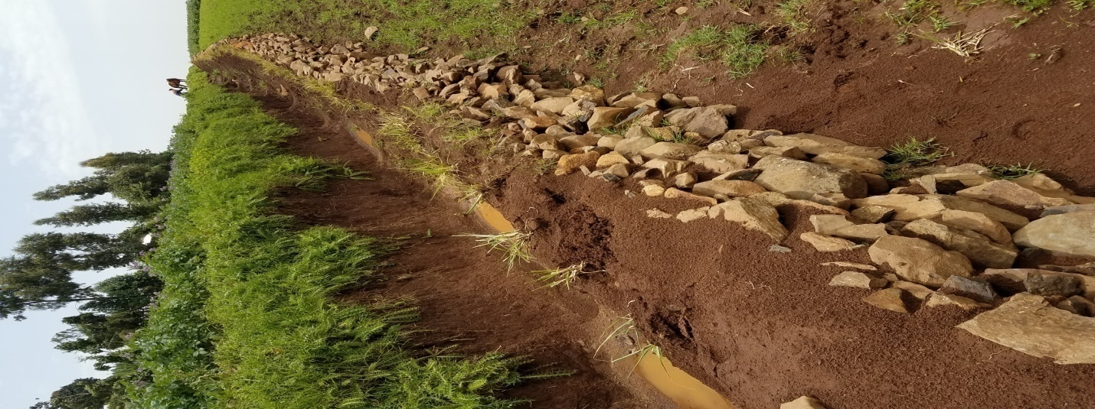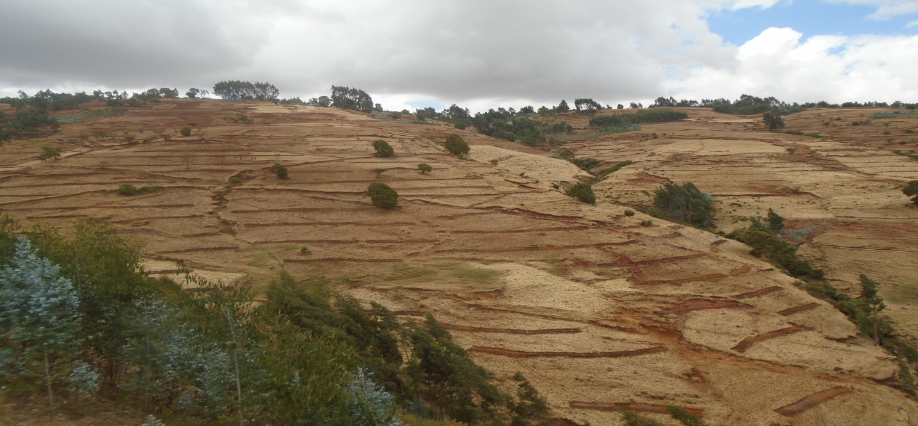
Pic. Terracing, Soil and stone bund

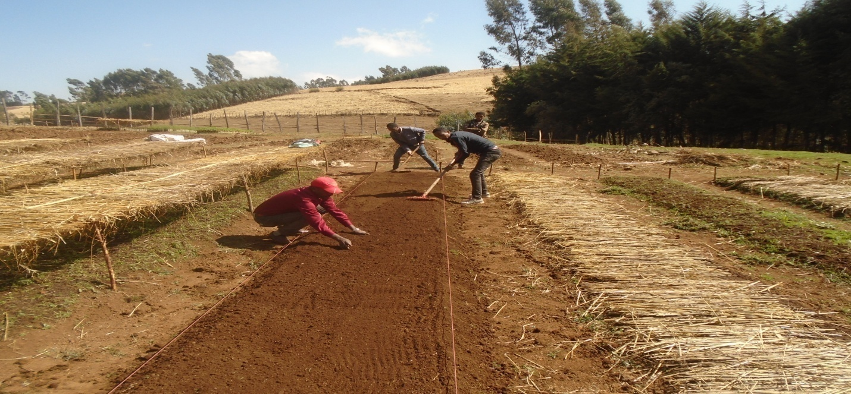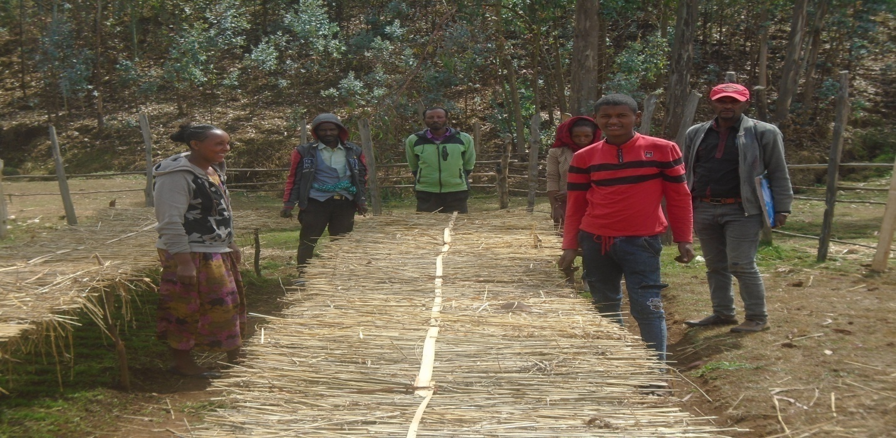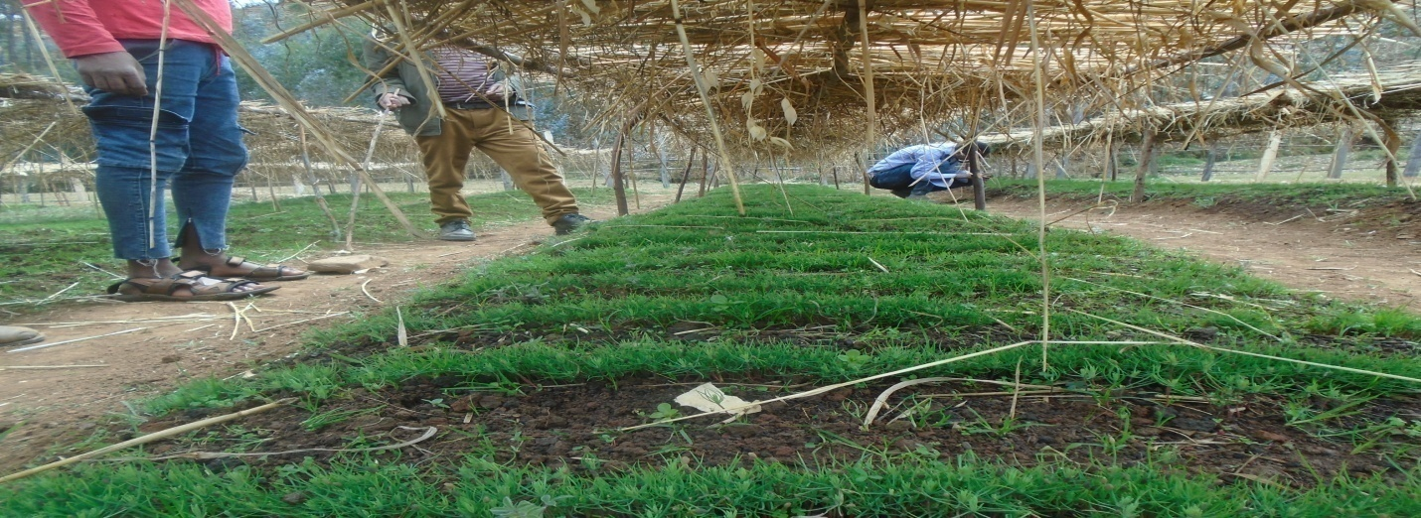
Figure. Made up of planting tress

Appendix.10:- Questionnaires of survey data collection
Key informant discussion questions given for woreda SLM coordinator
Dear key informants,
My name is Sorsa Abdisa, as a master student at Ambo University, college of Business and Economics, Center for Economics in specialization of Development Economics I conduct research on Choice of Sustainable land management (SLM) practices and it’s Determinant among small holder farmer in the selected study areas. The survey may take about 30 minutes of your time to complete, but your answer will play a crucial role to the study I am conducting. I would like to declare that the information collected through this questioner will be used only for academic research purpose; confidentiality of personal data is assured. I highly appreciate your cooperation and I thank you in advance for taking your time to fill in this survey!
Date of discussion _____________________
Woreda _______________________________
- When was the sustainable land management practice introduced in this woreda?
- Which type of practice is dominantly practice in this woreda?
- What are the best practices practiced currently in this kebele?
- How much is the current coverage of sustainable land management practice in this woreda as well as in this kebele?
- What are the factors affecting farmer’s determine to practice sustainable land management practice in this kebele?
- What are the major (potential) factors affecting the farmers‟ determine to practice SLM practices?
- What are the benefits of farmers getting from practicing sustainable land management practices?
- What do you think about the benefits obtained from sustainable land management practices?
- What are the losses those farmers facing because of don’t practicing SLM practices?
- Are there any efforts done to sustainable land management practices in collaboration with extension services and farmers in the woreda?
- How much time the extension workers give the information about SLM practices to the farmers (in a week or in a month)?
- What is the advantage and disadvantage of giving land to share
- What measure do you suggest for current and future practice of sustainable land management to be sustained?
Focus group discussion questions
Dear discussion participants,
My name Sorsa Abdisa,As a master student at Ambo University, college of Business and Economics, Center for Economics in specialization of Development Economics I conduct research on Choice of Sustainable land management (SLM) practices and it’s Determinant among small holder farmer in the selected study areas. The survey may take about 30 minutes of your time to complete, but your answer will play a crucial role to the study I am conducting. I would like to declare that the information collected through this questioner will be used only for academic research purpose; confidentiality of personal data is assured. I highly appreciate your cooperation and I thank you in advance for taking your time to fill in this survey!
Date of discussion ___________________ Kebele / village ______________________
- When sustainable land management practice was started at kebele?
- How many types of choice sustainable land management practice do you know?
- Which choice sustainable land management practice do you practice?
- What is your benefit after practicing choice sustainable land management practices?
- Are there any loses you face because of don’t practicing choice of SLM practices?
Which loses you face?
- Did you get information about sustainable land management practices?
- From where you get the information about the choice of sustainable land management practices?
- Which person is responsible to practice sustainable land management practices for shared lands?
- What is the determinant factors affecting your determine to choice of sustainable land management practices?
- What are the major challenges of practicing choice sustainable land management practices?
- What facility and support you need from government and concerned bodies to manage your farmlands?
- What would be your suggestion to improve, promote and SLM practice in an effective manner in your kebele?
- What did you say about future to sustain best choice SLM practices?

General information
- Question no. _______________
- Date of interview_____________________
- Enumerators name ____________________ sign.__________
- Checked by ______________________ sign.____________
Demographic characteristics
- Sex of respondent?
0=Male 1=Female
- Age of respondent? (______________)years
Age category (years) | Adult equivalent
Age category (years) | Male | Female
18-30
31-64
65+

- Family size ___________?
Age group(years) | Male | Female
<10
10-13
14-16
17-50
>50
- Marital status head of households [______]
(Married=1, Single=2, Divorced=3, Widowed=4)
- Educational level of household heads: what is your year of schooling? [_____] years
(Illiterate=1, From 1-12 =2, Above 12=3, Other (specify) _____________)
- Main occupation of the household head?
1. farming | 2.Off farm | 3.Non-farm

- What is your status in your locality
1. Model farmer 2. Ordinary farmer
House Hold Socio-economic factors
Source and estimated household annual cash income
No | Income source | Isincome sources  Yes=1  No=0 | Annual estimated income in Birr
1 | Crop sale
2 | Livestock sale
3 | Livestock product sale
4 | Off-farm income (causal labor, renting of animal, fishing e.t.c.)
5 | Non-farm income (petty trade, remittance, gift, sand sale e.t.c.)
- If you get income from non-farm activity is yes for question no. , from which activity do you get income?
1. Trade 2. Military 3.Daily labor 4.Handcraft 5.Carpentry 6.Masonry
7. Others (specify)
- Do you think that the availability of non-farm income affect your determine to practice SLM practices? No=0 Yes=1

Land resource
- Do you have your own lands? No=0 Yes=1
- What is the total size of your land (in ha)? _____________

- If your answer for Q1 is yes, what is the landform of your plot?

1. Flat 2. Rugged 3.Steep slope 4.Other (specify

- Do you think that the land form has any implication whether to choose SLM Practices? No=0 Yes=1
- What type of crop do you cultivate on your land?
- Pulses 2. Vegetables 3. Fruit 4. Cereals
- Do you think the type of crop one produces has anything to do with the determine to practice sustainable land management? No=0 Yes=1
- How many times do you cultivate your land in a year?
a. 1 b. 2 c. 3 d. more than 3
- Do you think that there are some reasons that the frequency of cultivation in a year has any relation to the determine of land management practice? No=0 Yes=1

Distance of farm land from home
- How far is your farm land from your home? ( either m or km) _____
- Do you think that the distance of your farm land from your home affect your determine to practice the SLM practices? Yes=1 No=0
Farming experience
- Household experience in farming [_________] year
Livestock ownership
No | Type | Number | Purpose of keeping
1 | Ox
2 | Cow
3 | Calves
4 | Heifers
5 | Donkey
6 | Horse
7 | Bull
8 | Sheep
9 | Goat
10 | Chicken

- SLM Practices and its constraints
- Do you believe that soil degradation can be controlled? Yes=1 No=0
- Are your choice of SLM practices effectively control land degradation? Yes=1 No=0
- Which choice of SLM practice do you practice? (Multiple answer is possible?
1= Terracing2= strip cropping 3= contour farming 4= shallow farming 5=Gabion check dam 6=other (specify) ______________________

- How you use experienceSLM practice?
1=before 5 years 2=before 10 years 3=> 15 years 4=others
- How many times do you choice of SLM practices?
a.1 b. 2 c. 3 d. more than 3
- Do you believe that practicing choice of SLM practices have their own benefits?
Yes=1 No=0
- Do you think that you get the benefit because of practicing choice of SLM practices?
Yes=1 No=0
- If your answer for Q7 is yes, which benefit you get from that?
1=Crop productivity increases 2=Soil fertility 3=Degradation of farmland decreases 5=Decrease financial problems 6=others (specify) __________________
- If your answer for Q7 is No, what is your reason for choice of SLM practices?
1=Lack of information 2=lack of access to credit 3=lack of extension services 4=characteristics of land forms 5=The Distance of farmland to home 6=Availability of nonfarm income 7=Farm experience 8=No need of practicing land management9=other
- Have you destroyed/avoided some of your SLM practices? 0= Yes 1= No
- If yes for Q11, would you please tell me the reason (multiple responses are possible)?

1=Lack of clear standard/design 2= Lack of actual profitability 3= Shortage of farm land
4=Harboring of rodents/birds 5= Hindering farming practice 6=for source of cash
- Are there any losses you faced because of SLM practices? 0= Yes , 1= No
- If you say yes, which losses you face?
1=Decrease crop production 2=Loss of soil fertility 3=Increase of land degradation 4=Financial problems 5=others (specify) _________________
Institutional factors
Lack of credit
- Have you got any chance for you to get credit? Yes=1 No=0
- Have you received any type of credit in 2-3 years? Yes=1 No=0
- If yesQ1, from where you get credit?
1=from bank 2=from credit and saving institution 3=from rich farmers 4=from pawnbroker 5=others
- If yesQ2, for what purpose did you receive credit?
1=To purchase livestock’s 2=To purchase farm equipment’s
3=To purchase fertilizers and pesticides 4=To purchase grain for food
5=others (specify)
- If no, for Q2 why? Multiple answer is possible
1=No one to give credit 2=Fear of inability to pay
3=High interest rate 4=No need of credit 5=others (specify)
Extension services
- Have you got advice about SLM activities from extension services? 1= Yes 0= No
- If yes, who has given you the advice? Multiple choices is possible
1=Government extension officers 2=Association of Farmers
3=NGOs (specify) 4=others (specify) ______________________
- On what issue did the advice focus on?
1=SLM practices 2=Crop diversification
3=Animal husbandry 4=others (specify)
- How often do you get advice?
1=Once a week 2=every 15 days 3=Once a month 4=Once in three month
5=Once in season 6=others (specify)
- From where did you get information about SLM practices?
0=From extension services 1=From neighbors
2=From research center 3=Others (specify)
- Did you believe that the information that you get about SLM activities help you to practice SLM activities? 1= Yes 0= No

Land tenure/ ownership
- Have you ever witnessed land redistribution (reform) in your area? 1= Yes 0= No
- If your answer for question 1 above is yes, do you think that this has any effect on determine of practicing sustainable land management practices? 1= Yes 0= No 3. No idea
- Do you think that the reason you give for question 2 has any relation with land tenure or ownership? 1= Yes 0= No
Agro Ecological Factors
- What are the main environmental problems in your Kebele (multiple responses are possible)?
1. Land degradation 3. Soil erosion 4. Deforestation 5. Other_____________________________
- Is soil erosion a problem on your farm land? 1= Yes 0= No
- If yes for Q2, which indicators have you observed (multiple responses are possible)?
1. Rills are observed 2. Gullies are observed 3. Increased stone cover 4. Yield reduction
5. Exposed plant roots 6. Decline in depth of top soil 7. Stream color changed 8. Soil color changed 9. Soil accumulations found in foot hills 10. Other______________________________________
- I f yes for Q2, which erosion forms are appearing on your farm plots (multiple responses arc possible)?
1. Sheet erosion 2. Rill erosion 3. Gully erosion 4. All are observed
5.0ther, _________________________
- If yes for Q2, would you tell me the trend of soil erosion on your farm plots for the last 10 years? 1. Increasing 2. Decreasing 3. No change
- If increasing for Q5, how do you retail extent?
1. Very severe 2. Severe 3. Moderate 4. Low 5. Very low
- Which natural factors you think triggers soil erosion (multiple responses are possible)?
1. Type of rain fall 2. Erodible soil type
3. Type of topography 4. Other________________________
- I f your answer is type of topography for Q7. What are the common slope types of your farm plot?
1. Steep s lope 2. Moderately steep slope 3. Gentle slope
4.0ther________________________________
- Which human factors you think aggravates soil erosion (multiple responses are possible)?
1. over grazing 2. Deforestation 3. Over cultivation 4. Population growth
5. Other,___________________________
- What is your opinion on the final consequence of soil erosion (multiple responses are possible)?
1. Famine 2.0ut-migration 3.Conflict over resources
4. Impoverishment 5.0ther___________________

II. PERCEPTION OF FARMERS ON CHOICE OF SLMP PRACTICE AND ITS DETERMINANTES
- What is the extent perception of choice of SLM practices?
0=Increase 1= Decrease 2= No differences
- What do you think the severity of choice of SLM practices of your farm?
0=Low 1=Moderate 2=High 3=Extreme
- Do you think use choice of SLM practices is to prevent soil erosion? Yes=1 No=0
- If the answer Q 3 is yes, do you implement choice of SLM practices are to prevent soil erosion and land degradation? Yes=1 No=0
- If the answer Q 4 is yes, what the major soil erosion conserved choice of SLM practices is to apply? (More than one answer are possible)
1=Terracing 2=Soil and stone bund 3=Gabion Check Dams 4= Planting Trees
- Do you think about doing soil erosion conservation methods by SLM practice are profitable? 0=Yes 1=No
- If the answer Q6 is yes, how the result of profit ability is expressed soil erosion conservation methods? (More than one answer is possible)
1= To prevents soil erosion 2=Improve land productivity 3=Improve soil fertility of farm 4= To increase moisture retention 5=Other, specify _________________
- If the answer Q4 is No, what are the disadvantages of soil erosion conservation measures do not apply in your farm? (More than one response are possible)
1= Reduction of crop productivity 2=Loss soil of crop land 3=Difficult to cultivates simply 4=Consume to more labor 5=other is specify____________
- If the answer Q4 is No, what are the major constraints to implement conservation technologies? (more than one answer are possible )
1=Do not understand of advantages conservation 2=Difficult implement technologies 3=required too much labor to construct bund 4=Decrease farm land /difficult to plow
5=Poor agricultural extension services 6=Not understand erosion impact on crop
7=others, specify_____________

