AMBO UNIVERSITY
SCHOOL OF GRADUATE STUDIES
COLLEGE OF NATURAL AND COMPUTATIONAL SCIENCE DEPARTMENT OF BIOLOGY, ENVIRONMENTAL SCIENCE PROGRAM
ASSESSMENT OF PHYSIOCHEMICAL AND BACTERIOLOGICAL QUALITY OF HAND-DUG WELLS WATER IN DENDI DISTRICT, WEST SHEWA ZONE, OROMIA REGIONAL STATE, ETHIOPIA.

MASTER OF SCIENCE THESIS
SUBMITTED TO THE SCHOOL OF
GRADUATE STUDIES OF AMBO UNIVERSITY FOR PARTIAL
FULFILLMENT OF THE REQUIREMENTS FOR THE MASTER OF
SCIENCE DEGREE IN ENVIROMENTAL SIENCE
BY: BEKELE FROMSA SEIFU
ADVISOR: ALEMAYEHU ADUGNA (PHD)

May, 2021
Ambo

AMBO UNIVERSITY
SCHOOL OF GRADUATE STUDIES
As Thesis research advisors, we hereby certify that we have read and evaluated this Thesis entitled: Assessment of Physiochemical and Bacteriological Quality of Hand-dug Wells in Dendi District, West shoa Zone, Oromia regional state, Ethiopia prepared under our guidance by: Bekele Fromsa Seifu . We recommend that it can be submitted as fulfilling the Thesis requirement.
---------------------------------------------- ------------------------ --------------- --------------------------------
Name of Major Advisor Signature Date
------------------------------------------- ----------------------------- ---------------------
Name of Co- Advisor Signature Date
------------------------------------------ ---------------------------- -----------------
As members of the Board of Examiners of the M.Sc. Thesis Open Defense Examination, we certify that we have read and evaluated the Thesis prepared by Bekele Fromsa and examined the candidate. We recommended that the Thesis be accepted as fulfilling the Thesis requirement for the Degree of Master of Science in Environmental Science.
------------------------------------------------ --------------------------------- ------------------
Name of Chairperson Signature Date
------------------------------------------------ --------------------------------- ------------------
Name of Internal Examiner Signature Date
-------------------------------------------------- ---------------------------------- ----------------
Name of External Examiner Signature Date

AMBO UNIVERSITY
SCHOOL OF GRADUATE STUDIES
COLLEGE OF NATURAL AND COMPUTATIONAL SCIENCE DEPARTMENT OF BIOLOGY, ENVIRONMENTAL SCIENCE PROGRAM
APPROVAL SHEET
Submitted by:
____________________ _______________ ____________
(PG Candidate) (Signature) (Date)
Advisor
____________________ _____________ _______________
(Name) (Signature) (Date)
Co-advisor
___________________ ____________ ________________
(Name) (Signature) (Date)
College/Institute Dean
___________________ __________ ________________
(Name) (Signature) (Date)
Director School of Graduate studies
___________________ __________ _________
(Name) (Signature) (Date)

Acknowledgements
First of all, I would like to thank almighty God for helping me to start and successfully complete this work. I convey my deepest thanks to my major advisor Dr. Alemayehu Adugna, for giving me constructive advice and guidance in preparing the proposal, research guidance and finalizing the thesis. Without his encouragement, suggestion and support the completion of this research work would not have been possible.

I would like to acknowledge the employers of Dendi woreda Agricultural Office for the materials, transport and computer support extended to me in my research work. Furthermore, particularly, I am thankful to Ato Bayisa Dhugasa, Ato Mitiku Oljira, Ato Adisu Berhanu and W/r.Meskerem Meshesha who have supported my research in many ways.

I would like to acknowledge Dendi Woreda Water and energy resource Office staffs who have given me necessary data and information needed for the research work during the study area survey. I would also like to acknowledge Ato Lema Kuma.

I would also like to thank Ambo University Laboratory technicians, particularly Ato Gemmechis Takele, Ato Bekele and W/r Jabane who supported me in providing the laboratory services.
I am grateful to my beloved Kebene Efa, my Brother Ato mulgeta Betemariyam and W/r Fasika Solomon who have given me moral support, strength and encouragement in completing my thesis on time.

Table of Contents
LIST OF TABLES vii
LISTS OF FIGURES viii
LISTS OF APPENDICES ix
ACRONYM x
ABSTRACT xi
CHAPTER ONE 1
1. INTRODUCTION 1
1.1. Background 1
1.2. Statement of the problem 2
1.3 Objective of the study 3
1.3.1. General Objective 3
1.3 2. Specific objective 3
1.4. Significance of the studies 3
CHAPTER TWO 4
2. LITERATURE REVIEW 4
2.1. Water 4
2.2. Sources of Water 4
2.3. Wells 4
2.4. Well contamination 5
2.5. Microbes associated with drinking water 6
2.5.1 Coliform bacteria 6
2.5.2. Escherichia coli 7
2.5.3. Salmonella 7
2.5.4. Giardia 7
2.6. Physiochemical Properties of water 8
2.6.1. PH of Water 8
2.6.2. Standards of pH 9
2.6.3. Turbidity 10
2.6.4. Electrical Conductivity 11
2.6.5. Hardness of Water 11
2.6.6.Nitrate in water 12
2.6.7. Fluorides in water 13
2.7. Treatment of Water 14
CHAPTER THREE 16
3. METHODOLOGY AND MATERIALS 16
3.1. Study site 16
3.2. Sample Size, Sampling, and Sample Handling. 17
3.3. Study Design and Parameters 18
3.4. Data analysis 20
CHAPTER FOUR 21
4. RESULT AND DISCUSSION 21
4.1. Socio-demographic characteristics of the study population 21
4.2. Household drinking water collection practices 22
4.3. Household water handling practices 22
4.4. Knowledge and information about household water handling practice 23
4.5. Physical and chemical properties of water samples 24
4.6. Bacteriological Quality of Drinking Water 34
CHAPTER 5 36
5. CONCLUSIONS AND RECOMMENDATION 36
5.1. Conclusion 36
5.2. Recommendation 36
REFERENCES 37

LIST OF TABLES

Table 1: WHO Bacteriological Quality of Drinking Water 8
Table 2. Socio-demographic characteristics of the respondents in Dendi District, West Shewa Zone, Ethiopia. 21
Table 3. Sources of drinking water and collection practices in Dendi District, West Shewa Zone, Ethiopia 22
Table 4. Household water handling practices 23
Table 5 . Knowledge and information about household water handling practice 24
Table 6: Calcium, Magnesium, Sodium and Potassium Ion of study area Compare with WHO and ESA Maximum Permissible Limit. 30

LISTS OF FIGURES

Figure 1: Map of the study Area 17
Figure 2: Turbidity of study area Compare with WHO Maximum Permissible Limit. 25
Figure 3: PH value of study area Compare with WHO Maximum Permissible Limit. 26
Figure 4: Total hardness of study area Compare with WHO Maximum Permissible Limit. 27
Figure 5: TDS of study area Compare with WHO and ESA Maximum Permissible Limit. 28
Figure 6: EC of study area Compare with WHO and ESA Maximum Permissible Limit. 29
Figure 7: chloride ion of study area Compare with WHO and ESA Maximum Permissible Limit. 31
Figure 8: Sulphate of study area Compare with WHO and ESA Maximum Permissible Limit. 32
Figure 9: Phosphate of study area Compare with WHO and ESA Maximum Permissible Limit. 32
Figure 10: Iron ion of study area Compare with WHO and ESA Maximum Permissible Limit. 33
Figure 11: Ammonia of study area Compare with WHO and ESA Maximum Permissible Limit. 34
Figure 12. Total and Fecal coliforms of the study hand-dug well 35

LISTS OF APPENDICES

Appendices 1: Household level Questioners for hand-dug well users 42

ACRONYM

CFU Colony forming unit
CSA Central statistics authority
EPA Environmental protection agency
ESDWQ Ethiopian Standard Drinking Water Quality
FC Fecal Coli form
HDW Hand-dug Well
M.a.s.l Meter above sea level
MCLG Maximum Contaminant Level Goal
Mg/l milligram per liter
MM Millimeter
MPN Most probable Number
NTU Nephelometric Turbidity Unit
PH Power of hydrogen
PPM parts per million
SDG Sustainable development Goal
SMCLG Secondary Maximum Contaminant Level Goal
SPSS statistical package for the social sciences
TC Total coliform
TDS Total dissolved solid
UKAID United Kingdom Agency for International Development
UNICEF United Nations international children’s Emergency Fund
WHO world health organization

ABSTRACT

In many rural areas in developing countries including Ethiopia access to clean drinking water is a primary concern of people. The study area relay on well water as a source of water for their livelihood. Therefore, this study aims to assess the quality of water based on physicochemical and bacteriological parameters and determine the suitability of hand dug wells of Dandi district area for drinking purpose. The study was conducted in Dandi district in West Shewa, Oromia, Ethiopia. The bacterial load of the water samples was determined using standard microbiological methods. Physicochemical properties including Total dissolved solids (TDS) , Turbidity (NTU), Ammonia , total hardness , calcium , magnesium , iron , chloride, phosphate, sulphate, sodium and potassium concentrations were determined in the Ambo University biology and chemistry laboratories. The values obtained were compared with the World Health Organization (WHO) standards for drinking water.The analysis of drinking water quality parameters were done using a total of 20 water samples collected from hand-dug well. The obtained result indicated that pH, Turbidity, Total dissolved solids , Electrical conductivity, sodium, iron concentration of the water samples ranged from 6.9-7.35 0.39 to 15.53NTU, 187.67 to 630.67mn/L, 277.67 to 906.33 µS/cm, 17.43 to 70.83 mg/L, 0.083 to .0475 mg/L respectively. In addition, the mean concentration of Total Hardness, calcium, magnesium and chloride were 216.33 to 467 mg/L, 59.7 to 143.4 mg/L, 27. to 11.5 mg/L, 35.03 to 200.21 mg/L respectively. The Sulphate, phosphate, potassium, Ammonia concentration were found to be 9.43 to 435.85 mg/L, 10.8 to 56.01 mg/L, 2.7 to 11.5 mg/L, 0.15 to 0.56 mg/L respectively. 75% of the water sample tested positive for faecal coliforms indicating that they had disease burden. This study revealed that, the majority of the tested parameters were within the permissible range of WHO. However, Mg, turbidity, Fe, S of the water samples were found to be above the tolerable limits set by the WHO. Besides, this study has shown that there is also bacterial contamination of well water by pathogenic organisms. The present study has revealed that some of the bacteriological data and physico-chemical parameters had values beyond the maximum tolerable limits recommended by WHO. Thus, it calls for appropriate intervention, including awareness development work and improving the existing infrastructure.

Keywords: well water, Dandi district, physico- chemical characteristics, Microbiological quality

CHAPTER ONE

INTRODUCTION

Background
Water is very important in the life of all living things found in the world because it constitutes to a large extent, the major solvent in which many of the body’s proteins and other substances are dissolved. It enables many metabolic activities of the body to take place (Samuel et al., 2016). Historically, (from time immemorial,) point of rural settlement was being determined by water source such as stream, river and spring (Okeola et al., 2010). The inhabitants of these early settlements relied on underground water often within a few meters of the surface and which they exploited in well digging.
About 1.1 billion people in the world lack access to good quality drinking water. Globally, 4 billion cases of diarrhea are reported every year causing 1.8 million deaths, out of which about 90% are children under five (UKAID, 2013). Water related diseases are responsible for 80% of all illness or death in the developing countries and kill more than 5 million people every year (UKAID, 2013). Drinking water can be polluted at the source, distribution line, and/or at the household level, and such polluted water can be vehicles for several pathogens (WHO, 2006). Moreover, in low and middle income countries like Ethiopia, a significant proportion of health care facilities lack improved water sources, improved sanitation, and lack water and soap for hand washing (Bedada et al., 2018).
To achieve Goal 6 of sustainable development goal (SDG), providing adequate and quality water has been a priority area in Ethiopia. Accordingly, Ethiopia has met the target of 57% of the population using safe drinking water by 2015 (CSA, 2016). Despite the considerable expansion of the water supply systems on account of reaching this goal, Ethiopia is still among the countries with the lowest basic water services and high prevalence of water related diseases. Access to potable water and sanitation services in Ethiopia is among the lowest in sub-Saharan Africa. For example, safe drinking water coverage is about 66% (CSA, 2016), and only 6.3% of households have access to improved sanitation. Problem is especially worst for rural people, who make up more than 80% of the Ethiopian population. More importantly, the majority of the ruralHouseholds do not have sufficient understanding of hygienic practices regarding food, water, and personal hygiene. Moreover, only 17% of people practice improved hygiene behaviors and live in healthy environments (CSA, 2016).
In Ethiopia, limited access to safe water and inadequate sanitation and hygiene services accounted for 60 to 80% of communicable diseases and an estimated 50% of children’s under nutrition. Poor sanitation, such as open defecation, can lead to stunting. Open defecation, for instance, can lead to fecal-oral diseases such as diarrhea, which in turn cause and worsen malnutrition. Diarrhea is the leading cause of under-five mortality in Ethiopia, accounting for 23% of all under-five deaths, that is, more than 70,000 children a year (UNICEF, 2020)..
Several studies have been conducted regarding the bacteriological quality of drinking water in the different localities of Ethiopia. For instance, a study in Jimma zone (south west Ethiopia) by Yasin et al. (2015) reported that all drinking water samples were tested positive for total and fecal coliforms. Tabor et al. (2011) reported that 77% of the drinking water samples in Bahir Dar city (Northwest Ethiopia) were tested positive for total coliform counts, and they had a high-risk score. A study by Berhanu (2015) in Bona District (southern Ethiopia) showed that 86% of the drinking water did not meet the WHO guidelines for drinking water quality. A study in Adama town (Eastern Ethiopia) by (Temesgen & Hameed, 2015) showed that 44.2% and 28.9% of the water samples were tested positive for fecal coliforms and fecal streptococcus, respectively; (Feleke et al., 2018) reported fecal coliform count of 82.1 to 86.8% in drinking water in Wogera town (Northern Ethiopia). Duressa et al. (2019) reported total coliform count of 100% and fecal coliform count of 37% in drinking water sample in Nekemte town (Western Ethiopia). A study by Gizachew et al. (2020) in Boloso Sore district (southern Ethiopia) reported that 91% and 44% of drinking water samples collected from households and the sources were tested positive for fecal coliforms.

1.2. Statement of the problem
In the study area, there are many hands dug well built by governments, or local or international agencies. But, lack of safe drinking water is a major problem of D/burka, Faji Galiia and wamura Seqo. Due to inadequate supply of pipe –borne water in the district, many people have been sourcing their daily water need from wells. Hand dug wells are normally found in the area as they are the least expensive to construct. The presence of major ion concentration, occurring either artificially or naturally in well water has risks to human life. In the study area also water treatment at source is not regularly done, constructed water schemes has not been regularly maintained, no regular sanitary survey was done, water schemes has not properly fenced this condition can exposed drinking water supply at source for contamination. Handling practice of drinking water at household is also one of the problems of the area, even though water is safe at source it can be contaminated during collection, storage and consumption at household. Therefore, using such contaminated water may have health risks. To the best of our knowledge, no study so far has been conducted into the major source of drinking water (wells) in the district as water from these sources are used without quality test .Therefore, evaluating water sources to confirm their compliance with quality standards is very much important because they have a direct effect on the health of individuals. This study is thus aimed to evaluate the bacteriological and physicochemical quality of hand dug well in three selected kebeles of Dendi district west shewa zone Ethiopia using standard procedures of WHO and Ethiopian drinking water quality guidelines.

Objective of the study

1.3.1. General Objective
The overall objective of the study is to analyse physiochemical and bacteriological water quality parameters of hand-dug Wells in D/burka Faji Galiia and Wamura Seqo District, West Shewa Zone, Oromia regional state

1.3 2. Specific objective
- To assess the household water collection and handling practices of the study area
- To determine the bacteriological quality of hand dug wells using Total Coli form (TC) and Fecal coli form (FC)
- To determine some of the physio-chemical quality of the hand dung wells
- To assess the sanitation condition of hand dug wells that influence the microbial and physiochemical qualities of the well water

1.4. Significance of the studies
Result of this study will reveal the extent of problems related to drinking water pollution and hence influence concerned bodies for appropriate intervention and trigger scientific communities for further studies on the problem. It will have also contributions in identifying implementation of drinking water management Practices by users and their effectiveness in controlling water contamination. Moreover, it will help as a reference for other studies in the area with similar or other themes of study.

1.5. Scope of the study
The present work is limited to few physico-chemical parameters and sampling frequency. Therefore, year round sampling and analysis of additional water quality parameters such as fluoride and heavy metals should be undertaken. Additionally, the scope of this research is limited in terms of sample size coverage and depth owing financial, logistic and time resource availabilities.

CHAPTER TWO

LITERATURE REVIEW

Water
Water is a liquid at ambient conditions, but it often co-exists on Earth with its solid state being ice, and gaseous state being water vapor or steam. Human bodies are approximately 60% water, blood is at least 50% water and the human brain made of 77% water (Desissa & Yibel, 2017).

2.2. Sources of Water
Water can be grouped into Surface water comprising of oceans, rivers, lakes, reservoirs, lagoons, streams and many others, Ground water which is considered mostly as purer than the surface water and lastly the rain water which falls as a result of condensation and precipitation of the clouds (Desissa & Yibel, 2017).
Surface water frequently contains substances that must be removed before it can be used as drinking water while ground water is that pumped from wells and boreholes that have been drilled from underground aquifers and is usually free from harmful contaminants.

2.3. Wells
A Well is an excavation or a structure created in the ground by digging, driving, boring or drilling to access groundwater in underground aquifers (ODNR, 2006).The well water maybe drawn by an electric submersible pump, a vertical turbine pump, a hand pump or a mechanical pump (e.g. from a water-pumping windmill). It can also be drawn up using containers, such as buckets that are raised mechanically or by hand. Wells can vary greatly in depth, water volume and water quality. Well water typically contains more minerals in solution than surface water and may require treatment to soften the water.
There are basically three types of wells. They include hand-dug wells, driven wells and drilled wells. Hand-dug wells are constructed by hacking at the ground with pick and shovel to dig until the water table is reached. If the ground is soft and the water table is shallow, then dug wells can work. The well is lined with stones, brick, tile, or other material to prevent collapse, and is either covered with a cap of wood, stone, metal or concrete (ODNR, 2006).
Driven wells are built by driving a small-diameter pipe into soft earth, such as sand or gravel (ODNR, 2006). A screen is usually attached to the bottom of the pipe to filter out sand and other particles. They can only tap shallow water, and because the source of the water is so close to the surface, contamination from surface pollutants can occur.
Drilled wells require a fairly complicated and expensive drill rig. They use rotary drill bits that chew away at the rock, percussion bits that smash the rock. Drilled wells can be drilled more than 1,000 feet deep. Often a pump is placed at the bottom to push water up to the surface (ODNR, 2006).

2.4. Well contamination
Shallow pumping wells can often supply drinking water at a very low cost, but because impurities from the surface easily reach shallow sources, a greater risk of contamination occurs for these wells when they are compared to deeper wells. Contamination of the wells increases during the rainy seasons where the aquifer is “topped up” more rapidly and both vertical and horizontal migrations of water are accelerated (Okeola et al., 2010). Dug and driven wells are easy to contaminate because they are relatively shallow.
The quality of the well water can be significantly increased by lining the well, sealing the well head, fitting a self-priming hand pump, constructing an apron, ensuring the area is kept clean and free from stagnant water and animals.
Most of the bacteria, viruses, parasites, and fungi that contaminate well water come from faecal material from humans and other animals. Common bacterial contaminants include E. coli, Salmonella, Shigella, and Campylobacter jejuni. Common viral contaminants include nor virus, sap virus, rotavirus, enter viruses, and hepatitis A and E. Parasites include Giardia lamblia, Cryptosporidium, Cyclospora cayetanensis, and microsporidia (mintah, 2011).

2.5. Microbes associated with drinking water

2.5.1 Coliform bacteria
Coliform bacteria are rod- shaped bacteria that are normally found in the colons of warm blooded animals and become a serious contaminant when found in water or food.
Total and Fecal coli forms are one of the most important parameters to consider when assessing the suitability of drinking water because of the infectious disease risk (WHO, 2006). Fecal coli forms indicate contamination by mammals and birds waste (faces) and signify the possible presence of pathogenic bacteria and virus which are responsible for water-related diseases such as cholera, typhoid and other diarrheal related illness (WHO, 2006). The total and fecal coli form bacteria are primary indicators of pot ability of drinking water. It measures the concentration of coliform bacteria associated with the possible presence of disease causing organisms.
Human and animal wastes are primary source of coliform bacteria in water. These sources of bacterial contamination include runoff from feedlots, pastures, dog runs, and other land areas where animal wastes are deposited (Hubbard et al., 2004). Additional sources include seepage or discharge from septic tanks, sewage treatment facilities, and natural soil/plant bacteria. Bacteria from these sources can enter wells that are either open at the land surface, or do not have watertight casings or caps. Coliforms also enter water in individual house wells via backflow of water from a contaminated source, carbon filters or leaking well caps that allow dirt and dead organism to fall into the water (Hubbard et al., 2004).
Insects, rodents or animals entering the well are other sources of contamination. Old wells, which were constructed by hand and lined (cased) with rocks or bricks usually have large openings. This makes it easier for insects, rodents, or animals to enter the well.
Coliform bacteria are indicators of pathogenic organisms that cause diseases. They could cause intestinal infections, dysentery, hepatitis, typhoid fever, cholera and other illnesses. However, these illnesses are not limited to disease-causing organisms in drinking water.
Intestinal infections and dysentery are generally considered minor health problems. They can however, prove fatal to infants, the elderly, and those who are ill (WHO, 2006). Other bacteria may also be present in water.
Coliform bacteria are not pathogenic (disease causing) organisms, and are only mildly infectious. For this reason these bacteria are relatively safe to work with in the laboratory (Wen et al., 2020). If large numbers of coliforms are found in water, there is a high probability that other pathogenic bacteria or organisms, such as Giardia, Salmonella and Cryptosporidium, may be present.
Public drinking water supplies must demonstrate absence of total and fecal coli form per 100mls of drinking water (Berhanu, 2015). There are no regulations however, governing individual water wells. It is up to the private well owner to have his or her water tested. The EPA Maximum Contaminant Level (MCL) for coliform bacteria in drinking water is zero per 100 ml of water.

2.5.2. Escherichia coli
Escherichia coli (E. coli); is a Gram negative rod-shaped bacterium that is commonly found in the lower intestine of warm-blooded organisms. Most E. coli strains are harmless, but some, such as serotype O157:H7, can cause serious food poisoning in humans, and are occasionally responsible for product recalls. The harmless strains are part of the normal flora of the gut, and can benefit their hosts by producing vitamin K2, and by preventing the establishment of pathogenic bacteria within the intestine.
E. coli are not always confined to the intestine, and their ability to survive for brief periods outside the body makes them an ideal indicator organism to test environmental samples for contamination (Ndoziya et al., 2019).

2.5.3. Salmonella
Salmonella is a microbe found in cold and warm blooded animals (including humans), and in the environment (Ifeanyi, 2018). They cause illnesses like typhoid fever, paratyphoid fever, and food borne illness. Salmonella infections are zoonotic and can be transferred between humans and nonhuman animals. They are found in foods and water contaminated with animal faces. Raw foods and vegetables can become contaminated (Ifeanyi, 2018).

2.5.4. Giardia
Giardia is a one-celled parasite that can cause a gastrointestinal illness. Giardia is a microscopic parasite (Ryan and Ray, 2004), that can be found in water. Giardia causes an intestinal illness called giardiasis or "beaver fever." Giardia is often found in mammalian faces. Drinking water sources become contaminated when faces containing the parasites are deposited or flushed into water. If treatment is inadequate, drinking water may contain sufficient numbers of parasites to cause illness (Duressa et al., 2019). Other sources include direct exposure to the faces of infected humans and animals, eating contaminated food, and accidental ingestion of contaminated recreational water.

Table 1: WHO Bacteriological Quality of Drinking Water
Organisms | Guideline value
All water intended for drinking  E.coli or thermotolerant Coliform bacteria  Treated water entering the distribution system  E.coli or thermotolerant Coliform bacteria | Must not be detectable in any 100ml sample
Total Coliform | Must not be detectable in any 100ml sample
Giardia | Must not be detectable in any 100ml sample
Salmonella | Must not be detectable in any 100ml sample

(Source; WHO, 2006)

Physiochemical Properties of water

2.6.1. PH of Water
The pH is a measure of the activity of the hydrogen ion [H+]; also, it is the reciprocal of the logarithm of the hydrogen ion concentration (Silberberg, 2000). The pH scale ranges from 0 to 14 (Ameyibor and Wiredu, 1991). In general, water with a pH less than 7 is considered acidic, soft and corrosive. pH more than 7 is considered basic (Ameyibor and Wiredu, 1991).

2.6.2. Standards of pH
The pH of pure water is 7 at 25ºC (Bowman & Mealy, 2010), but when exposed to the carbon dioxide in the atmosphere, equilibrium results in the pH of approximately 5.2. The WHO optimum limit of pH values is between 6.5 and 8.5. Because of the association of pH with atmospheric gases and temperature, it is strongly recommended that the water be tested as soon as possible.
Water with a low pH could contain elevated levels of toxic metals, cause premature damage to metal piping, and have associated aesthetic problems such as a metallic or sour taste, staining of laundry and the characteristic "blue-green" staining of sinks and drains (Bowman & Mealy, 2010).
Water with a pH more than 8.5 could indicate that the water is hard (Bowman & Mealy, 2010). Hard water does not pose a health risk, but can cause aesthetic problems. These problems include formation of a "scale" or precipitate on piping and fixtures causing water pressures and interior diameter of piping to decrease, causes an alkali taste to the water and can make coffee taste bitter, formation of a scale or deposit on dishes, utensils, and laundry basins, difficulty in getting soaps and detergents to foam and formation of insoluble precipitates on clothing.
    - Total Dissolved Solids
Dissolved solids refer to any minerals, salts, metals, cations or anions dissolved in water. Total Dissolved Solids (TDS) comprises of inorganic salts (principally, calcium, Magnesium, Potassium, Sodium, Bicarbonate, Chlorides and Sulphates) and some small amount of organic matter that are dissolved in water (WHO, 1996).
TDS originate from natural sources such as, sewages, urban run-offs industrial waste water and chemicals used in the water treatment process. Total Dissolved Solids concentration is the sum of the cations and the anions in the water.
An elevated TDS concentration is not a health hazard. The TDS concentration is a secondary drinking standard and therefore is regulated because it is more of an aesthetic rather than health hazard (WHO, 1996). An elevated TDS also indicate the following;
- The concentration of the dissolved ions may cause the water to be corrosive, salty or brackish taste, result in scale formation and interfere and decrease efficiency of hot water heaters and
- Many contain elevated levels of ions that are above the primary or secondary drinking water standard such as an elevated level of nitrate, arsenic, aluminum copper, lead etc.
The EPA establishes standards for drinking water in two categories; that is primary standards and secondary standards. The primary standard is based on health consideration and the secondary is based on taste, odor, and color, corrosivity, foaming and staining properties of water. There is no primary drinking water standard for TDS but secondary standard for TDS is 500mg/L (WHO, 2006).

Turbidity

Turbidity is an optical property where suspended and dissolved materials such as silt, clay, finely divided organic and inorganic cause light to be scattered rather than penetrate in a straight lines.
Turbidity is a measure the amount of light scattered by suspended particles and can be considered as the “cloudiness” of a water sample (Mintah, 2011). Turbidity is contributed mainly by suspended sediment and /or plankton, which are solid particles of inorganic or biological origin.
Human activities, including logging, grazing, agriculture, mining, road building, urbanization and commercial construction contribute to periodic pulse or chronic levels of suspended sediment in streams and other water bodies (Mintah, 2011).
In drinking water the higher the turbidity level, the higher the risk that people may develop gastrointestinal diseases. This is especially problematic for immuno-compromised people, because contaminant like viruses or bacteria can become attached to the suspended solids (Mintah, 2011).

Electrical Conductivity

Electrical Conductivity or simply Conductivity is a measure of water’s ability to conduct an electric current. The measurement is important because it indicates the concentration of dissolved ions in the water (Miller et al., 1988), which in turn reflects ground water input, catchment geology or diverse human impact. As the number of charged ions in the water increases, so does the electrical conductivity. Conductivity varies with temperature. High and low humidity result in evaporation of the water but leaves the ions behind giving the water a higher concentration of the salt and other compounds.
Ground water has higher electrical conductivity than surface water because the ground water is able to react with mineral in the soil and rocks in the ground. (Miller et al., 1988).The WHO permissible limit for electrical conductivity of water is 300μS/cm (WHO, 1996).

2.6.6. Hardness of Water
Hard water is water that has high mineral content. Hard water has high concentration of Ca²⁺ ions and Mg²⁺ ions (WHO, 2011). Hard water is generally not harmful to ones‟ health but can pose serious problems in the industrial setting. It is the measure of quantity of divalent ions (salts with 2 positive charges) such as Calcium, Magnesium and / or Iron in water.
The presence of Iron characteristically confers a brownish (rust-like) color calcification, instead of white which is the color of most of the other compounds. These ions enter water supply or ground water by leaching from minerals within an aquifer (WHO, 2011).
Water hardness is measured by adding up the concentration of Calcium, Magnesium and converting the value to an equivalent concentration of Calcium Carbonate (CaCO3) in milligram per liter (mg/L) (WHO, 2011).
Hardness does not pose a health risk and is not regulated by state agencies. In fact, Calcium and Magnesium in drinking water can help ensure average daily requirement for these minerals in a diet. With hard water, soap solution forms a white precipitate instead of producing lather. The effect arises because the dictions destroy the surfactant properties of the soap by forming a solid precipitate (WHO, 2011). It also forms deposit also called scale that cause clog plumbing. This scale mainly caused by CaCO3, Mg (OH)2 and CaSO4. It often causes aesthetic problems, such as an alkali taste to the water that makes coffees taste bitter.

2.6.7.Nitrate in water
Nitrate is a colorless, odorless, and tasteless compound that is present in some groundwater. Nitrate can be expressed as either NO-3 (nitrate) or NO3-N (nitrate-nitrogen) (WHO, 2011). Nitrate (NO⁻³) is a naturally occurring form of nitrogen found in soil. Nitrogen is essential to all life. Most crop plants require large quantities to sustain high yields.
The formation of nitrates is an integral part of the nitrogen cycle in our environment. In moderate amounts, nitrate is a harmless constituent of food and water. Plants use nitrates from the soil to satisfy nutrient requirements and may accumulate nitrate in their leaves and stems. Due to its high mobility, nitrate can leach into groundwater (WHO, 2011).
Nitrates form when microorganisms break down fertilizers, decaying plants, manures or other organic residues. Usually plants take up these nitrates, but sometimes rain or irrigation water can leach them into groundwater. Although nitrate occurs naturally in some groundwater, in most cases higher levels are thought to result from human activities. Common sources of nitrate include fertilizers and manure, animal feedlots, municipal wastewater and sludge, septic systems, and N-fixation from atmosphere by legumes, bacteria and lightning. High nitrate levels in water can cause methemoglobinemia or blue baby syndrome, a condition found especially in infants less than six months.
This causes an increase in bacteria that can readily convert nitrate to nitrite (NO-2). Nitrite is absorbed in the blood, and heamoglobin (the oxygen-carrying component of blood) is converted to methemoglobin. Methemoglobin does not carry oxygen efficiently. This results in a reduced oxygen supply to vital tissues such as the brain. Methemoglobin in infant blood cannot change back to heamoglobin which normally occurs in adults. Severe methemoglobinemia can result in brain damage and death (WHO, 2011). Infants should not be allowed to drink water that exceeds 10 mg/l NO3-N. This includes formula preparation.
The most obvious symptom of methemoglobinemia is a bluish color of the skin, particularly around the eyes and mouth. Other symptoms include headache, dizziness, weakness or difficulty in breathing. If recognized in time, methemoglobinemia is treated easily with an injection of methylene blue (WHO, 2011).
Nitrate in water is undetectable without testing because it is colorless, odorless, and tasteless. A water test for nitrate is highly recommended for households with infants, pregnant women, nursing mothers, or elderly people. These groups are the most susceptible to nitrate or nitrite contamination. Nitrate-nitrogen occurs naturally in groundwater, usually at concentrations far below a level of concern for drinking water safety. Nitrate values are commonly reported as either nitrate (NO-3) or as nitrate-nitrogen (NO3-N). The maximum contaminant level (MCL) in drinking water as nitrate (NO-3) is 45 mg/l (WHO, 2010).
Protecting your drinking water supply from contamination is important for health and to protect property values and minimize potential liability. High nitrate levels often are associated with poorly constructed or improperly located wells. Although there is no enforceable drinking water standard for livestock, it is not advisable to allow animals to drink water with more than 100 mg/l NO3-N. This is especially true of young animals. They are affected by nitrates the same way as human babies. Older animals may tolerate higher levels.

Fluorides in water

Fluoride naturally occurs in food and drinking water source. Fluoride does not alter the taste, color or smell of water (WHO, 2004). A water test is the only way to determine the presence of fluoride in drinking water. Public water system containing fluoride in excess of 4.0mg/L requires defloration. Children under 12years should not be allowed to drink such water.
Fluorides may be discharged as by product from fertilizer and aluminum factories and it can enter ground water Bedrock wells to create greater risk for high levels of fluoride. Fluoridated toothpaste may contain a large concentration of fluoride. Optimal levels, fluoride can have beneficial effects on children dental health making teeth more resistant to long life tooth decay. However, excessive fluorides consumption can mottle enamel, also known as fluorosis (WHO, 2004). Fluorosis is an aesthetic problem without health effect. Very high fluoride exposures can cause crippling skeletal fluorosis.
According to the EPA, the Maximum Contaminant Level Goal (MCLG) for fluoride in drinking water is 4.0mg/L. In addition, it has set a Secondary Maximum Contaminant Level Goal (SMCLG) of 2.0mg/L as guideline in areas that have high levels of naturally occurring fluoride. The best level of fluoride in drinking water is between 0.7mg/L to 1.2mg/L. This range is based on the temperature of the area (WHO, 2004).
    - Sulphate in water
Sulphate (SO2-4) is a combination of Sulphur (S) and Oxygen (O). It occurs naturally in many soil and rock formation (WHO, 2004). Sulphate also occurs naturally in most groundwater. At high levels, sulphate can give water a bitter or astringent taste and can have laxative effects. As water moves through soil and rock formations that contain sulphate minerals, some of the sulphate dissolves into the groundwater. Minerals that contain sulphate include Magnesium sulphate (Epsom salt), Sodium Sulphate (Glauber's salt), and Calcium Sulphate (gypsum).
Salt water intrusion and acid rock drainage are also sources of sulphate in drinking water. In addition, manmade sources include industrial discharge and deposition from burning of fossil fuel.
People unaccustomed to drinking water with elevated levels of sulphate can experience diarrhea and dehydration. Infants are often more sensitive to sulphate than adults. As a precaution, water with a sulphate level exceeding 400 mg/L should not be used in the preparation of infant formula. Older children and adults become accustomed to high sulphate levels after a few days. High sulphate levels may also corrode plumbing, particularly copper piping. According to Minnesota Health Department, if sulphate in water exceeds 250 mg/L, a bitter of medicinal taste may render the water unpleasant to drink. Sulphate above 500mg/L in water may affect the taste of the water. At levels above 1000mg/L, sulphate in drinking water can have a laxative effect, although, these levels are not normally found in drinking water.

Treatment of Water
Bacteria are removed by disinfection and/or filtration. Filtration alone may not be completely effective, but can improve the performance of disinfectants by removing sediment that can shelter the bacteria (Mintah, 2011). Methods of adding chlorine to water include solution feeders for dry chlorine or liquid chlorine or by feeding gas chlorine directly from 100, 150, or 200 lb. cylinders. Gas chlorination is recommended only for larger systems that can support the services of a trained water treatment plant operator. Chlorine is normally dosed to a concentration sufficient to maintain a free residual of at least 0.2 parts per million (PPM) (Mintah, 2011).
Other disinfectants include iodine, ozone, ultraviolet light, and physical methods such as boiling or steam sterilization. Chlorination is still the most common disinfection method widely used, although recent concerns have been raised about the reaction of chlorine with organic matter in water (Mintah, 2011). Such a reaction can result in the formation of trihalomethane, which are suspect carcinogenic compounds. More advanced techniques exist, such as reverse osmosis. It is important that the well is cleaned with 1% chlorine solution after construction and periodically every 6 months.

CHAPTER THREE

METHODOLOGY AND MATERIALS

Study site
The study was conducted in, West shewa Zone, Dendi Woreda (district) Oromia Region. Geographically, the study area (Dendi) is located between 8°43′04″N- 9°17′19″ N latitude and 37°47′39″ E-38°20′47″E longitude.The relative location of this area is bounded by Jeldu and Ilfata woreda in the north, Ejersa Lafo woreda in the east, Ilu woreda in the south-east, Dawo woreda in the south and Ambo in the west. Total area of the district is 109,729 ha with a total projected population in 2010/2011 of 180,215. There are 39 Kebeles (villages) in the district of which four were under township administration, while the rest (n=35) were exclusively rural. Out of the 35 villages, nine were in the dega agro-ecology (temperate climate) with an altitude range between 2000-3288 m.a.s.l., and twenty six in the weyna-dega agro-ecology (semi-arid climate) of altitude between 1500 to 2400 m.a.s.l. The area also receives an annual rainfall of 750-1170 mm. Groundwater from shallow aquifers is the main source for drinking water supply in the district. The water supply systems include springs, both on-spot and gravity piped distribution systems, and hand-dug and machine-dug wells fitted with hand-pump. People also use rivers and streams nearby for irrigation, cattle watering, washing clothes, and bathing (Fekadu, 2010).
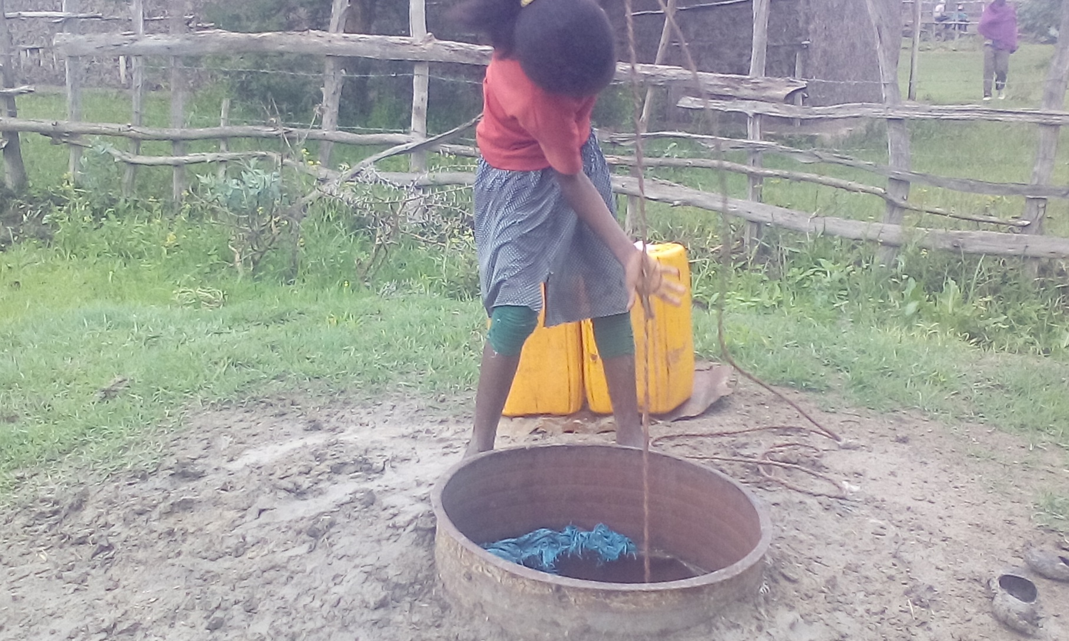
Fotograph of Well in D/burka kebele
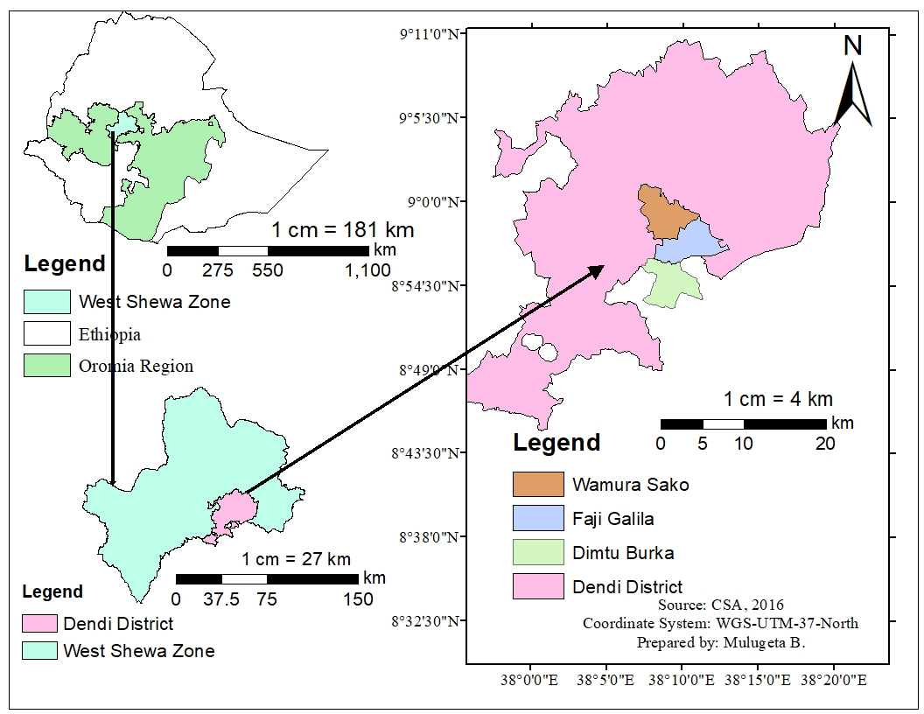
Figure 1: Map of the study Area

Sample Size, Sampling, and Sample Handling.
Structured and pre-tested questionnaires were used to gather pertinent information on socio-demographic characteristics of the study population and their level of awareness about waterborne diseases. A systematic random sampling technique was used to address representative households during socio-demographic data collection. A total of 20 water samples from hand-dug wells were collected for bacteriological examination and physicochemical analyses due to the limitation of financial, logistic and time resource availabilities. Two hundred and fifty milliliters of water sample were collected aseptically with sterilized bottles from the sources (hand-dug wells) and for bacteriological. The physical parameters of water were determined at the field. Samples for chemical analyses were collected with acid-washed one-liter polyethylene bottles. Samples were taken in the morning between 7.00 and 8.00 a.m. Water samples were then kept in an icebox and transported to the microbiology laboratory within 4 hours. Analyses were begun immediately after the sample had arrived at the microbiology laboratory of Ambo University, Ethiopia.

Study Design and Parameters
Three kebeles namely, D/burka, Faji Galiia and wamura Seqo which have hands dug well built by governments, or local or international agencies but lack of safe drinking water were purposively selected for this study area. A cross-sectional study was conducted to assess the microbiological and physicochemical quality of drinking water. Sampling sites were selected based on the availability (purposively) of the hand-dung well for drinking purposes. Water samples were collected from the source hand-dug well using clean and/or sterilized containers for both bacteriological and physico-chemical analyses.
Bacteriological water quality indicator organisms namely, counts of total coliforms and fecal coliforms using multiple fermentation tubes method. Selected physiochemical parameters, namely, magnesium, calcium, turbidity, iron, fluoride, pH, electrical conductivity, total hardness, , SO₄²⁻, NH3, PO₄³⁻ and total dissolved solid, were determined following standard methods. The pH and total dissolved solids were measured using pH meter (HI-99130, Italy). Electrical conductivity was measured using conductivity meter (JENWAY, multi-3410, UK). Turbidity was measured using turbidimeter (AL 250TIR, Germany). Total hardness, calcium, and magnesium hardness were determined using EDTA titrimetric method. Chloride and ammonia concentration were determined using argentometric titration method. The cations potassium and sodium were determined using flame photometry (JENWAY, PFP7, UK). The anions sulfate, and phosphate were measured using UV-visible spectrophotometer (Lambda, CE1021, and Australia) For bacteriological analysis (i.e. fecal coliform and total coliform) the collected samples were analyzed by most probable number (MPN) method. After sample incubation for required time it was possible to isolate and determine the fecal califorms from (APHA, 2005). In addition, visual assessment of the water sources (using observational checklist) and structured questionnaire was conducted to assess the sanitary status and risk factors for water quality deterioration.
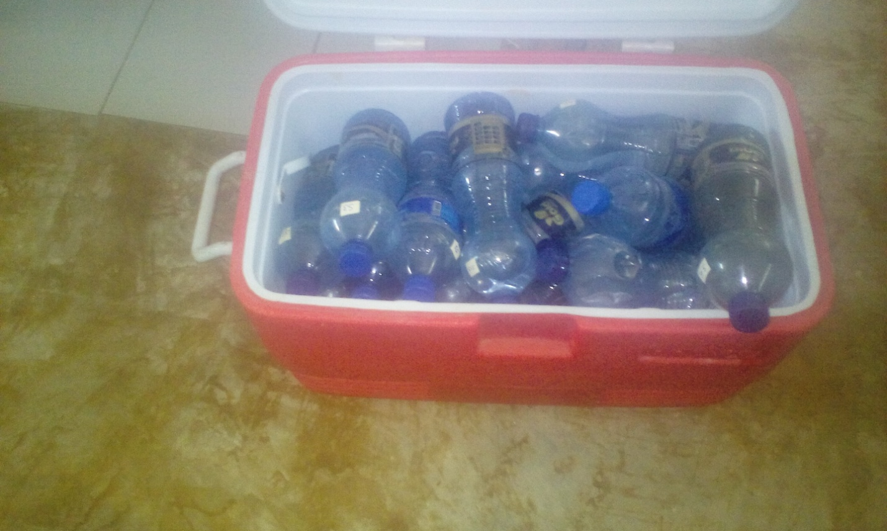
Photograph of samples taken from kebeles

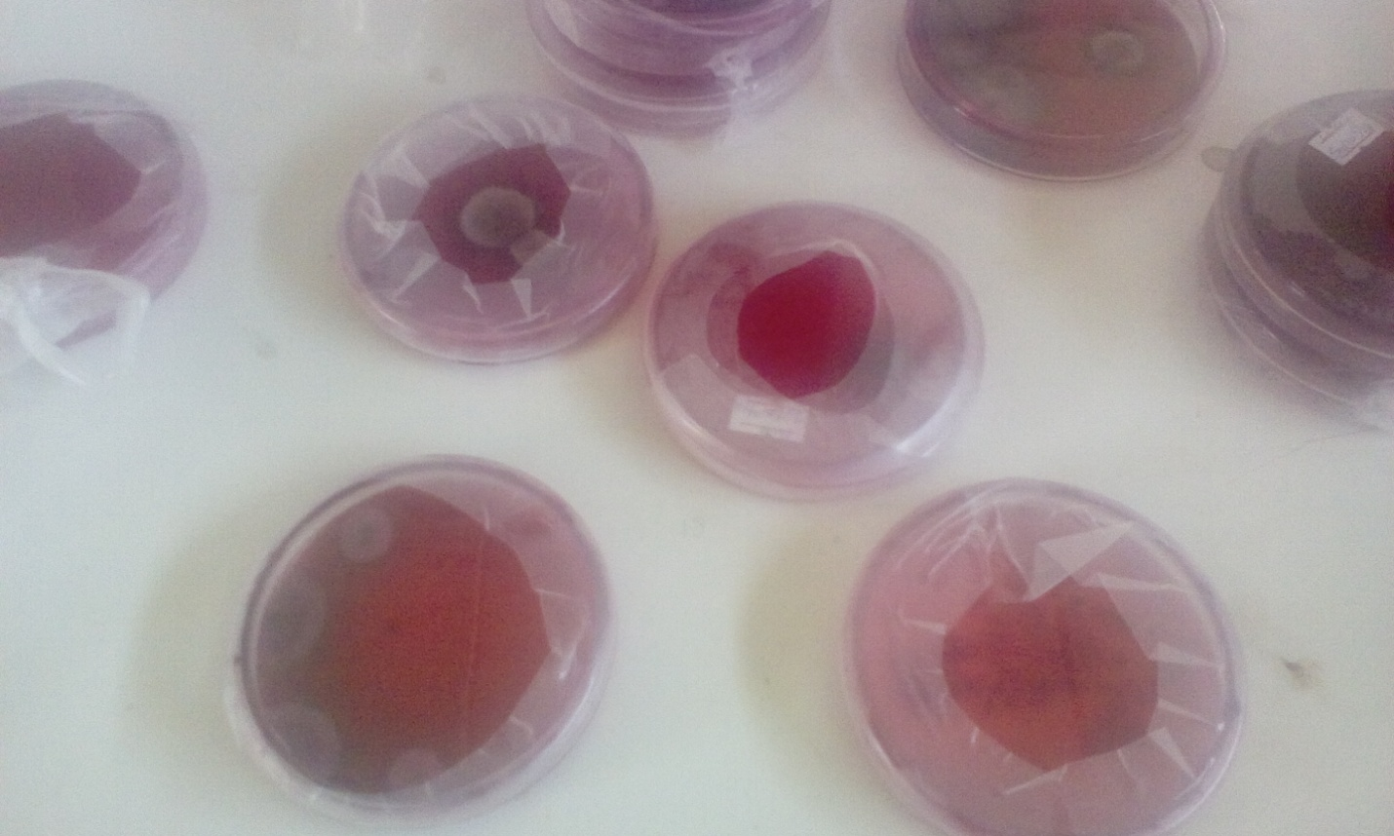
Photograph of showing Laboratory experiment

Data analysis
All collected data were organized on Microsoft Office Excel 2010. The analyzed water samples' bacterial counts and physicochemical properties were compared to WHO guidelines and Ethiopian standards for drinking water quality.

CHAPTER FOUR

RESULT AND DISCUSSION

4.1. Socio-demographic characteristics of the study population
The majority of the respondents (85%) from the 20 households were females between the ages of 35 and 45; unable to read and write or having only completed primary school (80%); housewife (80%); earning less than 2,000 Ethiopian Birr monthly (85%); and had a family size of four or more (75 % ).
Table 2. Socio-demographic characteristics of the respondents in Dendi District, West Shewa Zone, Ethiopia.
VARIABLES | NUMBER | PERCENT
Sex of respondents
Male | 3 | 15
Female | 17 | 85
Age of respondents
15-25 | - | 0
26-35 | 4 | 20
36-45 | 14 | 70
>46 | 2 | 10
Occupation of respondents
House wife | 14 | 70
Merchants | 1 | 5
Farmers | 3 | 15
Government employee | 2 | 10
Others | - | -
Educational status
Illiterate | 8 | 40
Primary | 8 | 40
Secondary and above | 4 | 20
Family size
≤3 | 5 | 25
4-6 | 11 | 55
≥7 | 4 | 20
Household income in Birr per month
≤2,000 | 17 | 85
≥2,001 | 3 | 15

Household drinking water collection practices
Around 20% of the total households surveyed had one or more alternate water sources. 80 % of them only have hand-dung wells as a source of water. Women and children were the primary water collectors in the family. The most prevalent sort of material utilized to gather water from the hand-dug well was jerikan. According to a survey conducted in north Gondar, 95.2 % utilized jerikan to collect and store water (Damtie et al., 2014). The majority of the collecting materials lacked cover, with just 30% having cover, which is lower than the study conducted in Bona District, Sidama Zone, southern Ethiopia (Berhanu and Hailu, 2015). Furthermore, a research for the Dire Dawa rural community was described that was similar to the current study (Amenu et al., 2013).
Table 3. Sources of drinking water and collection practices in Dendi District, West Shewa Zone, Ethiopia
VARIABLE | NUMBER | PERCENT
Where do you get drinking water?
Spring | - | -
Only Hand-dug well | 16 | 80
Only machine-dug well | - | -
Both hand-dug well and machine-dug well | 4 | 20
What types of collection container do you use?
Jerry can | 18 | 90
Plastic bucket | 2 | 10
Clay pot | - | -
Who frequently collects water?
Children | 3 | 15
Woman | 17 | 85
Man | - | -
Does the water collection container have cover materials?
Yes | 6 | 30
No | 14 | 70

Household water handling practices
Despite the fact that the majority of the respondents were illiterate, they had their own perceptions of the state of their water source service and its quality. In this study site, 70% of respondents washed their hands before collecting water, which was higher than the 64.1 % found in the Tehulader District (Tiku et al., 2003). In comparison to Dire Dawa rural village (Amenu et al., 2013), the study area community had better water managing practices. 75 % of respondents in the present research area wash their water collection material before collecting water, which is strikingly similar to the 73.4 % recorded in the Tehulader District survey (Tiku et al., 2003). In the research area, 70% of respondents did not treat their drinking water at the household level, which is similar to a study conducted in Dire Dawa's rural community, where 87 % did not treat their water at the household level (Amenu et al., 2013). Prior to using the water as a drinkable supply, the majority of the families never utilized any form of standardized treatment or filtering method. Only a small fraction of people boiled or filtered their water before drinking it or using it for other purposes.
Table 4. Household water handling practices
VARIABLE | NUMBER | PERCENT
Do you wash your hands before water collection?
Yes | 14 | 70
No | 6 | 30
Do you regularly wash your water containers before water collection?
Yes | 15 | 75
No | 5 | 25
Do you cover the well after water collection?
Yes | 13 | 65
No | 7 | 35
Do you treat drinking water in the house?
Yes | 14 | 80
No | 6 | 20
What method you use for well protection from contamination
Covering | 14 | 70
Fencing | 2 | 10
None | 4 | 20
What treatment measures do you use for unsafe water?
Not at all | 14 | 70
Boiling | 3 | 15
Filtration | 3 | 15

Knowledge and information about household water handling practice
The population in the study area had limited understanding of household water treatment practices, implying that the information provided by health extension workers on household water treatments may be inadequate. A study of the Dire Dawa community was also published similar report (Amenu et al., 2013).
Table 5 . Knowledge and information about household water handling practice
Variable | Number | Percent
Have you been visited by Health extension worker in the last 3 months?
Yes | 3 | 15
No | 17 | 85
During the last 3, month did you receive any information from Health extension worker on safe water handling at home
Yes | 3 | 15
No | 17 | 85
During the last 3 month did you receive any information from Health extension worker about home water treatment
Yes | 3 | 15
No | 17 | 85

Physical and chemical properties of water samples
PH, Electrical conductivity (EC) (µS/cm), Total dissolved solids (TDS) (mg/L), Turbidity (NTU), Ammonia (NH₃) (mg/L), total hardness (T.H) (mg/L as CaCO3), calcium (Ca) (mg/L), magnesium (Mg) (mg/L), iron (Fe) (mg/L), chloride (Cl⁻) (mg/L), phosphate (PO₄⁻²) (mg/L), sulphate (SO₄⁻²) (mg/L), sodium (Na) (ppm) and potassium (K) (ppm) were the physical and chemical water quality parameters examined in the laboratory for this study.
Turbidity
Turbidity is a measurement of how transparent water has become due to the presence of suspended particles. The maximum acceptable permissible limit value for turbidity, according to the WHO (2012) guideline, must always be low, preferably less than 1NTU. It is suggested that the turbidity of disinfected water be consistently less than 5NTU, with a median value of less than 1NTU. Figure 4-1 demonstrates that the turbidity of the study area ranges from 0.39 to 15.53 NTU, with 75 % samples within the WHO Maximum Permissible level and 15% falling short of it. Similarly, in a research conducted in Bona district, Sidama Zone, southern Ethiopia, one rehabilitated well reported 11NTU, whereas the other wells reported 5NTU (Berhanu and Hailu, 2015).

Figure 2: Turbidity of study area Compare with WHO Maximum Permissible Limit.
pH value
pH is a measure of how much hydrogen (H+) is present in a substance. The pH scale is calculated using neutral chemicals as a reference. Alkaline or basic substances have a pH of greater than 7.0 (7.1-14.0). Acidic substances are those with a pH of less than 7.0(0-6.9). The minimum and maximum pH values for drinking water, according to the WHO, are 6.5 to 8.5. There are no negative health effects from drinking mildly acidic or basic water (WHO, 2011).. Figure 2 depicts the pH levels of the water in the study area. The research area's PH values vary from 6.9 to 7.35, which is within the WHO's minimum and maximum allowed PH values (WHO, 2011). All of the wells had pH values that were within the WHO and ESA criteria of 6.5–8.5 (WHO, 2011; ESA, 2013). In a similar study conducted in the southern Ethiopian district of Wondogenet, the PH value reported was 6.6 to 7.8 (Haylamicheal and Moges ,et al,2012). Similar results were also obtained from groundwater sources in Dire Dawa City, Eastern Ethiopia, which were within the acceptable pH range (6.5–8.5) (Amenu et al., 2013). However, the pH of the water in the Agbongbon borehole was slightly higher than the WHO's recommended limit (WHO, 2011).

Figure 3: PH value of study area Compare with WHO Maximum Permissible Limit.

Total Hardness
A variety of dissolved polyvalent metallic ions, primarily calcium and magnesium cations, create hardness in water. Calcium carbonate is commonly measured in milligrams per litre. Hardness is a conventional indicator of water’s ability to react with soap, with hard water necessitating significantly more soap to form lather. Total hardness concentrations in well water samples ranged from 216.33 mg/L to 467 mg/L, with 100% of the total samples falling under the WHO Maximum Permissible standard. Hardness of water should be 500 mg/l, according to the World Health Organization (WHO, 2011). Similar findings were found in Guya Village and its environs in Tigray, Northern Ethiopia, with hardness levels ranging from 170.00 to 327.50 mg/L (Gebrehiwot et al., 2011). A comparable investigation was likely undertaken in Temeke area, with total hardness ranging from 30mg/L to 710mg/L. (Napacho and Manyele, 2010).

Figure 4: Total hardness of study area Compare with WHO Maximum Permissible Limit.

Total Dissolved Solids.
The amount of mobile charged ions in a particular volume of water, including minerals, salts, and dissolved metals, is measured in milligrams per liter (mg/L). Total dissolved solids (TDS) in well water samples ranged from 187.67 mg/L to 630.67 mg/L. Except for one hand dug well sample, which had TDS levels of 630.67 mg/L, all samples had TDS concentrations below the WHO (500 mg/L) and ESA (1000 mg/L) permitted limits. These findings are consistent with those of an Indian study (Sankor and Jama, 2019), which found total dissolved solids values ranging from 146 mg/L to 467 mg/L.

Figure 5: TDS of study area Compare with WHO and ESA Maximum Permissible Limit.

Electrical Conductivity
Pure water is a good insulator rather than a good conductor of electric current. The electrical conductivity of water improves as ions concentration rises. The electrical conductivity of water is usually determined by the amount of dissolved particles in it. Electrical conductivity (EC) is a measurement of a solution's ionic process, which allows it to transmit current. Conductivity is a measure of the conducting ability of water and it is determined by the presence of ionic species in the water. Electrical conductivity (EC) value for all the sampling sites varied from 277.67 to 906.33 μS/ cm. The measured EC value indicates that all examined water samples had values which were within the permissible limit of WHO 1200 μS/cm and ESA 1500 μS/cm for drinking water. Similar results reported for EC value of the drinking water in the Adaa woreda, in Oromia Regional State of Ethiopia, which is 426-712 μS/cm (Desissa, 2016). Because electrical conductivity is directly proportional to total dissolved solids, the presence of a slightly high value of electrical conductivity in the water sample indicates that contaminations owing to dissolve ions are high. This could be related to the study area's soil type and geology, as well as wastes arriving from nearby water sources.

Figure 6: EC of study area Compare with WHO and ESA Maximum Permissible Limit.
Calcium, Magnesium, Sodium and Potassium Ion
Calcium and magnesium ions are the most common constituents present in various types of rock and are the most common constituents present in natural waters ranging from zero to several hundred mg/L. The Calcium concentration in well water samples ranged from 59.7 mg/L to 143.4 mg/L. About 65% of the studied wells were within the WHO and ESA drinking water criterion ( 100 mg/L) (WHO, 2011; ESA, 2013). The dissolution of carbonate minerals, as well as the decomposition of sulfate, phosphate, and silicate minerals, can naturally produce calcium ion (Ca²⁺) in groundwater.
Magnesium ions concentrations in the wells ranged from 2.35 mg/L to 79.62 mg/L. According to the results, 90% of the well water samples had magnesium ions below the WHO and ESA standards for drinking water, which is 50 mg/L (WHO, 2011; ESA, 2013). The principal sources of magnesium in the subsurface water samples might be due to geological sources such as dolomite and other magnesium
The weathering of rocks was the natural supply of sodium and potassium in groundwater, but the elevated levels in contaminated water might be linked to the outflow of waste water. The concentrations of sodium ions in well water samples ranged from 17.43 mg/L to 70.83 mg/L. The amount of salt found in all well water samples was less than the WHO and ESA drinking water maximum permitted level of 200 mg/L (WHO, 2011; ESA, 2013). Similar results were found in the groundwater of Dire Dawa City, Eastern Ethiopia, with sodium concentrations ranging from 7.31 mg/L to 74.94 mg/L (Amenu et al., 2013).
95% of the potassium concentrations in all well water samples were below the WHO and ESA drinking water maximum permitted level of 10 mg/L (WHO, 2011; ESA, 2013). Similar results were found in the groundwater of Dire Dawa City, Eastern Ethiopia, with potassium concentrations ranging from 0.55 mg/L to 3.33 mg/L (Amenu et al., 2013)..
Table 6: Calcium, Magnesium, Sodium and Potassium Ion of study area Compare with WHO and ESA Maximum Permissible Limit.
Parameters | Concentration | Hand-dug well |  | WHO Standards
Calcium Ion(mg/L) | Mean | 90.49384 |  | 100
 | stdv | 25.53602
 | Min | 59.2
 | Max | 146.2857
Magnesium Ion (mg/L) | Mean | 25.45425 |  | 50
 | stdv | 18.5444
 | Min | 1.944
 | Max | 79.704
Sodium Ion (mg/L) | Mean | 35.56167 |  | 200
 | stdv | 13.3207
 | Min | 17.4
 | Max | 70.9
Potassium Ion (mg/L) | Mean | 5.303333 |  | 10
 | stdv | 1.745305
 | Min | 2.7
 | Max | 11.6
Chloride Ion
Run-off wastes from human activities, wastewater discharges into water bodies, inorganic fertilizer use, landfill leachates, and septic tank effluents are all forms of anthropogenic and natural sources of chlorides in surface and groundwater. The chloride ion concentration in the well water samples ranged from 35.03 mg/L to 200.21 mg/L. The chloride ion content in all water samples was below the WHO and ESA drinking water permitted limit of 250 mg/L (WHO, 2011; ESA, 2013). Different levels of chloride salts in the soil and sediments, or variances in the degree of waste entering the hand-dug wells, could cause the significant variations in concentrations. The results of this study are similar to those of hand-dug wells in the Hantebet Catchment, Tigray, and Northern Ethiopia (Gebrehiwot et al., 2011)

Figure 7: chloride ion of study area Compare with WHO and ESA Maximum Permissible Limit.
Sulfate and Phosphate
The sulfate ion concentration in the well water samples ranged from 9.43 mg/L to 435.85 mg/L. According to the results, 75% of the sulfate content in well water samples was less than the WHO and ESA allowed limit of 250 mg/L for drinking water (WHO, 2011; ESA, 2013). The presence of sulfate-containing minerals such as gypsum (CaSO42H2O) and anhydride (CaSO4) in the research area might be the cause for high sulfate content of some well water samples (WHO, 2011).

Figure 8: Sulphate of study area Compare with WHO and ESA Maximum Permissible Limit.
Phosphorus is released in phosphate form as a result of microbial detraction of organic materials. Phosphorus' importance stems from its capacity to promote eutrophication in the presence of other nutrients, particularly nitrogen. The phosphate levels obtained in the well water samples of the sampling area were ranging from 10.81to 56.01 mg/L (Table). While other similar studies conducted in water quality assessment was well in Kumasi district of Ghana phosphate reported range from 0.33 mg/L to 9.30 mg/L. (Nkansah.et.at,2010). The concentrations of phosphate in all well water samples of this study were above the permissible limit of WHO and ESA for drinking water, 2 mg/L (WHO, 2011; ESA, 2013). This might be caused by microbial decomposition of organic substances (WHO, 2011).

Figure 9: Phosphate of study area Compare with WHO and ESA Maximum Permissible Limit.
Iron
Iron was the sole heavy metal found in all of the study area's well water tests. All well water samples had iron concentrations ranging from 0.083 mg/L to 0.475 mg/L. According to the results, 80% of the well water samples showed iron concentrations within the WHO and ESA permitted limit for drinking water, which is 0.3 mg/L (WHO, 2011; ESA, 2013). The greater iron content in the study locations could be due to natural sources. This could be caused by the weathering of minerals, soil type, and iron-rich sediments (Tadesse et al., 2011). Although iron does not offer any health risks, it does give water a bitter taste when present in high concentrations. People who drank iron-rich water complained about the flavor, color, and corrosion of their plumbing systems, as well as liver damage. Those exposed to low concentrations, on the other hand, would be more prone to anemia (Tadesse et al., 2011). In a similar investigation, values of 0.26 to 1.37 mg/L were found in hand dug wells in Ilaro and Aiyetoro, Ogun State, Southwestern Nigeria (Uruola et al., 2015).

Figure 10: Iron ion of study area Compare with WHO and ESA Maximum Permissible Limit.
Ammonia
Ammonia in water is a sign of bacterial, sewage, and animal waste contamination (WHO, 2011). In the current study the ammonia concentration of the hand- dug well ranged from 0.15mg/l to 0.56 mg/l. According to the results, all the well water samples showed ammonia concentrations within the WHO and ESA permitted limit for drinking water, which is 1.5 mg/L (WHO, 2011; ESA, 2013). In Ita-Baale, a similar analysis was carried out on hand-dug well water, obtaining the highest concentration of ammonia of 1.45 mg/l and the lowest concentration of 0.12 mg/l.

Figure 11: Ammonia of study area Compare with WHO and ESA Maximum Permissible Limit.

Bacteriological Quality of Drinking Water
Accordingto WHO guidelines, total coliforms (TC) bacteria should not be detectable in any water intended for drinking. In this investigation, total coliforms (TC) were found in all of the drinking water samples. Only 25% of the hand-dug well samples meet the TC standards (1-10 CFU/100 ml) set by WHO, whereas about 75% of the samples failed to meet “safe water quality “indicating that they didn't fulfill WHO standards (WHO, 2011). The highest recorded TC was 58 MPN/100 ml and the lowest recorded was 1 MPN/100 ml. 100 percent (all 20 samples) of the water samples from the hand-dug wells were contaminated from low risk to high risk positive for TC. In terms of fecal coliforms (FC), 100% of the water samples were found to be positive for FC, indicating that they did not meet WHO standards. Similarly, a previous study had detected both TC and FC in all hand dug water samples (Samuel et al., 2016).
Because of several factors such as poor container washing, hygiene issues, and hand contact with water, no household water treatment methods, and a lack of understanding of bacterial disease transmitted through water, they drink water from similar Jeri cans and utensils at home. Intervention studies have indicated that covering containers lower FC and TC counts in stored water by 50 percent (Chidavaenzi et al. 1998; Mazengia et al. 2002).

Figure 12. Total and Fecal coliforms of the study hand-dug well

CHAPTER 5

CONCLUSIONS AND RECOMMENDATION

5.1. Conclusion
Water is an essential component of our lives. Given that it is a necessary and irreplaceable resource for human survival, it must be maintained in great condition. Although most of the compounds detected in water are naturally occurring, the key objective of water quality testing is to ensure that they do not exceed levels that are likely to be harmful to human health. Bacteriological quality of most water samples analyzed in the current study did not meet the standards set for drinking water. They had values beyond the maximum tolerable limits recommended by WHO. Almost all water samples from the distribution systems were contaminated with TC and FC since the record values were above the recommended guide line value of TC <10CFU/100ml and both FC and FS 0CFU/100ml. Similarly, most of the physico-chemical data indicated marginally tolerable quality with respect to pH and TSS but poor quality in relation to turbidity, conductivity, and fluoride concentration with values much in excess of the permissible standards.

Recommendation

- The present work is limited to few physico-chemical parameters and sampling frequency. Therefore, year round sampling and analysis of additional water quality parameters such as nitrate and other heavy metals should be undertaken
- Hand-dug wells in the study area contain pollutant levels exceeding the WHO drinking-water standard. Therefore, if possible here should be portable supply of water if not there has to be regular microbial assessment and disinfection of wells for drinking.
- Further study is needed to determine the seasonal variations in the contamination level of the hand-dug well water

REFERENCES
Bedada, T. L., Mezemir, W. D., Dera, F. A., Sima, W. G., Gebre, S. G., Edicho, R. M., Biegna, A. G., Teklu, D. S., & Tullu, K. D. (2018). Virological and bacteriological quality of drinking water in Ethiopia. Applied Water Science, 8(2), 70. https://doi.org/10.1007/s13201-018-0716-8
Berhanu, A. (2015). Bacteriological and Physicochemical Quality of Drinking Water Sources and Household Water Handling Practice Among Rural Communities of Bona District, Sidama Zone-Zouthern, Ethiopia. Science Journal of Public Health, 3(5), 782. https://doi.org/10.11648/j.sjph.20150305.37
Bowman, G., & Mealy, R. (2010). Importance of General Chemistry Relationships in Water Treatment (pH Alkalinity Hardness). 608, 1–47.
CSA. (2016). Demographic and Health Survey in ETHIOPIA. In Adolescent Health, Medicine and Therapeutics: Vol. Volume 8. https://doi.org/10.2147/ahmt.s148434
Desissa, D., & Yibel, B. (2017). QualityAssessement of Rural Drinking Water Supply Schemes From Source To -Point of- Use. (A Case Study of Ada’a Woreda, in Oromia Regional State of Ethiopia). Water Supply and Environmental Engineering, 2(6), 2–19.
Duressa, G., Assefa, F., & Jida, M. (2019). Assessment of Bacteriological and Physicochemical Quality of Drinking Water from Source to Household Tap Connection in Nekemte, Oromia, Ethiopia. Journal of Environmental and Public Health, 2019. https://doi.org/10.1155/2019/2129792
Fekadu, A. (2010). Farmers’ Perception of the Impacts of Population Pressure on the Environment and their Responses: The Case of Dandi Woreda, West Shoa Zone (Oromia Region). June.
Feleke, H., Medhin, G., Kloos, H., Gangathulasi, J., & Asrat, D. (2018). Household-stored drinking water quality among households of under-five children with and without acute diarrhea in towns of Wegera District, in North Gondar, Northwest Ethiopia. Environmental Monitoring and Assessment, 190(11), 1–12. https://doi.org/10.1007/s10661-018-7033-4
Gizachew, M., Admasie, A., Wegi, C., & Assefa, E. (2020). Bacteriological Contamination of Drinking Water Supply from Protected Water Sources to Point of Use and Water Handling Practices among Beneficiary Households of Boloso Sore Woreda, Wolaita Zone, Ethiopia. International Journal of Microbiology, 2020. https://doi.org/10.1155/2020/5340202
Hubbard, R. K., Newton, G. L., & Hill, G. M. (2004). Water Quality and the Grazing Animal Water Quality and the Grazing Animal Water quality and the grazing animal 1. https://digitalcommons.unl.edu/usdaarsfacpubhttps://digitalcommons.unl.edu/usdaarsfacpub/274
Ifeanyi, E. I. S. and O. E. (2018). a Review on Salmonella Species and. International Journal of Comprehensive Research in Biological Sciences, January. https://doi.org/10.22192/ijcrbs.2018.05.02.002
Miller, R. L., Bradford, W. L., & Peters, N. E. (1988). Specific conductance: theoretical considerations and application to analytical quality control. US Geological Survey Water-Supply Paper, 2311. https://doi.org/10.3133/wsp2311
Mintah, P. V. (2011). the Quality of Water From Hand Dug Wells in the Akim Oda Township the Quality of Water From Hand Dug Wells. 89.
Ndoziya, A. T., Hoko, Z., & Gumindoga, W. (2019). Assessment of the impact of pit latrines on groundwater contamination in hopley settlement, Harare, Zimbabwe. Journal of Water Sanitation and Hygiene for Development, 9(3), 464–476. https://doi.org/10.2166/washdev.2019.179
ODNR. (2006). Rainwater and Land Development. Development, 6605(614), 4–7.
Okeola, F. O., Kolawole, O. D., & Ameen, O. M. (2010). Comparative study of physico chemical parameters of water from a river and its surrounding wells for possible interactive effect. Advances in Environmental Biology, 4(3), 336–340.
Samuel, K. A., Ampadu, B., & Steve, A. (2016). Investigating the potability of water from dug wells: A case study of the Bolgatanga Township, Ghana. African Journal of Environmental Science and Technology, 10(10), 307–315. https://doi.org/10.5897/ajest2016.2127
Tabor, M., Kibret, M., & Abera, B. (2011). Bacteriological and Physicochemical Quality of Drinking Water and Hygiene- Sanitation Practices of the Consumers in Bahir Dar City, Ethiopia. Ethiopian Journal of Health Sciences, 21(1), 19–26. https://doi.org/10.4314/ejhs.v21i1.69040
Temesgen, E., & Hameed, S. (2015). Assessment of physico-chemical and bacteriological quality of drinking water at sources and household in Adama Town, Oromia Regional State, Ethiopia. African Journal of Environmental Science and Technology, 9(5), 413–419. https://doi.org/10.5897/ajest2014.1827
UKAID. (2013). DFID Evidence Paper: Water, sanitation and hygiene. May, 128 pp. http://r4d.dfid.gov.uk/Output/193434/Default.aspx
UNICEF. (2020). Summary Findings from Sustainability Checks for Rural WASH in Ethiopia. Wash Technical Paper.
Wen, X., Chen, F., Lin, Y., Zhu, H., Yuan, F., Kuang, D., Jia, Z., & Yuan, Z. (2020). Microbial indicators and their use for monitoring drinkingwater quality-A review. Sustainability (Switzerland), 12(6), 1–14. https://doi.org/10.3390/su12062249
WHO. (1996). Total Dissolved Solids in Drinking Water,Background document for development of WHO Guidelines for Drinking-water Quality. Southern Speech Journal, 1(2), 18–21. https://doi.org/10.1080/10417943609370625
WHO. (2004). Chemical sensors: Promising tools for the online monitoring of fluorides. 51(3), 252–266.
WHO. (2006). WHO guidelines for drinking-water quality. Water Supply, 11(3–4), 1–16.
WHO. (2010). A safer future: global public health security in the 21st century. WHO.
WHO. (2011). Hardness in Drinking Water. Eisei Kagaku, 34(5), 475–479. https://doi.org/10.1248/jhs1956.34.475
Yasin, M., Ketema, T., & Bacha, K. (2015). Physico-chemical and bacteriological quality of drinking water of different sources, Jimma zone, Southwest Ethiopia. BMC Research Notes, 8(1), 541. https://doi.org/10.1186/s13104-015-1376-5
World Health Organization, Guidelines for Drinking Water Quality, World Health Organization, Geneva, Switzerland, 2008.
Ethiopia Standard Agency, Compulsory Ethiopian Standard: Drinking Water Specifications, Ethiopia Standard Agency, Addis Ababa, Ethiopia, 2013.
N. Tadesse, A. Bairu, and K. Bheemalingeswara, “Suitability of groundwater quality for irrigation with reference to hand dug wells, Hantebet Catchment, Tigray, and Northern Ethiopia,” Momona Ethiopian Journal of Science, vol. 3, no. 2, 2011.
A. O. Eruola, G. C. Ufoegbune, J. A. Awomeso, and S. A. Abhulimen, “Assessment of cadmium, lead and iron in hand dug wells of Ilaro and Aiyetoro, Ogun State, SouthWestern Nigeria,” Research Journal of Chemical Sciences, vol. 1, no. 9, p. 2231, 2011
Amenu D Menkir S, Tesfaye G. Assessment of water handling practices among rural communities of Dire dawa administrative council, Dire dawa, Ethiopia. Science, Technology and Arts Research Journal 2013; 2(2): 75-82.
Tiku S, Legesse W, Endale H, Faris K. Factors affecting drinking water quality from source to home in tehuledere woreda, northeast Ethiopia. Ethiop J Health Sci 2003; 13(2): 95-106.
Tabor M, Kibret M, Abera B. Bacteriological and physicochemical quality of drinking water and hygiene-sanitation practices of the consumers in Bahir dar city, Ethiopia. Ethiop J Health Sci. 2011; 21(1):19-26.
D. Damite, M. Endris, Y. Tefera et al., “Assessment of microbial and physic-chemical quality of drinking water in North Gondar Zone, Northwest Ethiopia,” Journal of Environmental and Occupational Science, vol. 3, no. 4, p. 170, 2014.
A. Berhanu and D. Hailu, “Bacteriological and physicochemical quality of drinking water sources and household water handling practice among rural communities of Bona District, sidama zone-Zouthern, Ethiopia,” Science Journal of Public Health, vol. 3, no. 5, p. 782, 2015.
A. B. Gebrehiwot, N. Tadesse, and E. Jigar, “Application of water quality index to assess suitability of groundwater quality for drinking purposes in Hantebet watershed, Tigray, Northern Ethiopia,” ISABB Journal of Food and Agriculture Science, vol. 1, no. 1, pp. 22–30, 2011.

Appendices 1: Household level Questioners for hand-dug well users
Characteristics of respondent
1. Household’s name__________________________________________________
2. Sex of the household head: A) Male B). Female
3. Age of the household head in years: A) 18-25 B) 26-35 C) 35-45 D) above 45
4. Marital status: A) married B) Widowed C) Divorced D) unmarried
5. Educational status of household head A)Illiterate B) Elementary school (grade 1-8) C).Secondary school (grade 9-10) D)Preparatory school (Grade 11-12) E) Vocational and higher education
6. Total family number of the respondent’s ________________________
7. Social positions in the kebele A) member of kebele council B) Religious leader C) Others, specify D) none
8. Type of home: A) Compound home B) single family
Water quality and sanitation perception questions
- What does water quality mean to you? ________________________________________________________________________
2. Do you perceive that the water you consume is safe?
A) Not safe at all B) somewhat safe C) partially safe D) safe E) highly safe
3. What is the main indicator of the water quality?
A) Color B) test C) odor D) disease attack E) others specify _______
4. Is the taste, odor and color of water the same as the improved source?
A) Yes B) No
5. If no, what is the difference detected?
______________________________________________________________________
6. What do you think the major cause of water quality problem?
A) Animal wastes B) human wastes C) flood D) others _____________
7. What treatment measures do you use for unsafe water?
A) Not at all B) boiling C) sedimentation D) others specify (done by projects)
8. How many times your family sick due to water related disease last year?
A) None at all B) twice C) three times D) more than three
9. Have you participated in any educational and awareness activities about sanitation and hygiene parallel to water supply? A) Yes B) No
10. Do you have a latrine? A) Yes B) No
11. If yes, when did you dig a latrine (in relation to the constructed water source)?
A) 1 and less than 1 year B) 2years ago C) three and more
12. If yes, who teaches you to dig a latrine?
A) Own self B) sanitary expert C) water use & sanitation committee D) not at all
13. If yes, do you use it? A) Yes B) No
14. If yes, who use the latrine? A) Man B) wife C) child D) all families E) except child
15. If no, what is the reason? __________________________________________________
16. If no, why don’t have a latrine? ____________________________________________
17. Where do you defecate?
A) Public toilet B) neighbor C) open field D) own toilet
18. Distance of the well relative to latrine (meter)
A) 5-10 B) 11-15 C) 16-20 D)>20
19. Method of well protection from contamination
A) Covering B) Fencing
20. Position of well with respect to latrine
A) Uphill direction B) Same level (parallel) C) Downhill
21. Way of drawing water from the well
A) Using rope B) Using pulley system
Water handling, collection and transport practice of well water
22. Type of container to collect water
A) Bucket B) Clay pot C) plastic container (“Jerikan”)
23. Is the container covered/closed during fetching and storage?A) Yes__ B)No___________
24. Type of the material for covering the well
A) Screw cap B) Different plant leaves C) Tin
25. Who frequently collects water?
A) Children B) Women
26. Is there practice of washing hands before fetching?
A) Yes B) no

